Space Concordia – Spacecraft Division
Command & Data Handling (CDH) Intro Task
August 2025

Introduction:
The task consists of three parts: two optional components, a theoretical section and a research section, and a mandatory practical section. While it isn’t required to present the results of the theoretical and research section, they are highly recommended as the topics covered will be directly applied in the practical section. If you feel confident in the following topics then you can choose to skip the first two sections:

- Serial Communication (I2C and SPI)
- Rising/Falling Edge Detection
- Bitwise Operators and Bit Shifting
- Network Data Packets
- UML State Diagram

The aim is to familiarize you with the common software patterns seen in embedded systems programming. While there will be links provided for general guidance, the remaining information (such as libraries and software patterns) will be up to you to do research on. Once you’ve completed the practical section or if you feel stuck on a specific section, you can send an email to the CDH lead (currently either Minh-Tri Nguyen: minh-tri.nguyen@spaceconcordia.ca or Amro Atique: amro.atique@spaceconcordia.ca)

NOTE: This task does NOT require you to have or purchase any of the hardware components listed below, you are able to complete the entire project using the Arduino simulator linked below. The wiring and selection of the component is already done for you, the only thing you need to do is to implement the code. Before you start writing your code, make sure you create an account on the website and save a copy of the project.

Research Section:
Serial Communication
Link: https://learn.sparkfun.com/tutorials/i2c/all
- What is the difference between a half duplex and a full duplex communication channel? What kind of communication channel does SPI and I2C use ?

- In I2C, how many data frames are sent during a single message? For each data frame identified, give a brief description of their purpose.

- How many bits of information can you send in a single I2C message? Given a potentiometer that has a decimal range of 0d0 - 0d1023, how many messages would you have to send to include all of the potentiometer’s bits?

- Given a SPI network of 1 master and N slaves, give a general equation to identify the number of wires that will connect to the master board. Assume we only want a single slave to be selected at any given moment. How many wires would be needed if the network was using I2C?

- List some pros and cons to both I2C and SPI?

UML State Diagram
Link: https://www.visual-paradigm.com/guide/uml-unified-modeling-language/about-state-diagrams/
- Do research on all of the key concepts of a UML State Diagram
- From the figure below and the sample code provided, complete the implementation of the state diagram. You can choose to omit the sub-states for Heating.
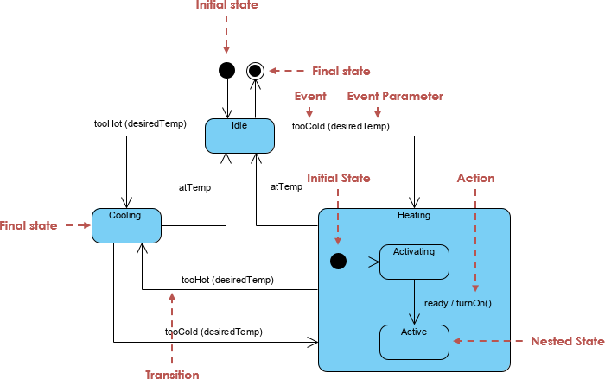

state = idle;
while(True){
switch(state){
//Implement your code here
}
}

Theoretical Section:
Link: https://www.geeksforgeeks.org/c/bitwise-operators-in-c-cpp/

- Perform the following boolean operations (0b denotes a binary value, 0x denotes a hexadecimal value)
  - 0xF3 & 0x81 = 0x?
  - 0b1 << 15 = 0b?
  - 0b1001 | 0b1100 = 0x?
  - (0b1110110 >> 4) & 0x3 = 0b?

- Given a 16 bit binary message, a uint16_t variable called msg, where the most significant bit (MSB) contains the value of a button input and the 10 least significant bits (LSBs) contain the values of a potentiometer reading, complete the following bitwise operations to extract the desired output from msg.
The format of msg would look as follows
msg = button 0 0 0 0 0 pot[9] pot[8] pot[7] pot[6] pot[5] pot[4] pot[3] pot[2] pot[1] pot[0]
bool buttonState = ?
uint16_t potValue = ?

- Write an arduino implementation for a rising edge triggered pushbutton.
pinMode(buttonPin, INPUT);
//Write your code here

- If you were to implement a falling edge triggered pushbutton, what would change from the code implementation above ?

- Give examples of when an edge sensitive pushbutton or a level sensitive pushbutton would be required.

Practical Section:

Reference Link:
https://docs.arduino.cc/learn/communication/wire/

Arduino Simulation link: https://www.tinkercad.com/things/5PecJSoT0cu-space-concordia-cdh-intro-task?sharecode=dVduqRra_3NSJGDJ4cVsRS7MHwUkDcEpY9mV5XIu7bo

*NOTE: The TinkerCAD compiler has an issue where it will not properly output the compilation error log when using the Wire.h library (It will output Invalid Header File). To work around this, it is recommended to write your code using the Arduino IDE and compile using the Verify button before pasting the code into the Simulation. Sorry for the hassle .-.

*As a reminder the leads are available to help if ever you feel stuck.

You are given a circuit with the following components:
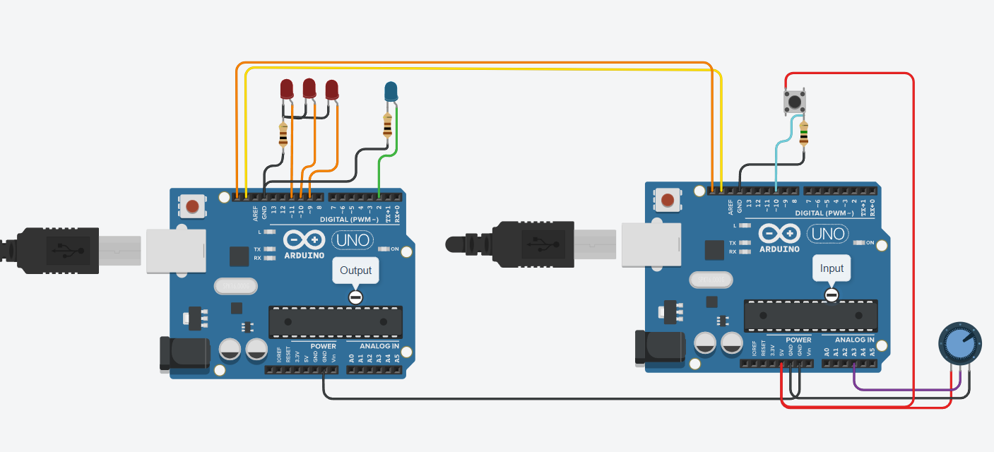
- 2 Arduinos
- 3 Red LEDs
- 1 Blue LED
- 1 Pushbutton
- 1 Potentiometer
- Resistors where needed

The circuit consists of two Arduino boards: One that reads input data and one that processes the input data. Data will be transmitted between the two boards through an I2C connection using the Wire.h built-in library provided by the Arduino IDE, where the Output board will be the master and the Input board will be the slave.

The circuit aims to mimic a combinational lock system where the potentiometer has to be moved to specific key values to be able to gradually unlock the system. The key values will have a given tolerance, creating a region of acceptable values. The equation to determine the region of acceptable values is given by:
region = value + tolerance

The output board will periodically request data from the input board, at which point the input board will transmit a uint16_t data packet with the following structure:
msg = button 0 0 0 0 0 pot[9] pot[8] pot[7] pot[6] pot[5] pot[4] pot[3] pot[2] pot[1] pot[0]

The button value will represent the Rising Edge reading of the pushbutton found on the input board. Once the output board receives a high value on the MSB of the msg, the output board will evaluate the potentiometer value to the current region of acceptable values.

The key values are stored in an array called keys, and at each correct guess a red LED will illuminate. The sequence in which the red LEDs illuminate can be described as follows:
- If the pot value falls within the region of acceptable values and a button press is registered, a single red LED will illuminate in the following order: LED1 -> LED2 -> LED3.
- If the pot value is not within the region of acceptable values and a button press is registered, a single red LED will be turned off in the following order: LED3 -> LED2 -> LED1.
- If the pot value is not within the region of acceptable values and a button press is registered while no LEDs are illuminated, there will be no changes to the system.
- If all three red LEDs are illuminated, the next registered button press will turn off LED3, regardless of the pot value.
A blue LED is provided to determine if the potentiometer falls within the region of acceptable values before registering a button press and starting the sequence. The blue LED is independent from the rest of the sequence.

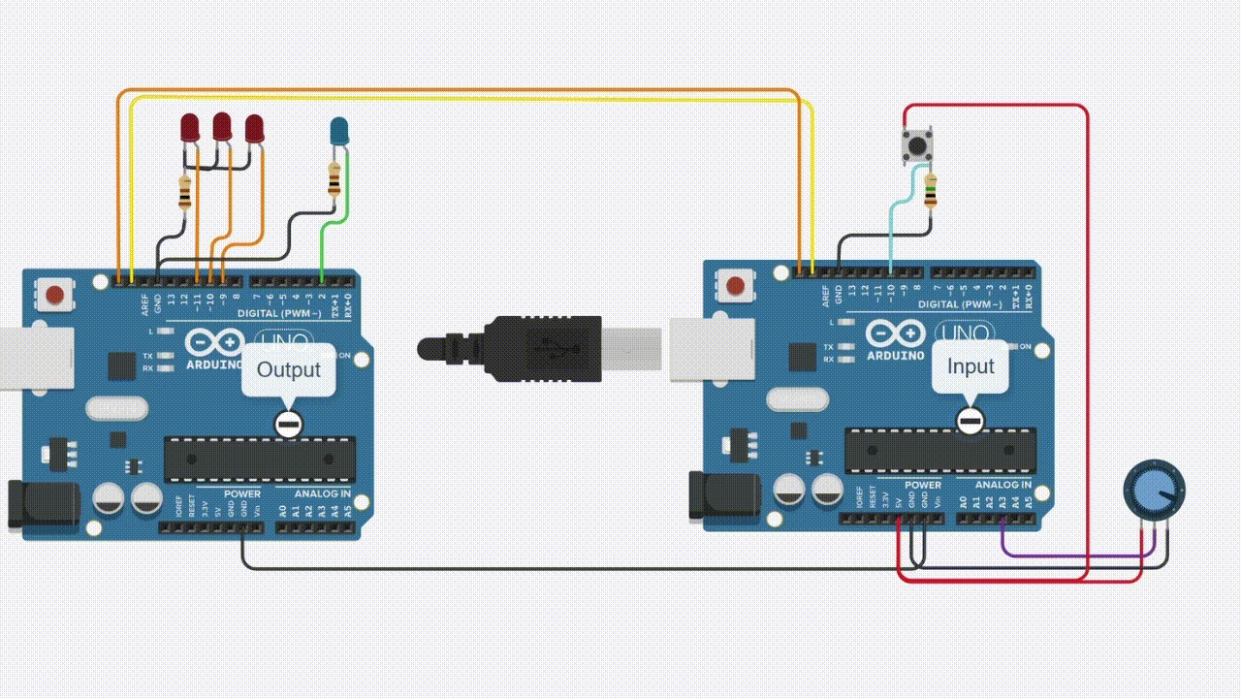

- Design a UML State Diagram that describes the sequence provided above. (Hint: You should have 4 states)

- From the Wire.h documentation, what functions would be useful in this context?

- Develop the code to achieve the described functionality.

- The instructions specifically ask for Rising Edge readings from the button, i.e. record only when the button is initially pressed. Why do you think that is? If the button were to be level sensitive for HIGH values, i.e. record when the button is held, how would that affect the rest of the circuit?

