TECHNICAL REPORT: RELATIONAL DATABASE DESIGN, NORMALISATION, PHYSICAL IMPLEMENTATION, AND GOVERNANCE FOR CROWNFIELD EYE HOSPITAL

Module: CPU4:103 Introduction to Database
Programme: BSc (Hons) Computing
Student Name: Fabio Andrade
GitHub Repository: https://github.com/FabioGBS/crownfield-eye-hospital-database
Master SQL Deliverable: CrownfieldEyeHospital_FullScript.sql

1. EXECUTIVE SUMMARY & LEGACY SYSTEM ANALYSIS

Crownfield Eye Hospital is a specialist tertiary ophthalmic provider. It offers outpatient consultations, diagnostic imaging, pharmacological treatment and post-operative monitoring for chronic eye conditions such as glaucoma, diabetic macular oedema, keratoconus and age-related cataract. Until now, patient scheduling, clinician assignments, diagnostic coding and prescription records have been kept in a single unnormalised flat-file spreadsheet. In a busy clinical setting this creates serious operational risk, along with the modification anomalies described by Connolly and Begg (2015):

• Insertion anomalies: A newly appointed ophthalmologist, or an approved ophthalmic medication, cannot be recorded unless it is attached to an active patient consultation row.
• Update anomalies: Patient demographics and clinician specialities are repeated across many appointment entries. Changing a telephone number or postcode means editing every historical row, and a partial update leaves contradictory medical records and risks missed clinical communication.
• Deletion anomalies: Removing a cancelled or obsolete appointment can erase the only record of a patient's diagnostic history, or of a clinician's contact details, where these sit in the same unnormalised tuple.
• Integrity, concurrency and security deficits: A spreadsheet has no domain validation, no referential integrity, no transaction isolation and no granular permissions. Confidential health records are therefore exposed to accidental corruption and unauthorised access.

This report sets out the relational design developed for Crownfield Eye Hospital. It covers normalisation from Unnormalised Form (UNF) to Third Normal Form (3NF), the physical implementation in MySQL 8.0, the analytical queries, and a Role-Based Access Control (RBAC) model, with attention throughout to the UK GDPR and the NHS Caldicott Principles.

2. TEAM COLLABORATION & INDIVIDUAL TECHNICAL CONTRIBUTION

The Crownfield Eye Hospital database was produced through a group workflow in which every member contributed to each phase and reviewed the others' work.

• Conceptual modelling and normalisation auditing: As a group, we analysed the legacy hospital dataset to establish the business rules, entity boundaries and relationship cardinalities. Functional dependency diagrams were first drafted by different team members, and we then reviewed together each step from UNF through First Normal Form (1NF) and Second Normal Form (2NF) to 3NF, to confirm that the decomposition was lossless. Only after that did we draw the Crow's Foot Entity-Relationship Diagram (ERD) in Draw.io.
• Physical schema and synthetic data: I led the physical implementation in MySQL Workbench, translating the logical schema we had agreed into the master script (CrownfieldEyeHospital_FullScript.sql). The whole team helped to create realistic synthetic clinical records, check the International Classification of Diseases (ICD-10) ophthalmic codes, verify pharmacological dosages, and test the foreign key cascading rules with controlled UPDATE and DELETE statements.
• Analytical querying, security and version control: Each member proposed clinical and administrative reporting scenarios, which we developed together into multi-table joins, views and stored procedures. I then wrote the Data Control Language (DCL) security roles and managed version control with Git in Visual Studio Code. This included resolving remote authentication problems and pushing the validated SQL scripts and presentation materials to the group's GitHub repository.

3. NORMALISATION PROOF (UNF TO 3NF) & CONCEPTUAL DESIGN

Normalisation followed the relational approach set out by Codd (1970). The aim was to remove redundancy and functional dependency anomalies while preserving the dependencies between relations.

3.1 Unnormalised Form (UNF) to First Normal Form (1NF)
Inspection of the legacy spreadsheet showed composite attributes, such as full names and combined contact details held in a single field. It also showed repeating groups, where several prescribed medications sat in one appointment cell (for example, "Latanoprost 0.005% eye drops; Timolol 0.5% eye drops"). To reach First Normal Form (1NF):
1. Each prescribed medication was moved into its own atomic row, which removed the repeating groups.
2. Composite attributes were split into atomic attributes: PFirstName, PLastName, CFirstName, CLastName, Phone, Email and PostCode.
3. A composite primary key of {PatientID, AppointmentID, Medicine} was defined so that each tuple in the 1NF relation could be identified uniquely.

3.2 Second Normal Form (2NF)
A relation is in Second Normal Form (2NF) when it is in 1NF and every non-prime attribute depends on the whole of the composite primary key, so that no partial dependencies remain (Elmasri and Navathe, 2016). Three partial dependencies were found in the 1NF relation:
• PatientID -> PFirstName, PLastName, DateOfBirth, Gender, Phone, Email, PostCode (these depend on PatientID alone and were extracted into a Patient relation).
• AppointmentID -> PatientID, ClinicianID, AppointmentDate, AppointmentLocation, AppointmentStatus, CFirstName, CLastName, Speciality, CPhone, CEmail, DiagnosisRef, Description, Severity, FollowUpDueDate, Priority, Notes (these depend on AppointmentID alone and were extracted into the clinical encounter relations).
• AppointmentID, Medicine -> PrescriptionID, IssuedDate (these depend on the combination of appointment and medication and were extracted into a Prescription relation with the surrogate primary key PrescriptionID).

3.3 Third Normal Form (3NF)
A relation is in Third Normal Form (3NF) when it is in 2NF and contains no transitive dependencies, that is, no non-prime attribute is determined by another non-prime attribute (Date, 2004). In the 2NF clinical encounter relation, the clinician details depended on AppointmentID only through ClinicianID (AppointmentID -> ClinicianID -> CFirstName, CLastName, Speciality, Phone, Email), so they were moved into Clinician_Table. The same reasoning separated the diagnostic findings (DiagnosisID -> DiagnosisRef, Description, Severity) and the post-consultation monitoring plans (Follow_UpID -> DueDate, Priority, Follow_UpStatus, Notes) into Diagnosis_Table and Follow_Up_Plan, each linked to its parent event by a foreign key.

3.4 Final 3NF Relational Schema & Cardinality Rules
1. Patient_Table (PatientID [PK], PFirstName, PLastName, DateOfBirth, Gender, Phone, Email, PostCode)
2. Clinician_Table (ClinicianID [PK], CFirstName, CLastName, Speciality, Phone, Email)
3. Appointment_Table (AppointmentID [PK], PatientID [FK], ClinicianID [FK], AppointmentLocation, AppointmentDate, AppointmentStatus)
4. Diagnosis_Table (DiagnosisID [PK], AppointmentID [FK], DiagnosisRef, Description, Severity)
5. Prescription_Table (PrescriptionID [PK], AppointmentID [FK], DiagnosisID [FK], IssuedDate, Medicine)
6. Follow_Up_Plan (Follow_UpID [PK], AppointmentID [FK], PrescriptionID [FK], DueDate, Priority, Follow_UpStatus, Notes)

In the conceptual Crow's Foot ERD, one patient can book many appointments (1:M) and one clinician can conduct many appointments (1:M). Appointment_Table therefore acts as the associative entity that resolves the many-to-many relationship between patients and clinicians. Each appointment produces one or more diagnoses (1:M), each diagnosis may lead to one or more prescriptions (1:M), and appointments or prescriptions may be linked to follow-up plans (1:M).

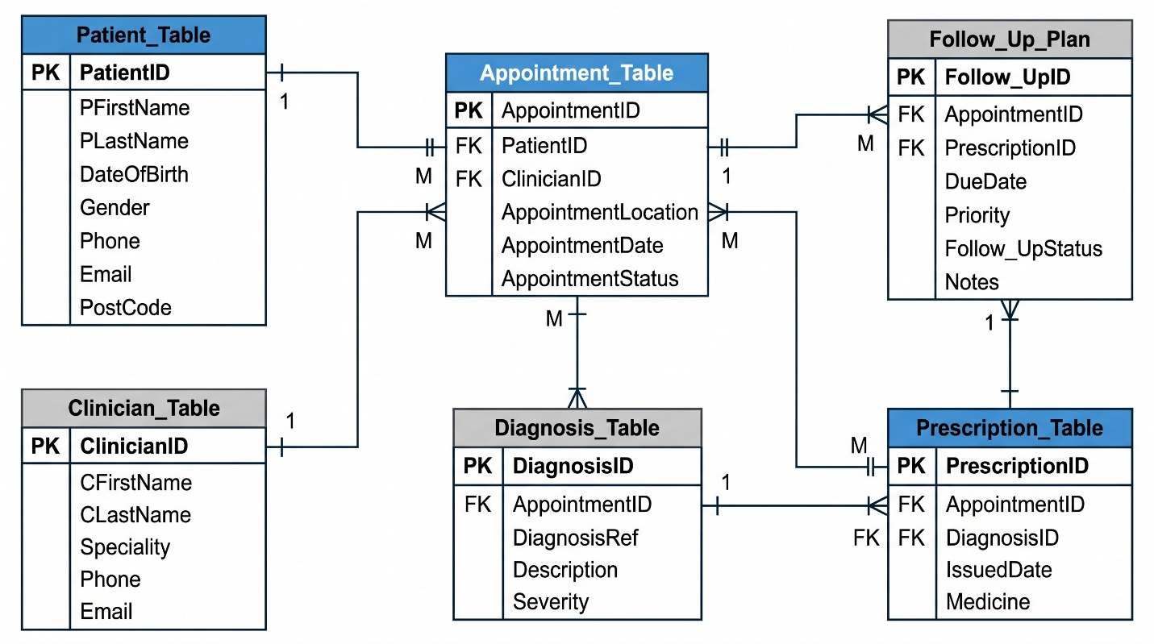

4. PHYSICAL IMPLEMENTATION, DATA DICTIONARY & INTEGRITY RULES

The logical 3NF schema was deployed in MySQL 8.0 using Data Definition Language (DDL). It was populated with fourteen patients, thirteen clinicians and fifteen appointments, drawn from a mix of legacy records and synthetic test cases:

• Entity and candidate key integrity: Every table has a NOT NULL primary key using a structured VARCHAR(10) identifier (OP001, DOC001, APP001, D001, PR001, FU001). UNIQUE constraints on Phone (VARCHAR(20)) and Email (VARCHAR(100)) in both Patient_Table and Clinician_Table prevent duplicate patient or staff registrations.
• Domain integrity: Categorical attributes are restricted with ENUM constraints and sensible defaults. These are Gender ENUM('Male', 'Female', 'Other'); AppointmentStatus ENUM('Scheduled', 'Completed', 'Cancelled', 'No-Show') DEFAULT 'Scheduled'; Severity ENUM('Routine', 'Mild', 'Moderate', 'Severe', 'High', 'Urgent') DEFAULT 'Routine'; Priority ENUM('Routine', 'High', 'Urgent') DEFAULT 'Routine'; and Follow_UpStatus ENUM('Pending', 'Completed', 'Cancelled', 'Overdue') DEFAULT 'Pending'. The date attributes (DateOfBirth, AppointmentDate, IssuedDate and DueDate) use the DATE type, which follows ISO 8601 format.
• Referential cascading policies: All foreign keys use ON UPDATE CASCADE, so changes to a primary key pass through to the child tables. The core tables (Patient_Table, Clinician_Table and Appointment_Table) use ON DELETE RESTRICT, which stops patients or clinicians with historical consultations from being deleted and supports compliance with NHS record retention standards. The optional foreign keys (DiagnosisID in Prescription_Table and PrescriptionID in Follow_Up_Plan) use ON DELETE SET NULL, so a patient's follow-up schedule stays intact if an individual medication is discontinued.

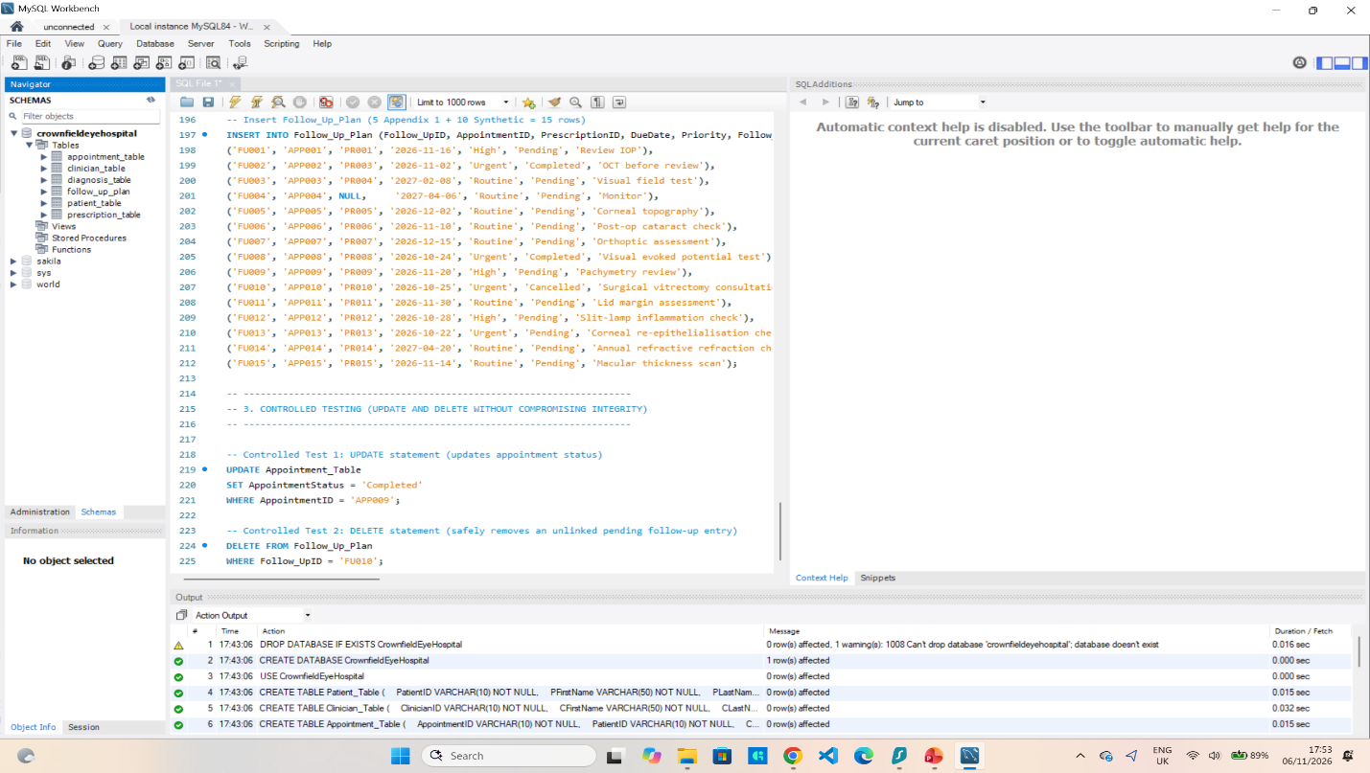

5. ANALYTICAL QUERIES & DATABASE PROGRAMMABILITY

Four objects were written in CrownfieldEyeHospital_FullScript.sql to support clinical operations and hospital management: two analytical queries, a view and a stored procedure.

• Query 1 (Comprehensive Patient Care Pathway): This joins Appointment_Table, Patient_Table and Clinician_Table with INNER JOIN to retrieve confirmed consultations, and then uses LEFT JOIN on Diagnosis_Table and Prescription_Table. The LEFT JOIN keeps consultations managed by observation rather than medication in the report, and COALESCE(pr.Medicine, 'None Prescribed') replaces NULL values with clear clinical text. Results are ordered chronologically by AppointmentDate.
• Query 2 (Clinician Workload and Acuity Stratification): This assesses specialist capacity by counting consultations per clinician with COUNT(DISTINCT a.AppointmentID), and measures high-priority follow-up caseloads through a conditional left join (LEFT JOIN Follow_Up_Plan f ON a.AppointmentID = f.AppointmentID AND f.Priority IN ('High', 'Urgent')). DISTINCT stops the counts being inflated by the one-to-many joins, which lets clinical directors balance routine outpatient throughput against urgent surgical or medical retina demand.
• Operational view (v_UrgentFollowUps): This view wraps a four-table join that filters for pending follow-ups with 'High' or 'Urgent' priority. It gives triage nurses and receptionists a usable recall list for sight-threatening conditions, such as diabetic macular oedema or corneal ulceration, without giving them direct access to the base tables.
• Stored procedure (sp_GetPatientSummary): This takes a single parameter (IN p_PatientID VARCHAR(10)) and returns a patient's consultations, diagnoses, prescriptions and follow-ups in chronological order. Parameterisation reduces exposure to SQL injection, and the procedure keeps the multi-table join logic away from front-end clinical workstations.

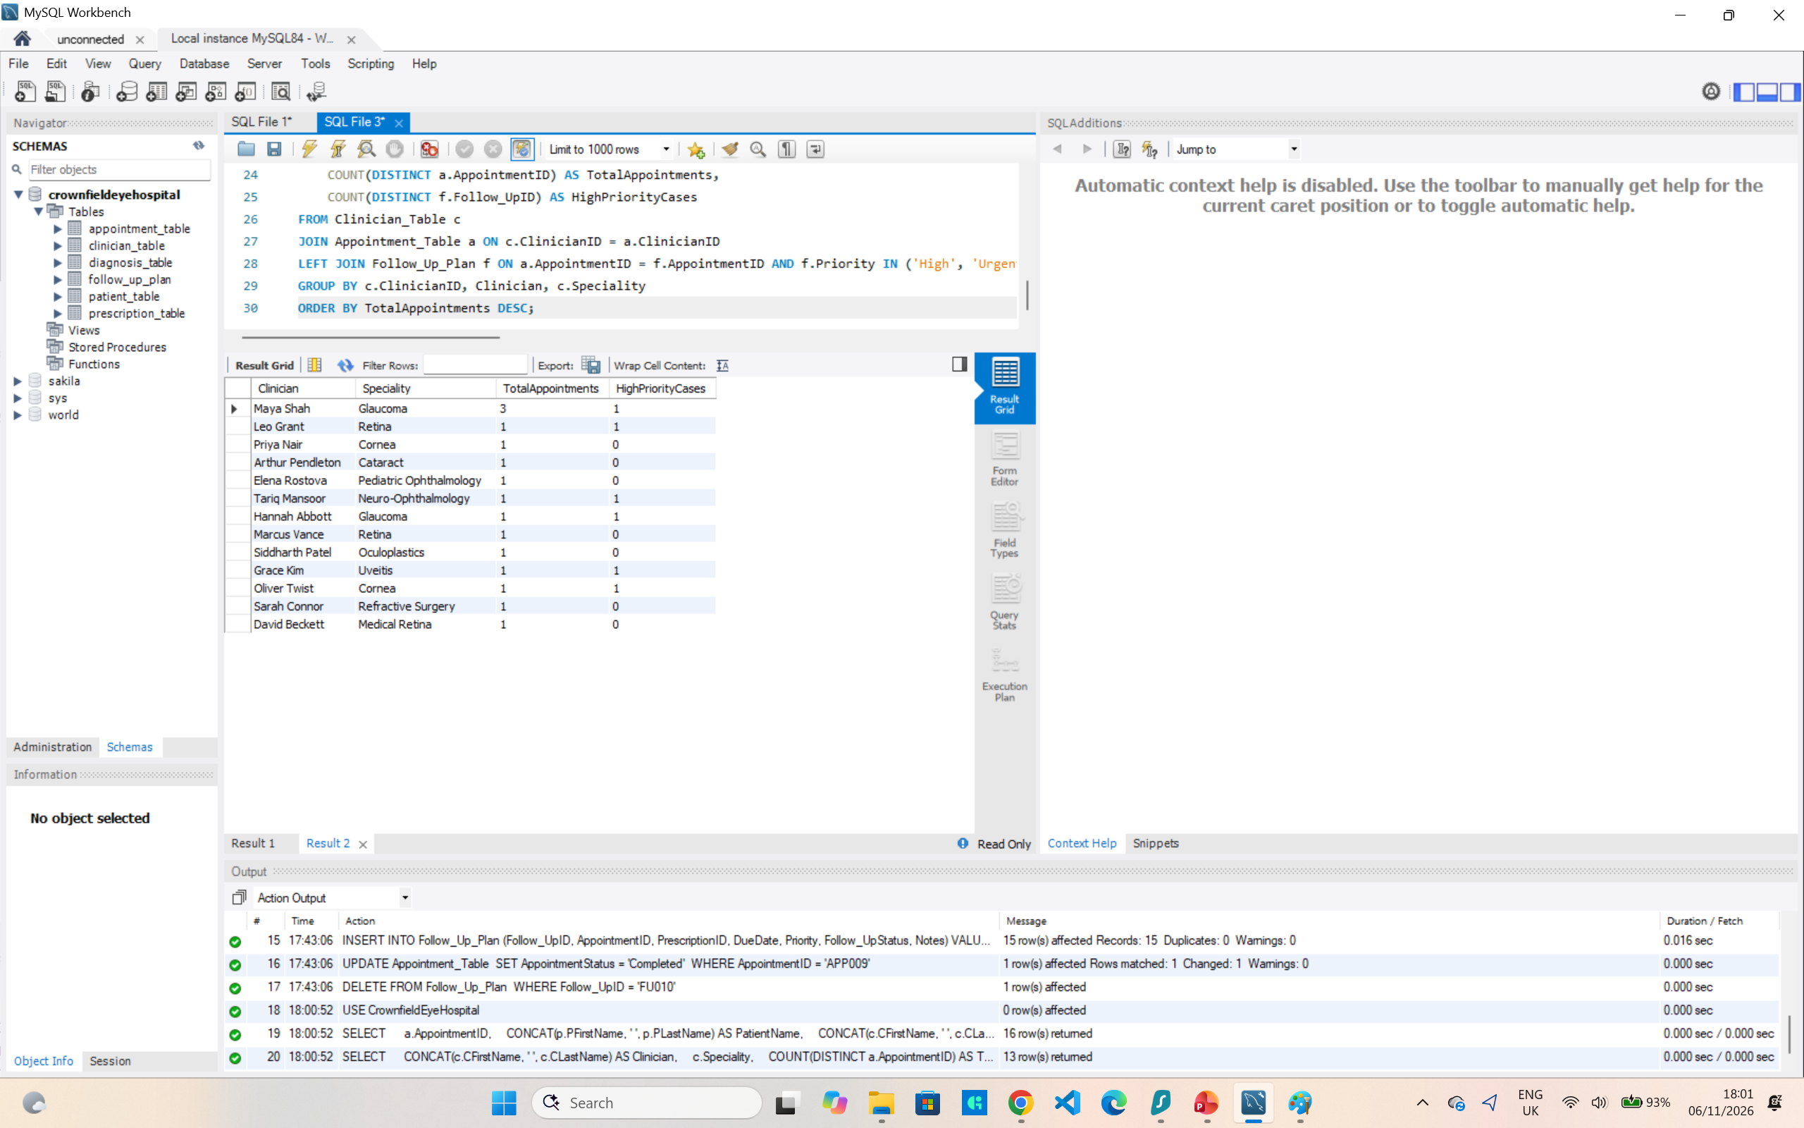

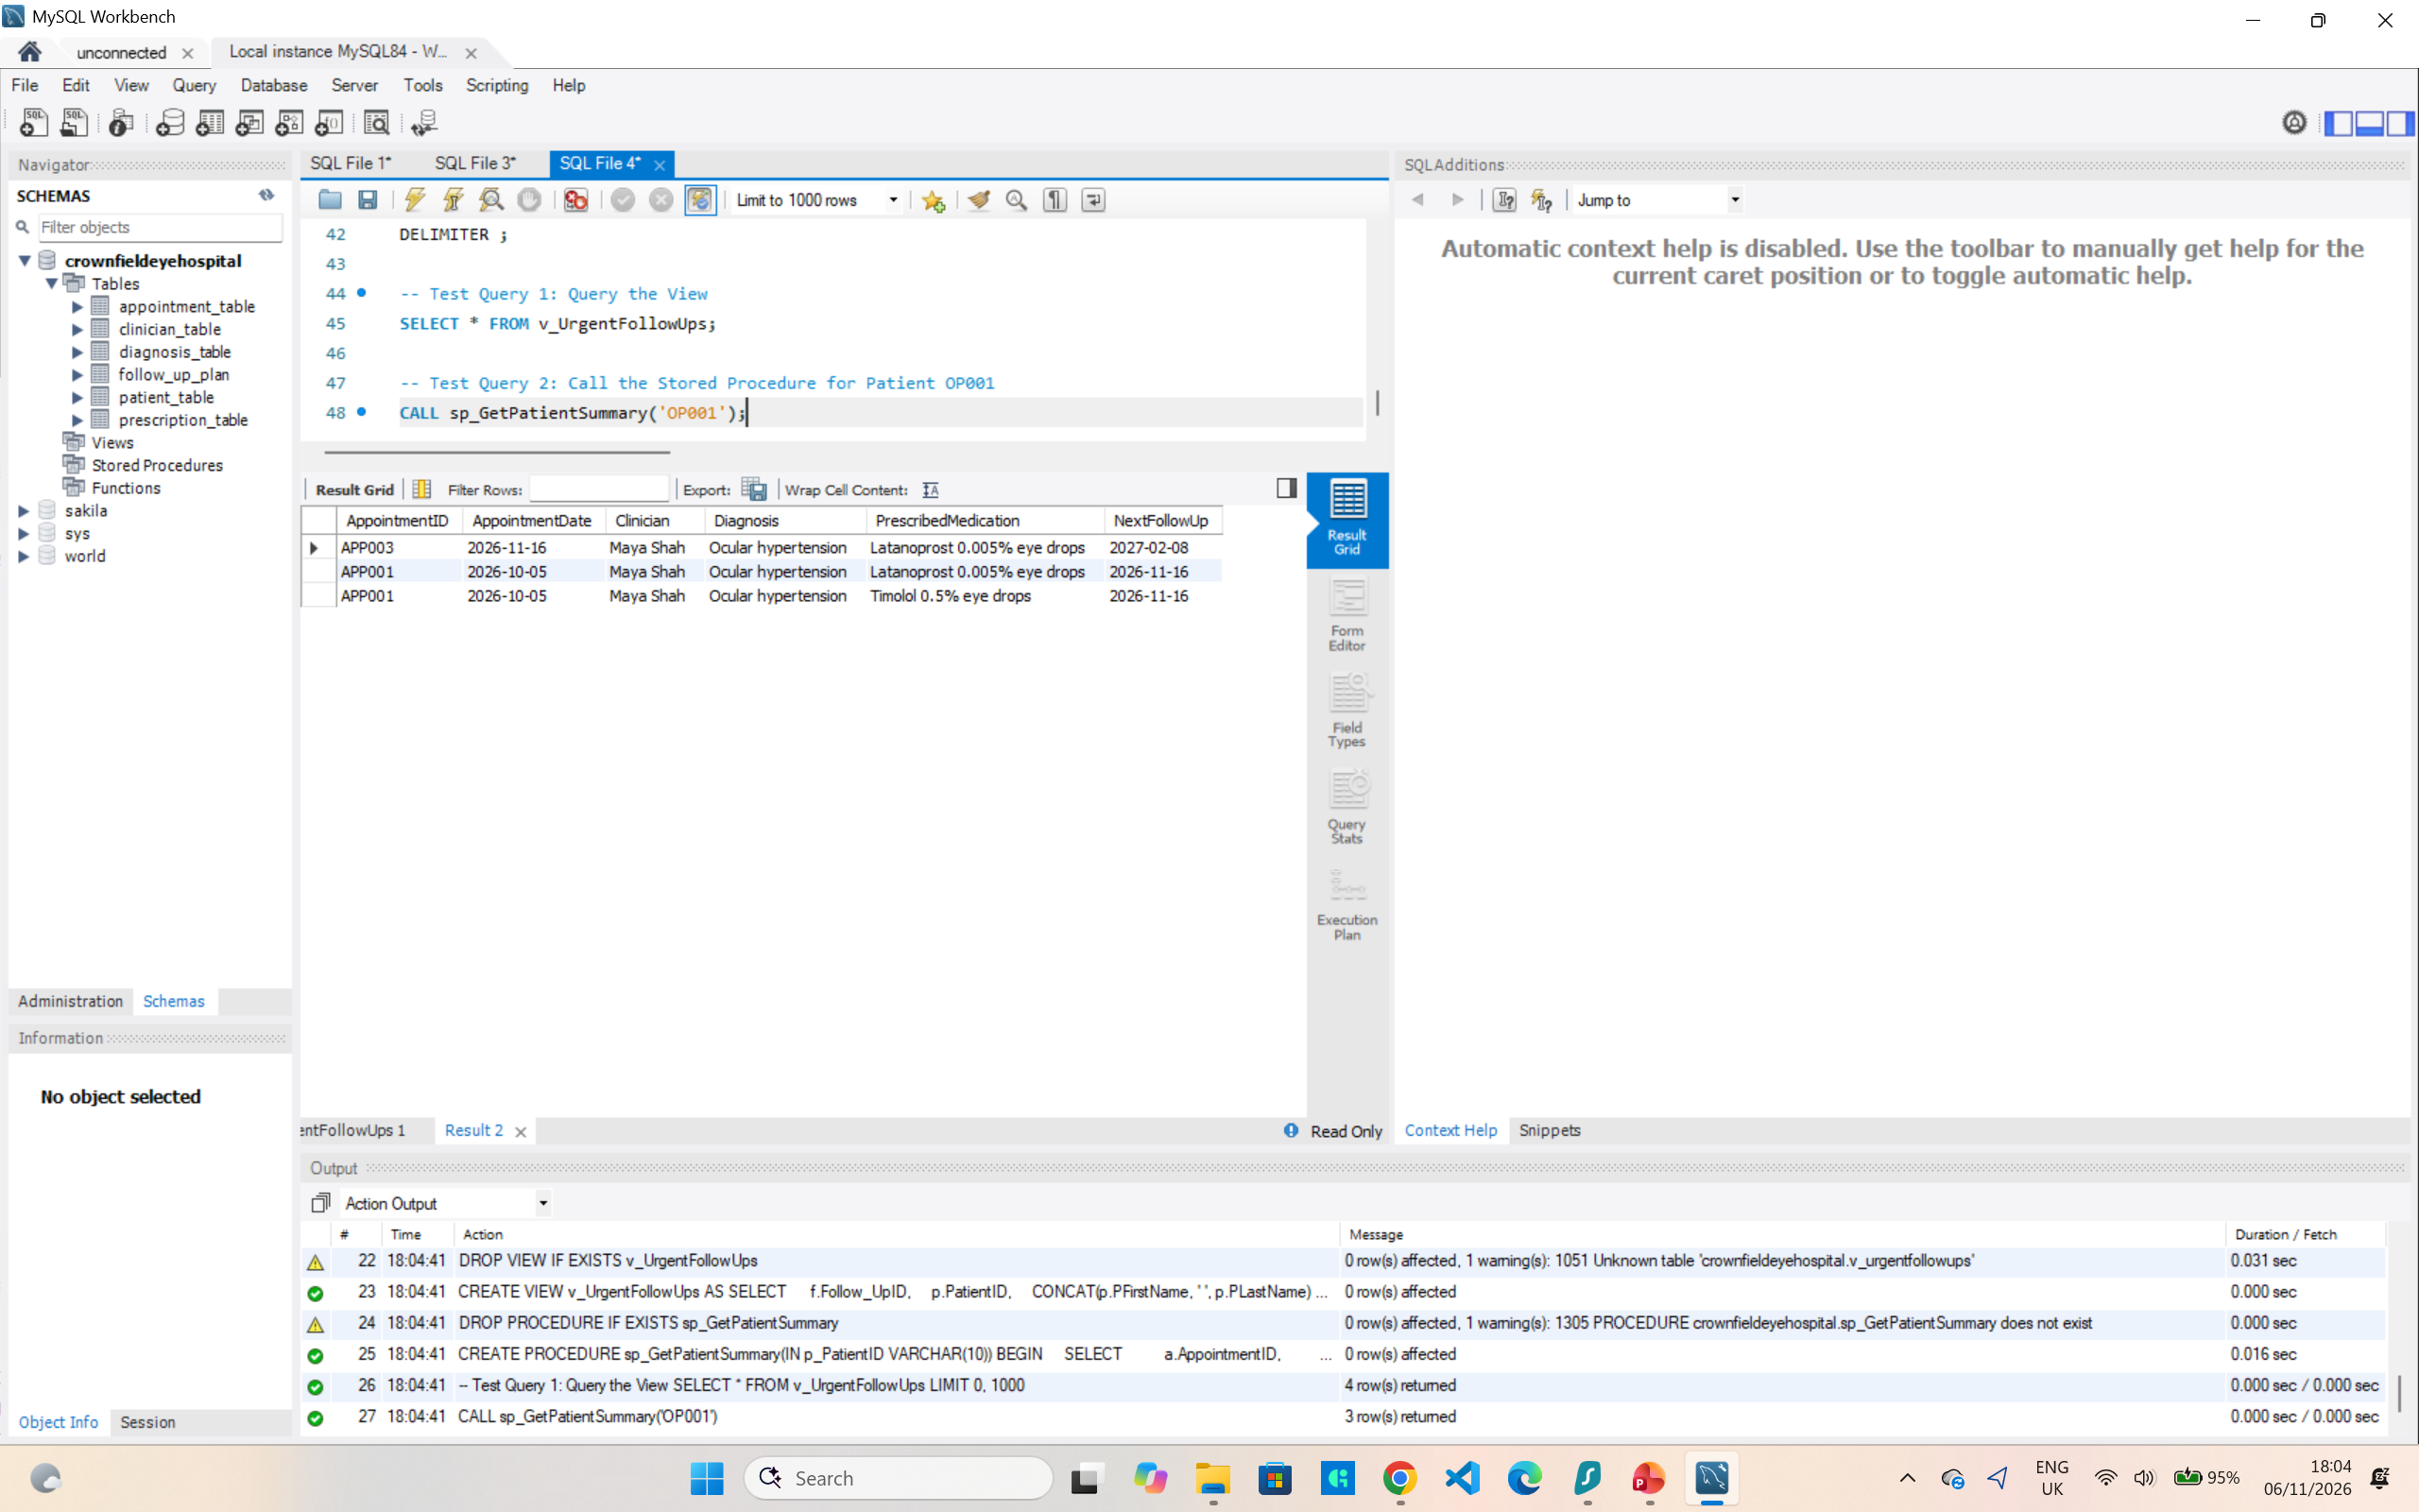

6. SECURITY GOVERNANCE, UK GDPR & NHS CALDICOTT COMPLIANCE

Patient medical records are Special Category Data under Article 9 of the UK GDPR and the Data Protection Act 2018 (Information Commissioner's Office, 2021). To meet Article 5(1)(c) (data minimisation) and Article 5(1)(f) (integrity and confidentiality), Role-Based Access Control (RBAC) was implemented on the principle of least privilege (Silberschatz, Korth and Sudarshan, 2020):

• receptionist_role (assigned to reception_staff@localhost): This role has SELECT, INSERT and UPDATE privileges on Patient_Table and Appointment_Table only. Front-desk staff can register patients and manage appointments, but cannot read or write diagnoses, prescriptions or treatment notes.
• clinician_role (assigned to dr_shah@localhost): This role has SELECT on Patient_Table, SELECT and UPDATE on Appointment_Table, and SELECT, INSERT and UPDATE on Diagnosis_Table, Prescription_Table and Follow_Up_Plan. Ophthalmologists can record assessments and issue prescriptions, but DELETE is withheld on all clinical tables so that the medico-legal audit trail is preserved.

This permission structure follows the NHS Caldicott Principles (National Data Guardian, 2020). Access to patient-identifiable data is justified by operational purpose (Principle 1), limited to the minimum necessary (Principle 3), and separated between administrative and clinical staff on a need-to-know basis (Principle 4).
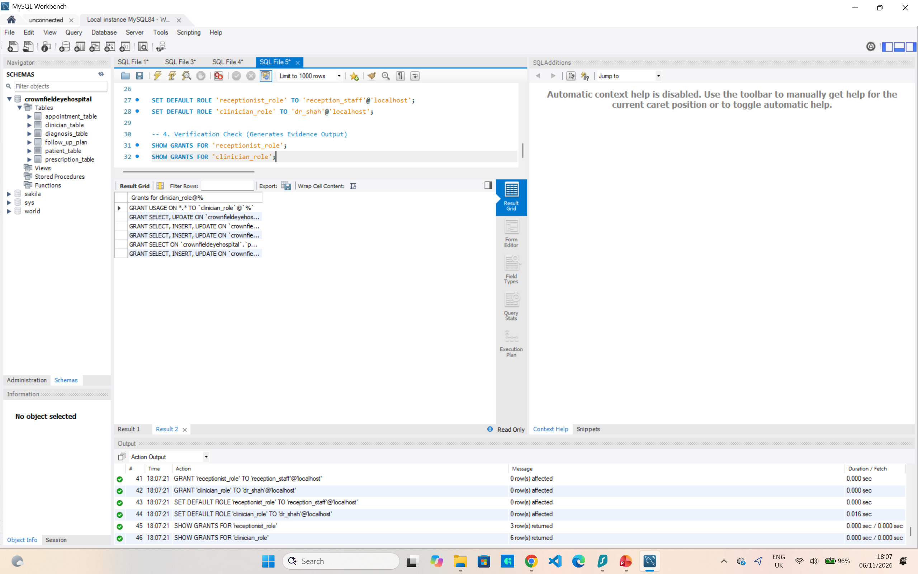
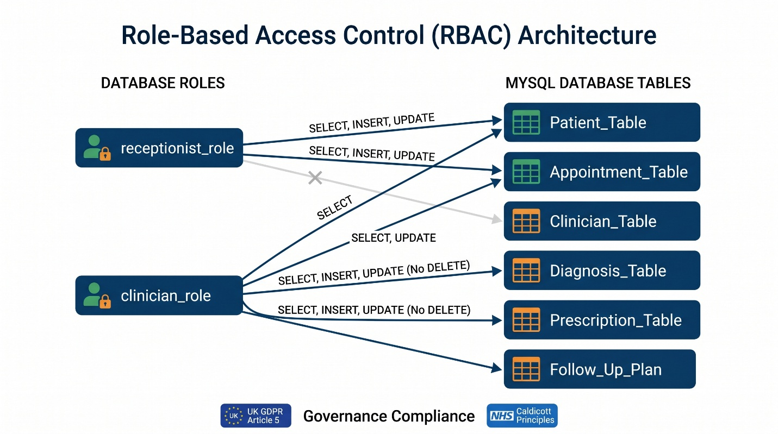

7. CRITICAL EVALUATION, LIMITATIONS & FUTURE ROADMAP

The 3NF database removes the flat-file modification anomalies and enforces strong relational integrity. Even so, it has three limitations that could be addressed in future work:

1. Automated audit logging: DELETE privileges are withheld from operational users, but the schema has no history tables to record how data changes over time. BEFORE UPDATE and BEFORE DELETE triggers on Prescription_Table and Diagnosis_Table could write prior values, timestamps and user identifiers to an immutable Clinical_Audit_Log table, giving full traceability for clinical governance.
2. Location entity: AppointmentLocation is currently a VARCHAR(100) attribute in Appointment_Table. If Crownfield Eye Hospital expands across regional sites in City Road, Bedford and Croydon, a separate Clinic_Location relation (LocationID [PK], SiteName, RoomNumber, PostCode), linked by a foreign key, would prevent inconsistent location names and allow room-level scheduling.
3. Encryption and data masking: RBAC controls access at session level, but patient contact details are stored on disk in plaintext. Future versions should encrypt sensitive columns with AES_ENCRYPT() and offer Dynamic Data Masking (DDM) views for non-clinical users.

8. ACADEMIC REFERENCES

Caldicott Committee. (1997) Report on the review of patient-identifiable information. London: Department of Health.

Codd, E.F. (1970) 'A relational model of data for large shared data banks', Communications of the ACM, 13(6), pp. 377-387.

Connolly, T.M. and Begg, C.E. (2015) Database Systems: A Practical Approach to Design, Implementation, and Management. 6th edn. Boston: Pearson.

Date, C.J. (2004) An Introduction to Database Systems. 8th edn. Boston: Addison-Wesley.

Elmasri, R. and Navathe, S.B. (2016) Fundamentals of Database Systems. 7th edn. Hoboken, NJ: Pearson.

Information Commissioner's Office (ICO). (2021) Guide to the UK General Data Protection Regulation (UK GDPR). Wilmslow: ICO.

National Data Guardian. (2020) The Caldicott Principles: Eight principles to ensure people's data is used securely and appropriately. London: Department of Health and Social Care.

Silberschatz, A., Korth, H.F. and Sudarshan, S. (2020) Database System Concepts. 7th edn. New York: McGraw-Hill.

