Campus Information System (CIS)
Student Information & Course Registration System
Project Documentation
Section 4 — Software Analysis & Design
(Academic Staff & Communications Staff Modules)
Section 6 — Implementation

Table of Contents
4. Software Analysis and Design 5
4.1 User Scenarios 5
4.1.1 Scenario 1 — Approving a Course Selection (Academic Staff) 5
4.1.2 Scenario 2 — Building and Publishing the Timetable (Academic Staff) 5
4.1.3 Scenario 3 — Announcing and Scheduling a Campus Event (Communications Staff) 5
4.1.4 Scenario 4 — Reviewing Club Join Requests (Communications Staff) 6
4.2 Use Cases 6
4.2.1 UC-01 — Approve Course Selection 6
4.2.2 UC-02 — Create Course Offering 6
4.2.3 UC-03 — Assign Teacher to Offering 7
4.2.4 UC-04 — Publish Announcement 7
4.2.5 UC-05 — Create Campus Event 7
4.2.6 UC-06 — Review Club Join Request 8
4.3 Behavioral Diagrams 8
4.3.1 Use Case Diagrams 8
Figure 1. Use Case Diagram — Academic Staff 8
Figure 2. Use Case Diagram — Communications Staff 9
4.3.2 Activity Diagrams 10
Figure 3. Activity Diagram — Review / Approve Course Selection 10
Figure 4. Activity Diagram — Create Course Offering 11
Figure 5. Activity Diagram — Add Timetable Entry (Conflict & Teacher-Hour Checks) 12
Figure 6. Activity Diagram — Manage Course Catalogue 13
Figure 7. Activity Diagram — Publish Announcement 14
Figure 8. Activity Diagram — Create Campus Event 15
Figure 9. Activity Diagram — Review Club Join Request 16
4.3.3 State Diagrams 17
Figure 10. State Diagram — Course Selection Lifecycle 17
Figure 11. State Diagram — Course Offering Lifecycle 18
Figure 12. State Diagram — Campus Event Lifecycle 19
Figure 13. State Diagram — Club Membership Lifecycle 20
4.3.4 Sequence Diagrams 21
Figure 14. Sequence Diagram — Approve Course Selection 21
Figure 15. Sequence Diagram — Create Course Offering 22
Figure 16. Sequence Diagram — Assign Teacher to Offering 23
Figure 17. Sequence Diagram — Publish Announcement to Feed 24
Figure 18. Sequence Diagram — Review Club Join Request 25
4.3.5 Collaboration Diagrams 26
Figure 19. Collaboration Diagram — Approve Course Selection 26
Figure 20. Collaboration Diagram — Create Course Offering 27
Figure 21. Collaboration Diagram — Review Club Join Request 27
4.4 Data Flow Diagram (DFD) 28
Figure 22. DFD Level 0 — Context Diagram 28
Figure 23. DFD Level 1 — Academic Structure Management 28
Figure 24. DFD Level 1 — Communications Management 29
4.5 Entity Relationship Diagram (ERD) 30
4.5.1 Relational Model 30
Figure 25. ERD — Relational Model (Module-Scoped) 30
4.5.2 Nonrelational Model 31
Figure 26. ERD — Non-Relational / Document Model 31
4.6 Structural Diagrams 32
4.6.1 Class Diagram 32
Figure 27. Class Diagram — Academic Structure Domain 32
Figure 28. Class Diagram — Communications Domain 33
4.6.2 Object Diagrams 34
Figure 29. Object Diagram — Offering Snapshot 34
Figure 30. Object Diagram — Club / Event / Announcement Snapshot 35
4.6.3 Component Diagram 36
Figure 31. Component Diagram — Academic & Communications Module 36
4.6.4 Deployment Diagram 36
Figure 32. Deployment Diagram — CIS Runtime Topology 36
6. Implementation 38
6.1 General Product Overview 38
6.2 Technology Stack 39
6.3 Code Snippets - Web App 41
6.4 Code Snippets - Backend 42
6.5 Code Snippets - Database 45
6.6 Open Source Libraries Used 47
6.6.1 Web App 47
6.6.2 Backend 48
6.7 Versioning 49
6.8 License 49
6.9 Instructions of Use 50
6.9.1 Web App 50
6.9.2 System Setup 51

4. Software Analysis and Design
This chapter presents the analysis and design models for the Academic Staff role and the Communications Staff sub-module of the Campus Information System (CIS). Academic Staff own the academic structure — the course catalogue, course offerings, the timetable, buildings and rooms, registration approvals and semester windows — while the Communications Staff sub-module (the same backend role, separated for governance) publishes announcements, manages campus events and reviews club membership requests.
Every model is derived from the implemented system: the FastAPI routers (staff.py, communications.py, courses.py, course_selections.py), the SQLAlchemy ORM models, and the React pages for these roles. System-wide artefacts (ERD, component and deployment diagrams) are shown module-scoped — limited to the entities, components and nodes these two roles touch. Behavioural flow and class diagrams are drawn with Mermaid; the remaining UML diagrams with PlantUML.

4.1 User Scenarios
The following narrative scenarios describe typical interactions of Academic Staff and Communications Staff with the system, establishing the context for the use cases and diagrams that follow.

4.1.1 Scenario 1 — Approving a Course Selection (Academic Staff)
Rebecca, an academic staff member for the Faculty of Computing, opens the Registrations page and filters selections with status “requested”. She picks a request from a second-year student for CS201, reviews the student’s programme, prerequisites and credit load, then clicks Approve. The system re-runs the eligibility gate (faculty/programme/year match, prerequisites passed, credit limits of 30 per semester and 60 per year, capacity, deadline and timetable conflicts). Because every rule passes, the selection becomes “enrolled”, a registration row is created, the offering’s enrolled count is incremented, and the student receives a notification. Had any rule failed, the selection would have been marked “rejected” with the exact blocking reason.

4.1.2 Scenario 2 — Building and Publishing the Timetable (Academic Staff)
Rebecca creates a new offering for CS201, choosing the course, programme, semester and instructor. She then adds timetable entries, selecting a building, room, day and time slot. The system verifies the room belongs to the chosen building and that the instructor does not exceed the four-teaching-hours-per-day limit. On success it stores the entry and synchronises a weekly class session, after which the schedule appears for the assigned instructor and the enrolled students.

4.1.3 Scenario 3 — Announcing and Scheduling a Campus Event (Communications Staff)
Mark, working in the communications capacity, opens the Communications workspace. On the News tab he publishes an announcement (optionally targeted to a role); it immediately becomes visible on the matching users’ feeds. On the Events tab he creates a “Robotics Open Day” event with a start and end time and a capacity. The system rejects any event whose end time precedes its start time. Once created, the event appears on the students’ feed where they can register — and are automatically waitlisted once the capacity is reached.

4.1.4 Scenario 4 — Reviewing Club Join Requests (Communications Staff)
On the Club Requests tab, Mark sees the pending and waitlisted membership requests aggregated across all clubs. For each request he can Approve, Waitlist or Reject. His decision updates the membership status, stamps the review time, and writes a notification to the student’s inbox describing the outcome (approved, waitlisted or declined).

4.2 Use Cases
The fully-dressed use-case specifications below detail the most significant interactions. Each maps to an implemented endpoint and its server-side rules.

4.2.1 UC-01 — Approve Course Selection
Use Case ID | UC-01
Name | Approve / Reject Course Selection
Primary Actor | Academic Staff (System Admin also authorised)
Supporting Actors | Student (request initiator), Notification service
Endpoint | POST /api/staff/course-selections/{id}/approve | /reject
Preconditions | Staff is authenticated and faculty-scoped to the offering.  A StudentCourseSelection exists with status “requested”.
Main Flow | 1. Staff opens Registrations and filters status = requested.  2. Staff selects a request and reviews student, prerequisites and load.  3. Staff clicks Approve.  4. System runs _selection_block_reason() (faculty, programme, year, prerequisites, credits, capacity, deadline, conflict).  5. System sets status = enrolled and stamps approved_by_staff_id.  6. System inserts/updates the registration (active) and recounts enrolled.  7. System creates a Notification and commits.
Alternate / Exception | 4a. Eligibility blocked → status = rejected, reason stored, HTTP 400 returned.  A1. Staff rejects with a reason → status = rejected, student notified.  6a. enrolled ≥ capacity → offering.status = full.
Postconditions | Student is enrolled, a registration is active, the offering count is updated, and the student is notified.
Business Rules | Faculty scope; max 30 credits/semester and 60/year; prerequisites passed; no timetable conflict.

4.2.2 UC-02 — Create Course Offering
Use Case ID | UC-02
Name | Create Course Offering
Primary Actor | Academic Staff
Endpoint | POST /api/staff/course-offerings
Preconditions | Staff authenticated.  Target course, programme and semester exist.
Main Flow | 1. Staff opens the Offerings Manager and clicks New Offering.  2. Staff fills course, programme, semester, instructor, capacity and period.  3. System resolves the faculty from the programme.  4. System checks the staff member may manage that faculty.  5. System creates the Offering (enrolled = 0) and commits.
Alternate / Exception | 4a. Staff not scoped to the faculty → HTTP 403.
Postconditions | A new offering exists and is visible to instructor, students and the catalogue.
Business Rules | Offerings are always tagged with faculty_id and created_by_staff_id; faculty scope enforced.

4.2.3 UC-03 — Assign Teacher to Offering
Use Case ID | UC-03
Name | Assign Teacher to Offering
Primary Actor | Academic Staff
Supporting Actor | Instructor (receives assignment)
Endpoint | POST /api/staff/course-offerings/{id}/assign-teacher
Preconditions | Offering exists and is in the staff member’s faculty.  Target instructor exists.
Main Flow | 1. Staff selects an instructor and confirms.  2. System validates the instructor’s total daily teaching hours stay ≤ 4.  3. System sets offering.instructor_id.  4. System re-syncs each class session’s teacher_id.  5. System commits.
Alternate / Exception | 2a. Existing + new hours > 4 → HTTP 400 (daily limit exceeded).
Postconditions | The offering and its class sessions reference the new teacher.
Business Rules | A teacher may teach at most four hours on any one day.

4.2.4 UC-04 — Publish Announcement
Use Case ID | UC-04
Name | Publish Announcement
Primary Actor | Communications Staff (System Admin also authorised)
Supporting Actor | Student / target-role users (readers)
Endpoint | POST /communications/announcements
Preconditions | Staff authenticated with role academic_staff or system_admin.
Main Flow | 1. Staff enters a title and content and an optional target role.  2. Staff clicks Publish.  3. System stores the announcement with created_by and published_at.
Alternate / Exception | 1a. Title or content empty → Publish disabled.
Postconditions | The announcement appears on the feed for users whose role matches (or where target_role is null).
Business Rules | Announcements are attributable to an authorised publisher with publication metadata.

4.2.5 UC-05 — Create Campus Event
Use Case ID | UC-05
Name | Create / Update Campus Event
Primary Actor | Communications Staff
Supporting Actor | Student (registers / waitlists)
Endpoint | POST /communications/events ; PUT /communications/events/{id}
Preconditions | Staff authenticated with role academic_staff or system_admin.
Main Flow | 1. Staff enters title, organizer, type, location and start/end times.  2. Staff clicks Create Event.  3. System validates the end time is after the start time.  4. System stores the event (status = open) and commits.
Alternate / Exception | 3a. ends_at < starts_at → HTTP 400 (end must be after start).
Postconditions | The event is visible on the feed; students may register until capacity, then are waitlisted.
Business Rules | Events carry publication metadata; capacity governs the registered/waitlisted split.

4.2.6 UC-06 — Review Club Join Request
Use Case ID | UC-06
Name | Review Club Join Request
Primary Actor | Communications Staff
Supporting Actor | Student (request initiator)
Endpoint | PUT /communications/clubs/requests/{id}
Preconditions | Staff authenticated.  A ClubMembership exists with status pending or waitlisted.
Main Flow | 1. Staff opens Club Requests; system lists pending memberships.  2. Staff chooses Approve, Waitlist or Reject.  3. System sets the membership status (active / waitlisted / rejected) and reviewed_at.  4. System writes a Notification to the student and commits.
Alternate / Exception | 2a. Invalid decision value → HTTP 400.
Postconditions | Membership status is updated and the student is notified of the outcome.
Business Rules | Approval stamps joined_at; every decision notifies the student.

4.3 Behavioral Diagrams
Behavioural diagrams capture how the two roles act over time — the goals they pursue (use case), the workflows they follow (activity), the lifecycles of the records they manage (state), and the message exchanges between system parts (sequence and collaboration).

4.3.1 Use Case Diagrams

Figure 1. Use Case Diagram — Academic Staff
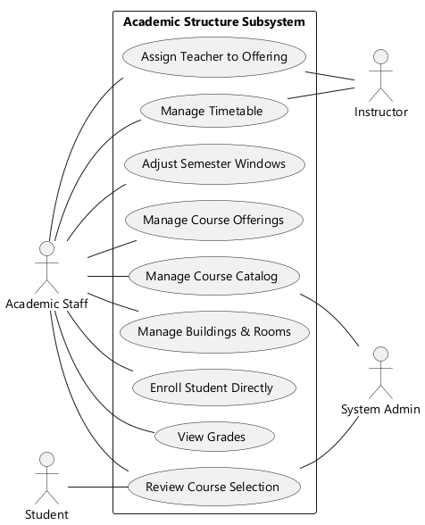

Figure 2. Use Case Diagram — Communications Staff
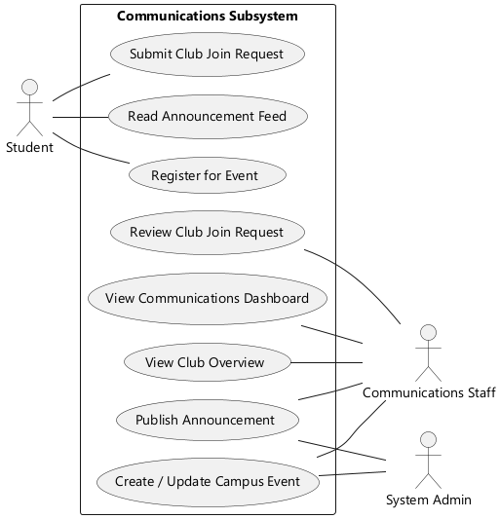

4.3.2 Activity Diagrams

Figure 3. Activity Diagram — Review / Approve Course Selection
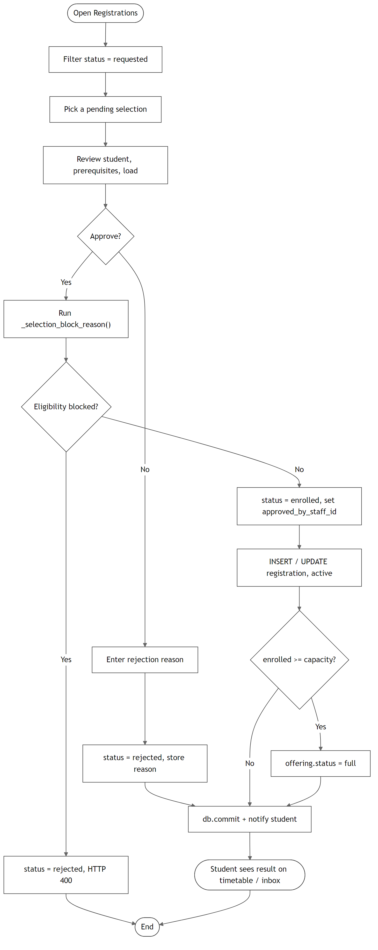

Figure 4. Activity Diagram — Create Course Offering
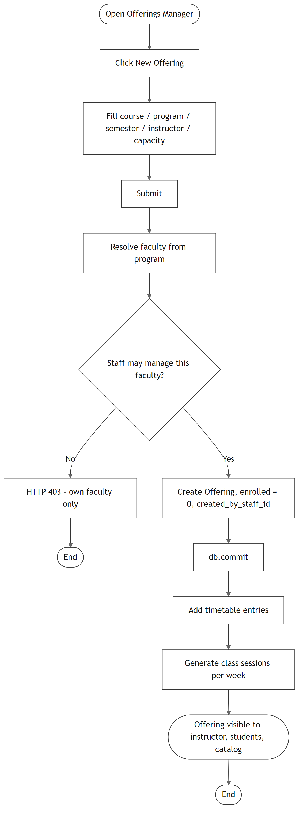

Figure 5. Activity Diagram — Add Timetable Entry (Conflict & Teacher-Hour Checks)
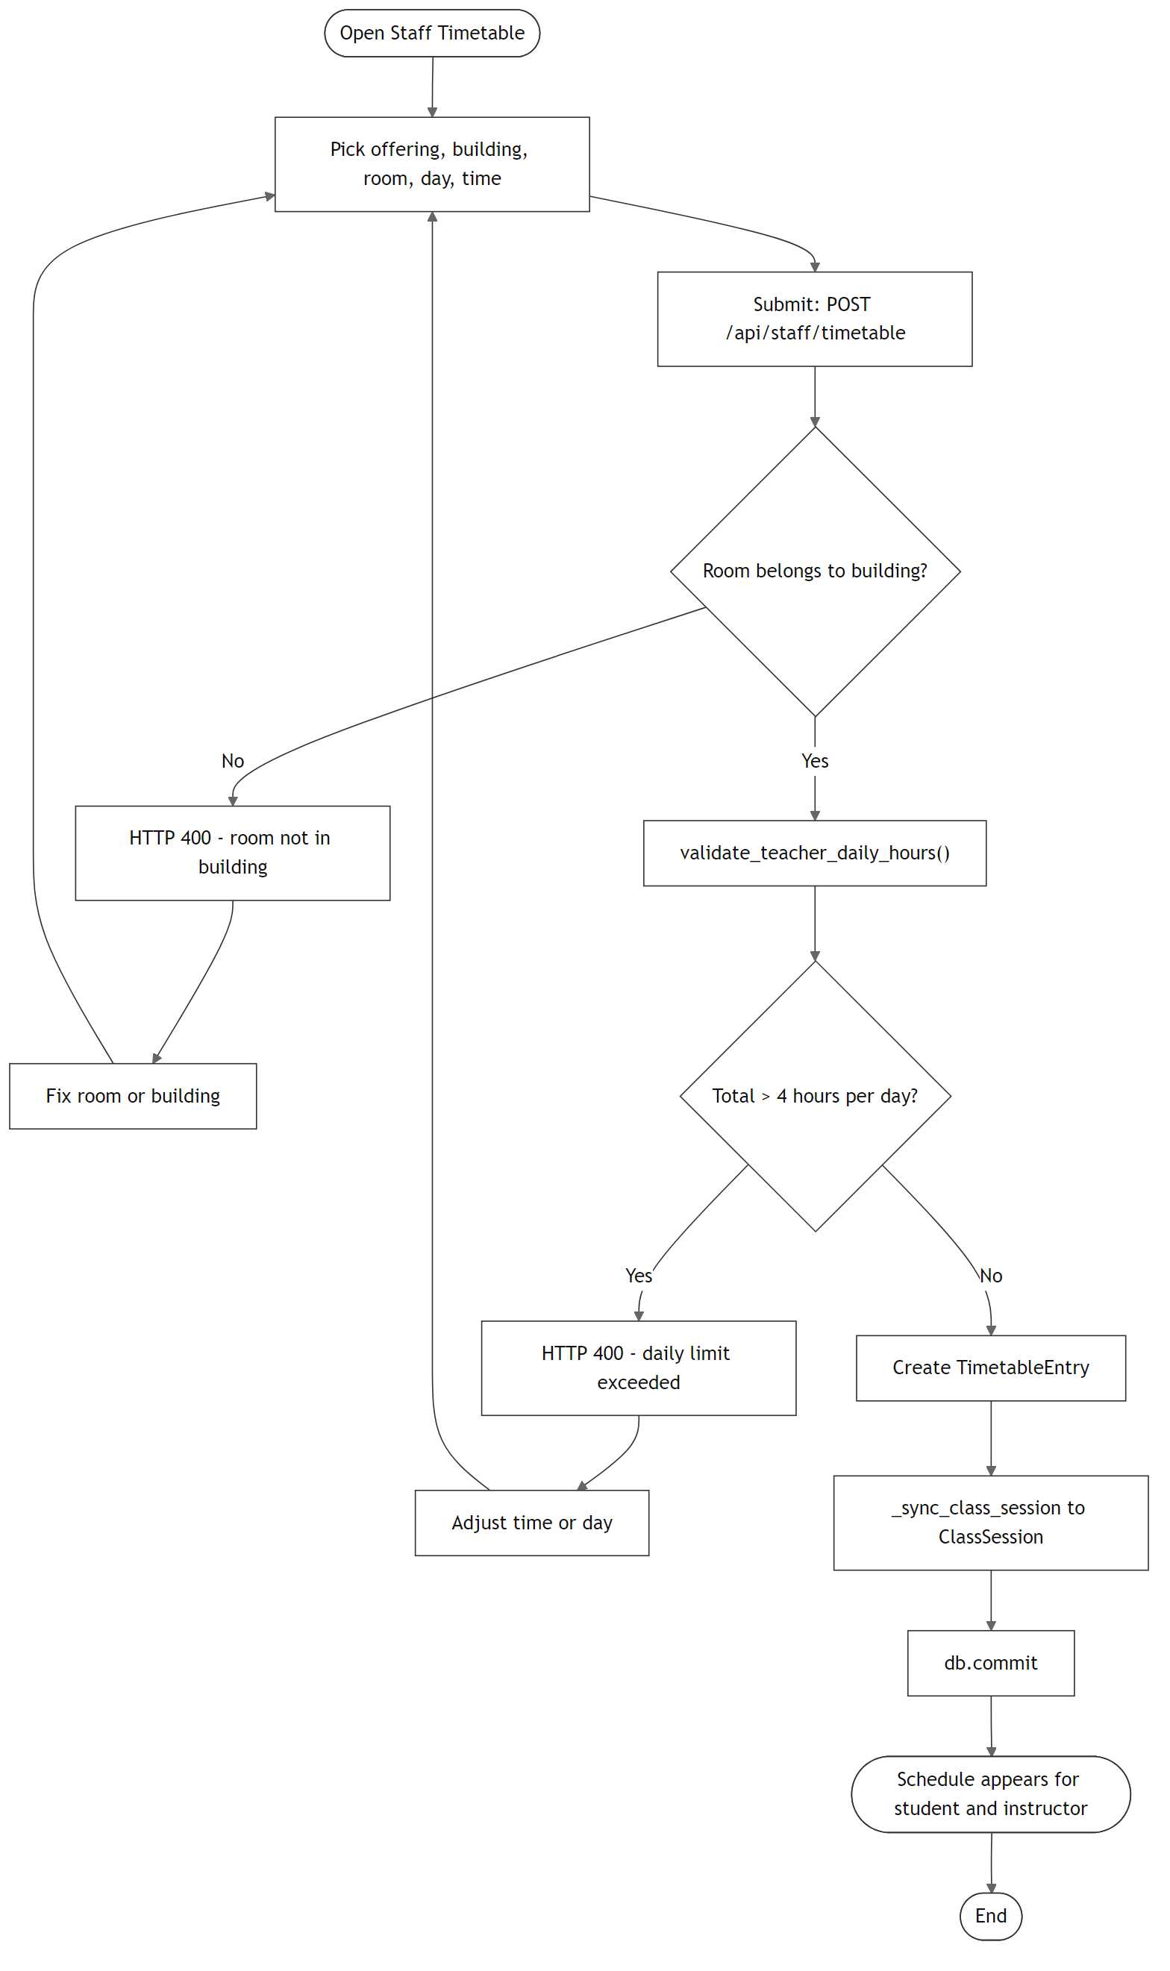

Figure 6. Activity Diagram — Manage Course Catalogue
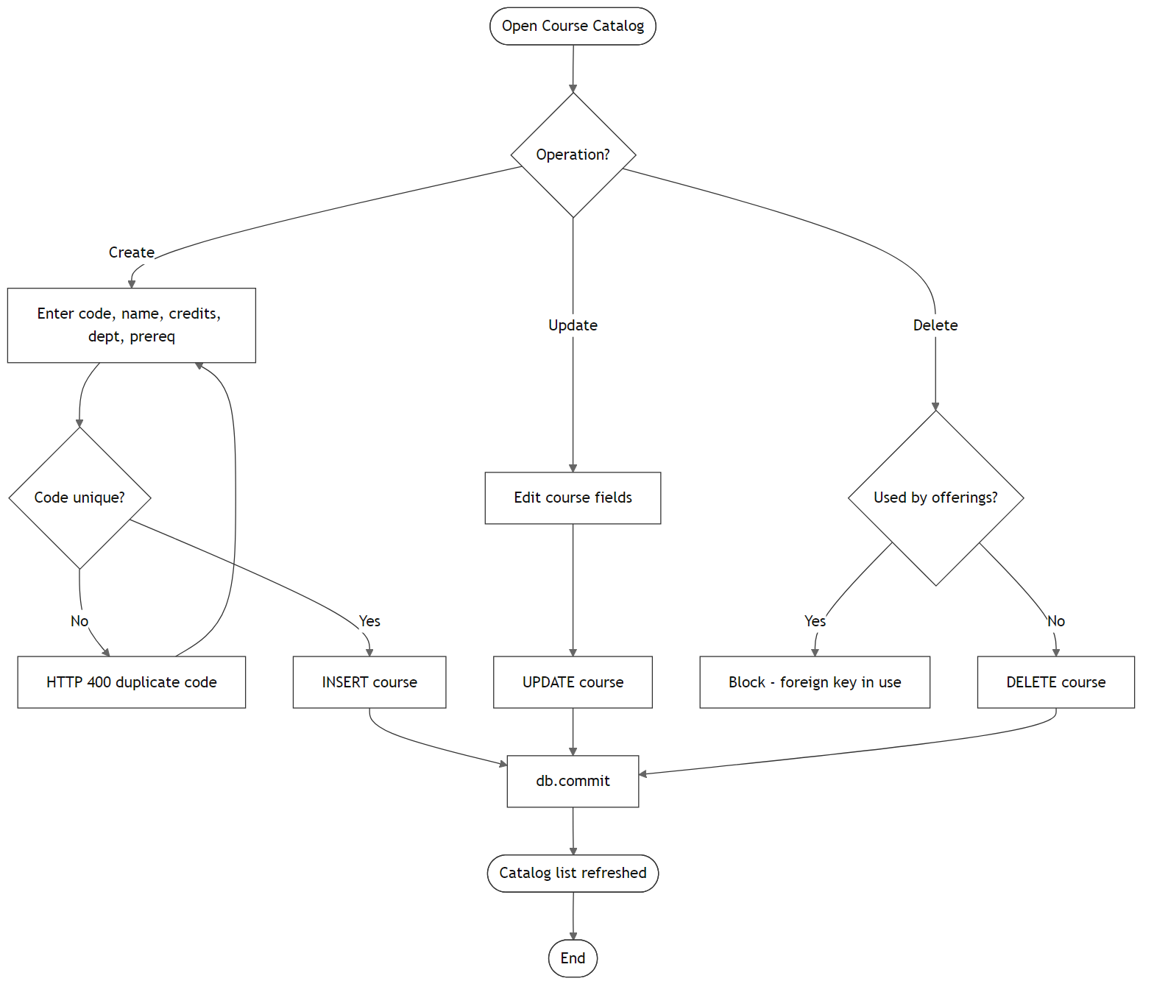

Figure 7. Activity Diagram — Publish Announcement
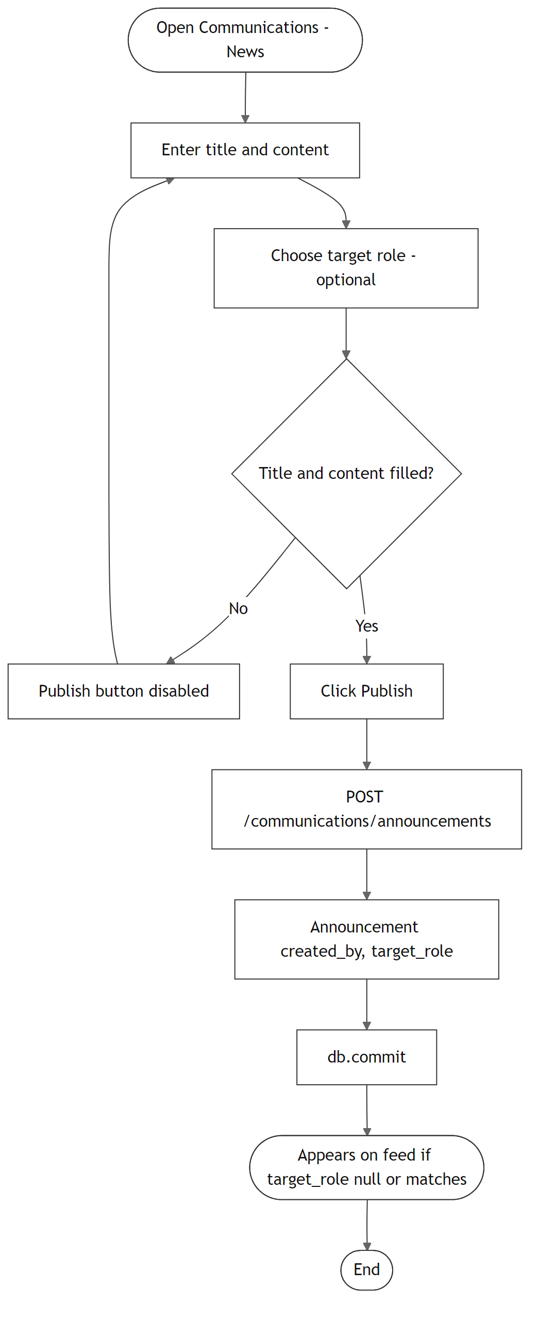

Figure 8. Activity Diagram — Create Campus Event
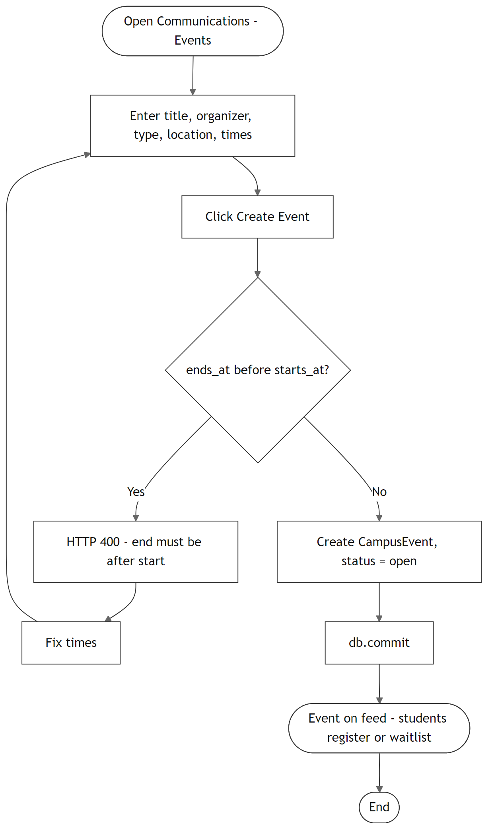

Figure 9. Activity Diagram — Review Club Join Request
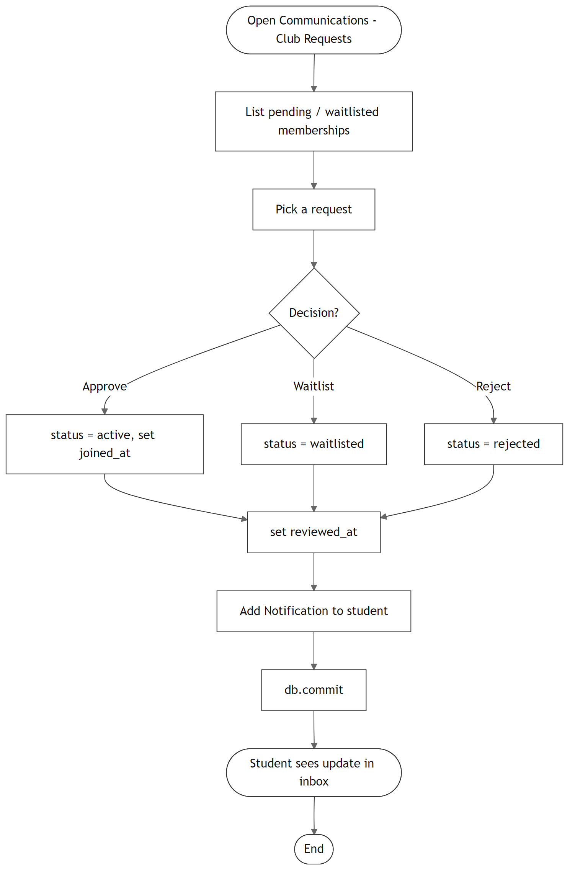

4.3.3 State Diagrams

Figure 10. State Diagram — Course Selection Lifecycle
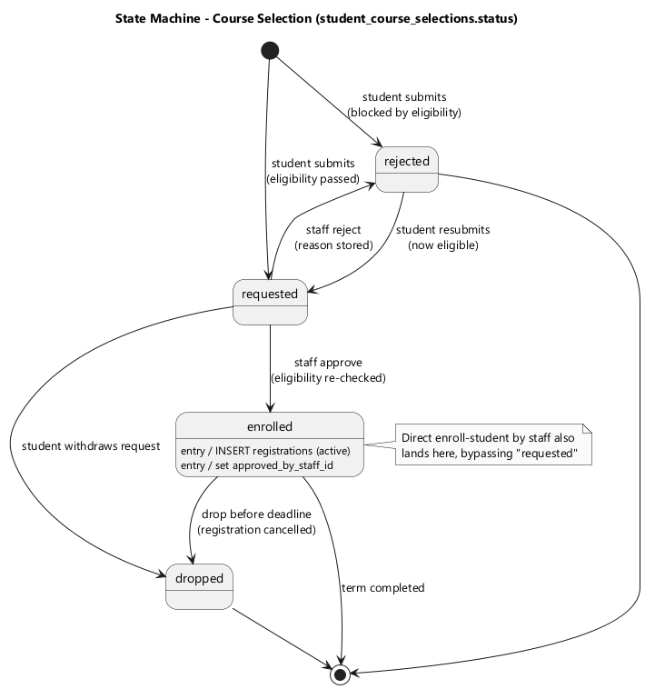

Figure 11. State Diagram — Course Offering Lifecycle
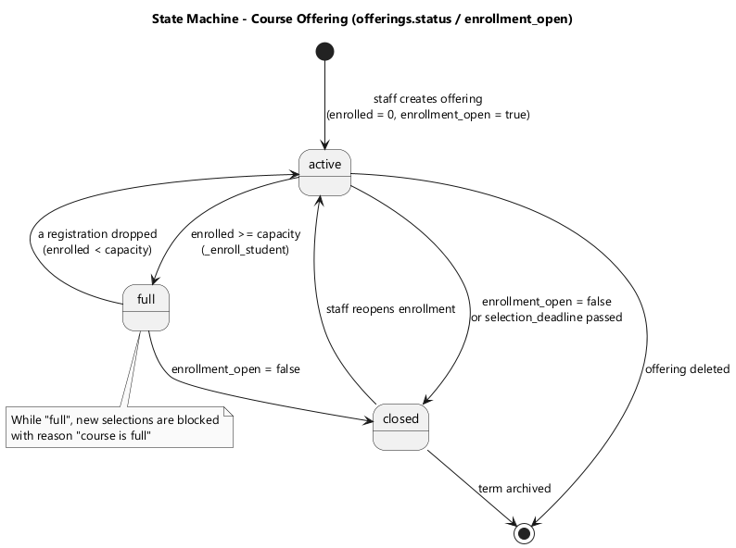

Figure 12. State Diagram — Campus Event Lifecycle
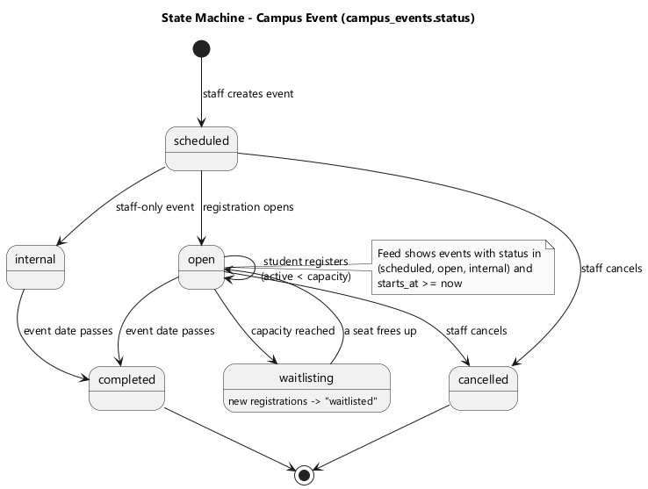

Figure 13. State Diagram — Club Membership Lifecycle
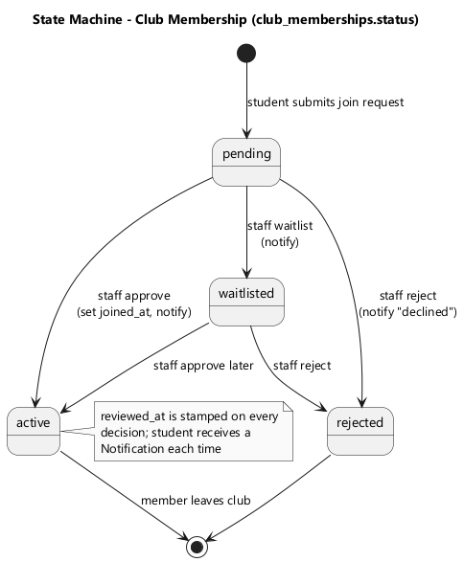

4.3.4 Sequence Diagrams

Figure 14. Sequence Diagram — Approve Course Selection
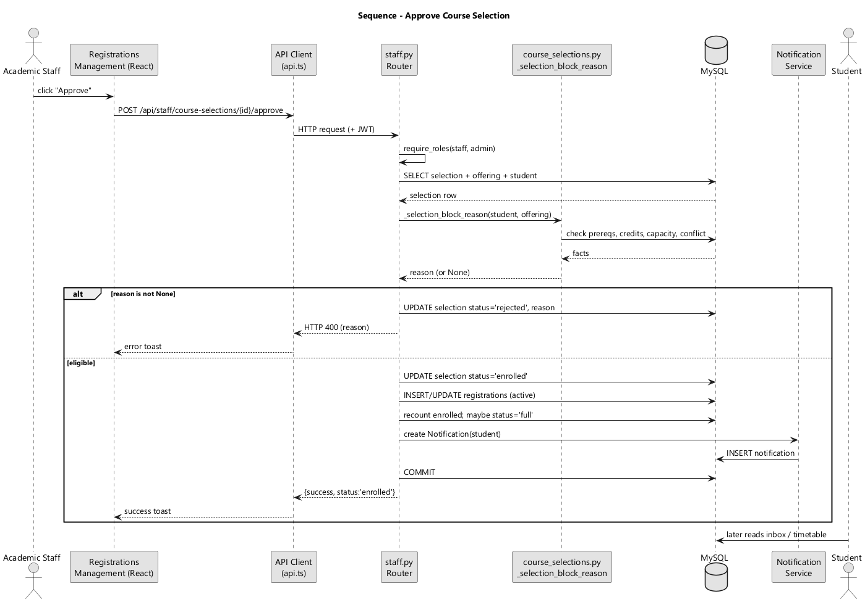

Figure 15. Sequence Diagram — Create Course Offering
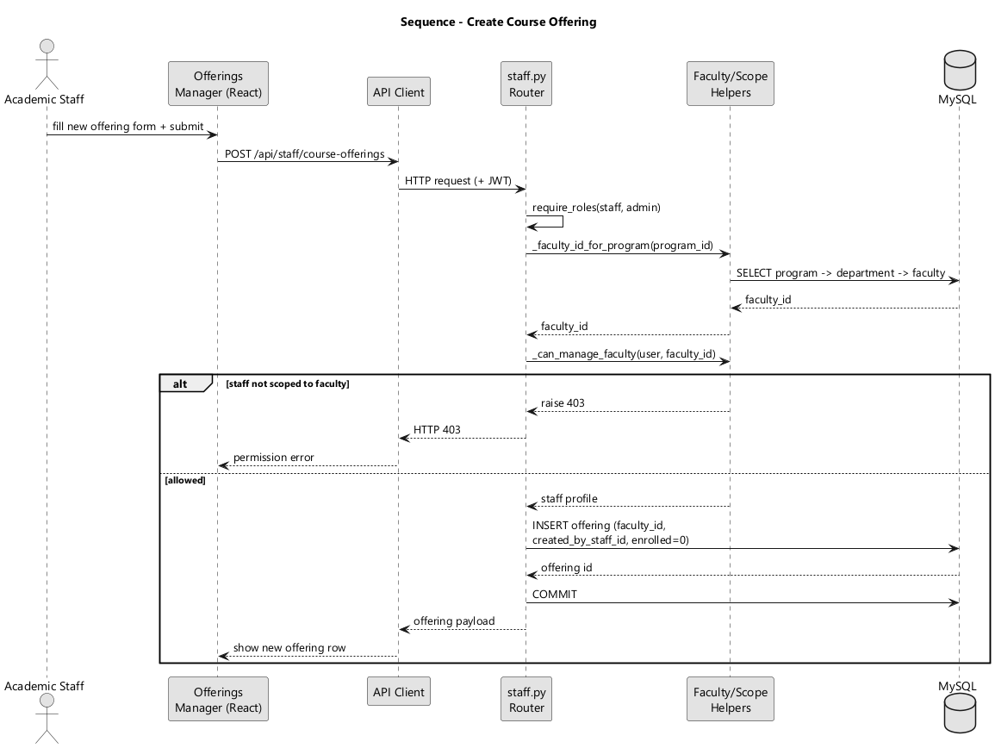

Figure 16. Sequence Diagram — Assign Teacher to Offering
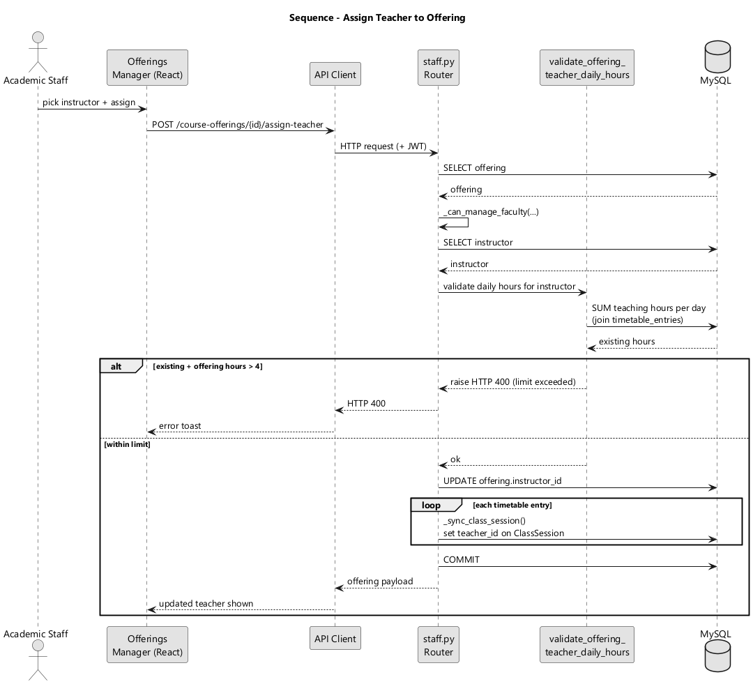

Figure 17. Sequence Diagram — Publish Announcement to Feed
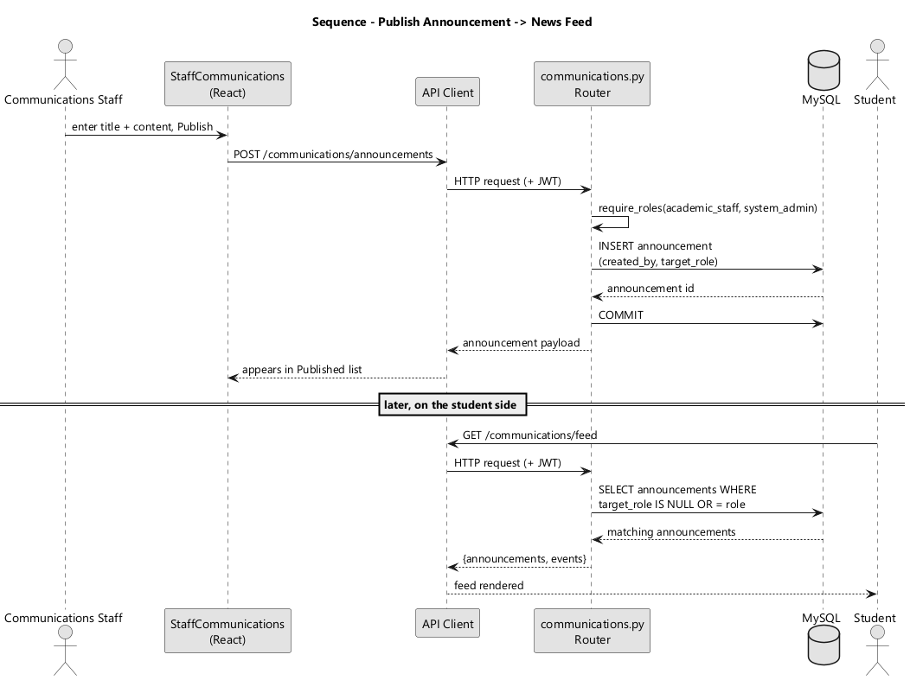

Figure 18. Sequence Diagram — Review Club Join Request
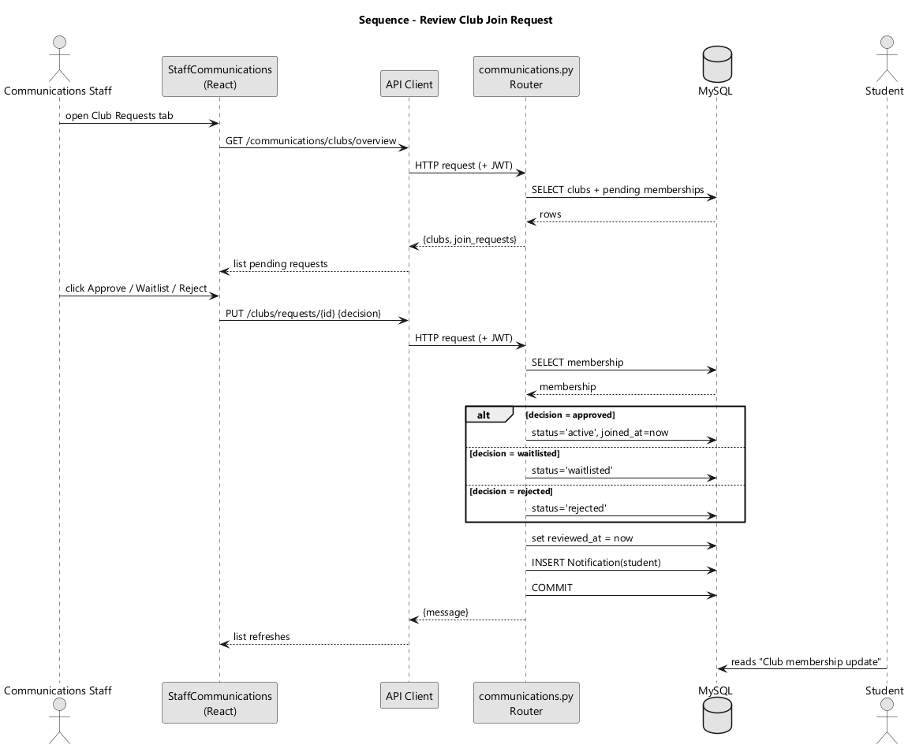

4.3.5 Collaboration Diagrams

Figure 19. Collaboration Diagram — Approve Course Selection
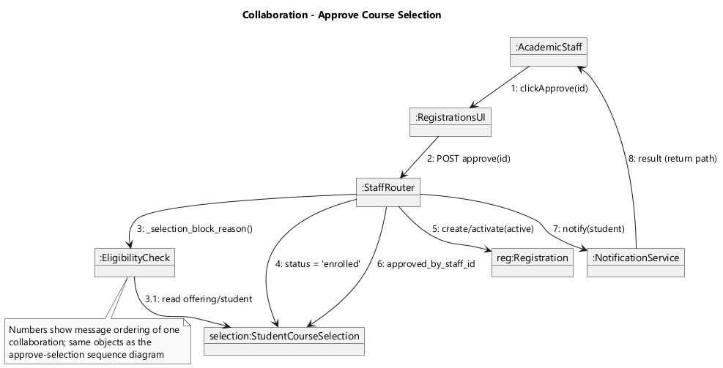

Figure 20. Collaboration Diagram — Create Course Offering
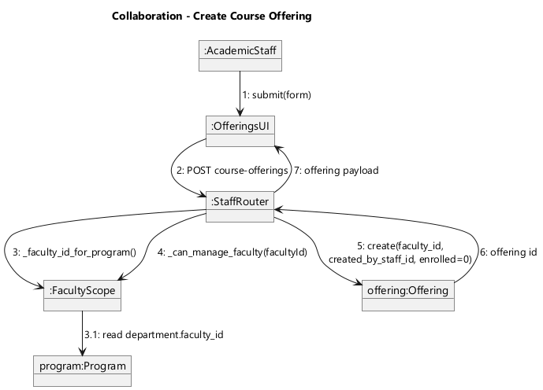

Figure 21. Collaboration Diagram — Review Club Join Request
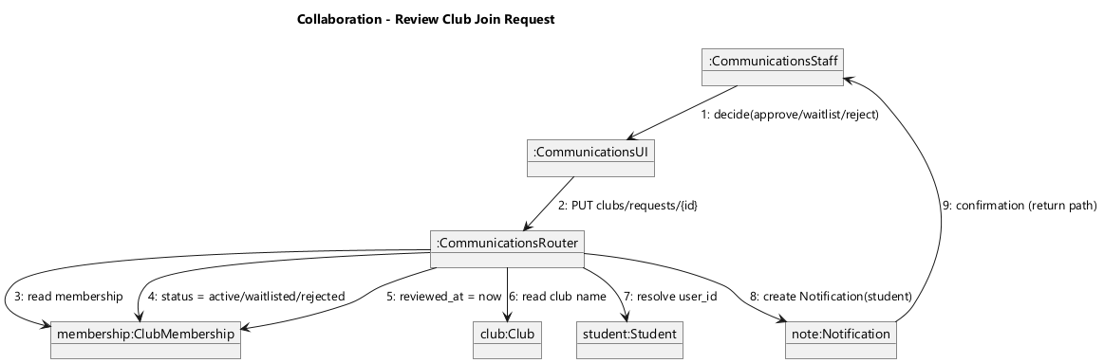

4.4 Data Flow Diagram (DFD)
The data-flow diagrams model how data moves between external entities (rectangles), processes (ellipses) and data stores (cylinders) for this module.

Figure 22. DFD Level 0 — Context Diagram
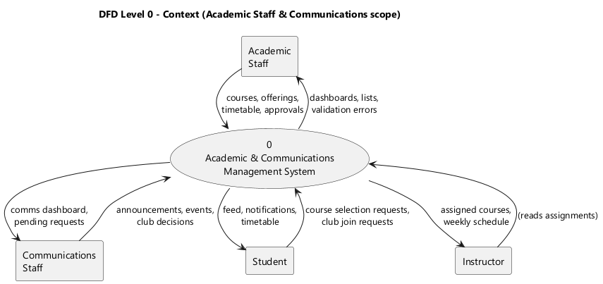

Figure 23. DFD Level 1 — Academic Structure Management
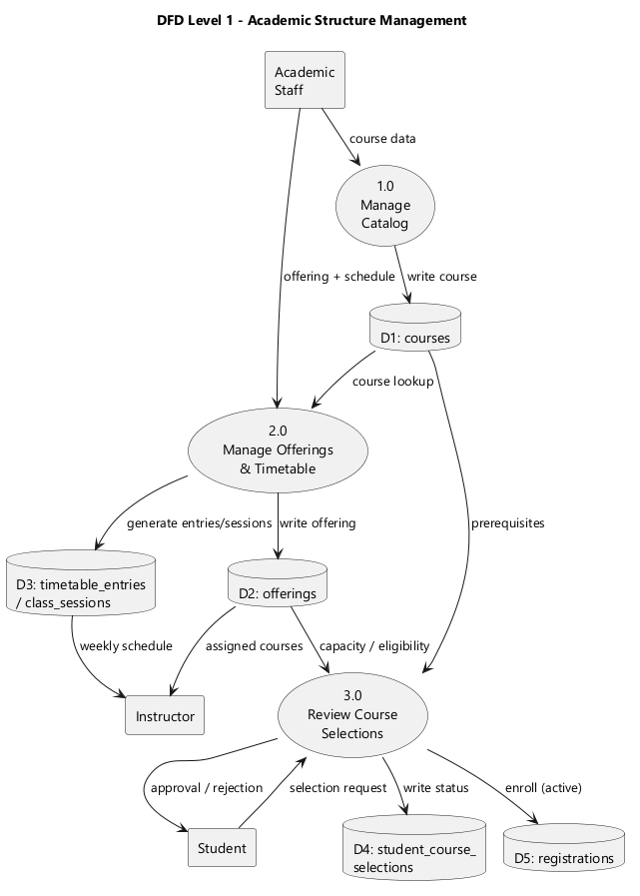

Figure 24. DFD Level 1 — Communications Management
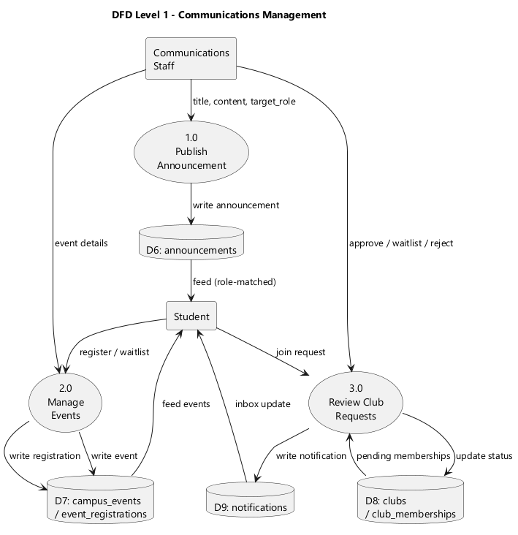

4.5 Entity Relationship Diagram (ERD)
The ERD is module-scoped: only the entities the Academic and Communications roles read or write are shown. The relational model uses crow’s-foot notation; the non-relational model re-expresses the same data as document collections.

4.5.1 Relational Model

Figure 25. ERD — Relational Model (Module-Scoped)
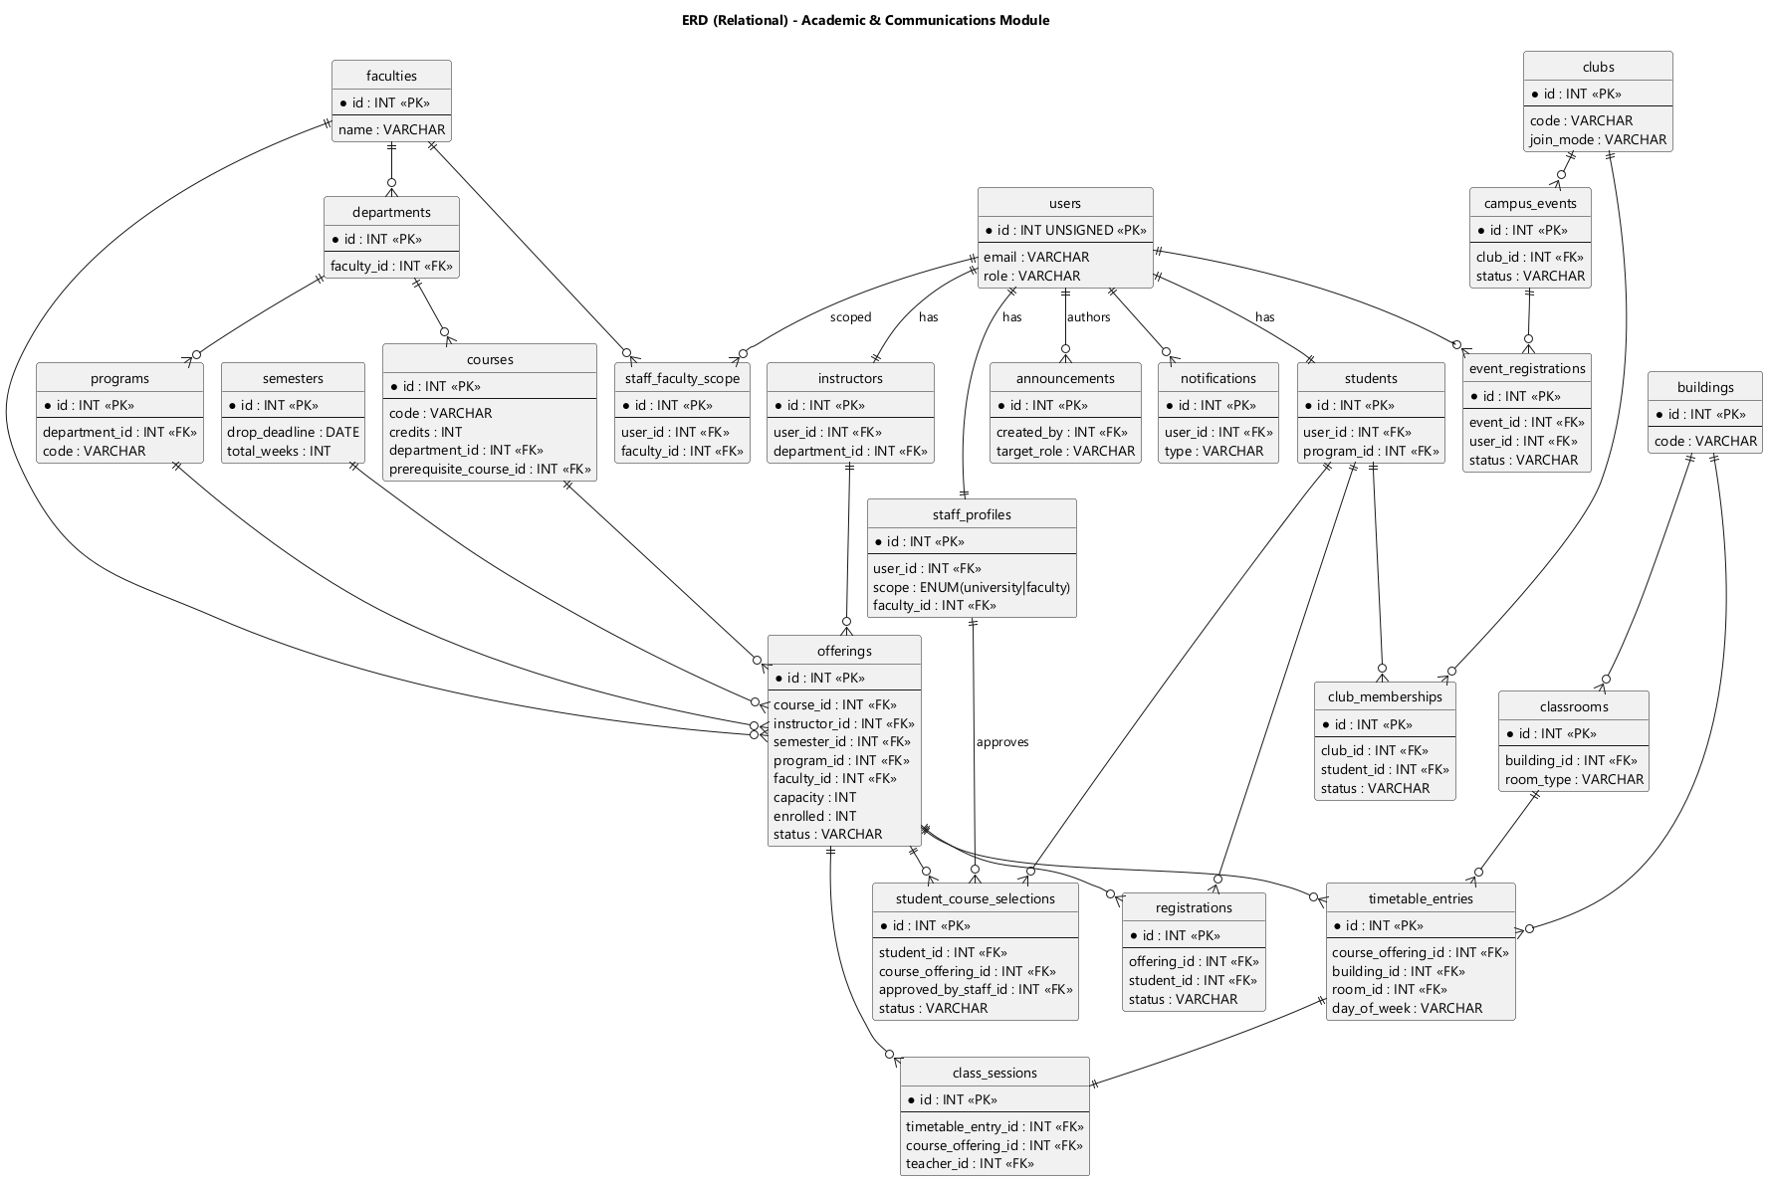

4.5.2 Nonrelational Model

Figure 26. ERD — Non-Relational / Document Model
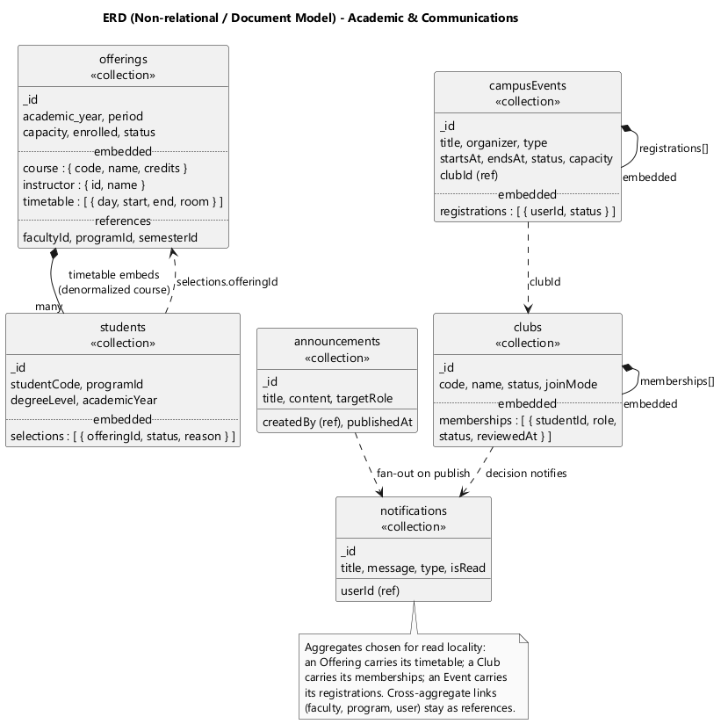

4.6 Structural Diagrams
Structural diagrams describe the static makeup of the module: its domain classes, an example object snapshot, the software components and their interfaces, and the physical deployment topology.

4.6.1 Class Diagram

Figure 27. Class Diagram — Academic Structure Domain
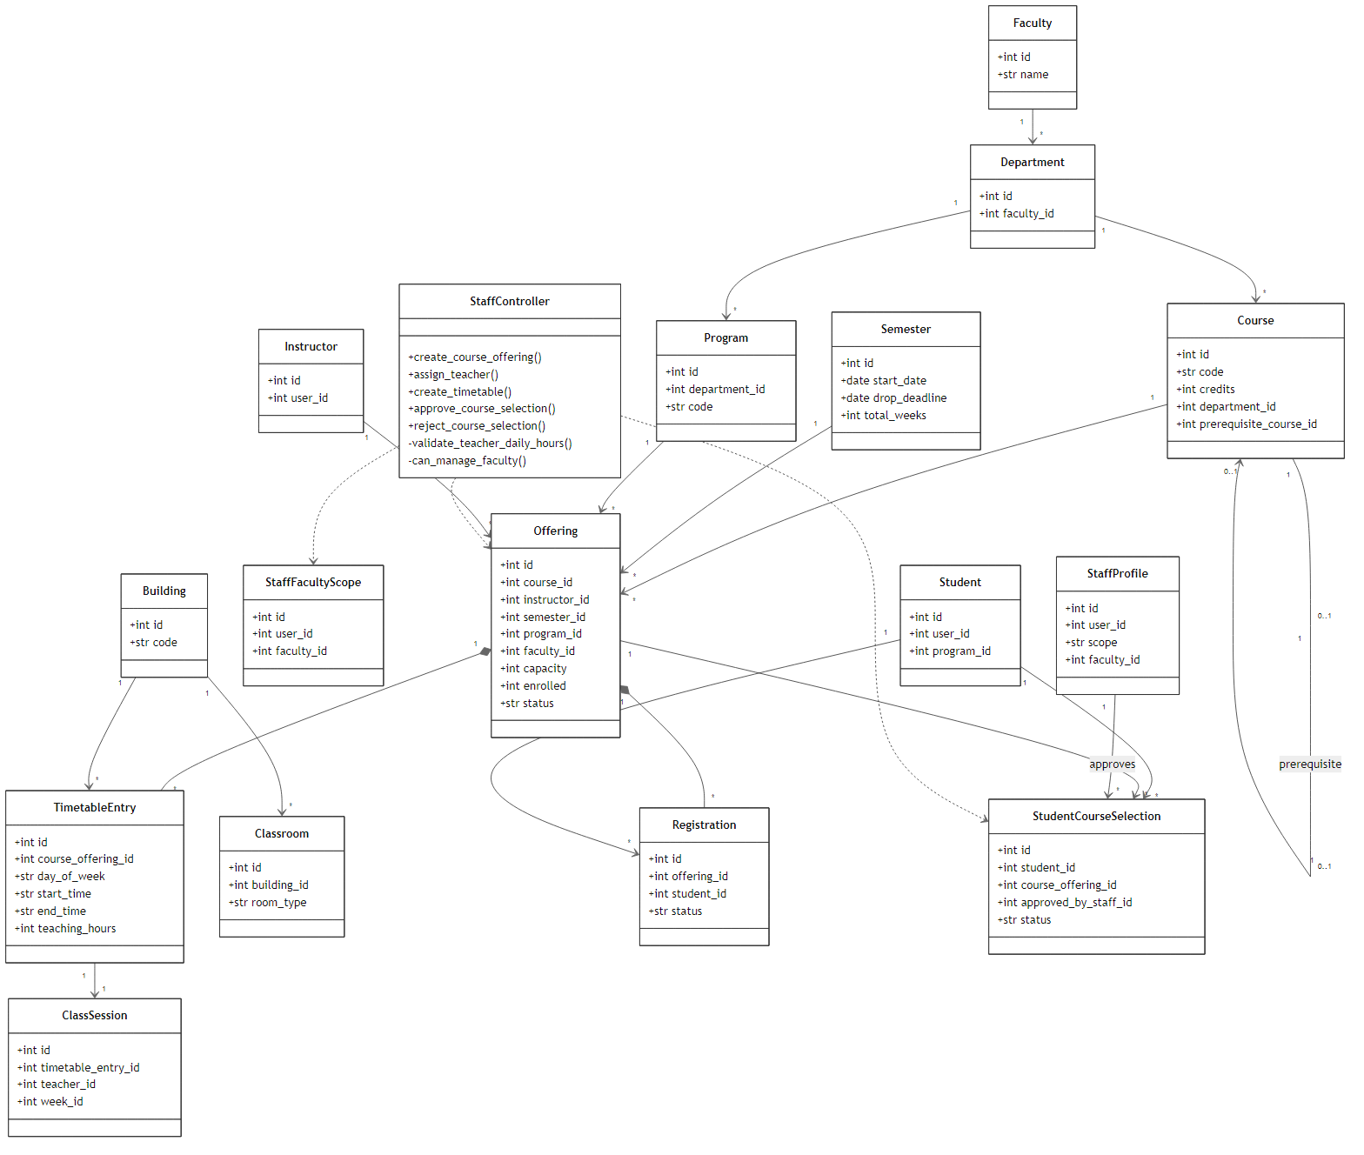

Figure 28. Class Diagram — Communications Domain
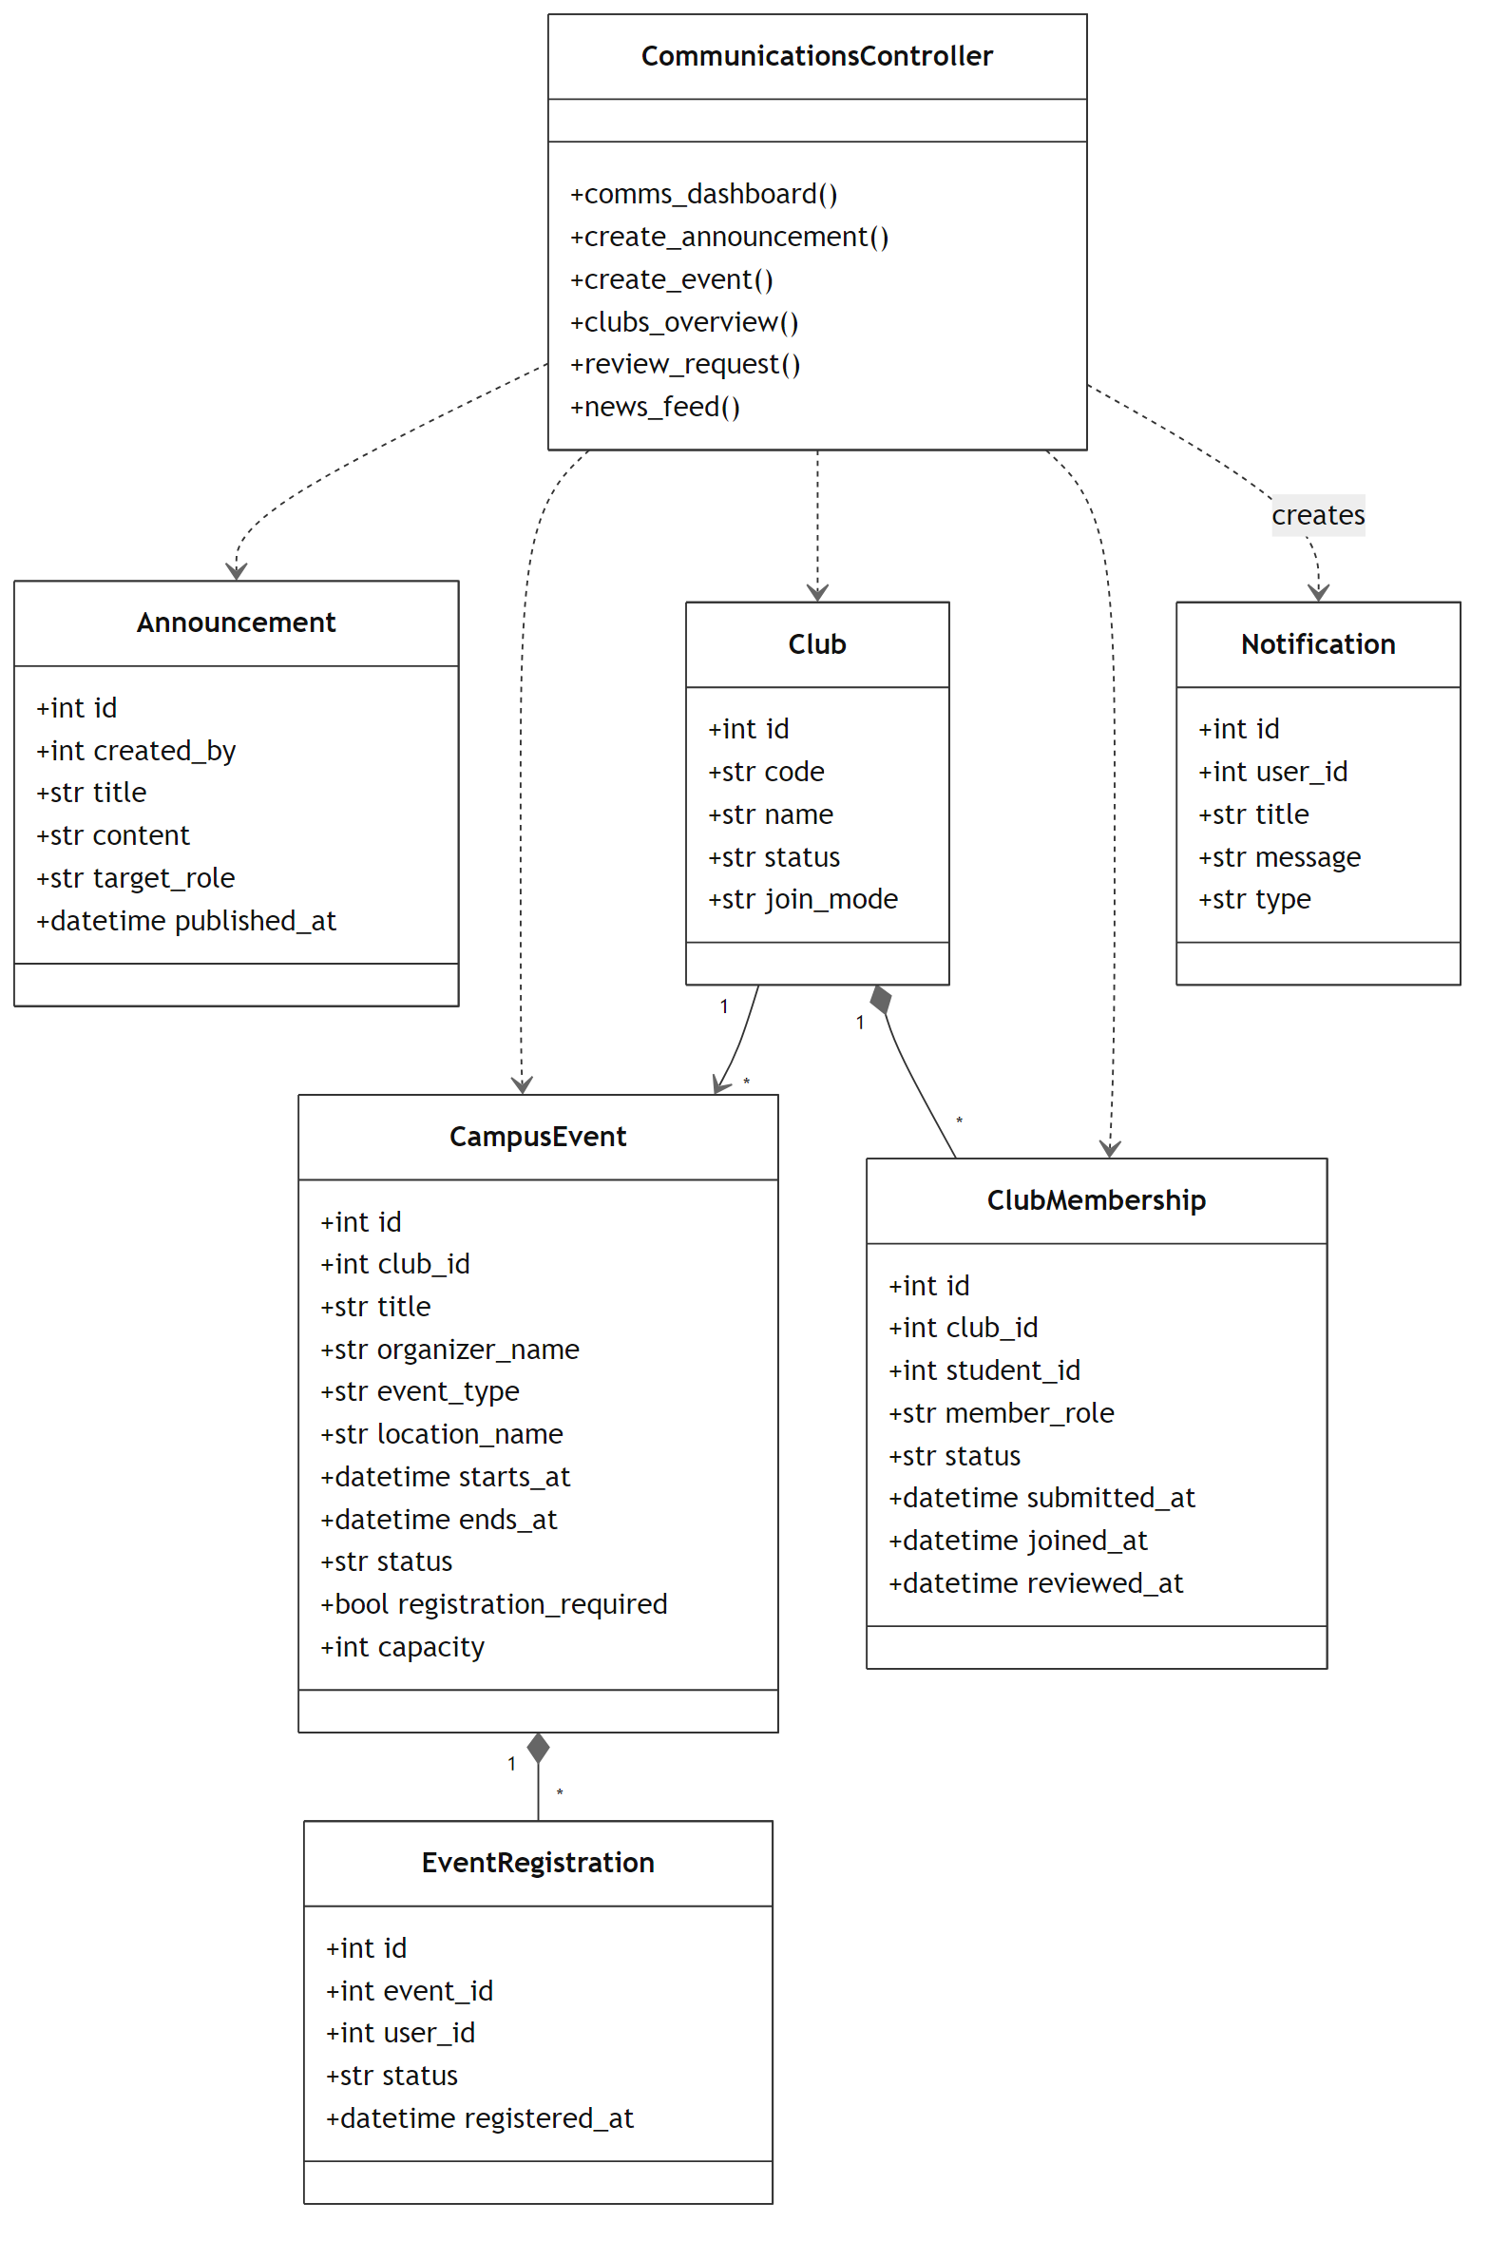

4.6.2 Object Diagrams

Figure 29. Object Diagram — Offering Snapshot
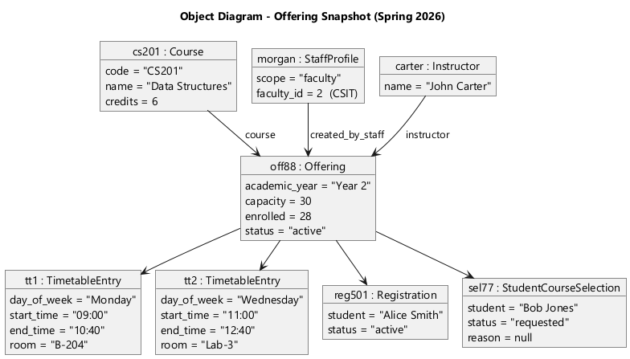

Figure 30. Object Diagram — Club / Event / Announcement Snapshot
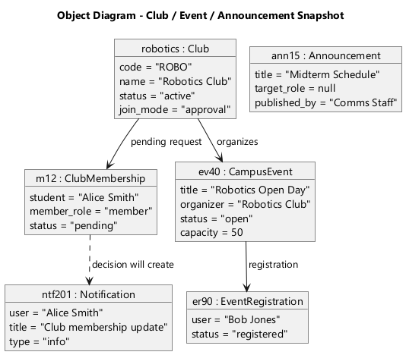

4.6.3 Component Diagram

Figure 31. Component Diagram — Academic & Communications Module
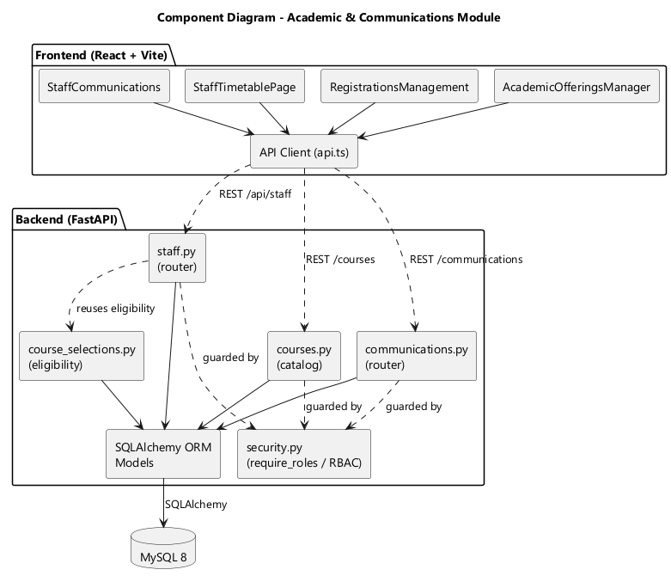

4.6.4 Deployment Diagram

Figure 32. Deployment Diagram — CIS Runtime Topology
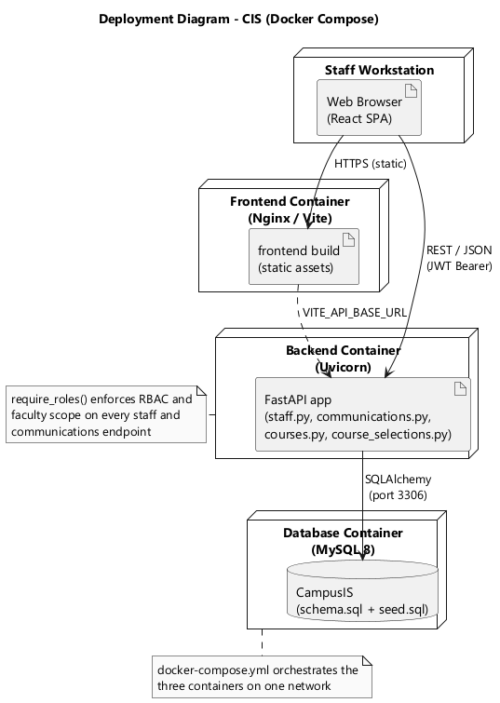

6. Implementation
The implementation of the Student Information and Course Registration System is organized as a modern full-stack web application. The repository contains a React and TypeScript client application, a FastAPI backend, and a MySQL or MariaDB relational database. Together these layers provide role-based dashboards and workflows for students, instructors, academic staff, finance staff, and system administrators.
The implementation is designed around separation of responsibilities. The frontend is responsible for user interaction, page routing, form handling, authenticated API calls, and display of academic information. The backend is responsible for validating requests, enforcing role-based access control, reading and writing database records, and exposing stable REST endpoints. The database stores institutional data such as users, students, programs, courses, offerings, registrations, attendance, grades, invoices, holds, notifications, announcements, messages, clubs, and events.
A notable characteristic of the product is its breadth. Course registration is a central workflow, but the system also includes instructor teaching tools, academic-staff administration, finance operations, student communications, and system administration. This gives the implementation the character of a campus information platform rather than a single isolated feature.
The system is implemented with a clear boundary between client and server. The browser application never writes directly to the database. It calls HTTP endpoints that validate the current user, evaluate business rules, and persist changes through SQLAlchemy sessions. This boundary makes the application easier to test and safer to extend because validation and permissions are centralized in the backend.
The source tree also shows an emphasis on maintainability. Frontend code is grouped into pages, layouts, contexts, hooks, UI components, and API helper modules. Backend code is grouped into configuration, models, routes, schemas, and utility modules. Database scripts are kept in a dedicated database folder so development and demonstration data can be recreated consistently.

6.1 General Product Overview
The product provides a secure web portal for academic and administrative work inside a university environment. Each user enters through the login page and is routed to a dashboard based on role. This design keeps the experience focused: a student sees student services, an instructor sees teaching tools, finance staff see financial records, and system administrators see management functions.
Students can view and maintain their profile, inspect registered and available courses, request subjects, review timetables, open course materials, submit assignments, monitor attendance, read grades, review finance information, join clubs, read campus news, use messages, and open an academic chatbot feature. These flows support the everyday academic tasks a student would expect from a campus information system.
Instructors have a teaching-oriented workspace. The instructor pages include dashboards, assigned courses, course detail views, weekly materials, assignments, attendance management, grade management, student lists, inbox, profile, and password changes. The backend scopes instructor data so teachers work with their assigned offerings instead of the entire database.
Academic staff operate the administrative side of the teaching process. Their pages support course catalog management, registration oversight, grade viewing, student lists, staff timetable management, course offering creation, building and room management, communications, inbox, and profile management. This role connects curriculum structure with operational scheduling and student progression.
Finance staff use a separate finance workspace. Their area focuses on invoices, payments, holds, student financial status, dashboards, profile, and password changes. The project includes finance-scope models so financial visibility can be associated with a faculty or wider institutional scope.
System administrators have the highest-level control surface. The administrator pages cover users, students, courses, semesters, analytics, settings, registrations, profile, and password changes. The administrator role is also represented in the backend RBAC helper, which normalizes older role names such as admin into the canonical system_admin role.
From an implementation viewpoint, the product uses both frontend and backend role enforcement. The frontend protects route trees with a RequireAuth component that checks the current authenticated user. The backend protects endpoints with FastAPI dependencies that decode the JWT, load the active database user, and compare the canonical role against the roles required for the route.
Identity and access | Login, registration, email verification, password reset, password change, JWT session handling, and role-based access. | All users
Academic records | Students, programs, departments, faculties, semesters, courses, offerings, registrations, course selections, attendance, and grades. | Students, instructors, academic staff, administrators
Teaching workflow | Course detail pages, weekly topics, course materials, assignments, submissions, attendance sessions, and grade publishing. | Instructors and students
Finance workflow | Invoices, payments, payment methods, holds, hold resolution, and student financial visibility. | Finance staff, students, administrators
Communication | Notifications, announcements, messages, clubs, club memberships, campus events, and event registrations. | Students, staff, instructors
Administration | User management, student administration, semester setup, settings, analytics, and privileged catalog operations. | System administrators

The repository size supports this product scope. It includes 55 frontend page components, 20 backend route modules, 28 backend model modules, SQL schema and seed scripts, Docker configuration, testing scaffolds, developer notes, and existing documentation folders. This breadth is important because it shows that the implementation is not only a mock interface; it contains persistent entities, real endpoint modules, and a database design that supports the stated workflows.

6.2 Technology Stack
The technology stack combines a TypeScript single-page application, a Python REST API, and a relational database. This is a practical architecture for a campus information system because the user interface needs many role-specific screens while the backend needs reliable validation, authorization, and transactional access to relational academic data.
Web application | React 18, TypeScript, Vite | Builds the single-page application, typed components, fast local development server, and production bundle.
Routing | React Router v6 | Defines route trees for students, instructors, academic staff, finance staff, and administrators.
Data fetching | TanStack Query and typed API wrappers | Coordinates asynchronous backend calls and gives frontend modules a consistent request model.
Styling and UI | Tailwind CSS, Radix UI, shadcn-style components, lucide-react | Provides reusable interface primitives, responsive layouts, accessible controls, and icons.
Backend API | FastAPI, Pydantic, Uvicorn | Exposes REST endpoints, request validation, OpenAPI documentation, and ASGI serving.
Persistence | SQLAlchemy ORM, PyMySQL | Maps Python models to relational tables and manages database sessions.
Database | MySQL 8 or MariaDB 10.4+ | Stores normalized institutional records for academic, finance, communication, and security modules.
Authentication | JWT, python-jose, PyJWT, passlib bcrypt | Creates and verifies access tokens and hashes user passwords.
Tooling | Vitest, ESLint, Pytest, Docker Compose | Supports testing, linting, repeatable local setup, and full-stack container execution.

React and TypeScript are used because the frontend has many forms, dashboards, and data views. TypeScript makes API response shapes explicit and reduces mistakes when passing records between UI components. Vite keeps local development fast and provides the production build pipeline.
FastAPI is a strong match for this backend because it encourages small route functions, explicit dependency injection, and generated OpenAPI documentation. Pydantic schemas can describe request and response payloads, while SQLAlchemy models represent persistent database records. The backend can therefore remain readable while still supporting a broad set of endpoints.
MySQL or MariaDB is appropriate because the data is highly relational. Users connect to students, staff profiles, instructors, registrations, offerings, courses, semesters, invoices, payments, attendance records, grades, and communication records. Foreign keys and unique constraints allow the database to enforce relationships that should not depend only on frontend validation.
Docker Compose is included to reduce setup friction. It can start the database, backend, and frontend together, which is useful for demonstrations and evaluator testing. Local manual setup remains useful for active development because it makes it easier to restart one layer without rebuilding the whole stack.

6.3 Code Snippets - Web App
The web application snippets show how the React client communicates with the API, stores authenticated user state, and protects role-specific routes. These excerpts were selected because they represent cross-cutting frontend behavior used by many pages.
Typed API request helper with bearer-token support (frontend/src/lib/api.ts, lines 1-43)
const BASE_URL = (import.meta.env.VITE_API_BASE_URL ?? "http://127.0.0.1:8001").replace(/\/$/, "");
function getToken(): string | null {
return localStorage.getItem("token");
}
async function request<T>(method: string, path: string, body?: unknown, auth = true): Promise<T> {
const isFormData = body instanceof FormData;
const headers: Record<string, string> = isFormData ? {} : { "Content-Type": "application/json" };
if (auth) {
const token = getToken();
if (token) headers["Authorization"] = `Bearer ${token}`;
}
let res: Response;
try {
res = await fetch(`${BASE_URL}${path}`, {
method,
headers,
body: body ? (isFormData ? body : JSON.stringify(body)) : undefined,
});
} catch {
throw new Error("Could not reach the backend. Please check that the API server is running.");
}
if (!res.ok) {
// Auto-clear stale auth on 401 from authenticated requests, so the app can recover
// (e.g. after a JWT secret rotation or token expiry).
if (res.status === 401 && auth && path !== "/auth/login") {
try {
localStorage.removeItem("token");
localStorage.removeItem("cis.user");
} catch { /* ignore */ }
if (typeof window !== "undefined" && window.location.pathname !== "/") {
window.location.href = "/";
}
}
const err = await res.json().catch(() => ({ detail: res.statusText }));
const detail = Array.isArray(err.detail)
? err.detail.map((item: { msg?: string }) => item.msg ?? "Validation error").join(", ")
: err.detail;
throw new Error(detail ?? "Request failed");
}
if (res.status === 204) return undefined as T;
return res.json() as Promise<T>;

This helper is the frontend's central HTTP abstraction. It builds the request URL from Vite configuration, attaches JSON headers unless the body is FormData, adds the bearer token for authenticated requests, handles network failures, extracts backend validation details, and redirects to login when a stale session receives a 401 response.
Centralizing this behavior reduces repeated code in page components. Instead of every page constructing fetch calls manually, domain wrappers such as studentsApi, coursesApi, gradesApi, financeApi, materialApi, and assignmentsApi can call the same request helper. This keeps error handling, token handling, and response parsing consistent across the application.
Authentication context and persisted session state (frontend/src/contexts/AuthContext.tsx, lines 33-68)
export function AuthProvider({ children }: { children: React.ReactNode }) {
const [token, setToken] = useState(() => localStorage.getItem("token"));
const [user, setUser] = useState<AuthUser | null>(() => readUser());
const value = useMemo<AuthContextValue>(
() => ({
token,
user,
signIn: async (email, password) => {
const data = await login(email, password);
const nextToken = data.token ?? data.access_token;
const nextUser: AuthUser = {
id: data.user?.id,
email: data.email,
name: data.display_name,
role: data.role,
require_password_change: data.require_password_change,
};
localStorage.setItem("token", nextToken);
localStorage.setItem("cis.user", JSON.stringify(nextUser));
setToken(nextToken);
setUser(nextUser);
return data;
},
signOut: () => {
localStorage.removeItem("token");
localStorage.removeItem("cis.user");
setToken(null);
setUser(null);
},
}),
[token, user],
);
return <AuthContext.Provider value={value}>{children}</AuthContext.Provider>;
}

The authentication context turns login state into a shared React service. After successful login, the token and user object are written to local storage and React state. Because the initial state also reads from local storage, a browser refresh can preserve the current session. The signOut function removes both stored values and resets state, giving the rest of the app a clean logout signal.
This design is simple but effective for a course project. It avoids over-engineering while still making authentication available to layouts, route guards, top bars, and pages. It also separates authentication state from individual forms, which makes the login flow easier to maintain.
Frontend route guard for role-specific pages (frontend/src/components/RequireAuth.tsx, lines 9-22)
export function RequireAuth({ allowedRole }: RequireAuthProps) {
const { user, token } = useAuth();
if (!token || !user) {
return <Navigate to="/" replace />;
}
const userRole = canonicalRole(user.role);
if (userRole !== canonicalRole(allowedRole)) {
return <Navigate to={homeRouteForRole(user.role) ?? "/"} replace />;
}
return <Outlet />;

The route guard protects the user experience before a backend request is even sent. If a user is not authenticated, the route returns to login. If the user has the wrong role, the application redirects to the home route for that role. This prevents a student from staying on an instructor URL, or an instructor from remaining on an admin URL, after navigation or manual address-bar entry.
The frontend route guard is not the only security mechanism. It is paired with backend authorization dependencies, which means the server still rejects unauthorized requests. The frontend guard improves navigation and clarity, while the backend guard enforces the actual permissions.

6.4 Code Snippets - Backend
The backend snippets show the API entry point, authentication and authorization utilities, database session creation, and representative registration endpoints. Together they demonstrate the server-side structure of the application.
FastAPI application setup, CORS, and route registration (backend/src/main.py, lines 21-63)
app = FastAPI(
title="Campus Information System API",
description="Backend API for the Student Information and Course Registration System",
version="1.0.0"
)
app.add_middleware(
CORSMiddleware,
allow_origins=[
"http://127.0.0.1:8088",
"http://localhost:8088",
"http://127.0.0.1:5173",
"http://localhost:5173",
],
allow_credentials=False,
allow_methods=["*"],
allow_headers=["*"],
)
app.include_router(auth.router)
app.include_router(students.router)
app.include_router(courses.router)
app.include_router(courses.catalog_router)
app.include_router(offerings.router)
app.include_router(registrations.router)
app.include_router(grades.router)
app.include_router(grades.teacher_api_router)
app.include_router(attendance.router)
app.include_router(attendance.teacher_api_router)
app.include_router(finance.router)
app.include_router(notifications.router)
app.include_router(users.router)
app.include_router(users.instructor_profile_router)
app.include_router(semesters.router)
app.include_router(materials.router)
app.include_router(materials.router, prefix="/api")
app.include_router(course_offerings.router)
app.include_router(campus_resources.router)
app.include_router(staff.router)
app.include_router(course_selections.router)
app.include_router(messages_routes.router)
app.include_router(clubs_routes.router)
app.include_router(communications_routes.router)

The FastAPI application is configured with a title, description, and version. CORS settings allow the local frontend development servers to communicate with the backend. Route modules are included by domain, which keeps the main entry point readable while allowing each business area to grow in its own file.
This modular route registration is important because the application covers many domains. Authentication, students, courses, offerings, registrations, grades, attendance, finance, notifications, users, semesters, materials, course offerings, campus resources, staff, course selections, messages, clubs, and communications can be maintained independently.
JWT creation, decoding, current-user lookup, and RBAC dependency (backend/src/utils/security.py, lines 19-59)
def create_access_token(data: dict) -> str:
payload = data.copy()
payload["exp"] = datetime.now(timezone.utc) + timedelta(minutes=settings.JWT_EXPIRE_MINUTES)
return jwt.encode(payload, settings.JWT_SECRET_KEY, algorithm=settings.JWT_ALGORITHM)
def decode_token(token: str) -> dict:
try:
return jwt.decode(token, settings.JWT_SECRET_KEY, algorithms=[settings.JWT_ALGORITHM])
except JWTError:
raise HTTPException(status_code=status.HTTP_401_UNAUTHORIZED, detail="Invalid or expired token")
def get_current_user(
credentials: HTTPAuthorizationCredentials = Depends(bearer_scheme),
db: Session = Depends(get_db)
):
from src.models.user import User
payload = decode_token(credentials.credentials)
user = db.query(User).filter(User.id == int(payload.get("sub"))).first()
if not user or not user.is_active:
raise HTTPException(status_code=status.HTTP_401_UNAUTHORIZED, detail="User not found or inactive")
return user
ROLE_ALIASES = {
"admin": "system_admin",
"staff": "academic_staff",
"teacher": "instructor",
"professor": "instructor",
}
def canonical_role(role: str) -> str:
return ROLE_ALIASES.get(role, role)
def require_roles(*roles: str):
def checker(current_user=Depends(get_current_user)):
allowed = {canonical_role(role) for role in roles}
if canonical_role(current_user.role) not in allowed:
raise HTTPException(status_code=status.HTTP_403_FORBIDDEN, detail="Insufficient permissions")
return current_user
return checker

The security utility is a central backend component. It creates access tokens with an expiry time, decodes incoming tokens, retrieves the current user from the database, rejects inactive users, normalizes role aliases, and provides a require_roles dependency. Route functions can declare their access rules in a compact way by depending on require_roles.
The role alias map is useful because the database and older parts of the project may use names such as admin, staff, or teacher, while the current user interface uses system_admin, academic_staff, and instructor. Canonical role conversion keeps those names compatible without duplicating permission checks in every route.
Database URL resolution and SQLAlchemy session lifecycle (backend/src/config/database.py, lines 8-29)
load_dotenv()
DATABASE_URL = os.getenv("DATABASE_URL")
if not DATABASE_URL:
db_host = os.getenv("DB_HOST", "127.0.0.1")
db_port = os.getenv("DB_PORT", "3306")
db_name = os.getenv("DB_NAME", "CampusIS")
db_user = os.getenv("DB_USER", "root")
db_password = os.getenv("DB_PASSWORD", "")
DATABASE_URL = f"mysql+pymysql://{db_user}:{db_password}@{db_host}:{db_port}/{db_name}"
engine = create_engine(DATABASE_URL, pool_pre_ping=True, future=True)
SessionLocal = sessionmaker(bind=engine, autoflush=False, autocommit=False)
Base = declarative_base()
def get_db():
db = SessionLocal()
try:
yield db
finally:
db.close()

The database module supports two configuration styles. A complete DATABASE_URL can be supplied directly, or the URL can be assembled from DB_HOST, DB_PORT, DB_NAME, DB_USER, and DB_PASSWORD. This makes the backend flexible enough to run with local MySQL, XAMPP MariaDB, or the Docker Compose database.
The get_db dependency creates one SQLAlchemy session for a request and closes it afterward. This pattern is common in FastAPI applications because it gives each endpoint access to the database while ensuring connections are returned properly.
Registration endpoints with student ownership and staff visibility (backend/src/routes/registrations.py, lines 42-89)
@router.get("/me", response_model=List[RegistrationOut])
def my_registrations(current_user: User = Depends(require_roles("student")), db: Session = Depends(get_db)):
student = _get_student(current_user.id, db)
registrations = db.query(Registration).filter(Registration.student_id == student.id).all()
return [_registration_payload(reg, db) for reg in registrations]
@router.post("", response_model=RegistrationOut, status_code=201)
def register(body: RegistrationCreate, current_user: User = Depends(require_roles("student")), db: Session = Depends(get_db)):
_get_student(current_user.id, db)
raise HTTPException(
status_code=400,
detail="Students must request subjects from Available Subjects. Staff/Admin approval is required before enrollment.",
)
@router.delete("/{registration_id}", status_code=204)
def drop_course(registration_id: int, current_user: User = Depends(require_roles("student")), db: Session = Depends(get_db)):
student = _get_student(current_user.id, db)
reg = db.query(Registration).filter(
Registration.id == registration_id,
Registration.student_id == student.id,
Registration.status == "active"
).first()
if not reg:
raise HTTPException(status_code=404, detail="Active registration not found")
semester = db.query(Semester).filter(Semester.id == reg.offering.semester_id).first()
if datetime.now(timezone.utc).date() > semester.drop_deadline:
raise HTTPException(status_code=400, detail="Drop deadline has passed")
reg.status = "dropped"
reg.offering.enrolled = max(0, reg.offering.enrolled - 1)
if reg.offering.status == "full":
reg.offering.status = "active"
db.commit()
@router.get("", response_model=List[RegistrationOut])
def list_registrations(offering_id: Optional[int] = None, student_id: Optional[int] = None, current_user: User = Depends(require_roles("academic_staff", "instructor", "system_admin")), db: Session = Depends(get_db)):
q = db.query(Registration)
if canonical_role(current_user.role) == "instructor":
instructor = db.query(Instructor).filter(Instructor.user_id == current_user.id).first()
if not instructor:
raise HTTPException(status_code=404, detail="Instructor profile not found")
q = q.join(Offering).filter(Offering.instructor_id == instructor.id)
if offering_id:
q = q.filter(Registration.offering_id == offering_id)
if student_id:
q = q.filter(Registration.student_id == student_id)
return [_registration_payload(reg, db) for reg in q.all()]

The registration route module shows how business rules are applied in endpoint logic. Students can retrieve their own registrations, but direct self-registration is blocked in favor of the subject-selection and approval workflow. Dropping a course checks ownership, active registration status, and the semester deadline.
Staff, instructors, and administrators can list registrations, but instructors are scoped to their assigned offerings. This pattern reflects the general authorization approach used across the project: broader staff and admin roles can perform institutional operations, while instructor access remains tied to teaching assignments.

6.5 Code Snippets - Database
The database implementation is expressed in SQL schema and seed files. The schema creates a normalized set of tables using InnoDB, utf8mb4 encoding, primary keys, unique keys, foreign keys, and check constraints. These definitions protect data integrity even if multiple backend routes write to related records.
User table with unique email, role validation, and account status validation (database/schema.sql, lines 20-34)
CREATE TABLE users (
id INT UNSIGNED NOT NULL AUTO_INCREMENT,
email VARCHAR(255) NOT NULL,
full_name VARCHAR(255) NULL,
password_hash VARCHAR(512) NOT NULL,
role VARCHAR(50) NOT NULL,
status VARCHAR(30) NOT NULL DEFAULT 'active',
is_first_login BOOLEAN NOT NULL DEFAULT TRUE,
is_active BOOLEAN NOT NULL DEFAULT TRUE,
created_at DATETIME NOT NULL DEFAULT CURRENT_TIMESTAMP,
PRIMARY KEY (id),
UNIQUE KEY uq_users_email (email),
CONSTRAINT chk_users_role CHECK (role IN ('student','teacher','staff','admin','instructor','academic_staff','finance_staff','system_admin')),
CONSTRAINT chk_users_status CHECK (status IN ('pending_verification','pending_approval','active','refused'))
) ENGINE=InnoDB DEFAULT CHARSET=utf8mb4 COLLATE=utf8mb4_unicode_ci;

The users table is the identity foundation. It stores email addresses, display names, password hashes, roles, status flags, activity flags, and timestamps. The unique email constraint prevents duplicate user identities. The check constraints document the supported roles and valid status values at the database level.
A system like this must protect identity records carefully because every other role-specific table depends on users. Student profiles, instructor profiles, staff profiles, finance scopes, messages, notifications, and audit logs all connect back to users directly or indirectly.
Course offerings and registration relationship (database/schema.sql, lines 215-262)
CREATE TABLE offerings (
id INT UNSIGNED NOT NULL AUTO_INCREMENT,
course_id INT UNSIGNED NOT NULL,
instructor_id INT UNSIGNED NOT NULL,
semester_id INT UNSIGNED NOT NULL,
program_id INT UNSIGNED NULL,
faculty_id INT UNSIGNED NULL,
created_by_staff_id INT UNSIGNED NULL,
academic_year VARCHAR(80) NULL,
group_name VARCHAR(80) NULL,
academic_period VARCHAR(80) NULL,
room VARCHAR(50) NULL,
schedule VARCHAR(200) NULL,
capacity INT NOT NULL,
enrolled INT NOT NULL DEFAULT 0,
enrollment_open BOOLEAN NOT NULL DEFAULT TRUE,
selection_deadline DATE NULL,
status VARCHAR(30) NOT NULL DEFAULT 'active',
created_at DATETIME NOT NULL DEFAULT CURRENT_TIMESTAMP,
updated_at DATETIME NOT NULL DEFAULT CURRENT_TIMESTAMP ON UPDATE CURRENT_TIMESTAMP,
PRIMARY KEY (id),
UNIQUE KEY uq_offering (course_id, semester_id, instructor_id),
CONSTRAINT fk_offerings_course FOREIGN KEY (course_id) REFERENCES courses(id),
CONSTRAINT fk_offerings_instructor FOREIGN KEY (instructor_id) REFERENCES instructors(id),
CONSTRAINT fk_offerings_semester FOREIGN KEY (semester_id) REFERENCES semesters(id),
CONSTRAINT fk_offerings_program FOREIGN KEY (program_id) REFERENCES programs(id),
CONSTRAINT fk_offerings_faculty FOREIGN KEY (faculty_id) REFERENCES faculties(id),
CONSTRAINT fk_offerings_staff FOREIGN KEY (created_by_staff_id) REFERENCES staff_profiles(id),
CONSTRAINT chk_offerings_capacity CHECK (capacity > 0),
CONSTRAINT chk_offerings_enrolled CHECK (enrolled >= 0),
CONSTRAINT chk_offerings_status CHECK (status IN ('active','full','cancelled'))
) ENGINE=InnoDB DEFAULT CHARSET=utf8mb4 COLLATE=utf8mb4_unicode_ci;
-- -------------------------------------------------------------
-- REGISTRATIONS
-- -------------------------------------------------------------
CREATE TABLE registrations (
id INT UNSIGNED NOT NULL AUTO_INCREMENT,
student_id INT UNSIGNED NOT NULL,
offering_id INT UNSIGNED NOT NULL,
registered_at DATETIME NOT NULL DEFAULT CURRENT_TIMESTAMP,
status VARCHAR(30) NOT NULL DEFAULT 'active',
PRIMARY KEY (id),
UNIQUE KEY uq_registration (student_id, offering_id),
CONSTRAINT fk_reg_student FOREIGN KEY (student_id) REFERENCES students(id),
CONSTRAINT fk_reg_offering FOREIGN KEY (offering_id) REFERENCES offerings(id),
CONSTRAINT chk_reg_status CHECK (status IN ('active','dropped','completed','failed'))
) ENGINE=InnoDB DEFAULT CHARSET=utf8mb4 COLLATE=utf8mb4_unicode_ci;

Course offerings are the operational instances of catalog courses. They connect a course to an instructor, semester, program, faculty, room, schedule, capacity, enrollment count, and status. Registrations connect students to those offerings, and the unique registration key prevents the same student from enrolling in the same offering more than once.
This structure separates the course catalog from the offered class. For example, a course such as Database Systems can exist once in the catalog, but it may be offered in different semesters, programs, rooms, groups, or by different instructors. That separation is essential for a real registration workflow.
Seed data import order and sample institutional reference data (database/seed.sql, lines 1-20)
-- =============================================================
-- Campus Information System (CIS) Demo Seed Data
-- Import order:
-- 1. database/schema.sql
-- 2. database/seed.sql
-- 3. Restart backend
-- Demo password for all seeded users: password123
-- All passwords are bcrypt hashes of "password123"
-- =============================================================
USE CampusIS;
SET FOREIGN_KEY_CHECKS = 0;
INSERT IGNORE INTO faculties (id, name, code) VALUES
(1, 'Faculty of Computer Science and IT', 'FCSIT'),
(2, 'Faculty of Engineering and Architecture', 'FEA'),
(3, 'Faculty of Economics', 'FECO'),
(4, 'Faculty of Law and Social Sciences', 'FLSS');
INSERT IGNORE INTO departments (id, name, code, faculty_id, degree_level) VALUES

The seed script provides a repeatable development dataset. It documents the import order, declares the demonstration password, and inserts faculties before departments, programs, users, and dependent records. This ordering matters because foreign-key constraints require parent records to exist before child records are inserted.
Seed data also improves evaluation. Instead of requiring an instructor to create users, faculties, departments, programs, courses, and accounts manually, the project can be loaded with ready-made data and then tested through the different user roles.

6.6 Open Source Libraries Used
The system is built with open-source libraries on both the client and server. These libraries reduce development time, improve accessibility and security, and provide maintained foundations for routing, validation, styling, database access, and testing. The versions listed below are taken from the project dependency files.
The dependency strategy is appropriate for a student information system because it avoids building low-level infrastructure from scratch. Instead, the project uses mature tools for common concerns and spends implementation effort on the domain-specific workflows: registration, teaching, grades, attendance, finance, communications, and administration.

6.6.1 Web App
react / react-dom | ^18.3.1 | Core UI rendering and component model.
vite | ^8.0.13 | Development server, frontend build pipeline, and preview server.
typescript | ^5.8.3 | Static typing for frontend components and API contracts.
react-router-dom | ^6.30.1 | Client-side routing for all role-specific dashboards.
@tanstack/react-query | ^5.83.0 | Asynchronous data fetching and cache coordination.
react-hook-form | ^7.61.1 | Form state management and input handling.
zod | ^3.25.76 | Schema validation and typed form data.
@radix-ui/react-* | multiple packages | Accessible UI primitives for reusable interface components.
tailwindcss | ^3.4.17 | Utility-first styling and responsive interface design.
lucide-react | ^0.462.0 | Icon set used across navigation and controls.
recharts | ^2.15.4 | Charts for dashboard and analytics views.
sonner | ^1.7.4 | Toast notifications for user feedback.
vitest | ^3.2.4 | Frontend unit test runner.
eslint | ^9.32.0 | Code quality and linting.

React provides the component model for reusable views. TypeScript adds safety around props, state, and API responses. React Router organizes the application by role-specific paths, while TanStack Query supports stable asynchronous data usage. Tailwind and Radix UI support consistent interface construction without forcing every page to define its own low-level controls.

6.6.2 Backend
fastapi | >=0.115,<1.0 | REST API framework, dependency injection, validation integration, and OpenAPI documentation.
uvicorn[standard] | >=0.30,<1.0 | ASGI server used to run the FastAPI application.
pydantic | >=2.7,<3.0 | Request and response schema validation.
sqlalchemy | >=2.0,<3.0 | ORM models, database sessions, and query construction.
PyMySQL | >=1.1,<2.0 | MySQL database driver used by SQLAlchemy.
PyJWT | >=2.9,<3.0 | JWT utility support.
python-jose[cryptography] | >=3.3,<4.0 | JWT encoding and decoding with cryptographic support.
passlib[bcrypt] | >=1.7,<2.0 | Password hashing abstraction.
bcrypt | >=4.0,<4.1 | Pinned password hashing backend compatible with passlib 1.7.x.
email-validator | >=2.2,<3.0 | Validation for email fields.
python-dotenv | >=1.0,<2.0 | Loads local environment variables from .env files.
python-multipart | >=0.0.20,<1.0 | Supports multipart form data and file upload endpoints.
cryptography | >=46.0,<47.0 | Cryptographic primitives used by authentication libraries.

FastAPI and Pydantic support request validation and interactive API documentation. SQLAlchemy and PyMySQL handle persistence. python-jose, PyJWT, passlib, bcrypt, and cryptography provide the foundation for token handling and password security. python-dotenv supports local configuration, and python-multipart enables file upload flows such as teaching materials and assignment submissions.

6.7 Versioning
The project identifies itself as version 0.1.0 in the frontend package file and records release information in CHANGELOG.md. The changelog states that the project follows semantic versioning, where version numbers use the form MAJOR.MINOR.PATCH.
A MAJOR version changes when incompatible workflow, API, or database changes are introduced. A MINOR version changes when backward-compatible features are added. A PATCH version changes when backward-compatible fixes or documentation updates are made. This approach is useful because the project has several layers that can break compatibility: frontend routes, backend endpoints, API payloads, database tables, seed data, and environment configuration.
The 0.1.0 release represents a full-stack handoff baseline. It includes React, TypeScript, Vite, FastAPI, MySQL or MariaDB support, Docker Compose setup, ordered SQL schema and seed scripts, demo credentials, frontend build/test/lint scripts, backend pytest scaffolding, and contributor workflow documentation.
- Patch releases should cover documentation corrections, small UI fixes, setup improvements, and test additions that do not change behavior.
- Minor releases should cover new backwards-compatible features such as richer reporting, expanded analytics, improved messaging, or additional finance workflows.
- Major releases should be reserved for breaking changes such as renamed endpoints, incompatible database schema changes, or role workflow redesigns.
- Each release should update CHANGELOG.md, package.json, backend API metadata, database migration notes, and verification results together.

6.8 License
The recommended license for this project is the MIT License. MIT is a permissive open-source license that allows the software to be used, copied, modified, merged, published, distributed, sublicensed, and sold, provided that the copyright notice and license text remain with substantial portions of the software.
A permissive license is suitable for a student academic project because it is simple, widely recognized, and easy for future contributors to understand. It allows instructors, classmates, and maintainers to reuse or extend the work while keeping attribution to the original project contributors.
The license also clarifies responsibility. The MIT License provides the software as-is and does not promise warranty, fitness for a particular purpose, or liability protection for users of the software. This is common for open-source academic and demonstration systems.
MIT License

Copyright (c) 2026 Student Information and Course Registration System Contributors

Permission is hereby granted, free of charge, to any person obtaining a copy of this software and associated documentation files (the "Software"), to deal in the Software without restriction, including without limitation the rights to use, copy, modify, merge, publish, distribute, sublicense, and/or sell copies of the Software, and to permit persons to whom the Software is furnished to do so, subject to the following conditions:

The above copyright notice and this permission notice shall be included in all copies or substantial portions of the Software.

THE SOFTWARE IS PROVIDED "AS IS", WITHOUT WARRANTY OF ANY KIND, EXPRESS OR IMPLIED, INCLUDING BUT NOT LIMITED TO THE WARRANTIES OF MERCHANTABILITY, FITNESS FOR A PARTICULAR PURPOSE AND NONINFRINGEMENT. IN NO EVENT SHALL THE AUTHORS OR COPYRIGHT HOLDERS BE LIABLE FOR ANY CLAIM, DAMAGES OR OTHER LIABILITY, WHETHER IN AN ACTION OF CONTRACT, TORT OR OTHERWISE, ARISING FROM, OUT OF OR IN CONNECTION WITH THE SOFTWARE OR THE USE OR OTHER DEALINGS IN THE SOFTWARE.

The license aligns with the project goal of being open source. It supports learning, review, modification, and redistribution while keeping the legal language short enough to include directly in the project documentation.

6.9 Instructions of Use
The system can be used through a local development setup or through Docker Compose. The local setup is useful for development and debugging because the database, backend, and frontend are started separately. The Docker setup is useful when the goal is to demonstrate the complete stack with fewer manual steps.
The order of setup matters. The database schema should be created first, then seed data should be loaded, then the backend should start with environment variables pointing to that database, and finally the frontend should start with an API base URL that points to the backend.

6.9.1 Web App
After the database and backend are running, the web application is accessed through the browser. In development, the Vite server is started from the repository root. The frontend source code is under frontend/src, but package scripts are located at the repository root.
- Install Node.js 18 or later.
- Open a terminal in the repository root.
- Run npm install to install frontend dependencies.
- Create or update the root .env file so VITE_API_BASE_URL points to the backend.
- Start the frontend with npm run dev -- --host 127.0.0.1 --port 8088.
- Open http://127.0.0.1:8088 in the browser.
- Log in with one of the seeded development accounts after loading database/seed.sql.
Student | alice.smith@cis.edu | password123
Instructor | john.carter@cis.edu | password123
Academic Staff | rebecca.morgan@cis.edu | password123
Finance Staff | finance.csit@cis.edu | password123
System Admin | admin@cis.edu | password123

Once logged in, the user should be redirected to the correct dashboard for their role. A student should see student services, an instructor should see teaching tools, academic staff should see administrative academic tools, finance staff should see finance operations, and a system administrator should see user and system management areas.

6.9.2 System Setup
A complete local setup requires MySQL or MariaDB, Python, Node.js, and the project dependencies. The backend expects the database schema to exist before most API workflows can run.
- Install prerequisites: Node.js 18 or later, Python 3.11 or later, and MySQL 8 or MariaDB 10.4 or later.
- Create the database by importing database/schema.sql. The schema creates the CampusIS database and all main tables.
- Load demo data by importing database/seed.sql after the schema has completed.
- In the backend folder, create a Python virtual environment with python -m venv .venv.
- Activate the virtual environment and install dependencies with pip install -r requirements.txt.
- Create backend/.env from backend/.env.example or the root .env.example and set database and JWT values.
- Start the backend using uvicorn src.main:app --reload --port 8000 from inside the backend folder.
- Verify the API at http://127.0.0.1:8000/health and inspect Swagger documentation at http://127.0.0.1:8000/docs.
- Install and start the frontend from the repository root with npm install and npm run dev -- --host 127.0.0.1 --port 8088.
Frontend | http://localhost:8088 | Browser-based React user interface.
Backend API | http://localhost:8000 | FastAPI REST service.
Swagger UI | http://localhost:8000/docs | Interactive OpenAPI endpoint documentation.
Health check | http://localhost:8000/health | Simple API status endpoint.
MySQL | localhost:3306 or 3307 | Relational database. XAMPP MariaDB commonly uses 3307.

The Docker option can start the database, backend, and frontend together with docker compose up --build. The compose file exposes MySQL on port 3306, the backend on port 8000, and the frontend on port 8088. This is the easiest route for demonstration when Docker is available.
Recommended verification after setup includes checking that the backend health endpoint returns ok, logging in through the frontend, loading a student dashboard, opening an instructor course page, viewing academic staff registrations, and confirming that Swagger lists the route groups described in this documentation.

