1. Executive Summary

1.1. Project Overview
The Campus Information System (CIS) is a centralized, web-based institutional platform developed to consolidate and streamline campus operations across academic administration, student services, finance management, communication, and institutional oversight. CIS is built on a modern technology stack comprising React and TypeScript on the frontend, FastAPI on the backend, and a relational MySQL database for persistence.

CIS is designed as a multi-role platform, recognizing that different categories of institutional actors — students, teachers, and administrators — require distinct functional interfaces, access controls, and workflows. The platform replaces fragmented, siloed tools with a unified system where all stakeholders interact through a role-appropriate workspace governed by a consistent authorization model.

The system covers core campus functions including identity and access management, academic structure management, course registration, attendance recording, grade management, invoicing and finance operations, campus club and event engagement, announcement publishing, and AI-assisted student support. CIS is not intended to serve as a public-facing portal or external LMS; it operates as an internal institutional system with accounts provisioned directly by administrators.

This project was initiated in response to the operational complexity and data fragmentation encountered when managing campus activities across multiple disconnected tools. The CIS initiative aims to provide a scalable, maintainable, and audit-ready platform that grows with institutional needs and supports both near-term operational requirements and long-term strategic objectives.

1.2. Purpose and Scope of this Specification
This Requirements Specification document serves as the authoritative reference for the design, development, and evaluation of the Campus Information System (CIS). It establishes the complete functional and non-functional requirements that the system must satisfy in order to reach production readiness and institutional acceptance.

The purpose of this document is threefold. First, it provides the development team with precise, actionable requirements that define what the system must do, how it must behave under operational conditions, and what constraints govern its design. Second, it serves as a communication artifact between the institution's technical team, academic stakeholders, and governance sponsors, ensuring shared understanding of system scope and acceptance criteria. Third, it functions as the baseline for quality assurance and validation activities, allowing acceptance to be assessed against traceable, measurable conditions.

The scope of this specification covers the following areas:

- Identity and access control, including account provisioning, authentication, role-based authorization, and audit logging.
- Academic operations, including the management of departments, programs, terms, courses, and offerings; teacher assignment; student registration; timetable generation; attendance management; and grade recording and publishing.
- Finance operations, including invoice management, payment recording, financial holds, and aid award administration.
- Campus engagement, including club management, event administration, announcement publishing, and notification delivery.
- Student support, including AI-assisted chat sessions, support request workflows, and personalized recommendation features.
- System administration, including user lifecycle management, reporting dashboards, and system configuration.

The following areas are explicitly outside the current scope of this specification: external payment gateway settlement, public admissions portals, integration with external Learning Management Systems (LMS), and real-time email or SMS delivery. These may be addressed in future phases and are noted as extension points within the architecture.

This document reflects the refined requirements baseline as of April 2026 and supersedes all prior draft versions. All implementation, testing, and acceptance activities should reference this document as the primary specification source.

2. Service Description

2.1. Product Context
CIS operates as an internal web platform deployed within a single institutional environment. It is not a commercial SaaS product and is not designed for multi-tenancy across independent institutions. The system boundary encompasses all campus users — students, teaching staff, and administrative personnel — who interact with the platform through role-specific browser-based workspaces.

The platform interfaces with an institutional SQL database as its primary persistence layer and exposes a RESTful API that the React frontend consumes. All business logic is enforced at the backend and database layers, ensuring that data integrity does not rely on frontend behavior alone. The system is designed to be containerized for deployment consistency and repeatability.

CIS sits within a broader institutional technology landscape where it is intended to serve as the central operational hub. It does not integrate with external LMS platforms, public enrollment portals, or third-party payment processors in its current release. However, its modular architecture and stable API contracts are designed to accommodate such integrations in future phases without requiring structural rewrites.

From a product positioning perspective, CIS is a mission-critical institutional system. It manages authoritative academic records, financial transactions, and identity information. Accordingly, its design priorities include data integrity, security, auditability, and operational reliability above feature richness or novelty.

2.2. User Characteristics
CIS serves four distinct categories of actors, each with different technical proficiencies, operational responsibilities, and expectations of the system.

Students represent the largest user group and are the primary beneficiaries of the platform's self-service capabilities. They are expected to have basic digital literacy and will interact with the system via desktop or mobile browsers. Their primary activities include browsing the course catalog, submitting registration requests, reviewing timetables, inspecting attendance records and grades, managing club memberships, reviewing financial statements, and reading notifications. Students interact with their own records only and have no visibility into administrative or staff-level data. Many students may be first-time users of a formal institutional information system and will require an interface that is intuitive, clearly labeled, and mobile-responsive.

Teachers are academic staff members responsible for instructional delivery and course-level record management. They are expected to be moderately comfortable with web-based tools. Their primary platform activities include managing attendance sessions, recording marks, publishing grades, reviewing course rosters, and communicating with students through the notification system. Teachers interact only with offerings explicitly assigned to them and do not have visibility into finance, administrative, or other teachers' course records. The teacher workspace must be efficient and minimize administrative overhead so that instructional focus is preserved.

Administrators are institutional operators with broad cross-functional authority. They are responsible for provisioning and managing all user accounts, maintaining the academic structure, issuing invoices, managing financial holds, publishing announcements and events, supervising club records, and accessing reporting dashboards. Administrators require a comprehensive and reliable interface that provides full visibility across academic, finance, and engagement domains. They are expected to be experienced users of institutional software and will interact with the system extensively throughout the academic cycle.

System Owners are institutional sponsors accountable for governance, compliance, and roadmap prioritization. They interact with the system primarily at a strategic level, reviewing acceptance criteria, validating deployment readiness, and overseeing operational maturity. System Owners may not interact with the platform's operational features directly but require confidence that audit records, reporting outputs, and data governance mechanisms are in place and functioning correctly.

2.3. Assumptions
The following assumptions underpin the design and scope decisions embedded in this specification. Deviations from these assumptions may require corresponding revisions to scope, architecture, or acceptance criteria.

- The institution is the sole authority for user account creation and role assignment. No self-registration pathway is required or permitted in the current release.
- All users interact with CIS through modern web browsers on desktop or mobile devices. No native mobile application is required at this stage.
- The initial deployment targets a single campus or a logically unified institutional data boundary. Multi-campus or multi-tenant operation is not within the current scope.
- The institution has access to a server environment capable of hosting containerized applications and a relational SQL database.
- Institutional email addresses are available for all provisioned users. Email-backed communication for password recovery and notifications is a future integration that is not required for initial launch.
- Academic structures — including departments, programs, terms, courses, and offerings — will be created and maintained by administrators within the system. No automated import from external academic systems is assumed.
- The AI-assisted student support feature operates under institutional policy regarding data retention, privacy, and chat history visibility. The system provides the infrastructure; policy enforcement is the institution's responsibility.
- Adequate institutional resources are available for data entry during the onboarding phase, including student records, course data, and historical financial information.

2.4. Constrains
The following constraints establish boundaries on design choices, technology decisions, and delivery scope. These are non-negotiable within the current release cycle.

- The system must be implemented using the agreed technology baseline: React and TypeScript for the frontend, FastAPI for the backend, and MySQL or MariaDB as the relational database engine.
- All authentication and authorization must be handled by the system's internal auth service. External identity providers and SSO integration are deferred to a future phase.
- External payment gateway integration is out of scope. Finance operations are limited to internally recorded invoices, payments, and holds managed by administrators.
- Live email delivery for notifications, password resets, and announcements is deferred. The system must support the data model and workflow for these features but does not need to integrate with an SMTP or email service provider in the initial release.
- All API endpoints must use REST-based JSON contracts over authenticated HTTP. GraphQL, WebSocket-based real-time updates, and other communication protocols are not required at this stage.
- The system must support containerized deployment. Bare-metal or platform-specific deployment configurations are acceptable only if containerization is also provided.
- Secrets, credentials, and environment-specific configuration must be managed through environment variables or an equivalent secure configuration mechanism. Hard-coded secrets in source code are not permissible.
- The platform must remain a single-institution deployment. Multi-tenant architecture is not required and should not be introduced prematurely.

2.5. Dependencies
The successful delivery of CIS depends on a set of technical, institutional, and operational dependencies. Risks to any of these dependencies may affect the delivery timeline, deployment readiness, or operational quality of the platform.

Technical dependencies include the availability and correct configuration of the MySQL or MariaDB database instance, the containerization environment for backend and frontend services, and the availability of package registries for Node.js and Python dependencies. The system also depends on the stability of the FastAPI and React ecosystems, including their associated libraries for authentication, ORM operations, routing, and state management.

Institutional dependencies include the availability of accurate master data to seed the system at launch, including user accounts, academic structures, course offerings, and historical records where applicable. Administrative staff must be trained on account provisioning workflows and reporting procedures before go-live. Governance approval from the System Owner is required to authorize the deployment of production data.

Operational dependencies include the ongoing availability of server infrastructure, routine backup procedures, and a defined process for system maintenance windows. Although external email delivery and payment processing are deferred, the system must be architected to accommodate these integrations without disruption to deployed services when they are introduced in later phases.

Future integration dependencies, while deferred, include SMTP service for email delivery, external payment processors for finance settlement, document storage services for file management, and analytics pipelines for institutional reporting enhancements. These are noted here to ensure the current architecture does not inadvertently foreclose these extension opportunities.

2.6. Onion Model Diagram
The Onion Architecture model is adopted for CIS to ensure that core domain logic remains independent of external concerns such as database drivers, UI frameworks, and third-party integrations. This architectural approach promotes modularity, testability, and long-term maintainability by enforcing strict dependency direction: outer layers depend on inner layers, never the reverse.

The following table represents the CIS Onion Architecture layered from the innermost core domain to the outermost infrastructure and delivery components:

Domain / Layer | Components
Core Domain (Centre) | Student Records, Academic Data, Grades, Attendance
Domain Services | Registration, Finance, Grading Workflows, Auth
Application Services | FastAPI REST Endpoints, Business Logic Layer
Infrastructure / Outer Ring | MySQL Database, React Frontend, External Integrations

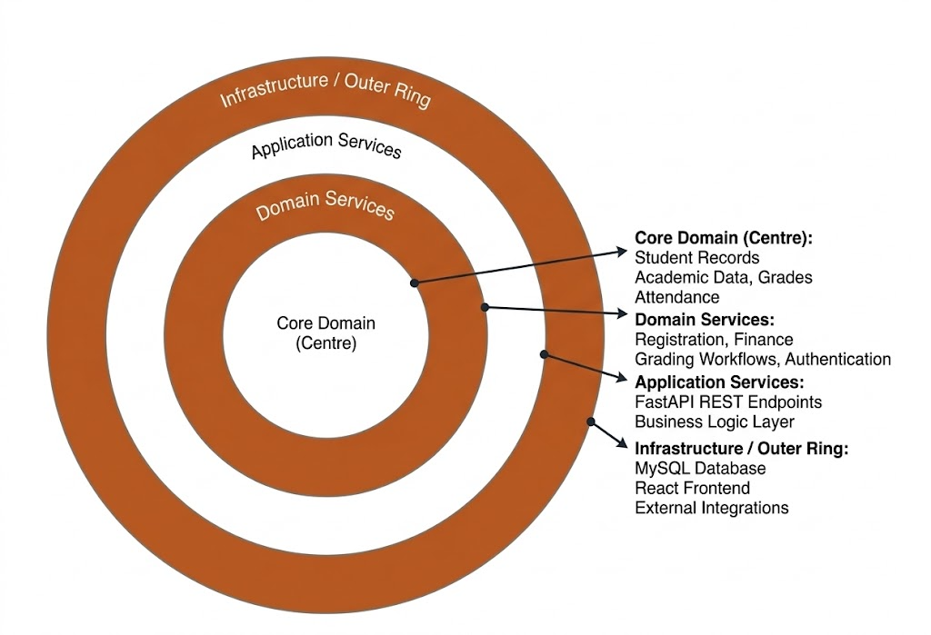

At the core of the architecture are the domain entities that represent the fundamental academic and operational concepts of the institution: students, courses, grades, registrations, invoices, and their associated rules and lifecycle states. These entities are independent of any framework, database technology, or interface concern.

The domain services layer encapsulates the business logic that operates on core entities — registration validation, grade publication workflows, finance hold enforcement, and authentication token management. These services know the domain rules but remain agnostic of how data is persisted or how requests arrive.

The application services layer coordinates use cases and orchestrates the interaction between domain services, repositories, and external interfaces. FastAPI route handlers and dependency injection patterns operate at this layer, translating HTTP requests into domain operations and formatting responses for API consumers.

The outermost infrastructure layer encompasses all external concerns: the MySQL database and its ORM adapter, the React frontend that consumes the REST API, and any future integrations with email services, payment processors, or analytics platforms. These components are replaceable without affecting the inner layers.

2.7. Stakeholder Identification Table
The following table identifies all primary and secondary stakeholders associated with the CIS platform, along with their role type, primary interests in the system, and their relative level of influence over design and acceptance decisions.

Stakeholder | Role / Type | Interest in CIS | Influence Level
Students | Primary End User | Course registration, grades, finance, club participation, timetable, and academic alerts. | Low – consume services
Teachers | Primary End User | Manage attendance records, gradebooks, course rosters, and communicate with students. | Medium – operate course workflows
Administrators | Operator / Manager | Provision accounts, maintain academic structure, manage finance, publish notices, and oversee system data. | High – control institutional data
System Owner | Governance Sponsor | Approve policy, validate acceptance criteria, oversee deployment, and ensure operational maturity. | High – strategic authority
IT / DevOps | Technical Stakeholder | Deployment infrastructure, environment configuration, backup procedures, and container management. | Medium – system reliability
Compliance / Auditors | External Oversight | Verify audit trail completeness, data privacy compliance, and security policy enforcement. | Medium – regulatory requirements

Each stakeholder group has been considered during requirements elicitation. Functional requirements are traceable to at least one primary stakeholder group, and acceptance criteria have been validated against the interests and authority of the System Owner and Administrator stakeholders who carry the highest institutional influence over the deployment decision.

Ongoing stakeholder engagement, particularly with teachers and students during user acceptance testing, is recommended to validate that role-specific workflows meet operational expectations before full institutional deployment.

