CSIS1275-01 Assignment 3 Due Date: Mar. 15th/2018

You can do this assignment with ONE partner

Part1
Write a program with the following class and functionality.

class Assign3W2018PT1 (save as Assign3W2018PT1.java)

You are given the following 2 String arrays:

String computerTerms[] = {"algorithm","byTe","Heuristic","instantiate","whetstone"};
String terms[] = {"InliNe ","instAntiate "," STrinG"," BYte"};

You can assume that the computerTerms[] arrays is sorted in ascending sequence, whereas the terms[] arrays is NOT sorted at all.

This program will merge the above 2 arrays into a third String array called merged[] , however it will NOT include any duplicated terms between the 2 existing arrays, i.e. once merged, the new array will NOT include “instAntiate” or “BYte” from the terms array. You can also assume that there are no duplicated strings in the computerTerms[] or terms[] (i.e. byte will not appear more than once in computerTerms[], and the same for terms[]). You can also assume that both arrays will at least have one item in it.

Below shows the typical screen dialogue:
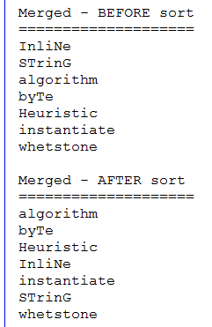

It shows that the new merged array contains the strings in terms[] that are not in the computerTerms[] array, and are added to the beginning of this new merged array. It is then sorted and displayed. Note that for any duplicated strings, use the case spelling from the computerTerms[] array.

The program should allow the user to search for licence plate number until “e” or “E” is entered, at which point the program will exit.

This class will contain at least the following instance methods.

main(..)
class Assign3W2018PT1 will contain the public static void main(..) method. It will contain the following String arrays.

String computerTerms[] = {"algorithm","byTe","Heuristic","instantiate","whetstone"};
String terms[] = {"InliNe ","instAntiate "," STrinG"," BYte"};

main(..) will invoke the following methods (and please note, when you create these array methods, they should all work for any sized arrays.:

sortArrayAsc(…) (instance method)
Use this method to sort the new “merged []” array in ascending order. This method will take a String array as a parameter. It will return nothing.
(DO NOT USE ANY of Java’s own array methods).
(HINT: You may need to use the “compareTo” method for string comparison)

dislayArray(...) (instance method)
This method will take a String array as a parameter, and will display the content of the array.

binSrch(…..) (instance method)
This method will take at least a String array as a parameter (there could be more parameters) and perform a binary search to indicate if the string items in the terms[] already exists or not in the computerTerms[] array. It is also important to note that this method must be able to search irrespective of case (whether it is uppercase, lowercase or mixture of both.). (DO NOT USE ANY of Java’s own array methods).
(HINT: You may need to use the “compareTo” method for string comparison)

Additional Methods

- You may need a method to determine the size of this new merged[] array.
- You may need a method to combine the computerTerms[] and terms[] to this new merged[] array

You can start with the following:
import java.io.*;
import java.util.*;
class Assign3W2018PT1
{
///////////////////////////////////////////////
// Your methods
//////////////////////////////////////////////
public static void main(String arg[])
{
String computerTerms[] = {"algorithm","byTe","Heuristic","instantiate","whetstone"};
String terms[] = {"InliNe ","instAntiate "," STrinG"," BYte"};
}
}

Things to Note:
- The program should be able to eliminate leading and trailing spaces
- It should also handle upper or lowercase during string comparisons
- You cannot use ArrayList or Vectors.
- You cannot use any StringBuilder methods.
- You cannot use any Java’s own Array methods for sorting or searching.
- Both the computerTerms[] and terms[] array should be left untouched.

Other Examples
When testing this program, try other content for the terms[] arrays, i.e:

String terms[] = {"byte "};

The output would be:
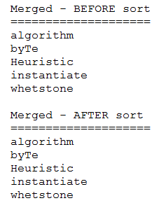

Part2
Write a program with the following class and functionality.

class Assign3W2018PT2 (save as Assign3W2018PT2.java)

You are given the following String array:

String computerTerms[] = {"algorithm","byte","heuristic","instantiate","whetstone"};

Your program will randomly choose of the above terms for the user to guess. The first letter will be given while the rest is hidden by “*”. If the first letter is repeated elsewhere in the term, then it will be displayed. Each time the user guesses a letter correctly, that “*” in that position will be replaced by the correct letter. If that letter is repeated elsewhere in the term, then those “*” will be replaced by that letter automatically. Once guessed correctly, the user will be prompted to either continue or exit. If continue, then it will randomly choose another term and so on.

Example 1
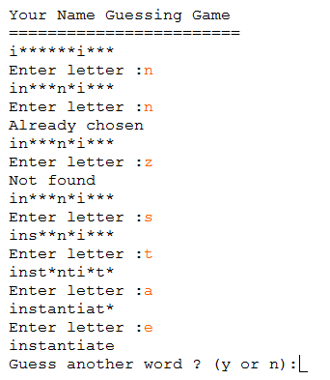

Example 2
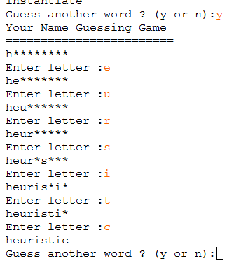

Example 3
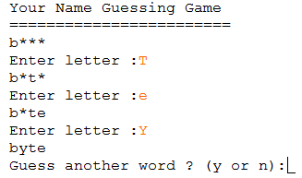
It should be able to handle upper or lowercase.

Hint:
You cannot use any StringBuilder methods, so you need to create a character array filled with ”*” and replace it gradually with the correctly guessed letter.

Methods
- You may need a method that will randomly return an integer that indicates the index of the word to guess for the user. (Hint: use the necessary method from the Random class)
- You may need a method that determine how many letters have been guessed correctly.
- You may need a method that will replace the “*” with the correctly guessed letter in that position. This method can also be where the “Already chosen” or Not found” messages are displayed.

Things to Note for BOTH parts of the Assignment:
- It should handle upper or lowercase during comparisons
- You cannot use ArrayList or Vectors.
- You cannot use any StringBuilder methods.
- You cannot use any Java’s own Array methods for searching or sorting. You can use the Array.fill() method to quickly fill in an array with a certain character (like “*”).

What to hand in:
- Front cover page with your name (your partner’s name), course, assignment number, instructor’s name, section and due date. (If you did this assignment with a partner, then hand in ONE piece of work with BOTH your names on it).
- Hardcopy of the program listing of ALL classes.
- Zip up the files as csis1275_YourSectionNumber_W2018Assign3YourName.zip
- Upload the zip file through blackboard

(If you did this with a partner, then please hand in one piece of work with both your names on the cover page. PLEASE ENSURE THAT THIS IS YOUR OWN WORK OR MARKS WILL BE LOST OR WORSE !)

