CSIS1275-01 JAVA Assignment 4 Winter 2018
Due date: April 12/ 2018
You can do this assignment with one partner, in which case, hand in one piece of work with both your names on it.

Create a stand-alone Java Application using Java Swing components and layout managers, call it WorldCup.java, that will allow customers to select matches from past world cups to download. It should have the following functionality and layout (please note that you are prohibited from using any software that can auto generate the code):

Main Screen
The initial main screen is as shown on the next page.

Layout and font

Ensure that the layout of the main screen remains the same, whatever the size of the application (i.e. use layout managers)

The main font is either Arial or Helvetical. Note some are bolded and in italics, but some may not. Use your own judgment on the exact font sizes, but the text on the buttons are mostly a bit larger.

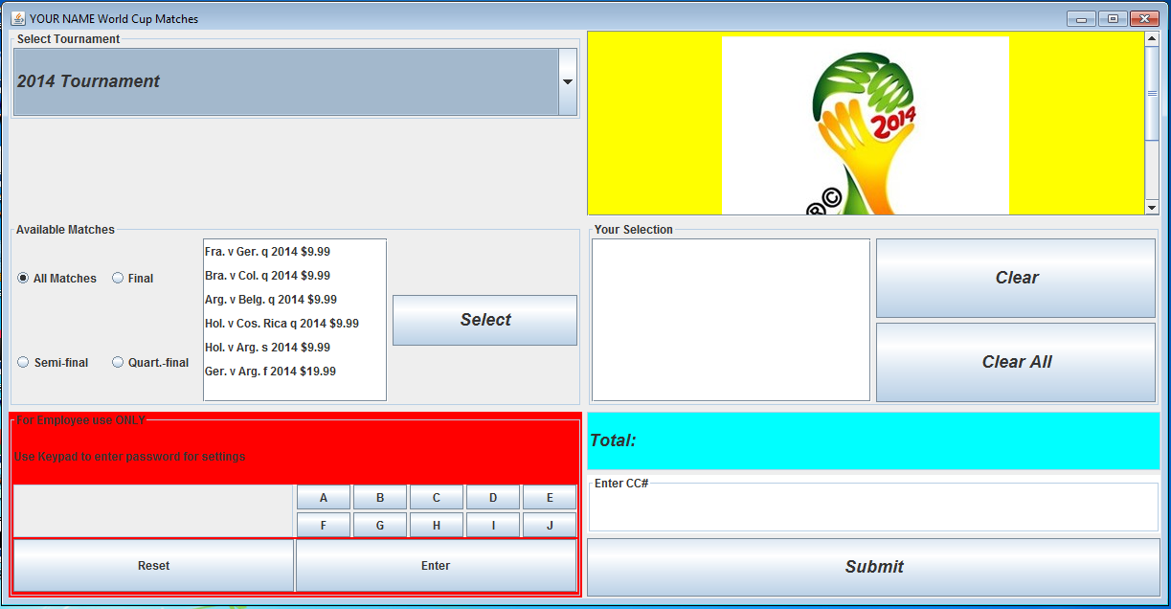
Please replace YOUR NAME with your lastname at the top of the application.

Functionality
- 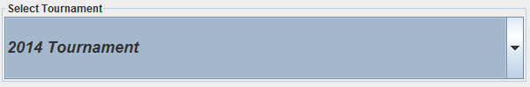 The user first selects which tournament to download from, with 2014 Tournament set as default. The combo box will have the following selections:
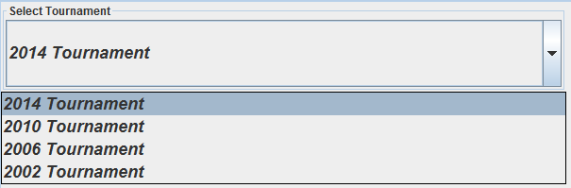

As soon as the tournament is selected, the corresponding logo appears on the right, i.e.:

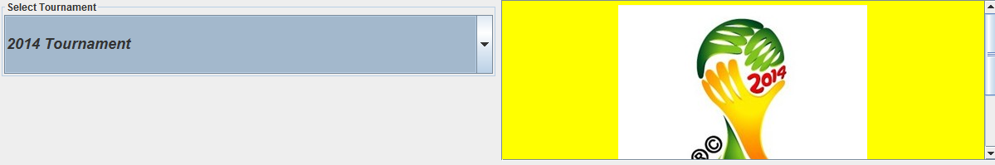
(please see page 16 as well)

- The user can then select the matches available for download in:
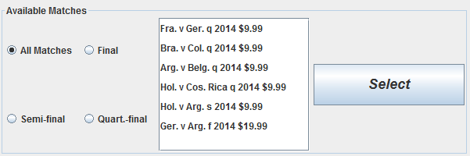
By default, the  will be selected. By clicking on the other radio buttons, only those matches that corresponds to that radio button will appear in the list box, i.e. below shows only the quarter-final matches for that tournament (the final and semi-final matches are not shown)

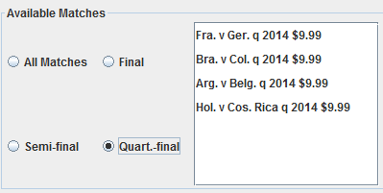

- Assuming is selected, when clicking on the matches, use the following colour scheme:

- For quarter-final games: black on yellow background 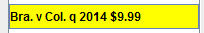
- For semi-final matches: white on blue background
- For final match: white on red background 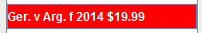

When the user selects a match, by clicking the 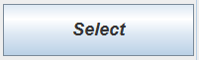, that match will appear in the 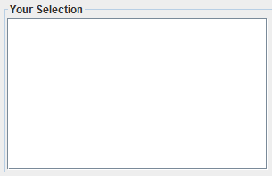, i.e:

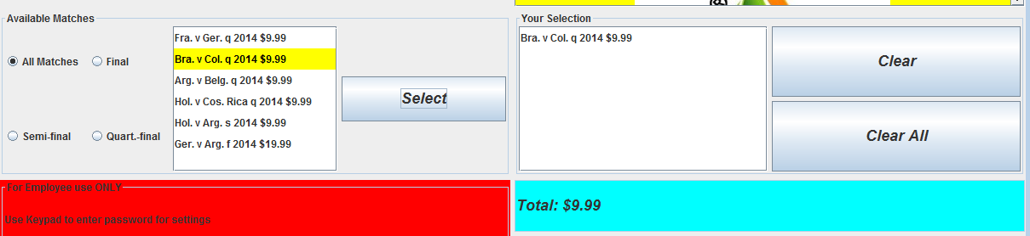

A running total is displayed in the Total JTextField (which of course is read-only) :
This total will keep accumulating and re-displayed, as soon as the Select button is clicked.

4. If the user accidentally chooses a match to download, that is already been selected, then the duplicated match is highlighted in the Your Selection list box, and an error message displayed, i.e.:

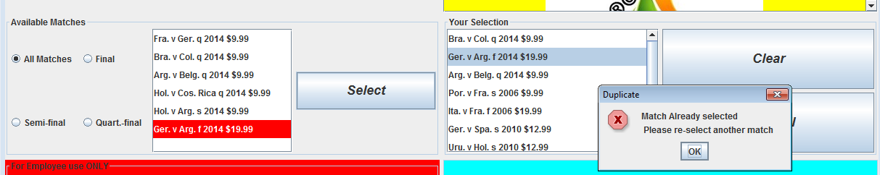

So, above shows the user has already selected numerous matches from different tournaments, and now tries to select a match that has already been chosen. As soon as the  is clicked, that match is highlighted in the Your Selection list box and the above error message displayed.

5. The user can now if he/she so wish, enter the credit card number (NOT an actual one of course) and click the submit button, i.e.: 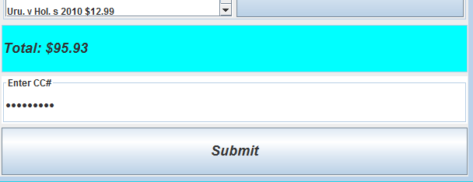 (Note the credit card field must be a JPasswordField)

A warning box appears, i.e.: 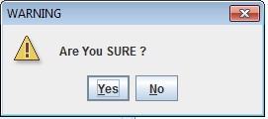 If the user clicks “Yes” then 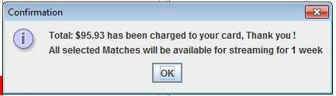 appears. Also the Your Matches JList box and the credit card field will all be cleared, with “0.00” displayed in the Total JTextField., i.e.: 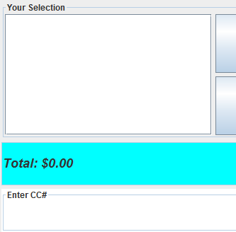

If the No button or close button is clicked, then NO action is taken (assuming the customer wants to purchase more).

If user clicks “Submit” after entering a credit card number, but did NOT select any matches to download, then after the usual “ Are You Sure Yes/No” dialog box, it should display: 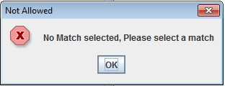.

If matches were selected for download, but the user did not enter a credit card number, then after clicking on “Submit” button, and after the usual “ Are You Sure Yes/No” dialog box, the following is displayed:
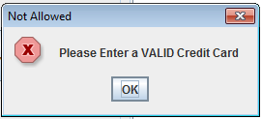

Clear and Clear All Button

The World Cup Your Selection JList Box is single-selectable, i.e. 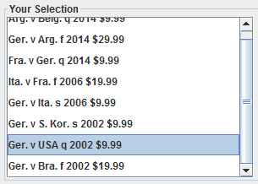. Here the user can remove any of his/her selections before actually purchasing the match. Once the match to remove is selected, the user can click the 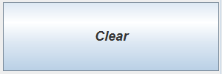 button, in which case the selection will be deleted from the JList box with the Total JTextField updated i.e. the amount should be reduced. 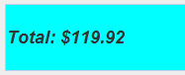 to 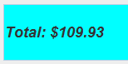, i.e. it should keep a running total. NOTE, if the user continues to clear every selection in the Your Selection JList box, then the total eventually should be 0.00, i.e. 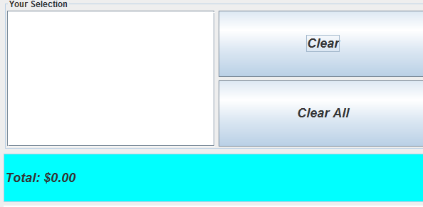..
If the Clear button was clicked BUT NO match selected, then the following error box should appear.
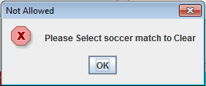.

If the  button is clicked then a warning box such as 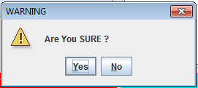 is displayed. If user clicks on Yes button, then ALL the matches selected will be deleted fromyou’re your Selection JList Box, with $0.00 displayed in the Total JTextField.

If the No button or close button is clicked, then NO action is taken.

Update
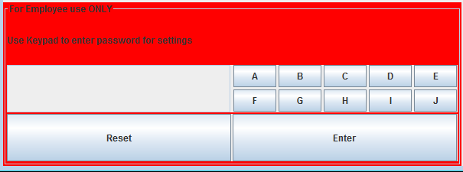
This is an alphabetic keypad, where employees can enter a password by clicking on the keypad 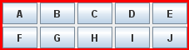 (i.e. NOT entering on the keyboard). If the enter is clicked, irrespective of whether the correct password was entered or not, if there are selections in the Your Selection JList box, then the following error box should be displayed:

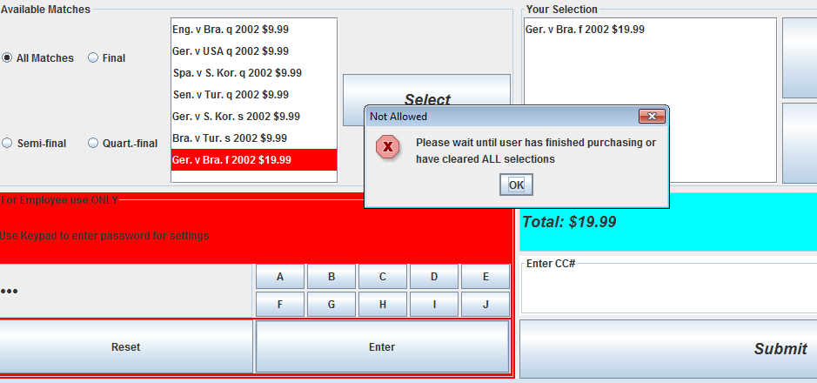
Above shows that the customer has not finished purchasing or clearing the items in the Your Selection JList box, so the employee cannot go into the World Cup Update screen.

If the button is clicked AND there are no items in the Your Selection JList box, and the correct password was entered, then it will go into the World Cup Update window (please see next page for details).

When clicking the password on the keypad, make sure that it is masked out i.e.. The password can be any number of characters, which I leave up to you. You can “hardcode” the password into the program. If user enters the wrong password (AND assuming there are no items in the Your Selection JList box), then the following error box should appear: 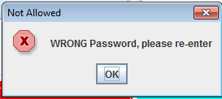 .
The  merely clears the password field (just in case you entered the wrong password and want to restart).

Upon entering the correct password it should first deselect ALL the radio buttons and clear the Matches JList box i.e.:
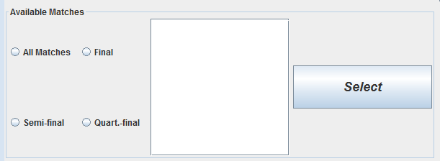

then the following World Cup Update window appears (see next section).

World Cup Update Window (Save this part as UpdateFrame.java)
Upon entering the correct password, this will generate a window with the following layout and components.
Note, this window is resizable BUT the layout should remain the SAME, whatever the size of the window, i.e. use Layout Managers.

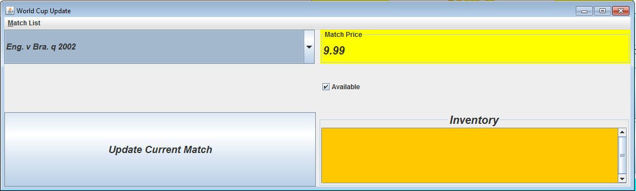

Match Inventory JTextArea, with scrollbar

Functionality

Here the user can change the availability of the match and it’s price. The user first select the match from the match pull down box, i.e. 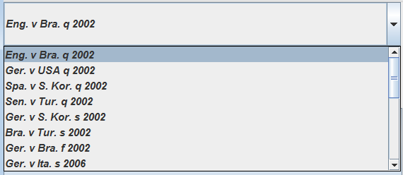. This is essentially a list of the matches as given in the class WorldCupList (by default the first item in the list is already selected). When the user selects a match, the current corresponding price and availability is displayed in their respective components, i.e. 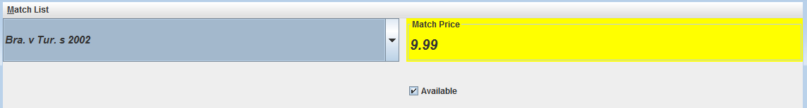
JTextField

The user can now change the price and it’s availability by changing the value in the JTextField and checking or unchecking the Available check box respectively.

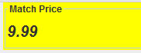 (Note, it has a yellow background. You can use your own judgement on the text size). HOWEVER if the user accidentally enters more that 2 decimal places, i.e. he or she enters 45.7892, then it will round to 45.79 and that will be the price displayed in the text box when the  is clicked, and used in subsequent calculations.(Hint: first convert to double, use DecimalFormat twoDecimal = new DecimalFormat("0.00"); to round to 2 decimal places and then resave back.
Once you are satisfied with all changes made to this ONE match, then the button MUST be clicked. The following confirmation dialog box should appear 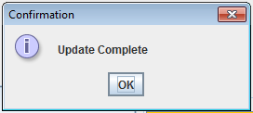. Note, the changes made here, MUST then be reflected in the previous main screen (see page 15). Note, any matches whose availability is false, will NOT be shown, when you back to the main application (i.e in WorldCup.java).

Do also make sure to clear the Inventory textArea box every time you update a record, i.e:.

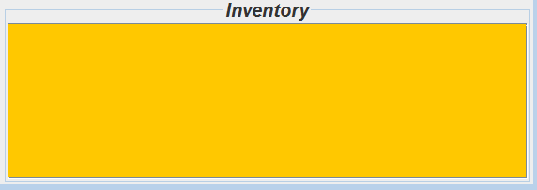

Match List Menu
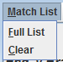
This should have the above selections and corresponding mnemonics.
- If the user selects Full List , then it should display in the Match inventory JTextArea, a full list of all the matches and their current status i.e. 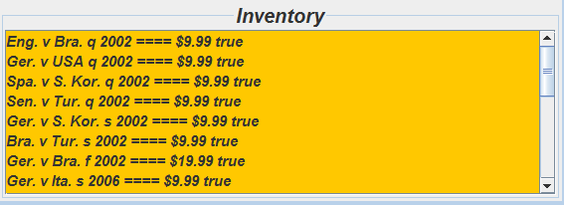 (Note, the font is Helvetica, bolded, italics at 14pt) AND HAVE a scrollbar available . Notice also the title has a larger font size and is centered
- If the user selects Clear , then it simply clears Match inventory JTextArea

Exiting World Cup Update
- Ensure also the following buttons  do work with this window.

Note: It is important that when the user exits from this World Cup Update screen and returns back to the main application, the following are blank.

The user MUST then select one of the radio buttons, to see the matches available and their new prices. Note, any matches whose availability is false, will NOT be shown.

When dealing with the World Cup logo images as detailed on page 3, to speed things up, you can just hardcode the following as an instance array in WorldCup.java
String[] worldCupLogo = {"wc2014.jpg","wc2010.jpg","wc2006.jpg","wc2002.jpg"};
This will line up with the 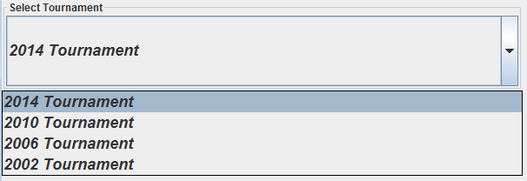

Classes
You must create at least 2 classes to start off with. These classes are in “WorldCupInfo.java” which will be given to you.

What to Hand in
- Front cover page with your name, course, assignment number, instructor’s name and due date
- Hardcopy of the program listing
- Zip up and Save your java source files and image files as csis1275_01Assign4W2018YourName.zip and either File Submission (Blackboard) or give to instructor with USB.
4. The password for the Match Update.
MARKS WILL BE LOST IF ANY OF THE ABOVE IS NOT MET OR IF THE FILES ARE NOT READABLE OR PROGRAM NOT COMPLIABLE OR IF THIS IS NOT YOUR OWN WORK.

