Reproducible research project 1

Narendra Sahu

8 August 2016

# Loading and preprocessing the data

## checking the structure of variables and converting them after

activity<-read.csv("activity.csv")  
head(activity)

## steps date interval  
## 1 NA 2012-10-01 0  
## 2 NA 2012-10-01 5  
## 3 NA 2012-10-01 10  
## 4 NA 2012-10-01 15  
## 5 NA 2012-10-01 20  
## 6 NA 2012-10-01 25

str(activity)

## 'data.frame': 17568 obs. of 3 variables:  
## $ steps : int NA NA NA NA NA NA NA NA NA NA ...  
## $ date : Factor w/ 61 levels "2012-10-01","2012-10-02",..: 1 1 1 1 1 1 1 1 1 1 ...  
## $ interval: int 0 5 10 15 20 25 30 35 40 45 ...

activity<-read.csv("activity.csv",colClasses = c("numeric","Date","numeric"))

# mean total number of steps taken per day

## histogram plot

totalsteps_by_date<-tapply(activity$steps,activity$date,sum,na.rm=T)  
hist(totalsteps_by_date,main = "Total steps by date",xlab="total steps by date",breaks = 10,col="red")

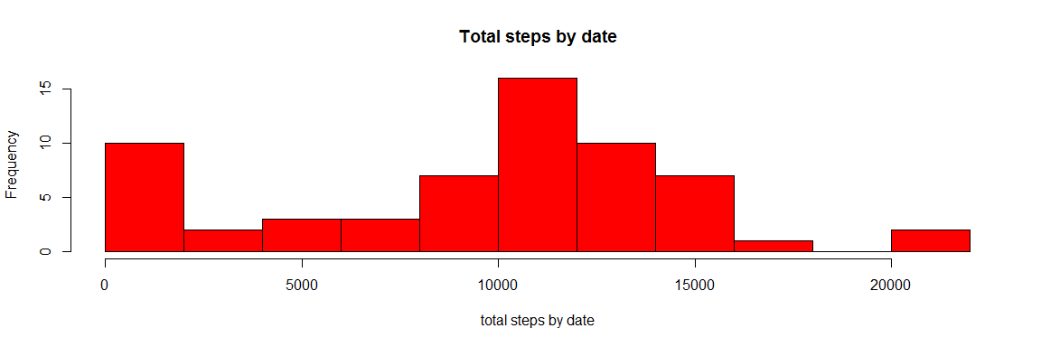 ##mean and median

mean(totalsteps_by_date)

## [1] 9354.23

median(totalsteps_by_date)

## [1] 10395

# average daily activity pattern

interval_mean<-tapply(activity$steps,activity$interval,mean,na.rm=T)  
plot(interval_mean,type="l",xlab="time(min)",ylab="avgerage total steps",main="average total steps")

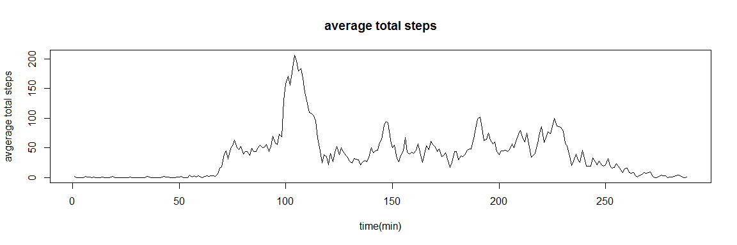

max_steps<-max(interval_mean)  
interval_mean[max_steps==interval_mean]

## 835   
## 206.1698

# Imputing missing values

## number of missing value rows

sum(is.na(activity))

## [1] 2304

activity_nomiss<- transform(activity, steps = ifelse(is.na(steps), round(mean(steps, na.rm=TRUE)), steps))  
sum(is.na(activity_nomiss))

## [1] 0

## replacing missing value by means and plotting histogram

new_steps_by_date<-tapply(activity_nomiss$steps,activity_nomiss$date,sum)  
hist(new_steps_by_date,main = "Total steps by date(no missing value",xlab="total steps by date",breaks = 10,col="red")

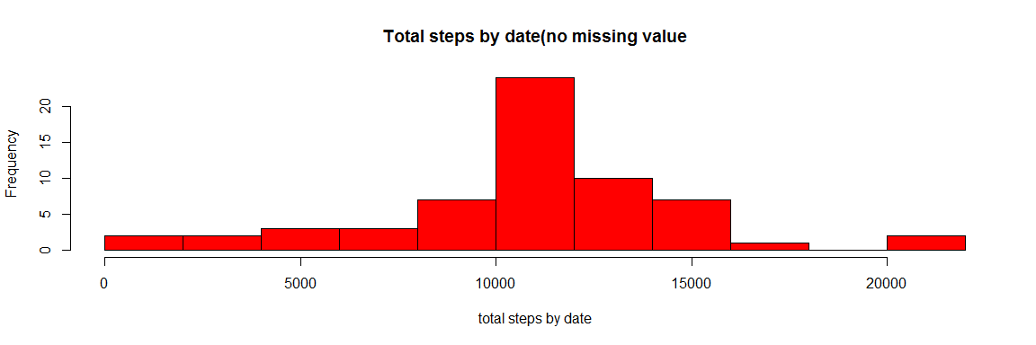

## mean and median of total sets(no missing values)

mean(new_steps_by_date)

## [1] 10751.74

median(new_steps_by_date)

## [1] 10656

# differences in activity patterns between weekdays and weekends

## assigning weekdays and weekend level

activity_nomiss$days <- weekdays(activity_nomiss$date)  
library(plyr)  
activity_nomiss$days <- revalue(activity_nomiss$days,c("Monday"="weekday","Tuesday"="weekday","Wednesday"="weekday","Thursday"="weekday","Friday"="weekday"))  
activity_nomiss$days <- revalue(activity_nomiss$days,c("Saturday"="weekend","Sunday"="weekend"))

## panel plot containing a time series plot of the 5-minute intervaland the average number of steps taken, averaged across all weekday days or weekend days.

library(lattice)  
activity_mean <- aggregate(steps ~ days+interval, data=activity_nomiss , FUN=mean)  
xyplot(steps ~ interval | factor(days),data=activity_mean,type="l")

