**MAZE**



**DATA INTERFACE MANUAL**

BrainXT é um software criado pelo Braincube que permite a coleta de dados de diversos tipos de fontes industriais. Também realiza a transformação desses dados em arquivos estruturados no formato TXT ou CSV. Uma vez transformado, esses arquivos podem ser enviados aos servidores na nuvem do Braincube utilizando o software IPTransfer.

Principais de fontes de dados compatíveis são:

* Servidores OPC;
* PLCs através do protocolo ModBus;
* PLCs através do protocolo Profinet;
* Banco de dados ODBC.

Summary

General 3

Requisites 3

New Configuration 3

Starting data extraction 4

PI Config 5

Compatibility 5

Specific Requirements 5

Historical extraction 5

Configuration 6

# General

## Requisites

To install and run MAZE it’s required to first install .NET framework version 4.5.2 or newer.

According to each feature that will be used, other specific requirements might be needed as follows;

* Excel - Access data base engine (x64 or x86 according to your office version);
* Access DB - Access data base engine (x64 or x86 according to your office version);
* Osisoft PI Server – PI Config (Installed with MAZE. Third party license may be required) and PI SDK.

## New Configuration

To start a new configuration, click on “New Config” button, give it a name and choose a type.

The available data sources to esxtract data from are:

1. Excel File – Extracts data from .xls files, with the option to filter which spreadsheets to extract and at which line to start extracting data from;
2. Microsoft Access DB – Extracts from microsoft access files with the option to filter what tables and what ranges to extract from;
3. Osisoft PI Server – Extracts data from Osisoft PI server. Possible to extract real time data (PI snap table) or historical data (PI archive). Uses the Osisoft PI Powershel, named PI Config, at the background. Recommended as an alternative only when there isn’t the option of using PI OPC Server.

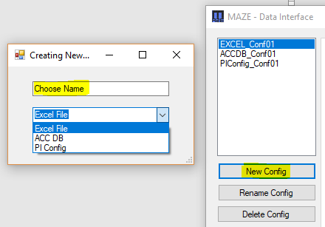

## Starting data extraction

The data extraction runs as a windows service. By clicking the “Start/Stop Service” button it can be turned on and off. It’s important to notice that after making any change to a configuration, clicking the “SAVE” button is not enough to activate the changes; the service must be restarted. It’s also worth noticing that stopping or starting the service will affect every configuration since although the extractions are run from different threads, all those threads are created from the same windows service named “MAZE”.

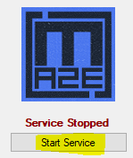 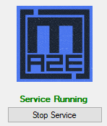

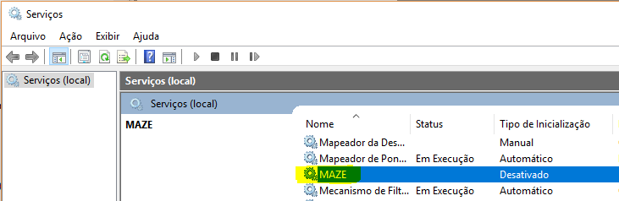

Obs: In some cases, due to access privileges, it will be important to configure the MAZE windows service to run with a specific user account that has read/write privileges to the paths where the source files and destination output are located. For that it’s important to manually input that account on the windows service properties windows (right click MAZE service>>properties>>Logon tab):

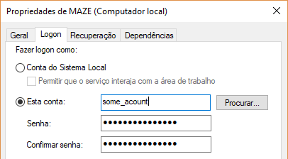

# PI Config

## Compatibility

PI Config is the Osisoft power shell for managing the server. Through a read-only access (list mode) it’s possible to extract data periodically in real time, from PI SNAP table, or historical from the PI ARCHIVE table. In the presence of PI OPC Server, it’s more recommended to use an OPC Client.

PICONFIG will often prompt for mvscp140.dll, which is a sign that C++ Redistributable for Visual Studio 2015 must be downloaded from Microsoft website and installed.

PI SDK (Deprecated by PI AF SDK) might also be need to run PI Config, and therefore to run PI Config based data extractor

## Specific Requirements

The requirements are:

- PI Server ip address;

- User account and password for PI server access;

- PI “explicit” access must be enabled (if running MAZE from a machine different than the PI server).

The “explicit login” option must be enabled to allow the login using an user name and password from a machine other than the server. To do that, the change bellow must be made on the PI server:

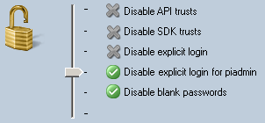

(PI BASE SUBSISTEM must be restarted to apply any changes)

## Historical extraction

Historical extractions are run directly from MAZE graphical user interface and although it won’t affect any other real-time extraction that might be running as a service, its recommended to stop the service to avoid conflict or memory leakage.

For historical extraction, a start and end date must be selected. If the “Interpolate data” option is selected, the interpolated data will be extracted every X seconds where X is the chosen period. If not, only one line of data will be created for each time there was a real data input on the server.

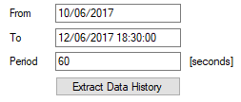

Acceptable date formats are:

* dd/MM/yyyy (by default, time will be 00:00:00)
* dd/MM/yyyy HH:mm
* dd/MM/yyyy HH:mm:ss

If your operational system time format is not set as one of the above, its recommended that it is changed. Also remember to configure you access before doing historical extractions, as follows:

## Configuration

All the access information like ip address, Port (default=5450), User and password must be filled on the corresponding fields.

The field “File Name Prefix” defines the name that will be given to each output file. A timestamp will be added to the end of the name of each file when its created.

The field “Output Path” selects the destination of the files. The output path Format should be like:

* “C:\folder\subfolder\”

The “Extraction period” field defines the frequency of data extraction.

Data can be outputted in MATRIX or LIST format, depending on your selection of the “Convert output to Matrix format” option. It can also be interpolated or real entrance only data.

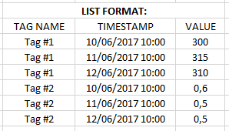 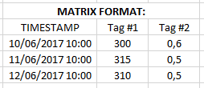

For real time extraction, if “Interpolate Data” was chosen, all data extracted will have the value of its last input, but the time stamp will be the time of extraction for all of them. If “Interpolate Data” was not chosen, then each data will have the time stamp and value of its last input.

For historical extraction, “interpolated data” will generate data with the desired frequency, interpolating the previous and next value when needed. Non “Interpolate Data” in the other hand will generate data only for the timestamp when real data was inputted to the server.

The name of the tags to be extracted must be filled and saved inside the .txt file that can be opened clicking at “Tag List” button. For consulting, the list of all tags available can be generated clicking at “Get PI List” and can be viewed by clicking “All tags List”. Remember to save the configuration (user, password, server ip and port) before trying to get the full list of tags from PI.

Always Remember: After making any modification to the configurations, save them and restart the service to have them applied.

