Univ. Fabio Vladimir Cachi Condori 8408798 LP.

WORKFLOW

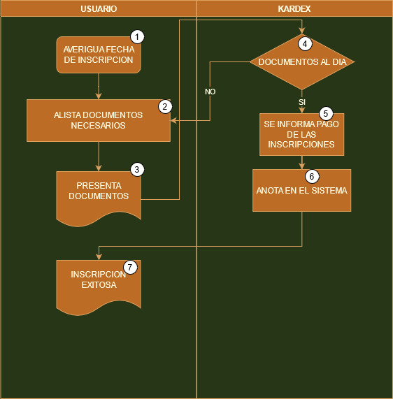

BMPN

