Table of Contents
Introduction 1
Developer Portal main page 2
API Catalogue 3
API Catalogue 4
API Overview 5
API Overview Figure A 6
API References 7
API References Figure A 8
Try it Section 10
Try it Figure A 11
Developer Guide 12
Developer Guide Figure A 14
Dashboard / Analytic (How to) 15
Dashboard Figure A 16
Subscribe to API’s (How to) 17
Reset API Password (How to) 18
Unsubscribe to an API (How to) 19
My Organization (How To) 20
My Organization Figure A 21
My Account 22
Support 23
Support Figure A 24

Introduction

Canada Post’s Developer Portal and web services are available to our customers/users through Canada Post website.
Join the new Canada Post developer program and get the resources and support you need to give your customers real-time shipping capabilities right from your website.
Sign in and get comprehensive documentation, code samples and keys to integrate our APIs into your existing platform. Customize your shipping experience and deliver advanced features to your users. Or start by simply getting a test key and trying out our services in the sandbox before signing up.



Developer Portal main page

The main Developer Portal page provides a top navigation bar available on all pages for easy navigation.

A: Return user to the main Developer Portal page.
B: Access the API catalogue and browse available services.
C: Developer guide containing technical information for different topic.
D: Registered users of the Developer Portal have access to our community forum—a space to exchange ideas, ask questions, share best practices, and collaborate with other developers. You can also report issues or request help directly through the forum.
E: Support section contain FAQ’s and email support for the Developer Portal
F: Toggle between French&English
G: From My Account existing users can Sign in and new users can Register to the Developer Program
H: From My Account existing users can Sign in and new users can Register to the Developer Program

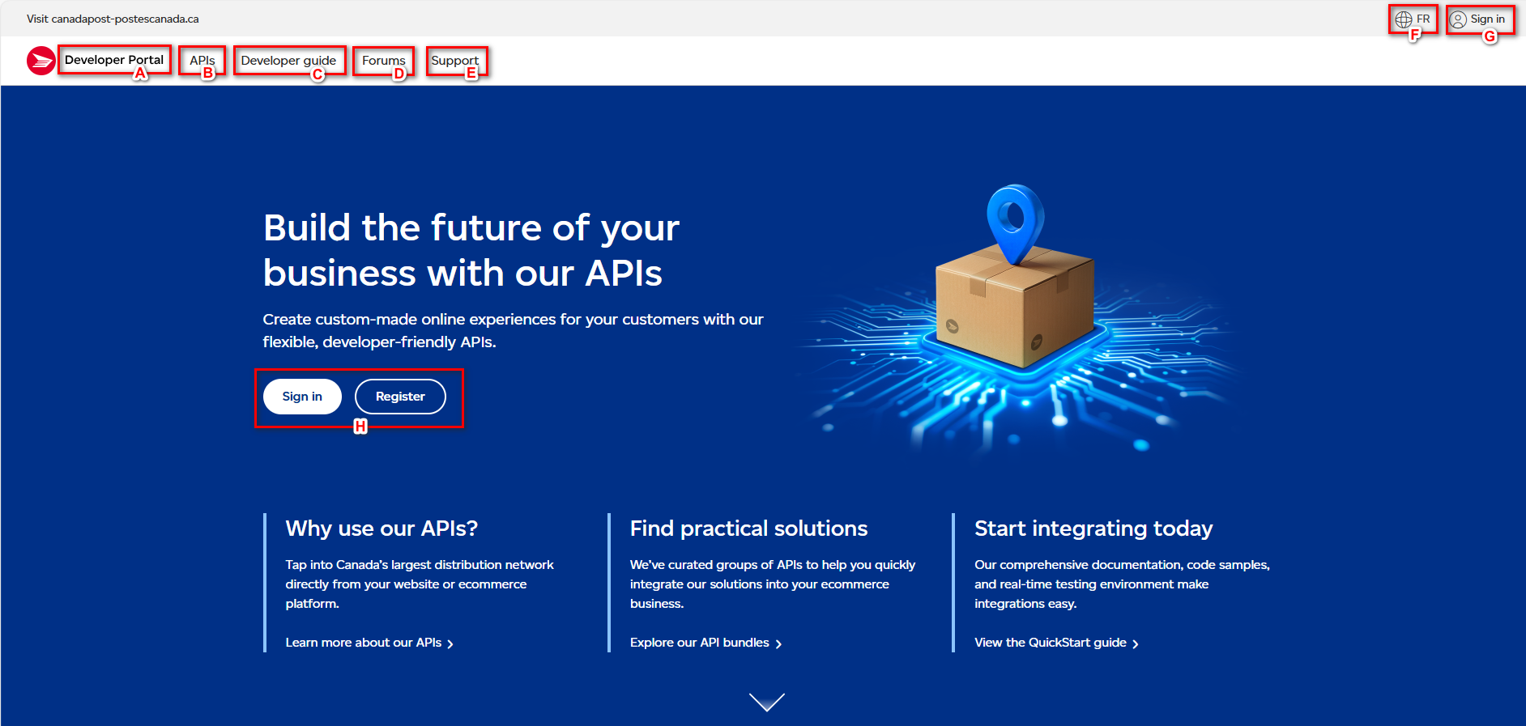

API Catalogue

Browse the APIs list and access the functional and technical descriptions of each. Then choose the right APIs for your website or ecommerce platform.
In the catalogue you will find all available APIs grouped by category for easy access. For each of the API technical documentation are made available for further explanation to help with integration.
From the API catalogue you will find the following available services in REST
- Shipping | - AddressComplete
- Rating | - Customer Information Services
- Tracking | - Merchant Registration
- Returns | - Service Information
- Post Office Services
- Pickup

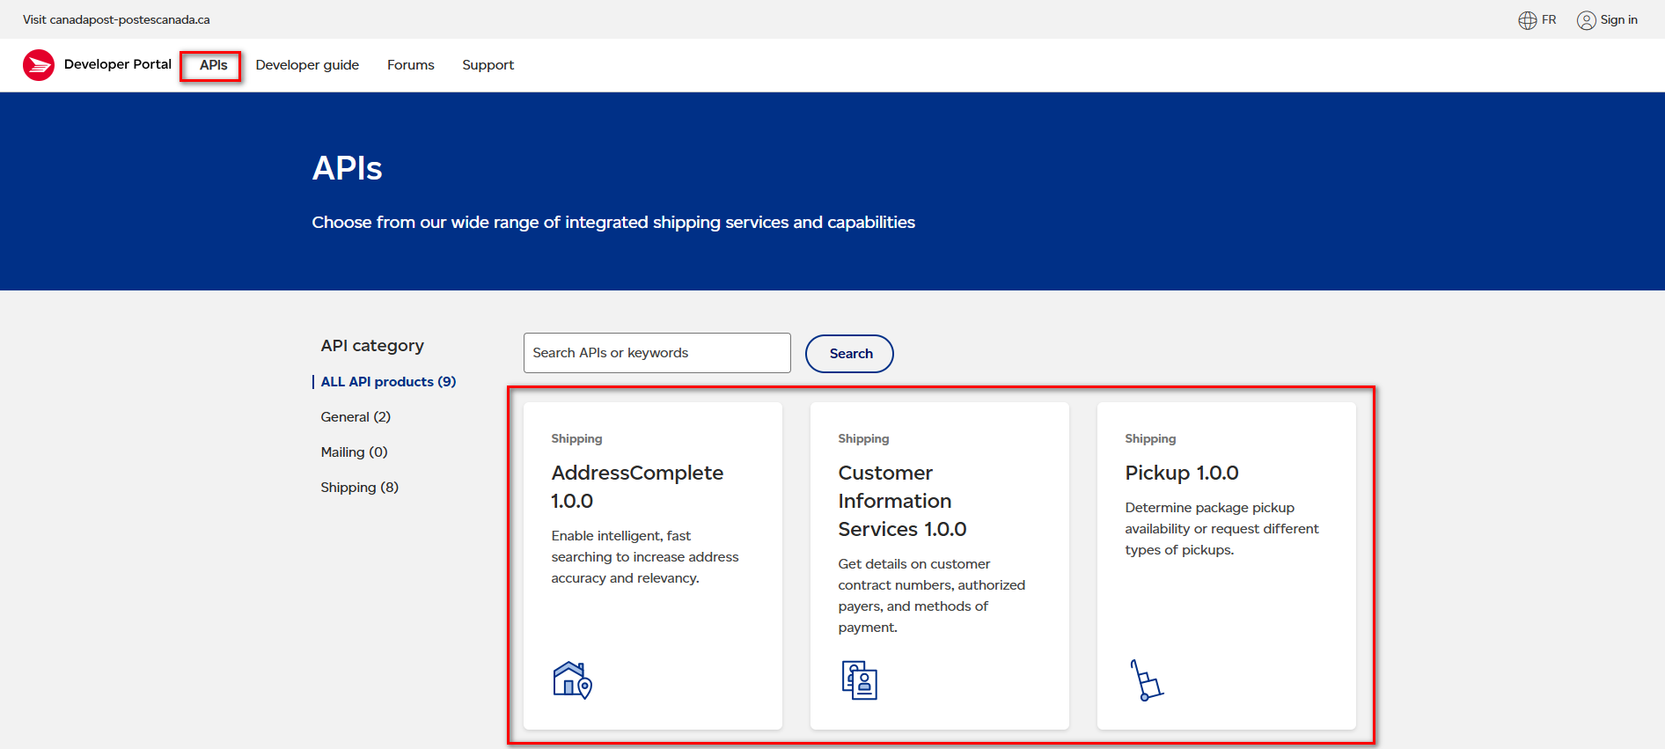

API Catalogue

On the API catalogue you can access overview information of an API and the technical documentation for each service which gives you details on what it does, how it works and includes a detail workflow for better understanding.



API Overview

On the API Overview you can access and review different information for each API. See next page for page layout.
- The left navigation menu allows you to easily navigate to the Overview page for the selected API group.
- This section allows you to Subscribe to the API to gain access to it and Try the API using our online tool on the portal.
- Get Access: Subscribe to the API.
- Try the API: Try the API using our online tool.
- Contain 3 sections to help better understand the API
- What it does: section to help understand the API capabilities.
- How it works: to help understand parameters and type of queries that can be done using the API.
- Tracking workflow: Graphical explanation on how you could typically use advantage of all the APIs in a typical flow.
- Table containing all services (API) with a brief description for each service.
- This section contain access to help documentation.
- Get Started: Consult our Developer guide for details about access tokens, authentication, rate limits, and more.
- Get Support: Get answers to common questions in our FAQs. If you can’t find your answers there, connect with our team.
- This section contains information on versioning and latest update concerning latest enhancement to the API’s.

API Overview Figure A
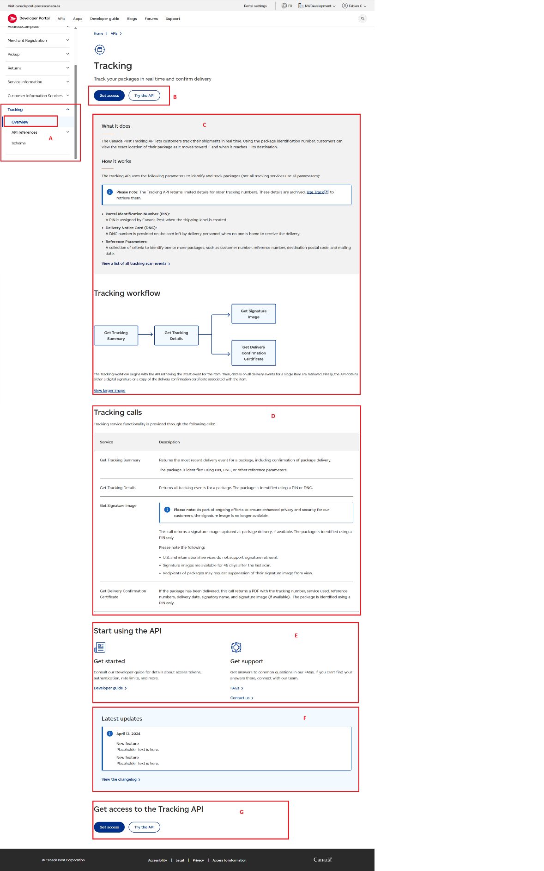

API References

On the API References section from the left menu you can access and review different API from the same category. See next page for page layout.

- The left navigation menu allows you to easily navigate to the API References page for the selected API group.
- Button allowing you to Subscribe to the API and add to your existing/new application.
- Link to Yaml file that can be downloaded locally and use with application such as Swagger Editor.
- This is the details page referencing detailed information such as endpoint, security, header, body, elements and parameters.
- This section allows you to Try the API using our online tool on the portal.
- The endpoint of the service
- Security section detailing the security type,
- Parameters section detailing the parameter settings.
- information on the body of the request for JSON and list every available element with a short description.
- Example Schema demonstrating an example of structure of the request.
- Example request that can be change using the drop list to demonstrate structure of a request in different programming languages such as PHP, JAVA, Ruby, Curl, Python, CSharp, Node, Go, Swift, C.
- Response example including JSON examples.

API References Figure A
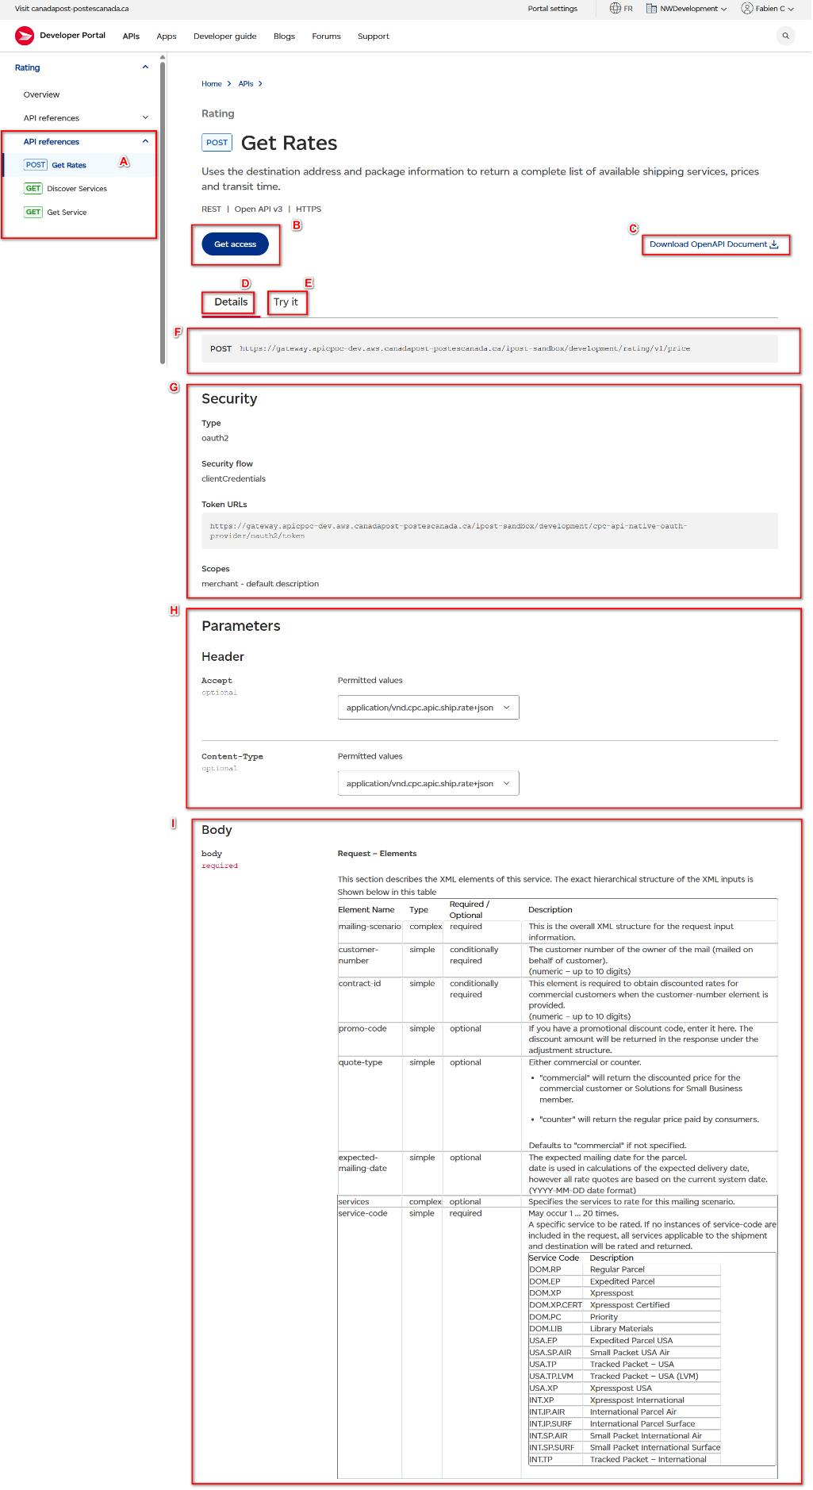
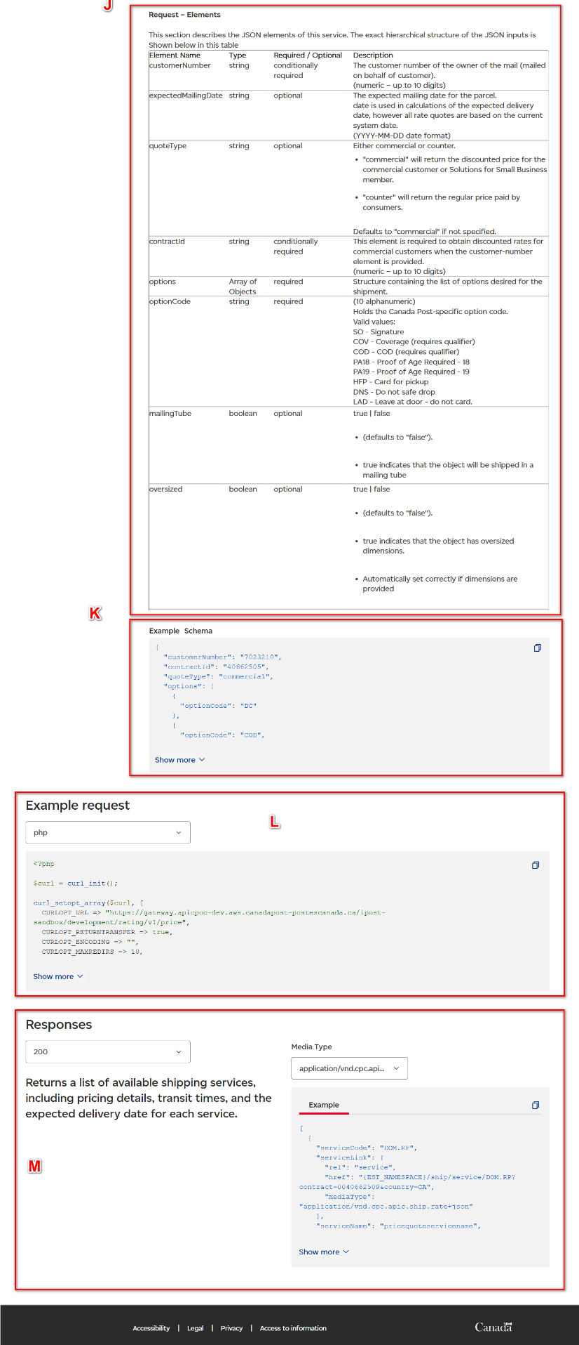

Try it Section

- Button allowing you to Subscribe to the API and add to your existing/new application.
- Try it section allowing interaction and testing of the API.
- Link to Yaml file that can be downloaded locally and use with application such as Swagger Editor.
- The endpoint of the service
- Security settings.
- identification
- Drop list allow you to choose your app of choice
- Input your API username and API secret
- Authorization
- Scopes: Check this box
- Get Token: Press the Get Token to generate a valid token good for 8hrs.

- Parameters settings.
- Header: Choose JSON setup
- Body settings.
- body: generate a sample using the generate button, you can edit the body to include/remove elements if needed.

Try it Figure A
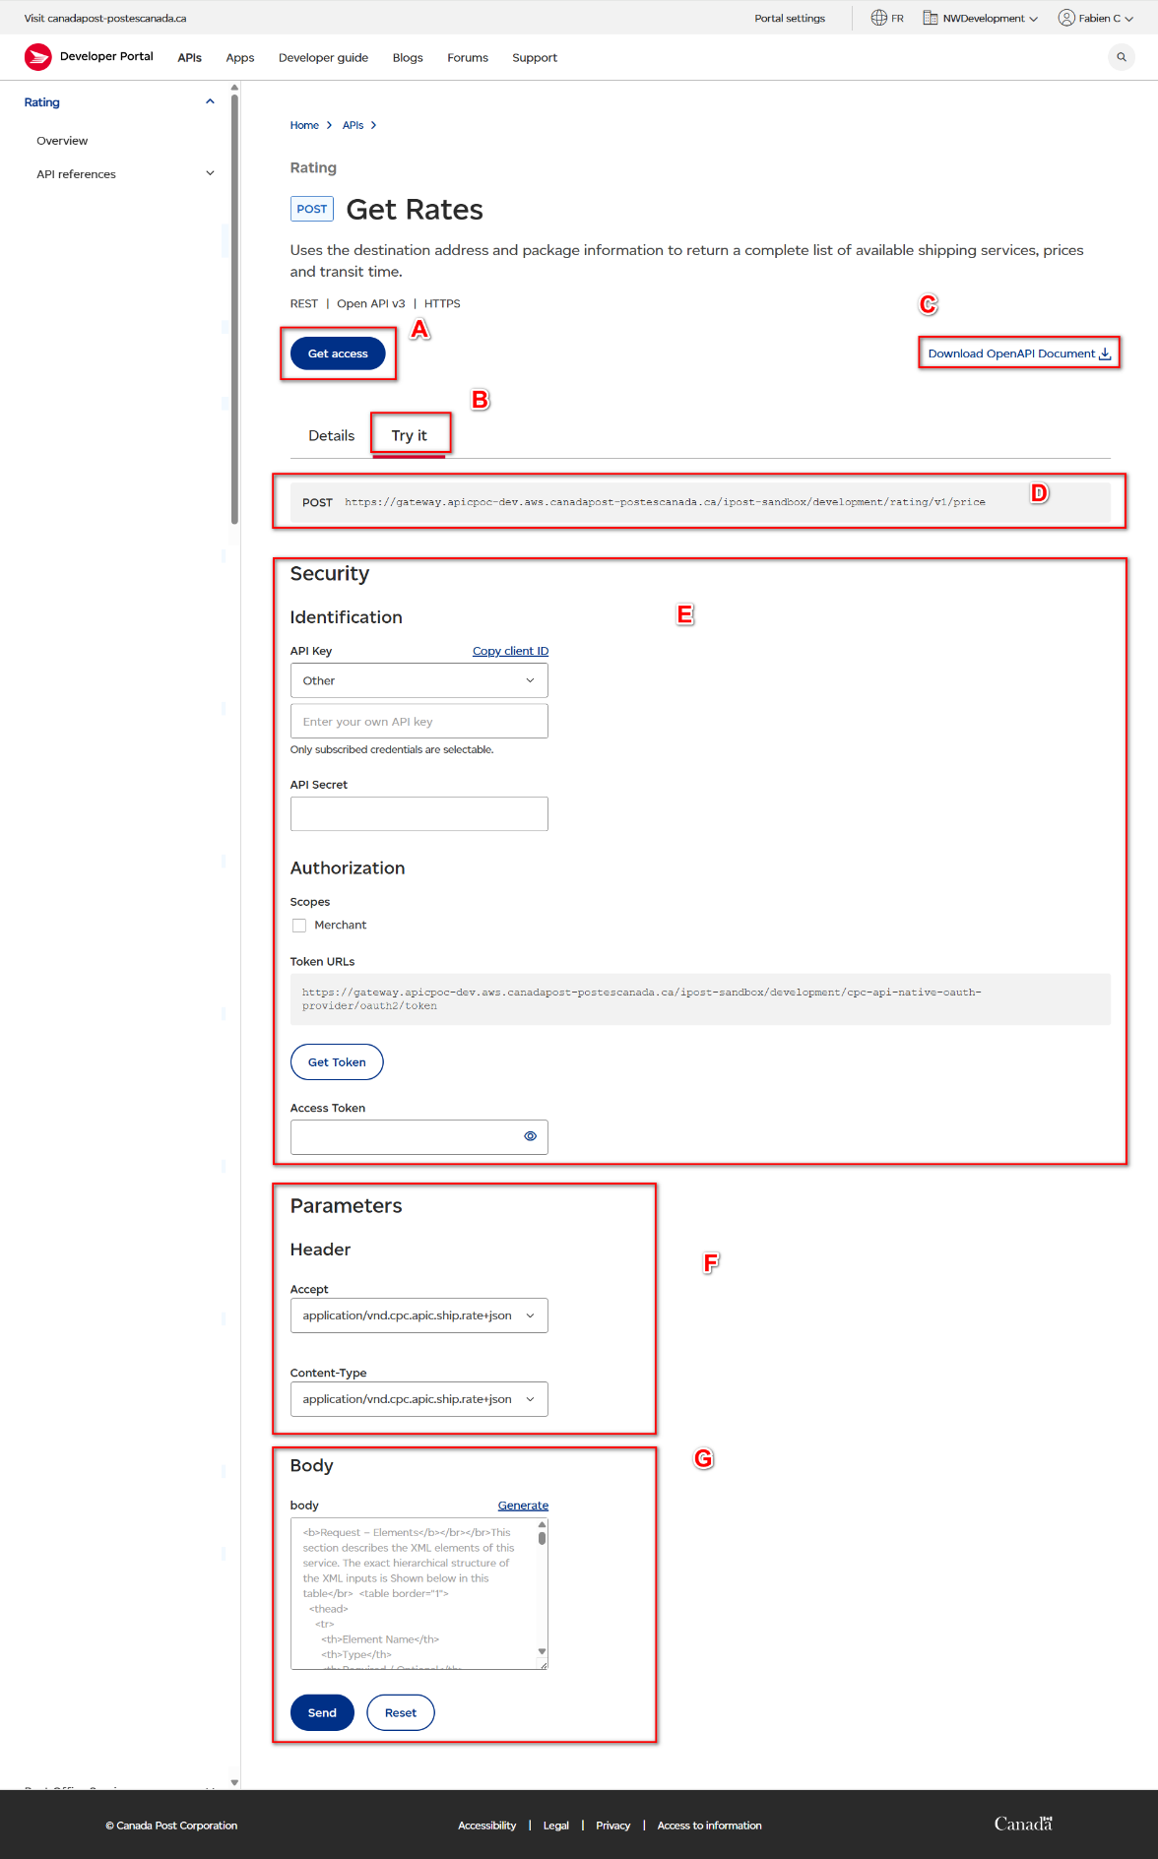

Developer Guide

The Developer Guide page include documentation to help with your development and testing; it consists of a left navigation menu to easily access technical information.

The categories found in the left navigation menu are:

- Quick Start Guide
- Get Started: Follow these easy steps to begin using our APIs.
- Manage Organization: Organizations let you manage your accounts and users, and view details of user activities.

- Resources
- API fundamentals: Fundamentals for integrating and interacting with Canada Post APIs.
- Authentication Guide: (Generating a Valid Token example): Ensure the integrity of our APIs and protect your data from unauthorized use.
- Printing Labels: Requirements for printing thermal and PDF shipping labels.
- Rate Limits: Learn how our API throttling and rate limits help to keep our platform stable.
- Security Guidelines: Keep your communications secure with digital certificate validation.
- Messages and code tables: Get information about error messages, code tables and abbreviations and tracking scan events.

- Announcements
- Release notes: Stay updated with the latest changes and updates to our APIs.
- Service Availability: Get timely updates about service availability here.

- API Bundles
- Ship parcels: Leverage our bundled APIs to quickly build and deploy ecommerce shipping solutions.
- Track Parcels: Provide real-time status updates and visibility for every shipment.
- Enable self-service returns: Build seamless return experiences using our Authorized Returns API.
- Integrate on-demand parcel pickups: Integrate our Pickup API into your ecommerce platform to enable on-demand pickups.
- Register new merchants: Integrate your platform to enable seamless onboarding for your merchants.

Developer Guide Figure A
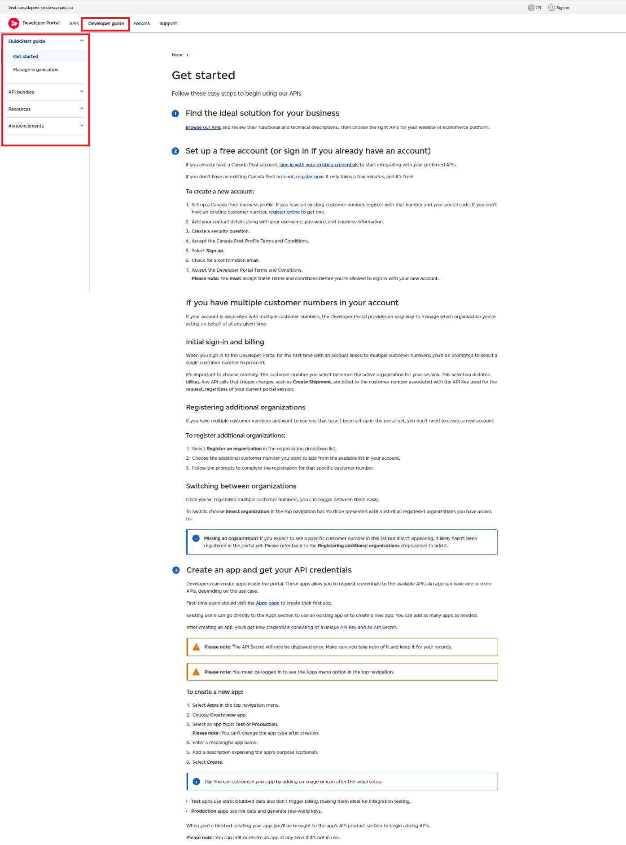

Dashboard / Analytic (How to)

The dashboard tool allows you visibility on API transactions / requests allowing to better manage traffic. Access to history log section giving visibility on detailed request and review them for troubleshooting.

You can access the dashboard by selecting Apps from the top menu and then selecting view details on the apps of your choice to access the dashboard.

- 9 reports are accessible.
- Summary (Total calls, Total errors, Average response time)
- Number of API calls
- Status code
-Top Product over time
-Top APIS over time
- Response times
- Number of throttled API calls
-Number of errors
- API call history log report

Dashboard Figure A
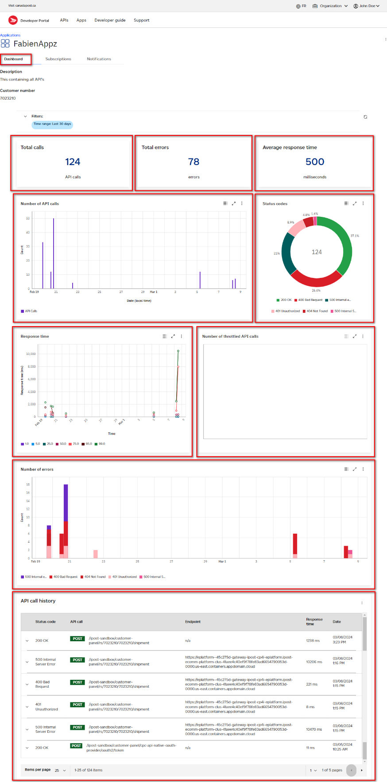

Subscribe to API’s (How to)

To start using/testing API’s you require subscribing to one or several API group and add them to your existing or newly created application.

Step 1: Browse the API catalogue and select the API you are looking to integrate by selecting Docs hyperlink from the API category you are looking to integrate/test/develop.
Step 2: Click Get Access located on the top right of the screen.
Step 3: Select an existing application or create a new application and add the API(s) to it.
Step 4: The API Key and Secret have been generated for your application. Please copy your API Secret and keep it for your records.

Reset API Password (How to)

To reset your API password, you require to be logged into your developer profile.

Step 1: Click on Apps link found on the top menu of the page.
Step 2: Click on the application container that contain the API you wish to change the password for.
Step 3: Select API products TAB
Step 4: From the Credentials section select the 3 dots located on the right corner of the screen.
Step 5: Select Reset Credentials from the sub menu.

Unsubscribe to an API (How to)

To unsubscribe to an API, you require to be logged into your developer profile. It might occur that you no longer need to be subscribed to an API and wish to remove the subscription from your existing application.

Step 1: Click on Apps link found on the top menu of the page.
Step 2: Click on the application container that contain the API you wish to change the password for.
Step 3: Select API products TAB
Step 4: From the product subscriptions table select the 3 dots located on the right corner of the screen for the API you wish to unsubscribe.
Step 5: Select Remove API product.

My Organization (How To)

My Organization page allow you to invite individuals to your organization and build specific profile for them such as Administrator, Developer, Viewer.

Administrator: Give full access
Developer: Give developer access
Viewer: Give viewer access only

A: You can access the My Organization page from the sub menu category
B: Select the Manage section to gain visibility on your organization setup
C: List of all members currently enabled to your organization
D: Invite button allowing you to invite new members to your organization
E: Action button allowing you to change member role or remove them from your organization

My Organization Figure A

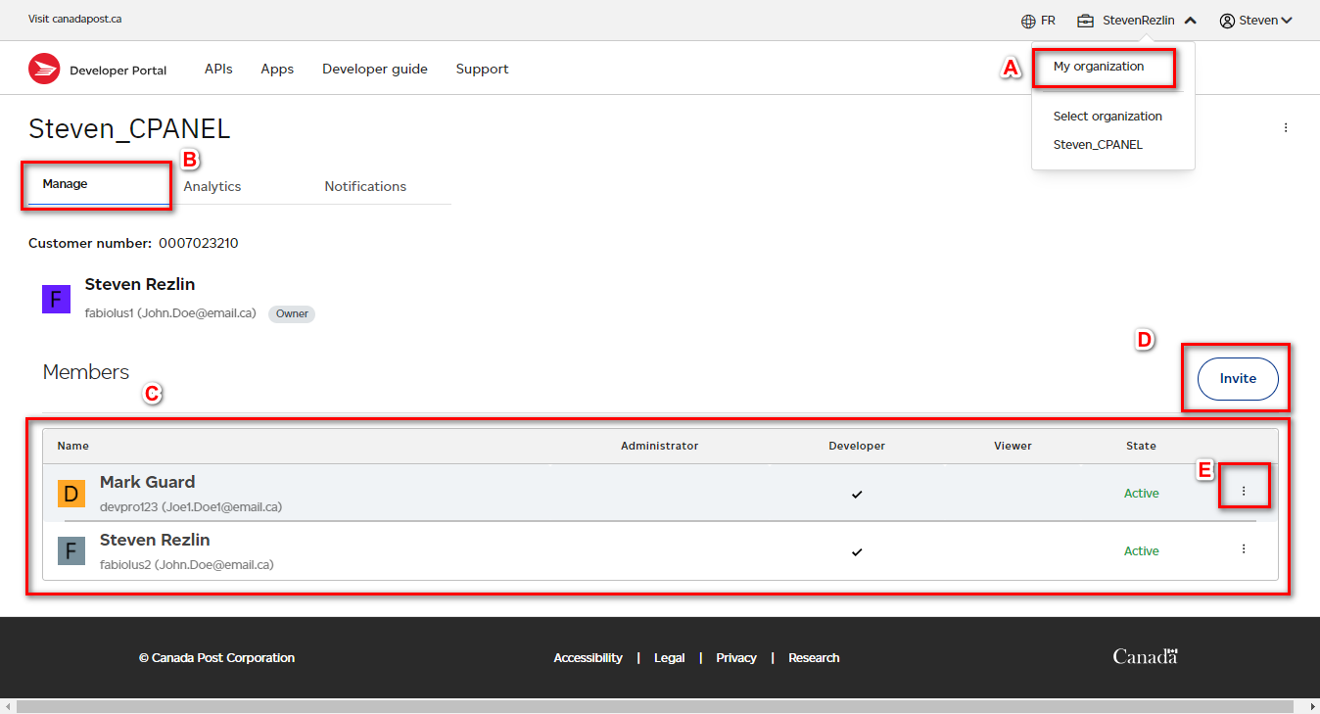

Support

The Support page provides 3 sections to help support clients.

- Predetermined list of frequently asked questions.
- Access to the developer portal email support.
- Feedback section allowing users to email feedback to the developer support team.

Support Figure A

