Canada Post Developer Portal
Platform Onboarding Guide
This guide describes the process for an existing Canada Post Developer Portal user to enroll as a Platform Provider and begin developing integrations using Canada Post APIs. The onboarding process includes authentication through the Developer Portal, submission of a platform request, internal account enablement, and application configuration for API access.

Section 1 — Overview
The Canada Post Developer Portal allows approved partners and software providers to integrate their platforms with Canada Post shipping and logistics APIs. Organizations wishing to build platform integrations must first enroll as a Platform Provider within the portal.
The onboarding process for existing users involves the following high‑level steps:
- Sign in to the Canada Post Developer Portal.
- Accept the Developer Portal Terms and Conditions.
- Submit a request to become a Platform Provider.
- Canada Post internal team enables the platform account.
- Create an application and obtain API credentials.
- Add API products and begin development.

Section 2 — Platform Enrollment

Step 1 — Sign in to the Developer Portal
Navigate to the Canada Post Developer Portal and sign in using the available authentication options. Users are redirected to the Canada Post Single Sign‑On (SSO) authentication page where they must enter their credentials.

Figure 1 – Developer Portal sign‑in screen.

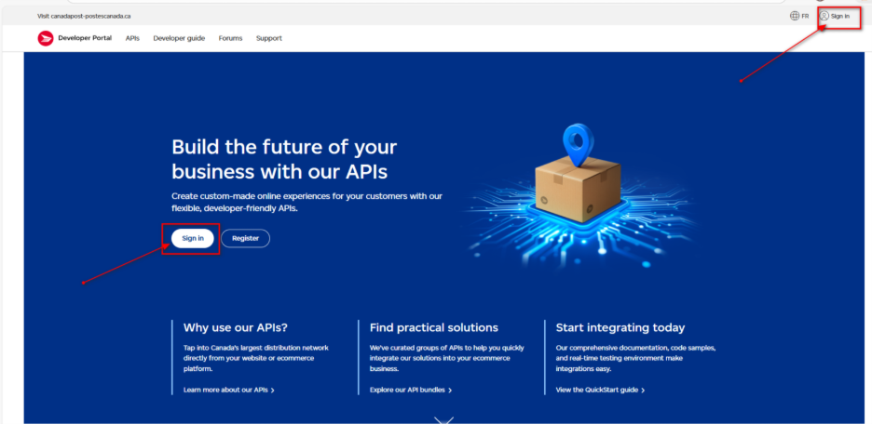
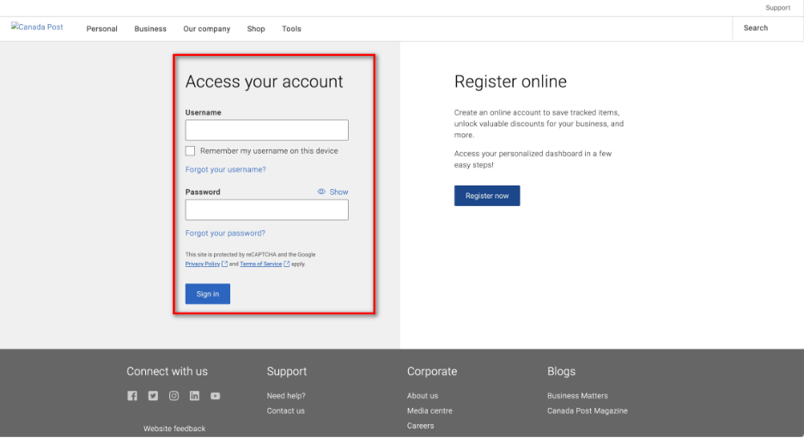

Step 2 — Accept Terms and Conditions
After successful authentication, the user is redirected back to the Developer Portal. If the Terms and Conditions have not yet been accepted, a modal window will appear prompting the user to review and accept the terms before continuing.
Figure 2 – Terms and Conditions acceptance modal.

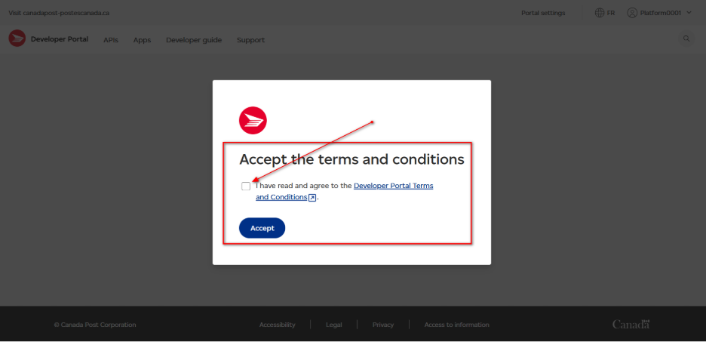

Step 3 — Registration Confirmation
Once the Terms and Conditions have been accepted, the portal displays a confirmation message indicating that registration has been completed successfully. At this stage the user has access to the Developer Portal but is not yet configured as a Platform Provider.
Figure 3 – Successful registration confirmation message.
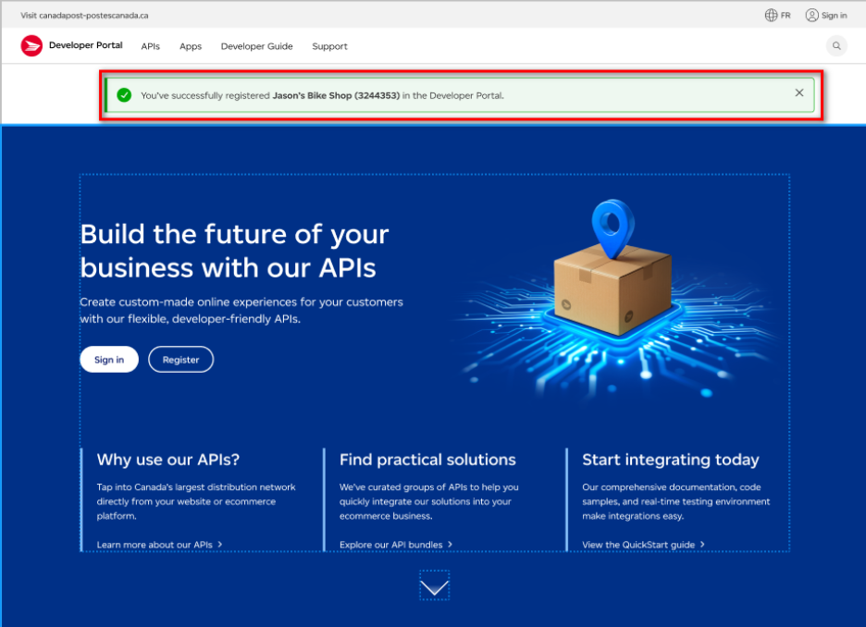

Step 4 — Request Platform Provider Access
After signing in, the user must request Platform Provider status. From the portal dashboard, click the button labeled Become a Platform Provider to begin the request process.
Figure 4 – 'Become a Platform Provider' action button.
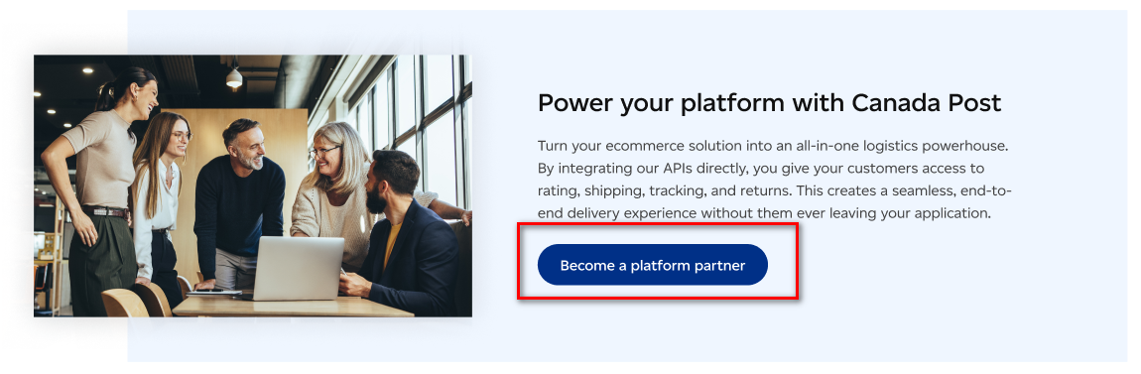

Step 5 — Complete the Platform Request Form
The user will be presented with a platform request form requiring information such as platform name, organization details, platform domain, technical contacts, and a description of the intended integration.
Figure 5 – Platform Provider request form.
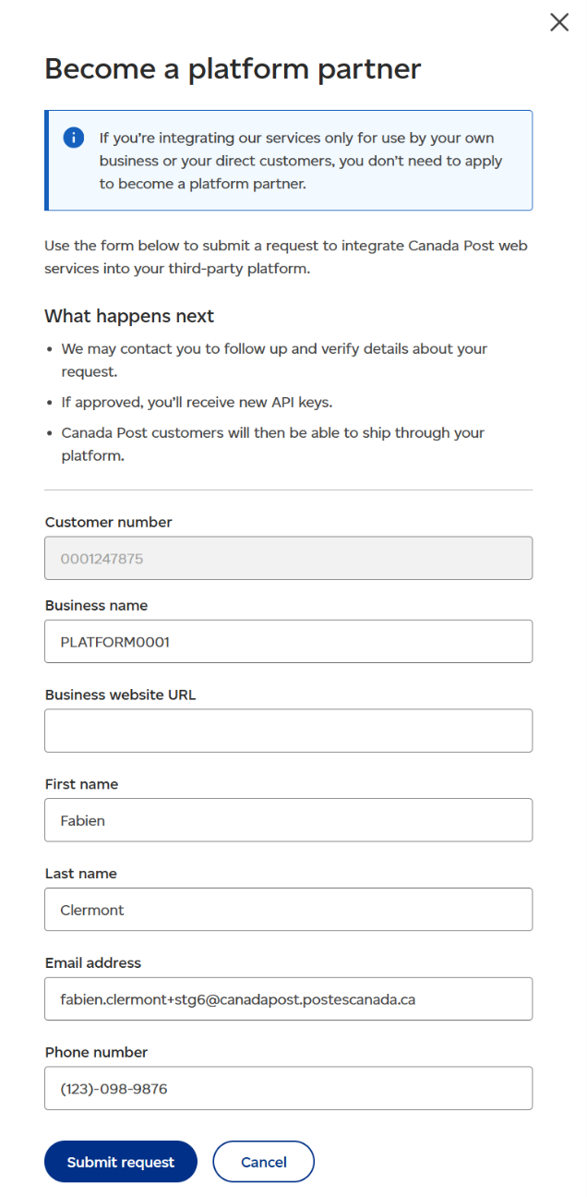

Step 6 — Request Confirmation
After submitting the form, a confirmation modal is displayed indicating that the request has been successfully submitted for review.
Figure 6 – Platform request submission confirmation.
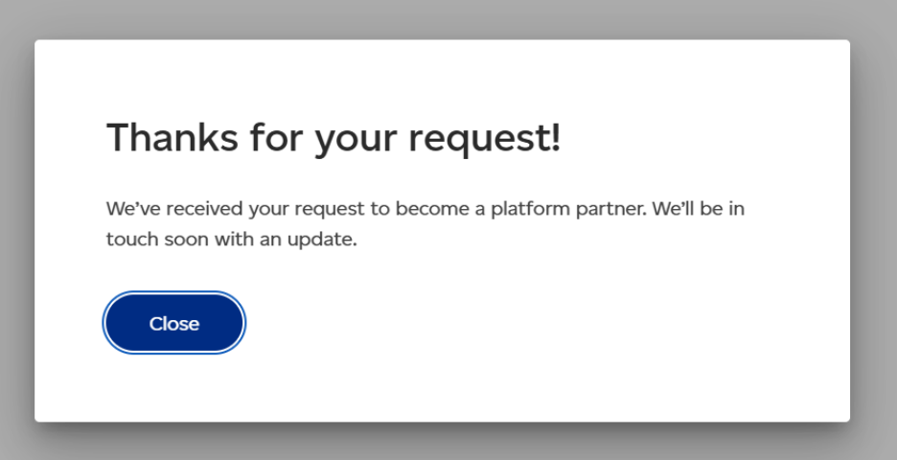

Internal Processing
Following submission, an automated email notification is sent to the Canada Post Developer Program team at developer.program@canadapost.ca.
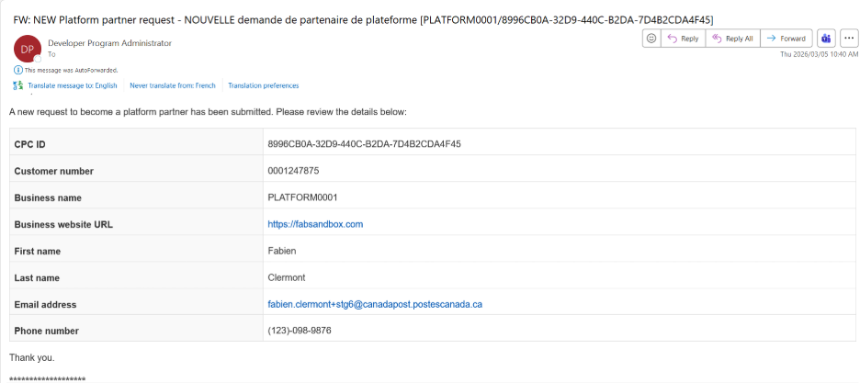

A Canada Post employee with SAP CRM access must then enable the developer account as a Platform Provider using the Business Partner (BP) transaction.
The responsible employee must:
- Locate the Business Partner account associated with the developer.
- Register the platform domain.
- Add the appropriate marketing attributes.
- Enable the account as a Platform Provider.

Figure 7 – SAP CRM configuration for platform enablement.

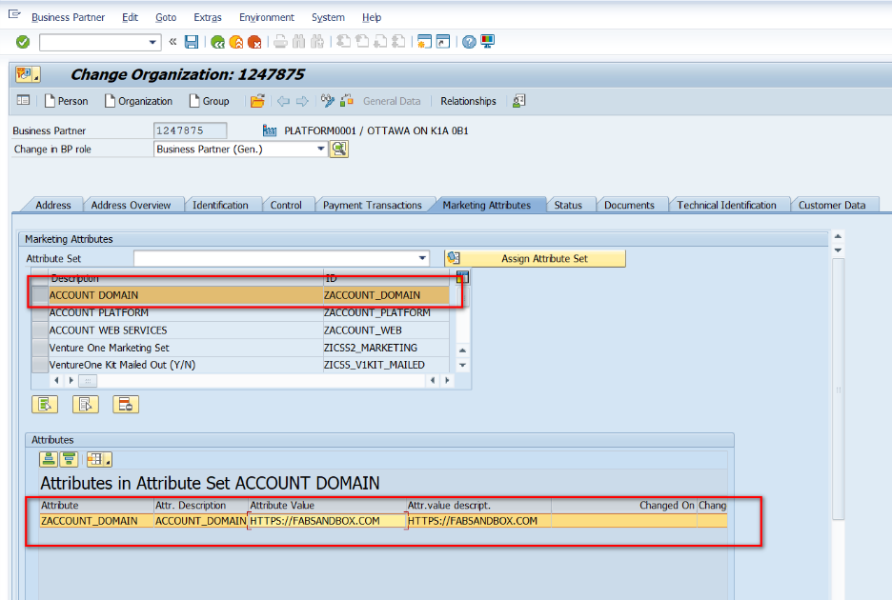
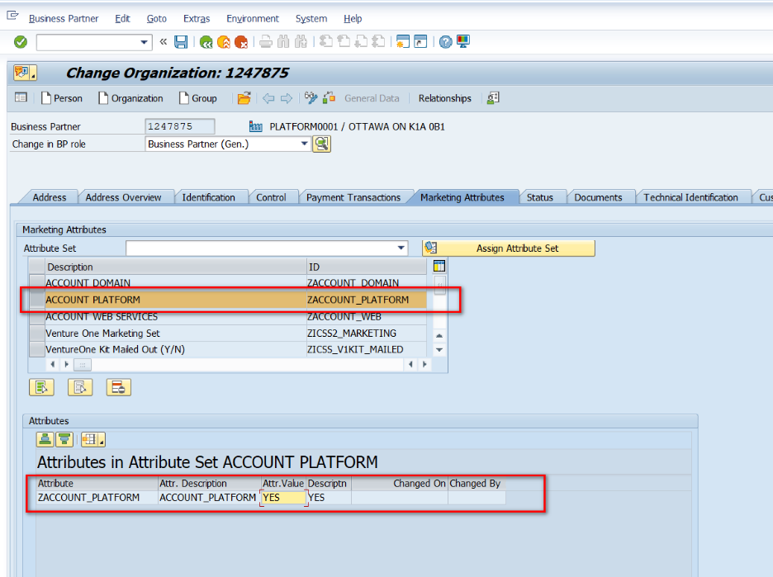

Section 3 — API Integration Setup

Step 7 — Create an Application
Once the platform account has been enabled, the developer must create an application within the Developer Portal to obtain API credentials.
To create a new application:
- Navigate to the Apps section in the Developer Portal header.
- Open the Apps page.
- Click 'Create New App'.
Figure 8 – Application creation screen.
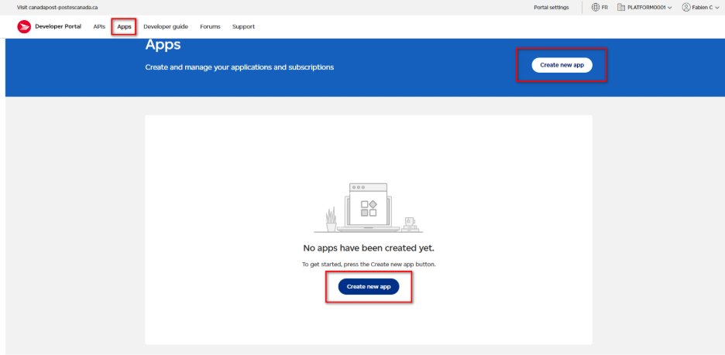

Step 8 — Select Application Environment
During application creation, the developer must choose between the Test or Production environment.
- Test – Generates credentials for the Canada Post testing environment (recommended for development).
- Production – Generates credentials for the production environment for live integrations.

Figure 9 – Environment selection during app creation.
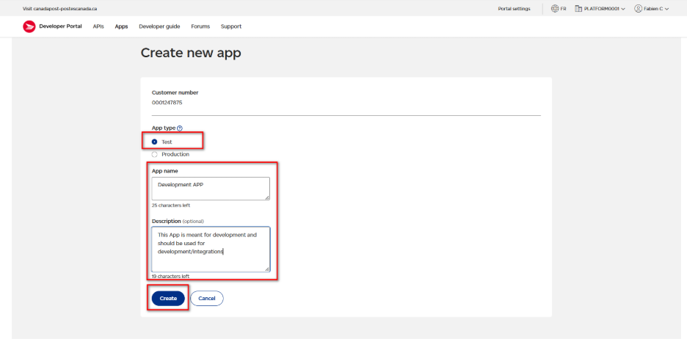

Step 9 — Record API Credentials
Once the application is created, the Developer Portal generates a Client ID and Client Secret used for API authentication.
Important: The Client Secret is displayed only once. Developers must securely store these credentials when they are generated.
Figure 10 – Application credentials displayed after creation.
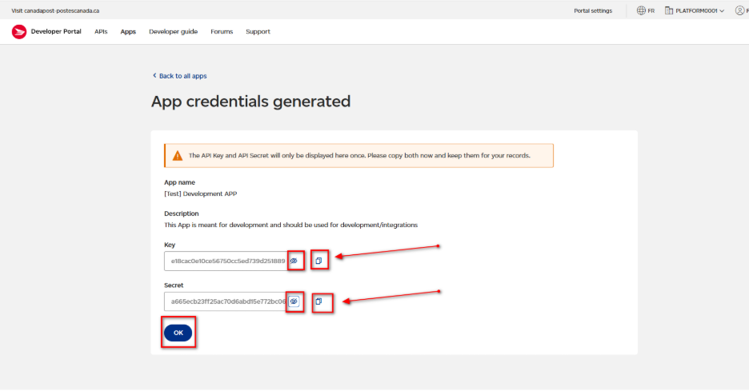

Step 10 — Add API Products
After the application has been created, API products must be added to enable access to Canada Post services.
- Open the application configuration.
- Navigate to the API Products section.
- Select the required API products.
- Save the configuration.
Figure 11 – Adding API products to the application.
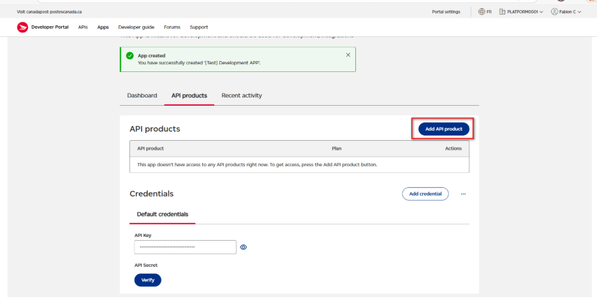

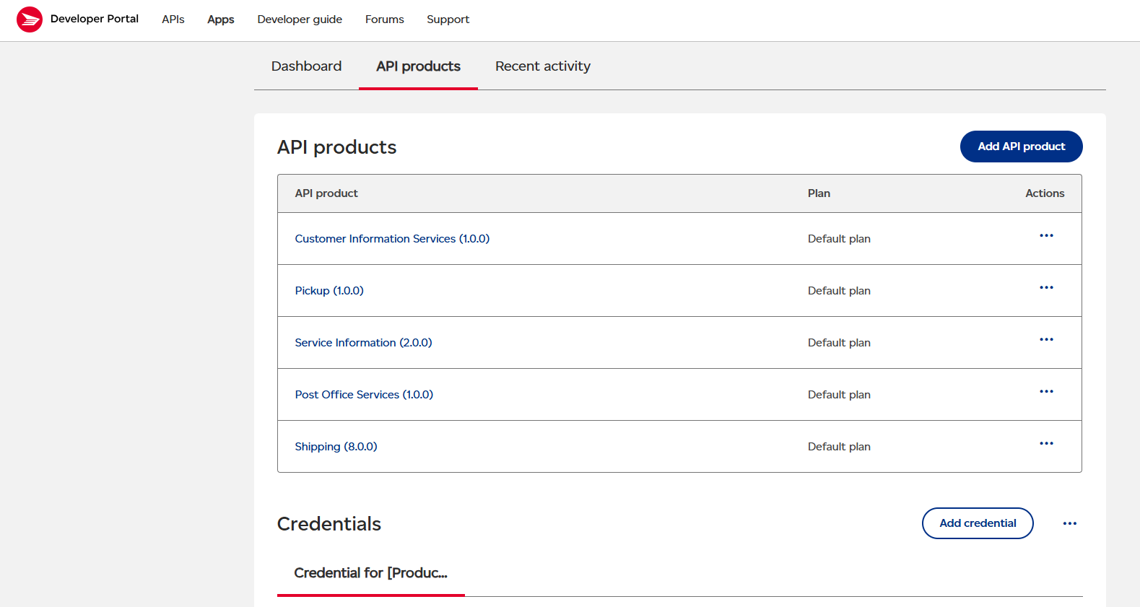

Development Ready
After API products have been successfully added, the platform is ready for development. The developer can begin building integrations using the generated credentials and the selected Canada Post APIs.

