Table of Contents
Introduction 1
Integrated development environment (IDE) 2
Using Insomnia/Postman 3
Using global variables setup 4
API Authentication 5
Making API requests 6

Introduction

This guide was created to provide information on the samples created to help you with your development.
In this guide you will find step by step on how to download Insomnia or Postman IDE and successfully import the samples found in the developer guide section of the Developer Portal.
For any questions or assistance please contact us via the email address developer.program@canadapost.ca .



Integrated development environment (IDE)
.
An integrated development environment (IDE) is a software application that helps programmers develop software code efficiently. It increases developer productivity by combining capabilities such as software editing, building, testing, and packaging in an easy-to-use application.

Insomnia and Postman are an open-source, cross-platform API client for GraphQL, REST, WebSockets, Server-sent events (SSE), gRPC and any other HTTP compatible protocol.

With Insomnia you can: Debug and test APIs using the most popular protocols and formats by sending request and analyzing answer returned from your requests.

Using Insomnia/Postman

Download one of the free applications below to start testing against our APIs.
Insomnia is an open-source desktop application that takes the pain out of interacting with and designing, debugging, and testing APIs.
Download Insomnia
Using Postman, you can send a request to an endpoint, retrieve data from a data source, or test an API's functionality.
Download Postman

Download the Canada Post JSON library samples. As a first step you should download the Insomnia file to gain access to the API request samples offered.
The library uses global variable settings for you to use your own Canada post account information and credentials.
- Click on DEVELOPMENT
- Select the edit button.

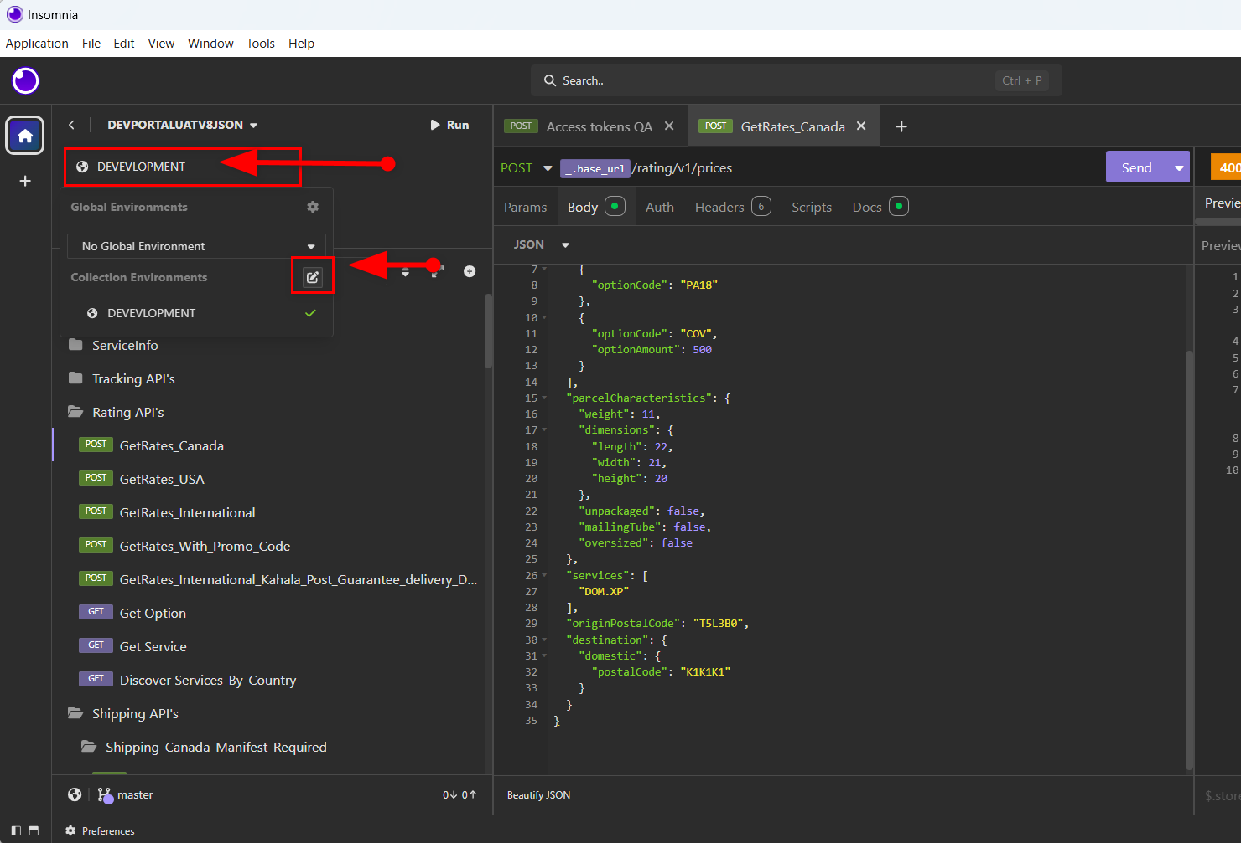

Using global variables setup

On the Manage Environments setup page you can add your own credentials and account information making it easier to use the library.
Base url: Endpoint. Only use the main endpoint
Mailby: merchant Canada Post account
Mobo: merchant Canada Post account
Paid by: Canada Post account responsible for paying shipments.
AccesToken: Token that needs to be generated every 30 min.
API username/Password: credential generated in the Developer Portal.

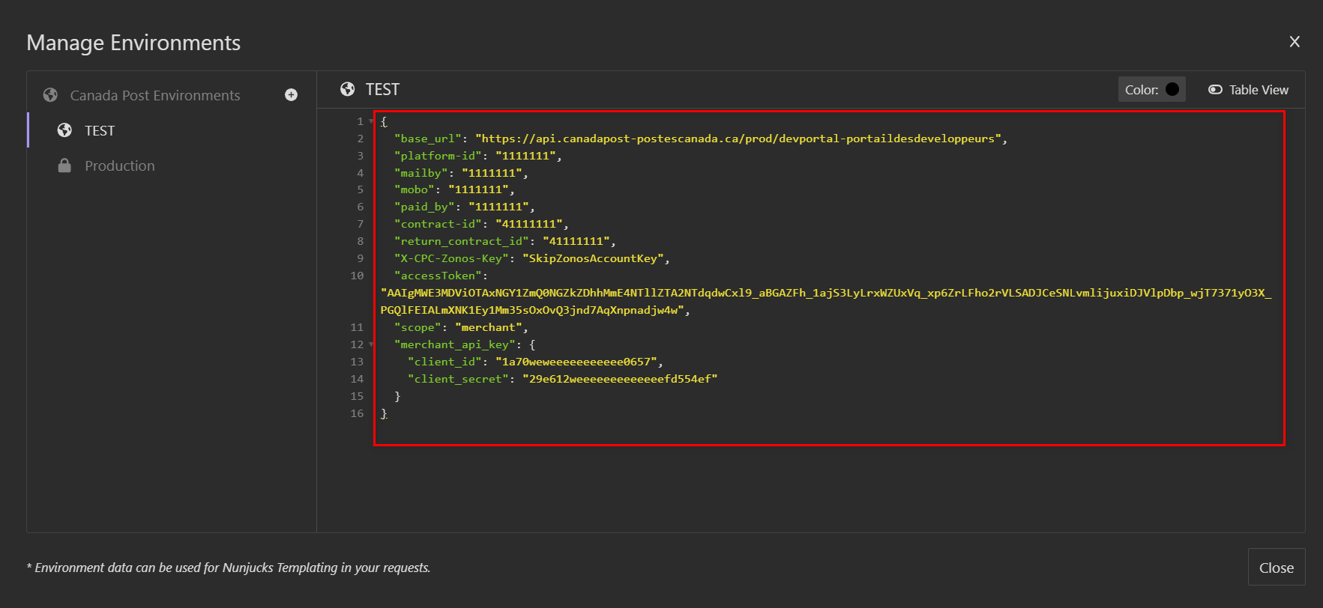

API Authentication

All API operations require an OAuth 2.0 Bearer access token. Per the OAuth 2.0 protocol, you receive an access token by providing a valid client_id and client_secret to an authorization service, along with the client credentials grant type and any optional scopes. The access token is then passed in the Authorization header for every request.
Client credentials are based on the OAuth 2.0 grant type. The access token is passed in all resource calls as an HTTP header. The resource validates the token by calling the OAuth provider's introspection service; if the token is valid, the resource provider processes the request.
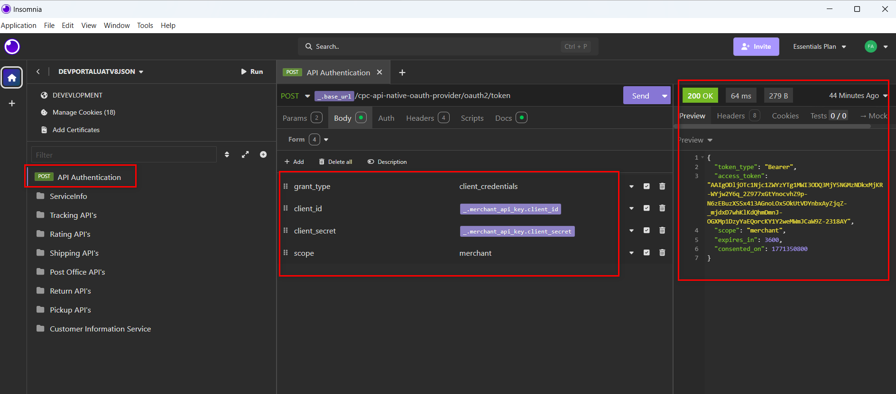

Making API requests
You can access samples using the left navigation. The samples give you visibility on the payload and can as well be modified if needed.

