SPIDER FARMER

GGS Grow Tent Controller
Setup & Configuration Guide
Hardware wiring • App pairing • Automation settings • Monitoring • Reports
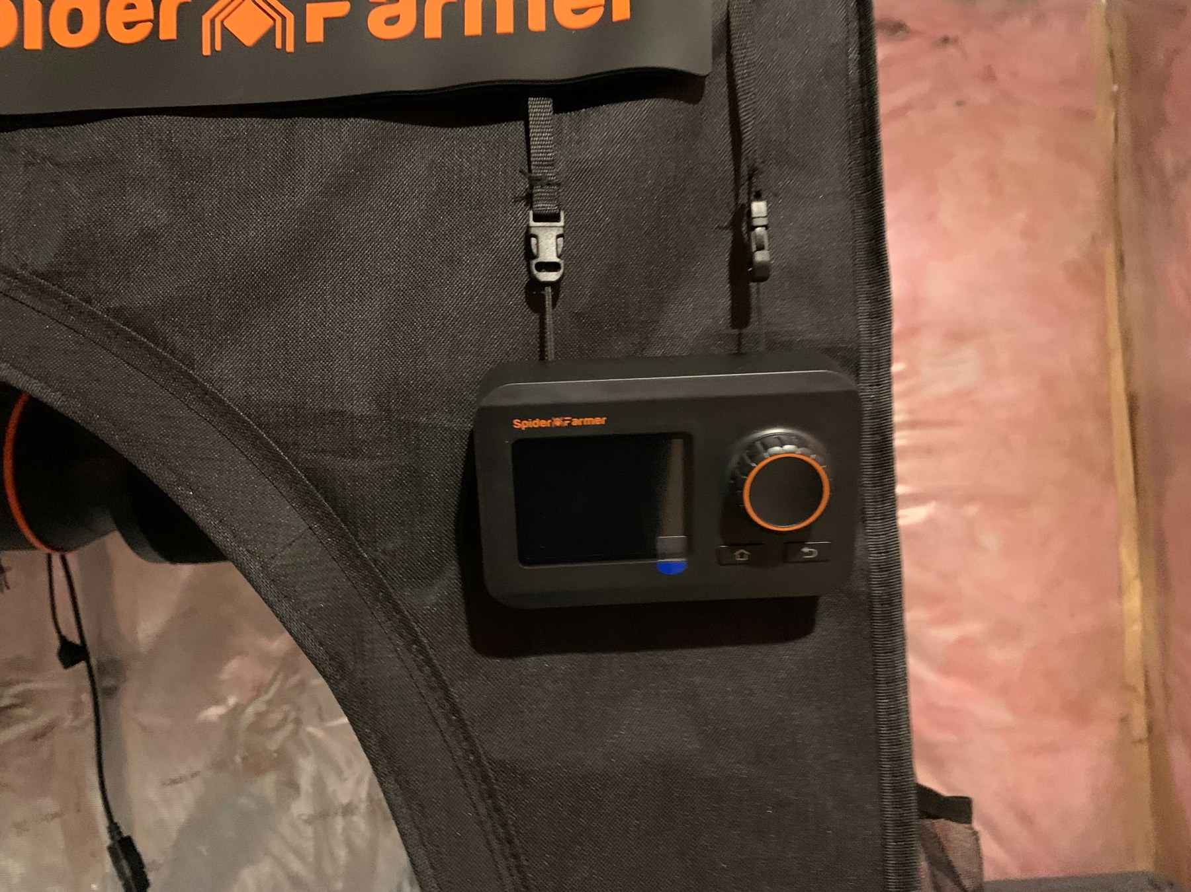
GGS controller mounted on the grow tent - real installation used for this guide.
DRAFT v2.0 — October 2026
Community guide based on a real Spider Farmer 4×4 / SE5000 installation.
Official specifications should always be checked against the latest Spider Farmer documentation.

Complete Wiring Overview — Our AP10 Configuration
The following diagram is the visual reference for the working configuration documented in this guide. It shows the AP10 hub in the center of the GGS network so every control connection can be traced at a glance.
AP10 Port | Connected Device | Connection / Purpose
1 | GGS Light Adapter | DEVICE port; Light Adapter LIGHT 1 continues to the SE5000 UP/control port
5 | GGS Controller | Controller DEV 1
6 | Inline Fan | GGS/RJ12 control connection
9 | Oscillating Clip Fan | GGS/RJ12 control connection
10 | Environmental Sensor | Temperature / humidity / VPD sensing
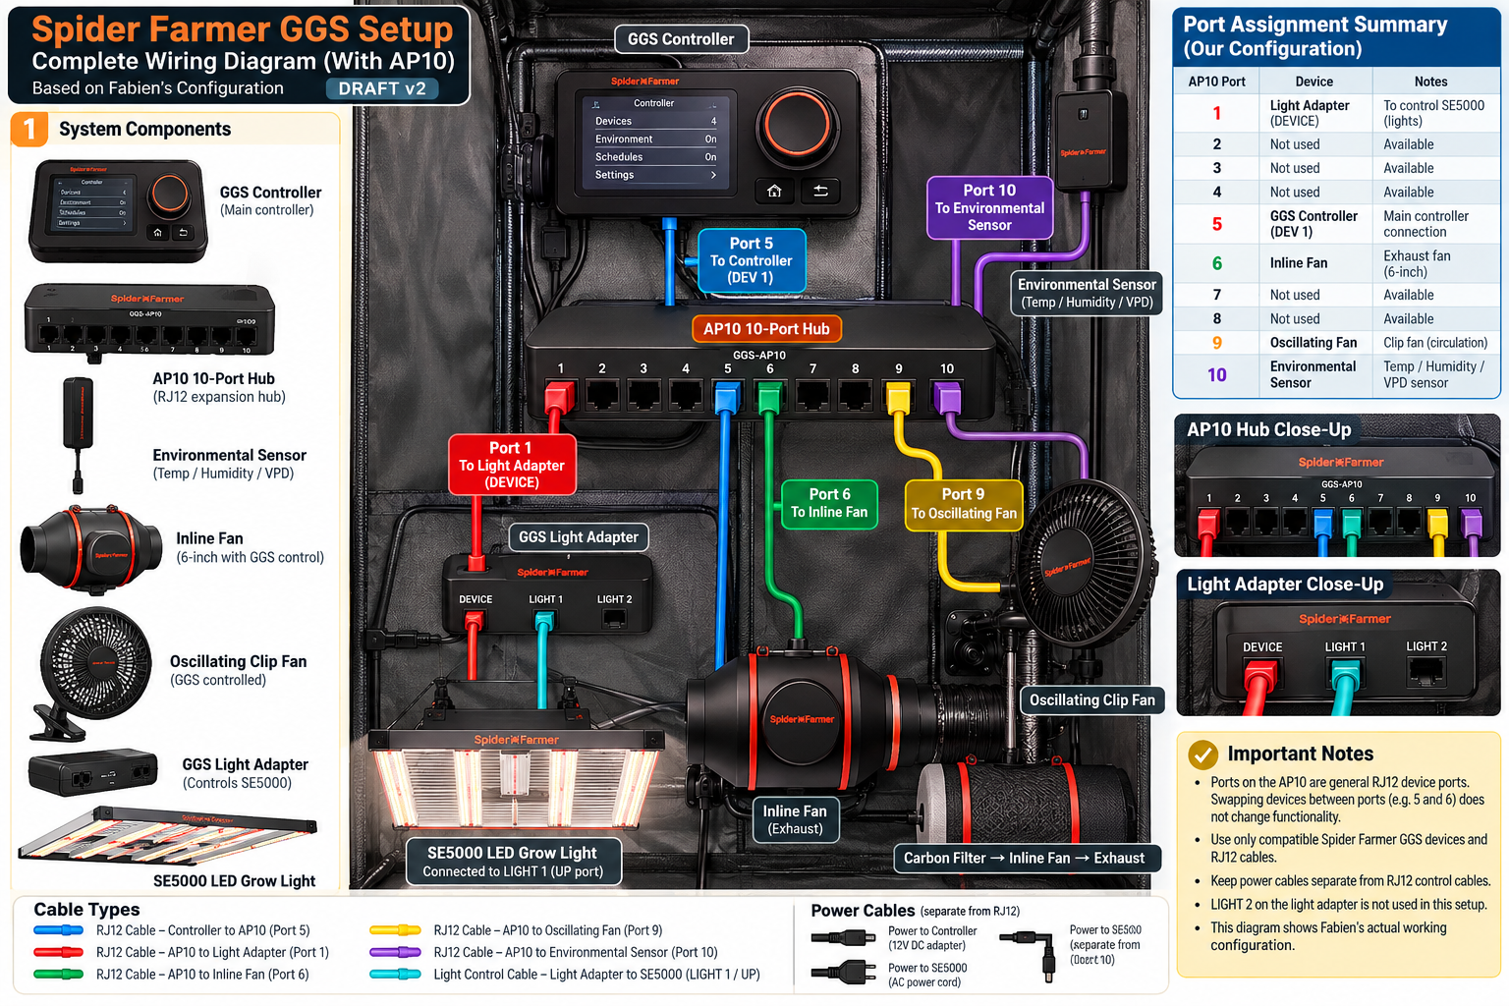
Figure — Complete Spider Farmer GGS wiring overview with AP10 10-port hub (Draft v2).
Draft note: AP10 ports 5 and 6 were intentionally arranged for cleaner physical cable routing. The guide treats the numbered AP10 connections as the documented installation mapping, while the final publication will retain the distinction between RJ12/GGS control wiring and separate AC/DC power wiring.

1. Purpose of this guide
This guide documents a complete real-world installation of the Spider Farmer Grow Genius System (GGS) used with a 4×4 grow tent, SE5000 LED, 6-inch inline exhaust system, oscillating clip fan and environmental sensor. It is written for a first-time owner who wants to understand not only where each cable goes, but also why each controller setting matters.
Draft status: The wiring photographs and tested settings are real. Any item marked VERIFY / PHOTO NEEDED will be checked before the public GitHub release.

2. Hardware used in this installation
Component | Role
Spider Farmer GGS Controller | Central controller; reads sensors and manages compatible devices.
SF-GGS-AP10 GGS Pro Adapter | 10-port interface expansion hub used to distribute GGS connections.
GGS Light Adapter | Interface between the GGS control bus and compatible Spider Farmer LED grow lights.
SE5000 480W LED | Primary grow light; controlled by the GGS schedule and dimming settings.
6-inch inline fan + carbon filter | Exhausts warm/humid air and maintains air exchange.
Spider Farmer oscillating clip fan | Provides circulation across the canopy.
GGS temperature/humidity sensor | Supplies environmental data used for temperature, RH and calculated VPD.
RJ-style GGS cables | Low-voltage communication/control links between GGS devices.

3. Know the adapters before wiring
The two small black adapters are easy to confuse. Identify them before connecting anything.
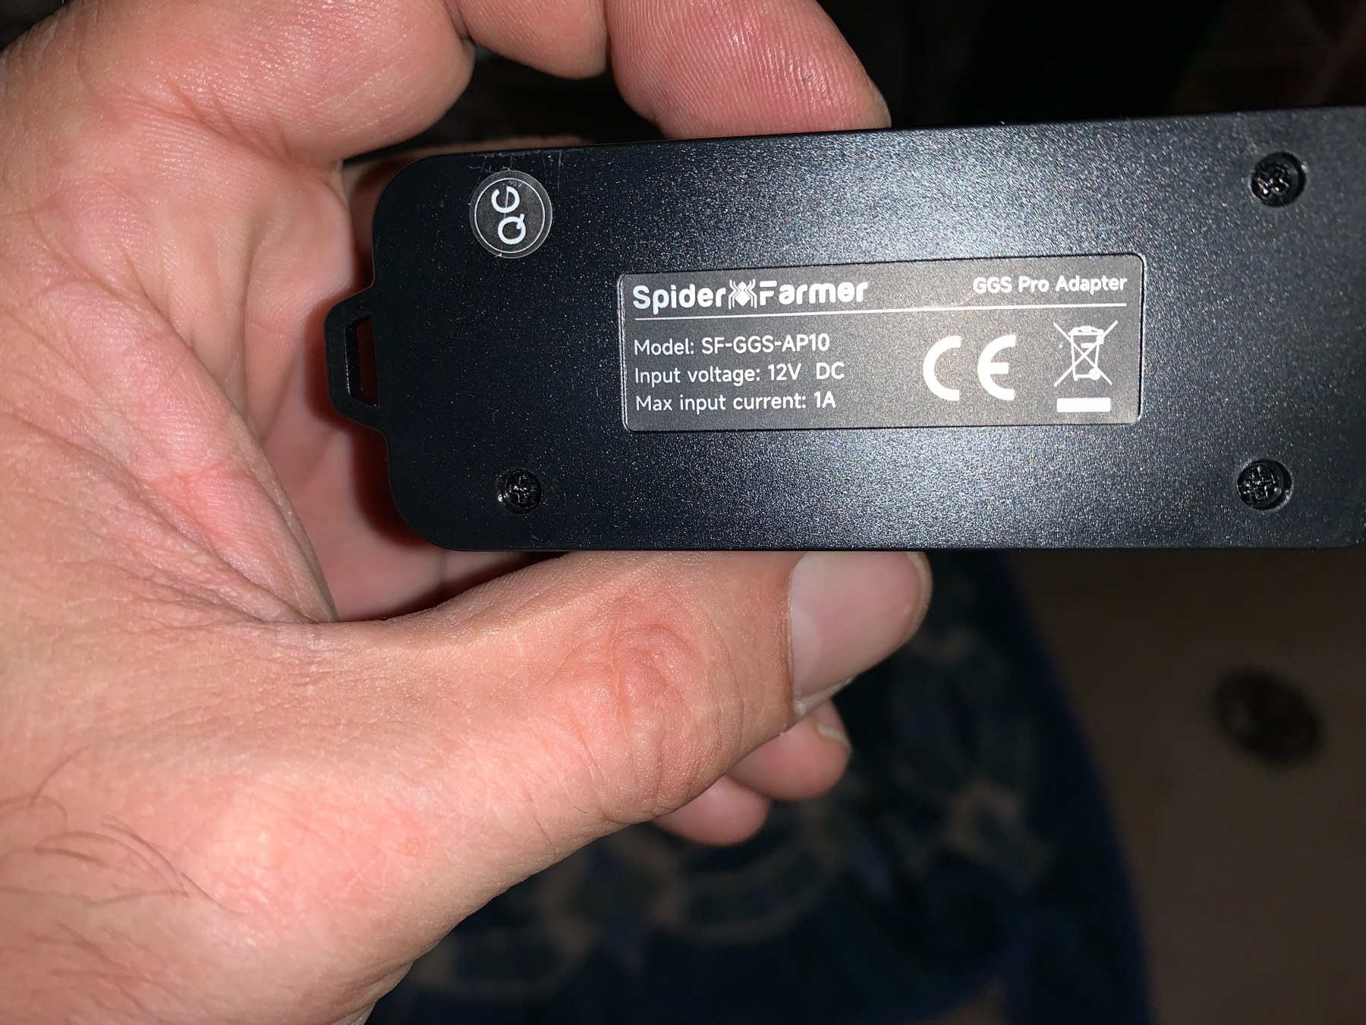
SF-GGS-AP10 GGS Pro Adapter. The label identifies model SF-GGS-AP10, 12 V DC, max input current 1 A.
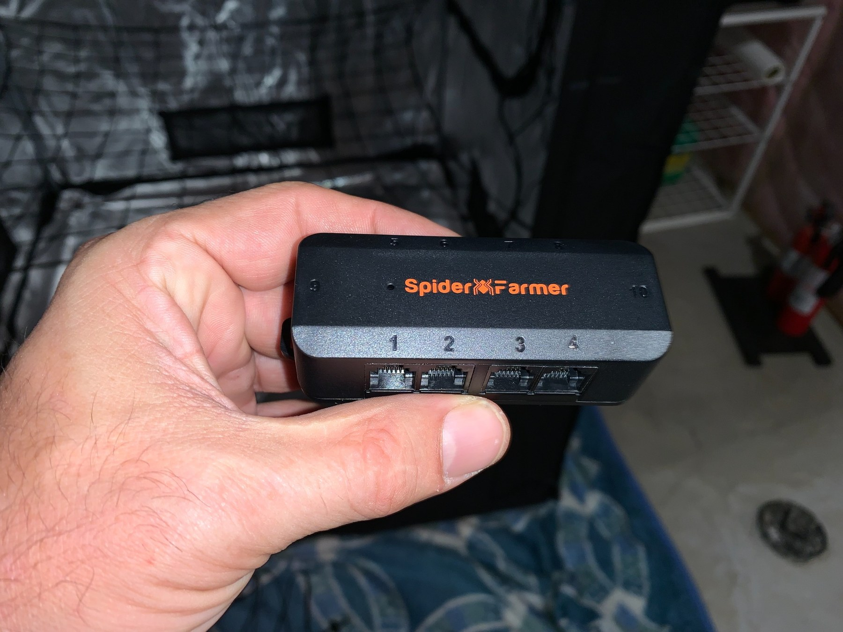
Front side of the AP10: ports 1–4. Additional numbered ports continue on the opposite side.
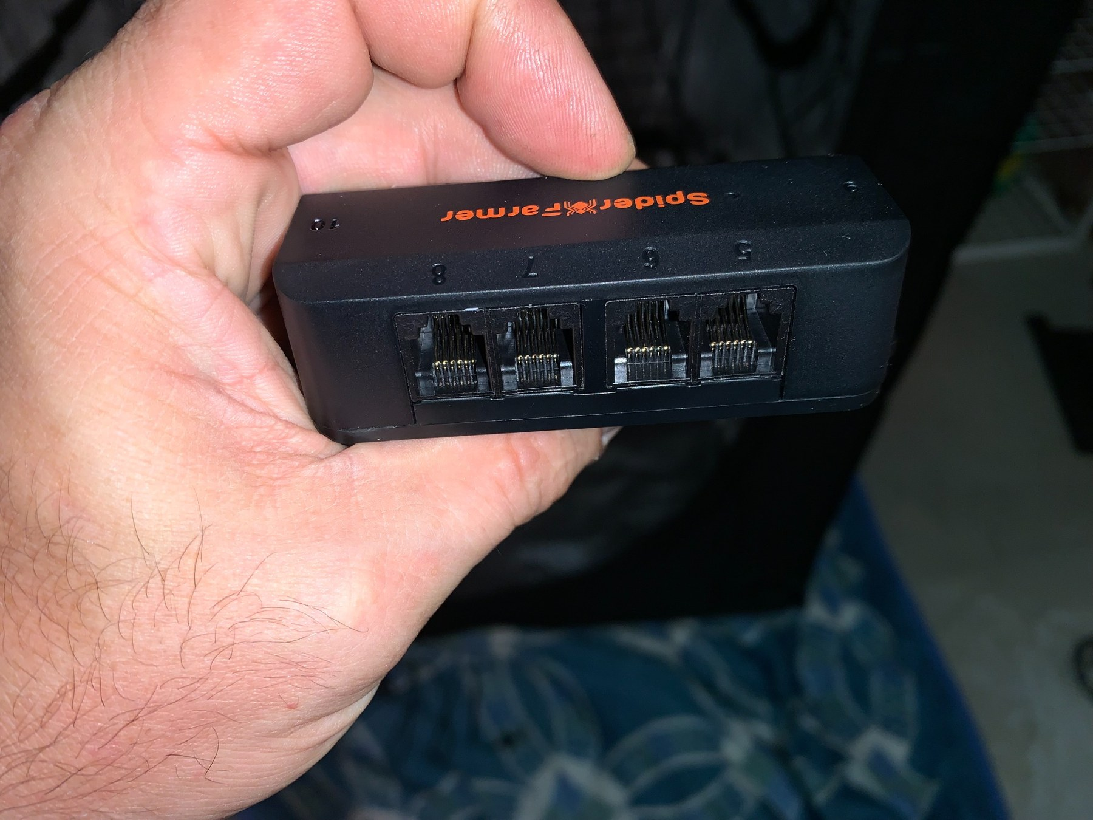
Opposite side of the AP10: ports 5–8 are visible here; the adapter provides numbered expansion connections.
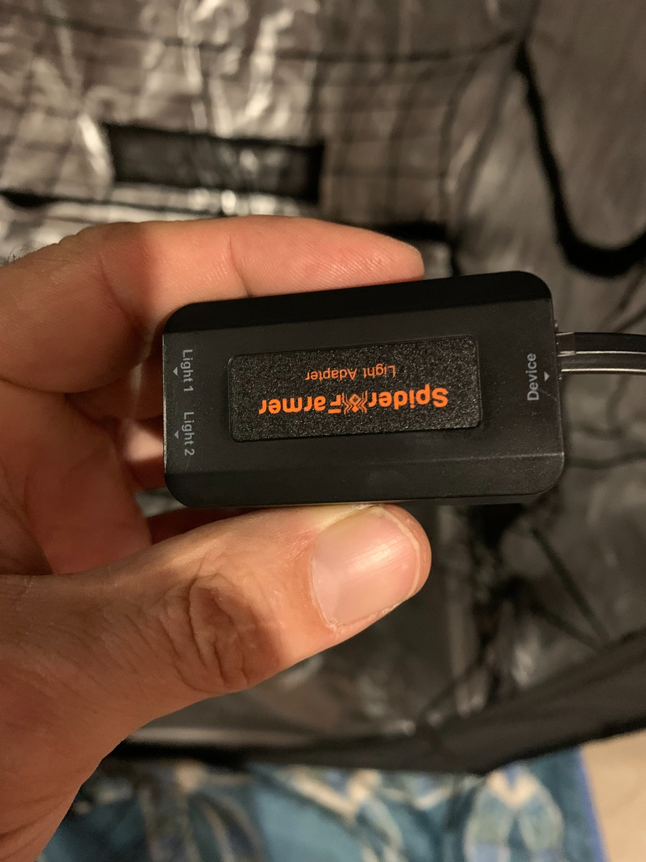
GGS Light Adapter. Note the markings Light 1 / Light 2 on one side and Device on the other.
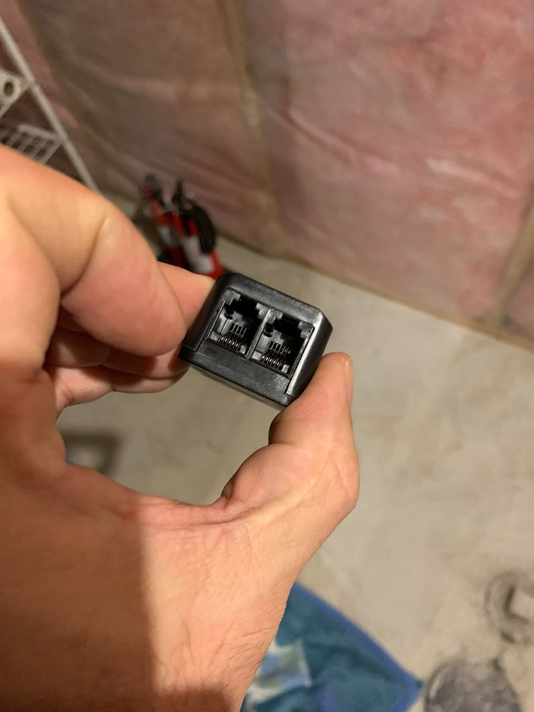
Close-up of the two light-side modular sockets on the GGS Light Adapter.

4. Wiring architecture
The safest way to understand the installation is to think of the controller as the master, the AP10 as an expansion/distribution point, and the Light Adapter as the interface dedicated to compatible LED lighting. Compatible inline and clip fans use their GGS/RJ12 control connection so the controller can adjust speed rather than simply switching AC power on and off.
GGS Controller | → | GGS / AP10 expansion path
Environmental sensor | → | GGS sensor connection
AP10 expansion adapter | → | GGS Light Adapter
GGS Light Adapter | → | SE5000 control connection
GGS Controller / expansion | → | Inline fan RJ12 control
GGS Controller / expansion | → | Clip fan RJ12 control
AC mains power | → | Light driver + inline fan power as required
VERIFY before public release: We will add a labeled photograph showing the exact controller/AP10 port assignments used in this installation. Do not infer a port assignment solely from this draft diagram.

5. Physical installation
Mount the carbon filter and inline fan high in the tent so warm air is removed from the upper zone. Keep the environmental sensor near canopy height, away from direct LED radiation and away from the direct blast of the intake, exhaust or circulation fan. Mount the clip fan so air moves across and around the plants rather than continuously blasting one leaf surface.
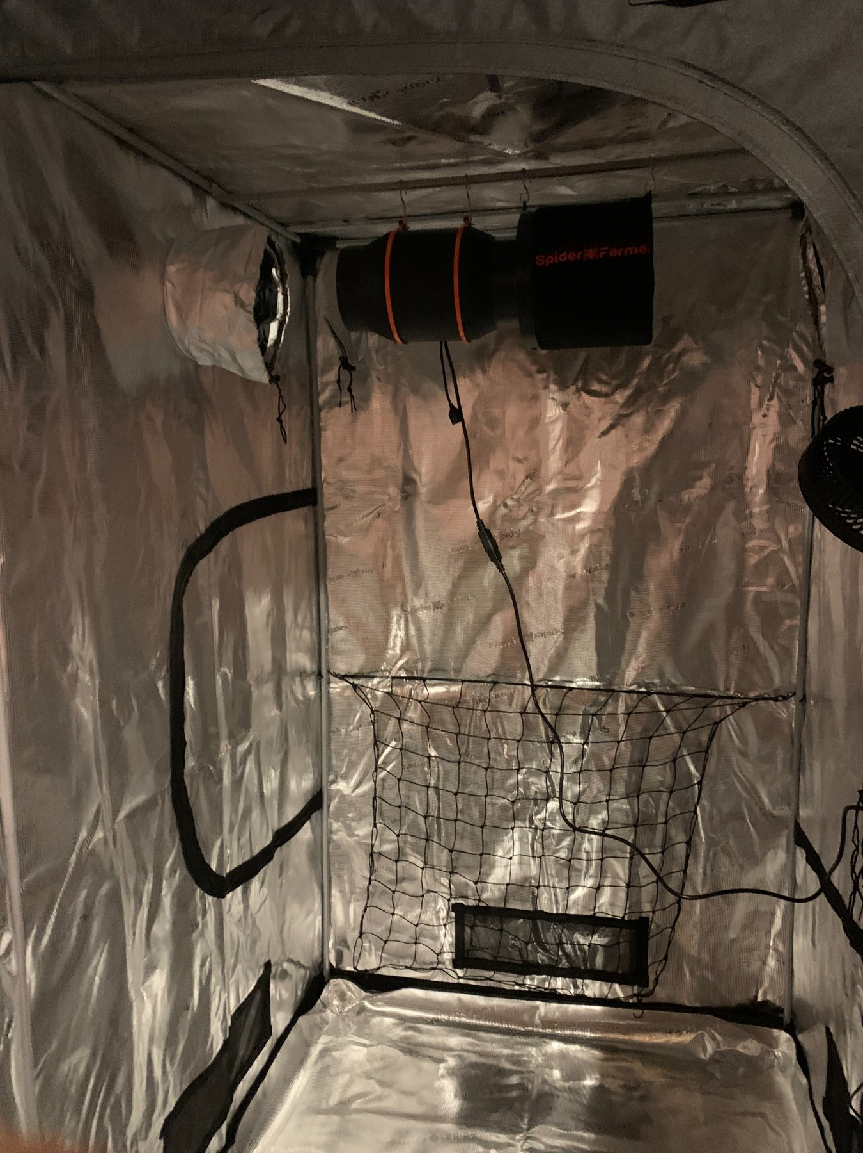
Inside the 4×4 tent: carbon filter / inline exhaust mounted at the top of the tent.
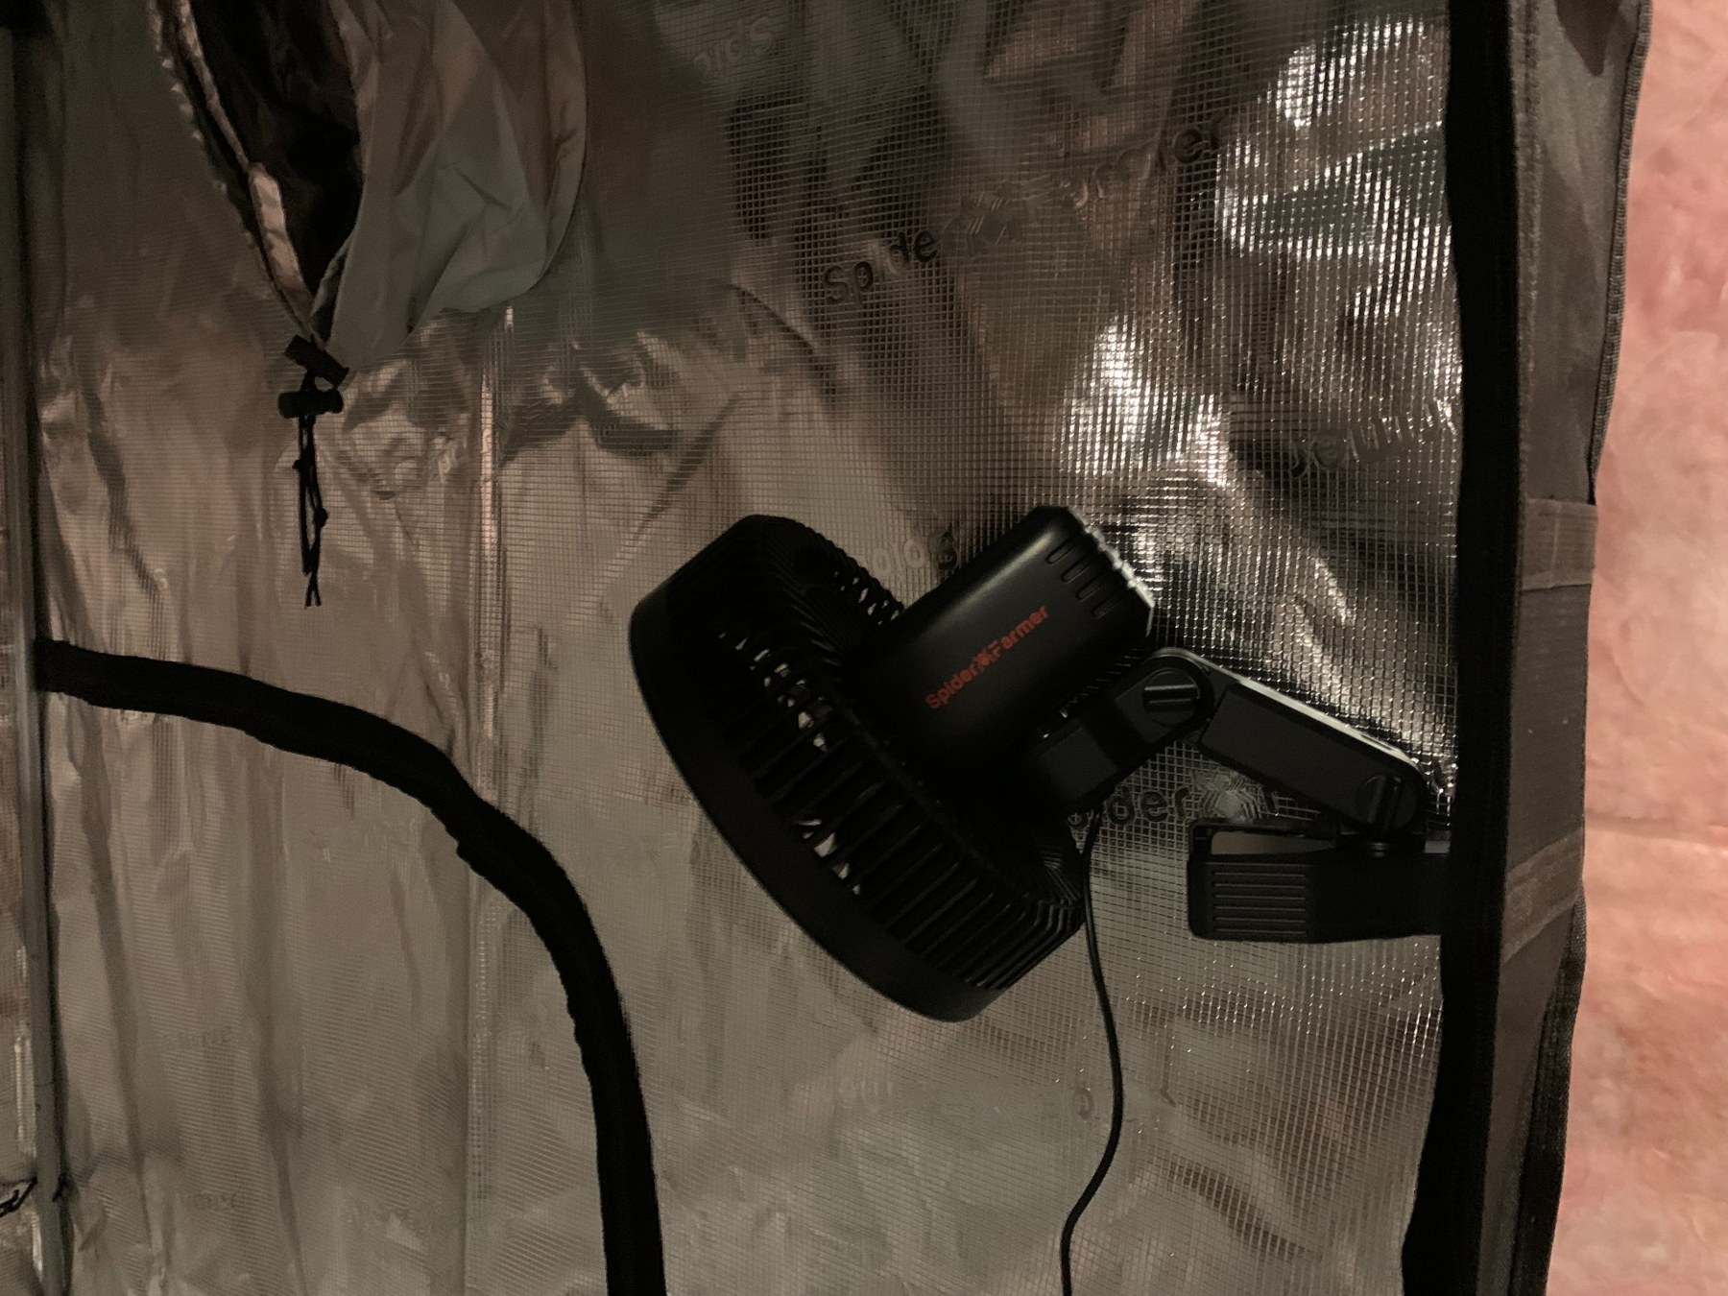
Oscillating clip fan mounted to a tent pole for canopy circulation.
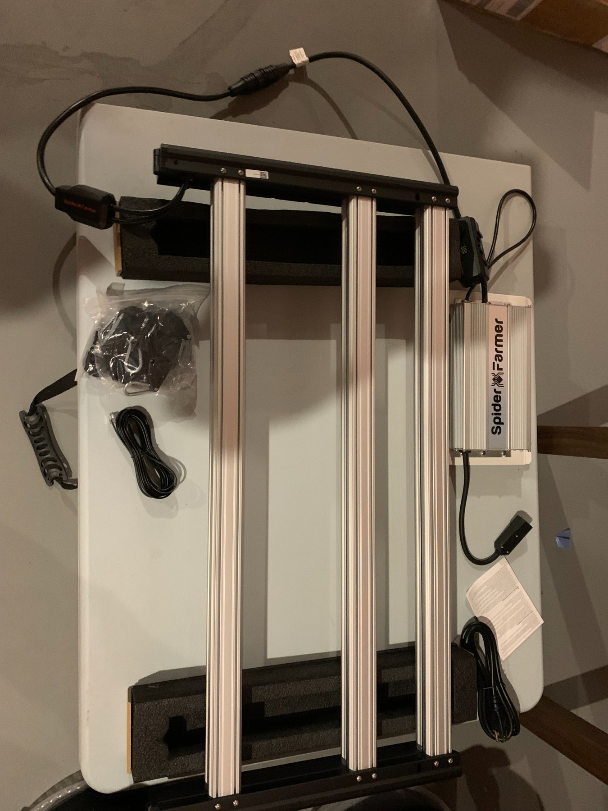
SE5000 LED and driver during installation.
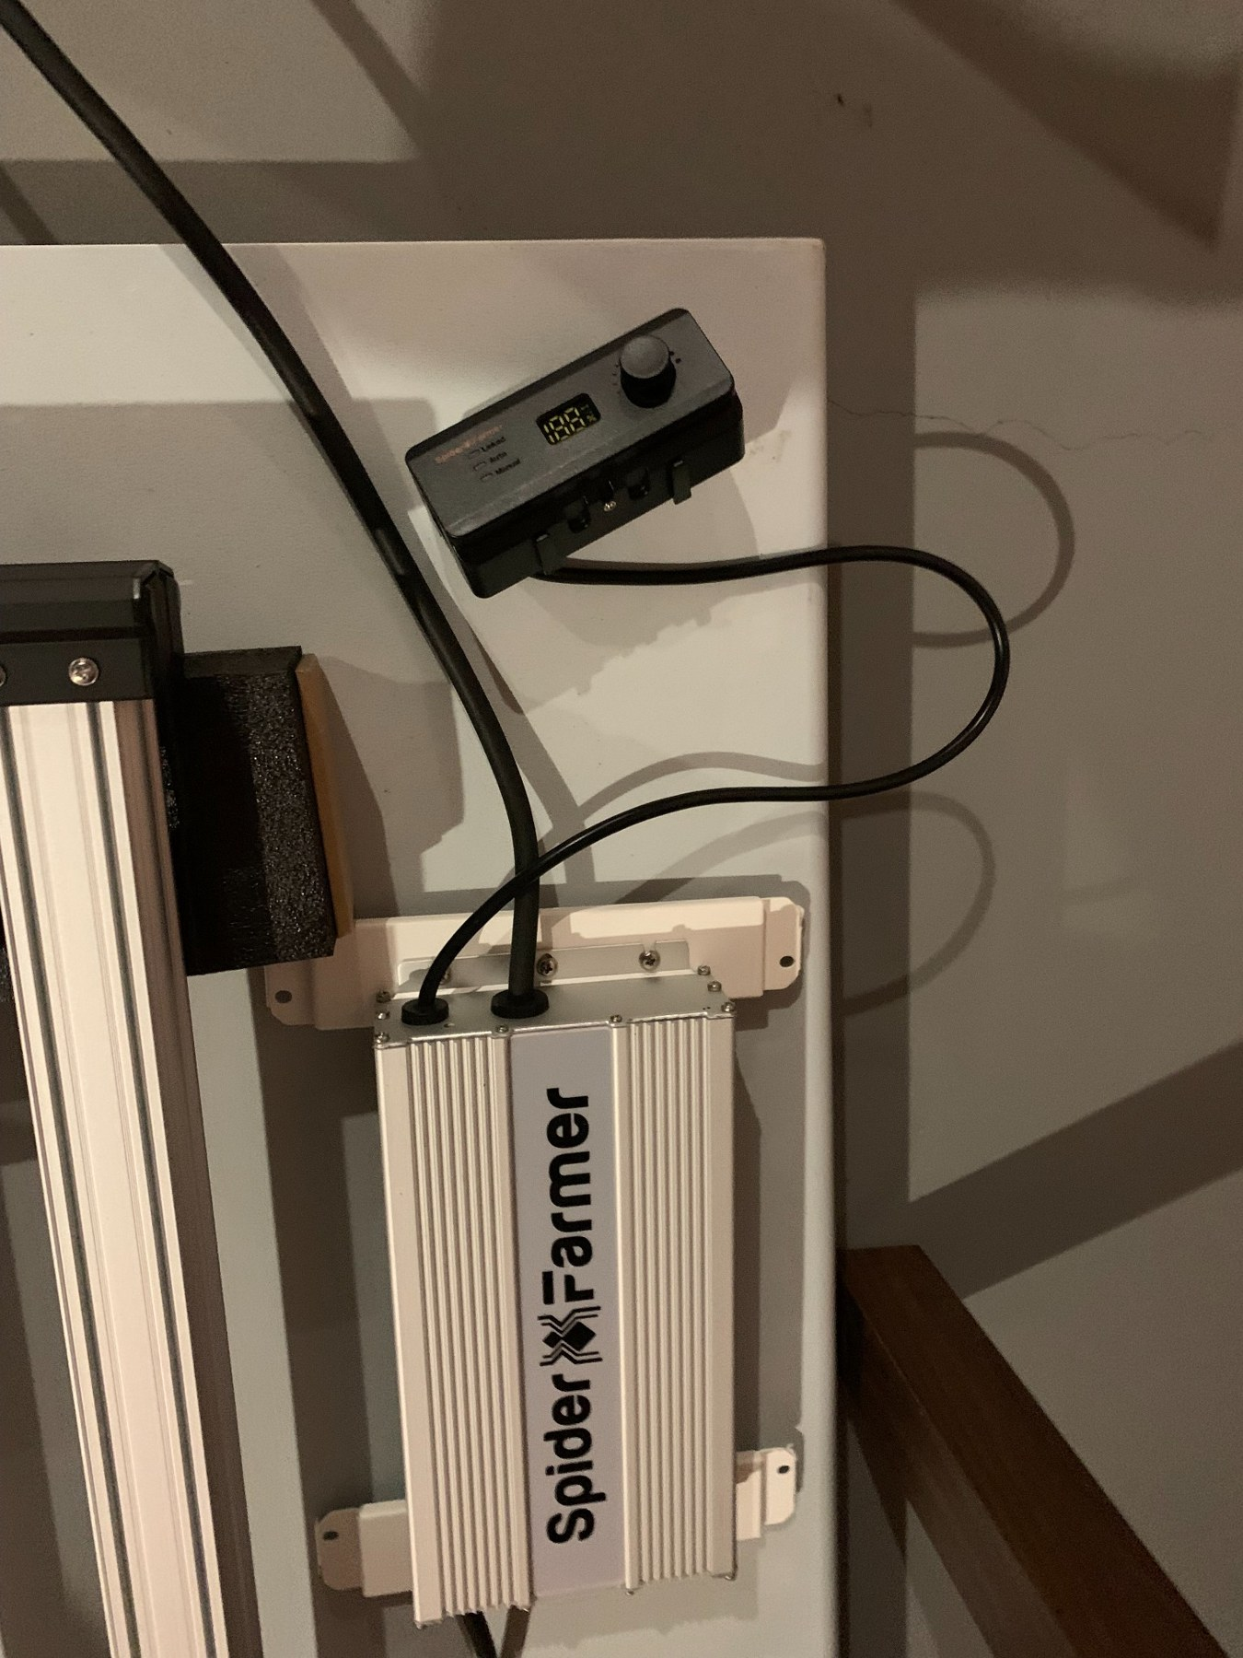
SE5000 driver and local light control hardware before final GGS configuration.

6. Recommended connection sequence
1. With equipment powered down, mount the controller, sensor, light, inline fan and clip fan.
2. Identify the AP10 expansion adapter and GGS Light Adapter by their printed labels before connecting cables.
3. Connect the environmental sensor using the correct GGS sensor cable. Seat modular plugs fully.
4. Connect the AP10 / GGS control path to the controller as required by the kit configuration.
5. Connect the GGS Light Adapter to the GGS control path, then connect the light-control side to the SE5000.
6. Connect the compatible inline fan's RJ12/GGS control port.
7. Connect the compatible clip fan's RJ12/GGS control port.
8. Connect normal AC power to the light driver, inline fan and controller as required. GGS communication does not replace mains power for devices that require it.
9. Power on and verify that the controller sees each device before configuring automation.

7. App pairing and initial setup
The GGS system uses the Spider Farmer mobile app. During initial setup, Bluetooth is used to discover/activate the controller and a 2.4 GHz Wi‑Fi network is used for network connectivity. Confirm the controller's local time, time zone and daylight-saving setting before creating schedules.
Verified on this installation: Time Zone = America/Toronto; Daylight Saving Time enabled when applicable.
Screenshot placeholder: Add screenshots for My Garden → controller discovery → activation → 2.4 GHz Wi‑Fi → device dashboard.

8. Environment settings used for the pepper tent
Setting | Value | Notes
Day cycle | 08:00 AM–10:00 PM | Matches the 14-hour light schedule.
Day temperature | 25°C | Environmental target/reference.
Night temperature | 21°C | Environmental target/reference; this does not heat the tent by itself.
Temperature dead zone | 2°C | Day cooling trigger observed at 27°C; night trigger observed at 23°C.
Day humidity | 60% RH | Target/reference.
Night humidity | 60% RH | Target/reference.
Humidity dead zone | 5% RH | High-humidity trigger observed at 65% RH.
CO₂ | 800 / 800, dead zone 100 | Left unchanged; no supplemental CO₂ is being used.

9. SE5000 light configuration
For the current young pepper plants, the SE5000 is running in Time Slot Mode at 30% output with a 14-hour photoperiod from 8:00 AM to 10:00 PM. Sunrise and sunset simulation are set to 30 minutes. The light is approximately 30 inches above the test canopy.
Important: These are example settings for this specific installation and plant stage, not universal pepper-lighting prescriptions. Adjust intensity and height according to plant response and measured PPFD when available.
Screenshot placeholder: Insert the Time Slot Mode, brightness, schedule and sunrise/sunset screenshots from the setup session.

10. Inline blower configuration
The inline exhaust is configured in Environment Mode using Temperature & Humidity. Running Speed is 40% and Standby Speed is 25%. This gives the tent a continuous low baseline exhaust while allowing the controller to increase airflow when the environmental trigger is reached.
Observed behavior during setup: when Running Speed was set to the minimum non-zero 25%, the app offered only OFF for Standby. Raising Running Speed to 40% made 25% Standby available. This is an observed behavior from this system and will be labeled as such unless Spider Farmer documentation explicitly confirms the rule.
Trigger logic: Day: trigger at ≥27°C OR ≥65% RH; return at 25°C / 60% RH. Night: trigger at ≥23°C OR ≥65% RH; return at 21°C / 60% RH.

11. Clip circulation fan configuration
The clip fan is configured in Environment Mode using Temperature & Humidity. Gear is set to Automatic, Oscillation to L2, Standby Speed to L1 and Natural Wind is Off. During setup, Standby Speed became available after Gear was changed to Automatic.
The practical goal is gentle continuous circulation at standby, with the controller able to increase circulation when environmental conditions call for it. We will continue to document the exact Automatic-mode behavior as more history is collected.

12. Understanding VPD
VPD means Vapor Pressure Deficit. It combines air temperature and relative humidity into a single value, expressed in kPa, that helps describe the drying demand of the air around the leaves. Lower VPD generally means the air is more humid and pulls moisture from leaves more slowly; higher VPD means greater drying demand.
The GGS controller calculates VPD automatically from temperature and humidity. In the first overnight test, the tent remained around 0.84–0.90 kPa while temperature slowly declined and humidity stayed stable.

13. History, reports and export
A very useful feature is hidden behind the parameter tiles themselves. Open the controller dashboard, then tap the parameter you want to review (Temperature, Humidity or VPD). The history view provides 24H, Week and Month views as data accumulates, plus an Export option.
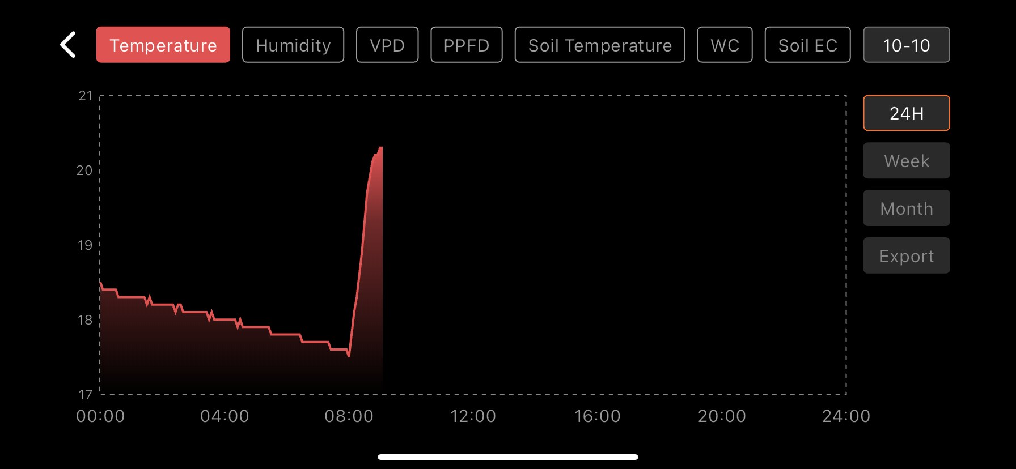
24-hour Temperature history: the overnight cooling trend and rapid rise after the 8:00 AM light start are clearly visible.
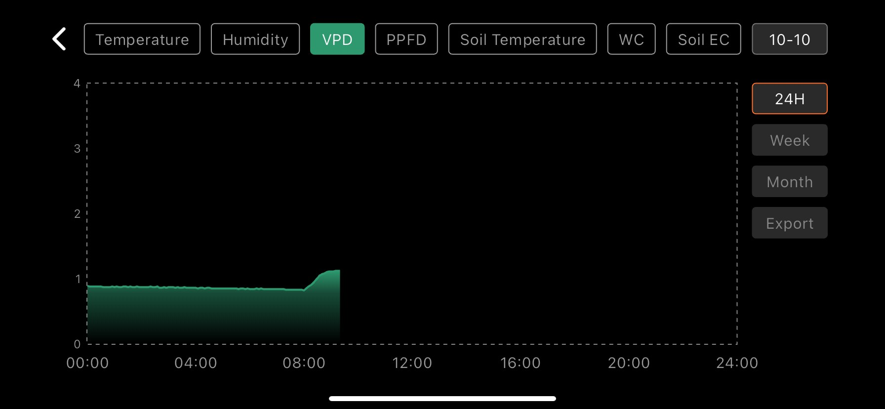
24-hour Humidity history: overnight RH remained stable before dropping as the lights warmed the tent.
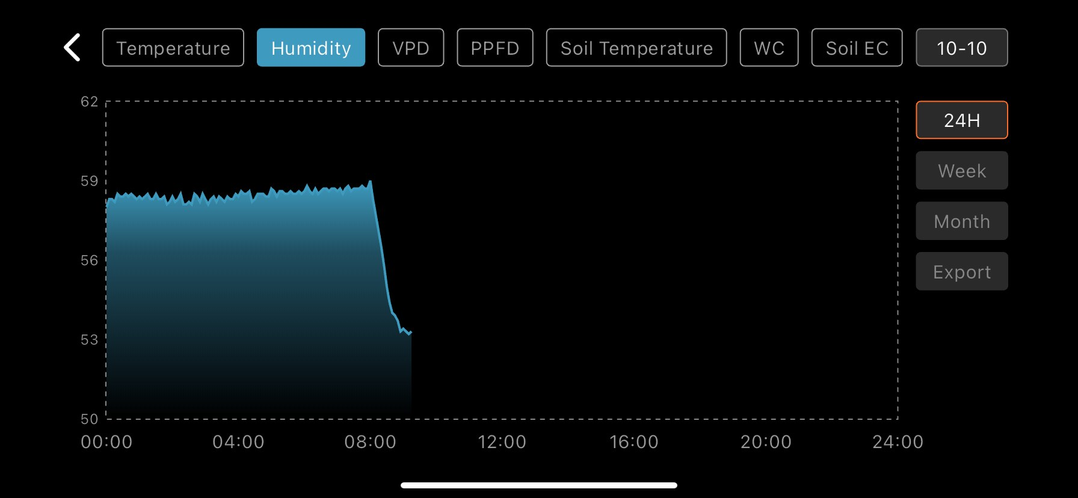
24-hour VPD history: VPD remained steady overnight and rose after lights-on.

14. First overnight baseline
Metric | Observed overnight | After lights-on
Temperature | ~18.4°C → ~17.5°C | Rose rapidly toward ~20.3°C
Humidity | ~58–59% RH | Fell toward ~53% RH
VPD | ~0.84–0.90 kPa | Rose toward ~1.1 kPa
This baseline is useful because it shows the tent's natural nighttime floor without a heater. The 21°C night temperature setting does not create heat; it only participates in control logic for connected equipment. If the surrounding room cools below the target, a heating device would be required to actively raise temperature.

15. Troubleshooting notes from the real setup
- No standby speed option: check whether the active/running speed leaves room for a lower non-zero standby value.
- Clip-fan standby options missing: in this installation, setting Gear to Automatic exposed the Standby Speed option.
- Sensor shows dashes: reseat the sensor cable, confirm the correct port and inspect the cable.
- Controller schedule seems wrong: verify Device Time, Time Zone and Daylight Saving Time.
- History seems missing: tap the parameter tile itself; the graph is not located in the controller Settings menu.
- Night temperature is below the configured target: remember that fans can remove heat but cannot add heat.

16. Items to add before GitHub release
- Exact labeled photo of every controller port used in this installation.
- Exact cable-by-cable photo sequence from controller → AP10 → Light Adapter → SE5000.
- Close-up of inline-fan RJ12 control port and final cable connection.
- Close-up of clip-fan RJ12 control port and final cable connection.
- Environmental sensor and its final canopy-height placement.
- App screenshots for pairing, Environment Settings, light schedule, blower settings and clip-fan settings.
- CSV Export example and a short section explaining how to analyze exported data.
- Final verification against the latest Spider Farmer GGS manual and firmware/app version.

17. Reference sources for final publication
Final GitHub edition will cite Spider Farmer's current GGS Controller Operating Manual, GGS System User Manual, GGS Learning Center and GGS FAQ. These official sources will be used to separate manufacturer-documented behavior from observations made during this installation.

