FLAGS

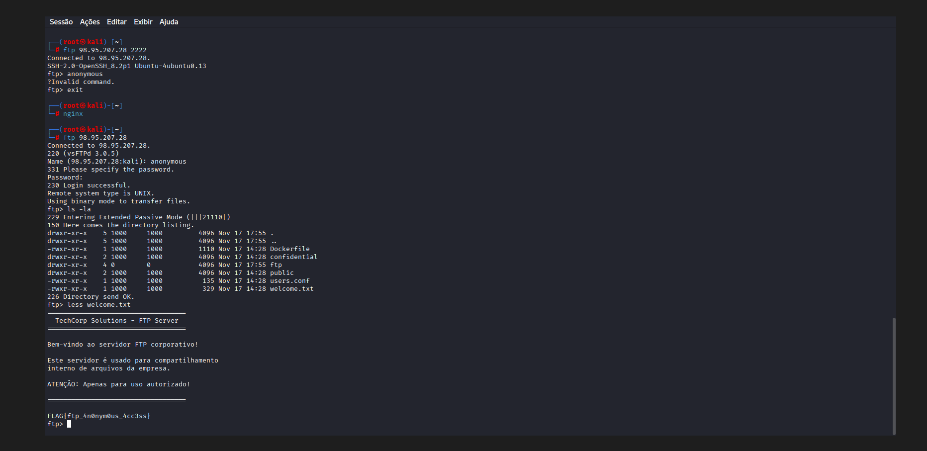
FLAG{ftp_4n0nym0us_4cc3ss} 10+
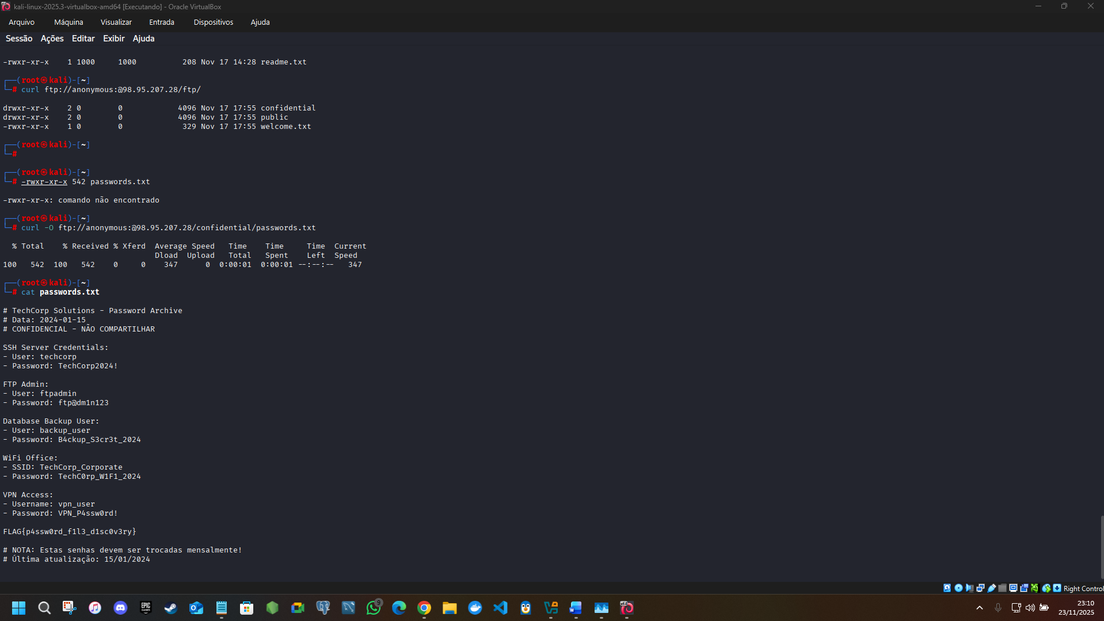
FLAG{p4ssw0rd_f1l3_d1sc0v3ry} 20+
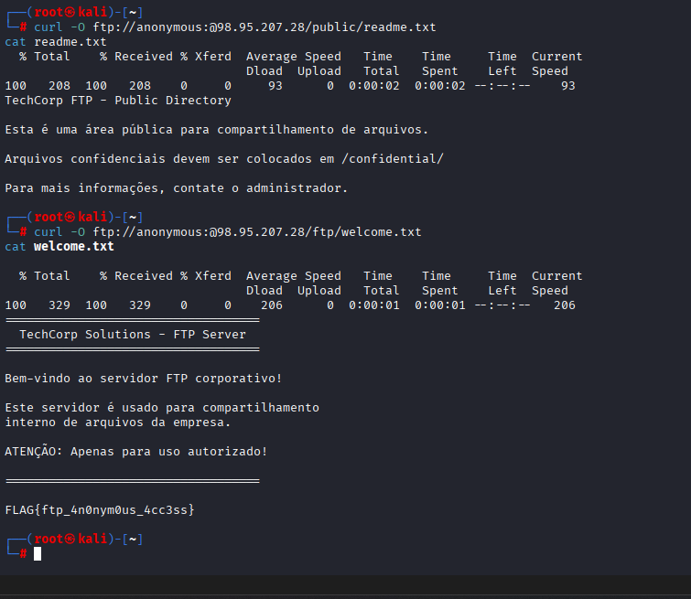
FLAG{ftp_4n0nym0us_4cc3ss} duplicada

FLAG{r0b0ts_txt_l34k4g3} 10+

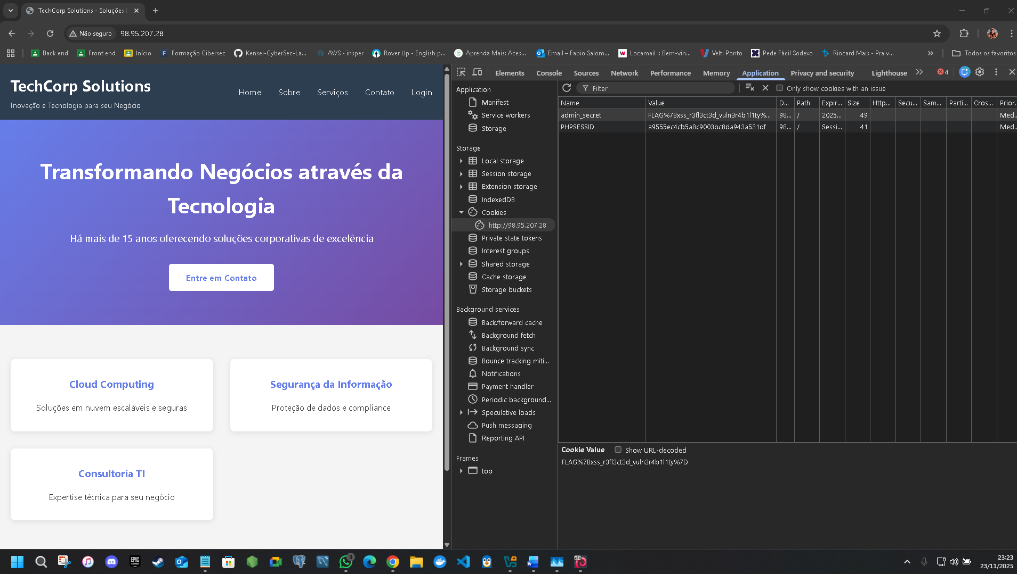
FLAG%7Bxss_r3fl3ct3d_vuln3r4b1l1ty%7D – falta ajuste para ver a flag
FLAG{xss_r3fl3ct3d_vuln3r4b1l1ty} 20+
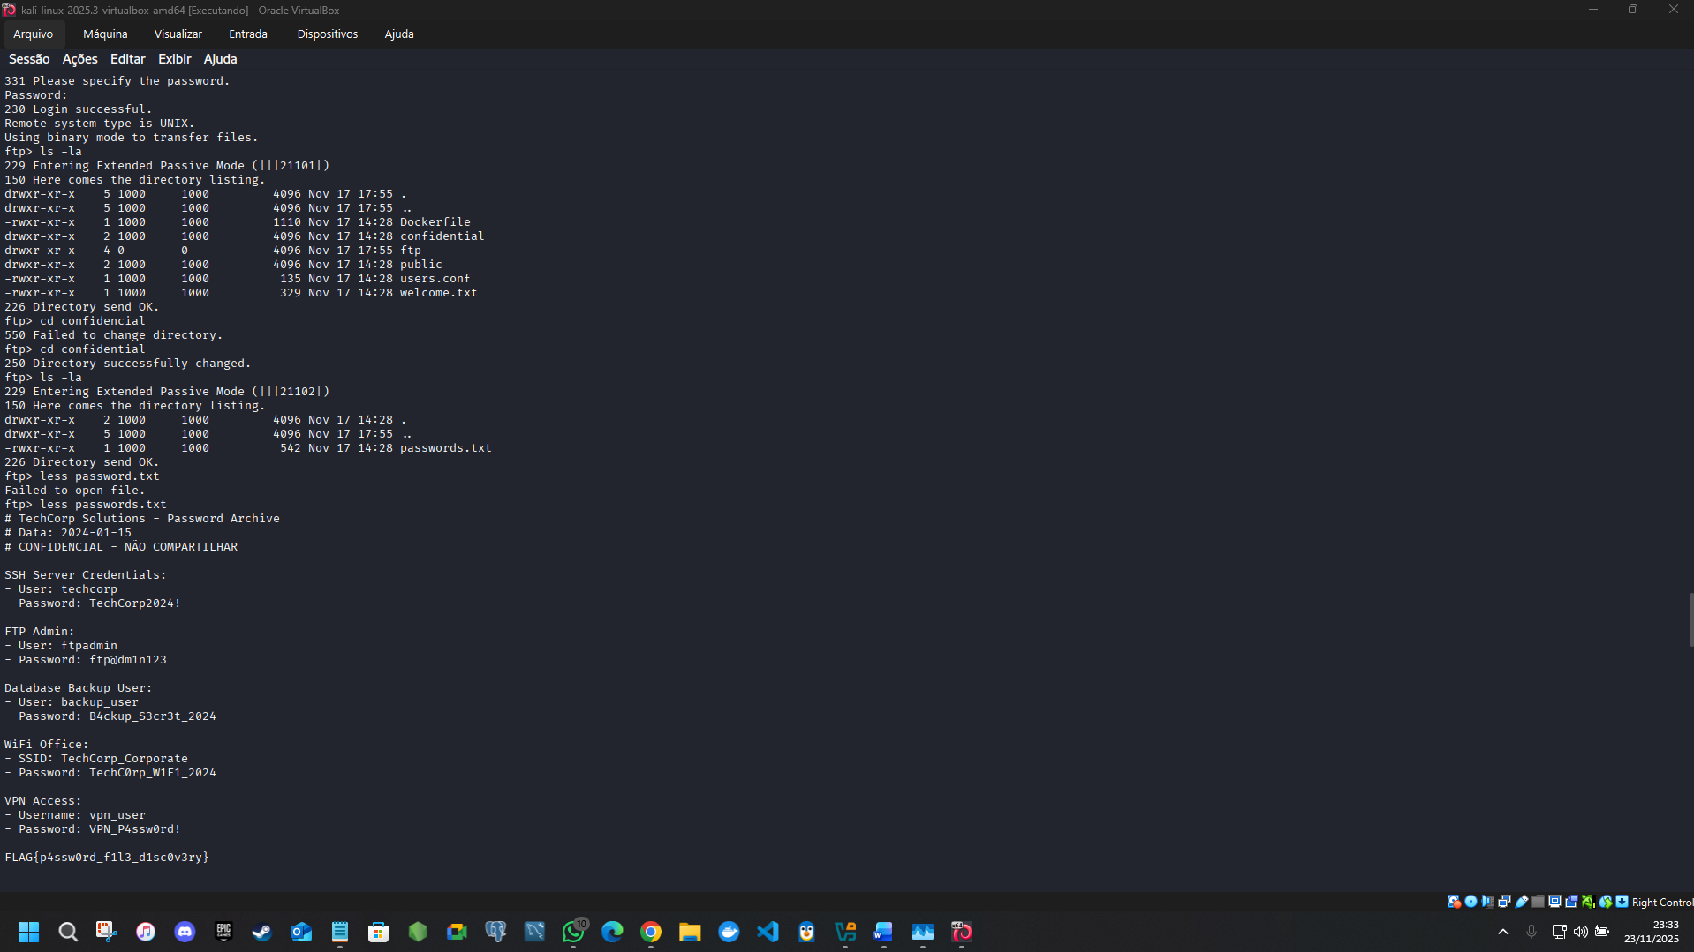
FLAG{duplicada}
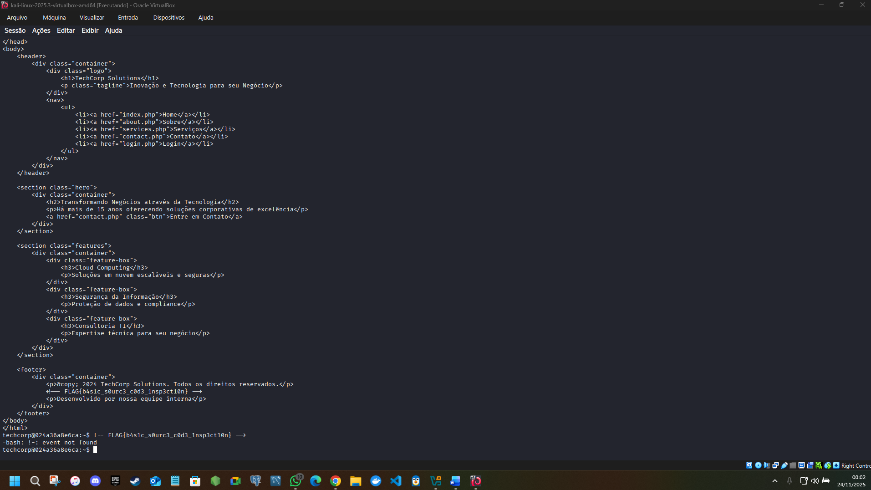
FLAG{b4s1c_s0urc3_c0d3_1nsp3ct10n} 10+


FLAG{ssh_h0m3_d1r3ct0ry_3xpl0r4t10n} 30+
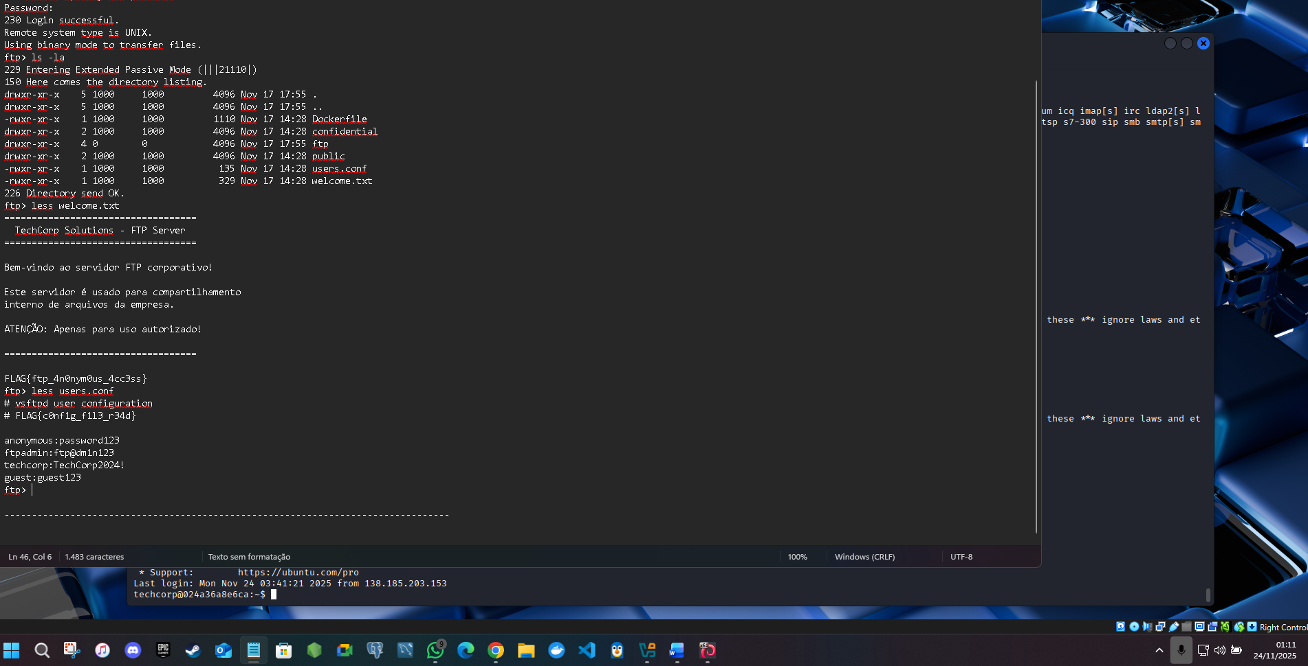
FLAG{c0nf1g_f1l3_r34d} 40+
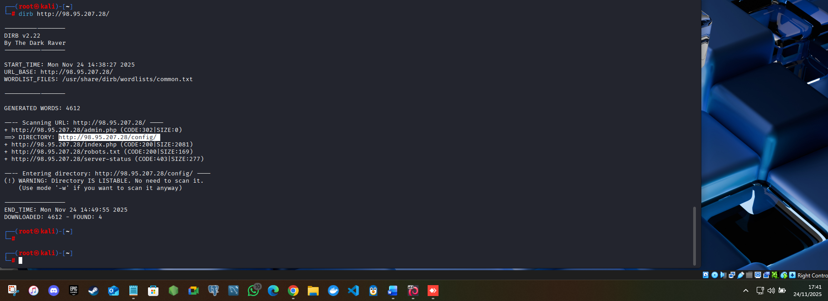
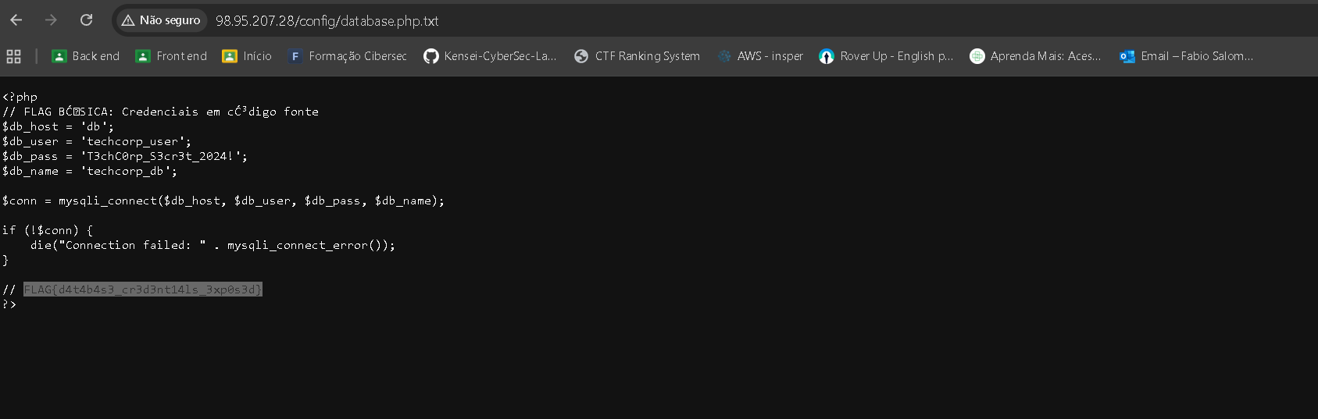
<?php
// FLAG BĆSICA: Credenciais em cĆ³digo fonte
$db_host = 'db';
$db_user = 'techcorp_user';
$db_pass = 'T3chC0rp_S3cr3t_2024!';
$db_name = 'techcorp_db';
$conn = mysqli_connect($db_host, $db_user, $db_pass, $db_name);

if (!$conn) {
die("Connection failed: " . mysqli_connect_error());
}

// FLAG{d4t4b4s3_cr3d3nt14ls_3xp0s3d}
?>

FLAG{d4t4b4s3_cr3d3nt14ls_3xp0s3d} 10+

FLAG{b4ckup_scr1pt_f0und} -------------------- erro flagh claudio ------------------

