ZEDU CORE PLATFORM • DESIGN SPECIFICATION & RFC
Channel Details Dialog:
Files Tab Redesign & Document Workflow
A Slack-Grade Architecture Featuring Dual View Modes (Hybrid vs. Pure List), Direct Actions, Non-Intrusive File Cues, and Desktop-Scale Document Inspection.

Author / Designer | Fabian Muoghalu (@Fabbenco)
Engineering Team | Team Vader (Frontend Core)
Target Surface | Zedu Channel Details Dialog (`#channel-details-modal` → `Files Tab`)
Status & Version | Approved Design Proposal • Version 2.2 • October 2026

1. Executive Summary
Files shared across high-velocity communication channels represent critical project artifacts: design guides, specifications, meeting recordings, code walk-throughs, sprint assets, and audio summaries. In large teams (such as Zedu channels exceeding 2,000 members), finding, previewing, and acting on files is a foundational daily routine.
The current production implementation of the Files tab suffers from severe usability and visual limitations: files are dumped into an undemarcated single stream, hovering over items triggers cramped popups that obstruct the screen, primary actions like downloading or sharing require circuitous clicks, and inspecting multi-page documents opens a tiny, cramped modal dialog where text is illegible.
This design proposal establishes a comprehensive, Slack-grade redesign of the Files tab within the existing channel details bounds (600px × 600px), paired with a wide desktop-grade document preview experience. Key architectural achievements include:
- Sub-Category Demarcation: Immediate filtering via All, Documents (first right after All), Images, Videos, and Audio pills.
- Dual View Mode System: Providing users with a Hybrid view (square media gallery on top + documents below) and a Pure List view (every item presented as a uniform list row).
- Subtle Micro-Interaction Cues: Replacing invasive hover previews with clean, contextual 'Open file ↗' and 'Play video ↗' cues.
- Direct Action Suite: Exposing immediate Download, Share, and Open in Browser action buttons directly on document cards.
- Wide Multi-Page Document Preview: Expanding the document modal to 1024px with thumbnail page navigation, zoom, fit, print, and instant sharing controls.
📌 ZERO-REGRESSION DESIGN OBJECTIVE: The redesign preserves the established channel details modal dimension (600px × 600px) and navigation tabs (About, People 303, Agents, Files 24), elevating information density, aesthetics, and user productivity without disrupting user muscle memory.

2. Problem Statement & Production UX Audit
A rigorous heuristic evaluation of the current production channel details dialog revealed five critical UX defects that hinder team collaboration and asset discovery:
❌ Defect 1: Undemarcated Clutter & Media Pollution: In the current Files tab, all file types are grouped together without category isolation. When members upload numerous screenshots or video clips, important text specifications, PDF guidelines, and contracts are pushed far down the list, forcing users into tedious continuous scrolling.
❌ Defect 2: Invasive & Broken Hover Preview Popups: Attempting to preview a file in the existing interface renders a 350px-400px floating tooltip directly over the list cursor. This popup obscures adjacent files, triggers accidental dismissed clicks, and cannot render documents legibly, causing friction and frustration.
❌ Defect 3: Missing Direct Actions on Document Cards: Users cannot perform essential document tasks—such as downloading a PDF, sharing an internal asset link, or opening a document in a dedicated browser tab—directly from the card row. Users are forced to open the file first, perform extra clicks, and navigate away from context.
❌ Defect 4: Cramped, Narrow Document Preview Modal: When a document (e.g., Ticket_Guide_Stage1.pdf) is opened, the current preview dialog renders in a constrained vertical box (~450px wide). Margins are crushed, headings are truncated, multi-page thumbnails are absent, and interns or contributors cannot read stage guides without extreme zooming and awkward horizontal panning.
❌ Defect 5: Rigid Layout Without User Customization: Power users reviewing legal documents or audit logs prefer high-density list scanning, whereas creative teams prefer visual image thumbnails. The current interface forces a single rigid layout without a clean toggle mechanism.

Figure 1: Production State Analysis (Before Redesign)
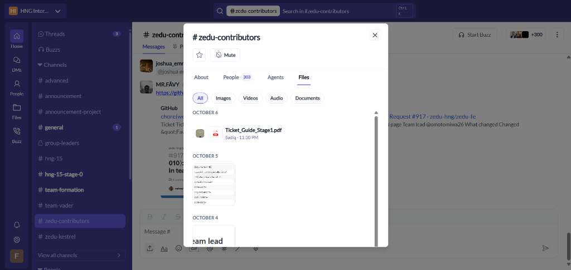  A: Current Files Tab (Undemarcated, mixed stream) | 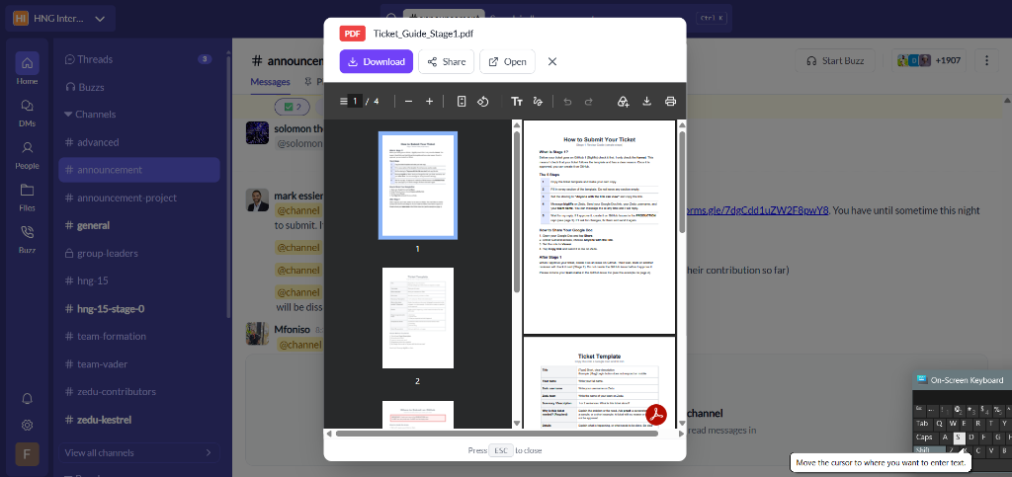  B: Current Document Modal (Cramped ~450px width)

3. Proposed Design Architecture & Core Pillars
To solve the identified defects while maintaining high performance and elegance, the redesign is structured around five foundational pillars:

Pillar 1: Sub-Toolbar Hierarchy & Category Demarcation
Directly below the channel details navigation tabs, a dedicated sub-toolbar provides immediate search and type demarcation:
• Instant Search: Real-time debounced query input with live count feedback.
• Demarcated Category Pills: All (24) → Documents (10) [ordered first after All] → Images (8) → Videos (4) → Audio (2).
• Strict Content Separation: Clicking 'Videos' isolates video files exclusively; clicking 'Images' displays images only; clicking 'Documents' shows docs only. The 'All' tab provides the unified overview.

Pillar 2: Dual View Mode System (Hybrid vs. Pure List)
Users can toggle between two purpose-built visualization modes using a segmented toggle button placed in the toolbar:
- Mode 1 (Hybrid Layout — Default): Employs an aspect-square (1:1) 4-column media grid at the top of each date section for rich visual assets (PNG, JPG, MP4 previews with timestamp pills), while documents (PDF, DOCX), Figma files, and audio notes are stacked in structured rows below. This achieves the optimal balance between visual browsing and textual detail.
- Mode 2 (Pure List Layout): Converts all items—including images and video clips—into uniform row-by-row cards. Each row features a 36px icon with format badge (PNG, JPG, MP4, PDF), file name, inline open cue, file size pill, uploader avatar, upload timestamp, and action buttons. Perfect for audit logs, administrative reviews, and high-density scanning.

Pillar 3: Non-Intrusive Micro-Interaction: Inline 'Open file ↗' Cue
The annoying floating hover thumbnail popup is permanently eliminated. In its place, card rows display a tiny, tasteful text cue: 'Open file ↗' (or 'Play video ↗' / 'Play audio ↗') rendered in primary brand indigo (#5F5FE1). On row hover, the cue subtly illuminates and underlines, giving users clear affordance that clicking opens the file without triggering visual obstruction.

Pillar 4: Direct Primary Document Action Buttons
Each document row features an integrated action cluster that appears on hover and remains fully keyboard-accessible:
• Download: Instant file download with progress feedback.
• Share: Copies channel file permalink to clipboard with toast notification.
• Open in Browser: Opens document directly in a new browser tab for native viewing.

Pillar 5: Wide Multi-Page Document Preview Modal (Desktop-Scale)
To address the cramped document modal defect, clicking any document launches a high-fidelity, desktop-grade preview modal designed to professional standards:
• Expansive Canvas: 1024px maximum width (up to 90vw) and 88vh height, centered over a frosted glass backdrop.
• Interactive Page Rail (140px): Interactive vertical thumbnail sidebar displaying page previews (Page 1, 2, 3, 4) with active page highlights.
• Dedicated PDF Control Toolbar: Displays current page counter ('Page 1 / 4'), Zoom Out (−), 100% scale indicator, Zoom In (+), Fit to Width (⛶), Rotate Clockwise (↻), and Print (🖶).
• Full Top Header Suite: Displays document title, file size, uploader metadata tag, and quick Download, Share, Open in Browser, and Close (✕) action pills.

Figure 2: Redesigned Interface & High-Fidelity Prototypes
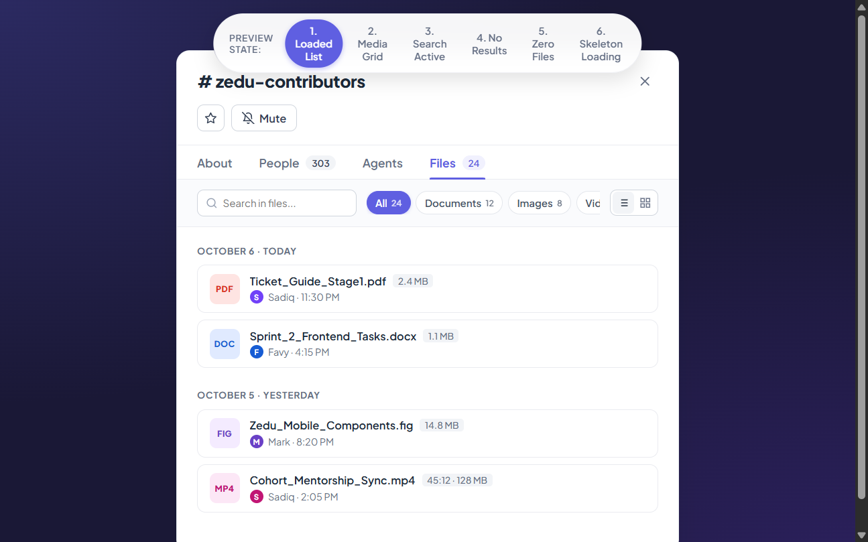  A: Hybrid View Mode (Square media grid + Doc rows) | 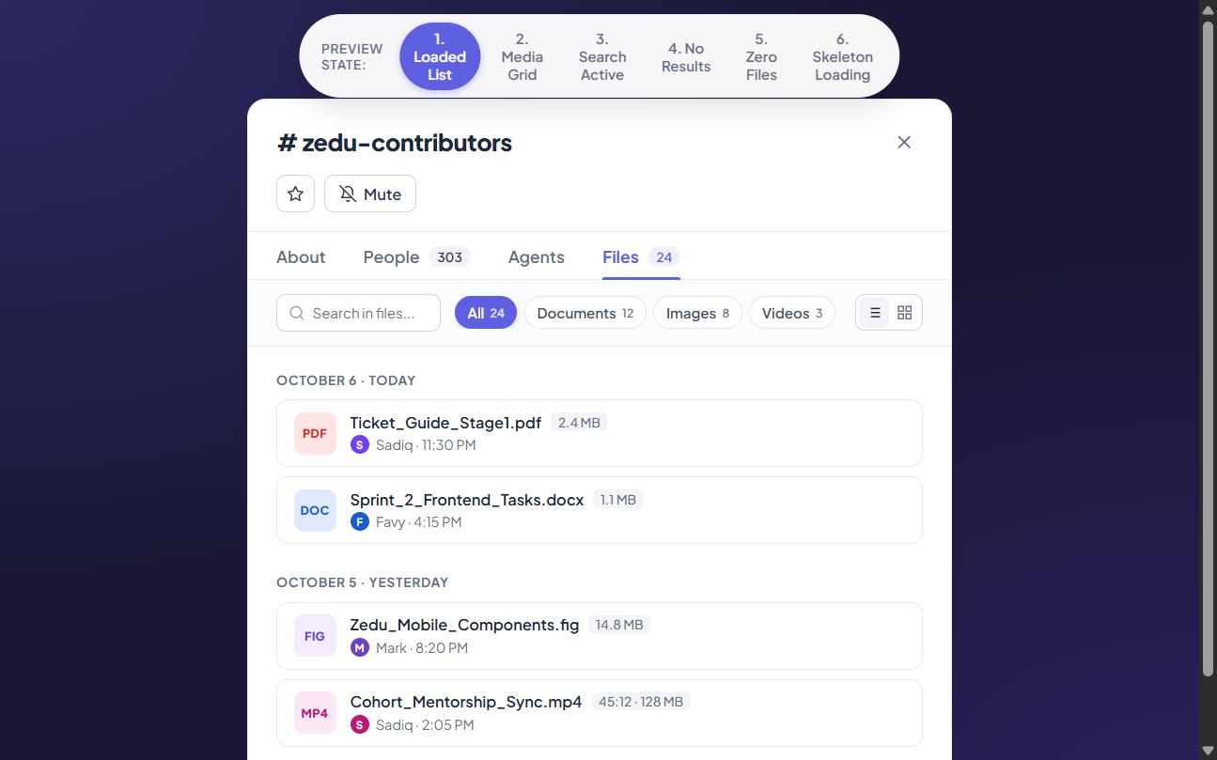  B: Pure List View Mode (Every file listed row-by-row)

4. Before vs. After Detailed Comparison Matrix
UX Dimension | Current Production State (Before) | Redesigned Implementation (After)
Category Organization | All files dumped into a single unsorted feed. No sub-tabs. | Demarcated pills: All (24), Documents (10) first, Images (8), Videos (4), Audio (2).
Layout Modes | Single fixed layout; no user toggle or personalization. | Segmented Dual Toggle: Hybrid Mode (Media grid + Doc list) and Pure List Mode.
File Interaction / Preview | Intrusive 400px hover popup that obstructs the screen. | Subtle, non-blocking inline 'Open file ↗' cue. Zero screen clutter.
Document Actions | No actions on file row. Requires opening the file first. | Direct Download, Share link, and Open in Browser buttons directly on row hover.
Document Preview Width | Cramped vertical dialog (~450px wide). Margins clipped. | Expansive 1024px multi-page modal with thumbnail page sidebar and PDF tools.
Multi-Page PDF Support | Single unpaged vertical scroll without thumbnails. | Dedicated 140px interactive thumbnail sidebar with active page indicators.
Video & Media Treatment | Small inline thumbnails mixed with text files. | Rich 1:1 aspect ratio square media grid with play buttons and timestamp tags in Hybrid mode.
State Handling | Basic loading indicator. Missing empty/error states. | Fully styled Loading Skeletons, Empty Channel State, Zero-Match Search, and Retry State.

5. State Management & Comprehensive Edge Cases
To deliver a robust, production-ready implementation, all application states have been designed and validated:
- 1. Populated State (Default): Displays date-grouped file collections with full counters, media grid thumbnails, and metadata rows. Supports both Hybrid and List rendering.
- 2. Filtered States (Docs, Images, Videos, Audio): Instantly filters file list to single content type. Category counters reflect accurate item counts without layout shift.
- 3. Active Search State: Filters file results in real-time as user types into `#file-search-box`. Highlights matching file name strings.
- 4. Zero Search Results State: Renders an illustrative 'No files found' state with a friendly search icon and a 'Clear Search' button that restores default view in 1 click.
- 5. Channel Empty State: When a newly created channel has no uploaded files, displays an inspiring empty state icon with 'Share the first file' call-to-action button.
- 6. Skeleton Loading State: When fetching files over high-latency connections, presents pulsing shimmer cards matching the exact dimensions of file cards and media squares to prevent Cumulative Layout Shift (CLS = 0.0).
- 7. Error & Offline State: If network request fails, displays a non-blocking error badge with a 'Retry Sync' button.

6. Technical Implementation Blueprint (Zedu Frontend)
The redesign directly integrates into the Zedu Next.js/React frontend codebase (`zedu-fe`). The component hierarchy and TypeScript data structures are specified below:
📌 FRONTEND ARCHITECTURE PRINCIPLE: Components adhere strictly to existing Zedu patterns: Tailwind CSS utility tokens, Lucide-React icons, Radix UI dialog accessibility primitives, and zero external viewer bloat.

TypeScript Component Hierarchy & Data Model:
// 1. Data Model Interface
export type FileCategory = 'all' | 'documents' | 'images' | 'videos' | 'audio';
export type LayoutMode = 'hybrid' | 'list';
export interface ChannelFile {
id: string;
name: string;
url: string;
sizeBytes: number;
formattedSize: string;
extension: 'pdf' | 'docx' | 'png' | 'jpg' | 'webp' | 'mp4' | 'm4a' | 'fig';
category: 'document' | 'image' | 'video' | 'audio';
uploadedAt: string; // ISO date
uploader: {
id: string;
username: string;
displayName: string;
avatarUrl?: string;
};
duration?: string; // For audio & video
pageCount?: number; // For PDF/DOC documents
}
// 2. Component File Organization
components/channel-details/
├── channel-details-modal.tsx // Root modal (maintains 600px x 600px)
└── files-tab/
├── files-sub-toolbar.tsx // Search bar, category pills, layout mode toggle
├── files-tab-container.tsx // Main date-grouped container & mode switcher
├── file-card-row.tsx // Document / list row card with direct actions
├── media-grid-tile.tsx // 1:1 square media thumbnail for Hybrid mode
└── wide-doc-preview-modal.tsx // 1024px desktop-grade multi-page viewer

7. User Acceptance Criteria (UAC)
✅ UAC-1: Category Pill Demarcation: Sub-filter pills display in exact order: All, Documents (first right after All), Images, Videos, Audio. Clicking 'Videos' displays only videos; clicking 'Images' displays only images; clicking 'Documents' displays only documents; clicking 'All' shows all items.
✅ UAC-2: Dual View Toggle: A segmented toggle allows switching between 'Hybrid' and 'List'. In Hybrid mode, images and videos render in square 1:1 grids at the top of each date section. In List mode, all items render row-by-row with individual format tags, metadata, and action buttons.
✅ UAC-3: Elimination of Hover Popups: Hovering over file items displays a clean inline text cue ('Open file ↗' or 'Play video ↗'). No floating hover cards obstruct the screen.
✅ UAC-4: Direct Document Action Buttons: Document rows render Download, Share, and Open in Browser action buttons on hover/focus. Clicking Download initiates instant download without extra dialogs. Clicking Share copies file permalink.
✅ UAC-5: Wide Desktop-Grade Document Preview Modal: Clicking a document opens a 1024px wide modal (88vh max height) with a 140px thumbnail sidebar showing multi-page cards (Page 1, 2, 3, 4). Includes page counter, zoom controls, fit, rotate, print, download, and close (✕) actions.
✅ UAC-6: Zero Layout Shift & Keyboard Accessibility: Modal supports full ESC key dismiss, Tab navigation, and WCAG AA contrast compliance (minimum 4.5:1 text contrast).

8. Implementation Roadmap & Sign-Off
Phase | Milestone / Deliverable | Target Owner | Timeline
Phase 1 | Interactive Design Prototype & Spec Approval | Fabian Muoghalu (@Fabbenco) | Completed
Phase 2 | Sub-Toolbar, Category Demarcation & Direct Actions | Team Vader Frontend | Sprint 2, Days 1-2
Phase 3 | Dual View Toggle (Hybrid & Pure List modes) | Team Vader Frontend | Sprint 2, Days 3-4
Phase 4 | Wide Multi-Page Document Preview Modal & QA Testing | Team Vader & QA | Sprint 2, Day 5

— End of Design Proposal Document —
Ready for Review & Frontend Implementation in Zedu Core

