**Assignment 0**

Fabrice Fonkou

Date - 10/4/2022

This Project was Built on Visual Studio Code using Python, HTML, CSS, JavaScript, and Flask[SQLAlchemy] In a virtual Environment.

Step 1: Ensure all File are unzipped and extracted properly.

Step 2: Open Visual Studio Code and Head to ‘File’ -> ‘Open Folder…’

Step 3: select ‘Assignment 0’ and click ‘Select Folder’

**The folder contains 4 Folders, app.py, and a db.sqlite3.

**The Templates Folder contains HTML Five HTML codes

**Static Folder contains a css and js folders.

**We will focus on app.py folder.

Step 4: Open app.py file and click on the ‘Run Python File’

Step 5: A link will be provided after Runing app.py. In this case <http://127.0.0.1:5000>

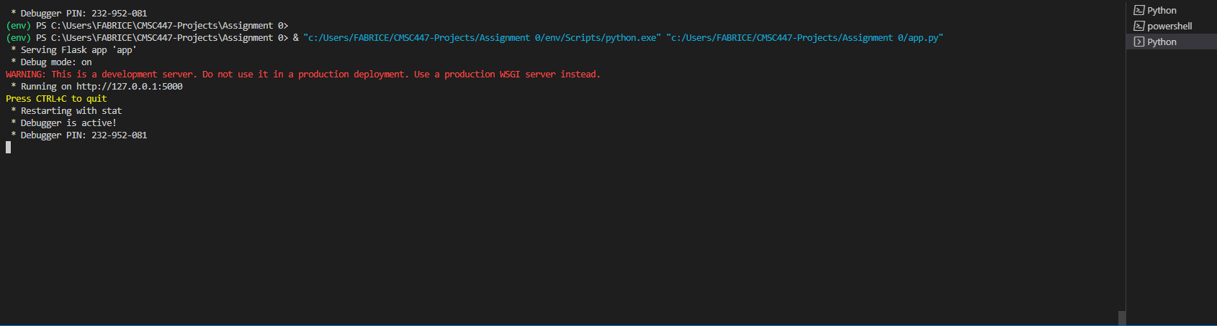

Congratulations! The Website Is up and Running!

**‘CTRL + C’ will end the server.**

**Homepage Layout**

The main Page consists of Student, Course, and Instructor Header, Clicking on any one of these will allow you to add, edit, or remove data from the database.

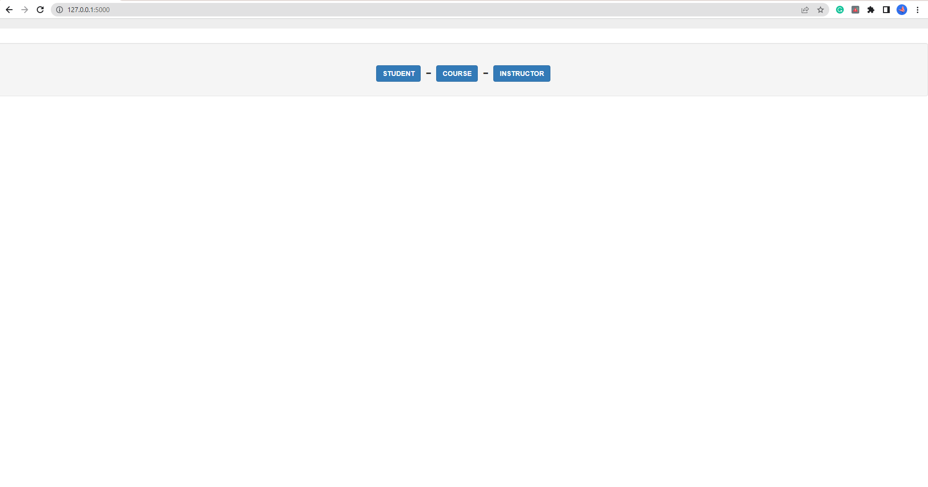

**Student Layout**

Student Layout, Allows you to view list of current students, Add new students. Edit each Student info (ID, Name, Credit Earned), delete students, and view which course they are enrolled in.

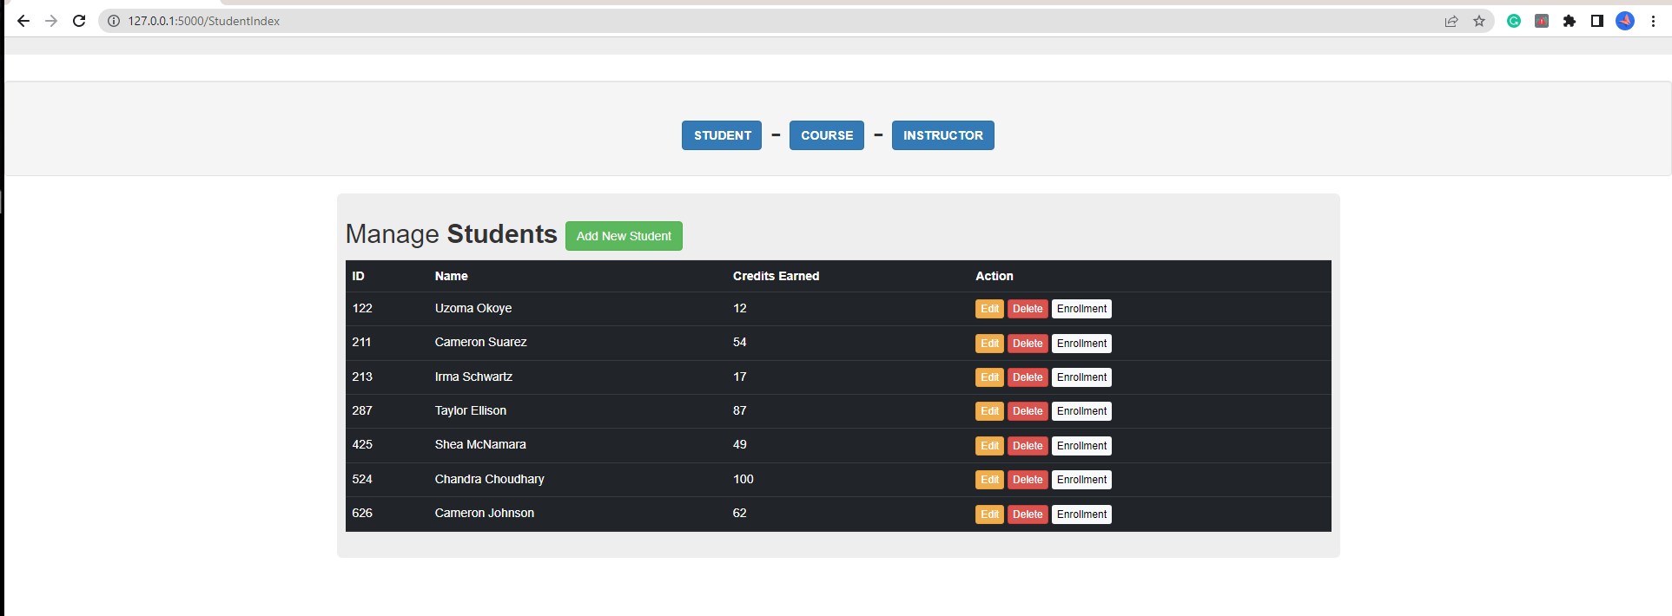

**Note: Anything with an Asterisk ‘*’must be filled out and anything without it are optional.**

**Instructor Layout**

Just like the Student Layout, The Instructor Layout allows the User to edit and delete Instructor. Each list contains ID, Name, and Department.

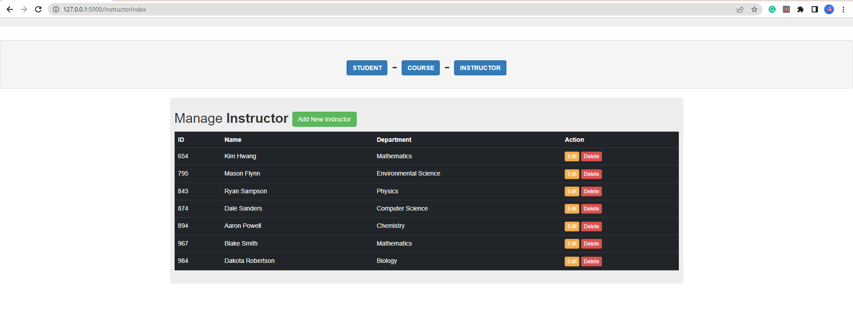

**Course Layout**

The Course Layout allows the User to View, Add, Edit and Delete each course. Another feature this page has, is the Add/Drop action which allows the User to add and drop students from each course. **Some important Note**: A course can NOT be deleted unless you

remove all enrolled students and Instructor. To remove instructor from a course, you must click ‘Edit’ and under ‘Instructor’ typing ‘**000’** will remove current Instructor from the course. You can Not remove an instructor without First emptying students from class.

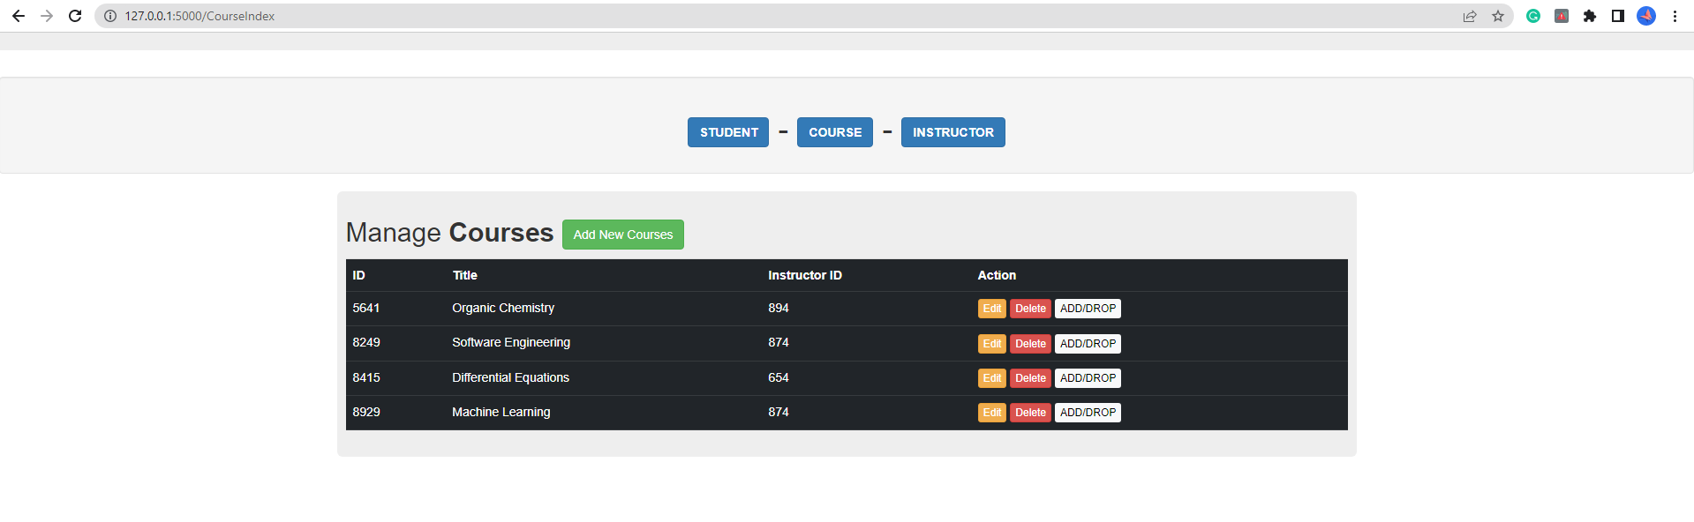

**Course Layout [ADD/DROP]**

Add/Drop student to course allows you to view each student enrolled and drop each student. Each student can be enrolled to into infinity courses and each course can have infinity students

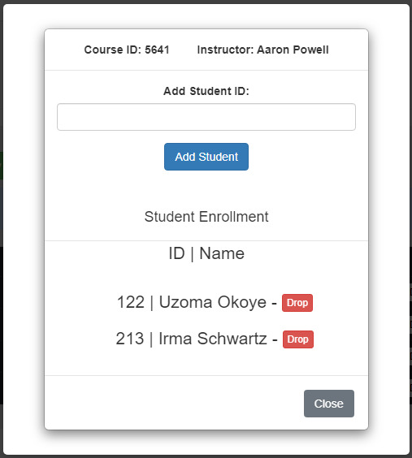

**E-R Diagram**

