
CSF3133
Web Interface Design
LAB REPORT 7

NAME: Lim Jun Han
MATRIC NUMBER: S76171
GROUP: K4
DATE: 19/11/2025

8.5 Bootstrap Text/Typography

8.5.1 Headings


8.5.2 Display Headings
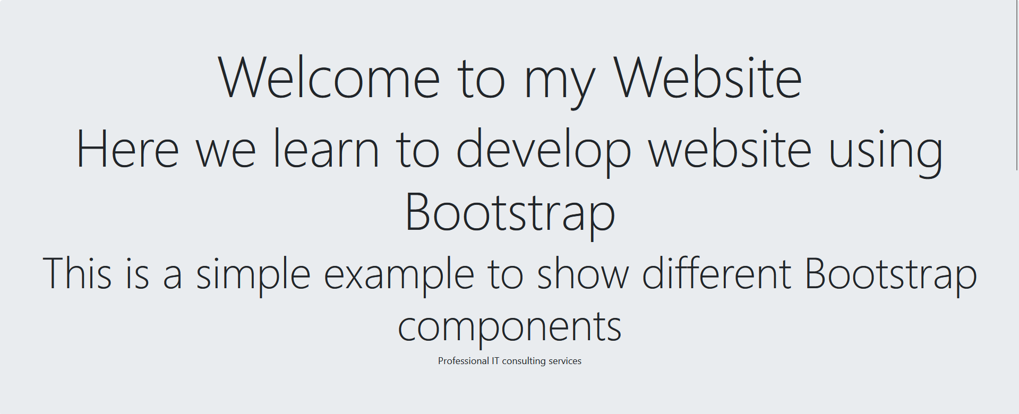

8.5.3 Inline Texts Elements
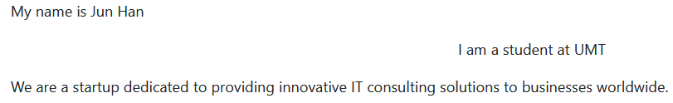
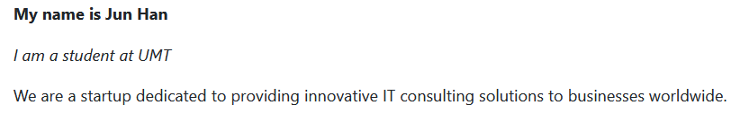

8.5.4 Text Color and Background
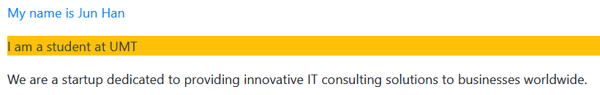

8.5.5 Text Wrapping and Overflow
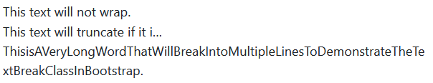

8.5.6 Font Size
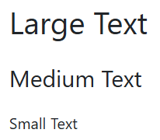

8.5.7 Font Weight and Style
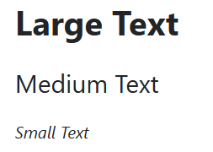

8.5.8 Line Height
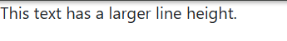

8.5.9 Lists
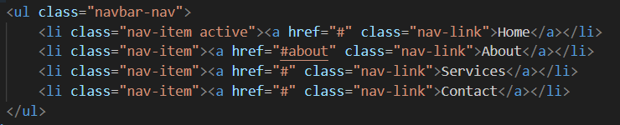


8.6 Bootstrap CSS Forms

8.6.1 Basic Form Structure
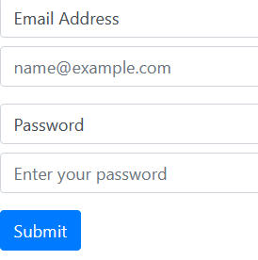

8.6.2 Form Layouts
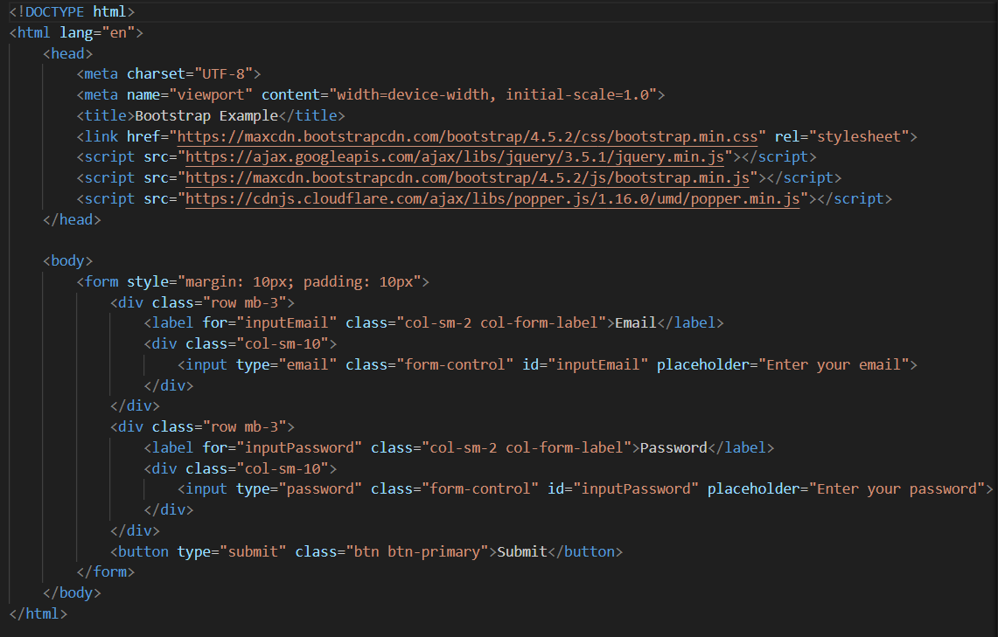
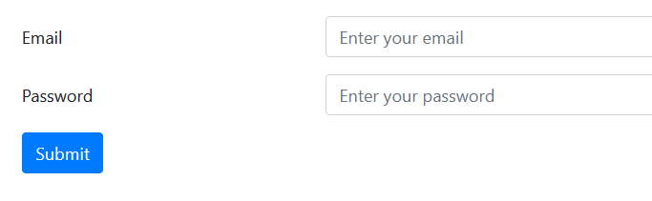

8.6.3 Inline Forms


8.6.4 Form Controls
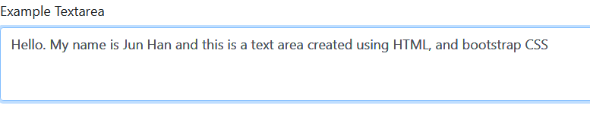

8.6.5 Select Menus
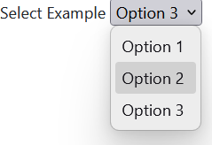

8.6.6 Form Validation
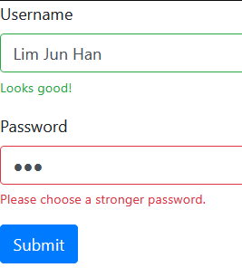

8.6.7 Checkboxes and Radios
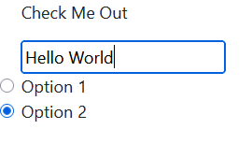

8.6.8 Input Groups
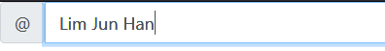

8.6.9 Floating Labels
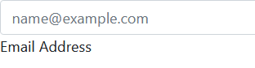

8.6.10 Disabled and Read Only Inputs
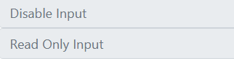

8.6.11 Example Form
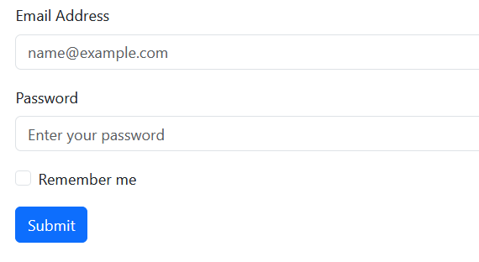

8.7 Using BootStrap Theme

