
CSF 3133 Web Interface Design
Lab Module 3

Name | Lim Jun Han
Matric No. | S76171
Date | 5/11/2025
Lab | MP2
Lecturer | Ts. Dr. Nural Jawahir Binti Hj Wan Yussof

Activity 3.2
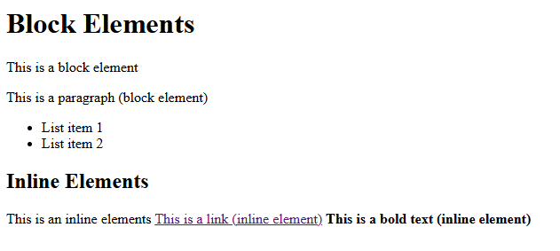

Activity 3.3
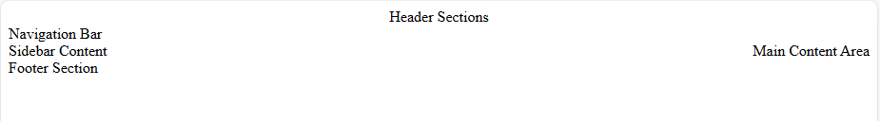

Activity 3.4
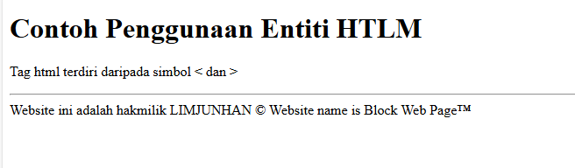

Activity 3.5
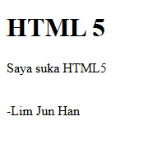
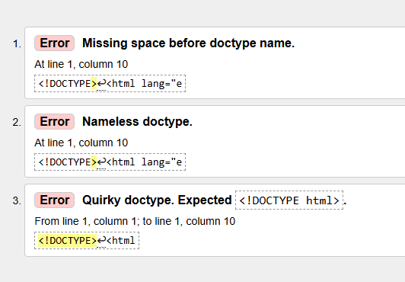
While the website displays everything properly. When validating the website, 3 errors are shown.
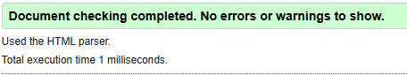
An error occured because the doctype element is not inputted correctly. To fix this error, we must name the doctype as html lang=’en’ which specifies the document language as English.

Activity 3.6

Activity 3.6.1
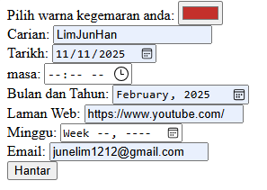
Input Elements in HTML5

Activity 3.6.2
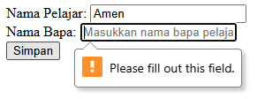
If name of the father is not input. The page will not let the user submit as the nama bapa field is a required input.
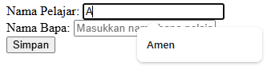
The autocomplete works as Amen will appear after ‘A’ is typed in.

Activity 3.6.3
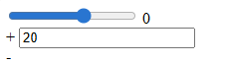

Lab Exercise