
CSF3133
Web Interface Design
LAB REPORT 4

NAME: Lim Jun Han
MATRIC NUMBER: S76171
GROUP: K4
DATE: 12/11/2025

4.2 Page Structure Elements
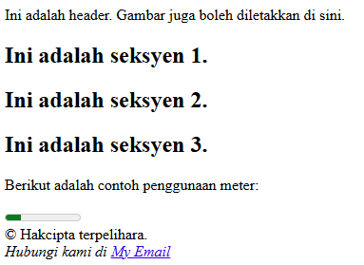

4.3 Insert Video into HTML5 Document
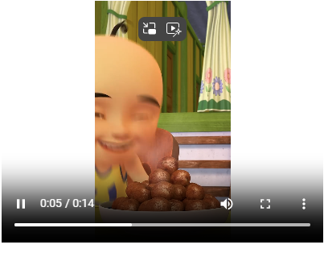

4.4 Cascading Style Sheets


4.5 Recognise ID and Selector Class


4.6 Navigation Bar using CSS
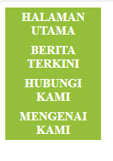

4.7 Recognising Text Decoration
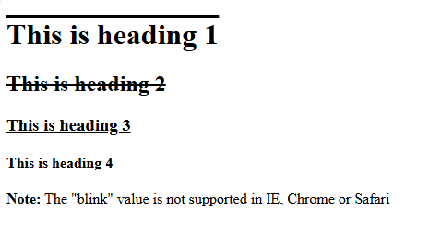
4.8 Recognising Styling Links
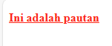
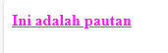
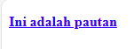
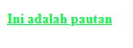
4.9 Lab Exercise
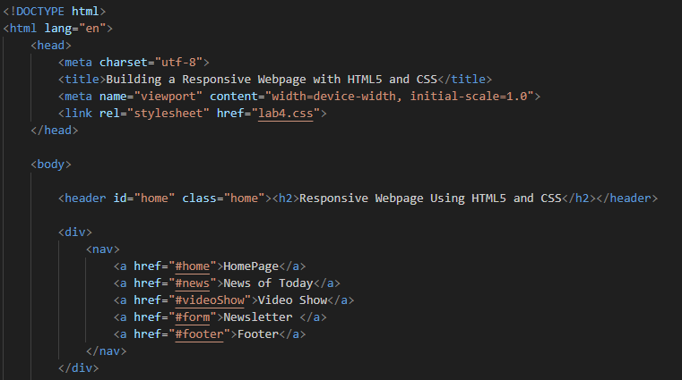

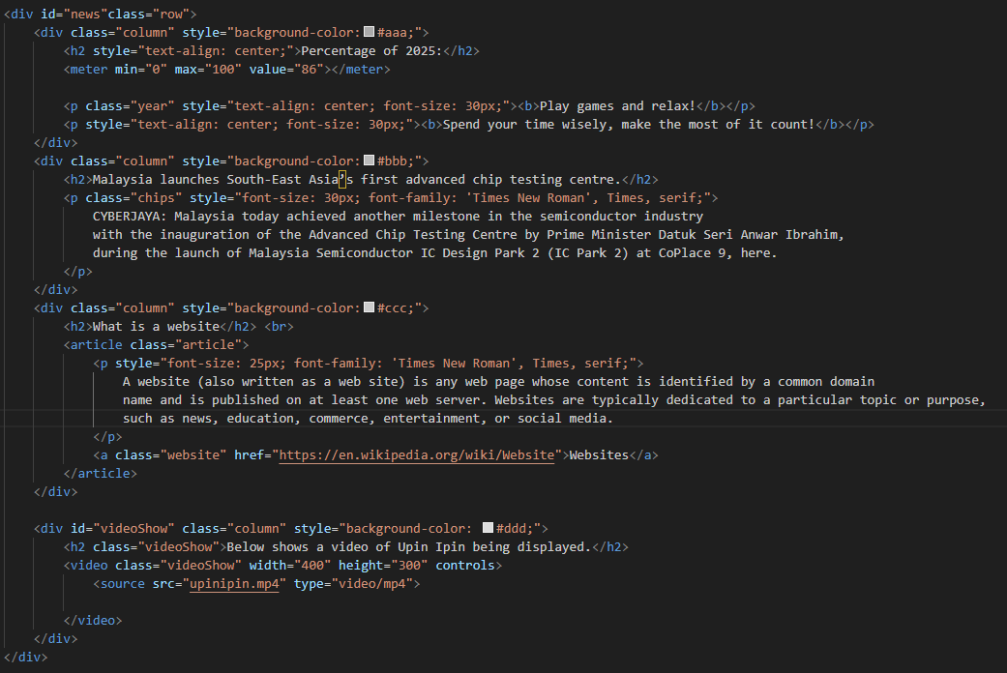
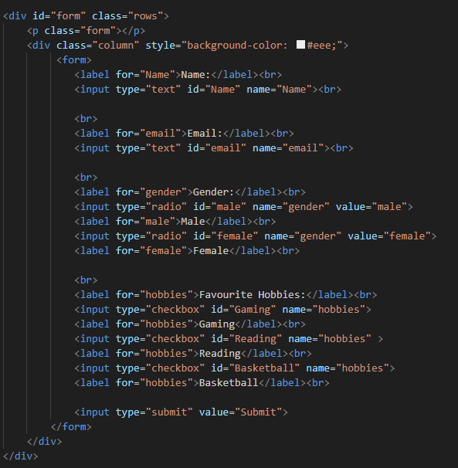

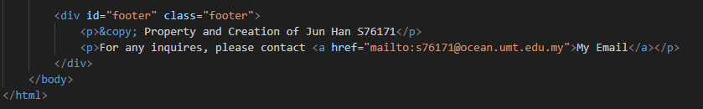

Lab4.css
