Opened terminal, used «bash» to invoke the shell.

First of all we shall check our git version by entering git —version command

lets do a new local repo by mkdir command && git init

following the task i cloned my C repo from github.com to this directory(local git repo)

on the next line we should check the data by executing ls command in local repo

and finally i will configure git account and default(core) editor

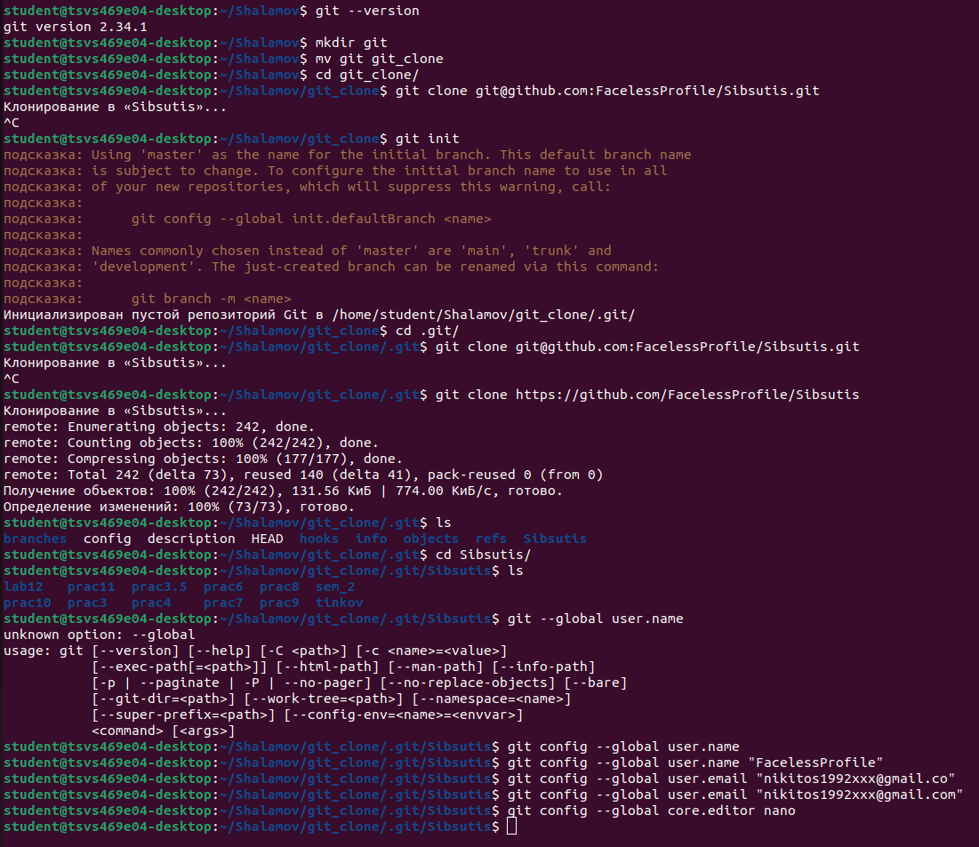

lets check the git status and git log

by writing the according commands

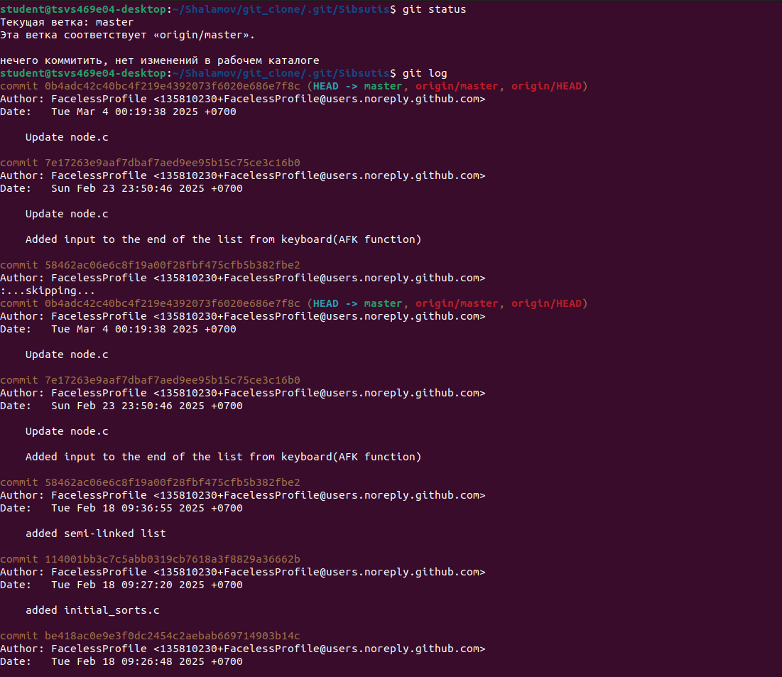

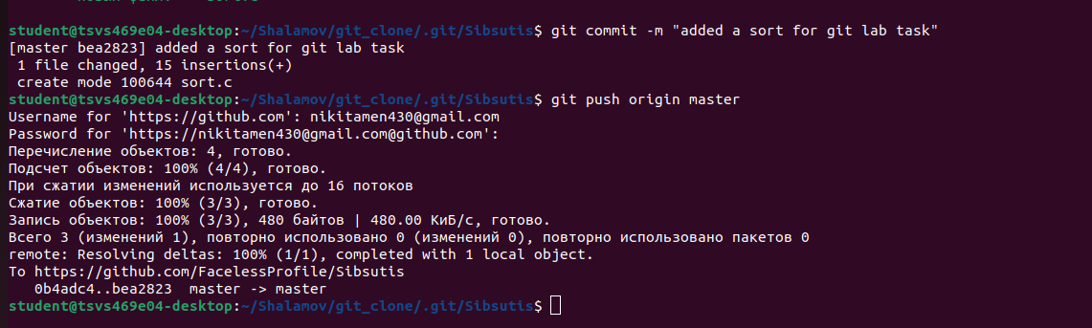on the next stage i created and commited select sort func to remote git repo

so doing the next point of the task i commited some komentarey in my sort func to my remote repo

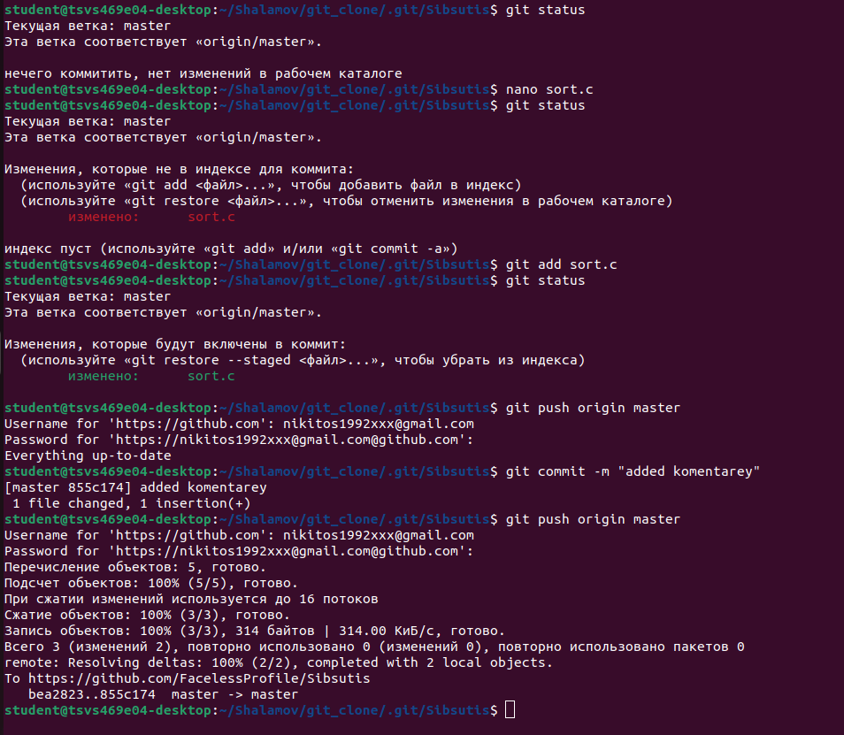

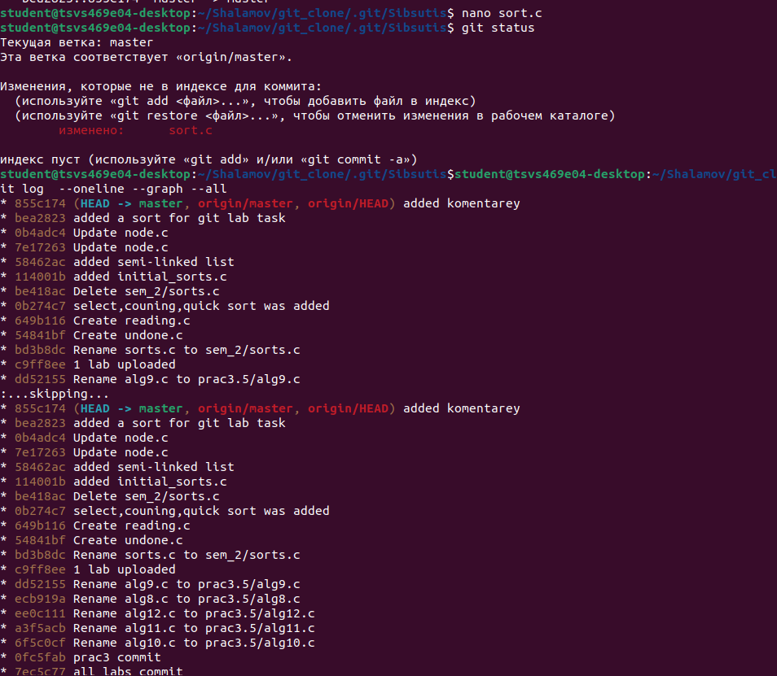

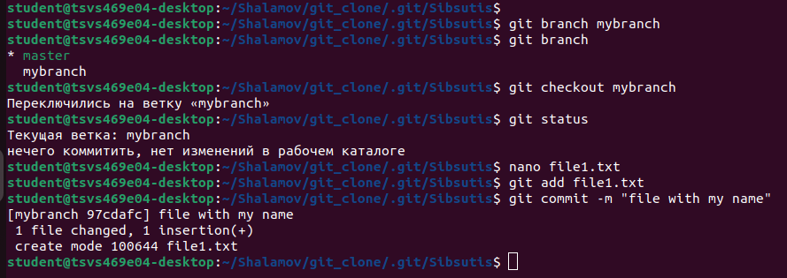

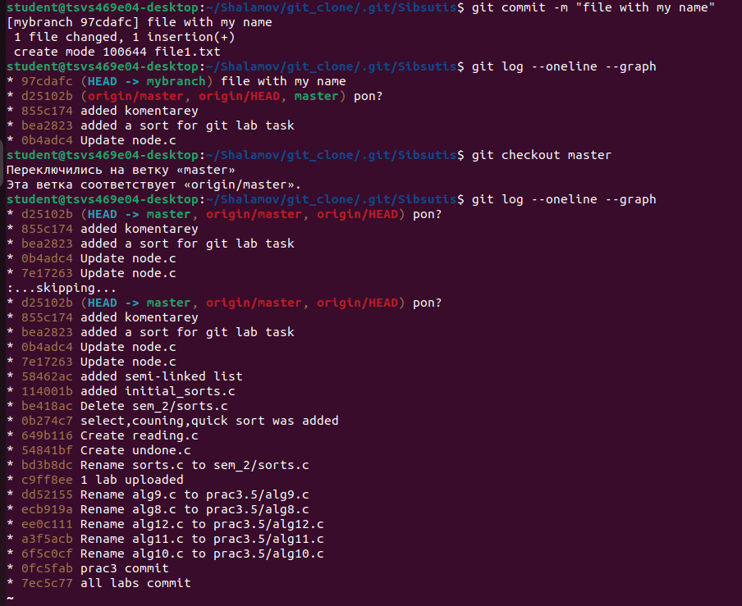

now head is pointing on master branch

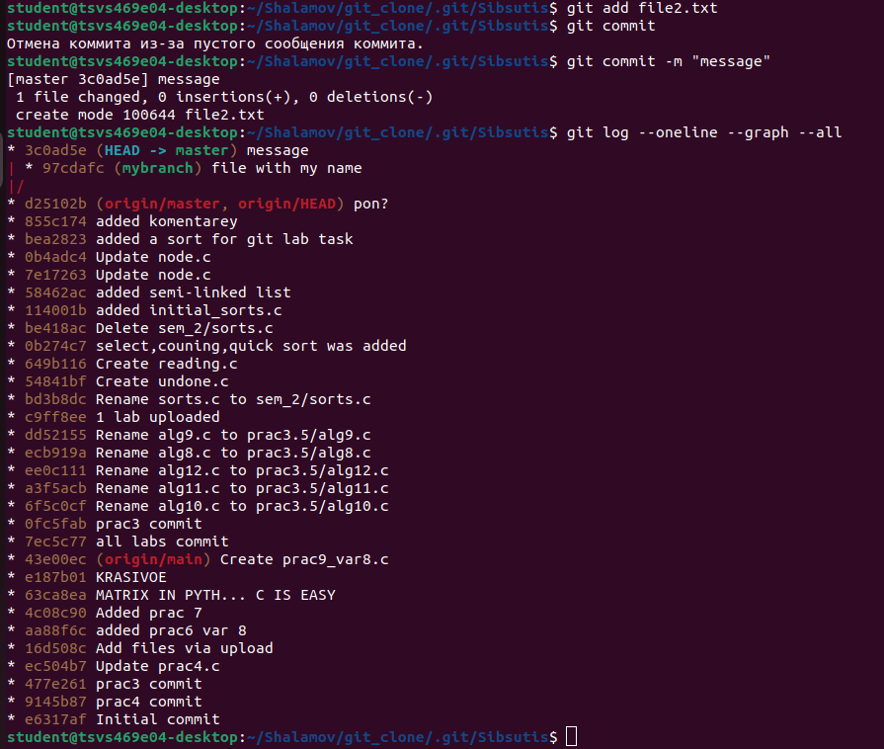

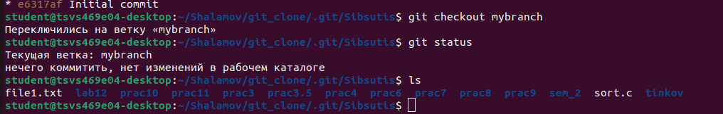

file 2 disappeared