**Final Year Project**

Project Synopsis

**Facial Recognition**

**Attendance Management**

*Submitted in fulfilment of*

*the requirements for the paper*

*PROJ-IT781*

**Bachelor of Technology**

**In**

**Information Technology**

Submitted By,

|  |  |
| --- | --- |
| Name:  Stream:  Semester:  Year:  Session:  University Roll No:  Registration No: | Abir Bhattacharya  Information Technology  7th  4th Year  July – December, 2022  16500219064  002046 of 2019-20 |

Group Details,

|  |  |  |
| --- | --- | --- |
| Roll No | Registration No | Name |
| 16500219055  16500219039  16500219056  16500219050 | 004313 of 2019-20  005507 of 2019-20  004272 of 2019-20  004848 of 2019-20 | Arkamitra Mukherjee  Padma Chhatait  Anusweta Das  Basudhara Mita |

________________________



Calcutta Institute of Engineering and Management

Department of Information and Technology

Kolkata, West Bengal – 700040

**Facial Recognition**

A facial recognition system is a system which is capable of detecting a human face from a given image or video. It primarily works by detecting facial landmarks on a face and comparing it with the predefined landmarks of an image in the database. [1]

Broadly the Steps of Facial Recognition can be classified into four parts:

1) Representing the Image on a 2D graph: This is the first step of any kind of Image Processing, and so is the case for Facial Recognition.

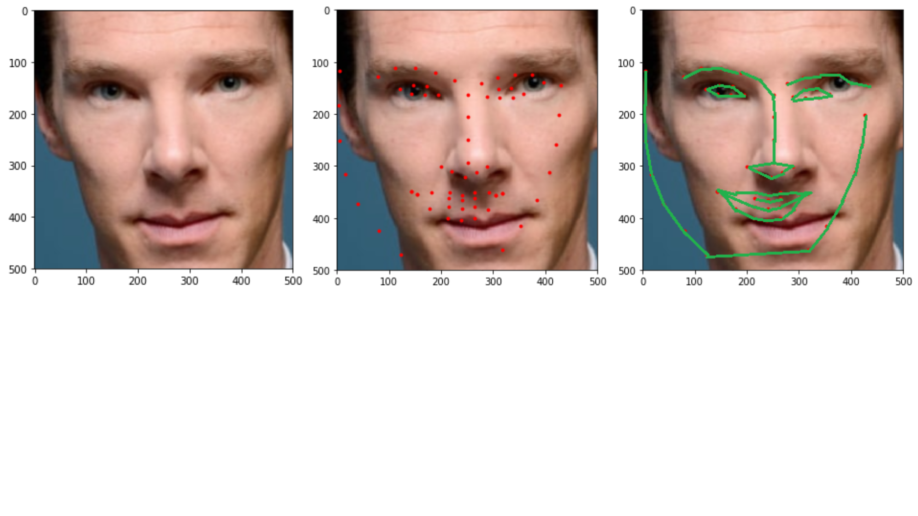

[2] Actual Image

2) Detecting Landmarks: Landmarks are determined by the help of predefined features. In case of a Human Face the features include nose, eyes, lips etc. However identifying these features is completely based on a set of dataset which is containing values in the form of a 2D matrix defining how a human facial feature would generally look like.



[2] Image with Landmarks

3) Generating Blueprint of Face: The Blueprint of a face is generated by connecting the dots of the landmarks generated in the previous step. This blueprint is unique for each human being except identical twins in some cases.



[2] Blueprint of Image

4) Comparison: The Last step of Facial Recognition is comparing it with an already present blueprint in the database. In this case the generated blueprint will be checked with all the other blueprints in the database and find the closest match possible. Most of the times a matching accuracy of more than 70-80% is the result. Once the blueprints are matched the respective name of the person is the answer whose face it is.

**Attendance Management System**

An attendance system is a smart way of keeping track of attendances of a bunch of individuals. Previously when there was no computer attendances were kept using an attendance register which was obviously a hard copy. With the revolution in technology attendance management became easier as well. Software like Ms Excel, Google Sheets and other spreadsheets became popular ways of managing attendance. Later on came several other software which incorporated the working of a spreadsheets into a database table.

**Problem Statement**

There have been several attendance systems which detects a man or woman’s face and registers their attendance. In case of a Classroom as well student’s when entering through the door might look at a camera and their face gets detected to automatically register their attendance. However this method has got certain disadvantages:

1. It is time consuming: The students have to stand in queue in order to get their attendance registered.
2. The process requires a software to be downloaded by the administration to monitor the proper working of the software.
3. Requires installation of a camera only for registering attendance purpose.

**Hypothesis**

Facial Recognition Attendance Management is capable of individual faces from an image including a group of people with different faces. In this way we can generate a list of student present in a class by taking images of the class from 2-3 angles using the CCTV cameras installed inside the class. Once the list of students is generated their attendances can be allotted in a databases by making a POST API call.

For the working of this system no other software is needed to be installed because the entire process can be implemented on a website.

Thus techstacks which will be required for this project are:

1. Mongo DB (For recording student attendances persistently)
2. Node.js (For making the APIs needed for this project)
3. HTML (For frontend scripting of the website)
4. CSS (For styling the frontend)
5. Vanilla JavaScript (For making the API calls)

Other open source services used:

1. face-api.js by Vincent Muhler [3]
2. cloudinary [4]

**References**

[1] <https://en.wikipedia.org/wiki/Facial_recognition_system>

[2] <https://medium.com/ml-everything/how-facial-recognition-works-part-2-facial-landmarks-72f1b0e2a33a>

[3] <https://justadudewhohacks.github.io/face-api.js/docs/index.html>

[4] <https://cloudinary.com/>