Fact Based Modeling – Exchange MetaModel

XML Schema Definition

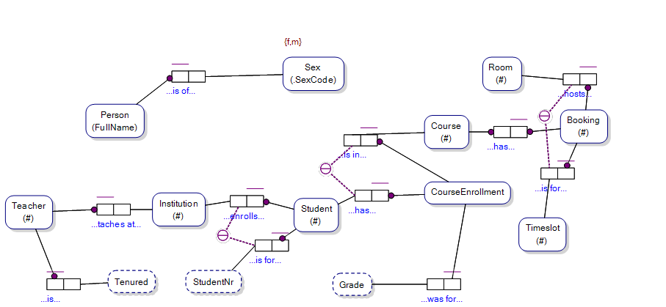

<?xml version="1.0" encoding="utf-8"?>
<xs:schema xmlns:msdata="urn:schemas-microsoft-com:xml-msdata" xmlns="" id="Model" xmlns:xs="http://www.w3.org/2001/XMLSchema">
<xs:element name="Instance">
<xs:complexType>
<xs:sequence>
<xs:element minOccurs="0" maxOccurs="unbounded" ref="String" />
</xs:sequence>
</xs:complexType>
</xs:element>
<xs:element name="String" nillable="true">
<xs:complexType>
<xs:simpleContent msdata:ColumnName="string_Text" msdata:Ordinal="0">
<xs:extension base="xs:string" />
</xs:simpleContent>
</xs:complexType>
</xs:element>
<xs:element name="Concept">
<xs:complexType>
<xs:attribute name="GUID" type="xs:string" />
</xs:complexType>
</xs:element>

Version: | V0.1
Table of Contents

1 Instance 3
1.1 Overview 3
1.2 XSD Text 3
2 String 4
2.1 Overview 4
2.2 XSD Text 4
2.3 Sample XML 4
3 RoleConstraintRole 5
3.1 Overview 5
3.2 XSD Text 5
4 Fact 6
4.1 Overview 6
4.2 XSD Text 6
5 Model 7
5.1 Overview 7
5.2 XSD Text 7
6 Value Types / ValueType / ValueConstraint 8
6.1 Overview 8
6.1.1 ValueTypes Element 8
6.1.2 ValueType Element 8
6.1.3 ValueConstraint Element 8
6.2 XSD Text 8
6.2.1 Sample XML 9
7 EntityTypes / EntityType 10
7.1 Overview 10
7.1.1 EntityTypes Element 10
7.1.2 EntityType Element 10
7.1.3 ReferenceModeRoleConstraint Element 10
7.2 Attribute Definitions – EntityType Element 10
7.3 Attribute Definitions – ReferenceModeRoleConstraint 11
7.4 XSD Text 11
8 Fact Type 12
8.1 Overview 12
8.2 XSD Text 12
9 Role Constraint 13
9.1 Overview 13
9.2 XSD Text 13
10 Model Note 14
10.1 Overview 14
10.2 XSD Text 14
11 Appendix A – XSD For the ‘Model’ Artefact 15

Instance

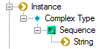

Contributors notes here:

Overview

A Object Type has a set of String values, each of which uniquely identify an Instance of that Object Type.

e.g. An Entity Type may have a unique Instance identified by a SID.

XSD Text

Below is the XSD text for the Instance artefact:

<xs:element name="Instance">
<xs:complexType>
<xs:sequence>
<xs:element minOccurs="0" maxOccurs="unbounded" ref="String" />
</xs:sequence>
</xs:complexType>
</xs:element>

String

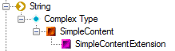

Contributors notes here:

Overview

A String element is used to store a data value of type, string.

e.g. A string value in a String element may provide the identity of an instance of an Object Type within an Instance element.

See Also: Instance element.

XSD Text

Below is the XSD text for the String artefact:

<xs:element name="String" nillable="true">
<xs:complexType>
<xs:simpleContent msdata:ColumnName="string_Text" msdata:Ordinal="0">
<xs:extension base="xs:string" />
</xs:simpleContent>
</xs:complexType>
</xs:element>

Sample XML

<String>c69ea3a6-6d73-47aa-abf6-c52311f4c3a5</String>

RoleConstraintRole

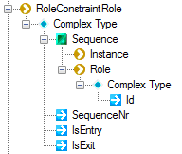

Contributors notes here:

Overview

The RoleConstraintRole element stores details of the Role/s referenced by a Role Constraint. Each Role Constraint element has a set of one or more RoleConstraintRole elements.

Each RoleConstraintRole element has a SequenceNr attribute representing the ordinal number in the sequence of RoleConstraintRole elements for a RoleConstraintRole (e.g. an External Uniqueness Constraint (RoleConstraint) may have a set of two RoleConstraintRole elements each with its own SequenceNr).

Attribute Definitions – RoleConstraintRole Element

Attribute | Definition
SequenceNr | The ordinal position of the RoleConstraintRole within the sequence of RoleConstraintRole elements for a RoleConstraint.
IsEntry | Has a value set to ‘true’ is the RoleConstraintRole element represents a RoleConstaint/Role link that is the ‘Entry’ link of a ‘Entry/Exit’ combination of RoleConstraint/Role links, else has a value set to ‘false’.  e.g. If a link to a Role from a RoleConstraint is an ‘Entry’ link of a Subset Constraint, the values of Instances referenced by that Role are the subset of Instances referenced by the Role of a corresponding RoleConstraint/Role link that is an ‘Exit’ link.
IsExit | Has a value set to ‘true’ is the RoleConstraintRole element represents a RoleConstaint/Role link that is the ‘Exit’ link of a ‘Entry/Exit’ combination of RoleConstraint/Role links, else has a value set to ‘false’.

Attribute Definitions – Role Element

Attribute | Definition
SequenceNr | The ordinal position of the RoleConstraintRole within the sequence of RoleConstraintRole elements for a RoleConstraint.

XSD Text

Below is the XSD text for the RoleConstraintRole artefact:

<xs:element name="RoleConstraintRole">
<xs:complexType>
<xs:sequence>
<xs:element msdata:Ordinal="0" minOccurs="0" name="Instance" type="xs:string" />
<xs:element minOccurs="0" maxOccurs="unbounded" name="Role">
<xs:complexType>
<xs:attribute name="Id" type="xs:string" />
</xs:complexType>
</xs:element>
</xs:sequence>
<xs:attribute name="SequenceNr" type="xs:string" />
<xs:attribute name="IsEntry" type="xs:string" />
<xs:attribute name="IsExit" type="xs:string" />
</xs:complexType>
</xs:element>

Fact

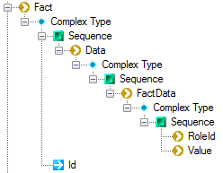

Contributors notes here:

Overview

The Fact element stores the set of FactData relevant to a Fact of a FactType.

XSD Text

Below is the XSD text for the Instance artefact:

<xs:element name="Fact">
<xs:complexType>
<xs:sequence>
<xs:element minOccurs="0" maxOccurs="unbounded" name="Data">
<xs:complexType>
<xs:sequence>
<xs:element minOccurs="0" maxOccurs="unbounded" name="FactData">
<xs:complexType>
<xs:sequence>
<xs:element msdata:Ordinal="0" minOccurs="0" name="RoleId" type="xs:string" />
<xs:element msdata:Ordinal="1" minOccurs="0" name="Value" type="xs:string" />
</xs:sequence>
</xs:complexType>
</xs:element>
</xs:sequence>
</xs:complexType>
</xs:element>
</xs:sequence>
<xs:attribute name="Id" type="xs:string" />
</xs:complexType>
</xs:element>

Model

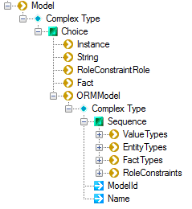

Contributors notes here:

Overview

The ‘Model’ element contains all elements that go into describing a Fact-Based Model.

XSD Text

No XSD text is provided for the Model artefact here.
See Appendix A

Value Types / ValueType / ValueConstraint

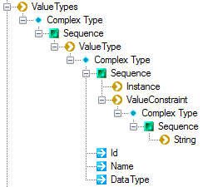

Contributors notes here:

Overview

ValueTypes Element

The ValueTypes element contains a list of ValueType elements. Each ValueType element describes a Value Type within a Fact-Based Model.

ValueType Element

The ‘ValueType’ element describes a Value Type within a Fact-Based Model.

ValueConstraint Element

The ValueConstraint element contains a sequence of String.

XSD Text

Below is the XSD text for the ValueType element:

<xs:element minOccurs="0" maxOccurs="unbounded" name="ValueTypes">
<xs:complexType>
<xs:sequence>
<xs:element minOccurs="0" maxOccurs="unbounded" name="ValueType">
<xs:complexType>
<xs:sequence>
<xs:element minOccurs="0" maxOccurs="unbounded" ref="Instance" />
<xs:element minOccurs="0" maxOccurs="unbounded" name="ValueConstraint">
<xs:complexType>
<xs:sequence>
<xs:element minOccurs="0" maxOccurs="unbounded" ref="String" />
</xs:sequence>
</xs:complexType>
</xs:element>
</xs:sequence>
<xs:attribute name="Id" type="xs:string" />
<xs:attribute name="Name" />
<xs:attribute name="DataType" type="xs:string" />
</xs:complexType>
</xs:element>
</xs:sequence>
</xs:complexType>
</xs:element>

Sample XML

EntityTypes / EntityType

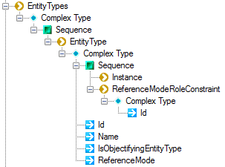

Contributors notes here:

Overview

EntityTypes Element

The EntityTypes element contains a sequence of EntityType elements. Each EntityType element represents an EntityType within a Fact-Based Model.

EntityType Element

The EntityType element stores the details of an Entity Type within a Fact-Based Model.

ReferenceModeRoleConstraint Element

If the EntityType defined within an EntityType element has a Reference Mode, the ReferenceModeRoleConstraint element contains a reference to the RoleConstraint that ranges over the Reference Mode of the Entity Type.

Attribute Definitions – EntityType Element

Attribute | Definition
Id | The unique identifier of the Entity Type within the Fact-Based Model.  NB Is unique amongst the Id values for:  Value Types;  Entity Types;  Fact Types;  Role Constraints;  Model Notes;
Name | The name of the Entity Type.  NB Is unique amongst the Id values for:  Value Types;  Entity Types;  Fact Types;  Role Constraints;
IsObjectifyingEntityType | If the EntityType is the objectifying Entity Type of an Objectified Fact Type then this attribute has a value of ‘true’, else this attribute has a value of ‘false’.
ReferenceMode | The string value of the ReferenceMode of the Entity Type if the Entity Type does not have a Compound Reference Mode, but has a Reference Mode, otherwise an empty string.  If the Reference Mode for an Entity Type is not yet defined, then this attribute contains an empty string.

Attribute Definitions – ReferenceModeRoleConstraint

Attribute | Definition
Id | The unique identifier of the Role Constraint that ranges over the Reference Mode for the Entity Type.

XSD Text

Below is the XSD text for the EntityTypes artefact:

Fact Type

Contributors notes here:

Overview

XSD Text

Below is the XSD text for the FactType artefact:

Role Constraint

Contributors notes here:

Overview

XSD Text

Below is the XSD text for the Role Constraint artefact:

Model Note

Contributors notes here:

Overview

XSD Text

Below is the XSD text for the Instance artefact:

Appendix A – XSD For the ‘Model’ Artefact

<xs:element msdata:IsDataSet="true" msdata:Locale="en-US" name="Model">
<xs:complexType>
<xs:choice minOccurs="0" maxOccurs="unbounded">
<xs:element ref="Instance" />
<xs:element ref="String" />
<xs:element ref="RoleConstraintRole" />
<xs:element ref="Fact" />
<xs:element name="ORMModel">
<xs:complexType>
<xs:sequence>
<xs:element minOccurs="0" maxOccurs="unbounded" name="ValueTypes">
<xs:complexType>
<xs:sequence>
<xs:element minOccurs="0" maxOccurs="unbounded" name="ValueType">
<xs:complexType>
<xs:sequence>
<xs:element minOccurs="0" maxOccurs="unbounded" ref="Instance" />
<xs:element minOccurs="0" maxOccurs="unbounded" name="ValueConstraint">
<xs:complexType>
<xs:sequence>
<xs:element minOccurs="0" maxOccurs="unbounded" ref="String" />
</xs:sequence>
</xs:complexType>
</xs:element>
</xs:sequence>
<xs:attribute name="Id" type="xs:string" />
<xs:attribute name="DataType" type="xs:string" />
</xs:complexType>
</xs:element>
</xs:sequence>
</xs:complexType>
</xs:element>
<xs:element minOccurs="0" maxOccurs="unbounded" name="EntityTypes">
<xs:complexType>
<xs:sequence>
<xs:element minOccurs="0" maxOccurs="unbounded" name="EntityType">
<xs:complexType>
<xs:sequence>
<xs:element minOccurs="0" maxOccurs="unbounded" ref="Instance" />
<xs:element minOccurs="0" maxOccurs="unbounded" name="ReferenceModeRoleConstraint">
<xs:complexType>
<xs:attribute name="Id" type="xs:string" />
</xs:complexType>
</xs:element>
</xs:sequence>
<xs:attribute name="Id" type="xs:string" />
<xs:attribute name="Name" type="xs:string" />
<xs:attribute name="IsObjectifyingEntityType" type="xs:string" />
</xs:complexType>
</xs:element>
</xs:sequence>
</xs:complexType>
</xs:element>
<xs:element minOccurs="0" maxOccurs="unbounded" name="FactTypes">
<xs:complexType>
<xs:sequence>
<xs:element minOccurs="0" maxOccurs="unbounded" name="FactType">
<xs:complexType>
<xs:sequence>
<xs:element minOccurs="0" maxOccurs="unbounded" ref="Instance" />
<xs:element minOccurs="0" maxOccurs="unbounded" name="RoleGroup">
<xs:complexType>
<xs:sequence>
<xs:element minOccurs="0" maxOccurs="unbounded" name="Role">
<xs:complexType>
<xs:attribute name="Id" type="xs:string" />
<xs:attribute name="Name" type="xs:string" />
<xs:attribute name="JoinedObjectId" type="xs:string" />
</xs:complexType>
</xs:element>
</xs:sequence>
</xs:complexType>
</xs:element>
<xs:element minOccurs="0" maxOccurs="unbounded" ref="Fact" />
</xs:sequence>
<xs:attribute name="Id" type="xs:string" />
<xs:attribute name="Name" type="xs:string" />
<xs:attribute name="IsSubtypeConstraintFactType" type="xs:string" />
<xs:attribute name="IsObjectified" type="xs:string" />
<xs:attribute name="IsPreferredReferenceModeFT" type="xs:string" />
</xs:complexType>
</xs:element>
</xs:sequence>
</xs:complexType>
</xs:element>
<xs:element minOccurs="0" maxOccurs="unbounded" name="RoleConstraints">
<xs:complexType>
<xs:sequence>
<xs:element minOccurs="0" maxOccurs="unbounded" name="RoleConstraint">
<xs:complexType>
<xs:sequence>
<xs:element minOccurs="0" maxOccurs="unbounded" ref="RoleConstraintRole" />
</xs:sequence>
<xs:attribute name="Id" type="xs:string" />
<xs:attribute name="Name" type="xs:string" />
<xs:attribute name="Cardinality" type="xs:string" />
<xs:attribute name="IsDeontic" type="xs:string" />
<xs:attribute name="CardinalityRangeType" type="xs:string" />
<xs:attribute name="RoleConstraintType" type="xs:string" />
<xs:attribute name="RingConstraintType" type="xs:string" />
<xs:attribute name="MinimumFrequencyCount" type="xs:string" />
<xs:attribute name="MaximumFrequencyCount" type="xs:string" />
<xs:attribute name="IsPreferredIdentifier" type="xs:string" />
</xs:complexType>
</xs:element>
</xs:sequence>
</xs:complexType>
</xs:element>
</xs:sequence>
<xs:attribute name="ModelId" type="xs:string" />
<xs:attribute name="Name" type="xs:string" />
</xs:complexType>
</xs:element>
</xs:choice>
</xs:complexType>
</xs:element>
</xs:schema>

