Fact Based Modeling – Exchange MetaModel

XML Schema Definition

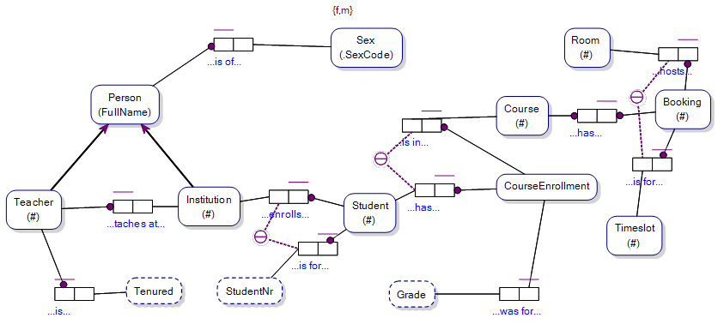

<?xml version="1.0" encoding="utf-8"?>
<xs:schema xmlns:msdata="urn:schemas-microsoft-com:xml-msdata" xmlns="" id="Model" xmlns:xs="http://www.w3.org/2001/XMLSchema">
<xs:element name="Instance">
<xs:complexType>
<xs:sequence>
<xs:element minOccurs="0" maxOccurs="unbounded" ref="String" />
</xs:sequence>
</xs:complexType>
</xs:element>
<xs:element name="String" nillable="true">
<xs:complexType>
<xs:simpleContent msdata:ColumnName="string_Text" msdata:Ordinal="0">
<xs:extension base="xs:string" />
</xs:simpleContent>
</xs:complexType>
</xs:element>
<xs:element name="Concept">
<xs:complexType>
<xs:attribute name="GUID" type="xs:string" />
</xs:complexType>
</xs:element>

Version: | V0.2
Table of Contents

1 Instance 4
1.1 Overview 4
1.2 XSD Text 4
2 String 5
2.1 Overview 5
2.2 XSD Text 5
2.3 Sample XML 5
3 RoleConstraintRole 6
3.1 Overview 6
3.2 Attribute Definitions – RoleConstraintRole Element 6
3.3 XSD Text 6
4 Fact 8
4.1 Overview 8
4.2 Attribute Definitions – Fact Element 8
4.3 Attribute Definitions – FactData Element 8
4.4 XSD Text 8
5 Model 10
5.1 Overview 10
5.2 Attribute Definitions – ORMModel Element 10
5.3 XSD Text 10
6 Value Types / ValueType / ValueConstraint 11
6.1 Overview 11
6.1.1 ValueTypes Element 11
6.1.2 ValueType Element 11
6.1.3 ValueConstraint Element 11
6.2 Attribute Definitions – ValueType Element 11
6.3 XSD Text 11
6.3.1 Sample XML 12
7 EntityTypes / EntityType 13
7.1 Overview 13
7.1.1 EntityTypes Element 13
7.1.2 EntityType Element 13
7.1.3 ReferenceModeRoleConstraint Element 13
7.2 Attribute Definitions – EntityType Element 13
7.3 Attribute Definitions – ReferenceModeRoleConstraint 14
7.4 XSD Text 14
8 Fact Types / Fact Type Elements 15
8.1 Overview 15
8.2 Attribute Definitions – FactType Element 15
8.3 Attribute Definitions – Role Element 16
8.4 XSD Text 16
9 Role Constraint 17
9.1 Overview 17
9.2 Attribute Definitions – Role Element 17
9.3 XSD Text 18
10 Model Note 19
10.1 Overview 19
10.2 XSD Text 19
11 Appendix A – XSD For the ‘Model’ Artefact 20

Instance

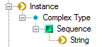

Contributors notes here:

Overview

A Object Type has a set of String values, each of which uniquely identify an Instance of that Object Type.

e.g. An Entity Type may have a unique Instance identified by a GUID.

NB Only Entity Types and Value Types have Instance elements within the exchange metamodel, and Instances of Entity Types are always instances of a Value Type. Fact Types that are ‘Objectified’ have an Objectifying Entity Type that has unique Instances.

XSD Text

Below is the XSD text for the Instance artefact:

<xs:element name="Instance">
<xs:complexType>
<xs:sequence>
<xs:element minOccurs="0" maxOccurs="unbounded" ref="String" />
</xs:sequence>
</xs:complexType>
</xs:element>

String

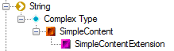

Contributors notes here:

Overview

A String element is used to store a data value of type, string.

e.g. A string value in a String element may provide the identity of an instance of an Object Type within an Instance element.

See Also: Instance element.

XSD Text

Below is the XSD text for the String artefact:

<xs:element name="String" nillable="true">
<xs:complexType>
<xs:simpleContent msdata:ColumnName="string_Text" msdata:Ordinal="0">
<xs:extension base="xs:string" />
</xs:simpleContent>
</xs:complexType>
</xs:element>

Sample XML

<String>c69ea3a6-6d73-47aa-abf6-c52311f4c3a5</String>

RoleConstraintRole

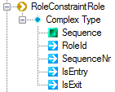

Contributors notes here:

Overview

The RoleConstraintRole element stores details of the Role/s referenced by a Role Constraint. Each Role Constraint element has a set of one or more RoleConstraintRole elements.

Each RoleConstraintRole element has a SequenceNr attribute representing the ordinal number in the sequence of RoleConstraintRole elements for a RoleConstraintRole (e.g. an External Uniqueness Constraint (RoleConstraint) may have a set of two RoleConstraintRole elements each with its own SequenceNr).

Attribute Definitions – RoleConstraintRole Element

Attribute | Definition
RoleId | The unique identifier of the Role referenced by the RoleConstraintRole element. Represents the Role linked to a RoleConstraint by the RoleConstraintRole.
SequenceNr | The ordinal position of the RoleConstraintRole within the sequence of RoleConstraintRole elements for a RoleConstraint.
IsEntry | Has a value set to ‘true’ is the RoleConstraintRole element represents a RoleConstaint/Role link that is the ‘Entry’ link of a ‘Entry/Exit’ combination of RoleConstraint/Role links, else has a value set to ‘false’.  e.g. If a link to a Role from a RoleConstraint is an ‘Entry’ link of a Subset Constraint, the values of Instances referenced by that Role are the subset of Instances referenced by the Role of a corresponding RoleConstraint/Role link that is an ‘Exit’ link.
IsExit | Has a value set to ‘true’ is the RoleConstraintRole element represents a RoleConstaint/Role link that is the ‘Exit’ link of a ‘Entry/Exit’ combination of RoleConstraint/Role links, else has a value set to ‘false’.

XSD Text

Below is the XSD text for the RoleConstraintRole artefact:

<xs:element name="RoleConstraintRole">
<xs:complexType>
<xs:sequence>
<xs:element msdata:Ordinal="0" minOccurs="0" name="Instance" type="xs:string" />
<xs:element minOccurs="0" maxOccurs="unbounded" name="Role">
<xs:complexType>
<xs:attribute name="Id" type="xs:string" />
</xs:complexType>
</xs:element>
</xs:sequence>
<xs:attribute name="RoleId" type="xs:string" />
<xs:attribute name="SequenceNr" type="xs:string" />
<xs:attribute name="IsEntry" type="xs:string" />
<xs:attribute name="IsExit" type="xs:string" />
</xs:complexType>
</xs:element>

Fact

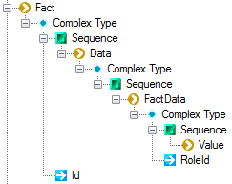

Contributors notes here:

Overview

The Fact element stores the set of FactData relevant to a Fact of a FactType.

Attribute Definitions – Fact Element

Attribute | Definition
Id | The unique identifier of the Fact represented by the Fact element.

Attribute Definitions – FactData Element

Attribute | Definition
RoleId | Has a value equal to the unique identifier of the Role within the Fact Type of the Fact for which the Fact Data is an element.

XSD Text

Below is the XSD text for the Instance artefact:

<xs:element name="Fact">
<xs:complexType>
<xs:sequence>
<xs:element minOccurs="0" maxOccurs="unbounded" name="Data">
<xs:complexType>
<xs:sequence>
<xs:element minOccurs="0" maxOccurs="unbounded" name="FactData">
<xs:complexType>
<xs:sequence>
<xs:element msdata:Ordinal="1" minOccurs="0" name="Value" type="xs:string" />
</xs:sequence>
<xs:attribute name="RoleId" type="xs:string" />
</xs:complexType>
</xs:element>
</xs:sequence>
</xs:complexType>
</xs:element>
</xs:sequence>
<xs:attribute name="Id" type="xs:string" />
</xs:complexType>
</xs:element>

Model

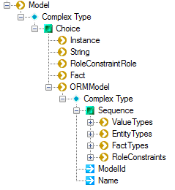

Contributors notes here:

Overview

The ‘Model’ element contains all elements that go into describing a Fact-Based Model.

Attribute Definitions – ORMModel Element

Attribute | Definition
ModelId | The unique identifier for the Model.
Name | The name of the Model.

XSD Text

No XSD text is provided for the Model artefact here.
See Appendix A

Value Types / ValueType / ValueConstraint

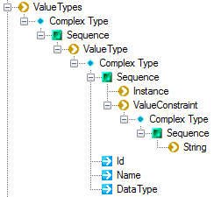

Contributors notes here:

Overview

ValueTypes Element

The ValueTypes element contains a list of ValueType elements. Each ValueType element describes a Value Type within a Fact-Based Model.

ValueType Element

The ‘ValueType’ element describes a Value Type within a Fact-Based Model.

ValueConstraint Element

The ValueConstraint element contains a sequence of String.

Attribute Definitions – ValueType Element

Attribute | Definition
Id | The unique identifier of the ValueType represented by the ValueType element.
Name | The name of the ValueType represented by the ValueType element.
DataType | The data-type of the ValueType represented by the ValueType element.

XSD Text

Below is the XSD text for the ValueType element:

<xs:element minOccurs="0" maxOccurs="unbounded" name="ValueTypes">
<xs:complexType>
<xs:sequence>
<xs:element minOccurs="0" maxOccurs="unbounded" name="ValueType">
<xs:complexType>
<xs:sequence>
<xs:element minOccurs="0" maxOccurs="unbounded" ref="Instance" />
<xs:element minOccurs="0" maxOccurs="unbounded" name="ValueConstraint">
<xs:complexType>
<xs:sequence>
<xs:element minOccurs="0" maxOccurs="unbounded" ref="String" />
</xs:sequence>
</xs:complexType>
</xs:element>
</xs:sequence>
<xs:attribute name="Id" type="xs:string" />
<xs:attribute name="Name" />
<xs:attribute name="DataType" type="xs:string" />
</xs:complexType>
</xs:element>
</xs:sequence>
</xs:complexType>
</xs:element>

Sample XML

EntityTypes / EntityType

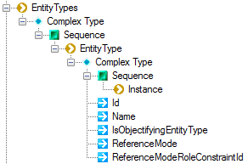

Contributors notes here:

Overview

EntityTypes Element

The EntityTypes element contains a sequence of EntityType elements. Each EntityType element represents an EntityType within a Fact-Based Model.

EntityType Element

The EntityType element stores the details of an Entity Type within a Fact-Based Model.

ReferenceModeRoleConstraint Element

If the EntityType defined within an EntityType element has a Reference Mode, the ReferenceModeRoleConstraint element contains a reference to the RoleConstraint that ranges over the Reference Mode of the Entity Type.

Attribute Definitions – EntityType Element

Attribute | Definition
Id | The unique identifier of the Entity Type within the Fact-Based Model.  NB Is unique amongst the Id values for:  Value Types;  Entity Types;  Fact Types;  Role Constraints;  Model Notes;
Name | The name of the Entity Type.  NB Is unique amongst the Id values for:  Value Types;  Entity Types;  Fact Types;  Role Constraints;
IsObjectifyingEntityType | If the EntityType is the objectifying Entity Type of an Objectified Fact Type then this attribute has a value of ‘true’, else this attribute has a value of ‘false’.
ReferenceMode | The string value of the ReferenceMode of the Entity Type if the Entity Type does not have a Compound Reference Mode, but has a Reference Mode, otherwise an empty string.  If the Reference Mode for an Entity Type is not yet defined, then this attribute contains an empty string.

Attribute Definitions – ReferenceModeRoleConstraint

Attribute | Definition
Id | The unique identifier of the Role Constraint that ranges over the Reference Mode for the Entity Type.

XSD Text

Below is the XSD text for the EntityTypes artefact:

Fact Types / Fact Type Elements

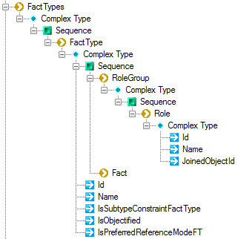

Contributors notes here:

Overview

Attribute Definitions – FactType Element

Attribute | Definition
Id | The unique identifier of the FactType within the Model.
Name | The name of the FactType within the Model.
IsSubtypeConstraintFactType | Has a value set to ‘true’ if the FactType represents the identity Fact Type of an Entity Type, else has a value set to ‘false’.  NB If an Entity Type is a subtype of another Entity Type, then a Fact Type (not displayed on the model) called an ‘Identity Fact Type’ is implied by the Subtype Constraint link between the subtype Entity Type and the supertype Entity Type. This attribute allows easy identification of those Fact Types which are Identity Fact Types and that are not displayed on the Model.
IsObjectified | Has a value set to ‘true’ if the Fact Type is ‘Objectified’, else has a value set to ‘false’.
IsPreferredReferenceModeFT | Has a value set to ‘true’ if the Fact Type links an Entity Type to a Value Type and where that Entity Type does not have a Compound Reference Mode, else has a value set to ‘false’.  Fact Types where this attribute has a value set to ‘true’ are not displayed in the Model under the standard view of an Entity Type/Reference Mode relationship, but may be displayed if the software allows the user to view the relationship between the Entity Type and Value Type of the Reference Mode.  If an Entity Type has a Reference Mode that is not a Compound Reference Mode, then the Fact Type mapping the Entity Type to the Value Type of the Reference Mode has this attribute having a value set to ‘true’.  Fact Types that are in no way associated with the Reference Mode of an Entity Type always have this attribute having a value set to ‘false’.

Attribute Definitions – Role Element

Attribute | Definition
Id | The unique identifier of the Role within the Model.
Name | If the Role has a Role Name, then this attribute has a value equal to that Role Name, otherwise this attribute has a blank value.
JoinedObjectId | The unique identifier of the Object Type linked by the Role within the Model.

XSD Text

Below is the XSD text for the FactType artefact:

Role Constraint

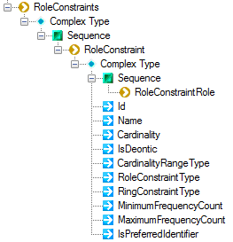

Contributors notes here:

Overview

Attribute Definitions – Role Element

Attribute | Definition
Id | The unique identifier of the Role Constraint within the Model.
Name | The name of the Role Constraint.
RoleConstraintType | The type of Role Constraint represented by the element.
RingConstraintType | If the RoleConstraintType attribute of the Role Constraint element has a value of ‘RingConstraint’ then this attribute has a value of the type of Ring Constraint.
Cardinality
IsDeontic | Has a value set to ‘true’ if the Role Constraint is ‘Deontic’, else has a value set to ‘false’.
CardinalityRangeType
MinimumFrequencyCount | If the RoleConsrtaintType attribute has a value of ‘FrequencyConstraint’ then this attribute has a value set to the minimum in the range of the Frequency Constraint.
MaximumFrequencyCount | If the RoleConsrtaintType attribute has a value of ‘FrequencyConstraint’ then this attribute has a value set to the maximum in the range of the Frequency Constraint.
IsPreferredIdentifier | Has a value set to ‘true’ if the Role Constraint represented by the element represents the ‘Preferred Identification Scheme’ for an Entity Type.

XSD Text

Below is the XSD text for the Role Constraint artefact:

Model Note

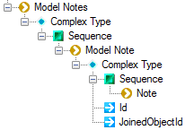

Contributors notes here:

Overview

XSD Text

Below is the XSD text for the Instance artefact:

Appendix A – XSD For the ‘Model’ Artefact

<xs:element msdata:IsDataSet="true" msdata:Locale="en-US" name="Model">
<xs:complexType>
<xs:choice minOccurs="0" maxOccurs="unbounded">
<xs:element ref="Instance" />
<xs:element ref="String" />
<xs:element ref="RoleConstraintRole" />
<xs:element ref="Fact" />
<xs:element name="ORMModel">
<xs:complexType>
<xs:sequence>
<xs:element minOccurs="0" maxOccurs="unbounded" name="ValueTypes">
<xs:complexType>
<xs:sequence>
<xs:element minOccurs="0" maxOccurs="unbounded" name="ValueType">
<xs:complexType>
<xs:sequence>
<xs:element minOccurs="0" maxOccurs="unbounded" ref="Instance" />
<xs:element minOccurs="0" maxOccurs="unbounded" name="ValueConstraint">
<xs:complexType>
<xs:sequence>
<xs:element minOccurs="0" maxOccurs="unbounded" ref="String" />
</xs:sequence>
</xs:complexType>
</xs:element>
</xs:sequence>
<xs:attribute name="Id" type="xs:string" />
<xs:attribute name="DataType" type="xs:string" />
</xs:complexType>
</xs:element>
</xs:sequence>
</xs:complexType>
</xs:element>
<xs:element minOccurs="0" maxOccurs="unbounded" name="EntityTypes">
<xs:complexType>
<xs:sequence>
<xs:element minOccurs="0" maxOccurs="unbounded" name="EntityType">
<xs:complexType>
<xs:sequence>
<xs:element minOccurs="0" maxOccurs="unbounded" ref="Instance" />
<xs:element minOccurs="0" maxOccurs="unbounded" name="ReferenceModeRoleConstraint">
<xs:complexType>
<xs:attribute name="Id" type="xs:string" />
</xs:complexType>
</xs:element>
</xs:sequence>
<xs:attribute name="Id" type="xs:string" />
<xs:attribute name="Name" type="xs:string" />
<xs:attribute name="IsObjectifyingEntityType" type="xs:string" />
</xs:complexType>
</xs:element>
</xs:sequence>
</xs:complexType>
</xs:element>
<xs:element minOccurs="0" maxOccurs="unbounded" name="FactTypes">
<xs:complexType>
<xs:sequence>
<xs:element minOccurs="0" maxOccurs="unbounded" name="FactType">
<xs:complexType>
<xs:sequence>
<xs:element minOccurs="0" maxOccurs="unbounded" ref="Instance" />
<xs:element minOccurs="0" maxOccurs="unbounded" name="RoleGroup">
<xs:complexType>
<xs:sequence>
<xs:element minOccurs="0" maxOccurs="unbounded" name="Role">
<xs:complexType>
<xs:attribute name="Id" type="xs:string" />
<xs:attribute name="Name" type="xs:string" />
<xs:attribute name="JoinedObjectId" type="xs:string" />
</xs:complexType>
</xs:element>
</xs:sequence>
</xs:complexType>
</xs:element>
<xs:element minOccurs="0" maxOccurs="unbounded" ref="Fact" />
</xs:sequence>
<xs:attribute name="Id" type="xs:string" />
<xs:attribute name="Name" type="xs:string" />
<xs:attribute name="IsSubtypeConstraintFactType" type="xs:string" />
<xs:attribute name="IsObjectified" type="xs:string" />
<xs:attribute name="IsPreferredReferenceModeFT" type="xs:string" />
</xs:complexType>
</xs:element>
</xs:sequence>
</xs:complexType>
</xs:element>
<xs:element minOccurs="0" maxOccurs="unbounded" name="RoleConstraints">
<xs:complexType>
<xs:sequence>
<xs:element minOccurs="0" maxOccurs="unbounded" name="RoleConstraint">
<xs:complexType>
<xs:sequence>
<xs:element minOccurs="0" maxOccurs="unbounded" ref="RoleConstraintRole" />
</xs:sequence>
<xs:attribute name="Id" type="xs:string" />
<xs:attribute name="Name" type="xs:string" />
<xs:attribute name="Cardinality" type="xs:string" />
<xs:attribute name="IsDeontic" type="xs:string" />
<xs:attribute name="CardinalityRangeType" type="xs:string" />
<xs:attribute name="RoleConstraintType" type="xs:string" />
<xs:attribute name="RingConstraintType" type="xs:string" />
<xs:attribute name="MinimumFrequencyCount" type="xs:string" />
<xs:attribute name="MaximumFrequencyCount" type="xs:string" />
<xs:attribute name="IsPreferredIdentifier" type="xs:string" />
</xs:complexType>
</xs:element>
</xs:sequence>
</xs:complexType>
</xs:element>
</xs:sequence>
<xs:attribute name="ModelId" type="xs:string" />
<xs:attribute name="Name" type="xs:string" />
</xs:complexType>
</xs:element>
</xs:choice>
</xs:complexType>
</xs:element>
</xs:schema>

