Org Explorer
User guide
Version | 1.0
Date | 27 August 2026
Author | David Ahlhaus
Status | Issued

This guide is for everyone at Factor1 who needs to look up people, teams, and reporting lines.
Contents
Contents 1
1. About this guide 1
2. What Org Explorer is 1
3. How you reach it 1
4. Before you start 1
5. Key ideas 2
6. Who can do what 2
7. Getting started 3
8. Finding people 3
8.1 Search 3
8.2 Filter 3
9. Moving around a branch 3
10. Other tasks 4
10.1 See everyone at once 4
10.2 Sign out 5
10.3 Update a person’s details 5
10.4 Update many people at once 5
11. Points to remember 6
12. If something goes wrong 6
13. Glossary 7
14. Contacts 7
15. Version history 7

1. About this guide
This guide shows you how to use Org Explorer.

2. What Org Explorer is
Org Explorer is Factor1’s live picture of who reports to whom.
You use it to find a person, see their manager and team, and move around the firm.
The people and their details come from Microsoft 365. When someone updates a detail in Org Explorer, Microsoft 365 stores that change.

3. How you reach it
Open Org Explorer in your web browser:
https://org-explorer-ruby.vercel.app/
Sign in with your Factor1 Microsoft account. Use the same sign-in you use for email.

4. Before you start
- Use a computer and a current browser, such as Microsoft Edge or Chrome.
- Have your Factor1 Microsoft password ready, or stay signed in to Microsoft already.
- Open the address in Section 3 and choose Sign in.
Innovation & Systems turns on Admin for the people who update details. If you need Admin, ask them.

5. Key ideas
Word | What it means
Branch | The slice of the firm you are looking at: a person in the centre, their manager above, people at the same level beside them, and the people who report to them below.
Card | The box for one person. It shows their photo, name, role, company, department, and team.
Company | The Factor1 business the person belongs to, such as Factor1 Shepp or Taxopia.
Department | The area of work, such as Service Delivery or Firm Management.
Team | The named group inside a department, such as Zeus or Avengers.
Role | The person’s job title.
Full tree | A zoomable view of everyone, or of the company–department–team–role structure.
Admin | The screens and buttons for people who update company, department, team, and role.

6. Who can do what
Who | What they can do
Everyone who signs in | Search, filter, open a branch, and open Full tree.
People with Admin | Everything above, plus edit a person’s company, department, team, and role. They can also download a list of everyone and apply an updated list.

Innovation & Systems decides who has Admin. The Admin button appears at the top of the screen when you have it.

7. Getting started
- Open https://org-explorer-ruby.vercel.app/.
- Choose Sign in.
- Pick your Factor1 Microsoft account and finish the Microsoft prompts.
- You land on your own branch. Your card sits in the centre.

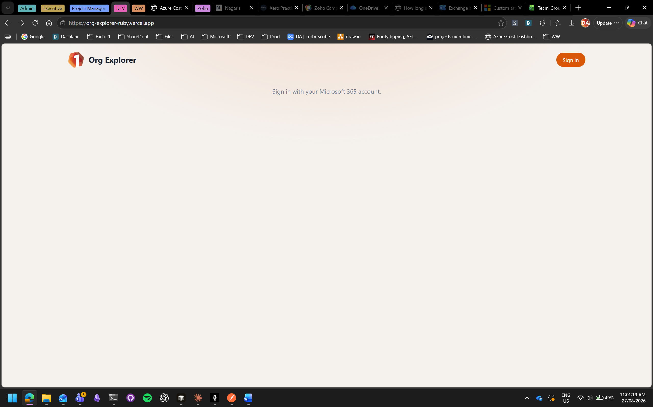
The top of the screen shows Sign out, My profile, and Full tree. Admin appears only if you have it.

8. Finding people

8.1 Search
Type a name in Search by name… at the top. A list of matches appears as you type. Choose a name to open that person’s branch.

8.2 Filter
Use the three lists to the right of search:
- All companies — show one company.
- All departments — show one department. This list follows the company you picked.
- All teams — show one team. This list follows the company and department you picked.
Set a list back to All… when you want to see everyone again.

9. Moving around a branch
This is the main way you use Org Explorer.
- Your card is in the centre. The person you report to is above you. People at your level sit beside you. People who report to you sit below you.
- To open someone else’s branch, choose their card. On a manager’s card this is labelled Go up. On a peer’s card this is labelled View branch. On a report’s card you see how many people report to them.
- A path of names appears above the cards after you move. Choose a name in that path to jump back to that person.
- Choose My profile at any time to return to your own branch.
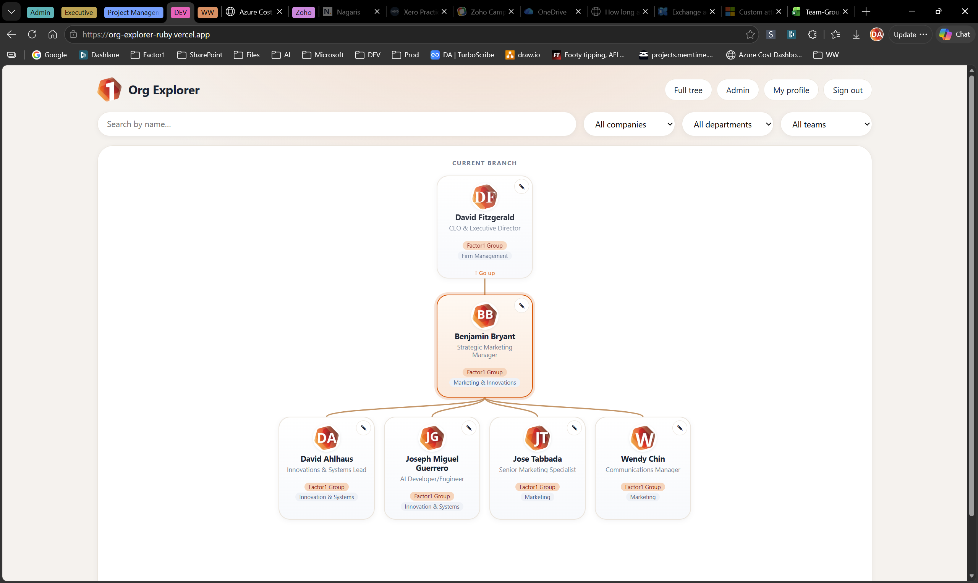

10. Other tasks

10.1 See everyone at once
- Choose Full tree.
- Choose Employees to see people, or Structure to see company, then department, then team, then role.
- Drag to move around. Scroll to zoom.
- Choose Focus me to jump to your own card.
- Choose Back to explorer to return to the branch view.
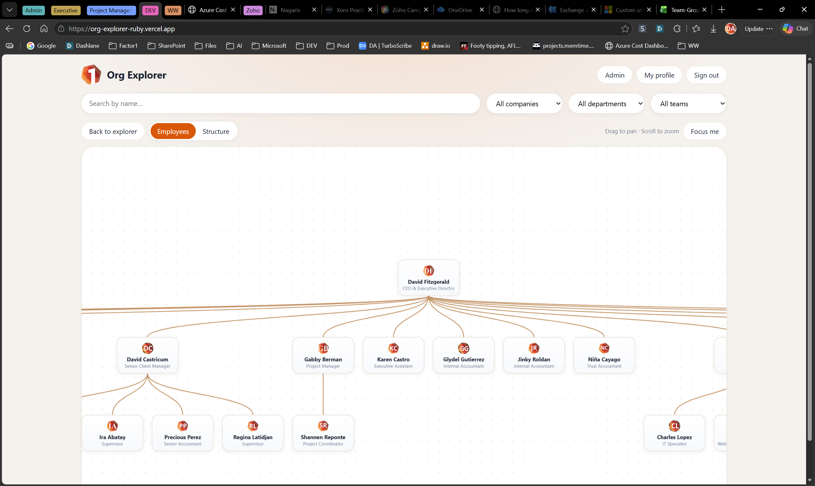

10.2 Sign out
Choose Sign out when you finish. Sign in again next time.

10.3 Update a person’s details
This section is for people with Admin.
You can change company, department, team, and role. Pick each value from a list. Microsoft 365 stores the change.
- Choose Admin, or choose the pencil on a person’s card.
- In Admin, type a name in Search people to edit… and choose Edit.
- Pick a value from each list. Use — None — if that field should be blank.
- To create a value that is not in the list, choose Add new value…, type the name, then choose Add.
- Choose Save changes. You should see “Saved to Microsoft 365.”
- Choose Cancel or the × if you want to leave without saving.

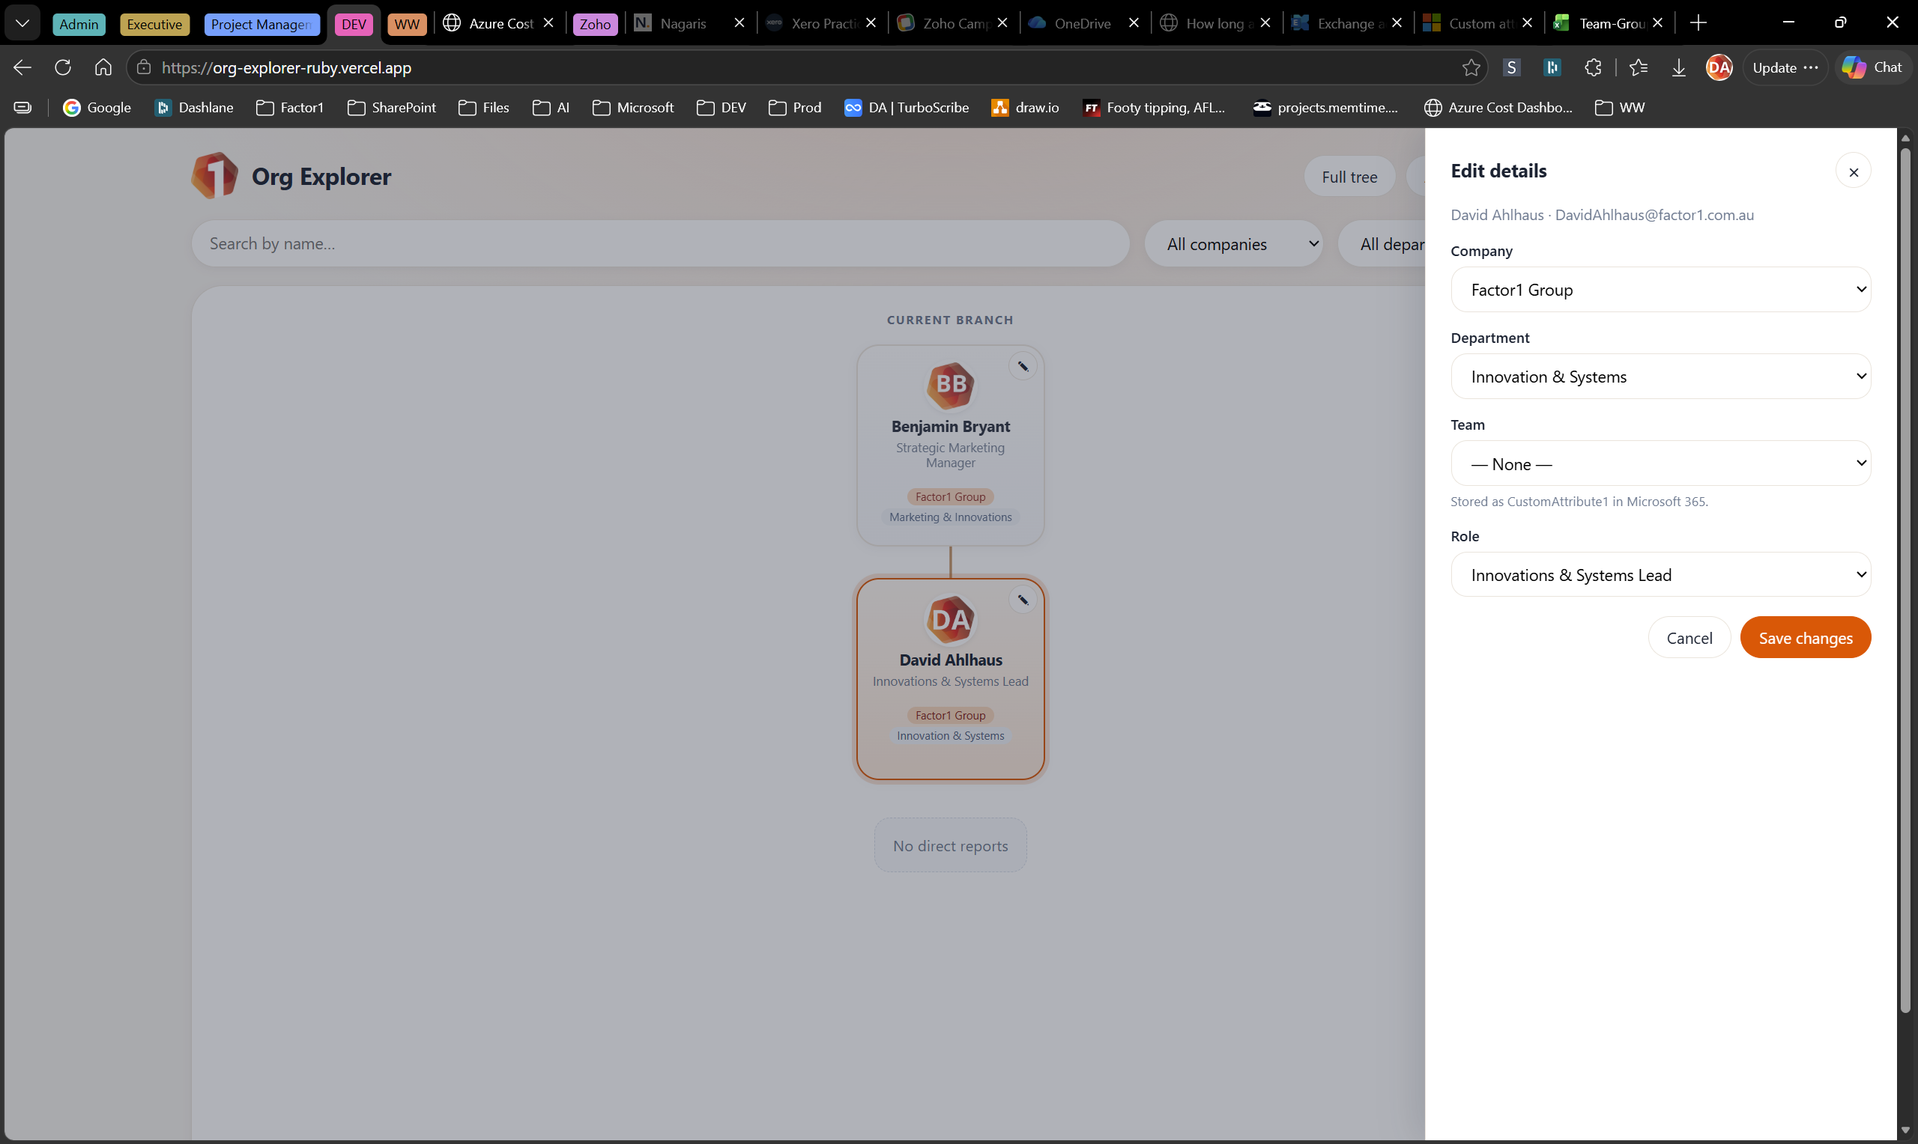
A value stays in the lists while at least one person has it. When the last person moves off a value, that value leaves the lists.

10.4 Update many people at once
This section is for people with Admin.
- In Admin, choose Download CSV. A file called org-users.csv saves to your computer.
- Open the file in Excel.
- Change only the company, department, team, and role columns. Leave the id column as it is, so each row still matches the right person.
- Save the file.
- In Admin, choose Apply CSV, pick your file, and confirm.
Wait until the status line at the top reports how many people were updated. If some rows fail, the status line explains why.

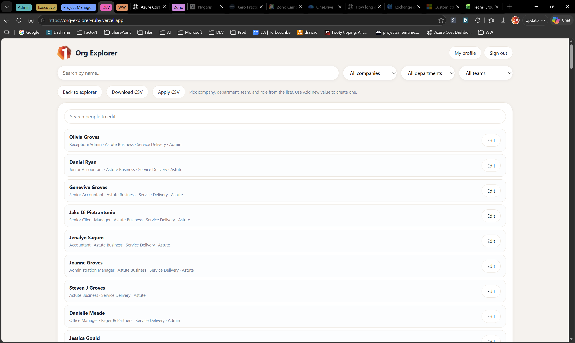

11. Points to remember
- Sign in with your Factor1 Microsoft account, not a personal Microsoft account.
- My profile always takes you back to your own branch.
- Search looks up names. Filters narrow the chart by company, department, and team.
- People with Admin pick values from lists. They create a new value with Add new value…, then Add.
- Finish Add, or pick an existing value, before Save changes.
- When you apply a list, leave each person’s id unchanged.
- A change you save in Org Explorer is the change Microsoft 365 keeps.

12. If something goes wrong
What you see | What to do
Microsoft asks you to sign in again, or sign-in fails. | Use your Factor1 account. Try a private window, or a different browser. If it still fails, contact Innovation & Systems.
The screen stays on Loading… | Refresh the page. If it continues, contact Innovation & Systems.
Admin is missing from the top of the screen. | Ask Innovation & Systems if you need it. The button appears only for people with Admin.
Save changes reports a problem. | Read the message on the panel. Try again. If it repeats, send the message to Innovation & Systems.
Apply CSV reports that some people failed. | Read the status line. Send that text to Innovation & Systems, with the file you applied.
A person’s team did not update. | Tell Innovation & Systems the person’s name. Some mailboxes need a change in Exchange instead.
A person is missing from the chart. | Confirm they have an active Factor1 Microsoft account. If they do, tell Innovation & Systems.

13. Glossary
Term | Meaning
Admin | The area of Org Explorer used to update company, department, team, and role.
Branch | The view centred on one person and the people directly around them.
Card | The on-screen box for one person.
Company | The Factor1 business a person belongs to.
Department | The area of work a person belongs to.
Full tree | The zoomable view of everyone, or of the structure of the firm.
Microsoft 365 | The firm’s directory of people. Org Explorer reads from it and, for Admin, writes back to it.
Role | A person’s job title.
Team | The named group inside a department.

14. Contacts
Question | Who to ask
How do I use Org Explorer? | IT
I need Admin. | IT
A save or list update failed. | IT
Someone is missing or in the wrong place. | HR

15. Version history
Version | Date | Author | Changes
1.0 | 27 August 2026 | David Ahlhaus | First issue. Covers sign-in, search, filters, branches, Full tree, and Admin updates.

