**Custom URI**

1. Go to Start then in Find type regedit -> it should open Registry editor
2. Click Right Mouse on HKEY_CLASSES_ROOT then New -> Key

[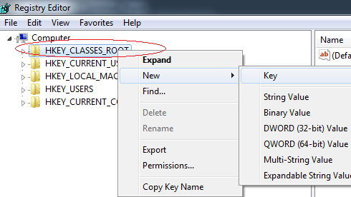](https://i.stack.imgur.com/9boI6.png)

1. In the Key give the lowercase name by which you want urls to be called (in my case it will be testus://sdfsdfsdf) then Click Right Mouse on testus -> then New -> String Value and add URL Protocol without value.

[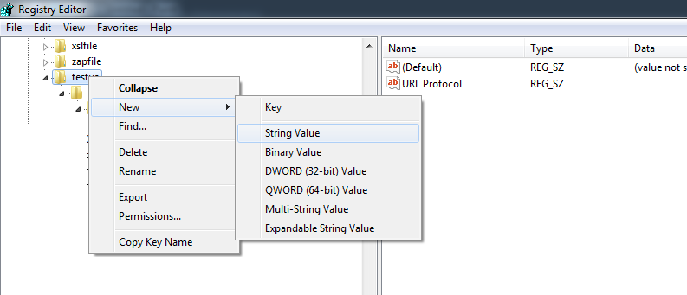](https://i.stack.imgur.com/4wLev.png)

1. Then add more entries like you did with protocol ( Right Mouse New -> Key ) and create hierarchy like testus -> shell -> open -> command and inside command change (Default) to the path where .exe you want to launch is, if you want to pass parameters to your exe then wrap path to exe in "" and add  "%1" to look like: "c:\testing\test.exe" "%1"

[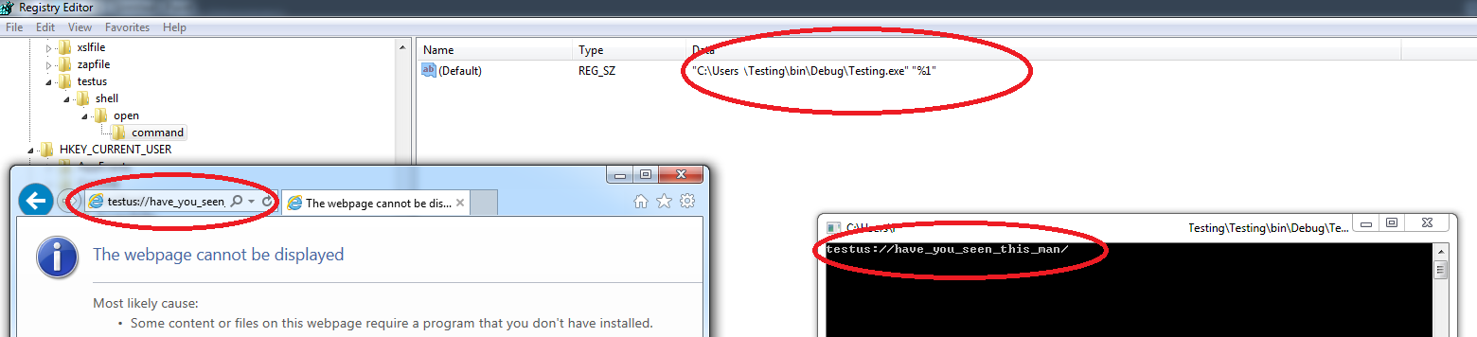](https://i.stack.imgur.com/VbhsZ.png)