JavaScript Basic: Exercise-1

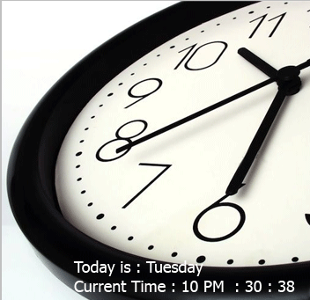Write a JavaScript program to display the current day and time in the following format.  
Today is : Tuesday.  
Current time is : 10 PM : 30 : 38

Pictoral Presentation :