|  |
| --- |
| Image containing furniture, table, drawing, flower  Auto-generated description**Practical work Devices E.** |

|  |  |
| --- | --- |
| **GROUP N°--------------** | **COURSE:R3031** |

|  |
| --- |
| **PROFESSORS: Ricardo Alberto Zuazquita and Eduardo Víctor Oreglia** |

|  |
| --- |
| **ATTEND DAYS: Monday and Friday** |

|  |
| --- |
| **ON DUTY: Afternoon** |

|  |
| --- |
| **PRACTICAL WORK N°: 2** |

|  |
| --- |
| **TITLE: Comprehensive Simulation and Analysis of BJT Transistors in LT-Spice** |

|  |
| --- |
| **Student: Costarelli Facundo Lautaro** |
| **DNI: 42.724.683** |
| **File: 176.291-6** |

|  |  |  |
| --- | --- | --- |
|  | **DATES** | **SIGNATURE AND CLARIFICATION OF THE TEACHER** |
| **CARRIED OUT ON** | 14/06/2024 |  |
| **CORRECTED** |  |  |
| **APPROVED** |  |  |

|  |
| --- |
| **INDICATIONS FOR CORRECTIONS:** |

**Index**

1. Introduction ----------------------------------------------------- Page 1
2. Development ------------------------------------------------------- Page 2

i. Survey of the output curves of a transistor - Page 2  
Ii. *Evaluation of the voltage amplification and frequency response of a BC546B transistor in a common emitter* ------ Page 10  
Iii. *Frequency response of a 2N2222 transistor configured as a common emitter* ------------------------------------------ Page 17

1. Conclusion ------------------------------------------------------ Page 22

**Introduction**

In this work, we seek to study the TBJ transistor in different presentations such as the 2N222 and the BC546B, which are the most typical in such a way that they provide conclusions and useful data to understand their basic functioning.

Current and voltage gain are studied and different graphs of transistor curves are visualized, in particular using the common emitter configuration which produces both types of gain. The working mode is then the active mode. It is also intended to study the response in the output voltage, as well as the frequency response for signals of different frequencies and amplitudes in order to determine the limitations of the transistor in its bandwidth and its range of valid input amplitudes, obtaining and visualizing distortion effects to a greater or lesser extent, as well as amplification or attenuation of the input signal. Finally, some of the internal parameters of the transistor, such as the parasitic capacitances Cpi and Cα, are modified, analyzing the effects produced.

The LT-Spice is used as software for simulating circuits, measuring and graphing the results. The conclusions that will be obtained will be very useful to understand how electronic devices work in a more real way as well as the theoretical concepts associated with them and learned in class.

**Development**

2) i. *Lifting the exit curves of a transient*

a) Based on the following circuit of a TBJ 2N2222 transistor in common emitter in active mode with a list of base currents, the output curves in the collector are studied being ic(vce). The ambient temperature is 27°C

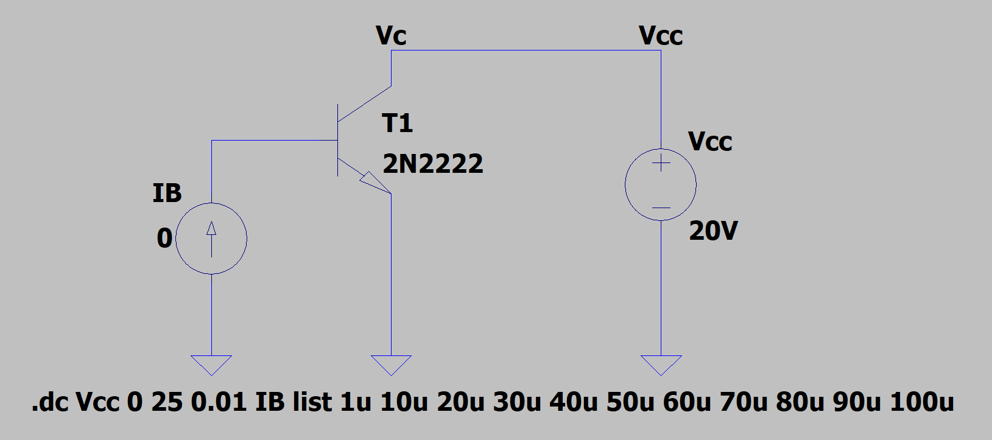

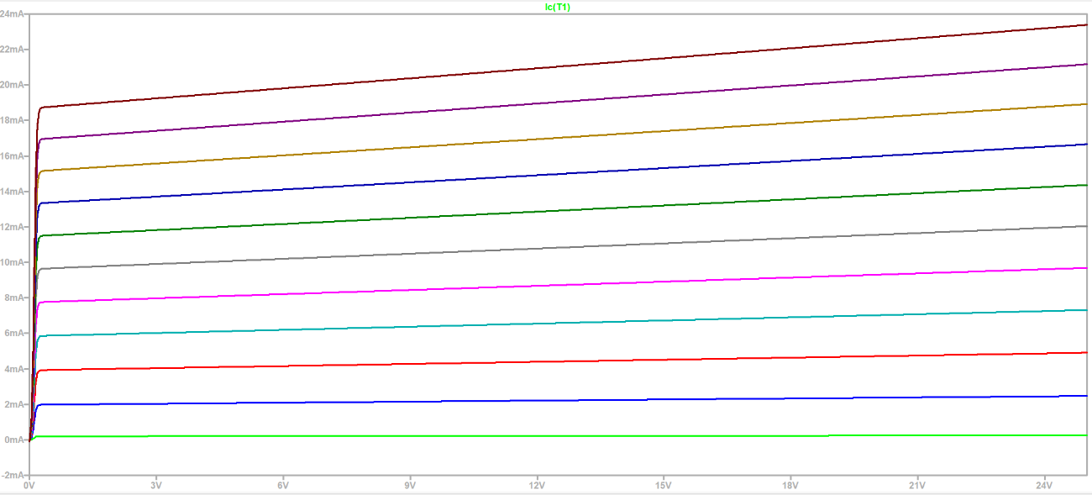

We observe the output curves of the collector currents as a function of the collector-emitter voltage, i.e. ic(vce). They have a fast-growing current behavior as in the form of low-amplitude spikes of current for low voltage values vce, and then the current grows approximately linear as the voltage vce increases. We see that the slope of each curve that becomes linear changes depending on the different values of the base current in IB list. It happens that Vceq depends on Iceq which in turn depends on the beta of the transistor (fixed parameter) and the base current, i.e., ic = ib + Beta

To find the current gain I choose one of the curves with the cursor, select a point Q by choosing the Iceq and the Vceq and also look at the Ib that produced that curve. Then I evaluate the variation of the Ib of this curve with respect to one of the contiguous curves and analogously I do the same with the Ic.

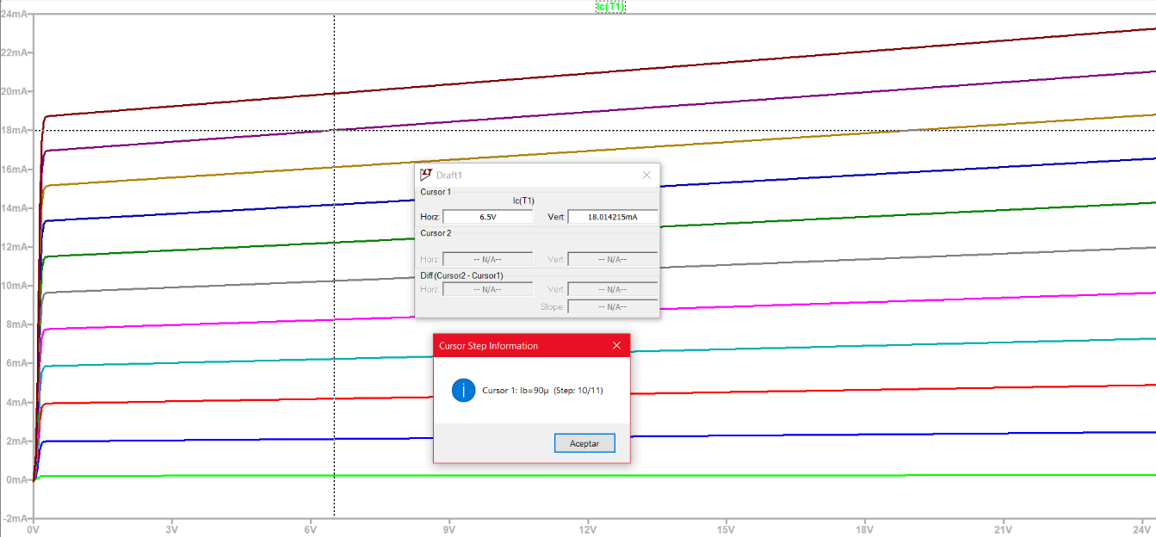

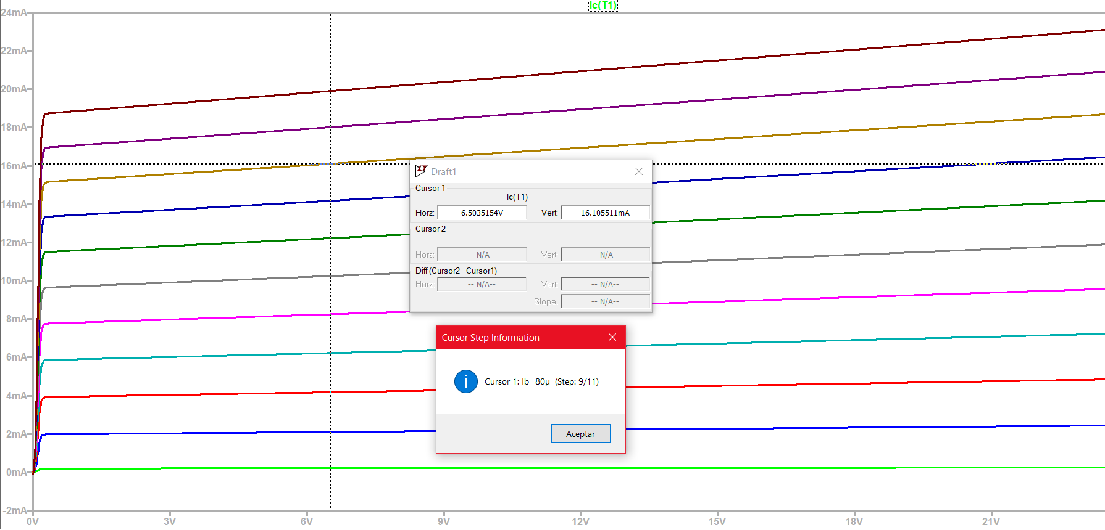

We have for the violet curve: Vceq = 6.5 V Iceq = 18 mA Ib = 90 uA

We have for the brown curve: Vceq = 6.5 V Iceq = 16 mA Ib = 80 uA

and the variation and gain of currents are:

∆Ib = 90 A – 80 A = 10 A ∆Ic = 18 mA – 16 mA = 2 mA

Current gain = ∆I == 200

Graphical User Interface, Application, Table, Excel

Auto-generated description

For the output resistance, staying on the previous violet curve and taking again the values of Vceq1 = 6.5 V and Iceq1 = 18 mA, I now move in an increasing direction to the right with the cursor and take another pair of values of my choice, these being Vceq2 = 18 V and Iceq2 = 20 mA. Then we have to:

∆Vce = 18 V – 6.5 V = 11.5 V with ∆Ic = 20 mA -18 mA = 2 mA

where the output resistor is R = = = 5.75 KΩ

b) Changing the temperature to 100 °C I get the ic(vce) curves again and I get the current gain and output resistance using the same circuit as in a).

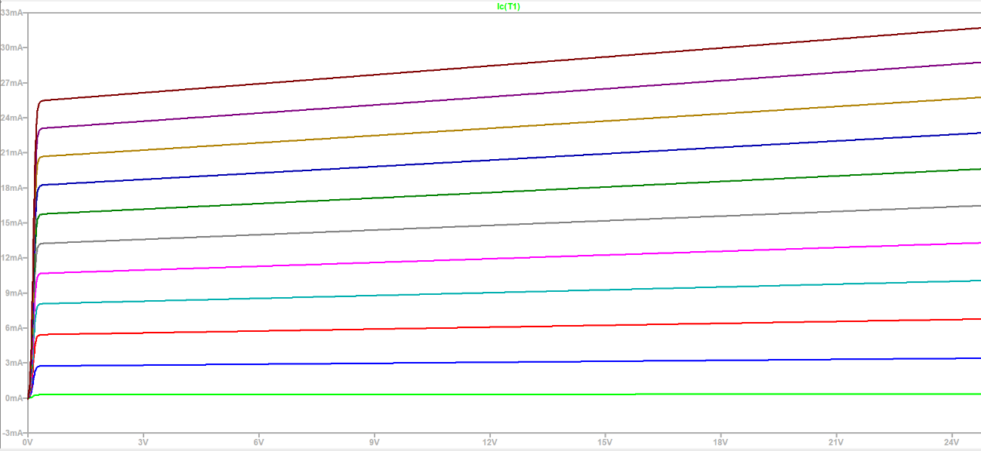

As the temperature varies, the Ic currents have varied for the same values of Vce. As the temperature increased, there was an increase in the Ic current. This is because they increase the number of mobile carriers due to broken bonds due to rising temperatures. The morphology of the curves has practically not changed with respect to the set of curves at 27 °C. On the other hand, the currents at the base have not changed with the change in temperature. Placing the cursor at the same points on the violet and brown curve as in a) to find the current gain and output resistance, we have the following:

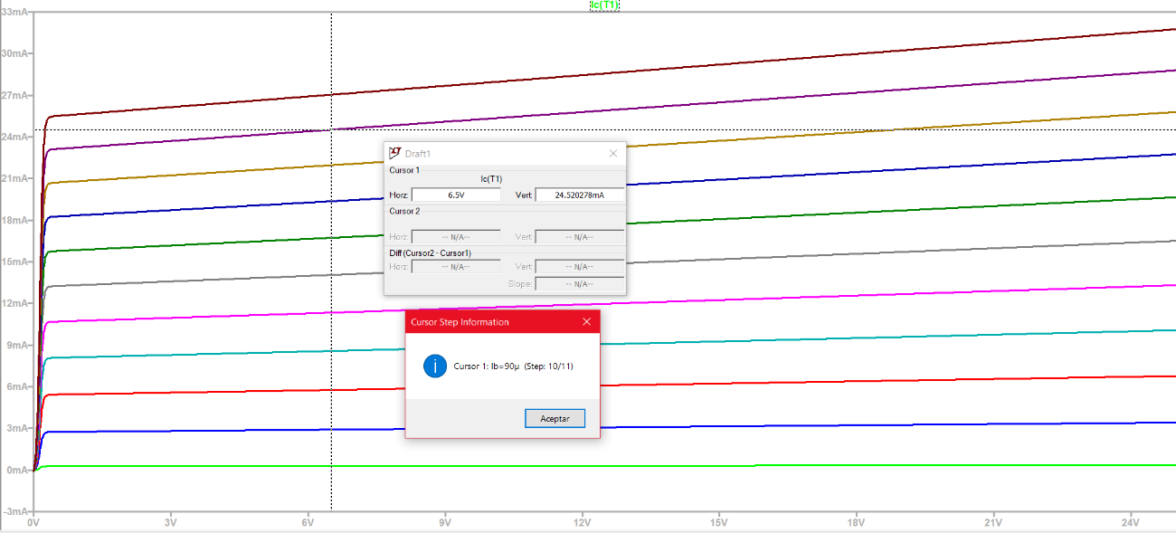

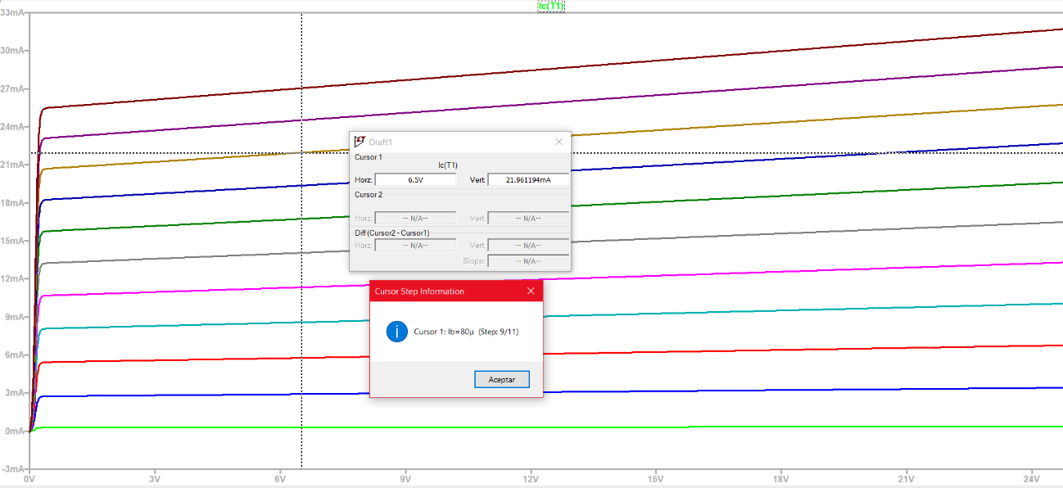

We have for the violet curve: Vceq = 6.5 V Iceq = 24.5 mA Ib = 90 uA

We have for the brown curve: Vceq = 6.5 V Iceq = 22 mA Ib = 80 uA

and the variation and gain of currents are:

∆Ib = 90 A – 80 A = 10 A ∆Ic = 24.5 mA – 22 mA = 2.5 mA

Current gain = ∆I = = = 250

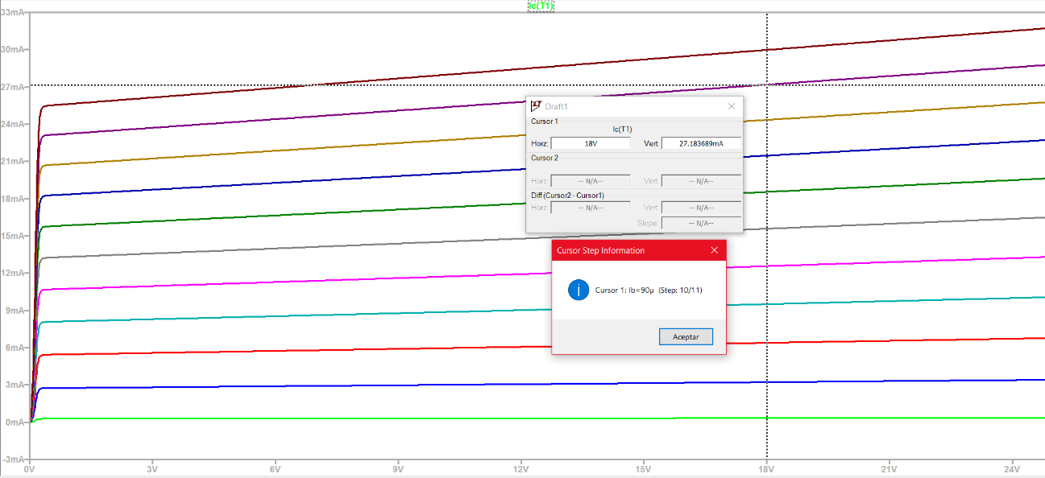

For the output resistance, staying on the previous violet curve and taking again the values of Vceq1 = 6.5 V and Iceq1 = 24.5 mA, I now move in an increasing direction to the right with the cursor and take another pair of values of my choice these being Vceq2 = 18 V and Iceq2 = 27.2 mA. Then we have to:

∆Vce = 18 V – 6.5 V = 11.5 V with ∆Ic = 27.2 mA – 24.5 mA = 2-7 mA

where the output resistor is R = = = 4.26 KΩ

c) We see that at 27 °C the current gain is 200 and the output resistor 5.75 KΩ. While for 100 °C the current gain is worth 250 and the output resistor is 4.26 KΩ. It is concluded that as the temperature increases, the Ic current increases and therefore the current gain increases and the output resistance decreases. This is due to an increase in mobile carriers due to the breakage of covalent bonds with increasing temperature. This suggests that the transistor becomes more efficient for current amplification and in transferring energy at high temperatures. The transistor is in active mode as a common emitter and just as it amplifies current it also amplifies voltage although it is not part of the analysis.

d) We see the Early effect from the following qualitative graph.

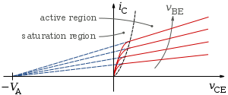

The Early voltage, or Early modulation factor, is an important feature of TBJ transistors. It refers to the variation of the collector current with respect to the collector voltage when the base voltage remains constant. In other words, the Early voltage represents the sensitivity of the collector current to changes in the collector voltage. The Early voltage is relevant in signal amplification applications as it can influence the gain, input impedance, and other properties of the TBJ.

To get the formula you have to think of the graph above as a triangle in the following way:

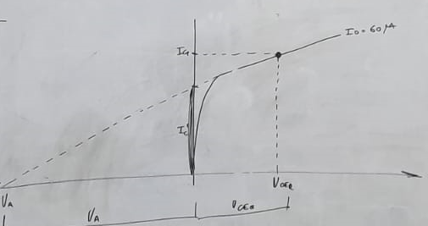

with which we have the following:

=

We know that VceQ1 ≈ 0 so:

=

So we would have to clear VA. After a few clearances, I get the following:

|VA| =

In the case of the work, again using the violet curve and using the cursor until we reach values close to the origin we see the following graph:

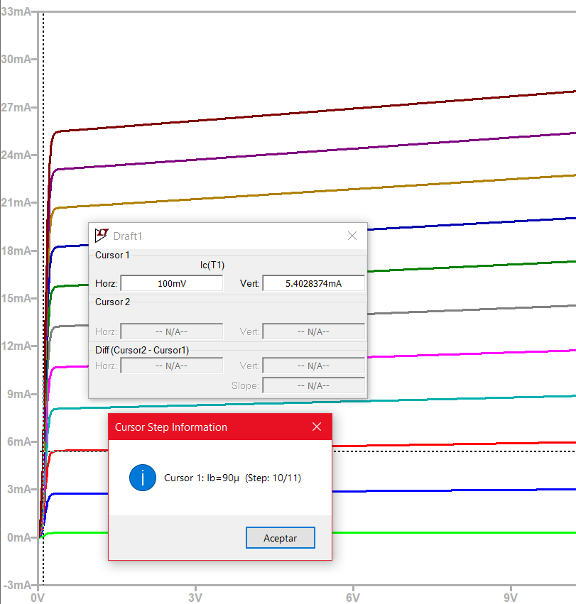

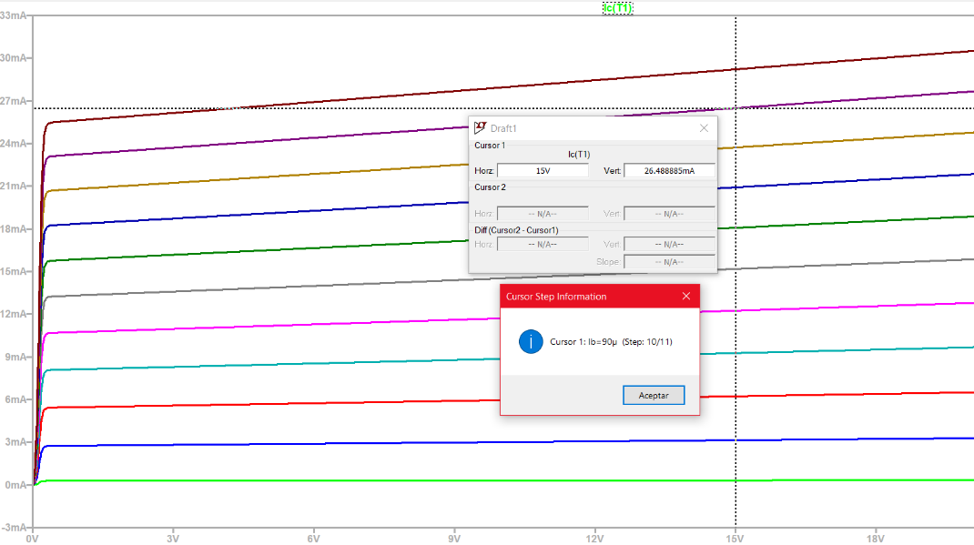

For the violet curve: Vceq1 = 100 mV ≈ 0 Iceq1 = 5.4 mA Ib = 90 uA

For the violet curve: Vceq2 = 15 V Iceq2 = 26.5 mA Ib = 90 uA

Early Voltage = |VA|== 18.83 V for T = 100 °C

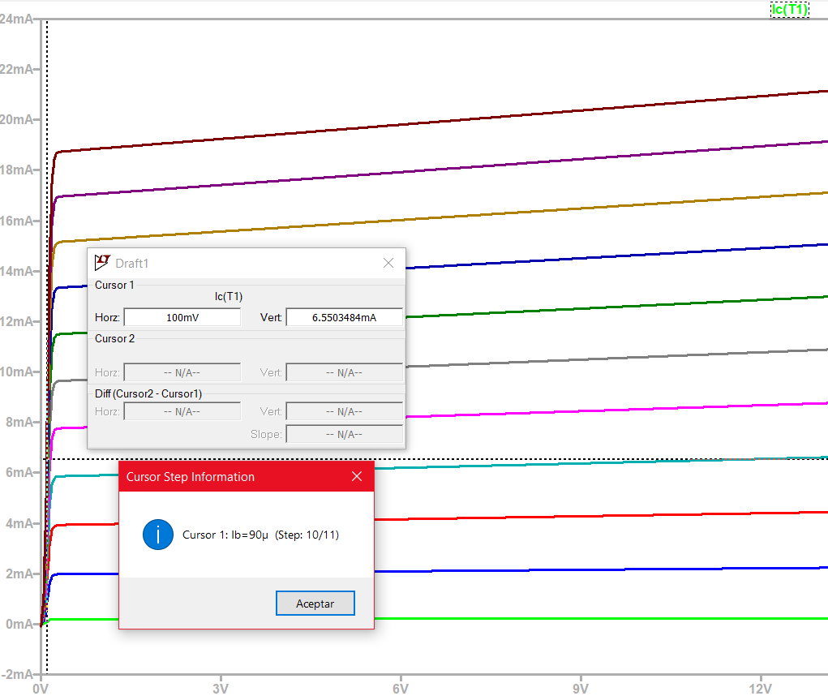

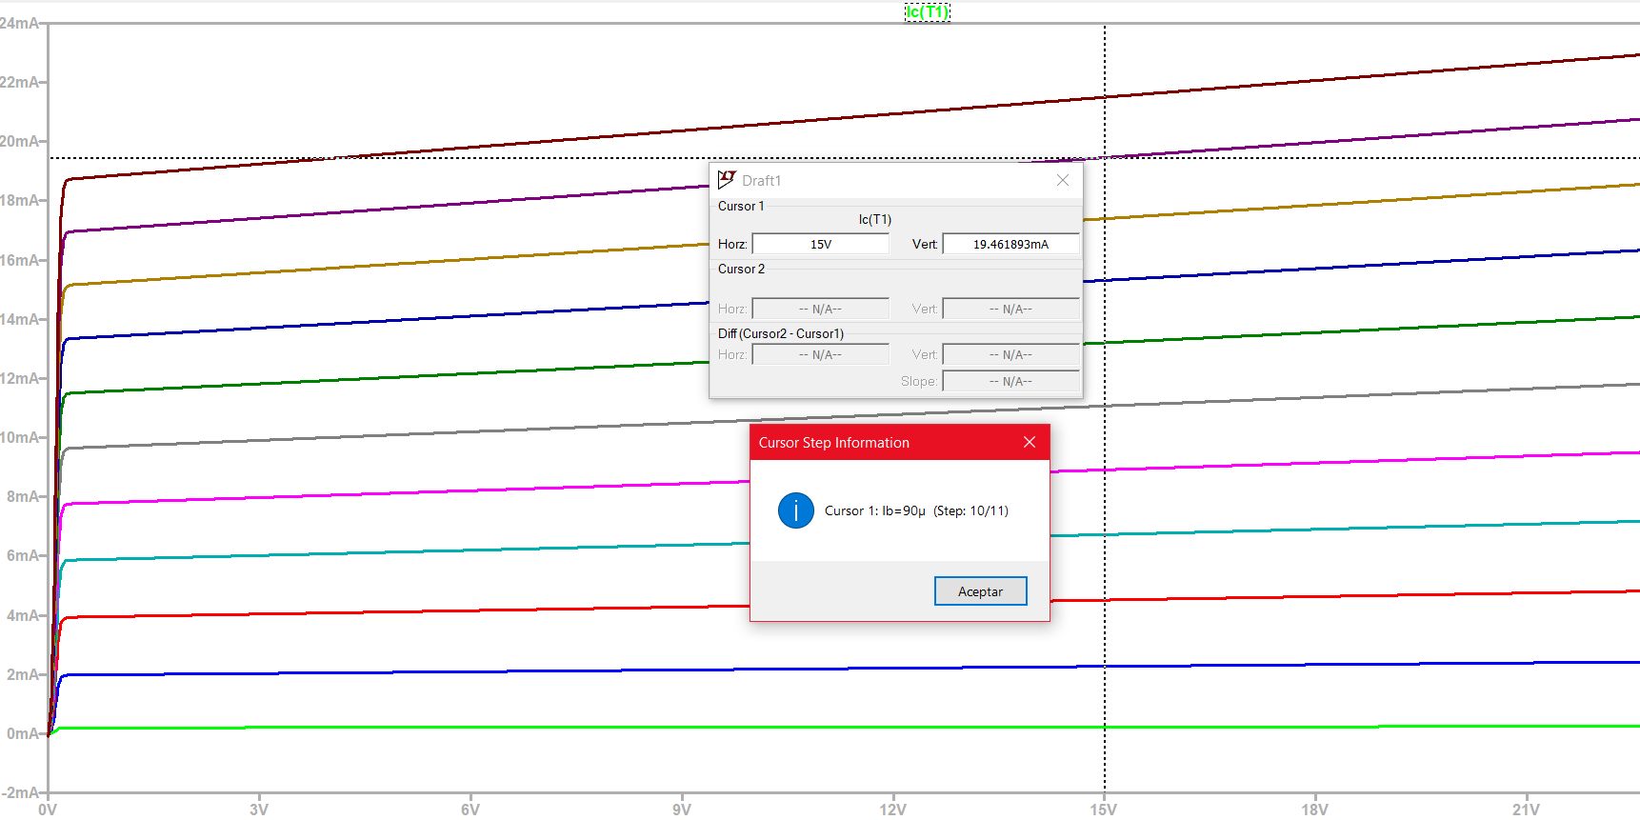

For the violet curve: Vceq1 = 100 mV ≈ 0 Iceq1 = 6.5 mA Ib = 90 uA

For the violet curve: Vceq2 = 15 V Iceq2 = 19.5 mA Ib = 90 uA

Early Voltage = |VA|== 22.5 V for T = 27 °C

If we take voltages Vceq1 closer to 0 as in order of uA or nA, then the Iceq1 ≈ 0 and the Early voltage approximates the Vceq2 since the numerator and denominator become almost equal. For a temperature increase the Early voltage decreases compared to a decrease in temperature where the Early voltage increases. With the lower Early voltage, there is a greater sensitivity to changes in the collector voltage compared to the higher Early voltage. This implies that, for the same collector voltage, the TBJ with a lower Early voltage will experience a greater variation in collector current compared to the TBJ with a higher Early voltage. That is, the slopes of the current curves are larger when the Early voltage is smaller and vice versa. This can affect the amplification of the transistors in a circuit.

2) ii. *Evaluation of the voltage amplification and frequency response of a BC546B transistor in a common emitter*

Starting from the next circuit of a BC546B transistor in common emitter configuration, the voltage gain, frequency response, and output voltage are evaluated according to some input voltage values. All this based on visualization, that is, qualitatively. The frequency and voltage parameters in "SINE" as well as in "transient" will be modified to achieve the necessary graphs.

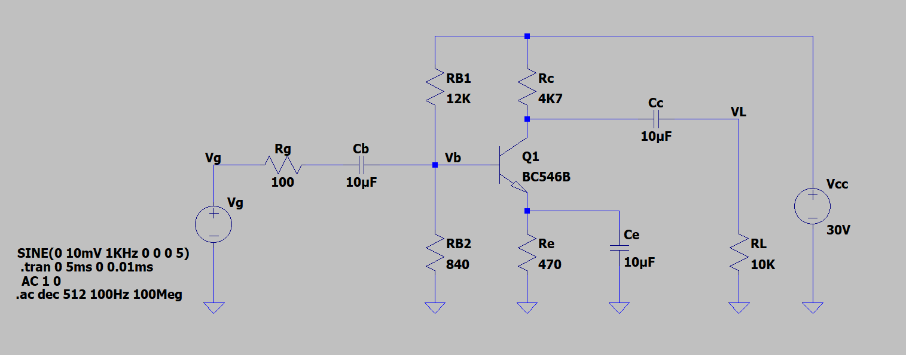

a) The voltage gain at frequencies 1 KHz, 10 KHz, 100 KHz, 1 MHz and 10 MHz is evaluated, based on the visualization of the Vg input and VL output signals

For 1 KHz

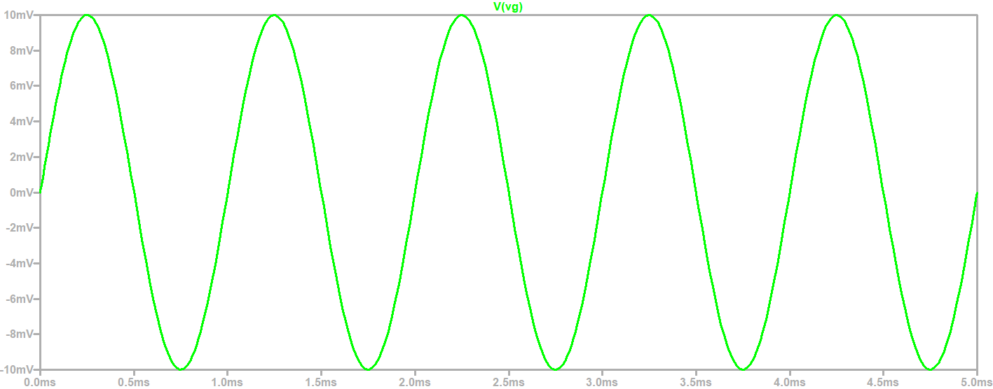

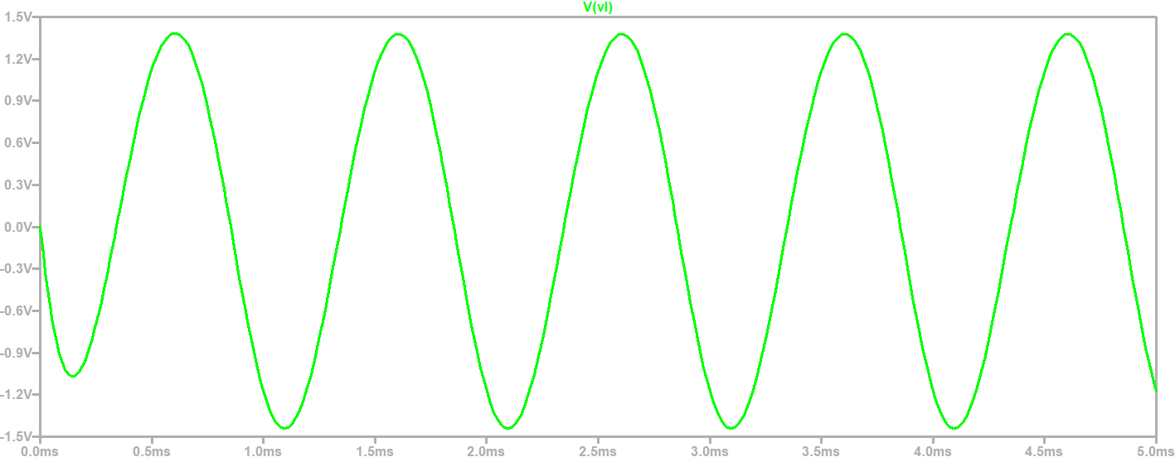

From the voltages at 1KHz we have: Vg = 10mV, Vl = 1.4V and there is a voltage gain = ∆V = = = 140

For 10 KHz

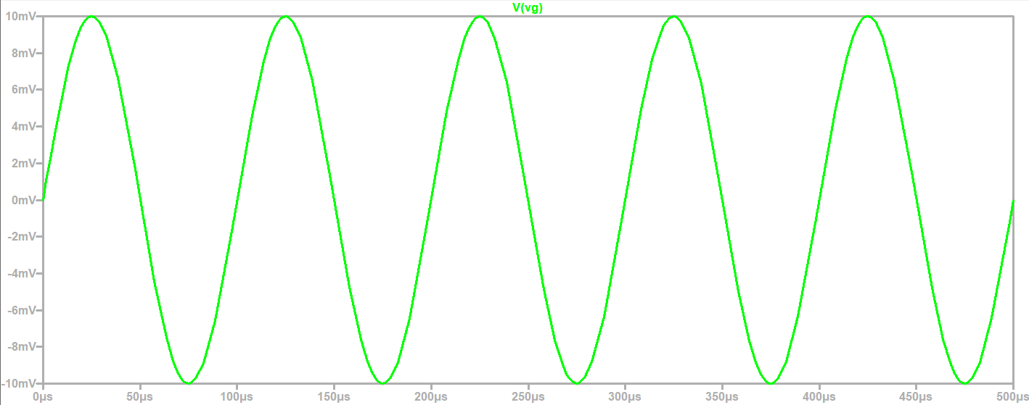

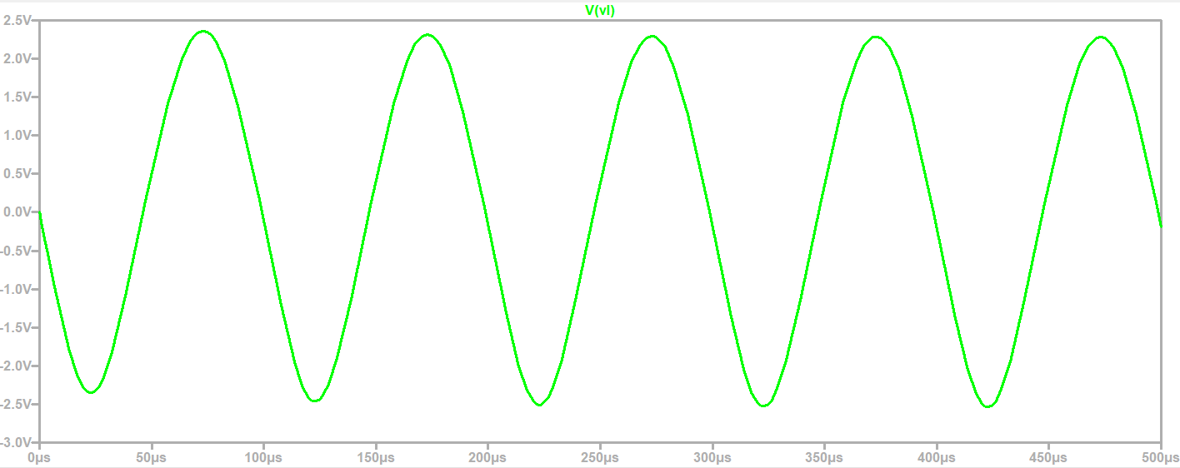

From the voltages at 10KHz we have: Vg = 10mV, Vl = 2.4V and there is a voltage gain = ∆V = = = 240

For 100KHz

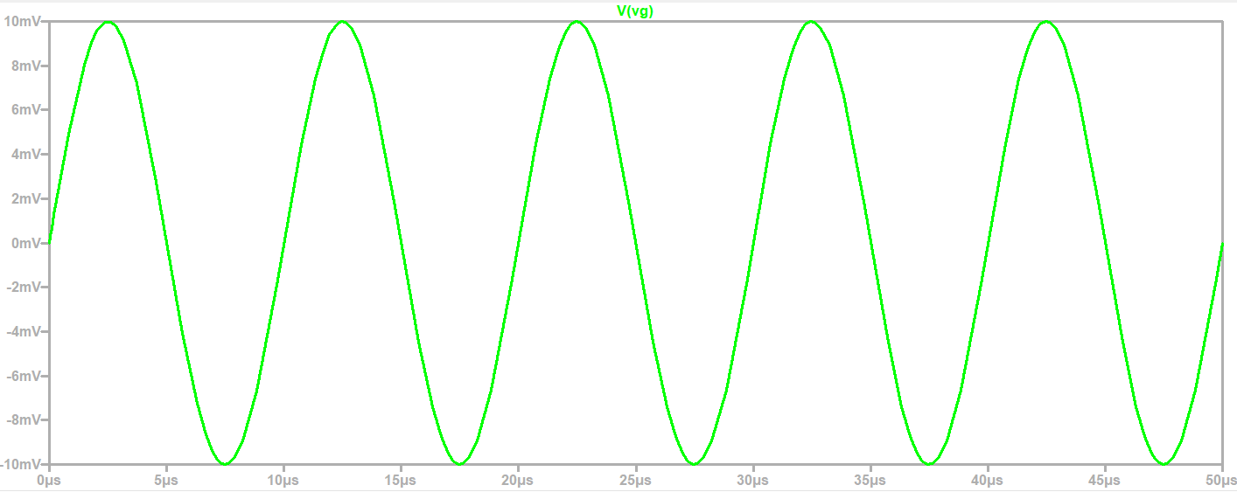

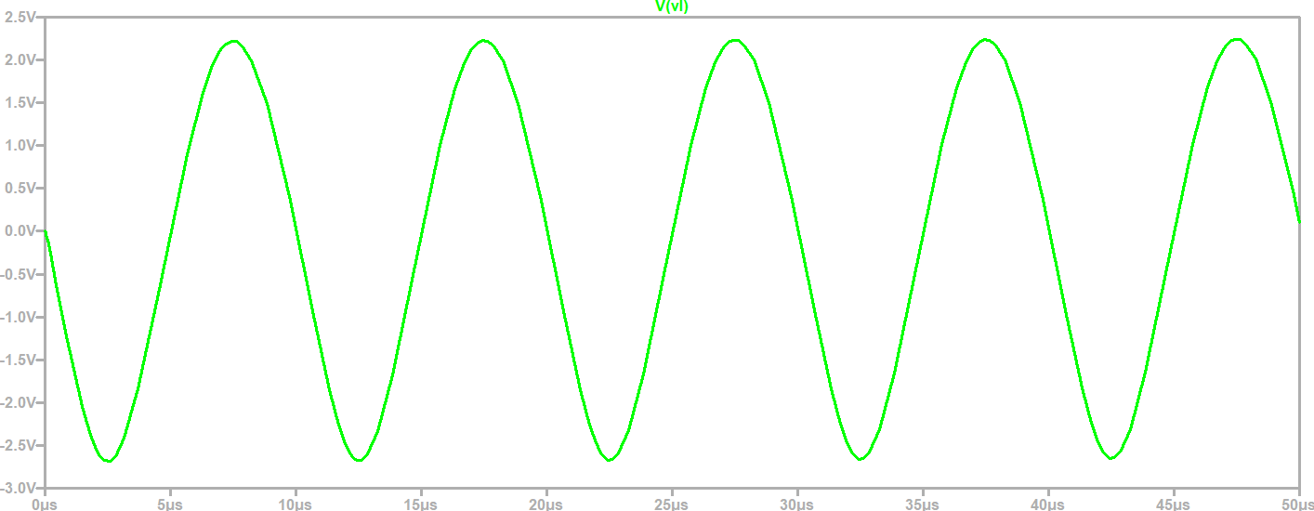

From the voltages at 100KHz we have: Vg = 10mV, Vl = 2.3V and there is a voltage gain = ∆V = = = 230

For 1MHz

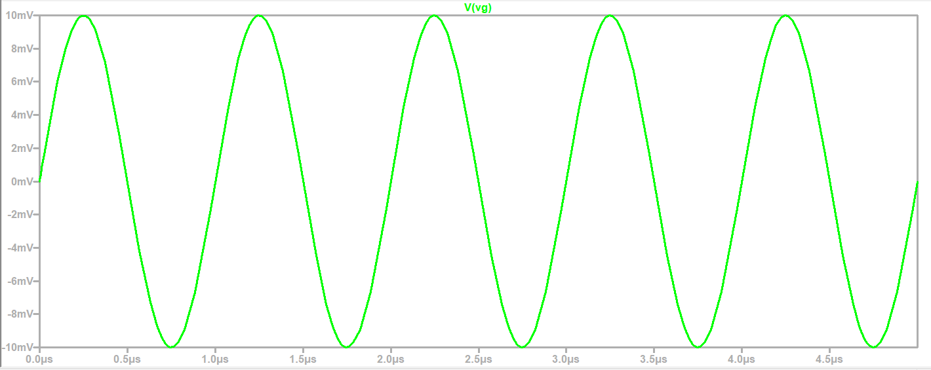

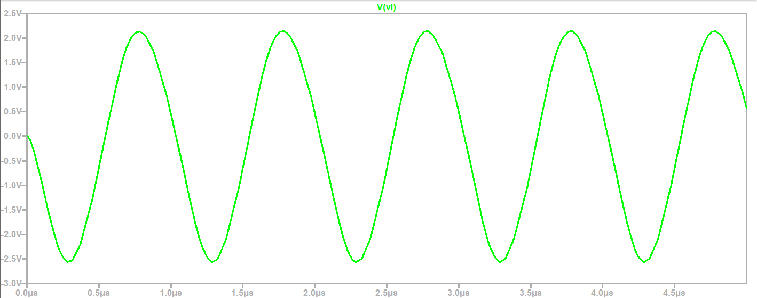

From the voltages at 1MHz we have: Vg = 10mV, Vl = 2.2V and there is a voltage gain = ∆V = = = 220

For 10MHz

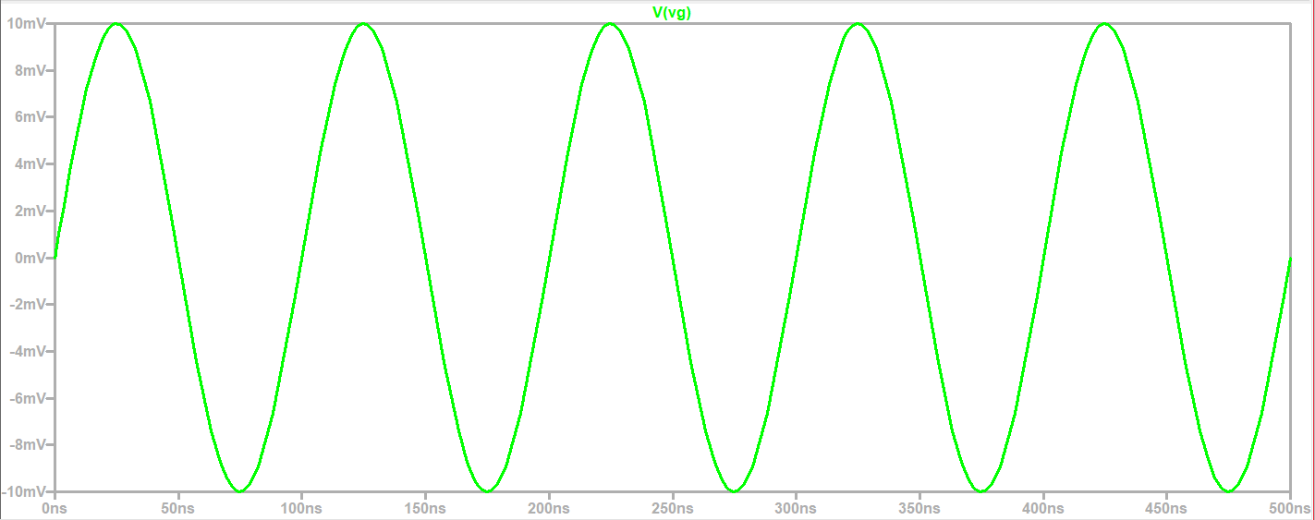

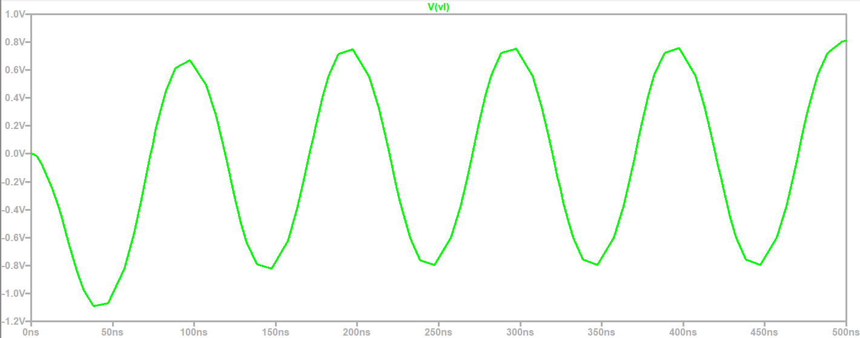

From the voltages at 10MHz we have: Vg = 10mV, Vl = 0.8V and there is a voltage gain = ∆V = = = 80

In all cases, in order to display well, you have to modify the "stop time" parameter in the "transient time" directive, reducing it more and more in value and magnitude.

b) I analyze the Frequency Response of the circuit and make a comparison in relation to what was obtained in a) together with an analysis.

The lower cut-off frequency is approximately 1.42 KHz and the upper one is qualitatively 3.75MHz approximately. To obtain them, the cursor 1 is placed at the maximum transfer value in dB which is approximately 47.82 dB, and then with a cursor 2 it is moved left and right until in each case, the Ratio (Cursor2/Cursor1) is worth -3 dB in the "Mag" box.

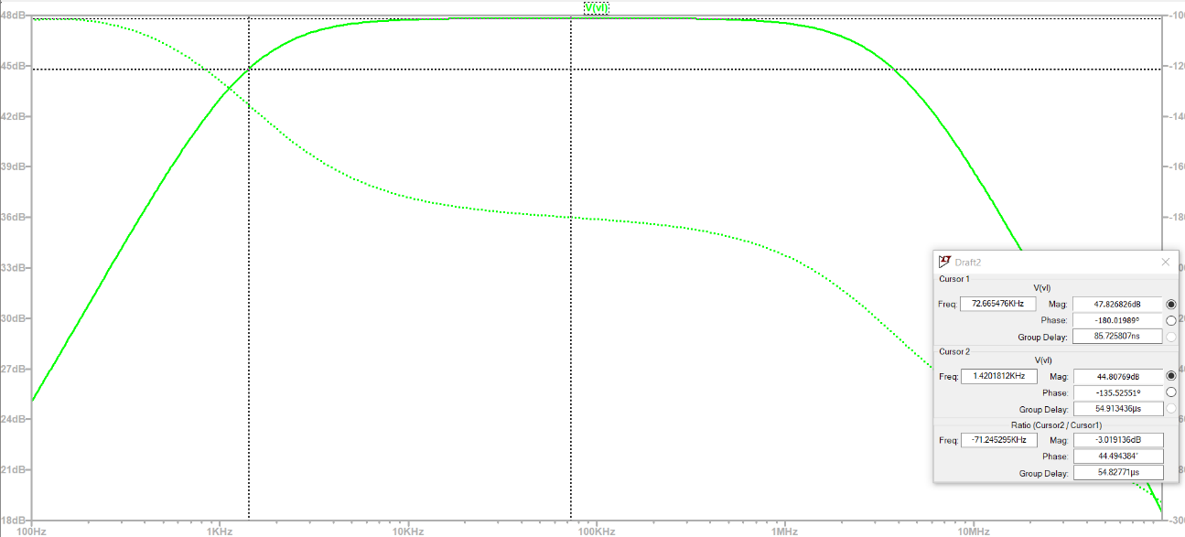

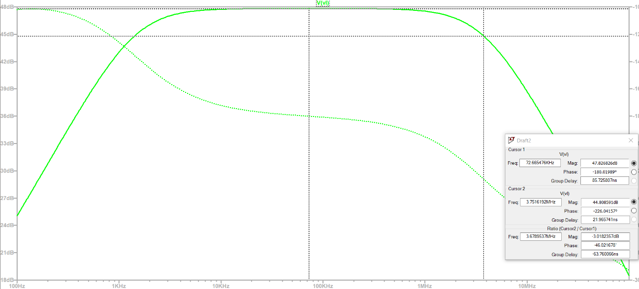

As the frequency of the input source increases, the gain of the circuit drops. This gain reduction is caused by parasitic capacitances and changes in the input impedance associated with the source and the load or output impedance. Parasitic capacitances are typically Cbe and Cbc. The first is the capacitance of the base-emitter junction, which appears by direct polarization of that junction and, therefore, is greater than Cbc which is the base-collector capacitance which appears by the said inversely polarized junction. In summary, the parasitic capacitances mentioned tend to be constant at low to medium frequencies and do not have much impact on the gain of the circuit; but they present a decrease at higher frequencies which results in the introduction of ballasts that affect the impedance of the circuit greatly decreasing the gain. It is said that there is a mismatch of the input signal and capacitive negative feedback. In addition, the Miller effect amplifies this problem because it increases the effective capacitance seen at the input, thus further lowering the gain at high frequencies.

A bandwidth BW = fs – fi can be determined such that in this frequency range the transfer is very high and the transistor gain is very good. But outside the bandwidth, that is, for f < fi and f > fs, attenuation of the transfer occurs, which translates into a reduction in gain.

c) Study the output voltage for a frequency of 50 KHz in the input signal taking 3 input application values these being 0.1V, 1V and 10V obtaining some conclusions.

For f = 50 KHz and Vi = 0.1 V

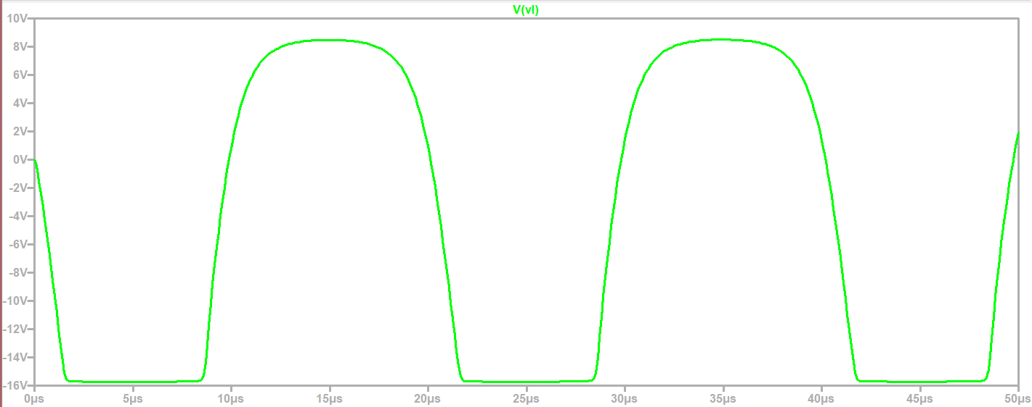

For f = 50 KHz and Vi = 1 V

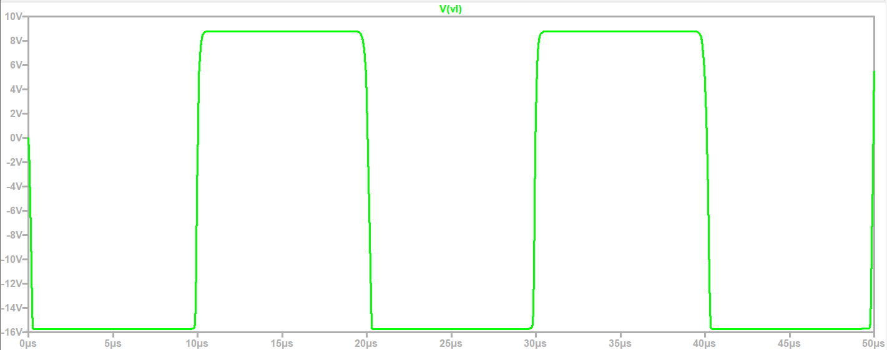

For f = 50 KHz and Vi = 10 V

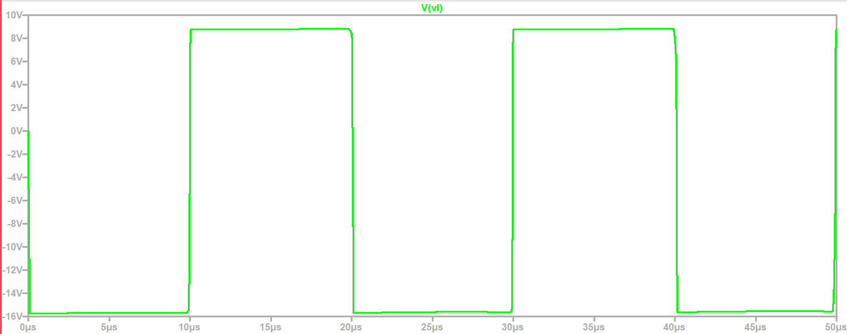

The output signal is amplified with respect to the input according to the gain of the transistor. However, as the voltage at the input increases, then the transistor distorts the output by changing the waveform primarily. That is, since an alternating sine signal entered, we would expect to see the same signal at the output but with much greater amplitude. However, although the amplitude increases, it happens that this shape is distorted until it becomes a square signal, which is unwanted. For lower voltages, i.e. weak signals, the transistor hardly distorts the output signal. All this analysis and phenomenon occurs while maintaining the same input frequency.

It can be said that this phenomenon is due, in part, to the transistor becoming saturated and we will say that the transistor enters saturation when the input signal has a sufficiently large amplitude such that it reaches the maximum amplitude limits allowed and expected in the transistor. As a result, the output signal is "clipped." Thus, a square with very fast ascending and descending flanks appears. We will say that a harmonic distortion phenomenon occurs that degrades the quality of the output and is undesirable in particular applications. With an active device such as the transistor, the aim is for the input to be amplified and maintain its morphology without distortion. But when an unwanted harmonic distortion occurs, the amplifier is replaced by a better one with more qualities and fewer limitations, or input signals of lower amplitudes and chord frequencies are simply injected.

2) iii. *Frequency response of a 2N2222 transistor configured as a common emitter*

With the following circuit of a 2N2222 transistor in common emitter configuration again with the modification of some parameters such as the base resistors and the ".ac" directive, the voltage gain is obtained, the frequency response is evaluated and the equivalent capacitances of the Giacolletto model Cα or Cπ are modified based on injecting an input with a certain frequency. Graphs are obtained and analyzed to deduce conclusions. The frequency and voltage parameters in "SINE" as well as in "transient" will be modified to achieve the necessary graphs. The internal libraries are also modified to vary Cα or Cπ.

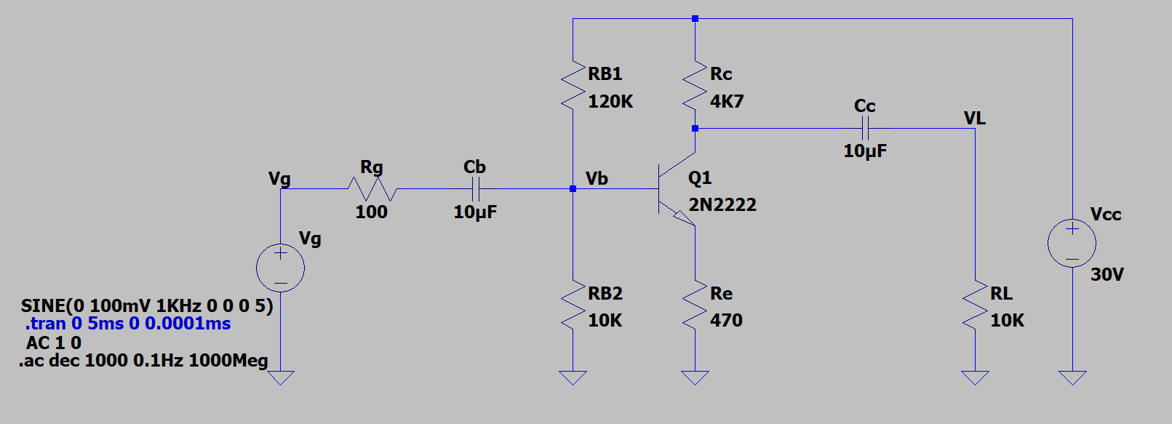

a) We obtain the voltage gain with an input signal of 1 Khz and Vi = 100 mV. We observe the following input and output voltage graphs:

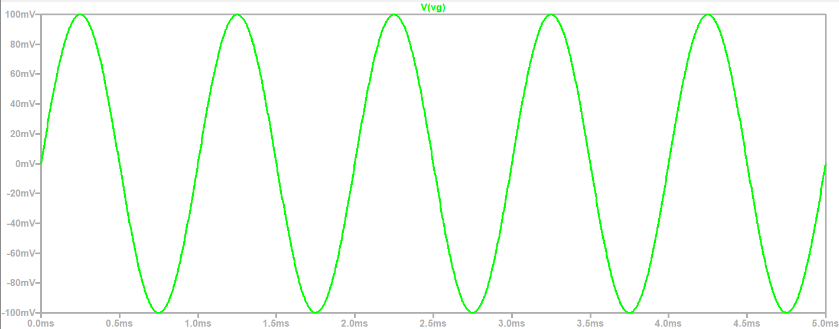

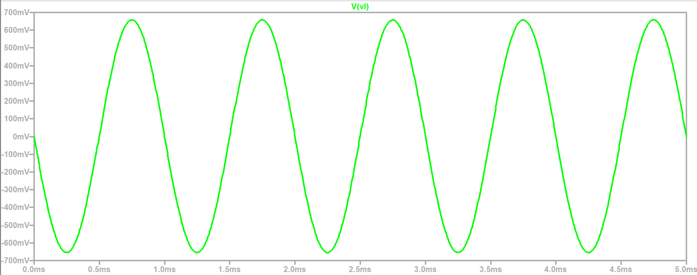

We see that Vg = 100mV, Vl = 650 mV and gain ∆V= = = 6.5

b) We evaluate the frequency response and obtain the corresponding cut-off frequencies using the following method:

The lower cut-off frequency is approximately 2.3 Hz and the upper one is qualitatively approximately 12.96 MHz. To obtain them, the cursor 1 is placed at the maximum transfer value in dB that is approximately 16.34 dB, and then with a cursor 2 it is moved left and right until in each case, the Ratio (Cursor2/Cursor1) is worth -3 dB in the "Mag" box.

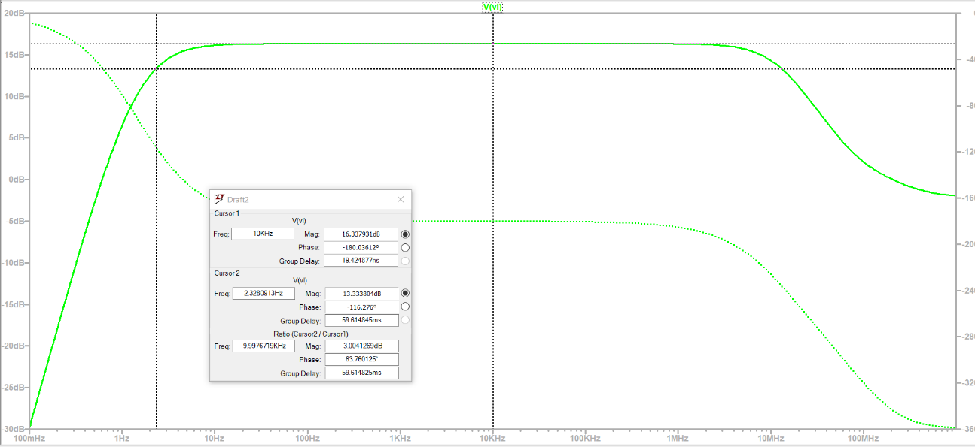

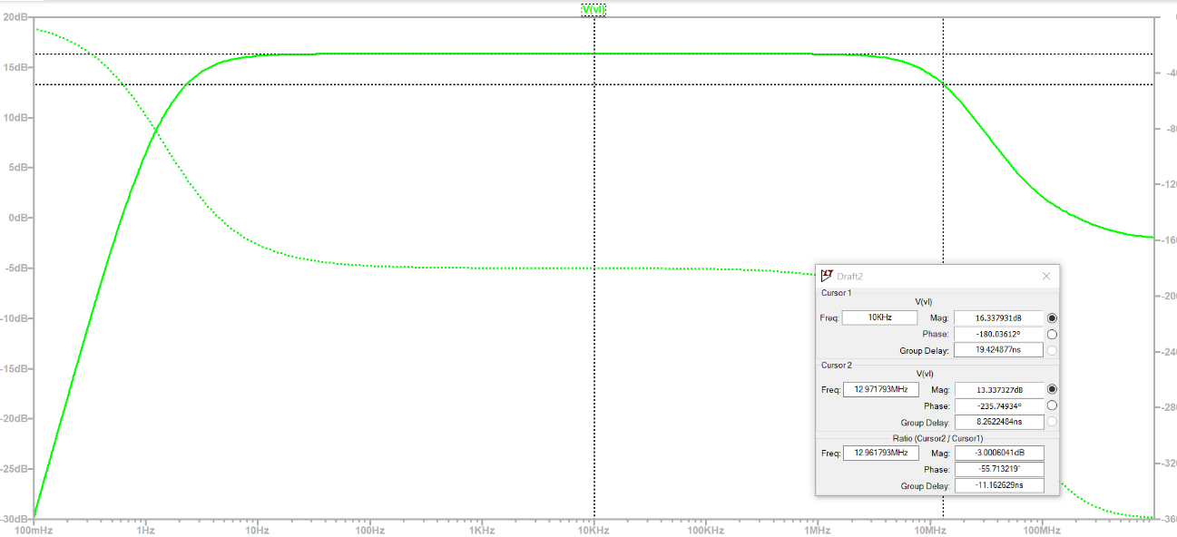

c) The figures obtained in point 2) iii. b), with the results of point 2) ii. a).

We see that the upper cut-off frequency is higher and the lower-cut-off frequency is lower in the circuit of 2) iii. b) with respect to the circuit of 2) ii. b). The change caused is due to the use of a different transistor in both cases. Bipolar junction transistors (TBJ) are available in different models and each model has its own characteristics and specifications, being that either one model or another can be applied for study such as the Ebers-Moll or the Giacolletto, etc.

A higher cut-off frequency tells us that the device can amplify higher frequency signals with better efficiency and with less distortion, this is useful in high-fidelity audio amplifiers. On the other hand, a lower cut-off frequency means that it is possible to amplify low-frequency signals more efficiently and with less distortion. This is important in applications where an accurate response is needed for very weak frequency signals giving the possibility of building better quality audio circuits.

d) We evaluate the frequency response by modifying in this case, the capacity by increasing it 1000 times more Cjc= 8X10-12🡪 Cjc=8X10-9where Cjc is the Cα and we obtain the corresponding cut-off frequencies using the following method:

The lower cut-off frequency is approximately 2.3 Hz and the upper one is qualitatively 13.1 KHz approximately. To obtain them, the cursor 1 is placed at the maximum transfer value in dB that is approximately 16.32 dB, and then with a cursor 2 it is moved left and right until in each case, the Ratio(Cursor2/Cursor1) is worth -3 dB in the "Mag" box.

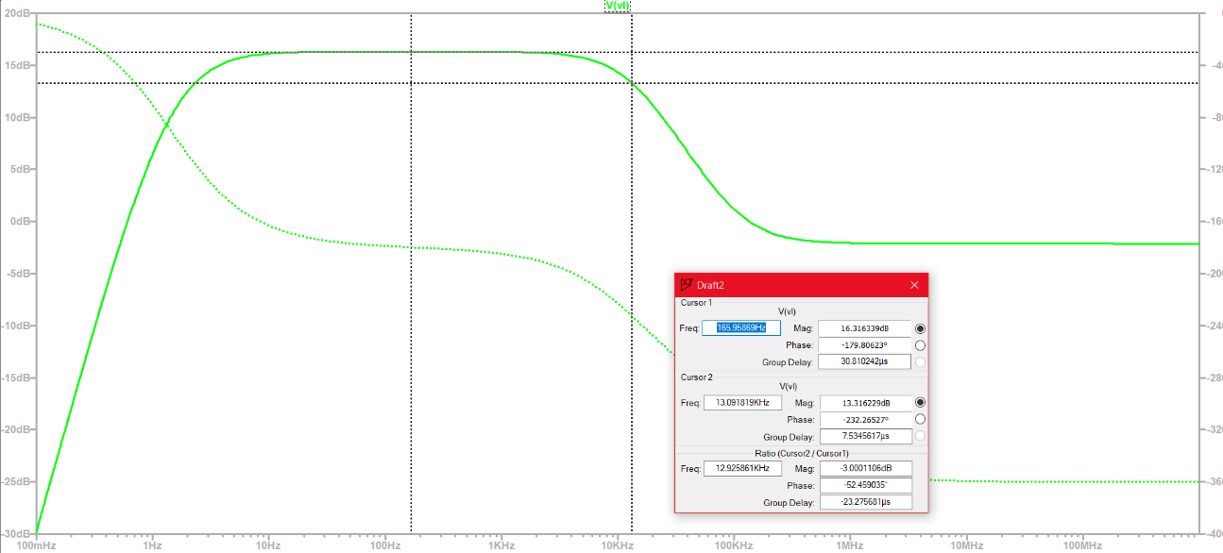

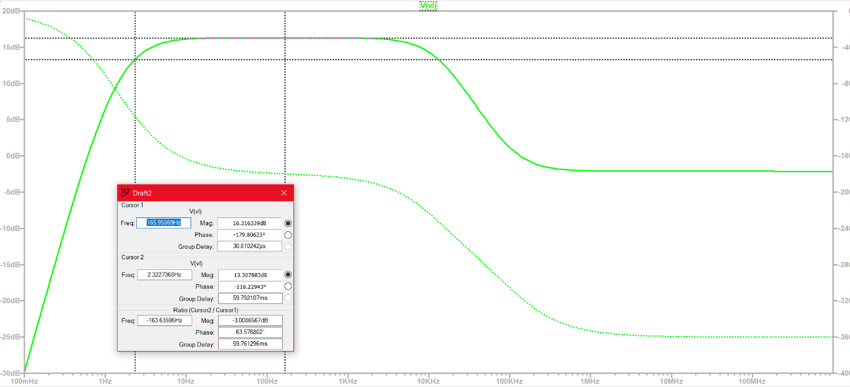

e) Comparing item b and d from modifying Cjc or Cα in the library and remembering that it is a parasitic capacitor between the gm.vbe current source and the base of the transistor in the giacolleto model, it is observed that this capacitor mainly affects the upper cut-off frequency or maximum frequency of the bandwidth of the passband or working band of the transistor. The upper cut-off frequency increases if the value of this capacitor is decreased and that frequency is reduced if the value of the capacitance mentioned increases. This results in a modification in the type of frequency signals supported by the transistor being that, if Cα is increased and Cpi is left fixed, then the transistor admits low frequency signals to amplify them almost without distortion, so higher frequency signals will not be well amplified but distorted. Profit will also be affected.

On the other hand, the Cpi parasitic capacitor, located between the base and the mass of the giacolletto model, determines. Such that, if it is varied, then the result is only a variation in the lower cut-off frequency and a variation in the upper cut-off frequency in much the same way as when Cα0 is varied

**Conclusion**

From the visualization of different graphs and the performance of some elementary operations seen in class, it was possible to study the gain of a TBJ transistor in active mode with also the frequency response using 2 similar but different models. It was observed that, for signals of very high frequencies and high amplitudes, the transistor distorts and attenuates. Whereas, for weak signals, i.e. amplitudes of a few millivolts and low to medium frequencies, the transistor manages to amplify practically perfectly and almost without distortion obtaining high gain values which is desired. Finally, it was seen that by varying some internal parameters of the transistor such as the parasitic capacitances of Cpi and Cα, we managed to vary the cut-off frequencies, in particular the upper one, being that the bandwidth of the transistor passband is modified, that is, the frequency range for which the transistor amplifies correctly and almost without distortion.