|  |
| --- |
| Image containing furniture, table, drawing, flower  Auto-generated description**Practical work Devices E.** |

|  |  |
| --- | --- |
| **GROUP N°--------------** | **COURSE:R3031** |

|  |
| --- |
| **PROFESSORS: Ricardo Alberto Zuazquita and Eduardo Víctor Oreglia** |

|  |
| --- |
| **ATTEND DAYS: Monday and Friday** |

|  |
| --- |
| **ON DUTY: Afternoon** |

|  |
| --- |
| **PRACTICAL WORK N°: 3** |

|  |
| --- |
| **TITLE: Comprehensive Simulation and Analysis of MOSFET Transistors in LT-Spice** |

|  |
| --- |
| **Student: Costarelli Facundo Lautaro** |
| **DNI: 42.724.683** |
| **File: 176.291-6** |

|  |  |  |
| --- | --- | --- |
|  | **DATES** | **SIGNATURE AND CLARIFICATION OF THE TEACHER** |
| **CARRIED OUT ON** | 15/07/2024 |  |
| **CORRECTED** |  |  |
| **APPROVED** |  |  |

|  |
| --- |
| **INDICATIONS FOR CORRECTIONS:** |

**Index**

1. Introduction ----------------------------------------------------- Page 1
2. Development -------------------------------------------------------- Page 2

i. *Obtaining the transfer curve of a MOSFET transistor* - ------------------------------------------------------- Page 2  
Ii. *Obtaining the Output Curves of a MOSFET Transistor* ------------------------------------------------------------------------Page 5  
Iii. *Single-stage amplifier with MOSFET. Obtaining the Voltage Gain* -------------------------------------------- Page 9

iiii. *Single-stage amplifier with MOSFET. Obtaining the frequency response of the -------------------------- circuit* Page 10

1. Conclusion ------------------------------------------------------- Page 16

**Introduction**

This report seeks to study the transfer curve of a MOSFET taking the BS170 as a reference in order to determine the threshold voltage, what type of channel it is as well as the type of contamination of it. Studying transconductance will help us understand how the output current Id varies or is regulated as a function of the variation of the bias voltage Vgs in the transistor. It will be important to study even transfer curves for different temperatures in order to see how the transistor interacts with different temperatures and what are the vital changes produced.

We will also seek to study the output curves of Id as a function of you in order to determine the cut-off, saturation and parabolic zones in order to understand the behaviors of the transistor in each of them. The dynamic resistance to small values of Vds and the transconductance will allow us to make comparisons with the previous case and observe particular important behaviors. Finally, from a single-stage amplifier circuit, we will see how the transistor behaves under these conditions, what is the voltage gain and the natural phase shift produced by this type of circuit. Evaluating the frequency response will be useful to be able to see the typical working frequency range of a transistor where it amplifies without loss or distortion ideally. Changing the internal values of cgs and cgd will allow us to evaluate how different transistor models or structures modify the cut-off frequencies of the working frequency range.

**Development**

2) i. *Obtaining the transfer curve of a MOSFET transistor*

a) Based on the following circuit of a BS170 MOSFET configured in common source and with direct Vgs polarization, the drain current transfer curve is studied where id(vgs) is studied. The ambient temperature is 27°C.

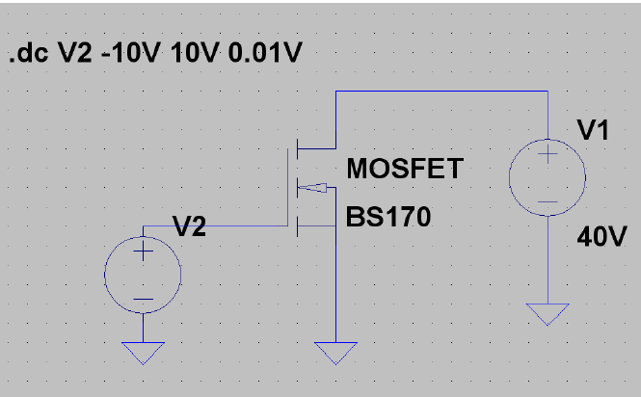

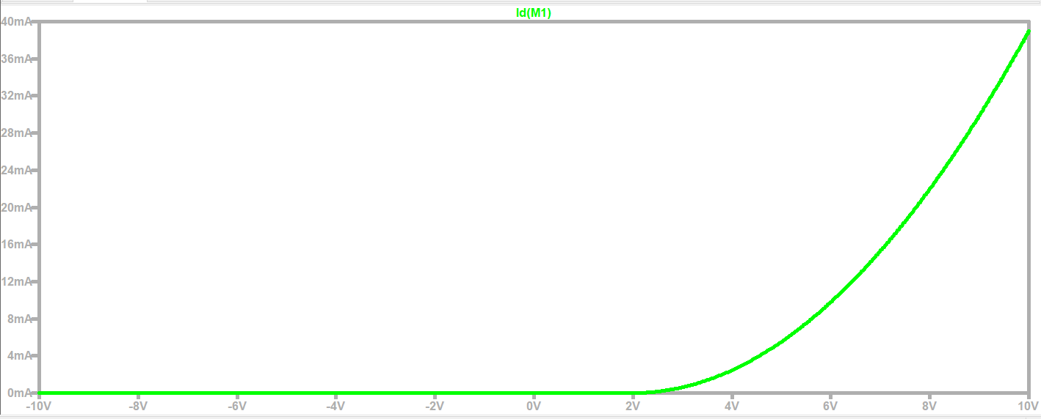

A direct voltage V2 is placed between Gate and Source of 10 V, and V1 = 40V is placed as indicated by the circuit. We see the transfer curve of the device. From here we have a Vth = 2 V where Vth is the threshold voltage, i.e., for which the reversal of the material type of the substrate occurs in a nearby region of the Oxide-Semiconductor interface, such that the channel is formed and current flows between Drain And Source. Since the output values ID of the curve are given for positive values of Vgs where the curve grows towards positive ones, then we can affirm that the channel is type N with substrate P. Because the transfer curve acquires non-zero values for a non-negative voltage of Vgs >= Vth, we can affirm that the MOSFET is an Induced Channel. In case of considering the "non-idealities" such as oxide loads, oxide-semiconductor interface loads and differences in S work functions $∅M ≠∅$, it could happen that there is a negative shift large $∆Vgs$ enough for the Vth to occur in negative values, there is a risk that we will obtain N Channel from Permanent Channel when we wanted it from Induced Channel. In Canal P this does not happen since the Vth is negative from the beginning of the study.

We also see that we are in inversion mode since Vgs > Vth and in saturation mode since Vdsat = Vgs – Vth = 10 V – 2 V = 8 V such that Vds > Vdsat, where Vds = 40 V.

The transconductance will be a slope of a line tangent to a point of the exit curve Id(Vgs). Then:

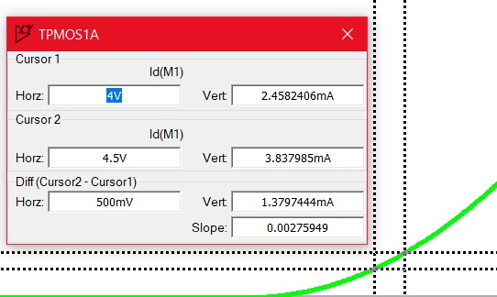

∆Vgs = Vgsup – Vginf= 4.5 V – 4 V = 500 mV

∆Id= 3.84 mA – 2.46 mA = 1.38 mA

Gm= = = $\frac{∆Id }{∆Vgs}\frac{1,38 mA}{500 mV}$ 2.76. ${10}^{-3}$ S

b) Using the following directive ". t" and typing: "temp 27 42 57 72 87 100 ", we see the transfer curves for this list of temperatures.

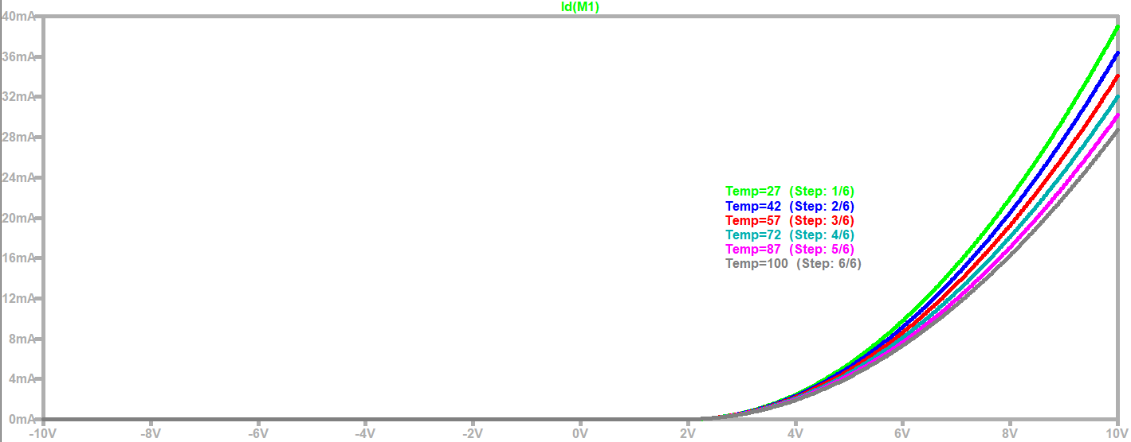

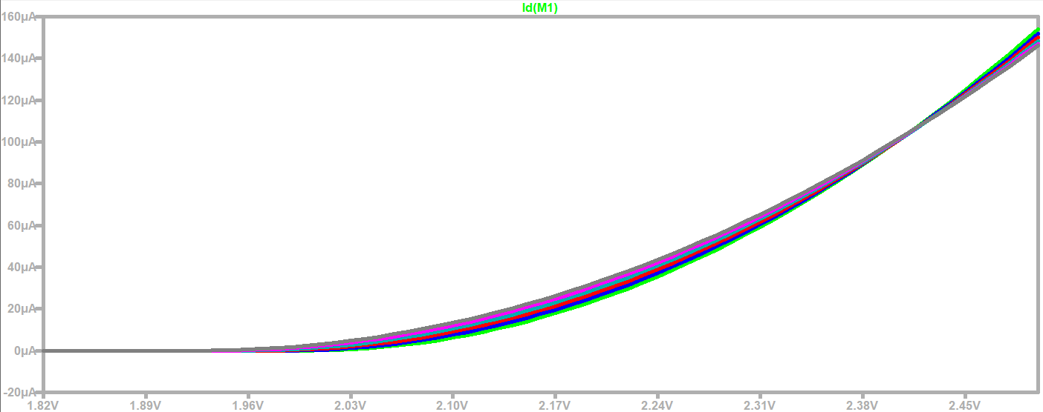

The Vth varies only slightly with temperature, in the graph. This is hardly noticeable for all curves with respect to sight in a).

In addition, the current Id decreases for the same input Vgs value, for example, in the first graph for 8 V we see qualitatively that the Id takes smaller values. As a last detail, for values close to Vth, we see that for the lowest temperatures towards the highest ones (green curve to gray), the Id grows but then for a value between 2.38 V and 2.45 V, all the curves intersect at one point and the aforementioned situation is reversed. This means that for lower temperatures to higher temperatures (green curve to gray), now the Id decreases.

c) Temperature increases result in increases in the effects of thermal agitation, which causes a decrease in the effective mobility of the mobile channel carriers, obtaining a decrease in Id for a given value: Vds and Vgs.

2) ii. *Obtaining the Output Curves of a MOSFET Transistor*

a) Based on the following circuit of a BS170 MOSFET configured in common source and with direct Vgs polarization, a family of drain current output curves is studied where id(vds) is studied. The ambient temperature is 27°C.

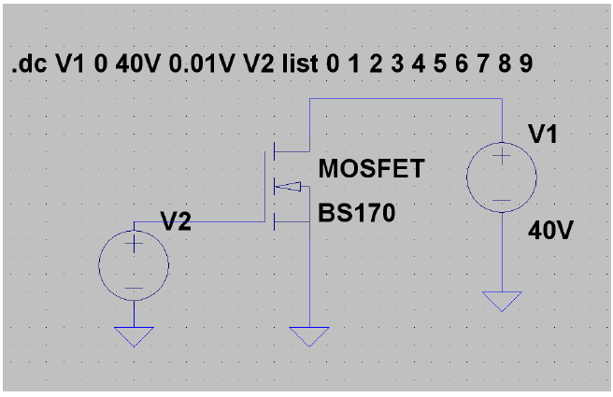

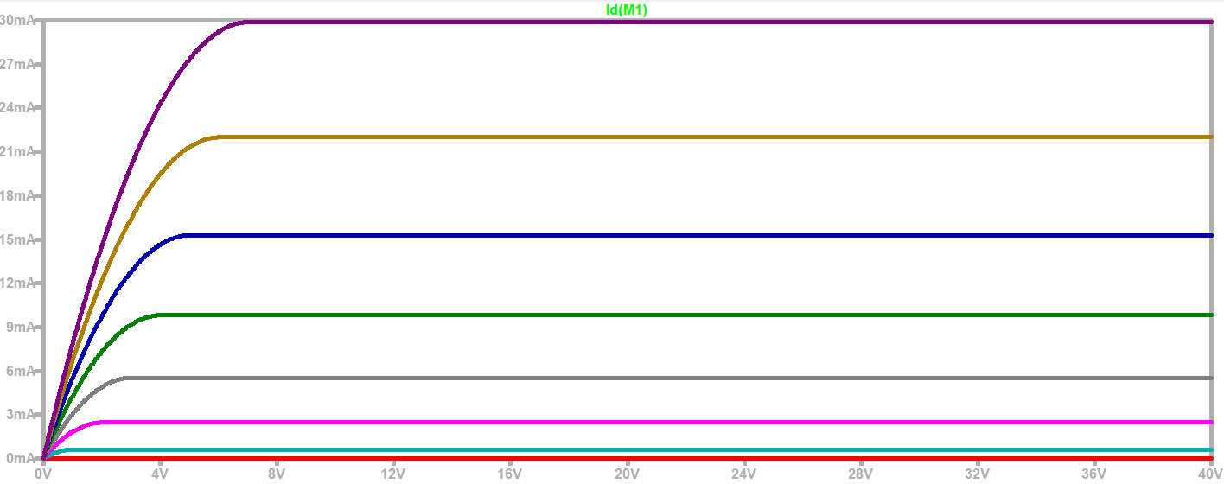



In black we see the borderline parabola, drawn roughly in Word with the pencil. This is the curve that joins the choke points. On the left, we see the ohmic zone which implies using the transistor as R= f(vgs) while on the right is the saturation zone which implies using the transistor as an amplifier and below, marked by the red curve, that is the cut-off zone which implies using the transistor as an open key.

b) To obtain the transconductance, we are going to locate 2 cursors, one for each curve where we measure the $∆Vgs y ∆Id$. In particular, by using the "list" command as follows: "list 0 1 2 3 4 5 6 8 9", we can differ from the . Study between the brown and blue curve in the saturation region. $∆Vgs=1 V$

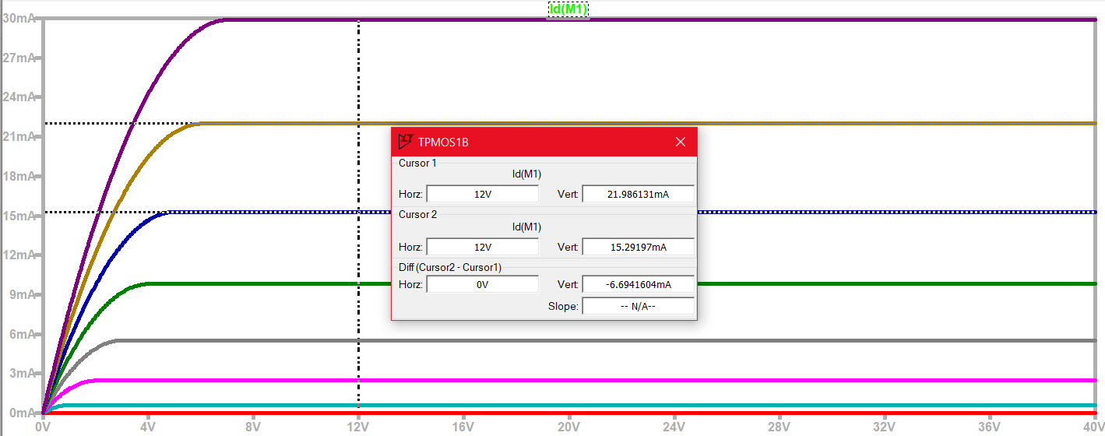

It is observed that for the same Vds = 12 V, in this case, we obtain approximately one $∆Id=7 mA$. Then we have that the transconductance is: Gm = = = S $\frac{∆Id }{∆Vgs}\frac{7 mA}{1 V} 7. {10}^{-3}$. If we compare the Gm obtained with the Gm obtained from 2) i. a) which was Gm = = = $\frac{∆Id }{∆Vgs}\frac{1,38 mA}{500 mV}$ 2.76. ${10}^{-3}$ Yes, we see that it is smaller than the one obtained now if we had taken one $∆Vgs=1 V$ before.

The variation caused between these Gm occurs because the way in which the Gm was calculated in both cases is different, in the previous exercise it was when we stood on the transfer curve Id = f(Vgs) but without taking into account what the working region was, that is, whether cut-off, linear or saturation. Now we take 2 consecutive curves from the graph of Id = f(Vds) and determine the analysis in the saturation region although it could be in the linear as well. The variation is small between the two, so the system is the same and at room temperature 27 °C in both cases.

c) We obtain the dynamic resistance "rd" for small values of Vds between 0 and 0.3 V approximately, this is very close to the origin and taking 2 cursors on the same curve associated with a value of Vgs. In this case, I study the brown and blue curve again and then compare the RDs obtained.

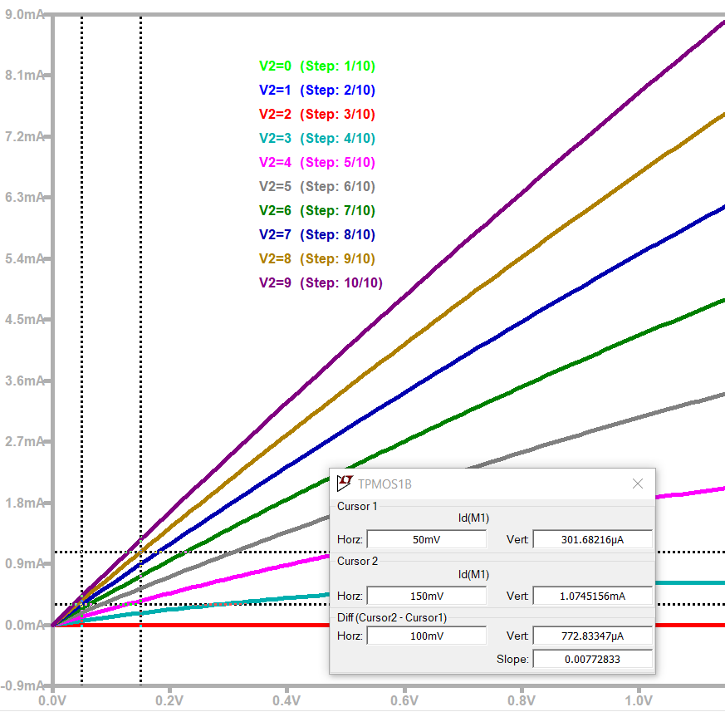

From the brown curve we see that: Vgs = 8 V, ∆Vds = 150 mV – 50 mV = 100 mV, ∆Id = 1.0745 mA - 301.68 uA = 722.83 uA so what happens

rd = = = 129, 4 Ω $\frac{∆Vds}{∆Id} \frac{100 mV}{772,83 uA}$

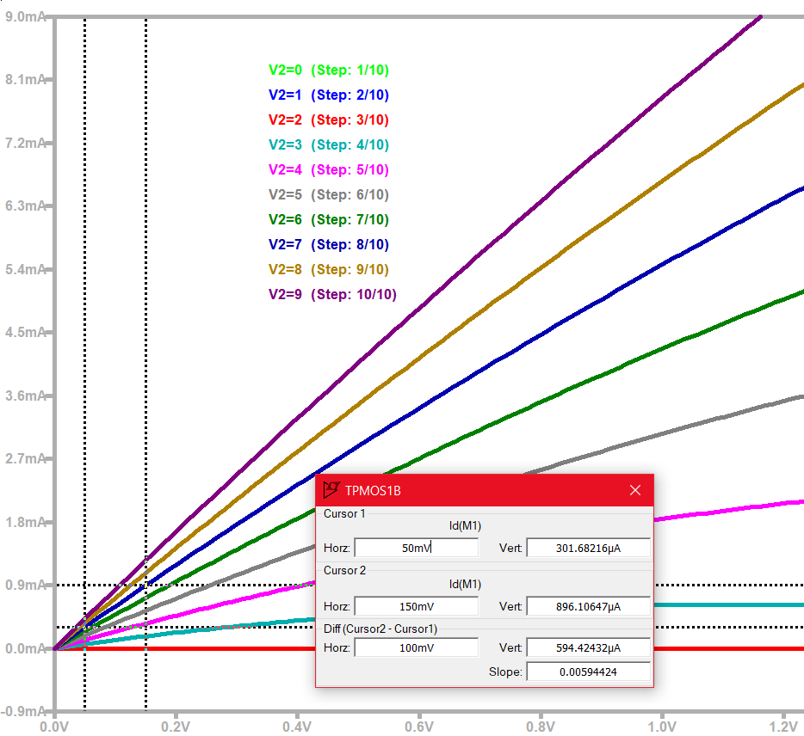

From the blue curve we see that: Vgs = 7 V, ∆Vds = 150 mV – 50 mV = 100 mV, ∆Id = 896,106 uA – 301, 7 uA = 594, 406 uA for what happens

rd = = = 168, 235 $\frac{∆Vds}{∆Id} \frac{100 mv}{594, 406 uA}$ Ω

d) On the one hand, for small values of Vds, the rd = dynamic resistance changes between curves of different values of Vgs whether or not we have the same ∆Vds for each curve. This results in the transistor behaving as a variable resistance by input voltage Vgs, i.e. rd = f(Vgs). In addition, there is the variation of this resistance for the same curve id(Vds), it is an almost linear variation such that there is an almost linear relationship between Id and Vds.

2) iii. *Single-stage amplifier with MOSFET. Obtaining the Voltage Gain*

a) From the following single-stage amplifier circuit of a BS170 MOSFET configured as a common source with a direct Vgs polarization, the aim is to obtain and study the input voltages Vgs and the output voltage VRl as well as the voltage gain at a frequency of 1 KHz.

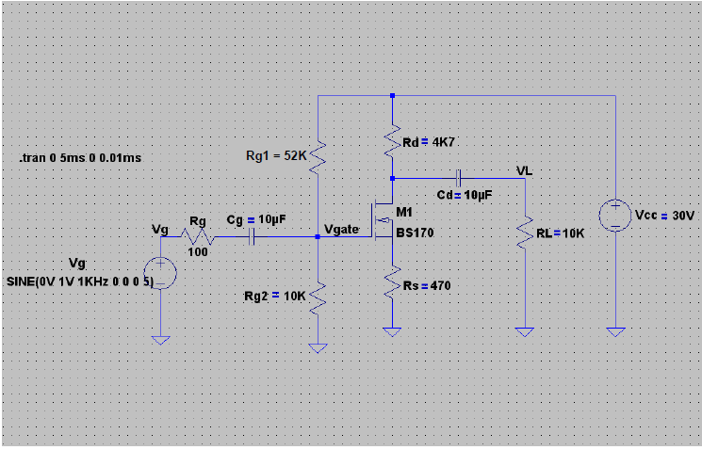

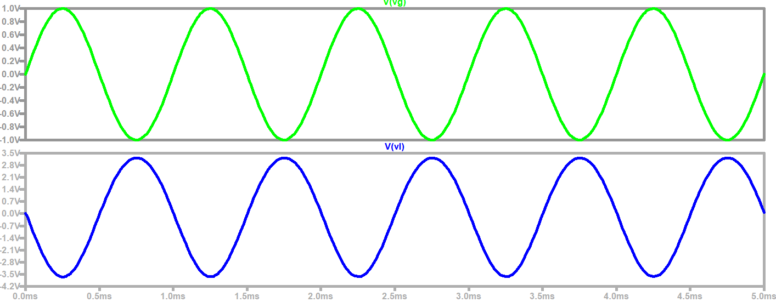

To obtain the voltage gain we take the relationship between the peak output value with respect to the peak value of the input, so: Voltage gain = $\frac{Vpl}{Vpg}$ = = 3.5 approximately. $\frac{3,5 V}{1 V}$

b) A phase shift appears in an amount of π 180° which is due to the nature of the circuit. $≡$

c) To conclude, we can understand the appearance of the 180-degree offset between the input signal Vg and the output signal Vl as a consequence of the inverse relationship between the current Id and the output voltage Vl.

* Increases in Vg cause increases in Id which increases voltage drop in rd (dynamic resistance) decreases Vl.
* Vg decreases Id and therefore decreases the voltage drop in rd (dynamic resistance) increasing Vl.

2) IIII. *Single-stage amplifier with MOSFET. Obtaining the Frequency Response of the Circuit*

a) From the following single-stage amplifier circuit of a BS170 MOSFET configured as a common source with a direct Vgs polarization, the aim is to obtain and study the frequency response as well as the lower and upper cut-off frequencies.

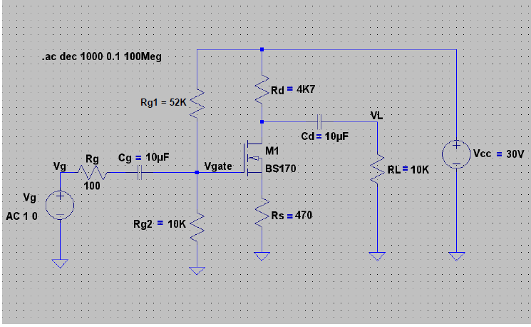

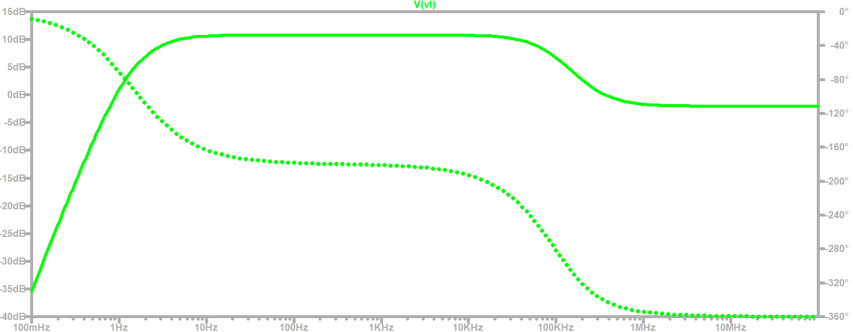

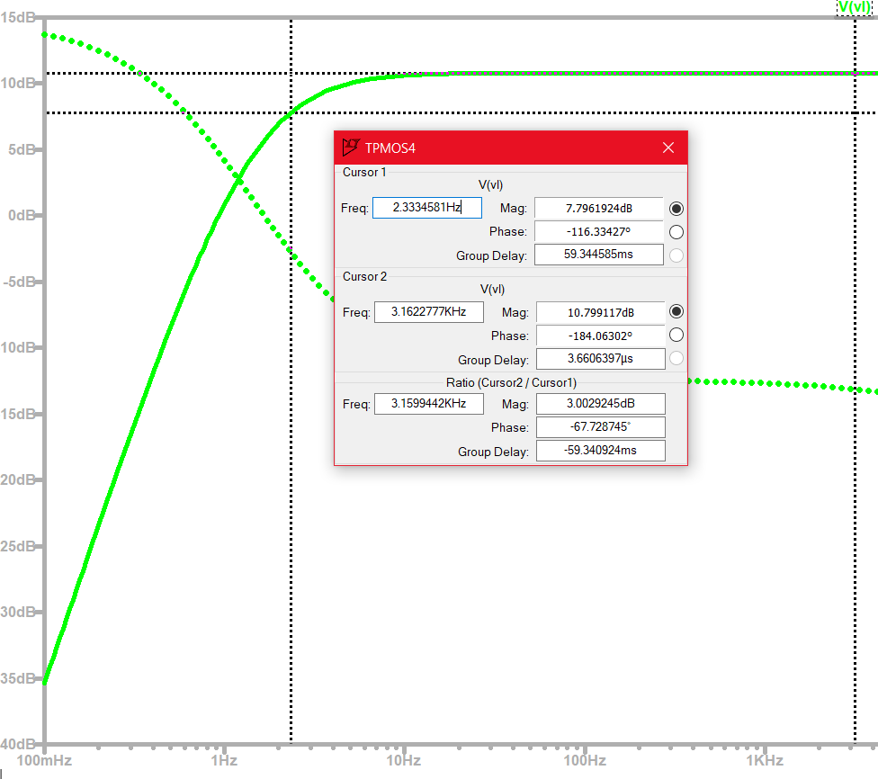

We see that the lower cut-off frequency is given for fci= 2.33 Hz

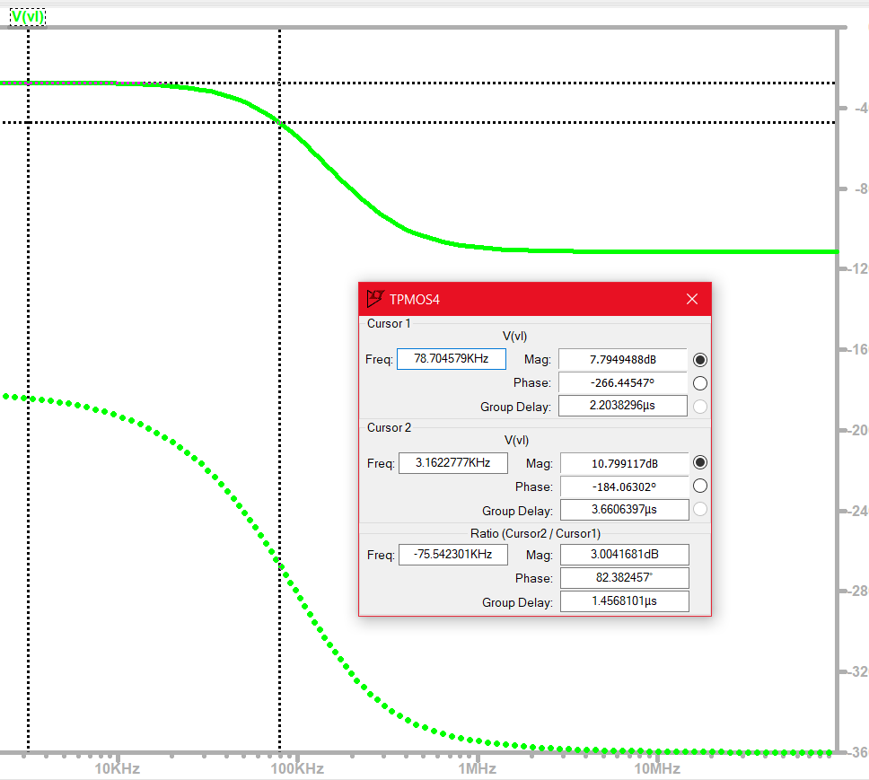

We see that the upper cut-off frequency is given for fcs = 78.7 KHz

b) Graph with Cgdmax = 100n Cgdmin= 2.5n Cgs=40n

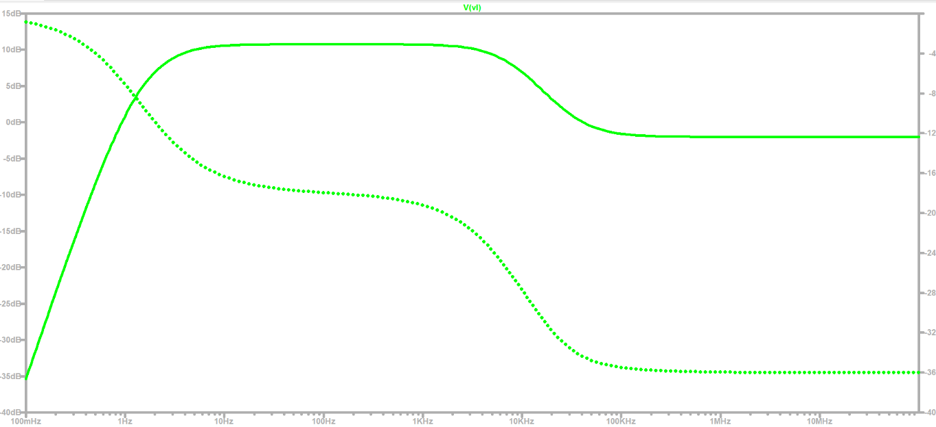

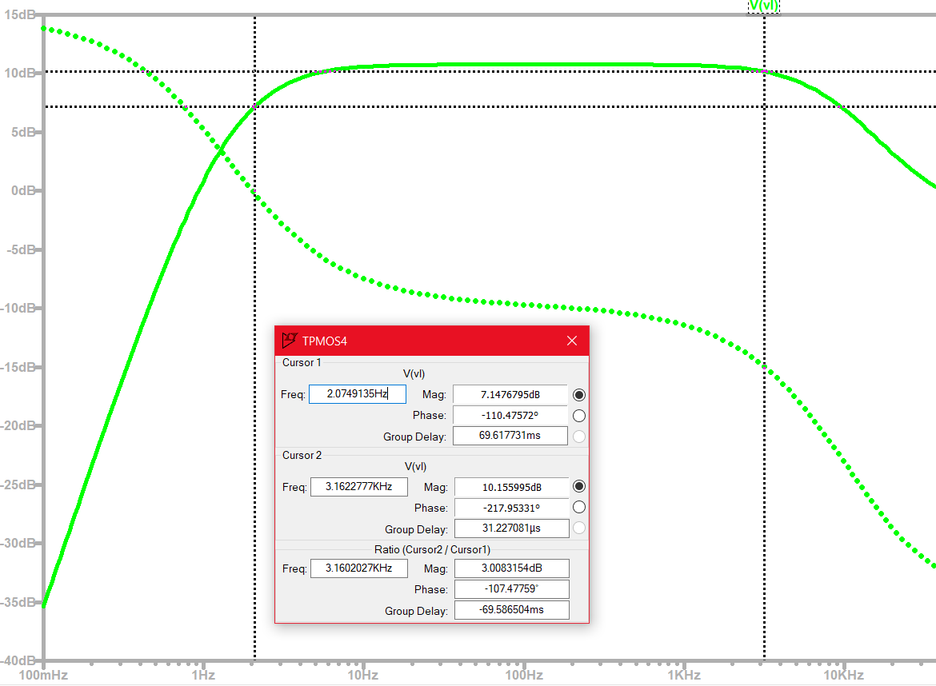

We see that the lower cut-off frequency is given for fci= 2.08 Hz

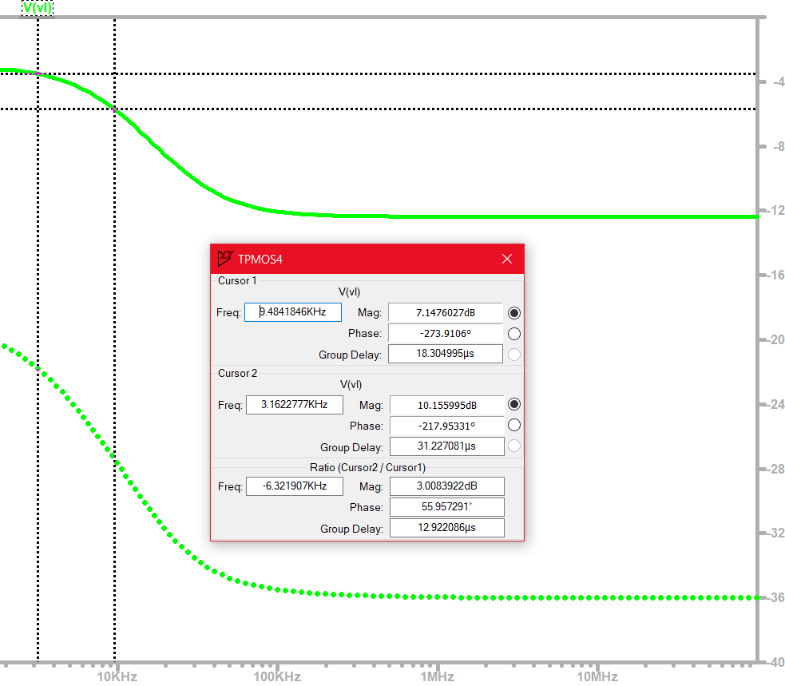

We see that the upper cut-off frequency is given for fcs = 9.48 KHz

Graph with Cgdmax = n Cgdmin= 2.5n Cgs=40n

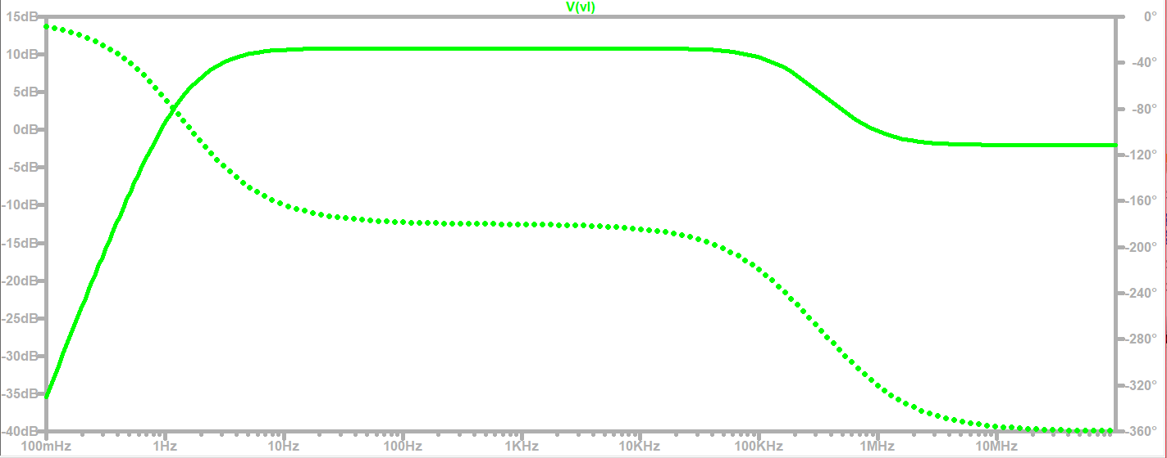

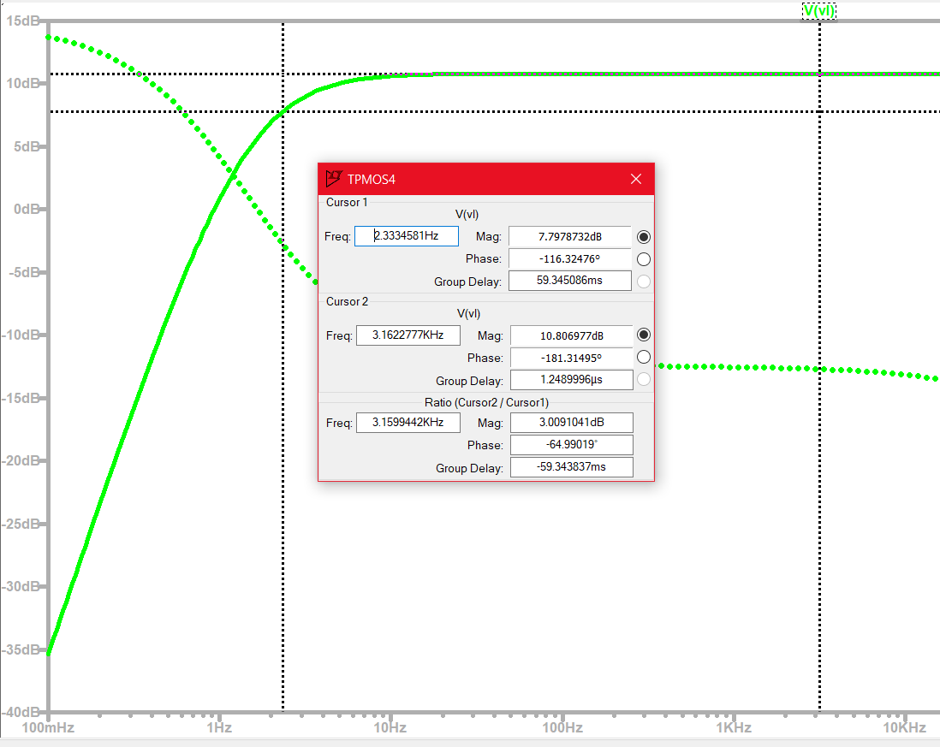

We see that the lower cut-off frequency is given for fci = 2.33 Hz

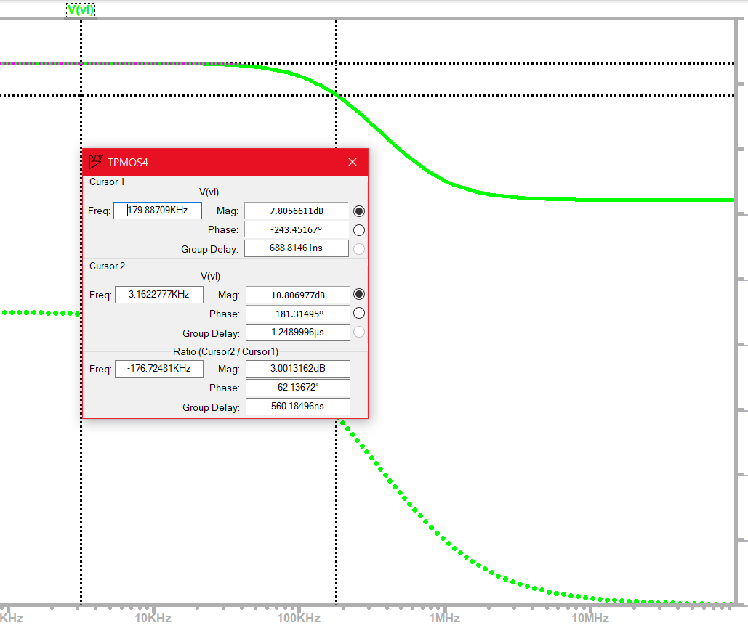

We see that the upper cut-off frequency is given for fcs = 179.88 KHz

C) In conclusion, we can say that the lower cut-off frequency almost does not vary when the internal capacitors of the device vary, it only depends on the capacitances external to the MOSFET. On the other hand, the upper cut-off frequency does vary significantly as the values of cgs and cgd vary.

**Conclusion**

From all that has been studied, we can say that in the study of the transfer curve it happens that increases in temperature result in increases in the effects of thermal agitation, which causes a decrease in the effective mobility of the mobile carriers of the channel, obtaining a decrease in Id for a certain value, Vds and Vgs. The Vth does not vary almost at all for different curves maintaining the nature of the type of channel, as well as its type of pollution. Now when studying the output curves Id as a function of Vds for small values of Vds, we see that the rd = dynamic resistance changes between curves of different value of Vgs whether or not we have the same ∆Vds for each curve. This results in the transistor behaving as a variable resistance by input voltage Vgs, i.e. rd = f(Vgs). In addition, the variation of this resistance for the same curve id(Vds), is an almost linear variation such that there is an almost linear relationship between Id and Vds.

On the other hand, when studying a single-stage amplifier circuit in common source such as the dado, there is hardly any voltage gain at a factor of 3.5 but where a 180° degree offset appears. We can understand the appearance of the 180-degree offset between the input signal Vg and the output signal Vl as a consequence of the inverse relationship between the current Id and the output voltage Vl. In addition, in the study of the frequency response for the same circuit we can say that the lower cut-off frequency almost does not vary when the internal capacitors of the device vary, it only depends on the capacitances external to the MOSFET. On the other hand, the upper cut-off frequency does vary significantly as the values of cgs and cgd vary.