

CIRCUIT THEORY II - R4053 - 2025
Professor: Navarro, Carlos | ATPs: Balbi Juan - Howlin Marcelo
T.P. No. 2: Modern Filter Theory
Group No.: 3 | Members: Costarelli Facundo  - De Cia Antonella - Germaniez  Francisco - Ríos Tamara
Responsible: e_mail: | Costarelli Facundo  fcostarelli@frba.utn.edu.ar
Submission date: | Approval date:
Observations:

INDEX
Exercise #1. 3-4
Exercise #2. 5
Exercise #3. 6-12
Exercise #4. 13-21
Exercise #5. 22-24
Exercise #6. 25-29
Exercise #7. 30-34
Exercise #8. 35-44
Exercise #9. 45-56
Exercise #10. 57-61

Exercise #1
The low-pass filter (image 1) should present a Butterworth response with a bandwidth of
-3dB at 1KHz. Determine the value of L and C knowing that the load is 1 Kohm. Verify the filter specifications using simulators. Suggestion: design the filter with normalized frequency and impedance values and then de-normalize to calculate the required filter value
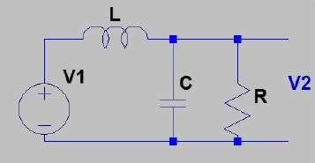

Low-pass filter circuit to be designed.
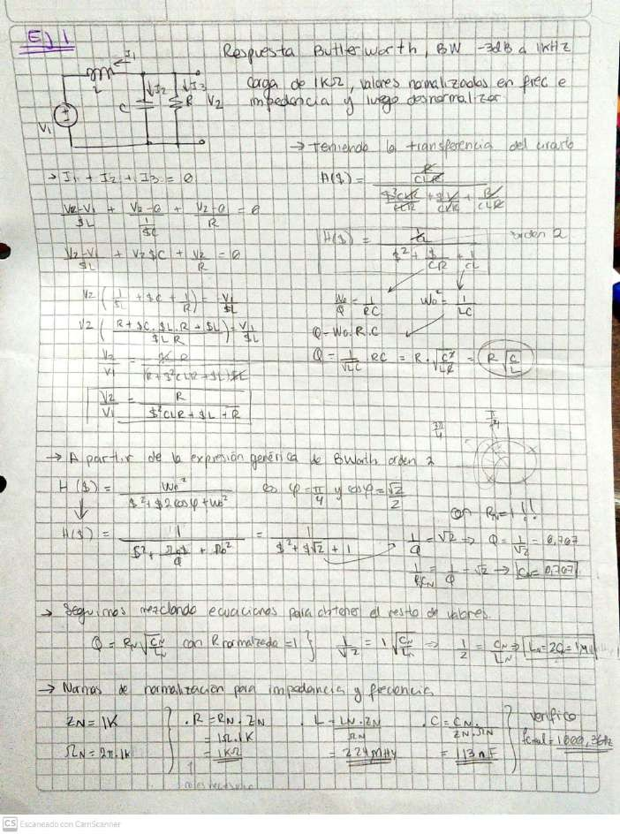
H
E
E
the
E
The
of
ta

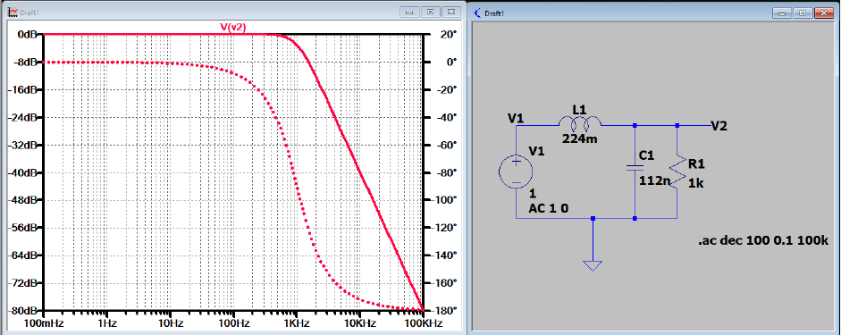
Simulation of the circuit with the denormalized values.

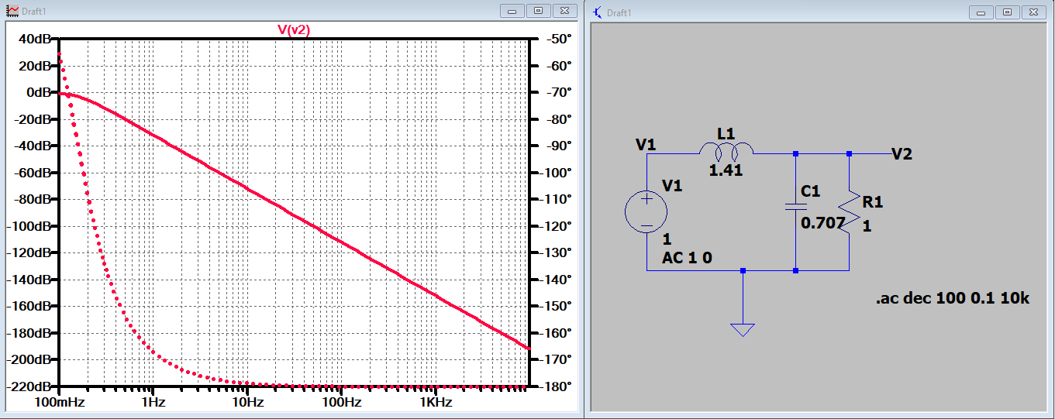
Simulation of the circuit with the normalized values.

Exercise #2

It is desired to design a low-pass filter with the following characteristics. ● Maximum flatness in the passband ● Maximum attenuation: 0.02 dB for 0 < w < 1 ● Minimum attenuation for w > 2.2 = 48 dB The parameters n and ε are to be obtained
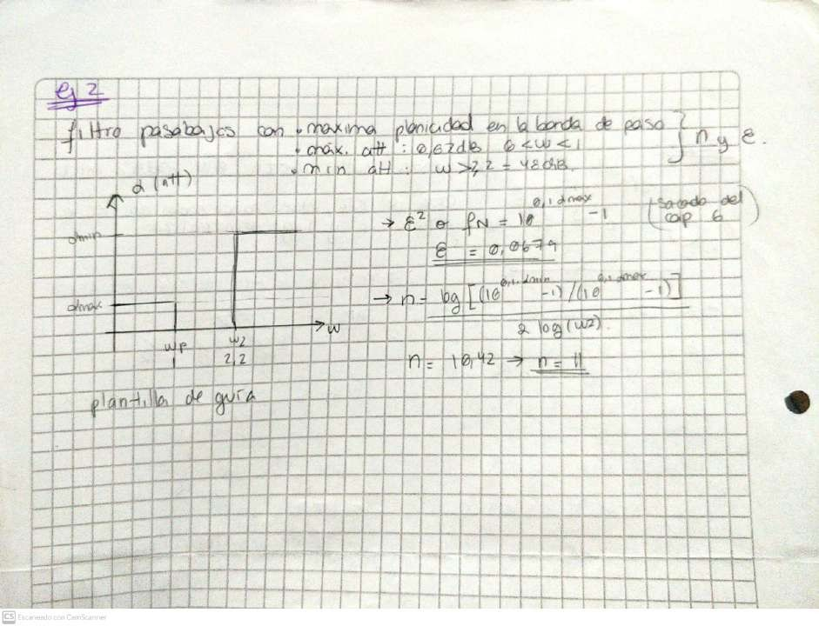
Li

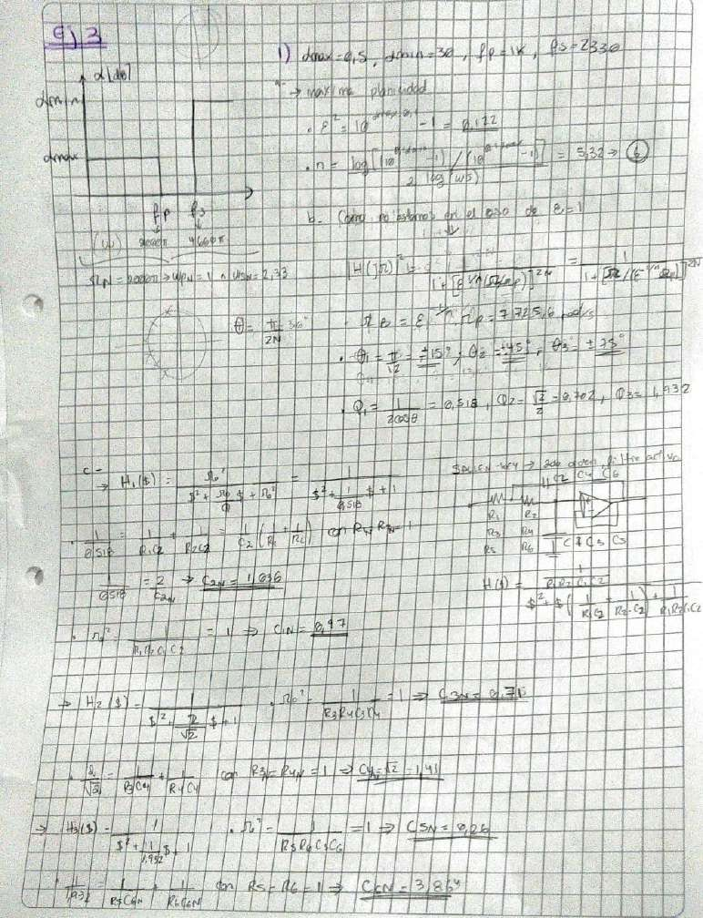
Exercise #3
TT
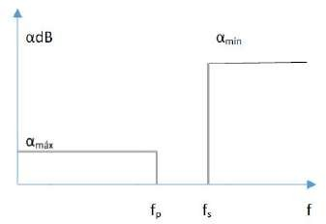
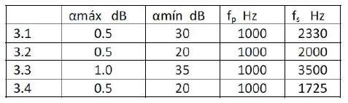
Determine the filter order for maximum flatness - Determine the location of the poles and the Q associated with them - Design the filters if a 20dB gain in the passband is desired, using Sallen Key structures for 3.1 and 3.3 and MFB for 3.2 and 3.4 - Verify the obtained circuits by simulation
Table
f0 Hz
amin dB
amax of

Filter specifications.
Image

Low-pass filter attenuation template.

3-1)

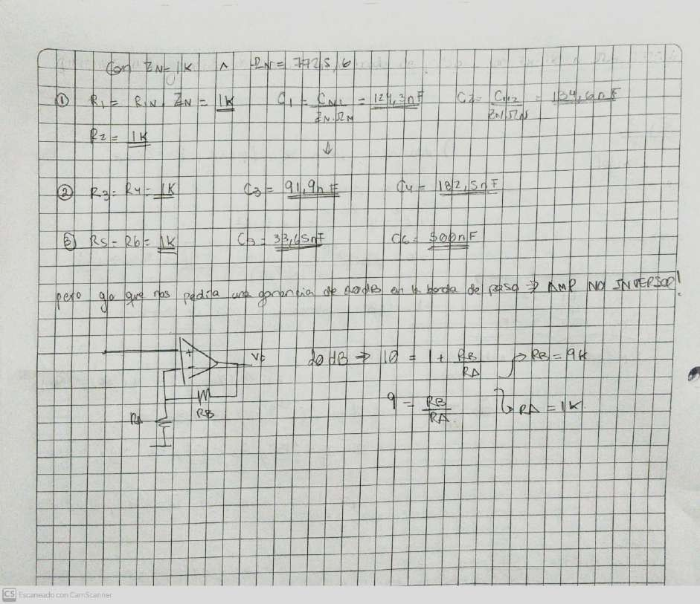
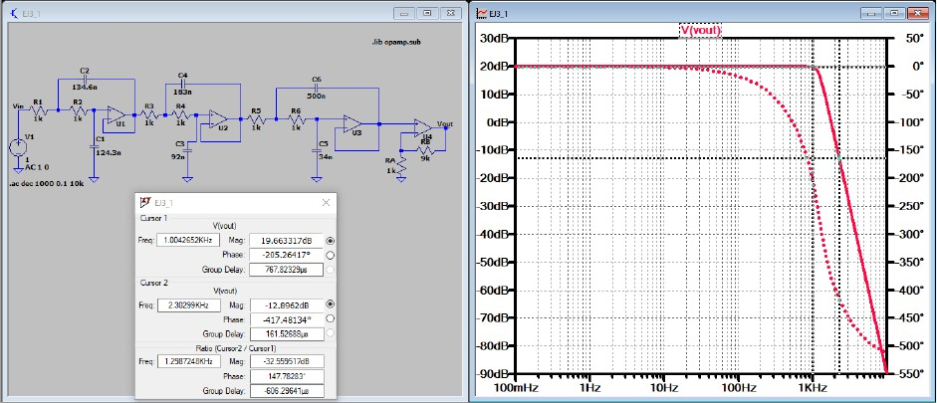
Simulation of circuit 3.1 with an attenuation of approximately 0.5 dB at 1 KHz and of 32.9 dB at 2.3 KHz.

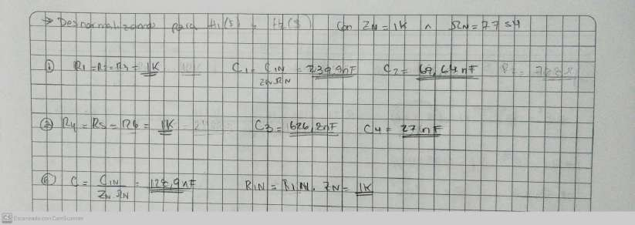
3-2)
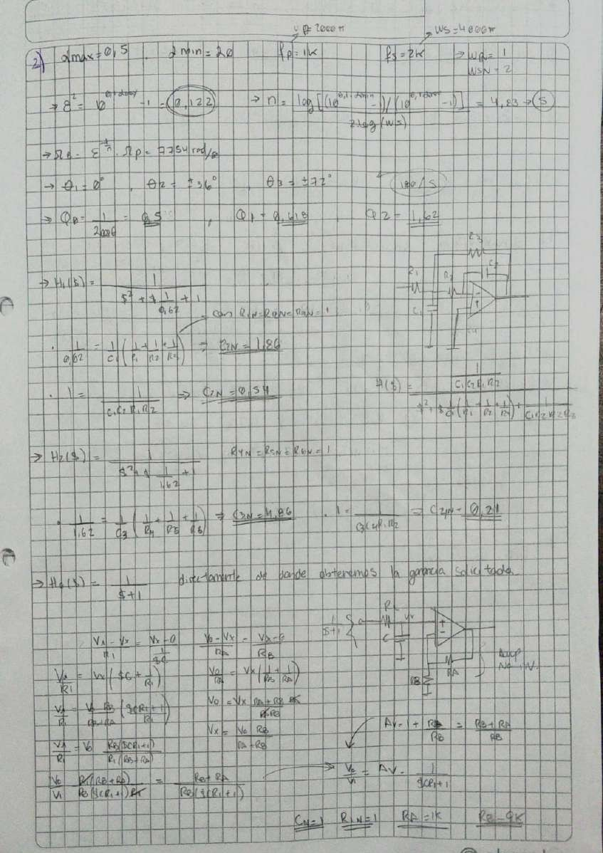

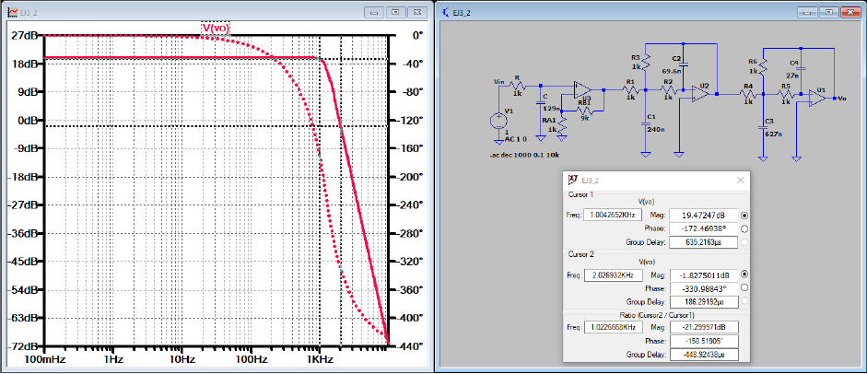
Image
Simulation of circuit 3.2 with approx. attenuation of 0.5 dB at 1 KHz and 21.8 dB at 2 KHz.

3-3)
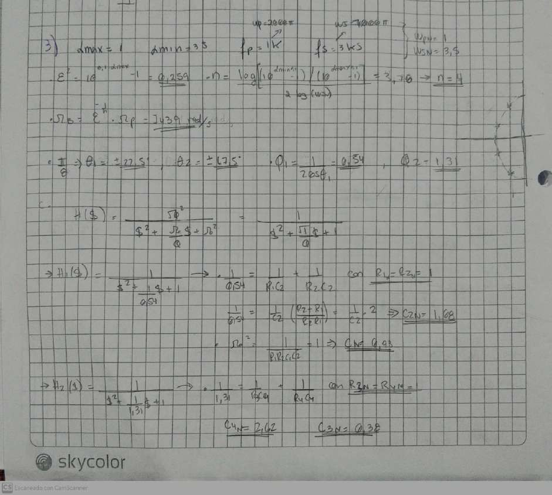

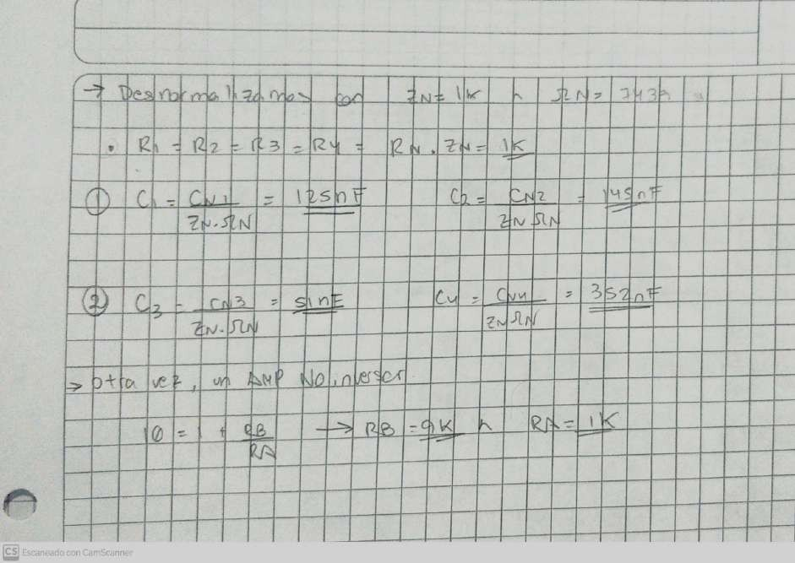
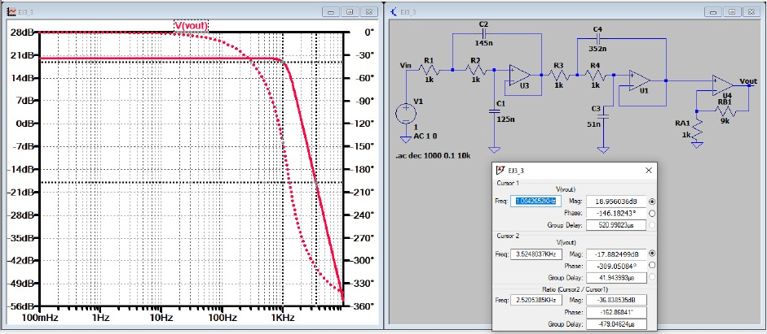
Simulation of the circuit 3.3 with approx. attenuation of 1 dB at 1 KHz and of 37.8 dB at 3.5 KHz.

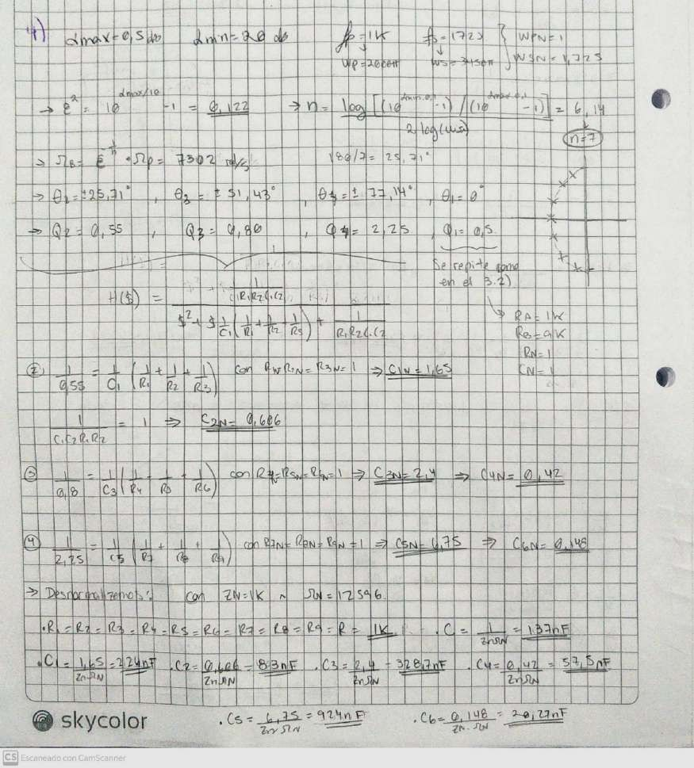
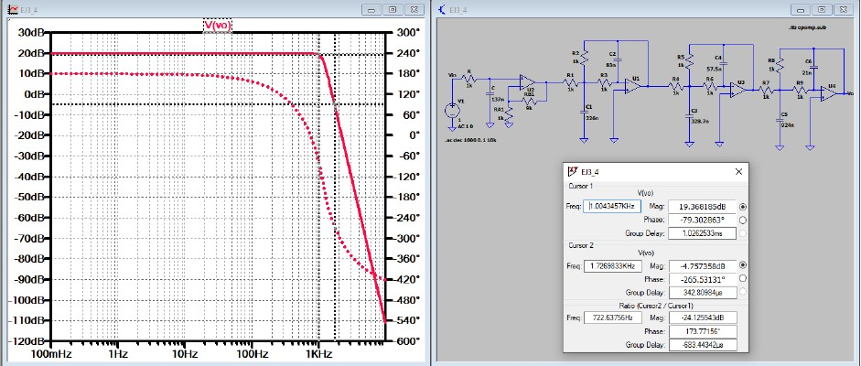
3-4)
Image

Simulation of the circuit 3.4 with approx. attenuation of 0.5 dB at 1 kHz and 24.8 dB at 1.75 kHz.

We see that with the Chebyshev filter we obtain a good roll-off with a lower order, in addition to better attenuation. However, the Q factors are higher and it complicates the adjustment of the circuit; on top of the ripple in the passband.

Exercise #4
A Chebyshev low-pass filter is designed to achieve a attenuation of 48 dB for frequencies greater than 9.6 kHz, with a maximum attenuation of 0.4 dB from DC to 3.2 kHz. a) Determine the order of the filter and the parameter ε b) Plot the magnitude response of the filter c) Determine the location of poles and zeros d) Synthesize the circuit and simulate verifying the design conditions. e) Repeat points a,b,c and d for a Butterworth filter, indicating advantages and disadvantages of both approaches.

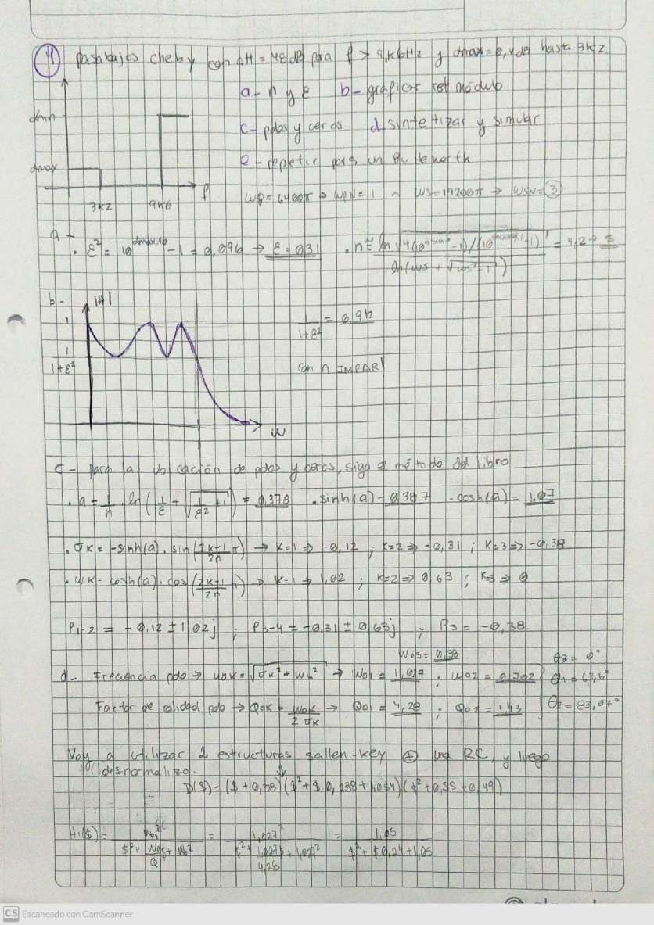
With Sallen-Key synthesis

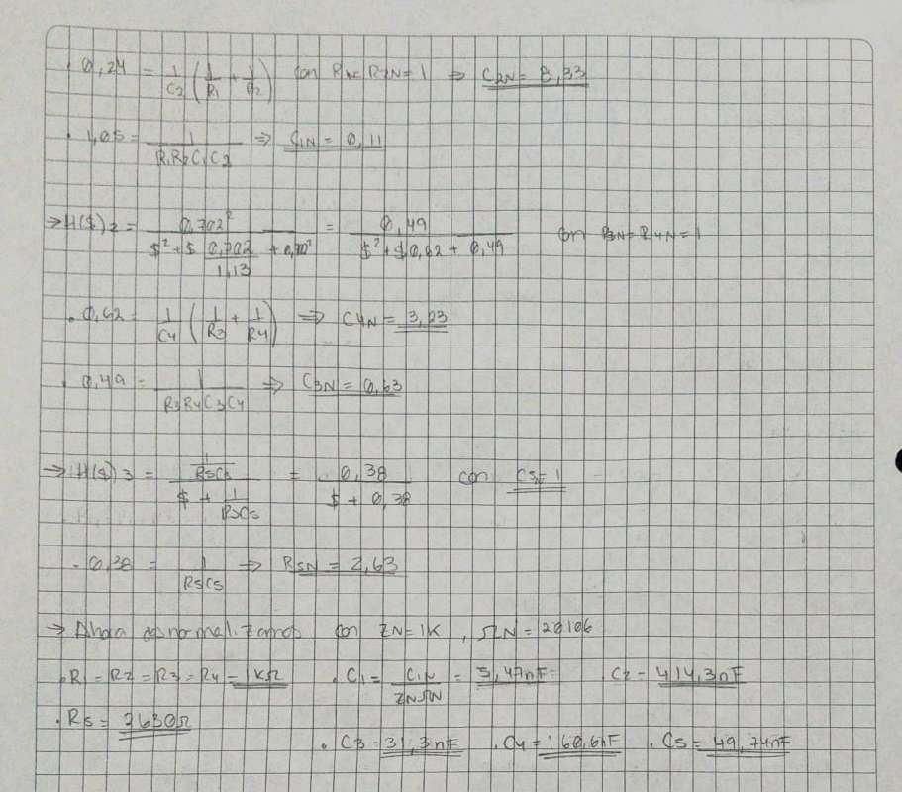

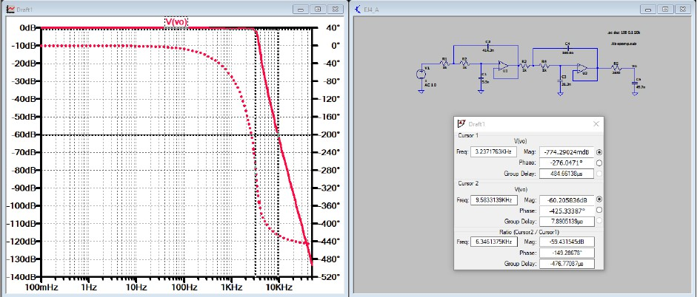
Image
Chebyshev filter simulation with attenuation of approximately 0.4 dB at 3.2 kHz and 60 dB at 9.6 kHz.

With MFB synthesis

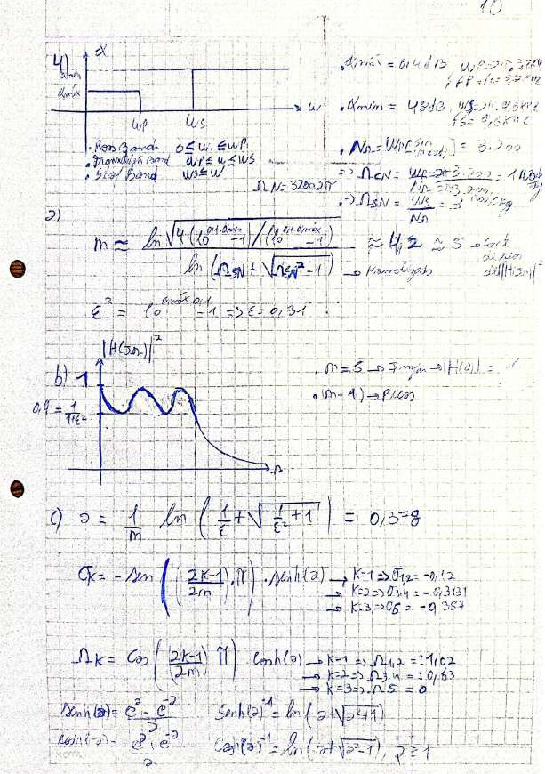
ur

s

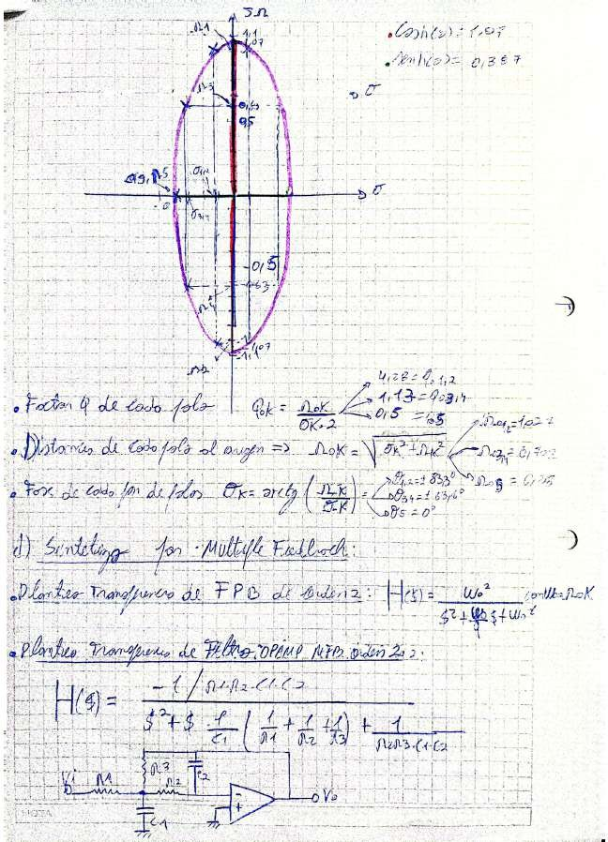

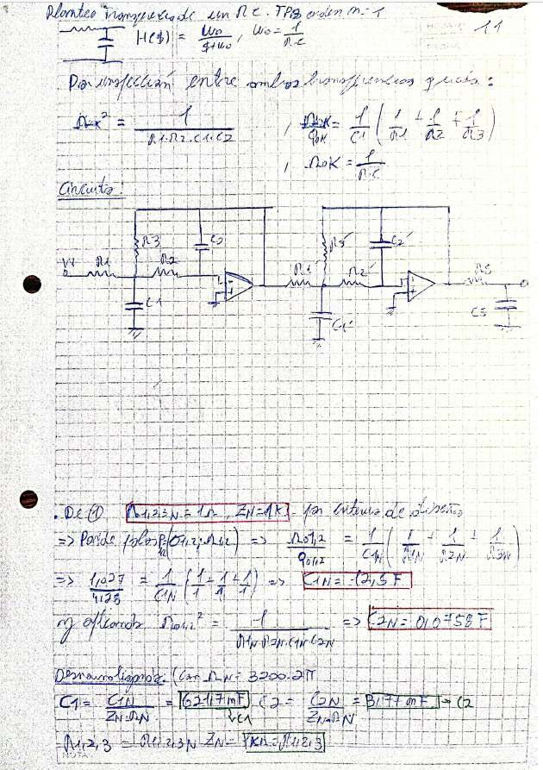

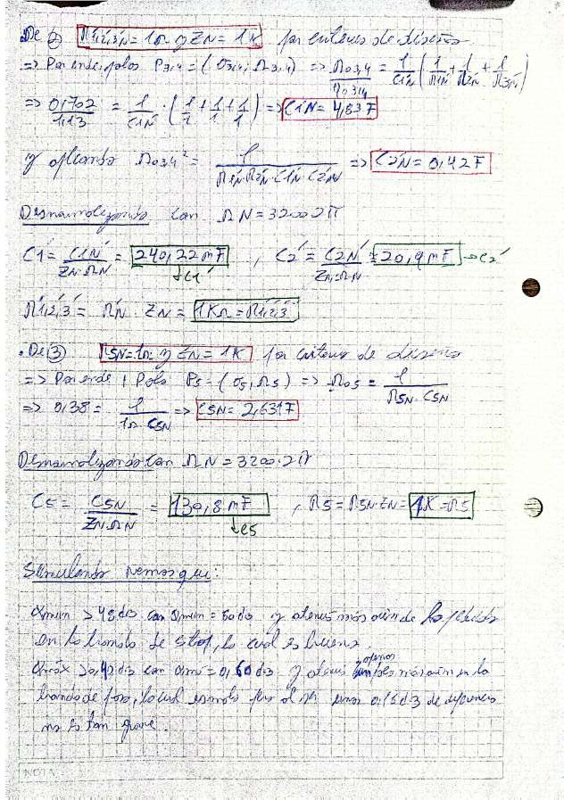

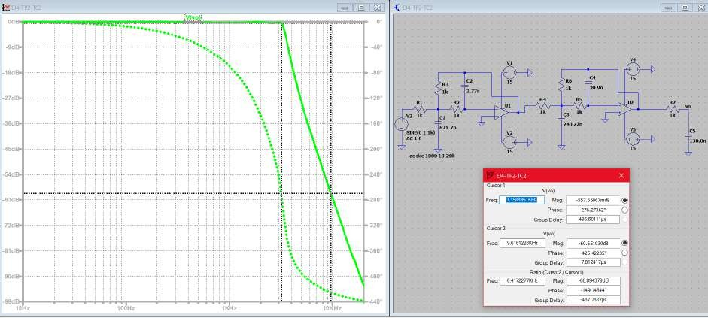
Image
Chebyshev filter simulation with attenuation approx. 0.57 dB at 3.2 KHz and 60 dB at 9.6 KHz.

Conclusion: Using Sallen-Key or Multiple Feedback synthesis, we obtain very similar results. This indicates that the obtained response mainly depends on the approximation used, which in this case was Chebyshev. It has a good roll-off and a good attenuation for a high order like n = 5.

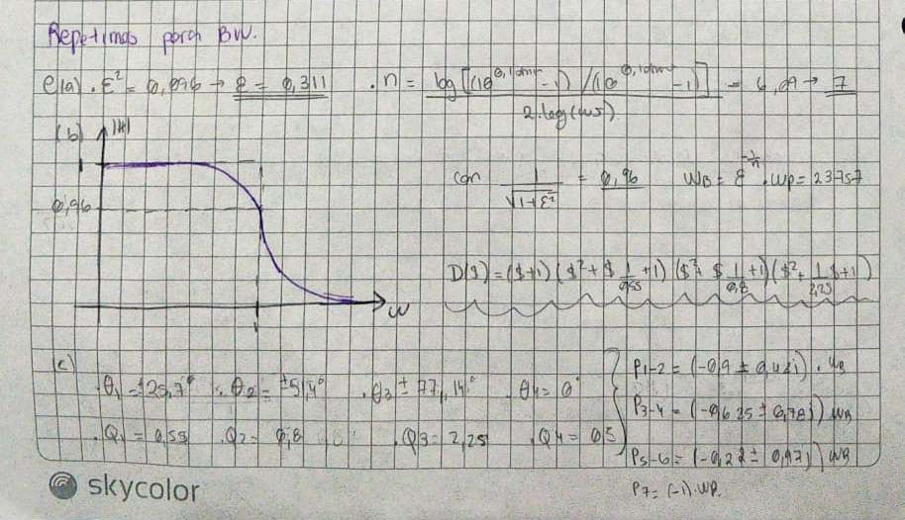
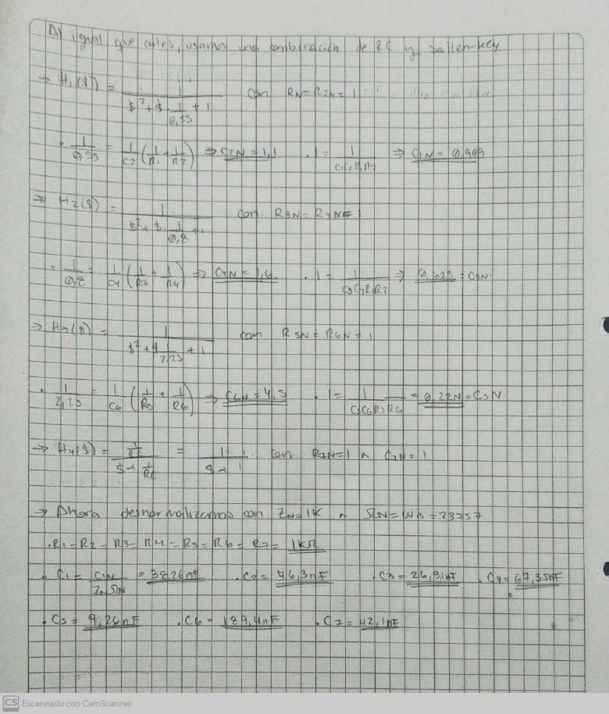

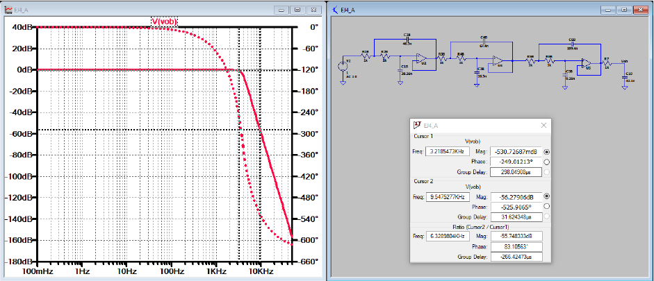
Image
Butterworth filter simulation with approx. attenuation of 0.4 dB at 3.2 KHz and 56 dB at 9.6 KHz.

Exercise #5

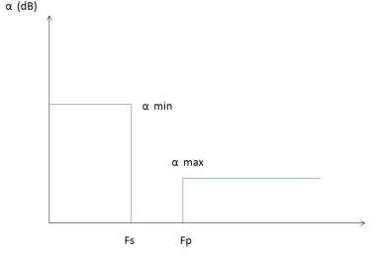
From the template in the image, knowing that: α min = 35 dB α max = 1 dB fs = 1000 Hz fp = 3500 Hz, obtain poles and zeros for maximum flatness in the passband and compare with exercise 3.3.

.

Image

Template of the requested filter.
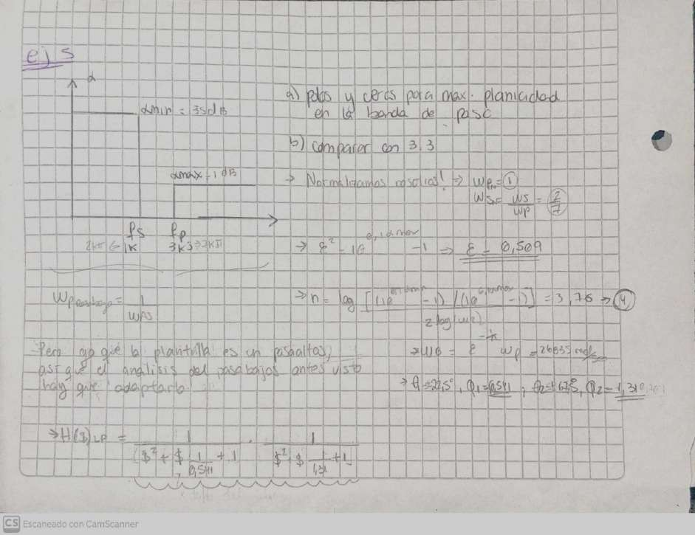

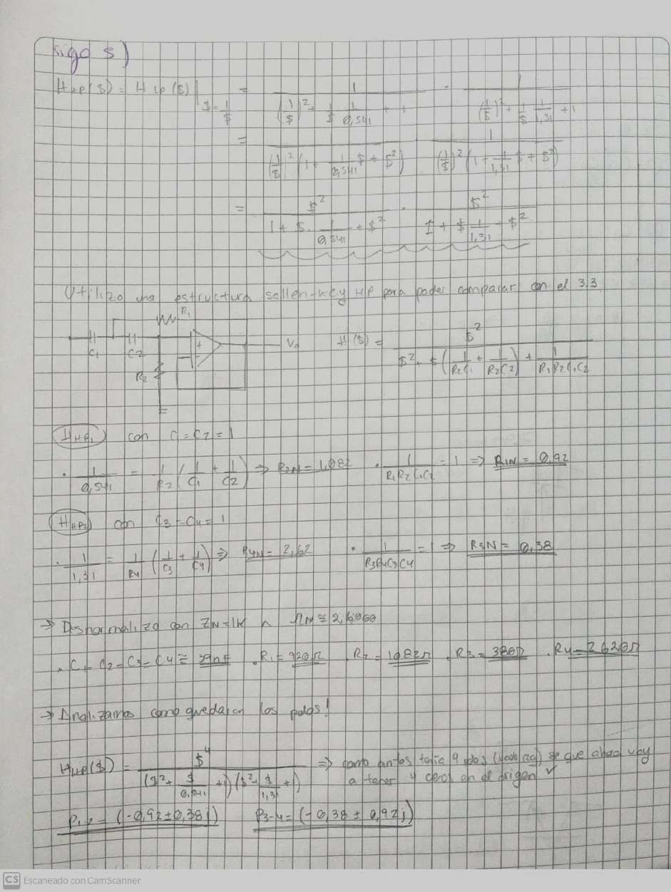

Since none of the Ө values nor the corresponding Q values change, we observe in image 12 that the pole diagram is identical to that of exercise 3.3, with the slight difference that now we have 4 zeros at the origin. This is because the pole reciprocity for the Butterworth response is direct: the poles of a low-pass filter of order “n” become the poles of a
high-pass filter, and “n” zeros are added at the origin.

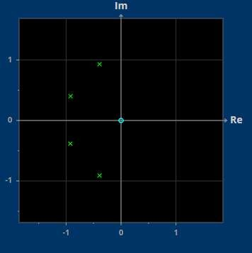
Image
Poles and zeros of the filter according to the sheet.

Exercise #6

Given the image template, a. Determine a filter that satisfies the template with the smallest possible order b. Compare the results with the poles of exercise 4.

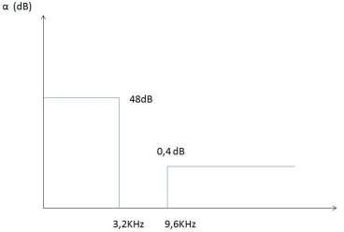
a

Image

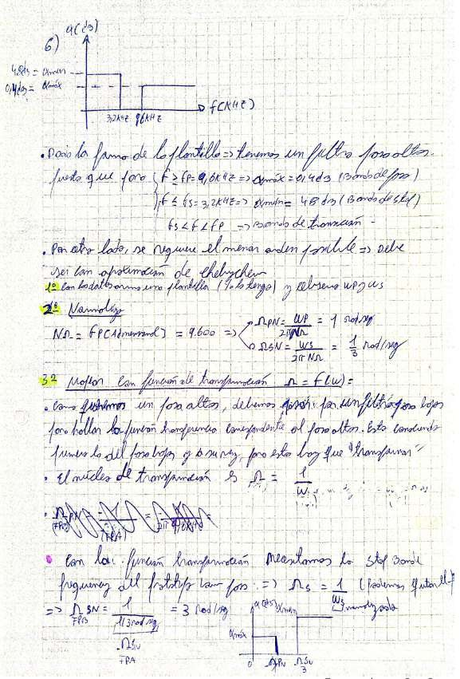
Template of the requested filter

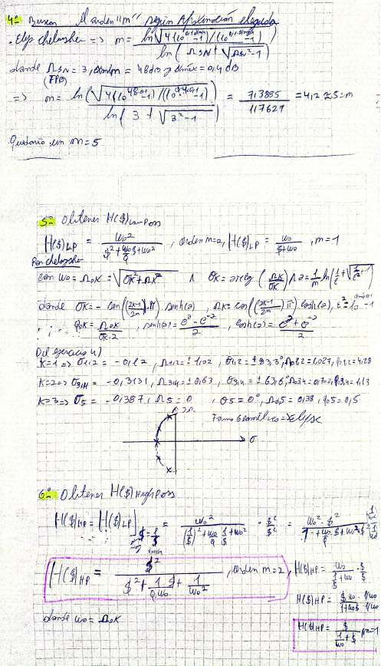

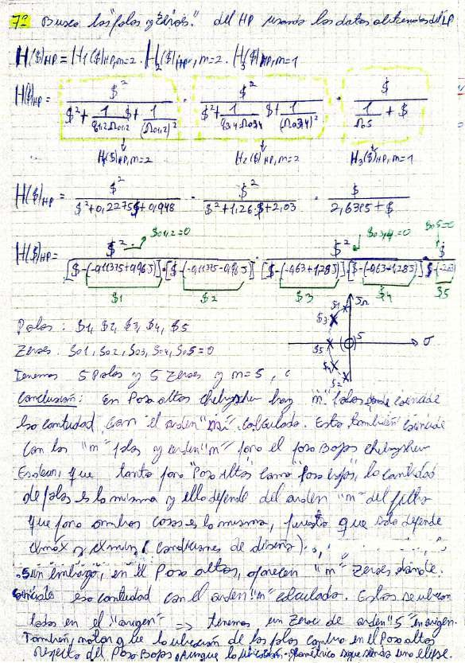
tp

Mon
The

and Ad

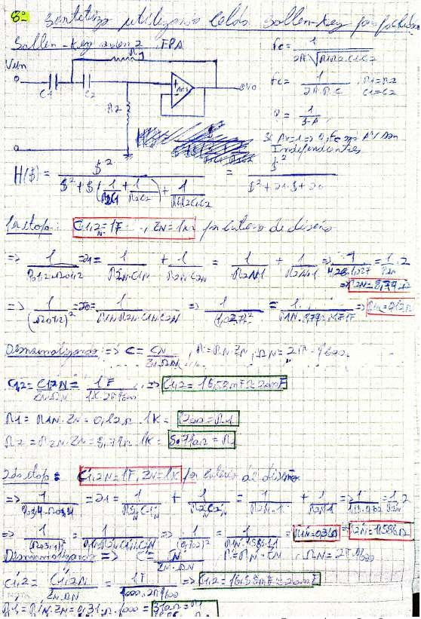

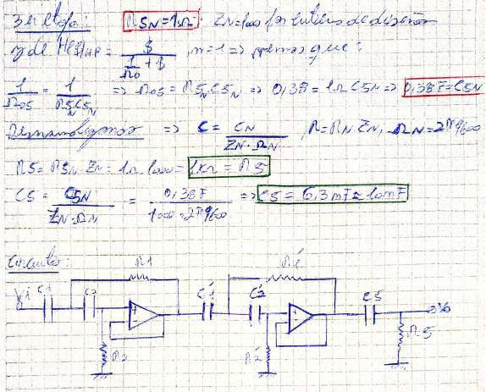

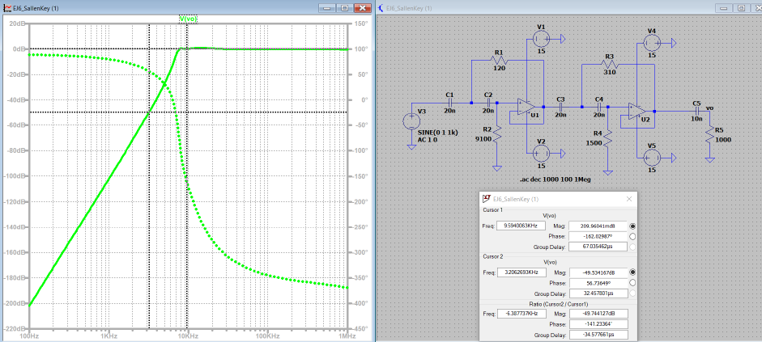
Filter simulation. It is a high-pass with Chebyshev approximation to have the smallest possible “n”.
Attenuation approx. of 0.4 dB at 9.6 KHz and 48 dB at 3.2 KHz.

Exercise #7
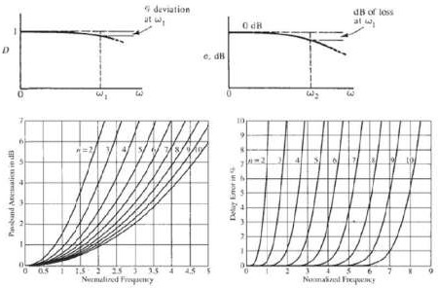
Design a low-pass filter based on an MFB structure knowing that it must provide a constant delay of 100 µs in the passband, with a maximum delay deviation of 10% for the frequency w1=25 krad/s and a maximum attenuation of 1 dB at the frequency w2=10 krad/s.
FER
H
and
Image

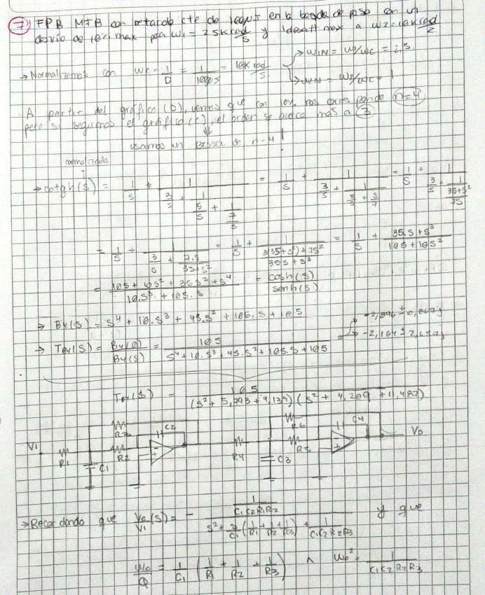
Passband attenuation and delay error as a function of normalized frequency

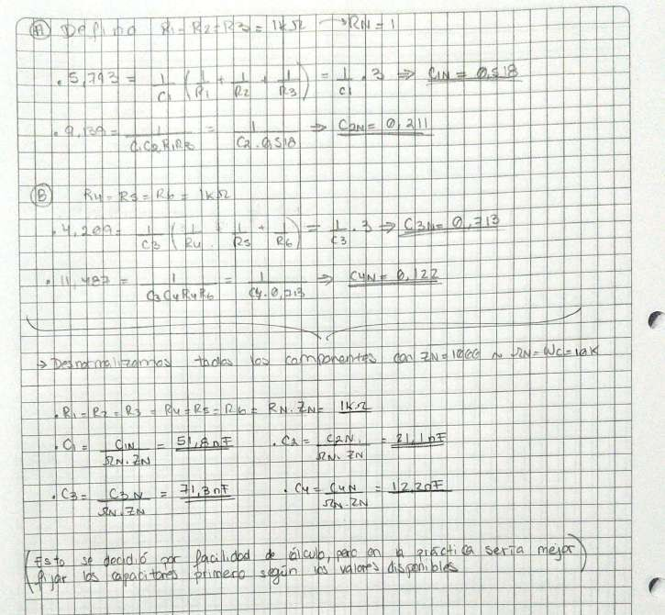
A
C
sia
eh
Y
and
C
ja
Cul
15h.
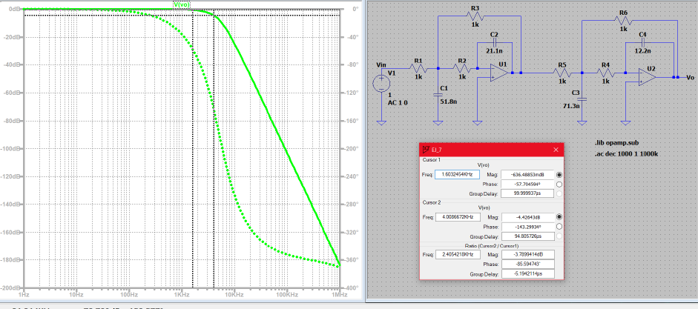
Image (a)
Filter simulation. It is a low-pass with Bessel approximation, conditions per statement. Approximate attenuation of
0.63 dB at fc = 1.6 kHz or its W1 = 10 krad/s equivalent; and 4.42 dB at fs = 4 kHz or its equivalent of
W2 = 25 krad/s. Of the attenuations, on average a maximum ripple of 3.79 dB.

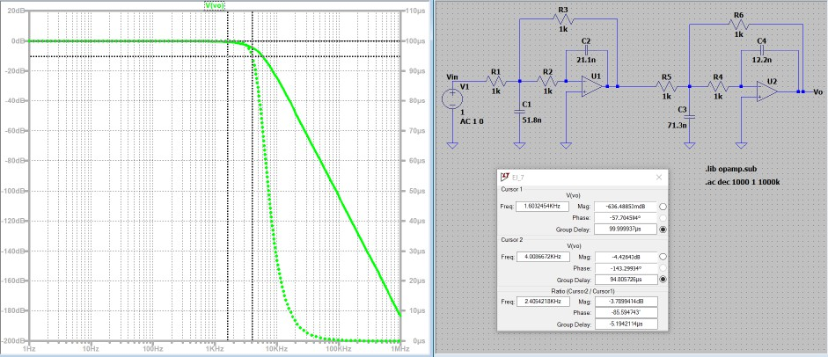
a
E
Image (b)
Filter simulation. It is a low-pass filter with Bessel approximation, conditions as stated. Group Delay of 99.997 us at fc = 1.6 KHz and 94.80 us at fs = 4 KHz. From the attenuations, on average a Group delay of 5.2
us

Exercise #8
A band-pass filter must be designed with the following specifications: ● Cutoff frequency lower: 1600 KHz ● Upper cutoff frequency: 2500 KHz ● Maximum ripple in the passband: 3dB ● Maximum flatness in the passband ● Maximum gain in the passband: 10 dB ● Minimum attenuation of 20 dB at frequencies of 1250 KHz and 3200

KHz. Requirements: a. Obtain the normalized transfer function of the filter b. Plot the
pole-zero diagram c. Plot the transfer function (magnitude and phase) of the requested filter d. Synthesize the filter using Ackerberg Mossberg structures e. Simulate the obtained filter, verifying the

design specifications
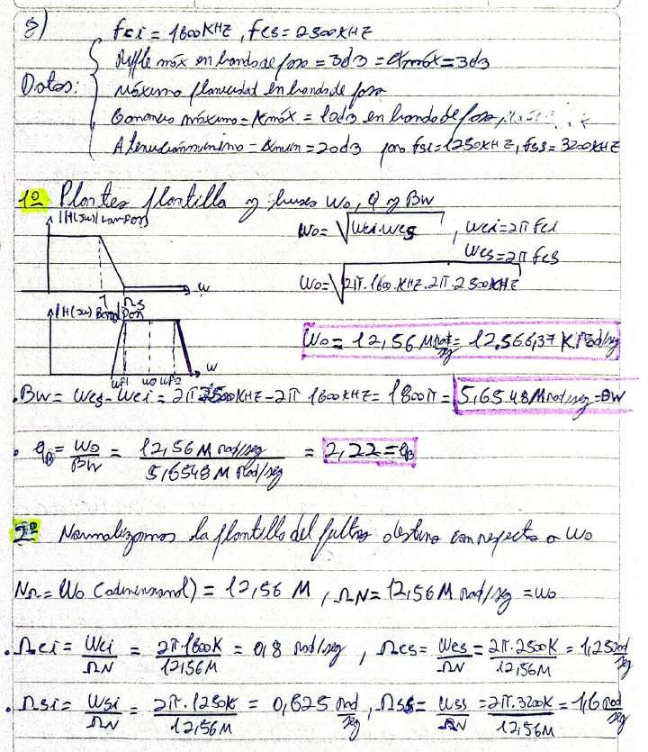
m
WoN
Wo
M
Wes
—Woz

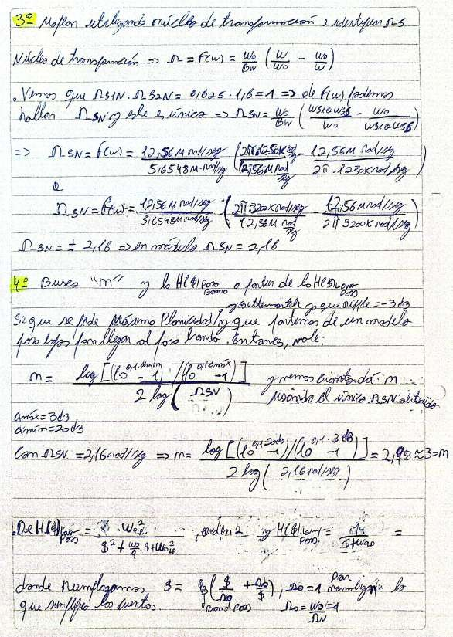
of _{Ue}

ue

the

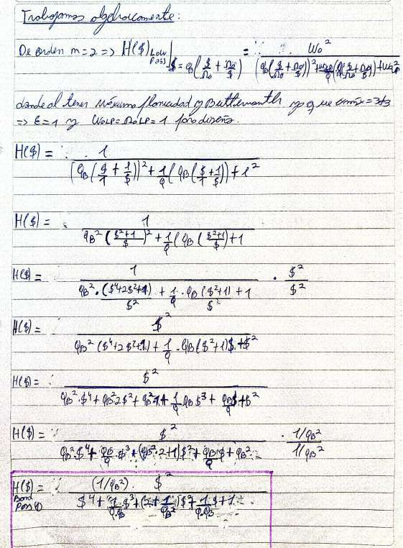

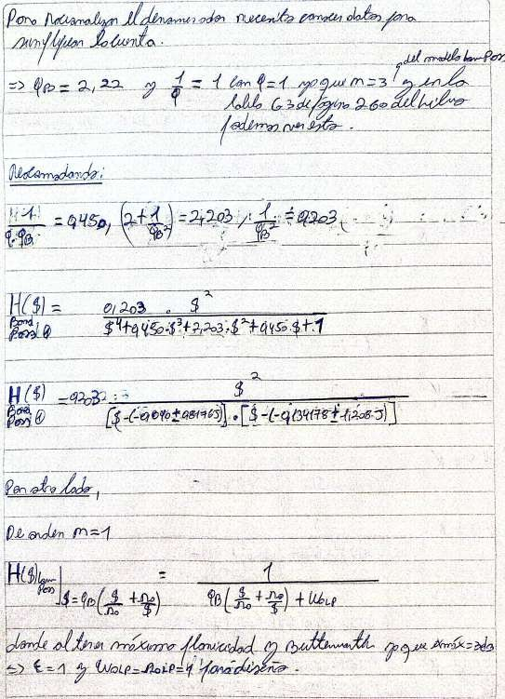
mz

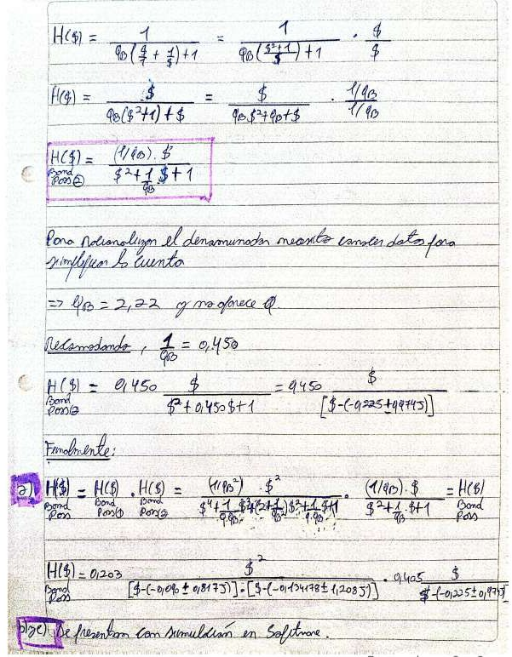
t

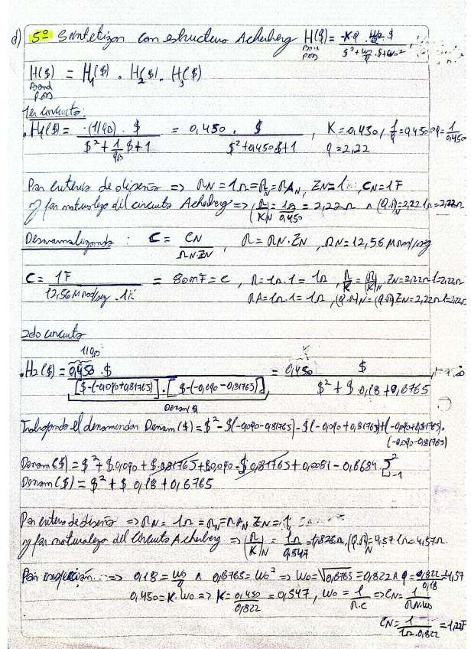
Pair

E=

of

Vo

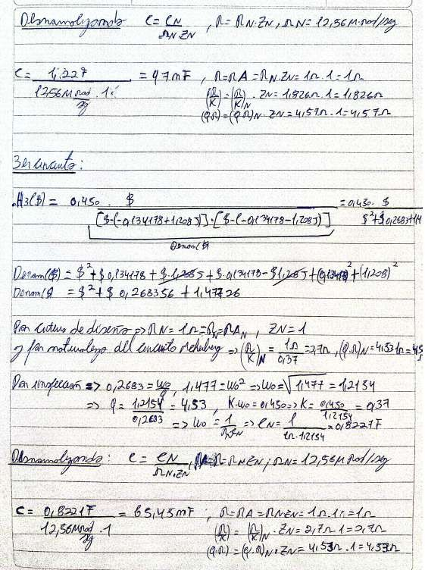
E
and

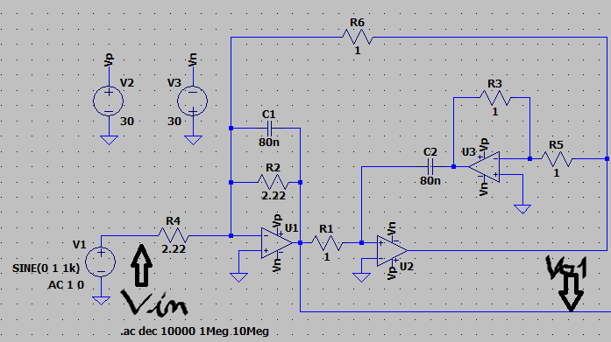
Filter circuit obtained in LTspice I.
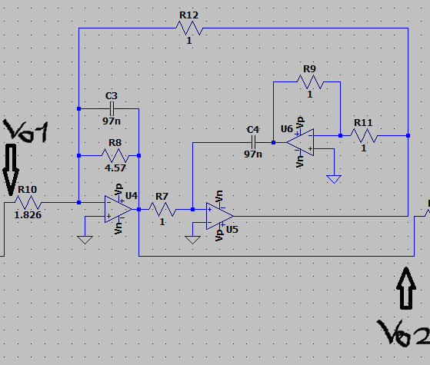
Image
Filter circuit obtained in LTspice II.

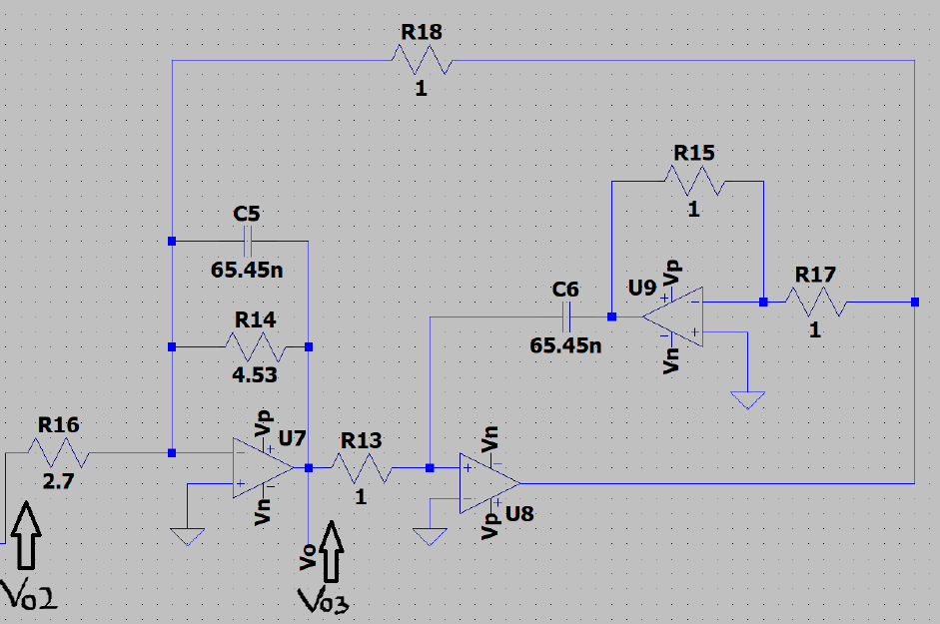
Image
Filter circuit obtained in LTspice III.
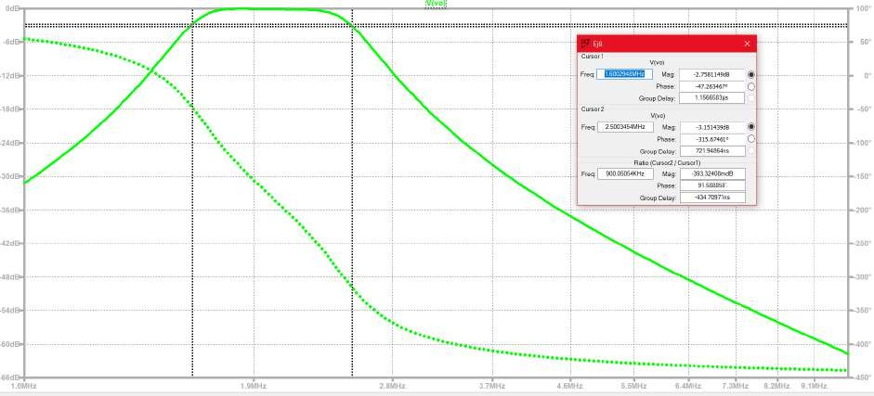
Filter simulation. It is a band-pass with Maximum Flatness approximation and also Butterworth, conditions by statement. Attenuation approx. 2.75 dB at fci = 1600 KHz and 3.15 dB at fcs = 2500 KHz. Of the
attenuations, on average a maximum ripple of 3 dB.

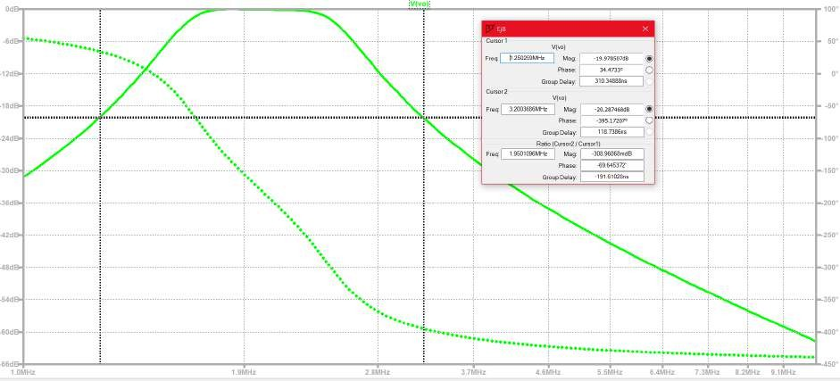
Image
Filter simulation. It is a band-pass with Maximum Flatness approximation and also Butterworth, conditions per statement. Attenuation approx. 20 dB at fci = 1250 KHz and 20.3 dB at fcs = 3200 KHz. Of the attenuations, on average we have approximately about 20 dB for the “band stop” frequencies in
forward.
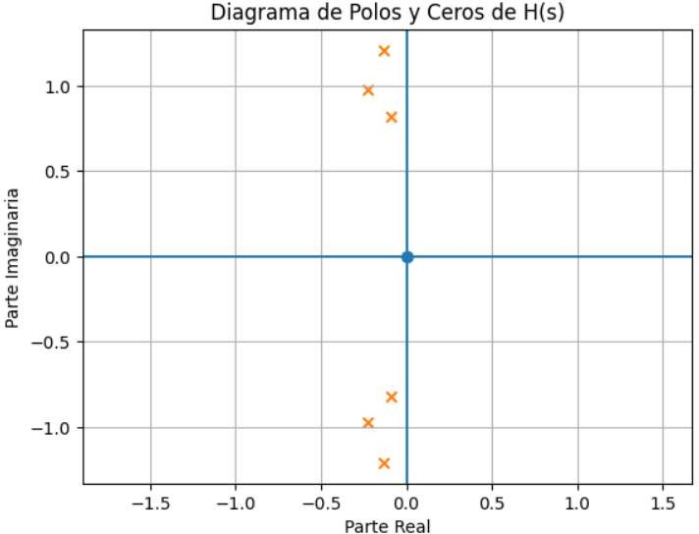
Pole-Zero Diagram of H(s)
x

x
Imaginary
Part
x
Real Part
Image

Pole-Zero Diagram of the band-pass filter with Maximum Flatness approximation with Butterworth as
a particular case.

Exercise #9

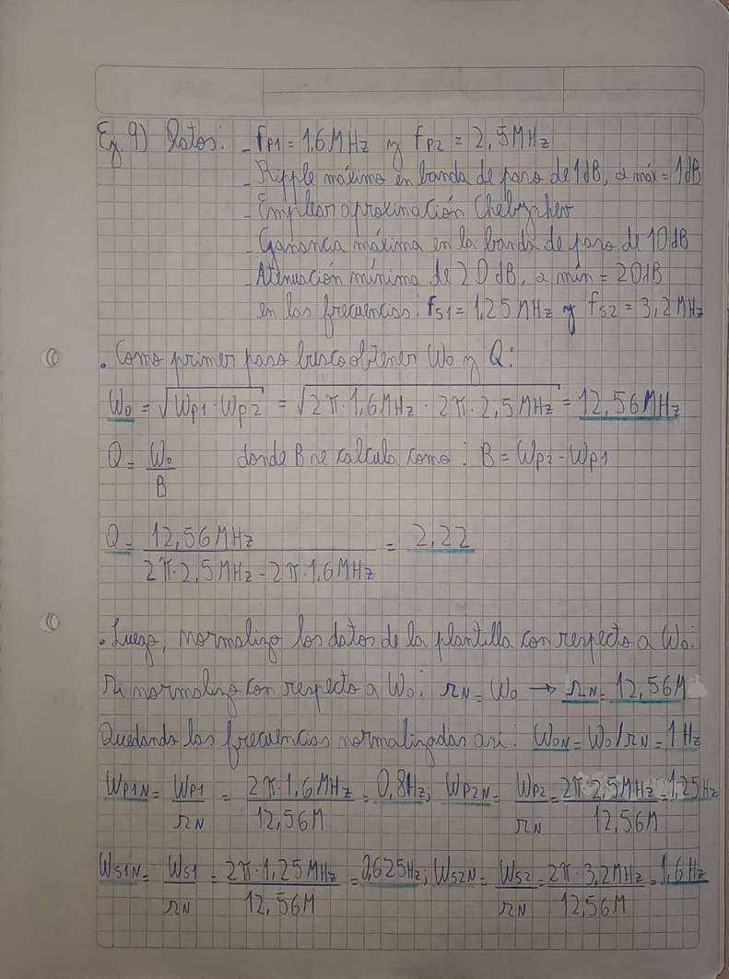
Same as previous using a Chebyshev approximation with a ripple in the passband of 1 dB

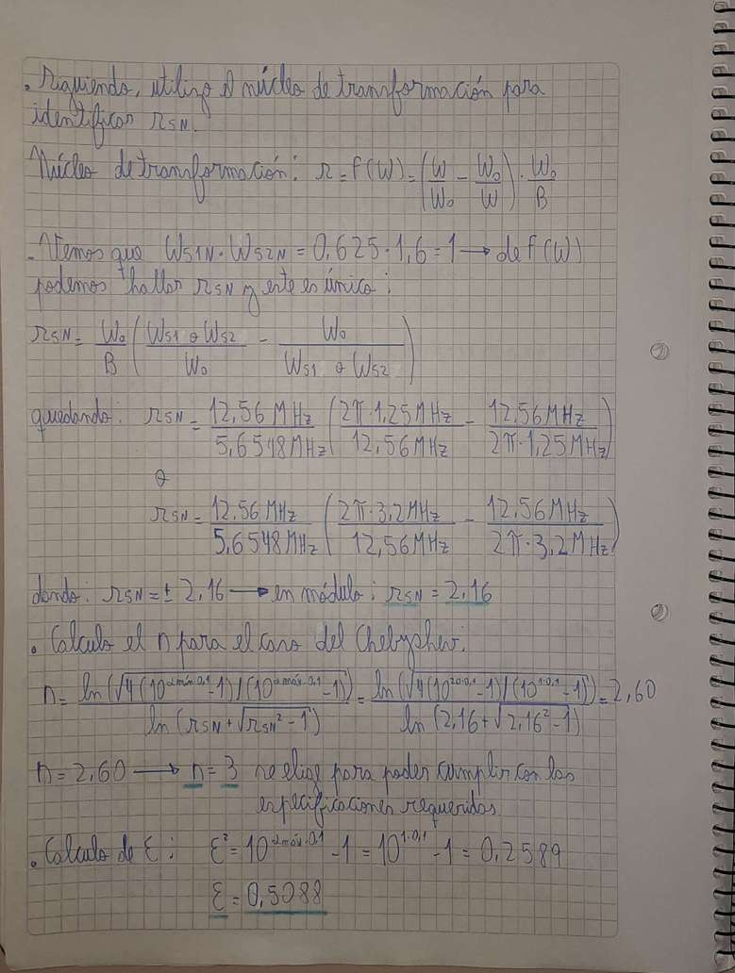

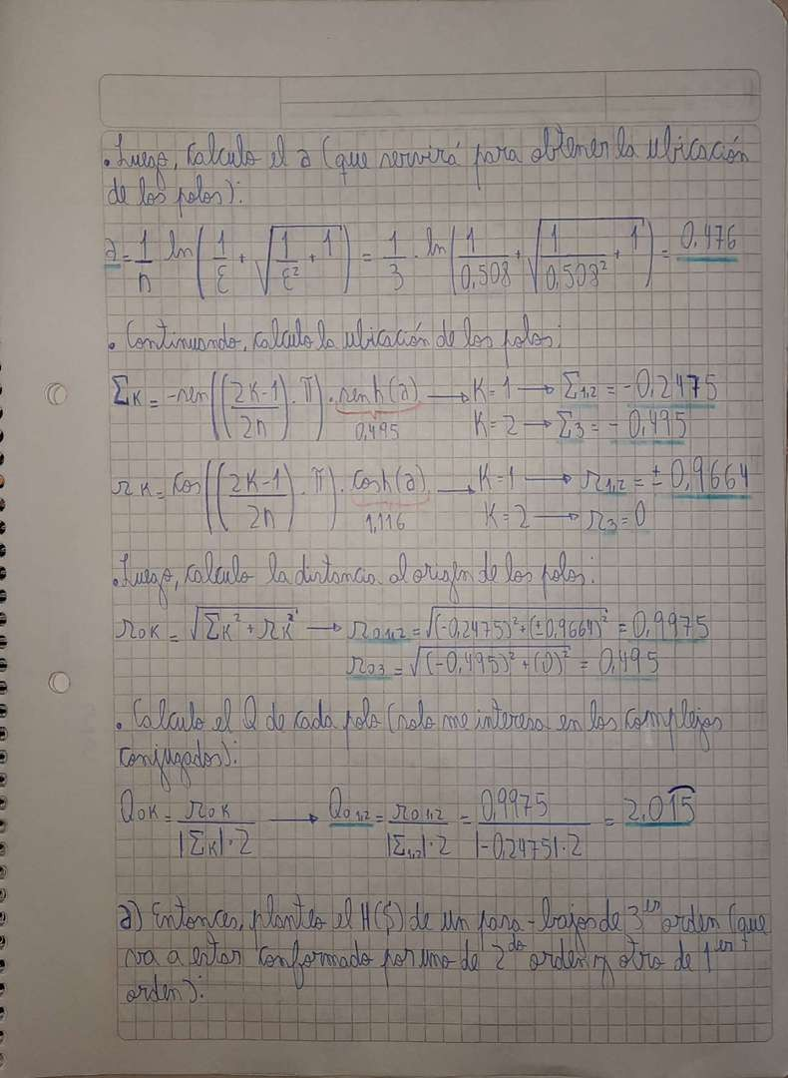

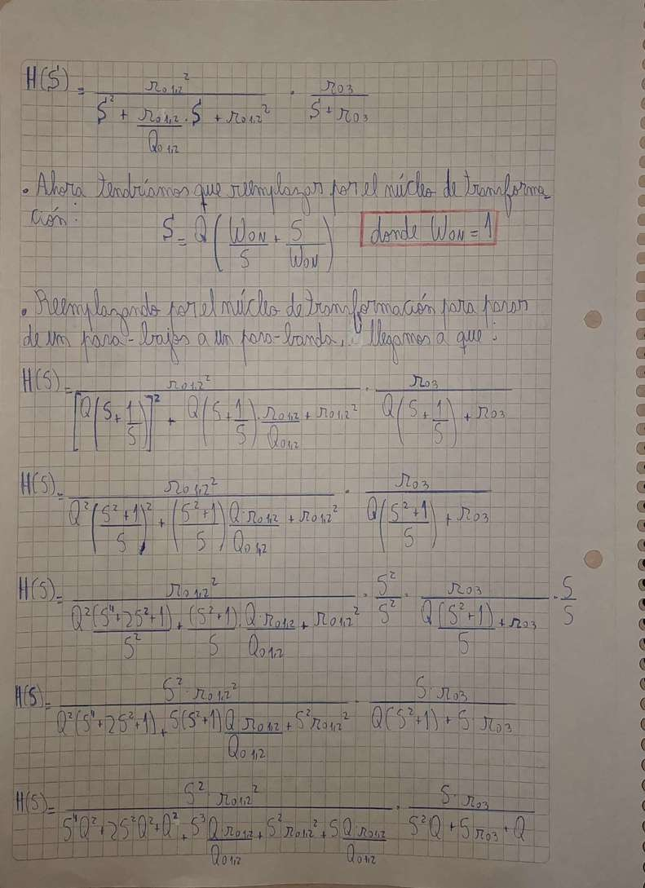

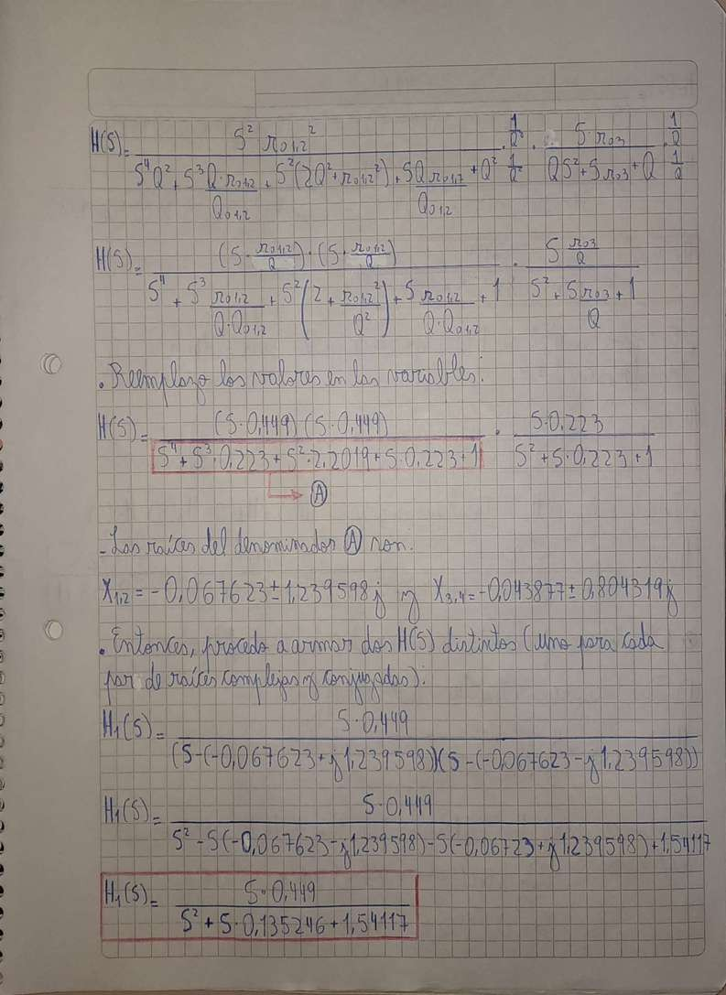

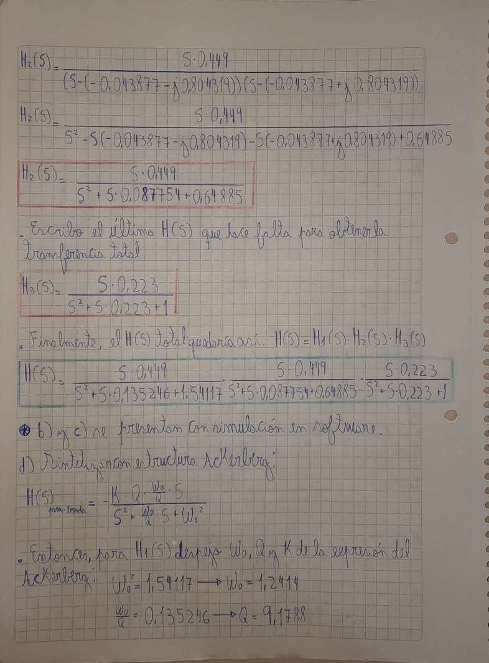

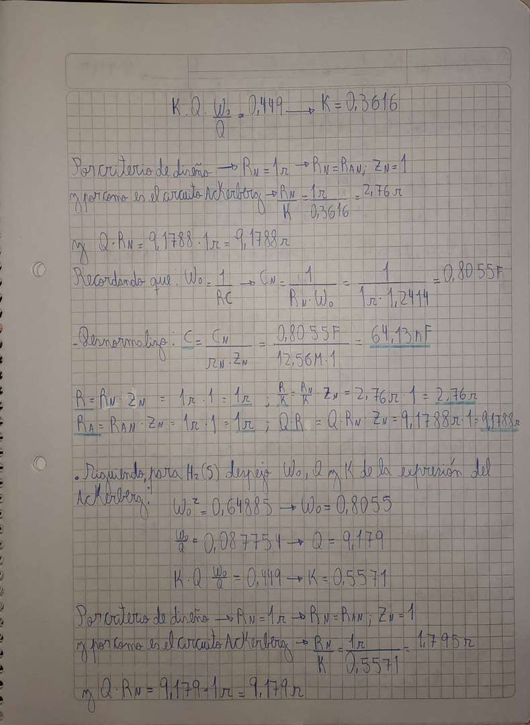

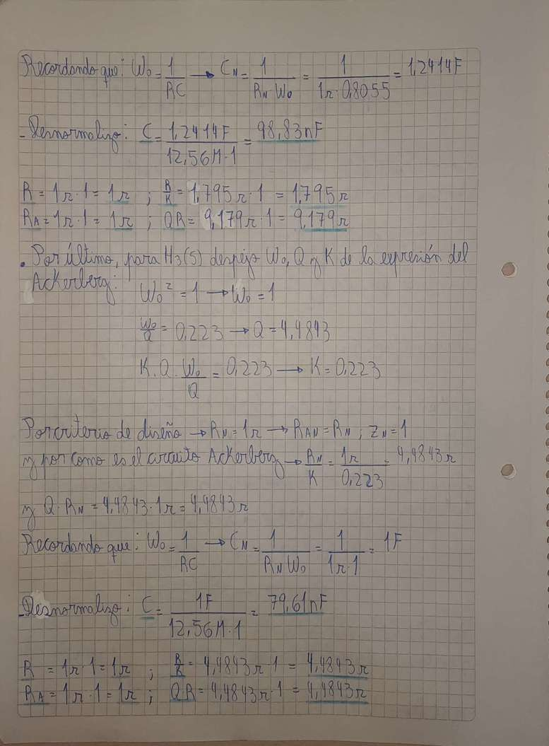

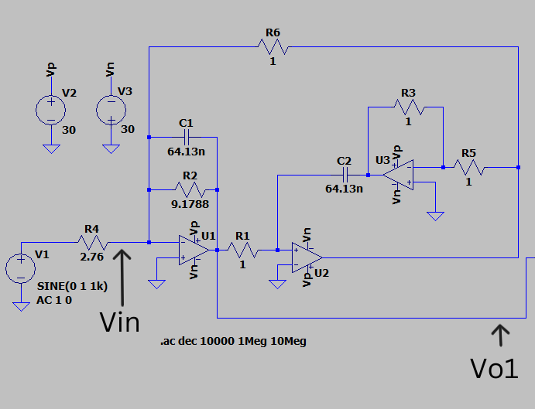
Filter circuit obtained in LTspice I.

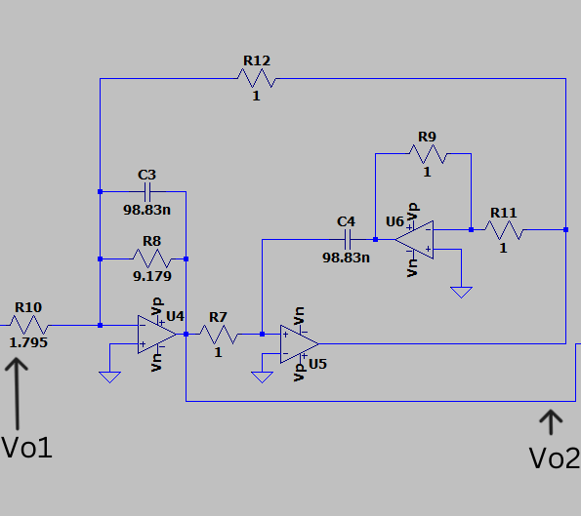
Filter circuit obtained in LTspice II.

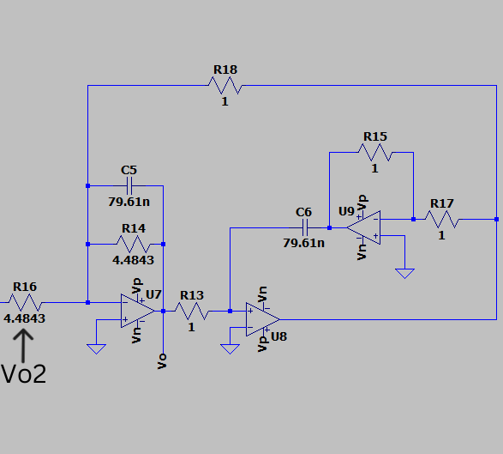
Image
R13
Ri4
79.61n
R18
Circuit of the filter obtained in LTspice III.
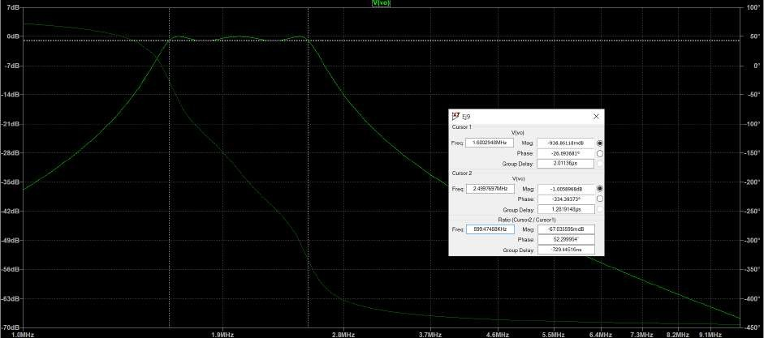
Filter simulation. It is a band-pass with Chebyshev approximation, conditions by the statement. Attenuation approx. 0.94 dB at fci = 1600 KHz and 1 dB at fcs = 2500 KHz. Of the attenuations, on average a Ripple.
maximum of 1 dB.

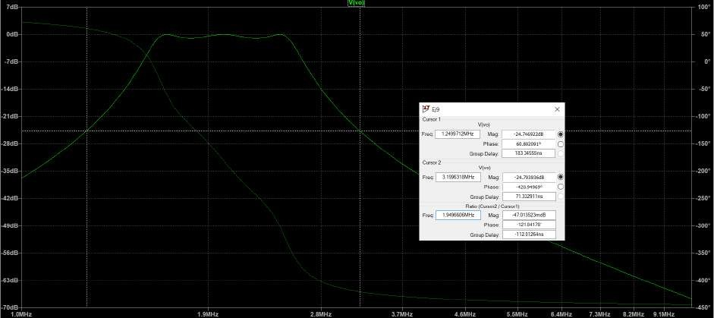
Image
Filter simulation. It is a bandpass with Chebyshev approximation, conditions per statement. Attenuation approx. 24.75 dB at fci = 1250 KHz and 24.79 dB at fcs = 3200 KHz. Of the attenuations, on average
we have approximately about 20 dB for the frequencies of “band stop” onwards.
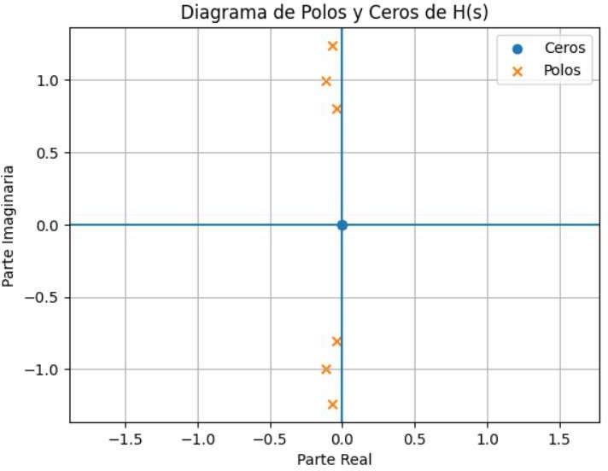
Pole-Zero Diagram of
and
Imaginary
Part
Real Part
Image
Poles
Pole-zero diagram of the band-pass filter with Chebyshev approximation.

Exercise #10
A tone of 45 KHz and a tone of 45 KHz and 200 mV of amplitude is distorted by a tone of 12 KHz and 2 V of amplitude. Design a high-pass filter that attenuates the interfering signal, such that the remnant is not greater than 2% of the 200 mV. The gain at high frequency should be 0 dB and the maximum attenuation in the passband less than 1 dB. Use the approximation that requires the fewest stages. Synthesize the filter using Sallen-Key structures.
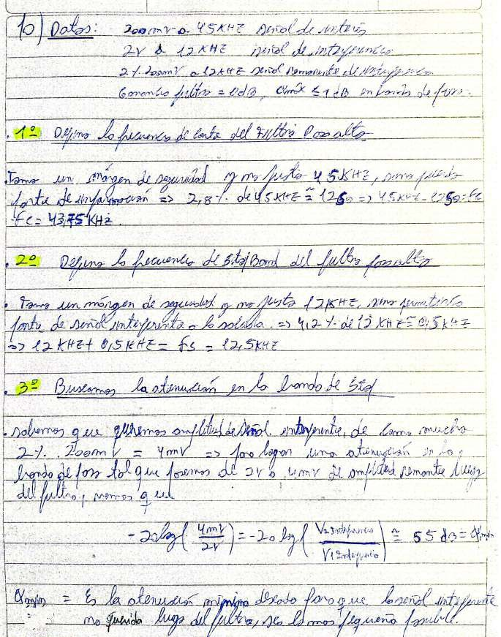
dp
of
fe
e
E

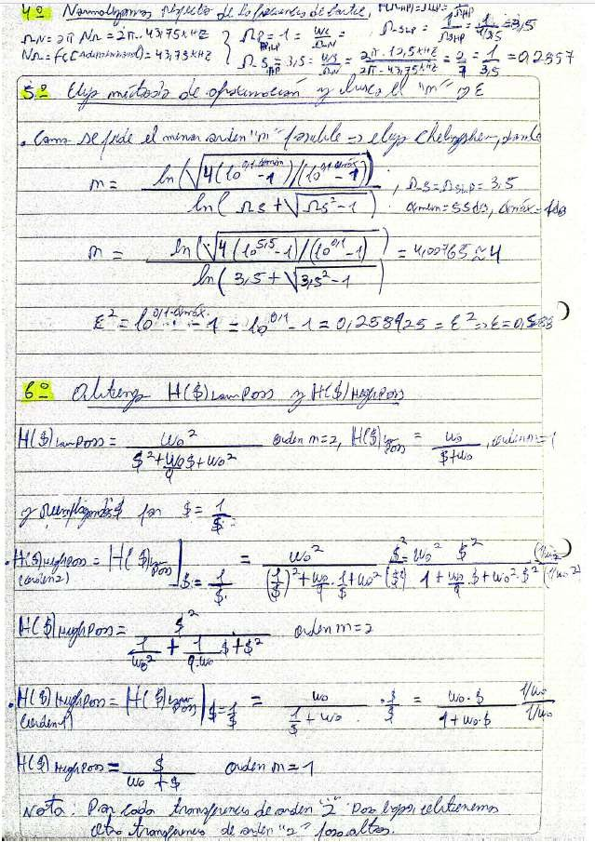
And

Za

Ara

Ue

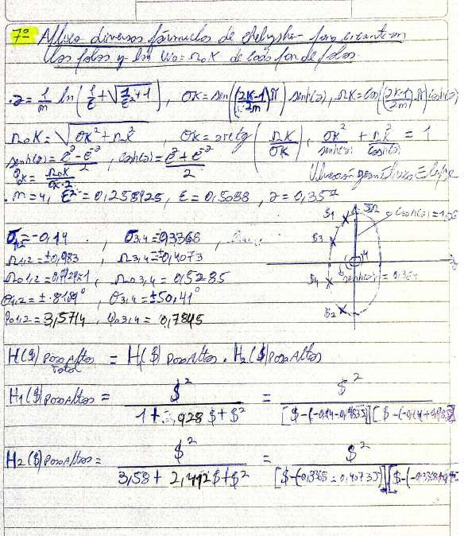
j
e

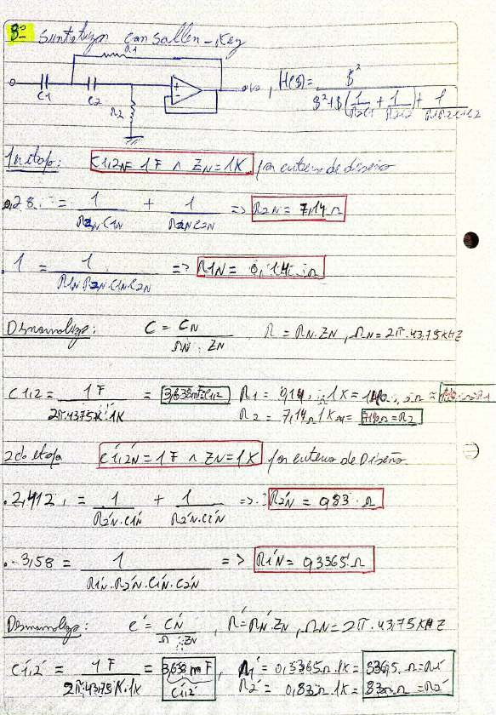
In

Mv:

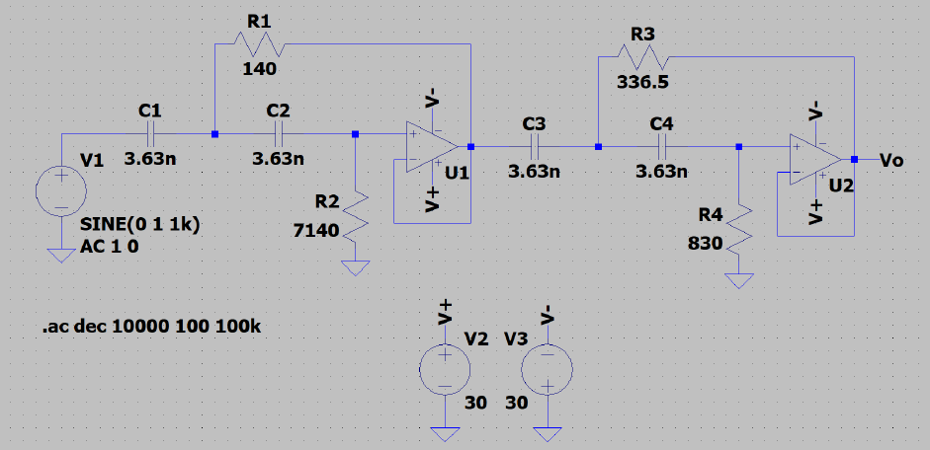
Filter circuit obtained in LTspice.
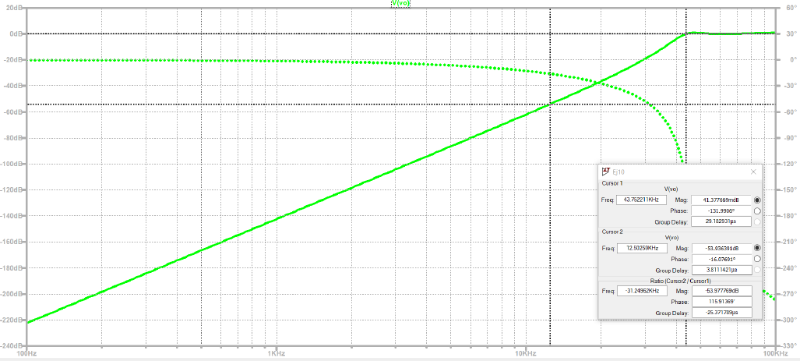

Filter simulation. It is a high-pass filter with Chebyshev approximation, conditions as stated. Approximate attenuation of
0.41 dB at fc = 43.75 KHz and 53.93 dB at fs = 12.5 KHz. From the attenuations, on average we have
approximately 54 dB of attenuation between one frequency and another.

