CIRCUIT THEORY II - R4053 - 2025
Professor: Navarro, Carlos | ATPs: Balbi Juan - Howlin Marcelo
T.P. No. 3: Parts of Bilinear and Biquadratic Transfer Function
Group No.: 3 | Members: Costarelli Facundo  - De Cia Antonella - Germaniez  Francisco - Ríos Tamara
Responsible: e_mail: | Costarelli Facundo  fcostarelli@frba.utn.edu.ar
Submission date: 11/06/2025 | Approval date:
Observations:

INDEX
Exercise #1. 2
Exercise #2. 4
Exercise #3. 5
Exercise #4. 7
Exercise #5. 9
Exercise #6. 12
Exercise #7. 14
Exercise #8. 16
Exercise #9. 27

Exercise #1
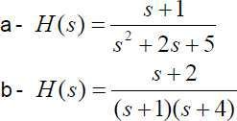
Determine the expression of the group delay corresponding to the following functions:

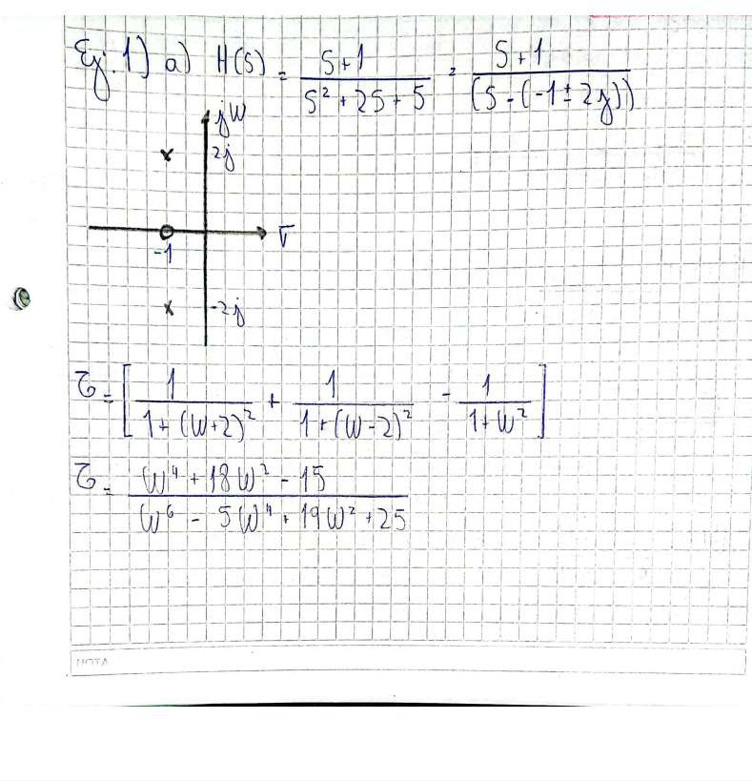

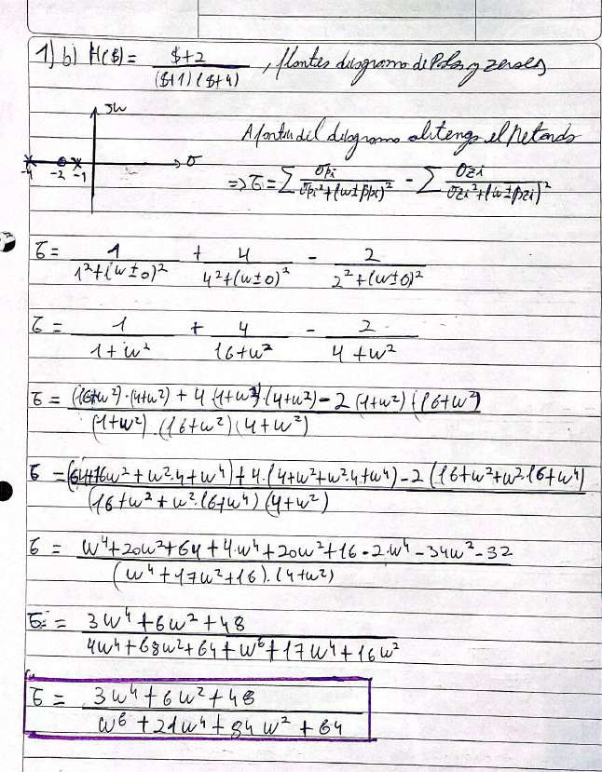

Exercise #2
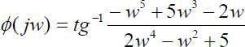
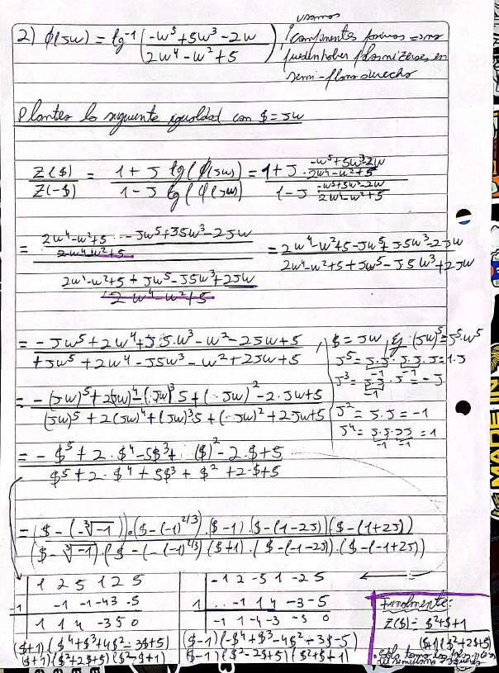
Obtain the Z(s) that corresponds to the following phase function:

Exercise #3
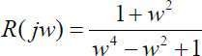
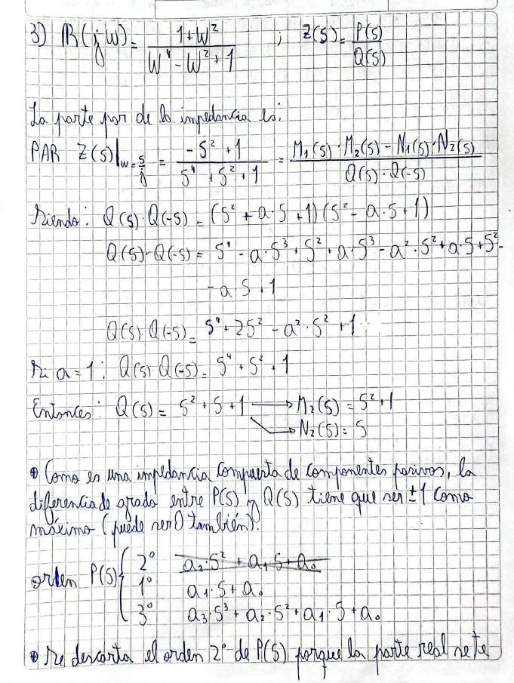
Given its real part, obtain Z(s)

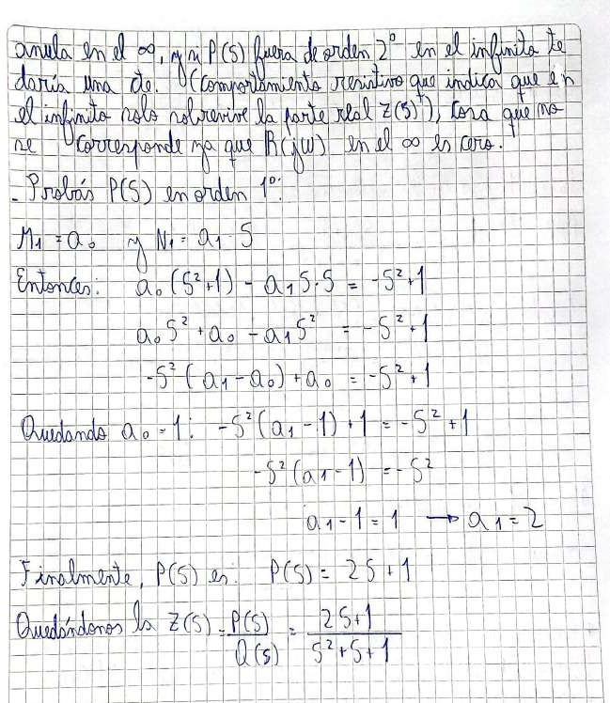

Exercise #4
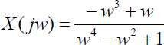
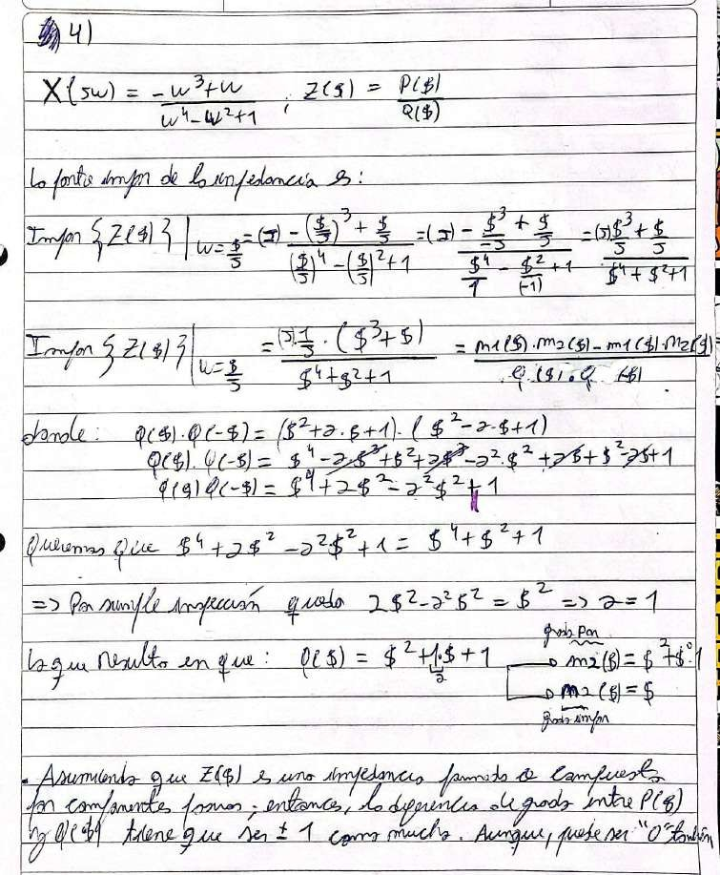
Given its imaginary part, obtain Z(s)

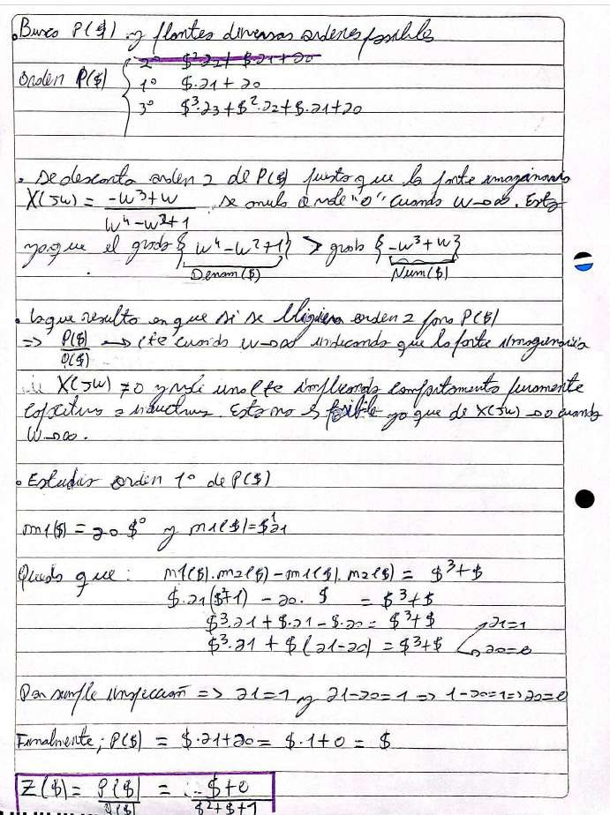

Exercise #5
The following Bode diagram (Figure 1) corresponds to the magnitude response of the transfer function of an emphasis network, used in a FM transmitter for Broadcasting. Design the circuit, verifying it through simulation.
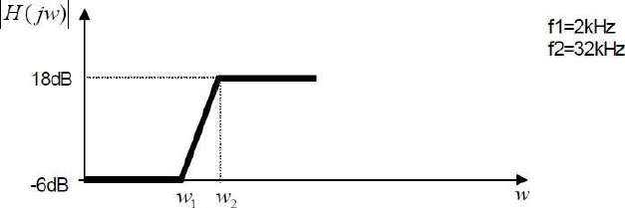
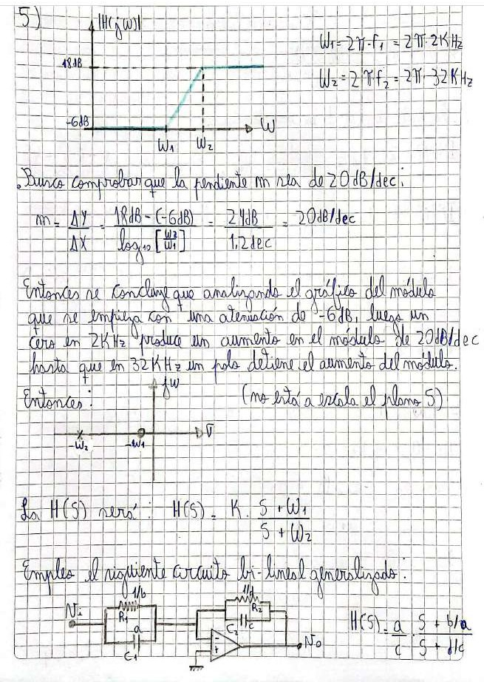

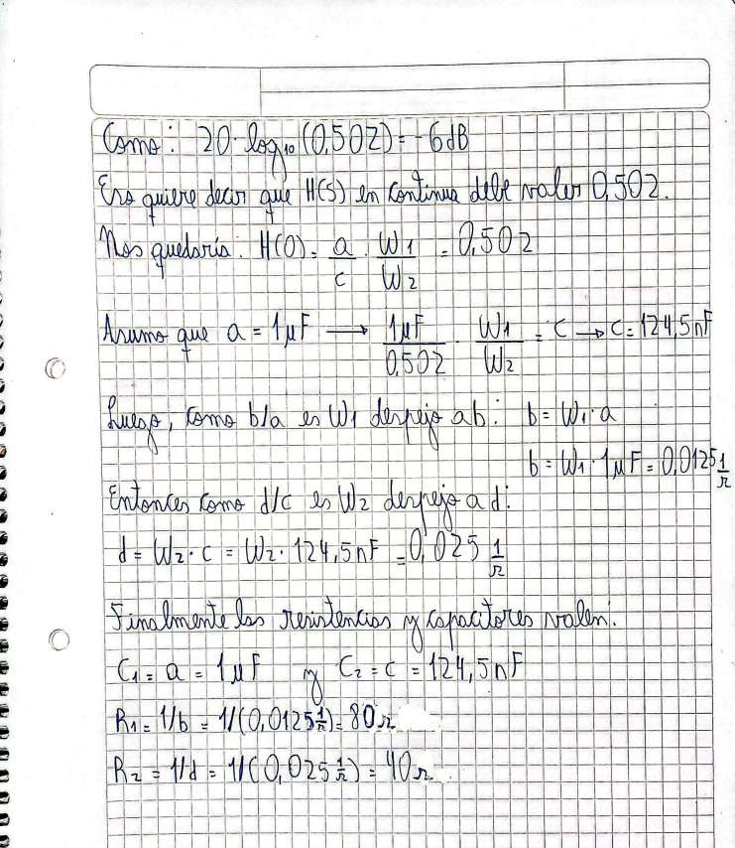

Simulation:

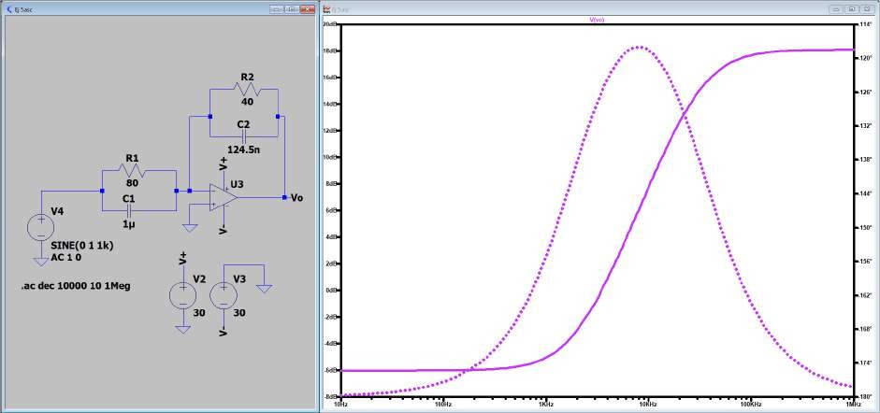
Frequency response of an emphasis network.

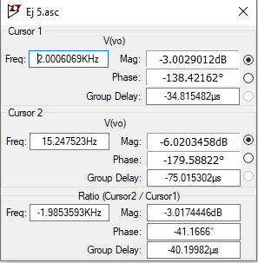
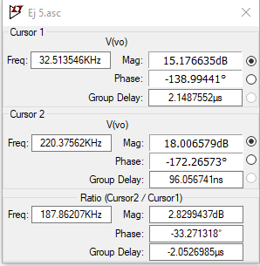
Cursor values for f1 and -6dB (left) & for f2 and 18dB (right).

Exercise #6
Design a broadband passive circuit, which presents a phase shift of 38° at

9200Hz
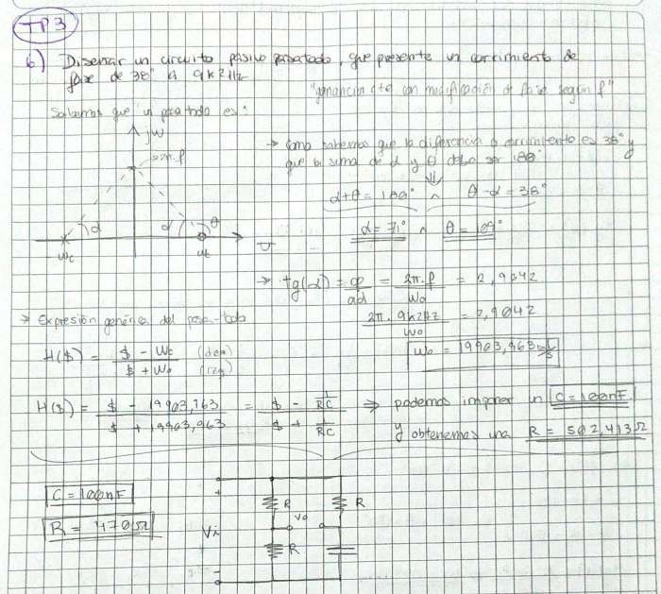

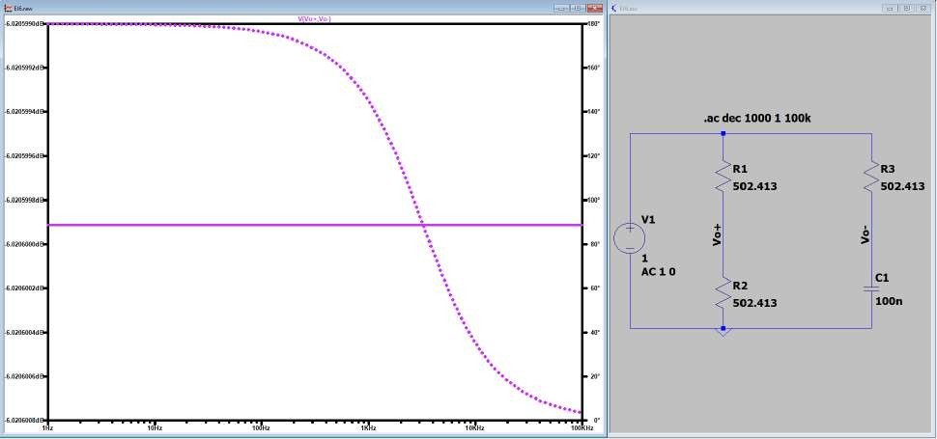
Simulation:

Simulation of the all-pass filter with the requested delay.

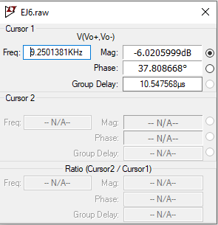
Cursor value for a frequency of 9.2 kHz.

Exercise #7
For a test in a power plant, a circuit must be implemented that generates the RST signals of a three-phase network in response to a 50Hz sinusoidal input, keeping the amplitude of those phasors constant. Verify via simulation
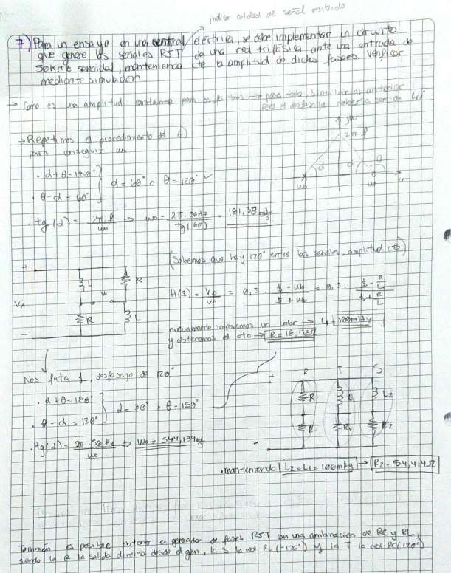

Simulation:

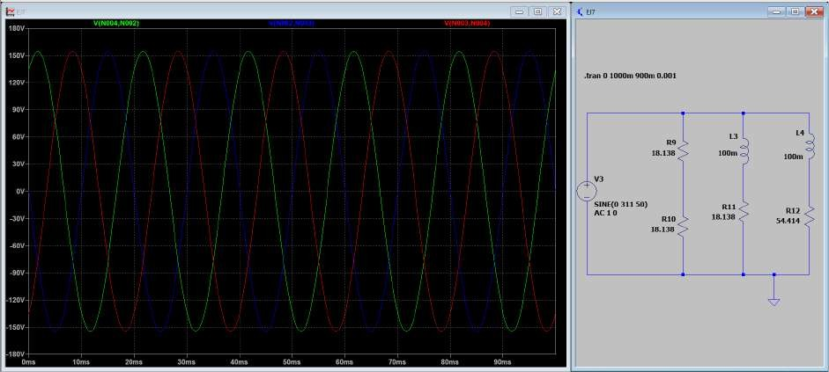
Simulation of the three phases of the circuit at 50Hz.

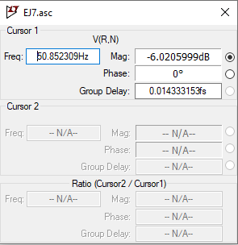
Cursor when simulating a frequency sweep.

Exercise #8
- Starting from an Ackerberg Mossberg structure, obtain a circuit that allows obtaining a generalized biquadratic transfer function
- With the above structure design a 50 Hz Notch filter that exhibits maximum flatness in the passband and a DC gain of 0 dB. The attenuation must not exceed 3 dB in a bandwidth of 5 Hz around 50 Hz c) With the same structure, design a Notch low-pass filter with a 3 dB gain at low frequency and an attenuation of 30 dB at high frequency. The passband should have maximum flatness in a bandwidth of 280 Hz

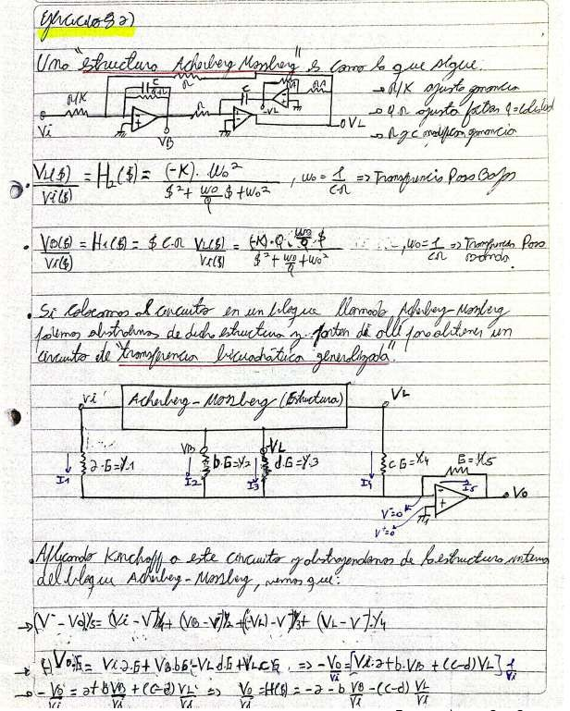
a)

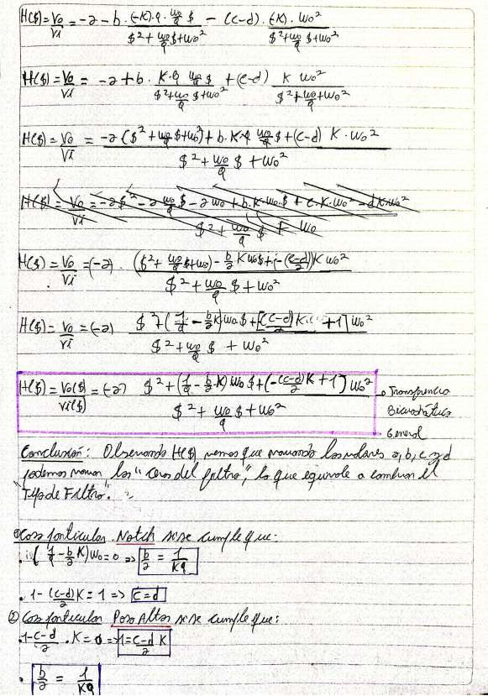

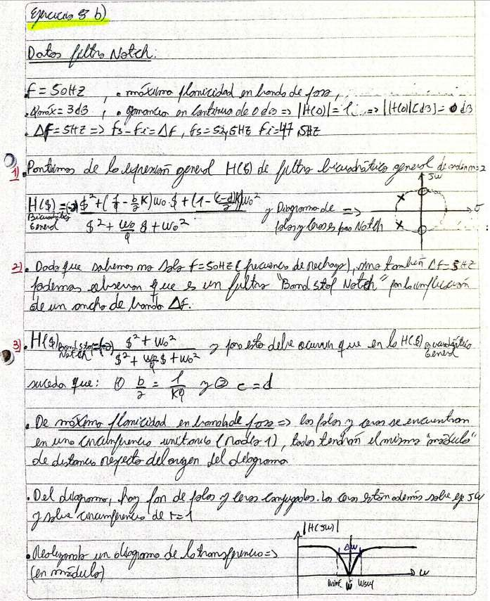
b)

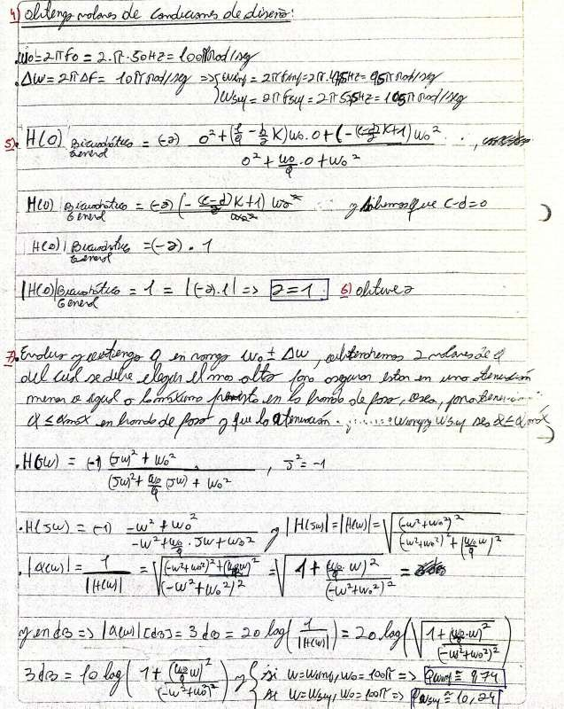

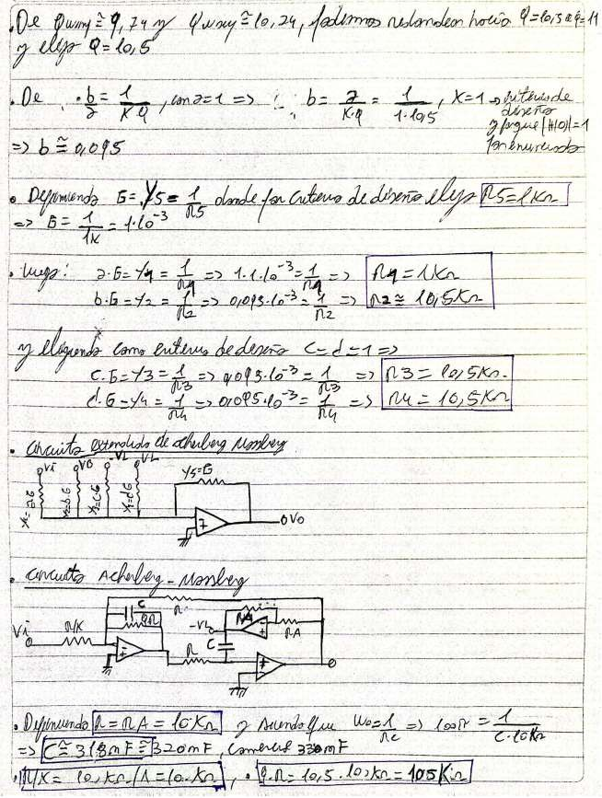

Simulation:

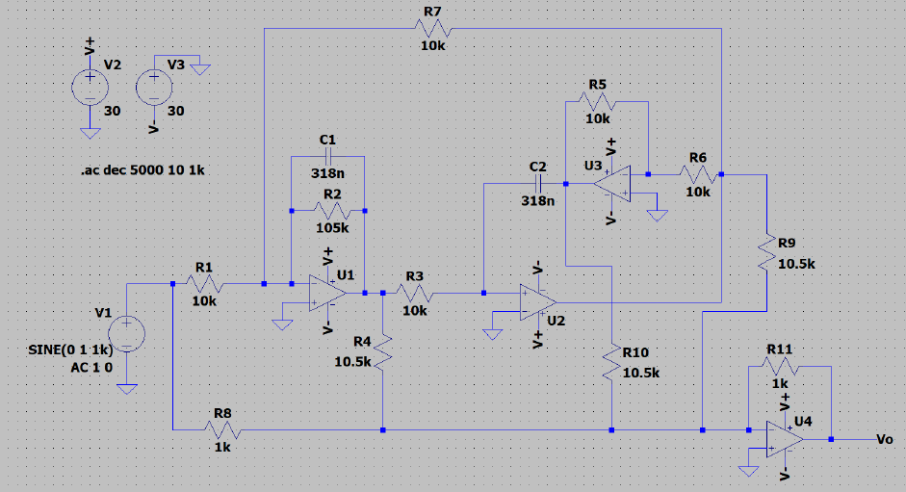
Band Stop Notch Circuit

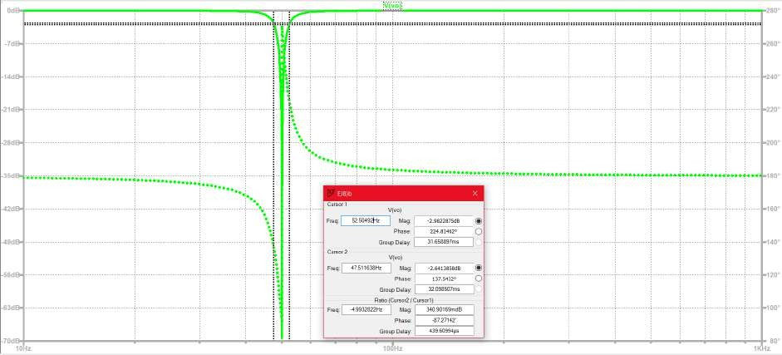
Frequency response of the Band Stop Notch filter
Graph

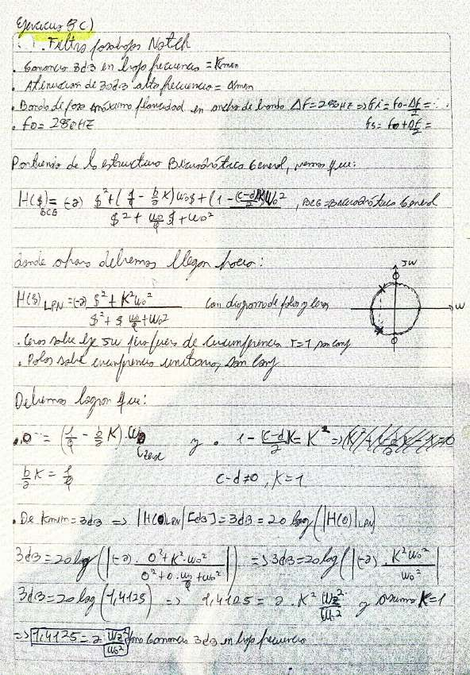
fo:

di

fo
from A

ol

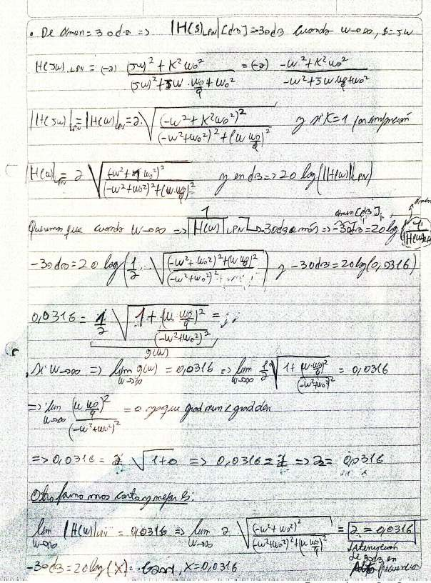
Of

E

EE

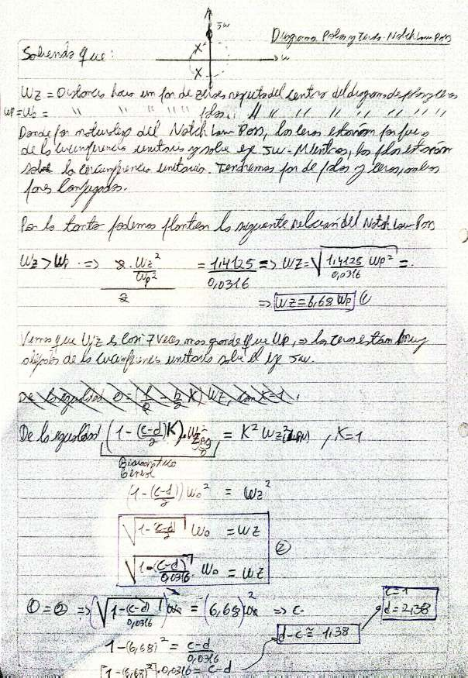

o:

The
fo

of

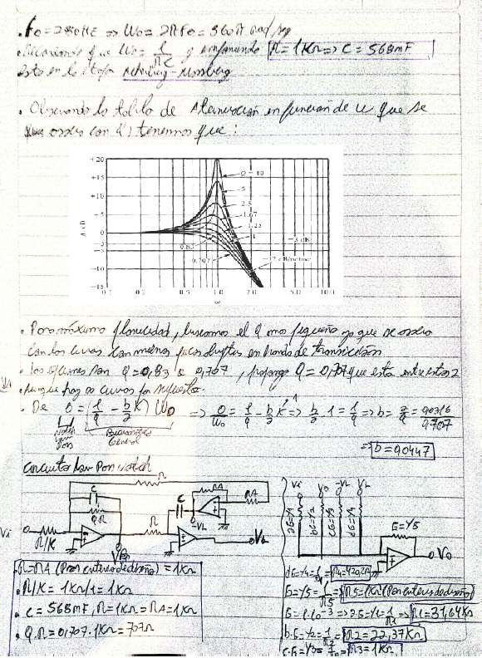
Z of

Can
them

Simulation:

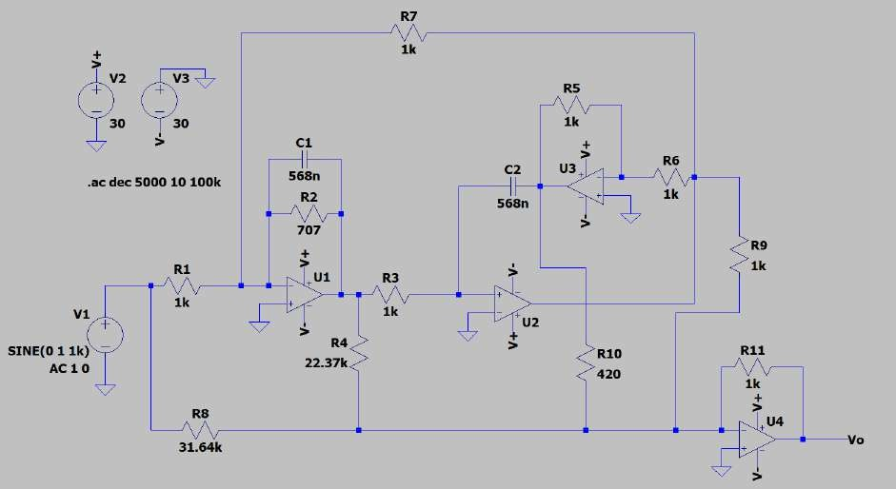
Low Pass Circuit with Notch
1k)
SINE(O
100k
dec

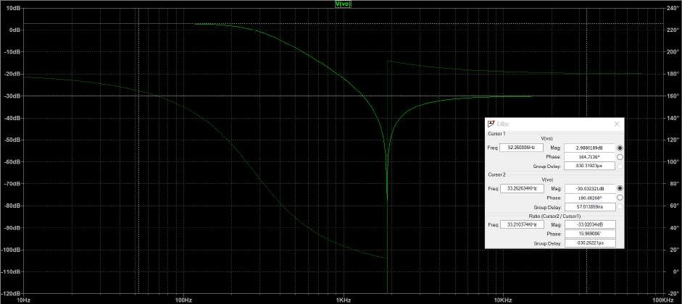
Frequency response of the Low Pass with Notch filter
Chart

Exercise #9

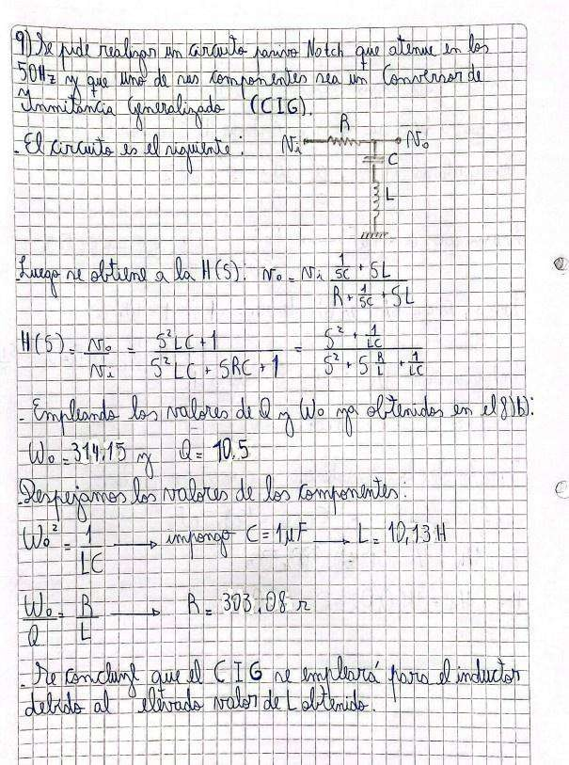
Repeat 8 b) using a generalized Admittance Converter.

cl The

or EÉ

Ñ E

a

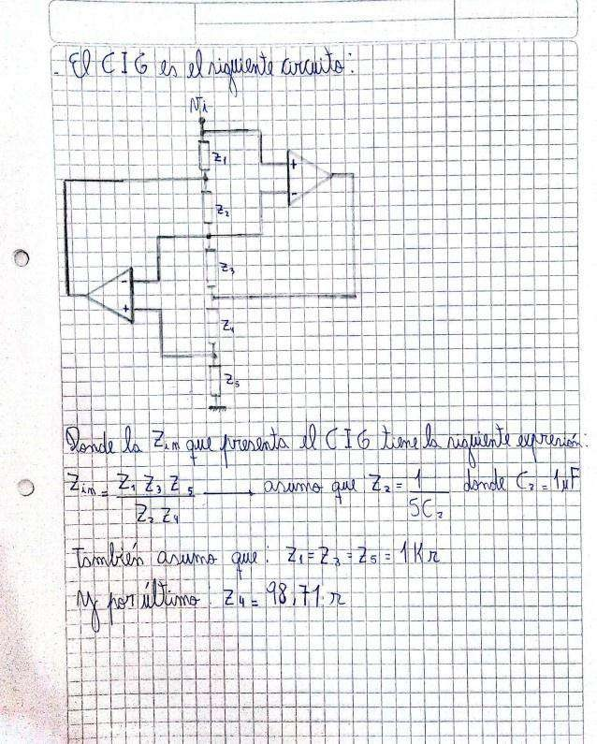

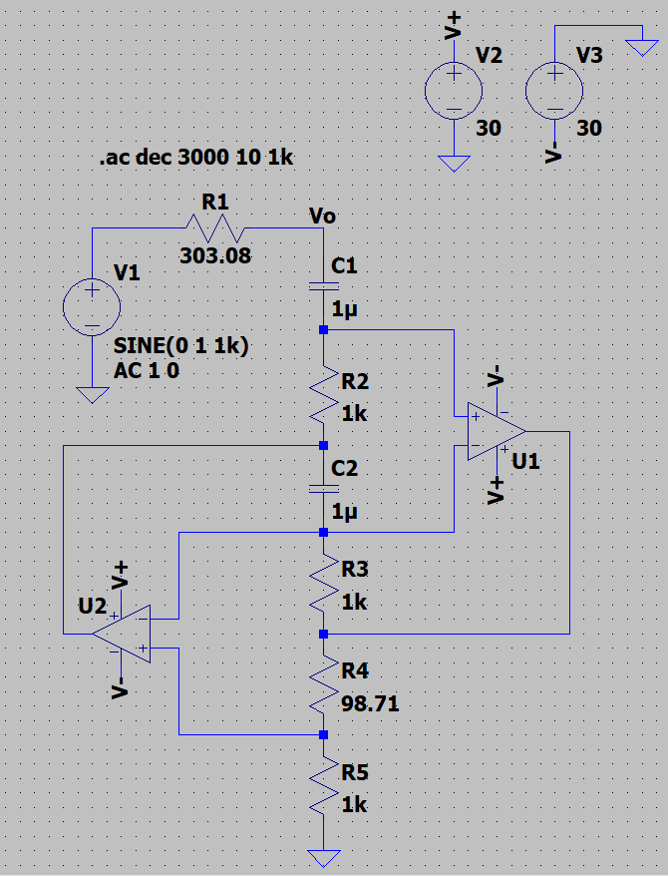
Simulation:
Chart
Band Stop Notch RLC Circuit with “L” modeled with CIG

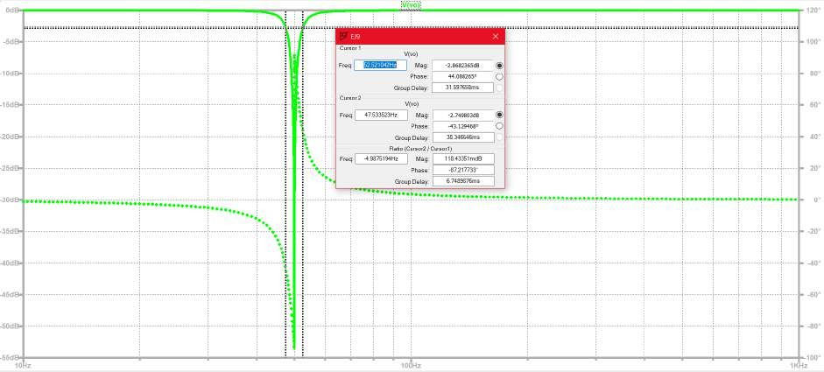
Frequency response of the passive Band Stop Notch RLC filter with “L” modeled with CIG
Chart

