CIRCUIT THEORY II - R4053 - 2025
Professor: Navarro, Carlos | ATPs: Balbi Juan - Leandro Starcman
T.P. No. 5: Four-Terminal Network Parameters
Group No.: 3 | Members: Costarelli Facundo  - De Cia Antonella - Fernández Juan - Germaniez Francisco - Ríos Tamara
Responsible: e_mail: | Germaniez Francisco  fgermaniez@frba.utn.edu.ar
Submission date: 20/08/2025 | Approval date:
Remarks:

INDEX
Exercise #1. 1
Exercise #2. 4
Exercise #3. 5
Exercise #6. 6
Exercise #7. 7
Exercise #8. 13

Exercise #1
E
Obtain the Z, Y and T matrices of the quadripoles from graphs 1, 2 and 3.
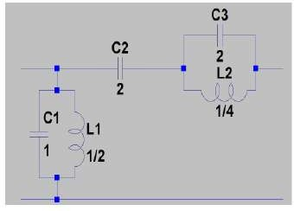
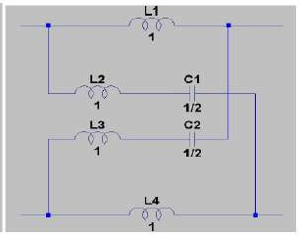
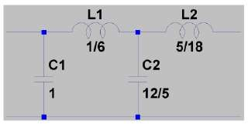
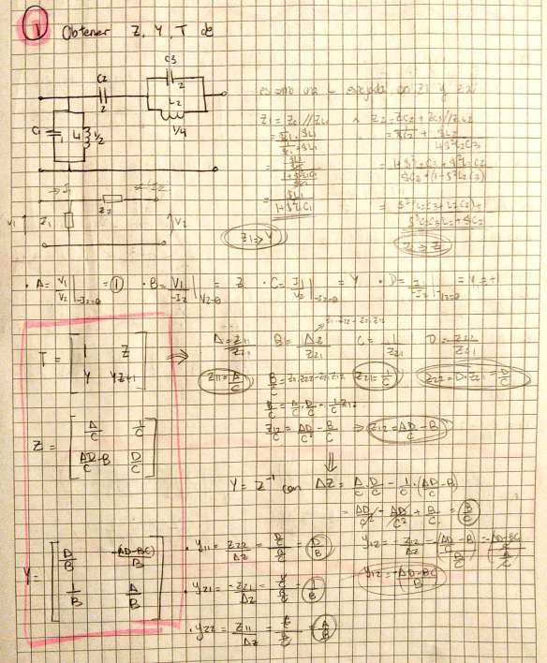
the
m
CTE
jo
É

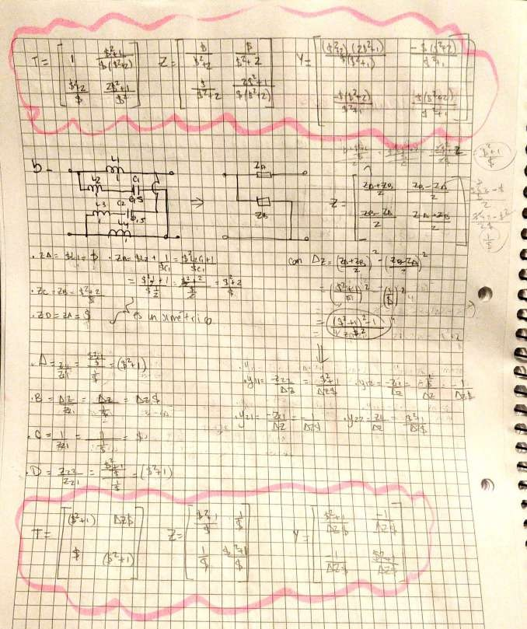
and
E
E
E
of the
A
L
my
H

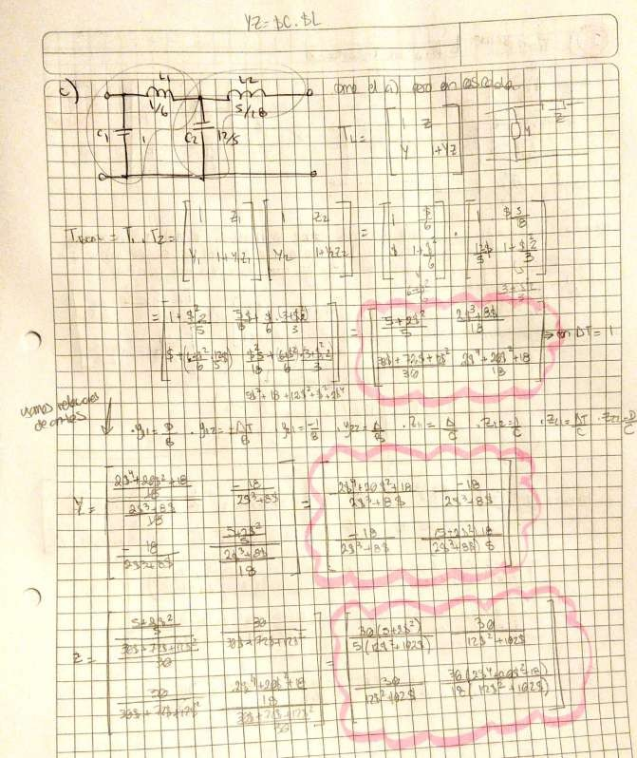
A
E
The
and

A
THE

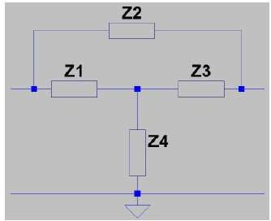
Exercise #2
A
Transform the lattice quadripole from figure 4 into an equivalent T-stubbed one like that of figure 5.
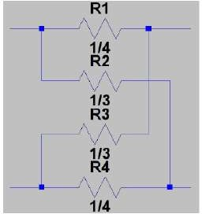
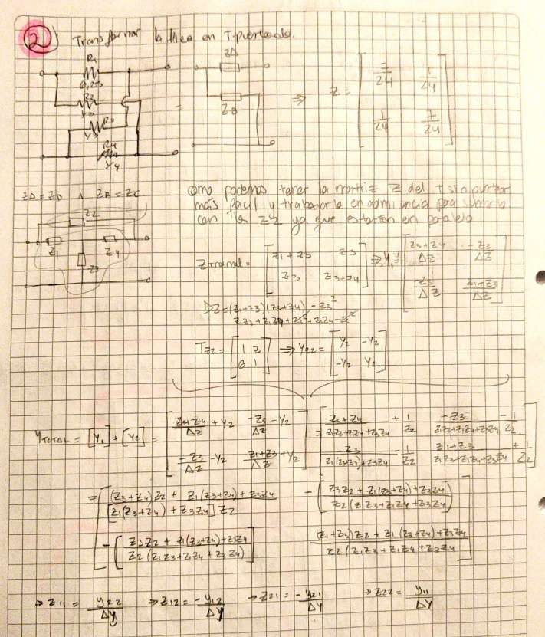
E
The
the
to the
E
E
E
pe
Ez
D
pr
ME e
to FE
mi
Y
E

Exercise #3
Given the T matrix of graph 6, obtain the components of the lattice quadrupole that satisfy it. Observation: Consider the passive and symmetric quadrupole.
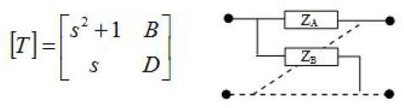
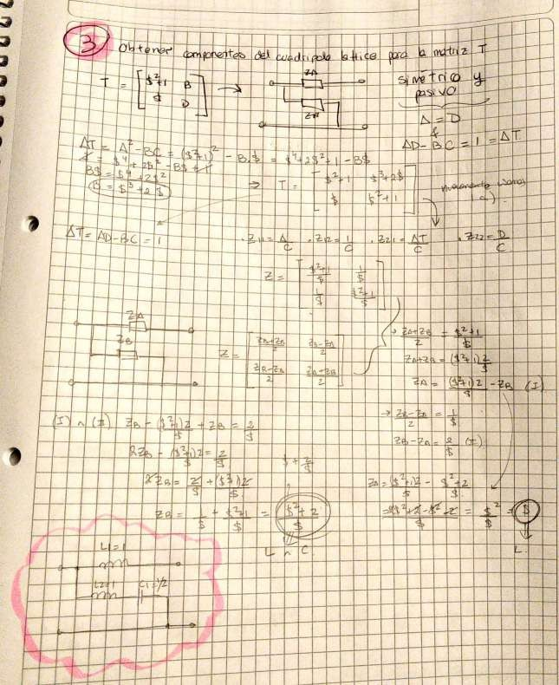
The
Figure

Exercise #6
Obtain a lattice circuit equivalent to the quadripole of diagram 7.
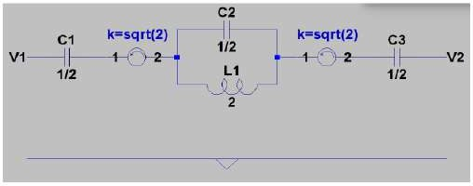
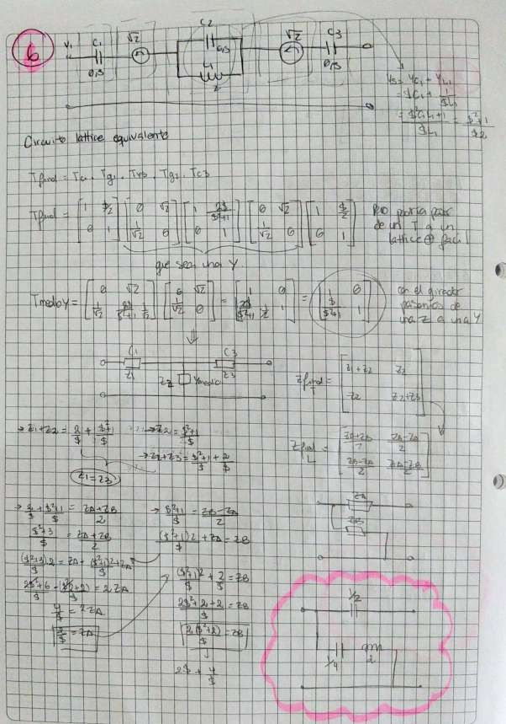

Exercise #7
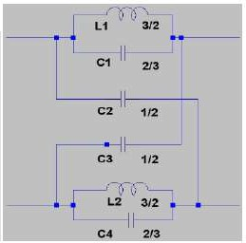
Indicate how you would implement the 'A' quadripoles from figure 8 so that the active structures behave like the proposed lattices (as in figure 9).
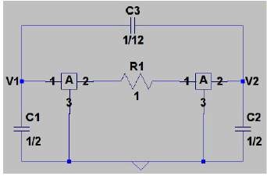
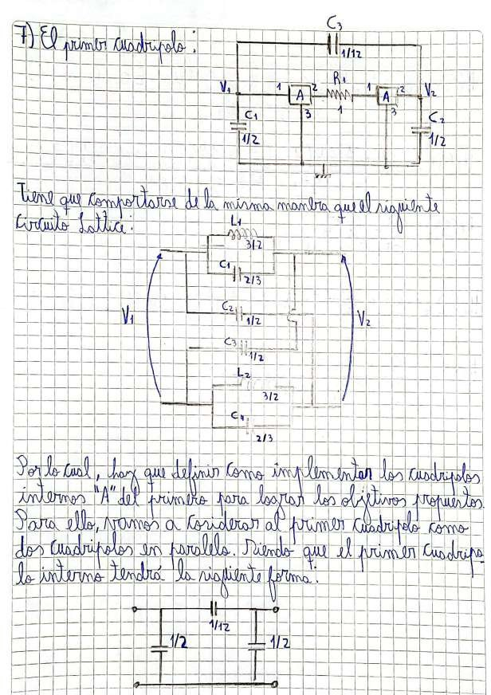
Figure
É
a
In or

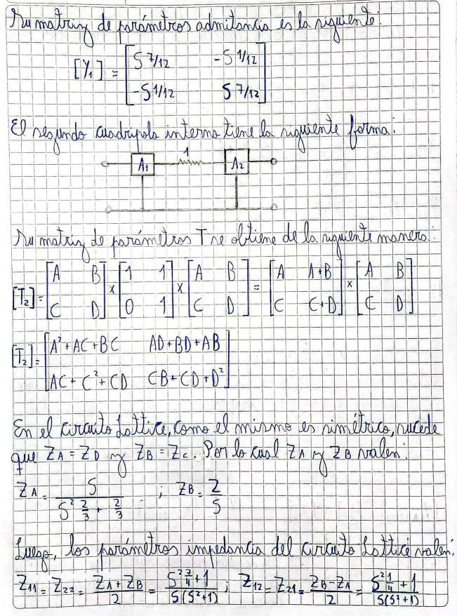
T

E

r

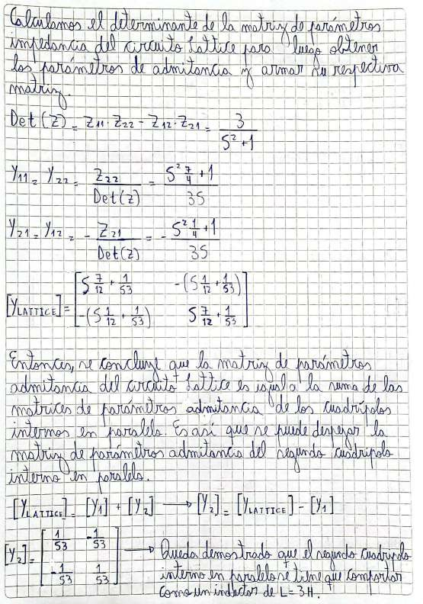
n
E
E
Y
E
hal
ka

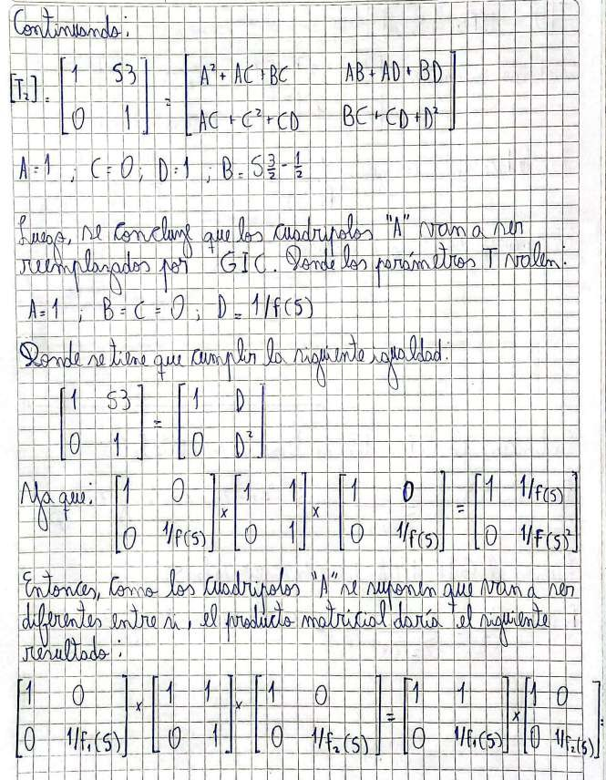
f Ñ f

E

T
D L

E

Pal

to

to the

to

to the

D
The

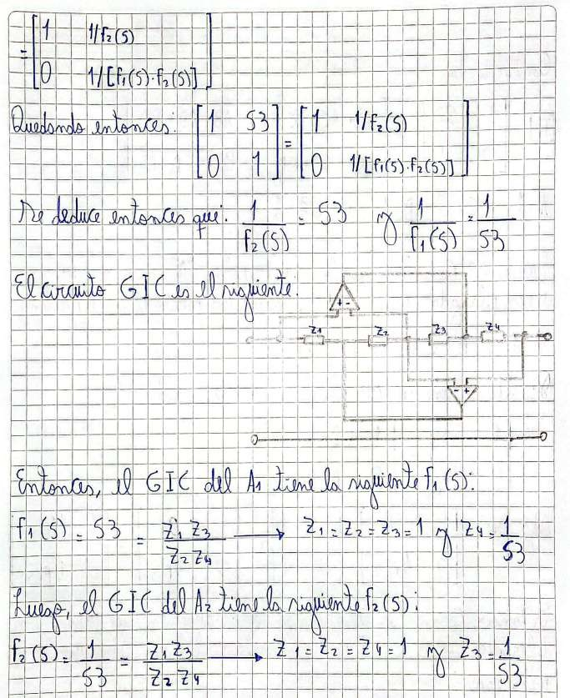
E
e
i
a
a
b)

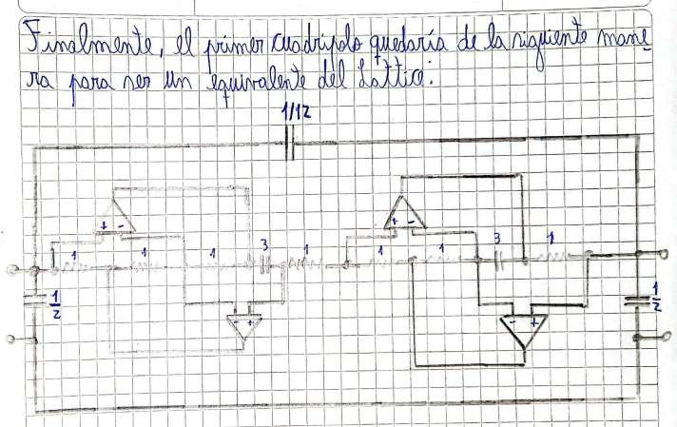
and
H

Exercise #8
The Y-parameters of a BS170 MOSFET transistor operating under the following conditions are to be determined:
- V_DS = 10V
- V_GS = 0V
- I_DS = 200mA
- Common-source configuration.
- Operating frequency: 1MHz
It is known that under these conditions the transistor presents the following characteristics (datasheet):
- g_fs = 200mS
- C_iss = 35pF
- C_rss = 5pF
- C_oss = 32pF
Furthermore, the manufacturer specifies the following:
- C_oss = C_ds + C_rss
- C_iss = C_gs + C_rss
- C_rss = C_gd
Find the Y-parameters of the transistor by setting C_rss = 0 and using the datasheet value. Note: the datasheet can be downloaded here: https://www.onsemi.com/pub/Collateral/BS170-D.PDF
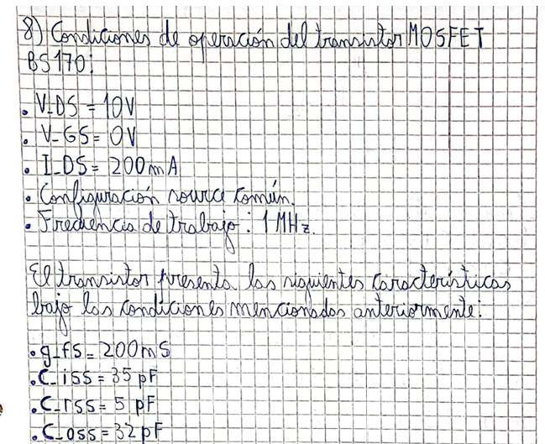
The El
N
A
SE
/UB

