CIRCUIT THEORY II - R4053 - 2025
Professor: Navarro, Carlos | ATPs: Balbi Juan - Rodríguez  Starcman Leandro
T.P. No. 6: Synthesis of quadripoles
Group No.: 3 | Members: Costarelli Facundo  - De Cia Antonella - Fernández Juan - Germaniez Francisco - Ríos Tamara
Responsible: e_mail: | Germaniez Francisco  fgermaniez@frba.utn.edu.ar
Submission date: 17/09 | Approval date:
Remarks:

INDEX
Exercise #1. 2-3
Exercise #2. 4-6
Exercise #3. 7-9
Exercise #4. 10
Exercise #5. 11-14
Exercise #6. 15-16
Exercise #7. 17-20
Exercise #8. 21-25
Exercise #9. 26-30

Exercise #1
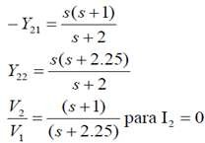
Synthesize an RC quadripole in vacuum that meets:
s(s+1)

(s+1)
for
(s+2.25)
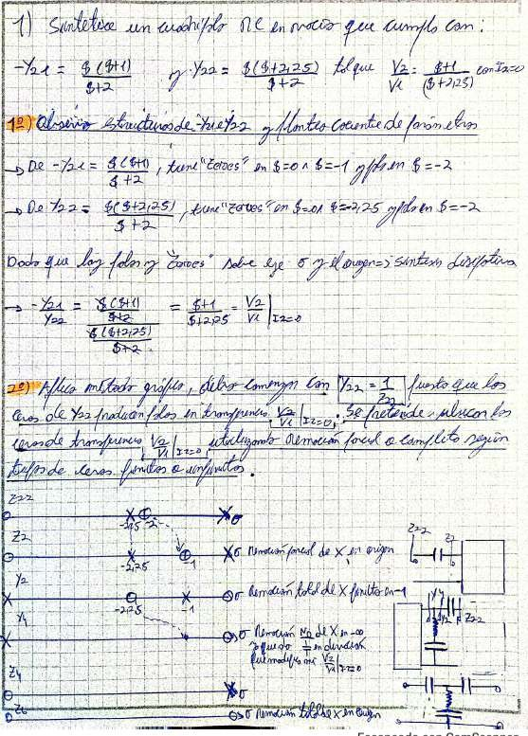
gives

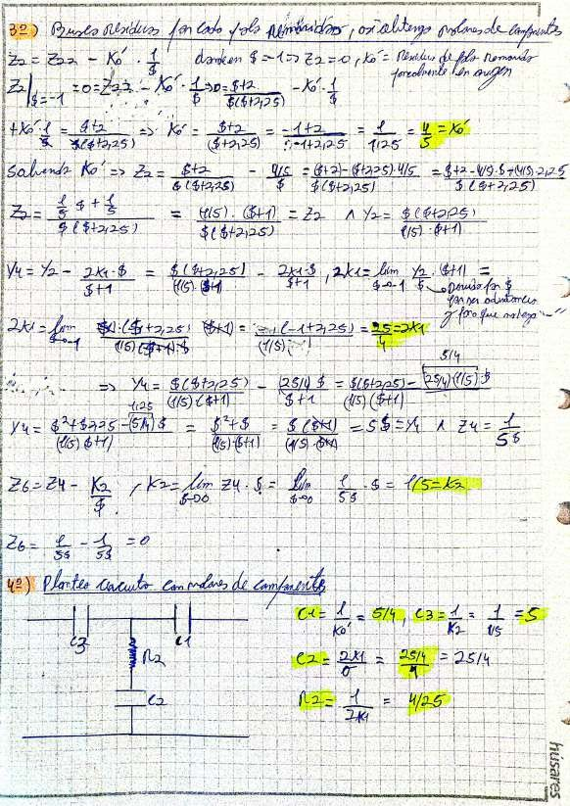

to

Exercise #2
Synthesize a quadripole that complies with:
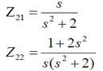
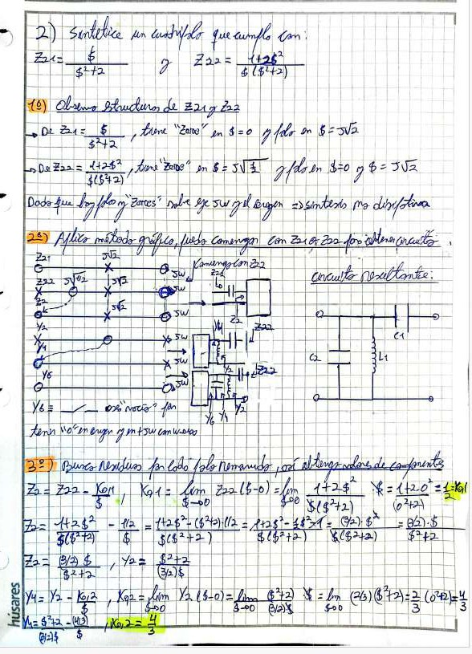

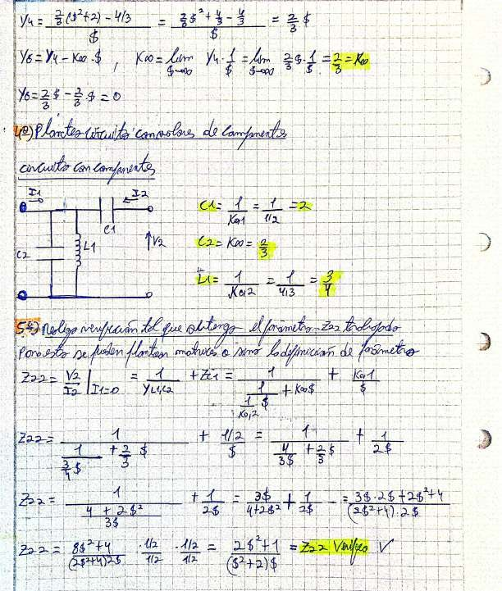

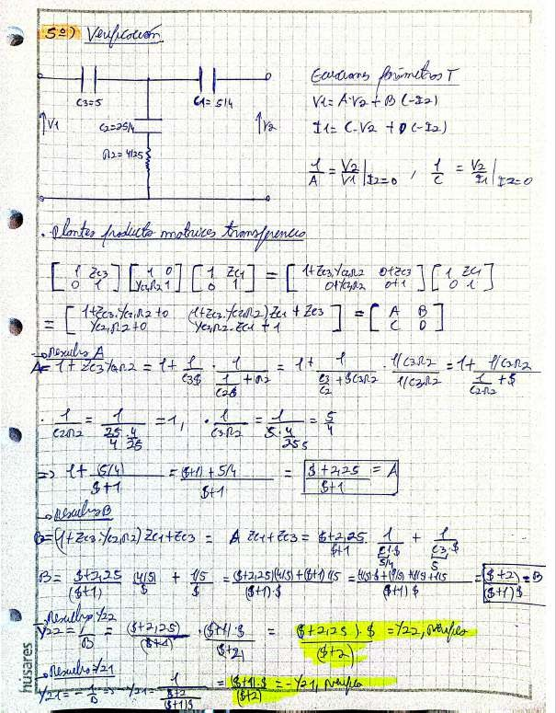

Exercise #3
Synthesize a quadripole that complies with:
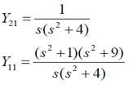
s(s”

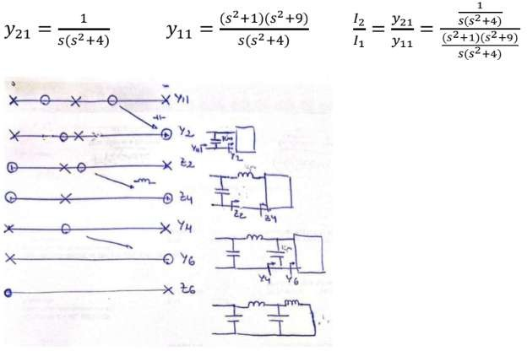
s(s?+4)
e
Te
Xx Yu
Yu
te
O Yo
e!
s(s?+4)

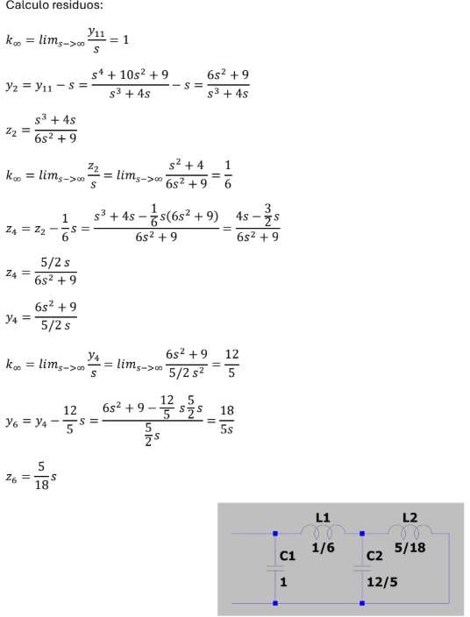
Residue calculation:
5s
Y:

F

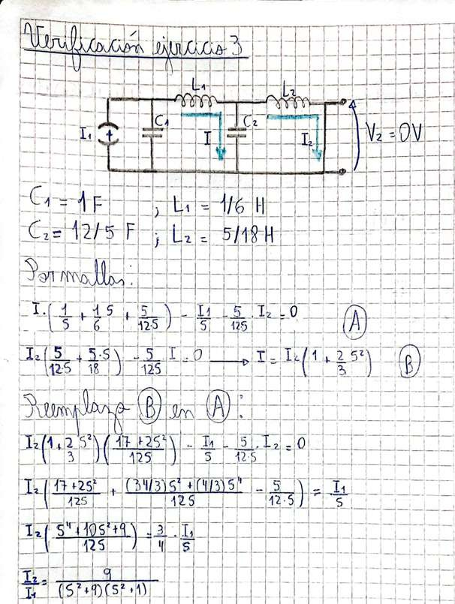
T

Exercise #4
Synthesize as symmetric Lattice:
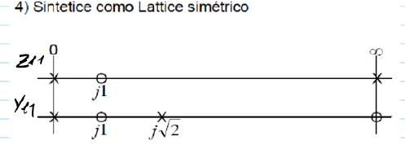
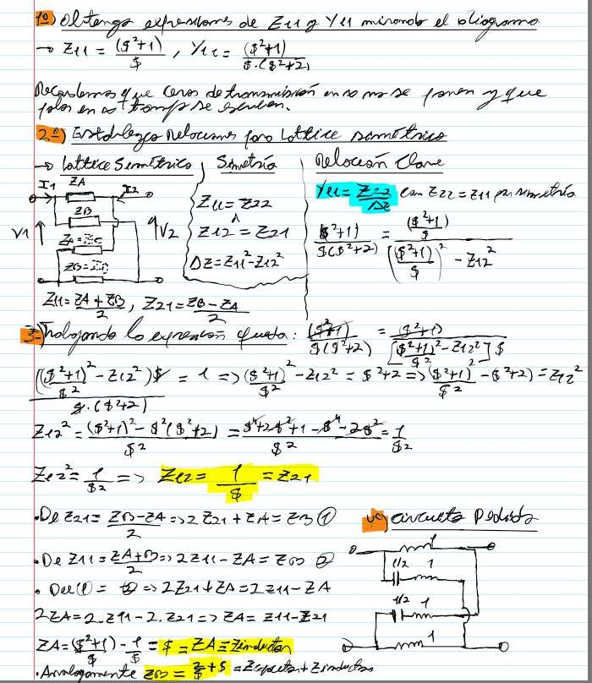
Synthesize as symmetric Lattice
ñ
Already
the
UN,
forum
and
Wz
ES
E
Of
ZA=
Zo-24
of

Exercise #5

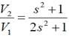
Knowing the transfer:
s
2s

- Obtain a circuit with 3 inductors and 1 capacitor.
- Obtain a circuit with 3 capacitors and 1 inductor.

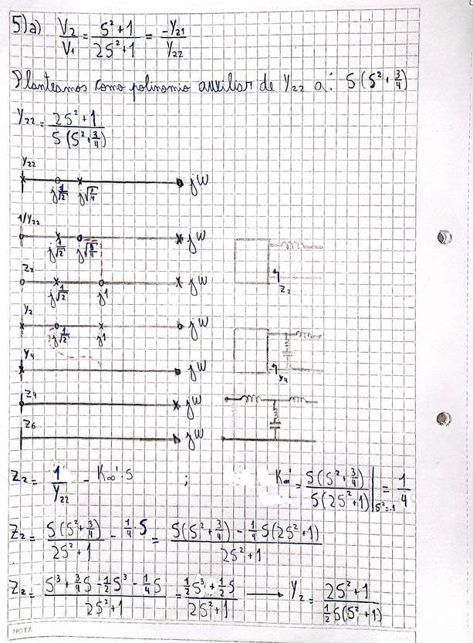
a)
í
f
H
a

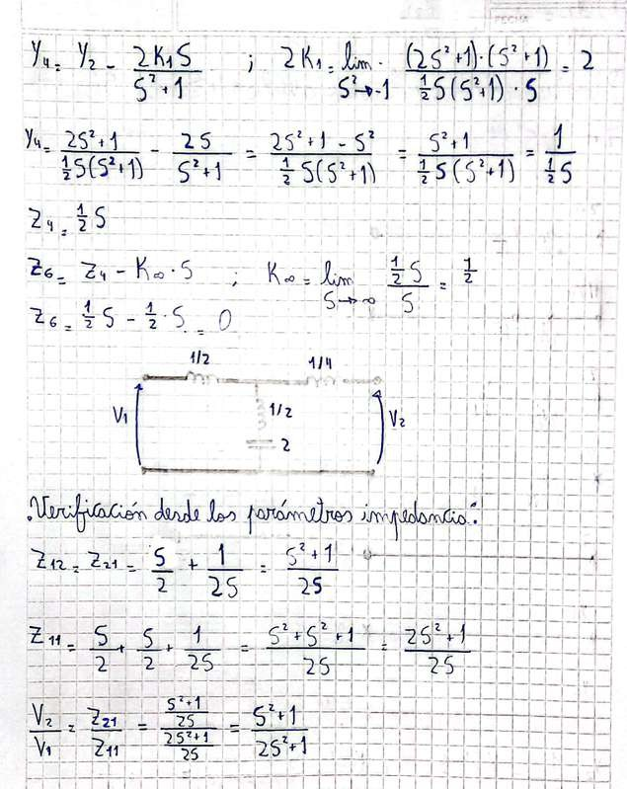

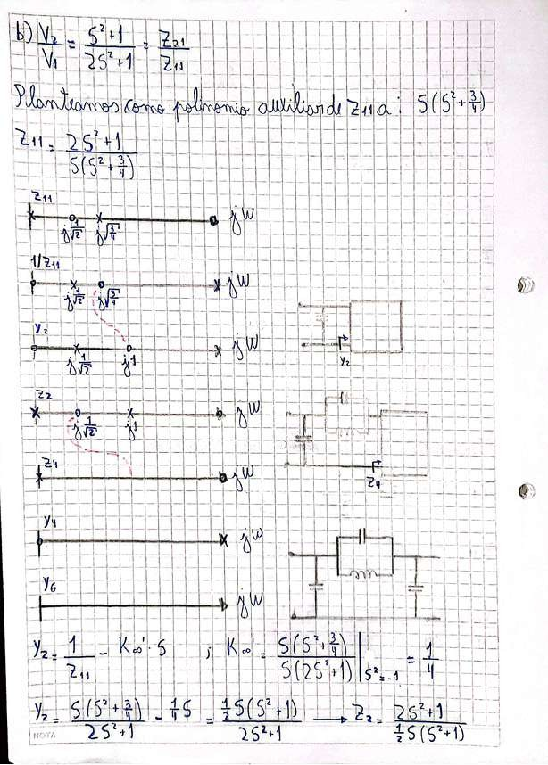

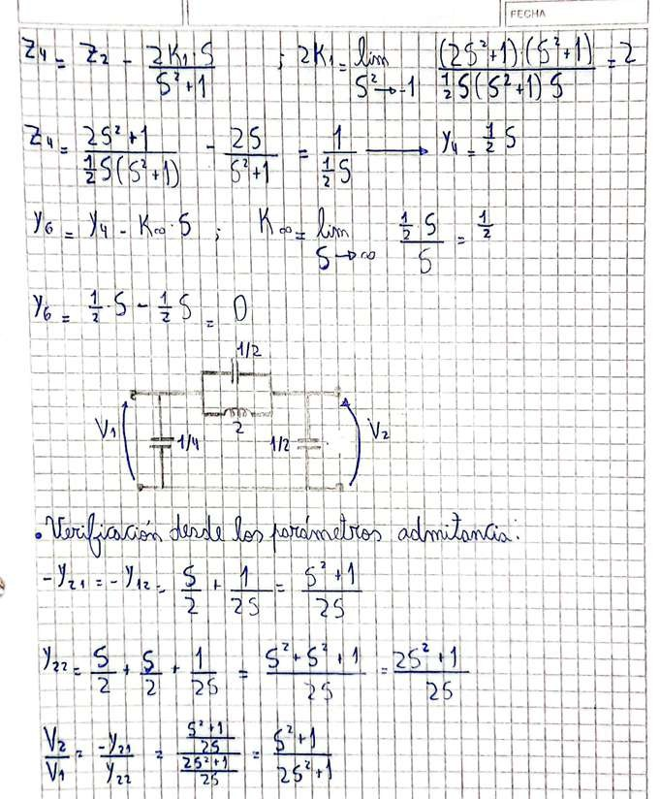

Exercise #6
Synthesize a quadripole that complies with:
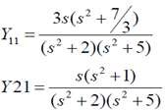
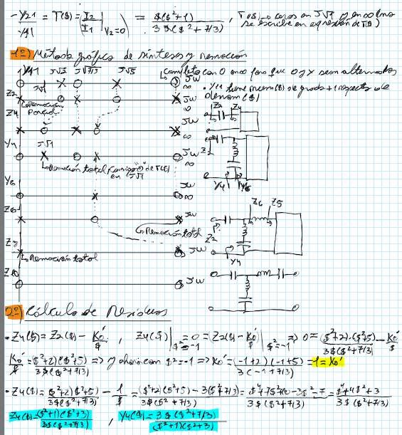
3s(s”
fu
A
his/her
T
The
Ke.
A
of

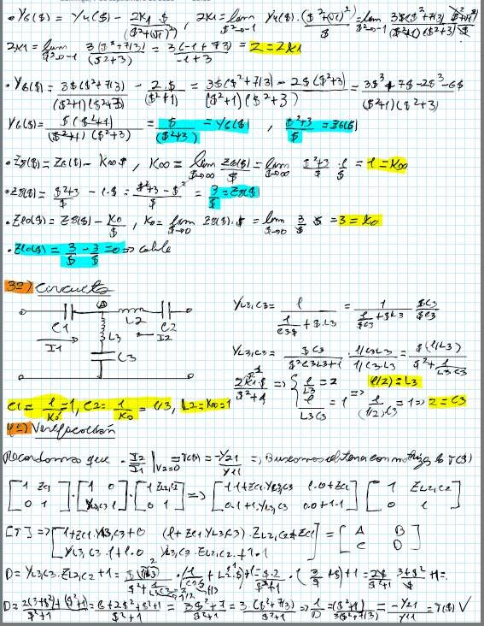
Km

and

Ly

and

And the
Ze

Exercise #7
Synthesize the following non-dissipative transfer:
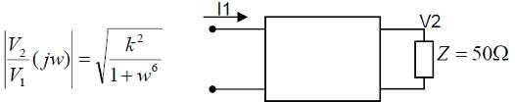
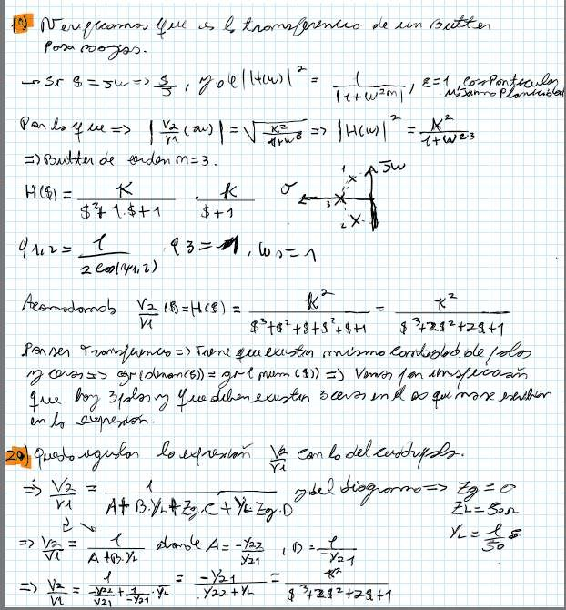
v2
k
y,
11m
Po

Mr

Le Y
of
É
mu
=Y
fre
A+

Alex
AZ
A-
E
T
Ls
É
Lo
that mane
A ca

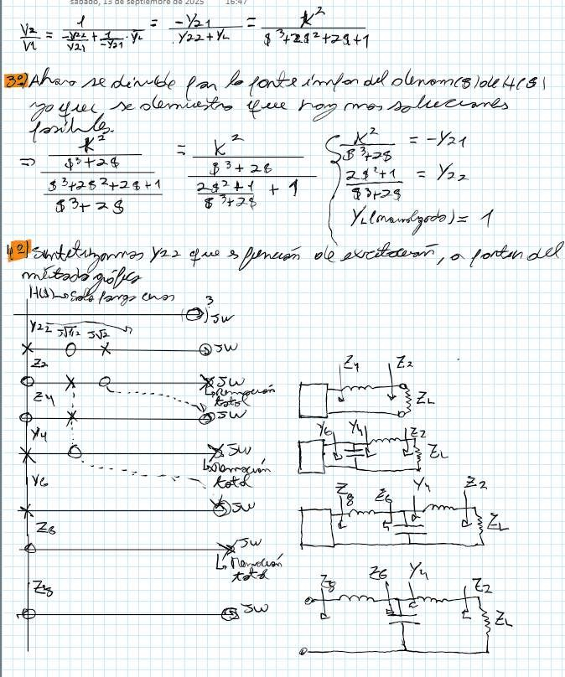
ge ge

A

ho
e
month

And to
And

aá
Fi

A

Z

Z

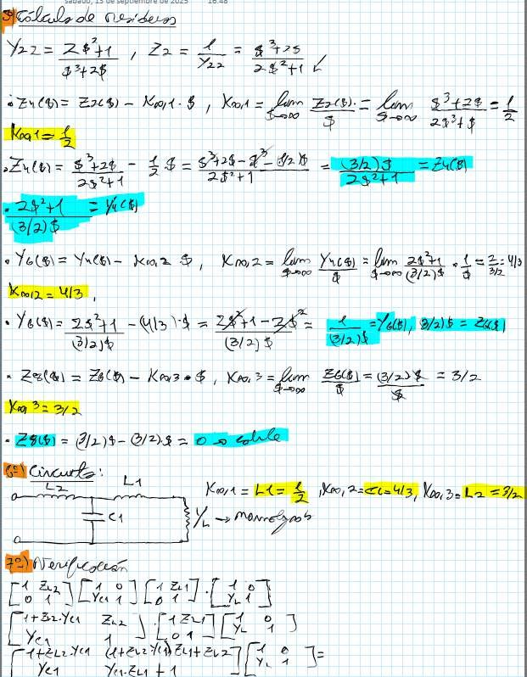

Yes
The
H=5

e

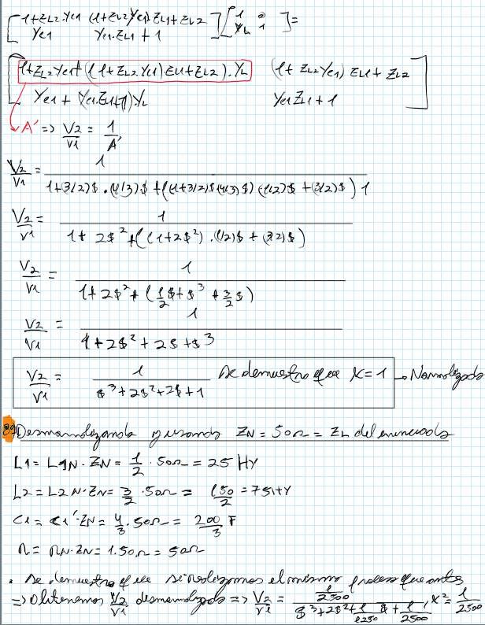
L

Yes
LE

VE

s
NA
goe
It
A qa

EL
L4= Hy
San ty

And
N=
tag

Exercise #8
Synthesize the following RC quadripole:
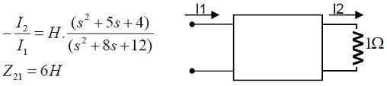
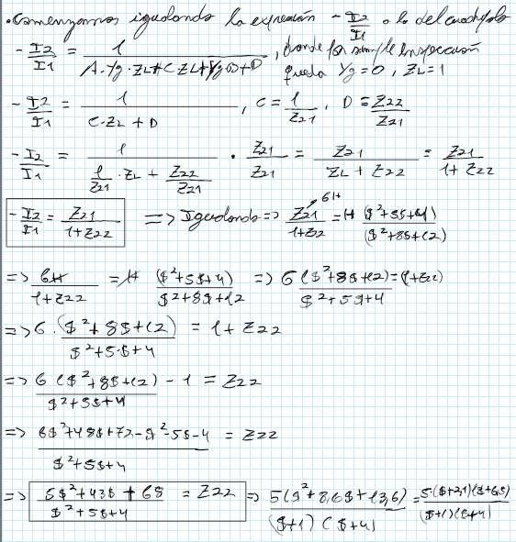
C
D
TA
ZL
ho

of
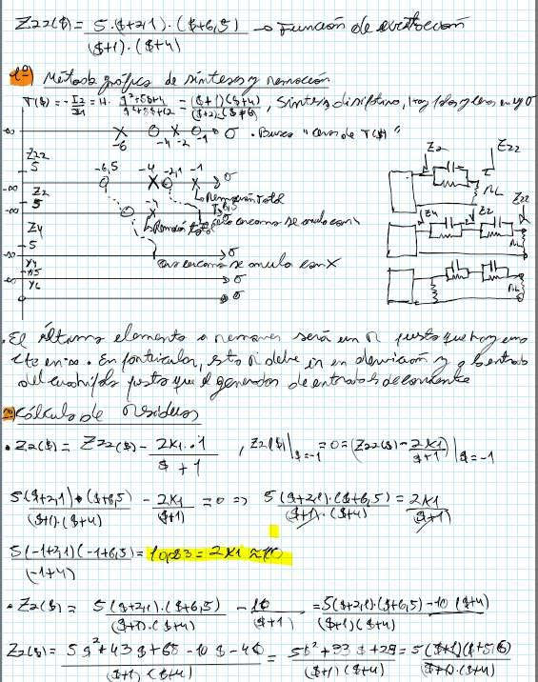
And

The

mule

yn

to

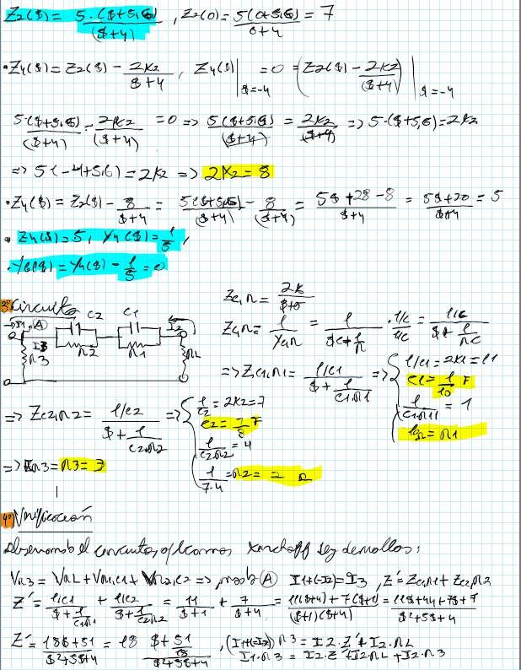

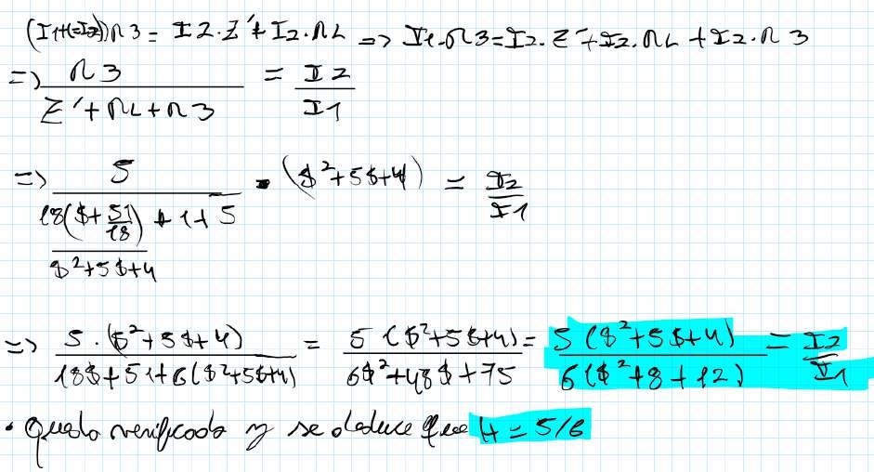
I>
E

Simulation:

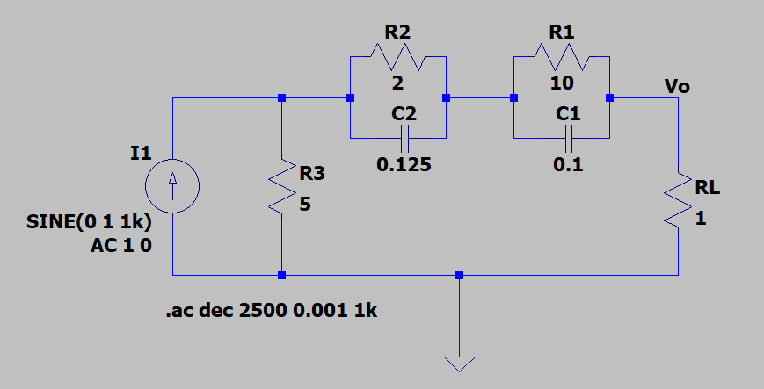
Circuit of exercise 8.

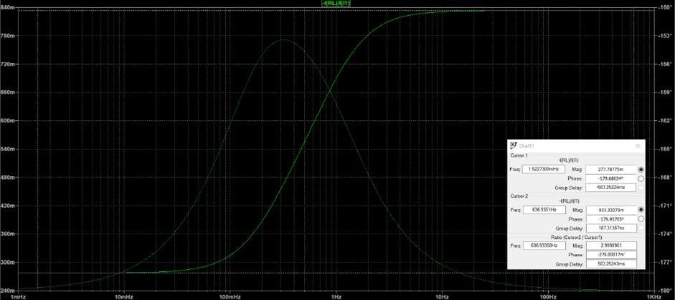
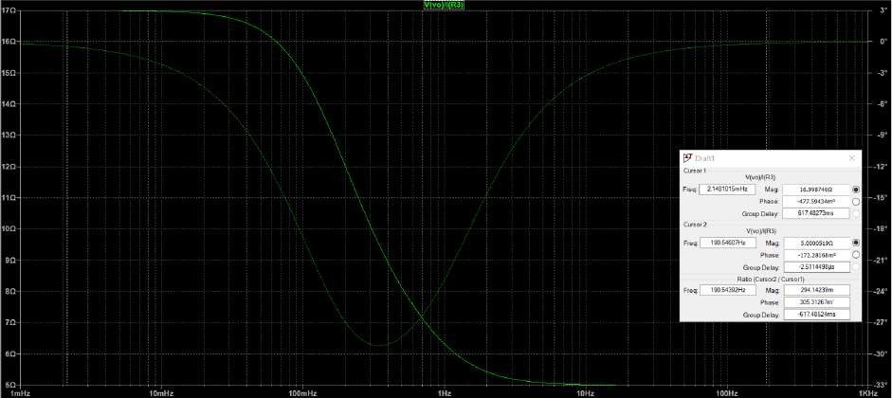
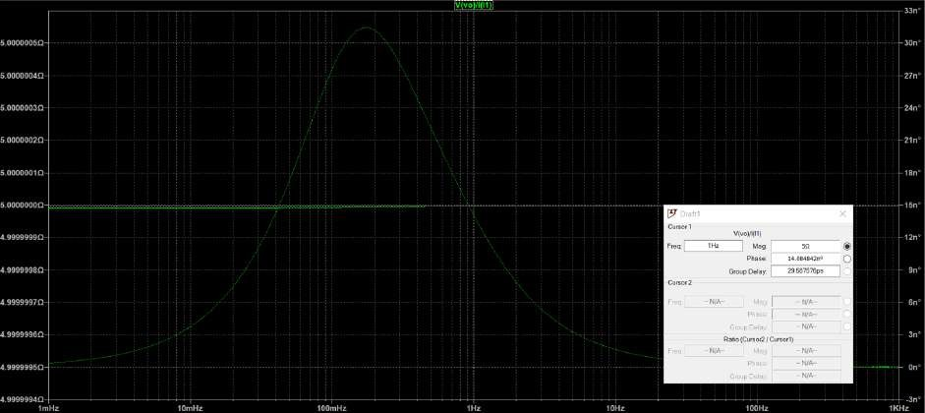
Cursor 1
Freq[ 15227308mHz M| ag: 277.78775m
Phase 179.68024*
Group Delay 583 25224ms
Mag 833.33273m
Phase 179.95705*
Group Delay:
Ratio (Cursor2/ Cursor1)
636.93358Hz Mag 29998901
Phase 276 80817m
Group Delay 58325243ms
10mHz
100mHz
G
raph 2
99999970
100mHz
y
y
3
10mHz
Frequency response of Z22.
99999990
Mag:
sa
Phase: 14.08484271
Group Delay: 29587576ps
99999960
172.28168m!
Group Delay: 25114
Ratio (CurMsor2a/ Cgurs:or!)
19054392Hz Phase2:94-14239m
Group Delay:
Ratio (Cursor2/ Cursor!)
99999950-
99999940
z
100mHz
Graph 4
Graph 3
n
PMhaga: se5:.00005199
Mag 16.998746
Phase 477.59434m*
Group Delay 61748273ms

Frequency response of the current transfer.

Frequency response of Z21.

Exercise #9
T
ñ

Synthesize using a ladder circuit:
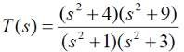
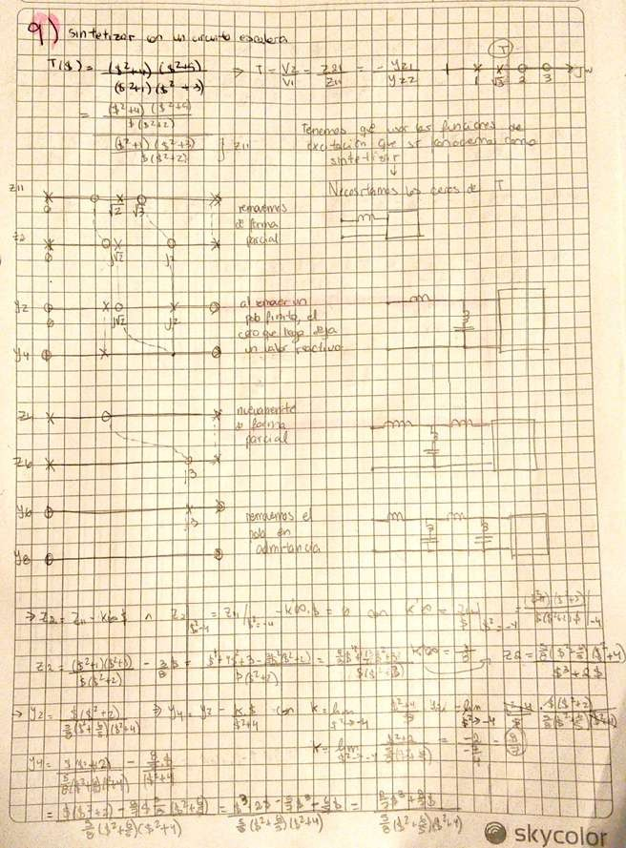
T(s)
L
e
a
Ip
TE
to the
The
TÍLA
r
the
ke
zh
L
E
tau
E
E
e
N The

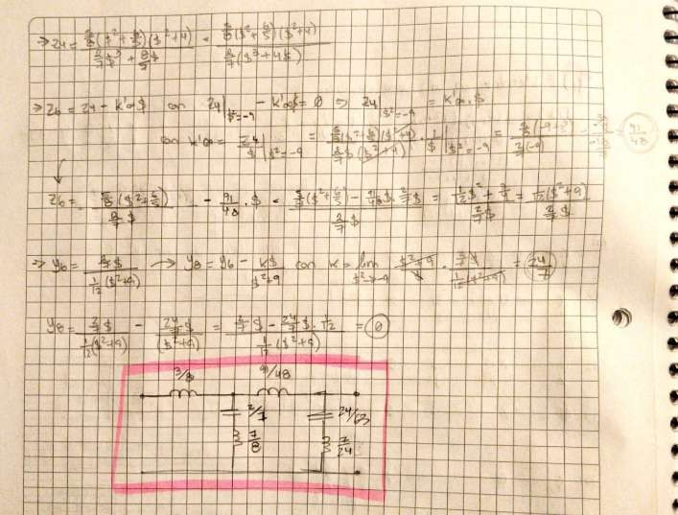

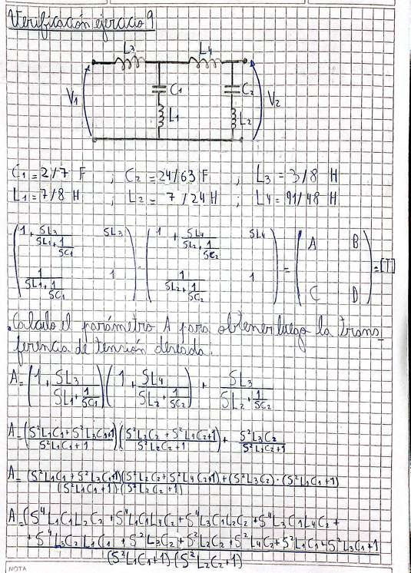
H
A

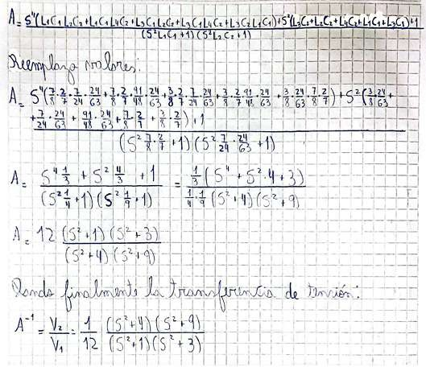

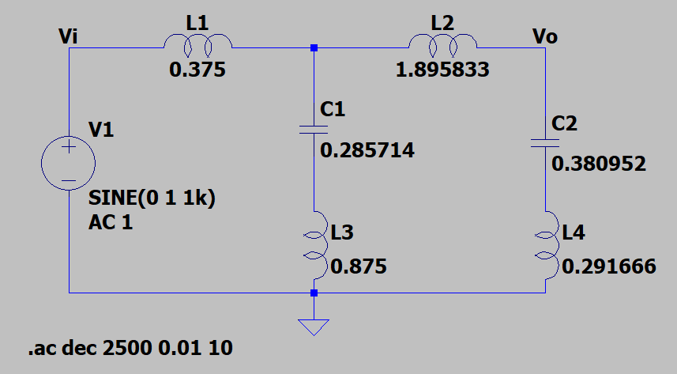
Simulation:

Circuit of exercise 9.

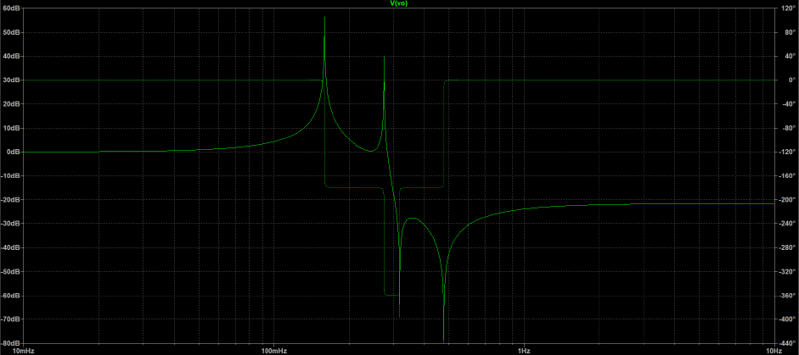
Output frequency response of the voltage transfer function.
-60dB
100mHz
Chart

