CIRCUIT THEORY II - R4053 - 2025
Professor: Navarro, Carlos | ATPs: Balbi Juan - Rodríguez  Starcman Leandro
T.P. No. 7: Design using classical filtering
Group No.: 3 | Members: Costarelli Facundo  - De Cia Antonella - Fernández Juan - Germaniez Francisco - Ríos Tamara
Responsible: e_mail: | Germaniez Francisco  fgermaniez@frba.utn.edu.ar
Submission date: 22/10/2025 | Approval date:
Remarks:

INDEX
Exercise #1. 2
Exercise #2. 4
Exercise #3. 5
Exercise #4. 9
Exercise #5. 16
Exercise #6. 20
Exercise #7. 25
Exercise #8. 27
Exercise #9. 32
Exercise #10. 34
Exercise #11. 38
Exercise #12. 43
Exercise #13. 46
Exercise #14. 51

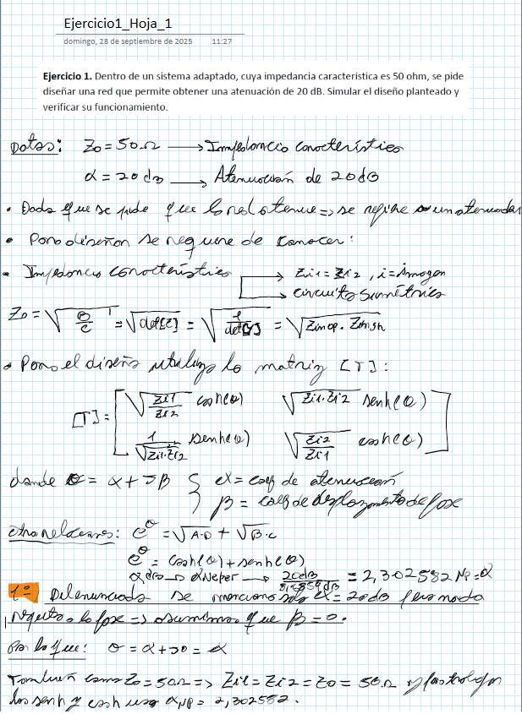
Exercise #1
Sunday, September 28, 2025
Exercise1 Page 1
11:27
Exercise 1. Within an adapted system, whose characteristic impedance is 50 ohms, it is requested to design a network that allows obtaining an attenuation of 20 d. Simulate the proposed design and verify its operation.

from 2046

Dodo Que ne qdo feu Coral
e Pore "e dui
'*
to now

a
— Era
== dde > Zea 2

2l diner lo
5

4
NS > hee
X= EN de

a
== x+7h

Eo
E
E - Caht Eli nenhi €)
2 A
=2,305%2 M4 el

o X
O =

des ant 2
22289 Epp=

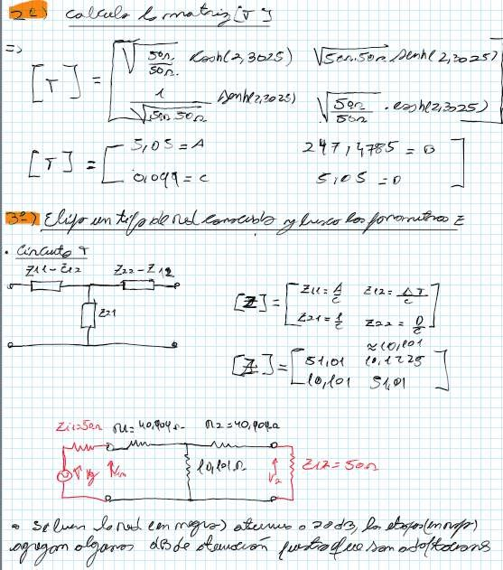
T
Y
em
dede
The
AT
Simulation:
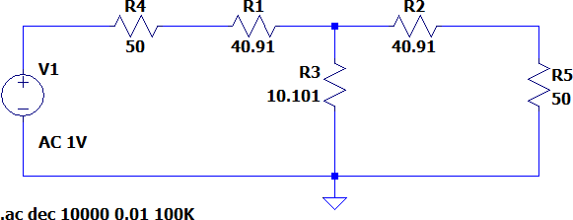
R4
RI
vi
R3
R5
.ac dec
100K
AC 1V
Graph
Circuit of exercise 1.
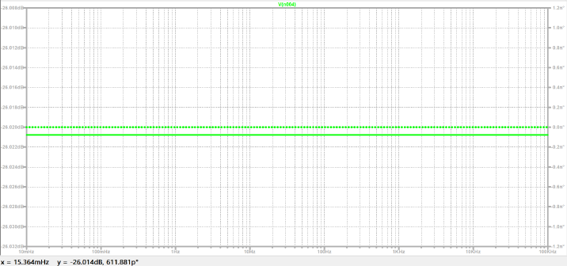
x= 15.364mHz and-26.014dB, 611.881p*
Graph
Frequency response of the voltage transfer of the circuit from exercise 1.

Exercise #2
Given a PI-type high-pass network, obtain the image parameters.
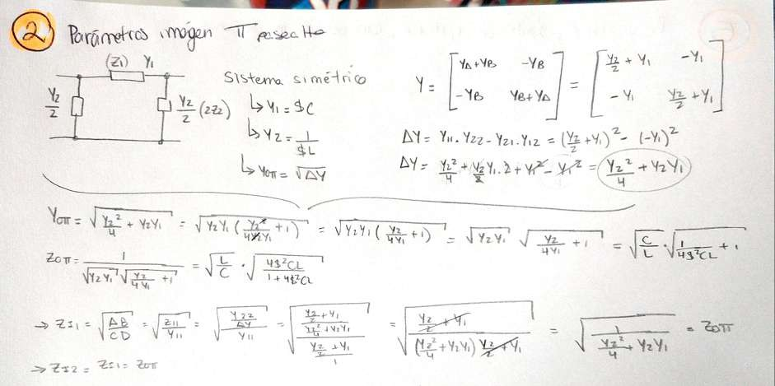
L
z
Yu.
L
System

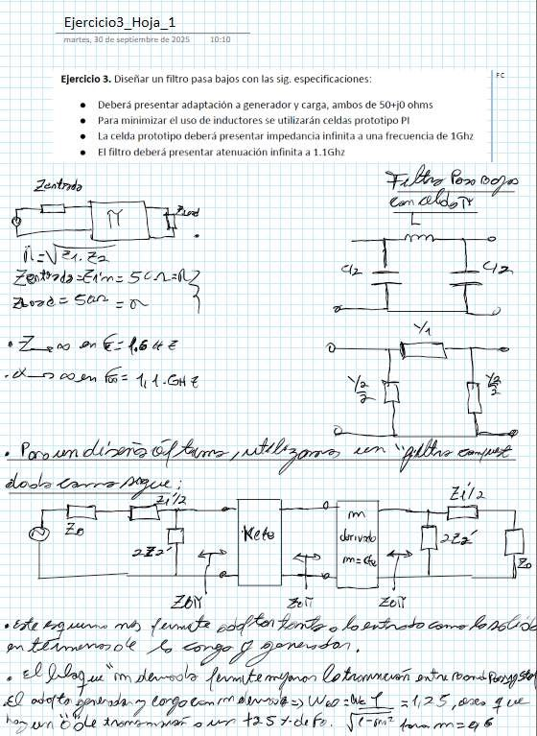
Exercise #3
Tuesday, September 30, 2075
e
o
(2.
1 yz,
|
E
72
Mete
zo
Zo
ap
"
TO gora 7
Mun inma oe 125 JC ha.
Moe =125 ¡E Ji
tn
e A
za" Tal
Exercise3 Page 1
of.
Line: SCA

dz E
Exercise 3. Design a low-pass filter with the following specifications:
10:10

Must present adaptation to source and load, both of To |  |  | hms
minimize the use of inductors, PI prototype cells will be used
The prototype cell must present infinite impedance at a frequency of 1 GHz
The filter must present infinite attenuation at

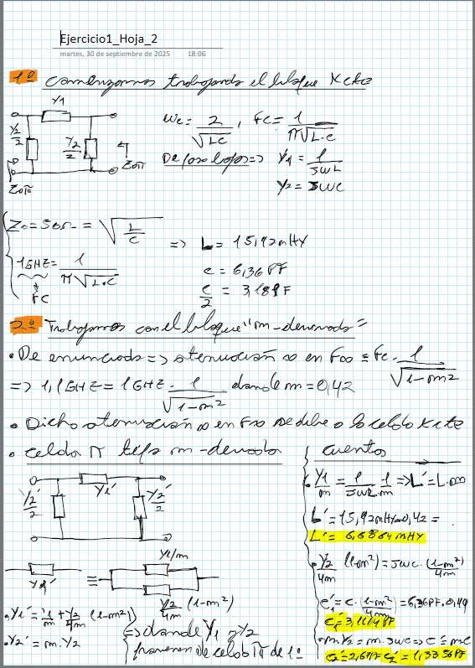
Exercise! Sheet_2

of
Tuesday, of

Y-=

«Do
or

bo

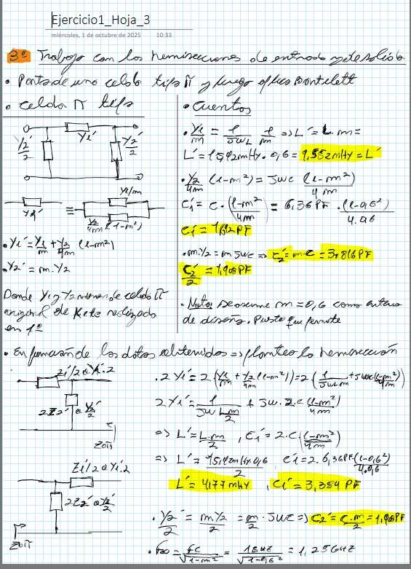
Wednesday,
UB
the
Z
L
Y.7 Ta
Kete
LE
late
ma
of
It
October of
ra
ra

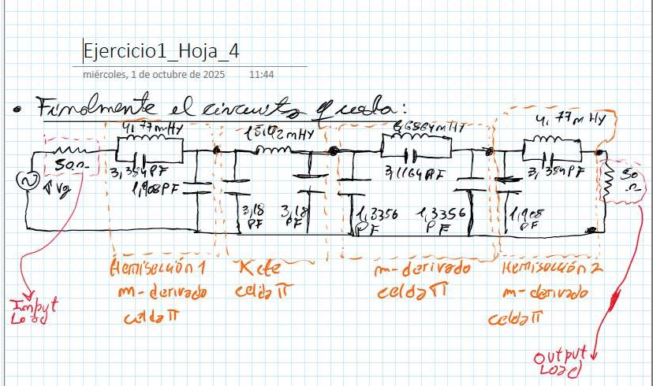
a
11:44
AE

2% 1 to ars Ja, ME
2
—
>.
m- derived
each TT
m-
I yield
IDt t Py
cell3 1
output
17
1
Mm derived and
L
e
Kde
DO
a
3
1
Exercise1_Sheet_4
Wednesday, October 1, 2025

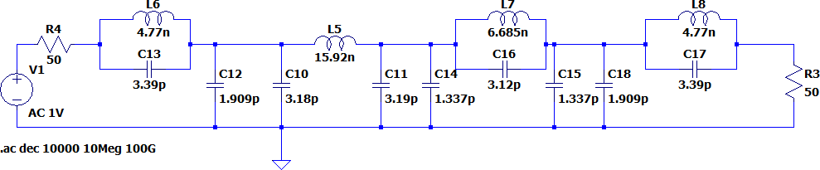
Simulation:
L7
LS
LS
6.685n
==
==
[o]
==
|1.337p
3.12p
1
==
3.39p
1.337p
==| 1.909p
Vv
cis
3.19p
ca
|3.18p
cio
a
es
.ac dec 10000 10Meg 100G
R3
50
15.92n
4.77n

 | c12
= | 1.909
Figure 3

Circuit of exercise 3.

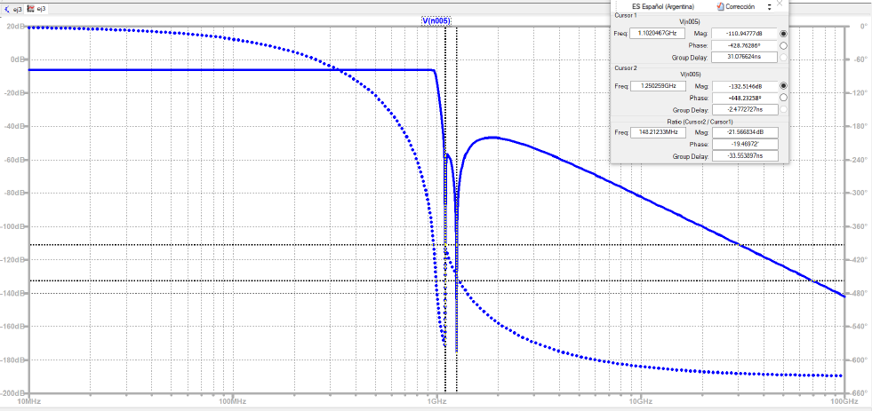
Frequency response of the voltage transfer of the circuit from exercise 3.
a
Freq:[
(O)
Group Delay: 31.076624ns
V(noos)
|
e-:448.232o)589
Group Delay: -2477272718
Mag:| 1109477788 —
Phase:
Le Res
7
O
><
ES Spanish (Argentina)
Susan
Freg[ 1.1020467GH7 |
-
Phas
Mag:
Freq:[ 14821233MHz| Mag:
_—
,
Ratio (Cursor2 / Cursor1)
Figure 4

Exercise #4
Exercise4 Sheet 1
Wednesday, October 1, 2025
11:57
Exercise 4. With the objective of eliminating frequencies, 50-ohm system, according to the following schematic:
an E-constant filter is placed in a
=
Gu OS
5e asks:

Obtain for what frequency value within the passband is the filter matched.
Obtain the attenuation of the filter for said frequency
and idem to point i, if Rg=RI is changed to a resistor of i ohms
Obtain the value of Rg=EL so that the system is matched to a frequency of 100 kHz
Simulate the proposed design and verify its operation.
MA 1 fp (to Leo 4
Le
Mi
.Zay
= PNL

, >
A Zool?

E
1)

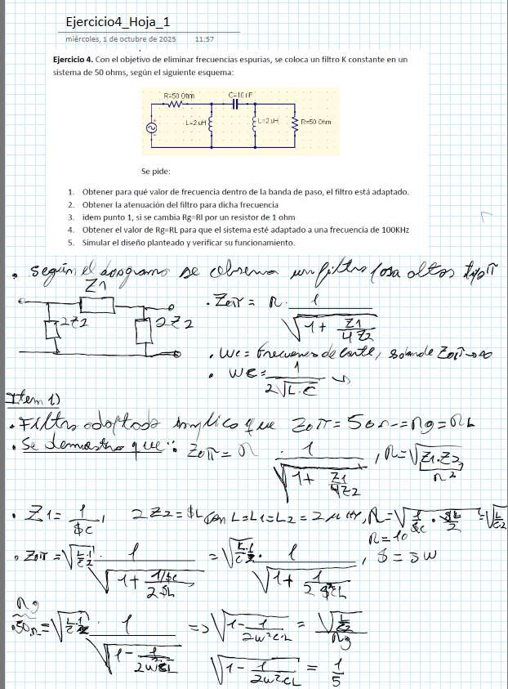

ZA 1,
Ho, La
Sd UE
1 >
or ZIT =
a
A
a
6
E

, d-5W
La

Exercises ingo, of October Sheet_2 of

and

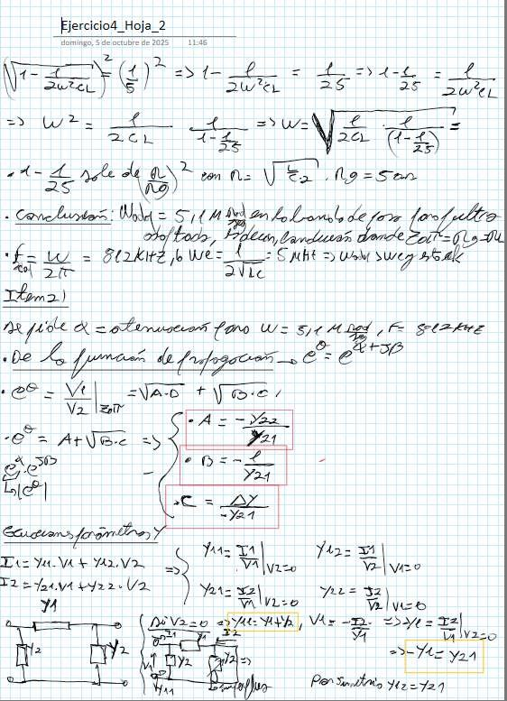
SM

.De
of of

And
VA

Y21=
YA
VAr

yaa

Sunday, of October of
Exercise4 Sheet_
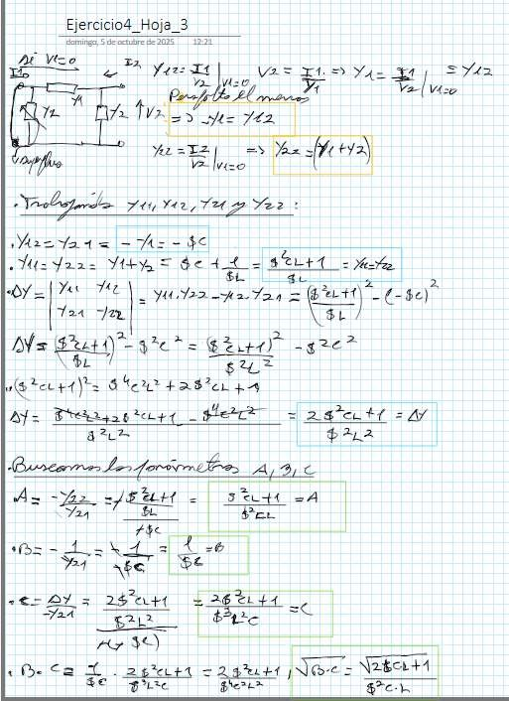
Ar

The
Has
ito

of

$e)
YU

E E

Az =A

The
tc

Sa

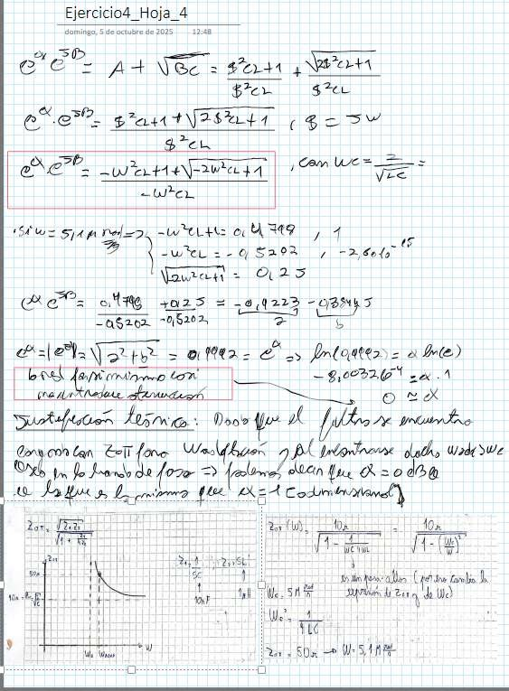
CE
e
and
E
or
to
of
lan of the
Side of
Pl
pra
(e
Do you see
Exercise4 Hoaja
Sunday, of October in

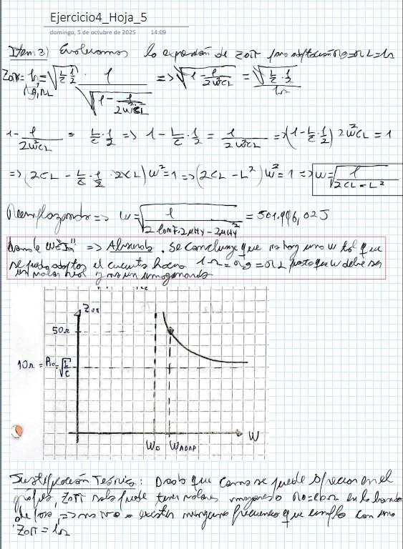
Sunday, of October
LAn
You
a-
E
NE
A
that
Lan
the
Exercise4
It

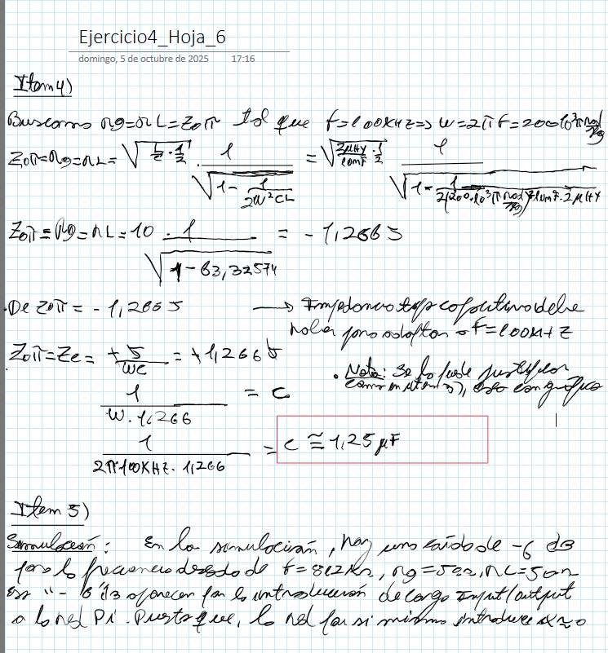
THE
From
To
of
¿e
Exercise4
Sunday, of October

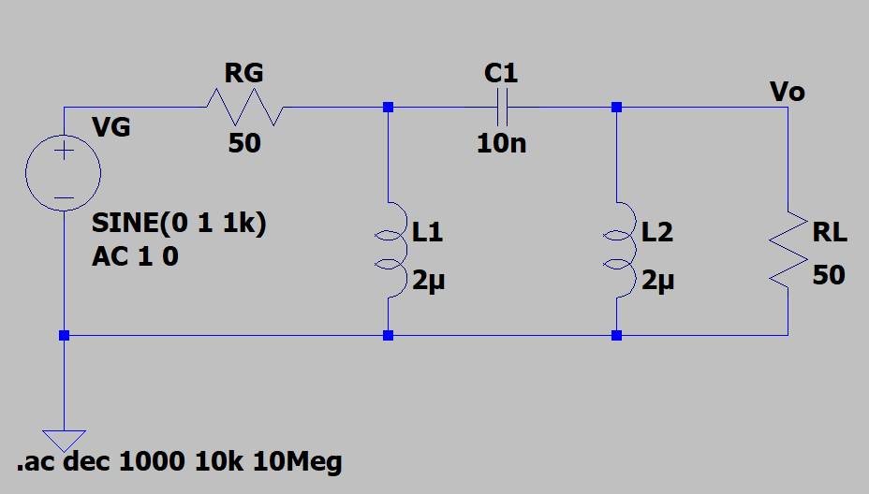
Simulation:
1k)
Li
L2
2H
2H
10k 10Meg
to
Graph
RL
SINE(O
AC10
10n
Vo
Re

Circuit of exercise 4.

P | Mag
 | hase

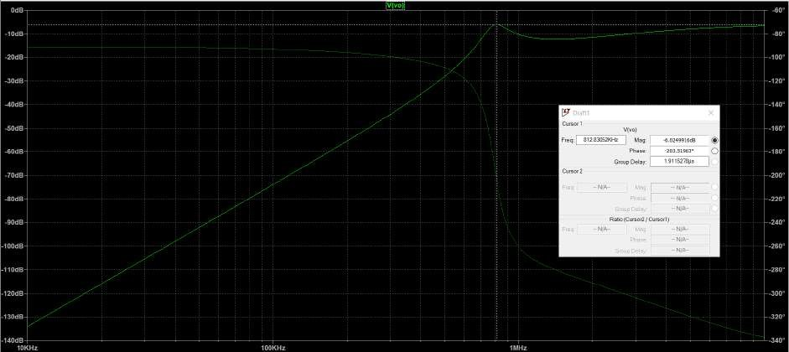
Frequency response of the voltage transfer function of the circuit from exercise 4.
Cursor
:
Group Delay:
Cursor2
(Cursor2/
T
100KHz
Graph

Exercise #5
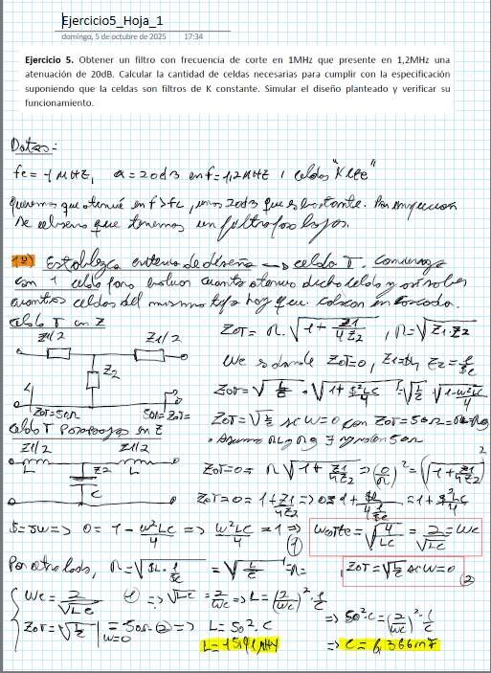
Wez= =>
-
1
"E
For and The
2/1| 3
7
-
NE AC
Le
17:34
VEL
>
ES
+
e
Exercises Sheet_1
Sunday, October 5, 2025
The
that presents in
EL.
Le]
(4720 ENE,
Mm E
attenuation of 20dB, Calculate the number of cells required to meet the specification
assuming the cells are constant-E filters. Simulate the proposed design and verify its
uma
-
5er
= And —
- 20%
funr— that
slo Aiho
+1
VE
E,
Y O with E
E) => EE
and IA
L
T
alle fo,
¡207
1
FF ¡2d fe
E
Exercise 5, Build a filter with a cutoff frequency in
1
ra
(7)
Fi
11710544
¡
Foo
0= T-WLc => Wic=1>
4 1
2,

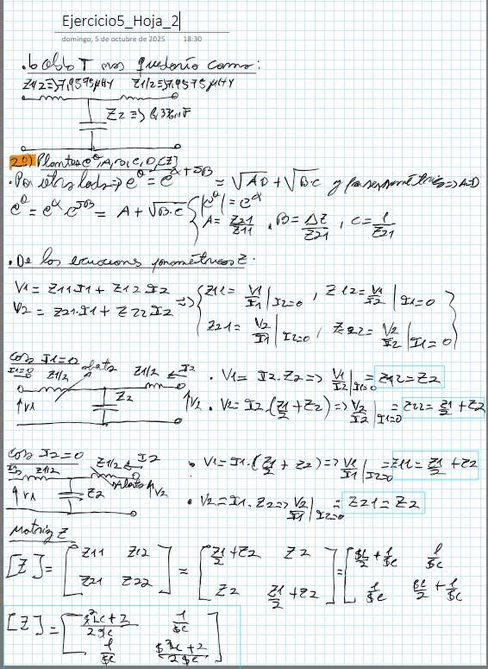
e
E=L
From
YU
Viz
Sunday, of October of

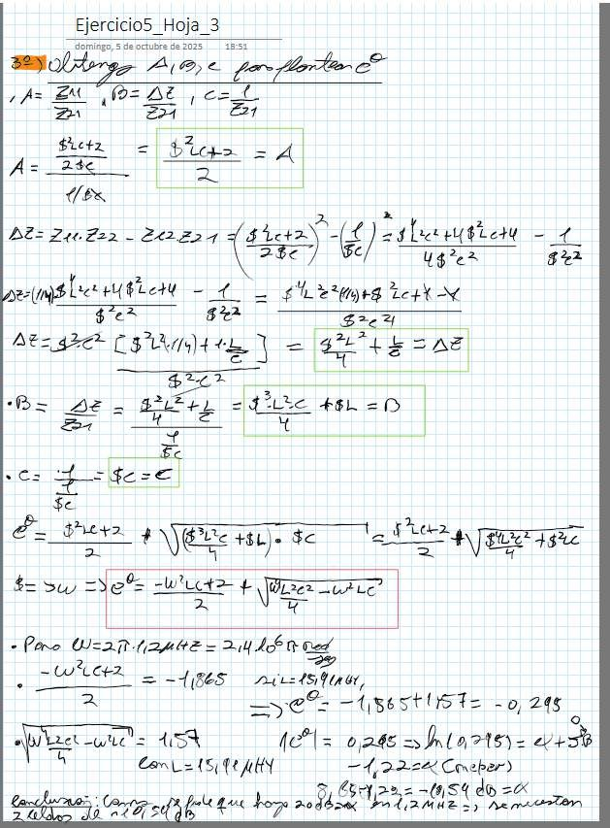
S
Exercises
unday, |  | of October of

EM From
Z21

aunt

Is,

Te+Y

Ec

$e
Bis e E

e

A,
NE fu

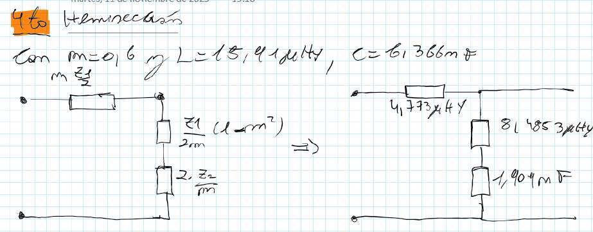
6
Can M=o| 6 77) Y
m
Z
C= 61
/
¿
— a “ YU)
6—
—
Mm
L
.—
kE

Simulation:

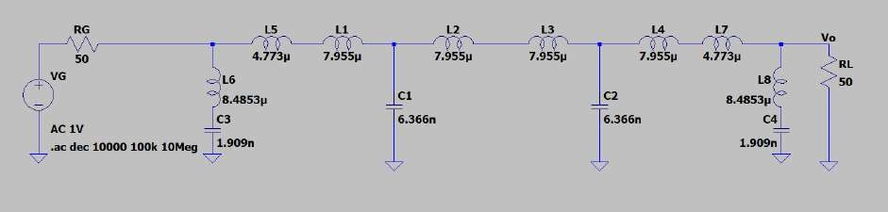
c3
L5
50
Li
Graph 7
6.366n
AC 1V
.ac dec 10000 100k 10Meg
6.366n
.
L6
L2
50
The
L7
L3
RG
vG
vo
e

Circuit of exercise 5.

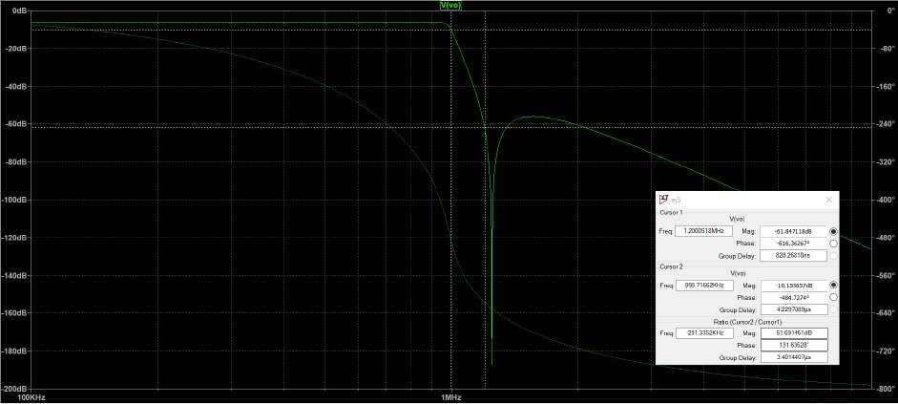
Cursor 1
Live
1.2000518MHPzM|haga: se-6:1.847118d8
Group Delay 828.26818ns

Live
Freg:[ 99871662KHPzMh|aga: se1:0.155657d8
R Group (Cursor2
atio |]
Delay:
Mag / Cursor!)
Group Delay: 3401440715
100KHz
)
Cursor2
)
Figure 8

Frequency response of the voltage transfer function of the circuit from exercise 5.

Exercise #6
Obtain a filter with a cutoff frequency of 1MHz that presents a 20dB attenuation at 1.2MHz. Calculate the number of cells needed to meet the specification assuming the cells are m-derivative filters.

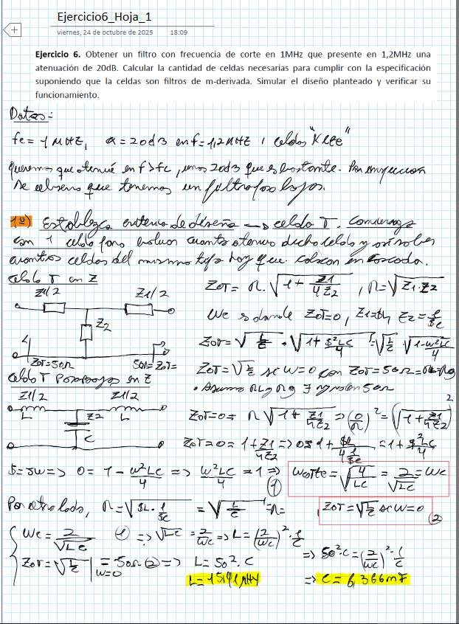
<+]
18:09
Exercises Sheet 1
Friday, October 24, 2025

Exercise 6. Obtain a filter with a cutoff frequency at 20dB  attenuation. Calculate the number of cells needed |  |  |  | that presents at 1.2MHz? one to meet the specification
assuming the cells are m-derivative filters. Simulate the proposed design and verify its operation.
 | -
 |  |  | 1 Choo Wee"

49)
Y.
I must
The
Miner Cat
and
1 dl forum

2,
Ue >
, 248,
TP 2
4 WE
Ze = E AC *
Mao
Sen
O or
zz TT ame o——1e£ —- ³
mE
2

b-5w=> O= T=
4

Wez_=> | and
fo re Lodo, NN

=>
Y
=-VE

4+ $
131€ y

Ue
- LE
=
EA
=1 5
4: 4r

Ve

=
> Is
(7) E,

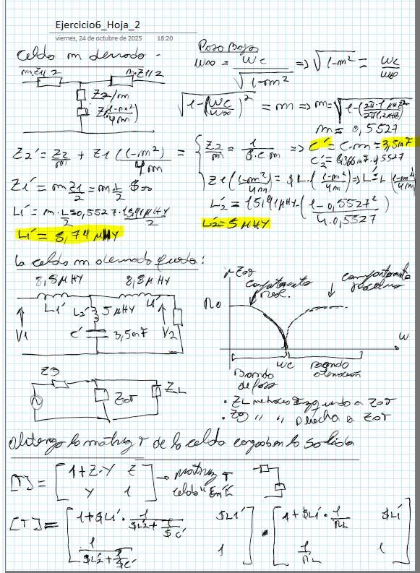

of October

And

EY

m
it

C

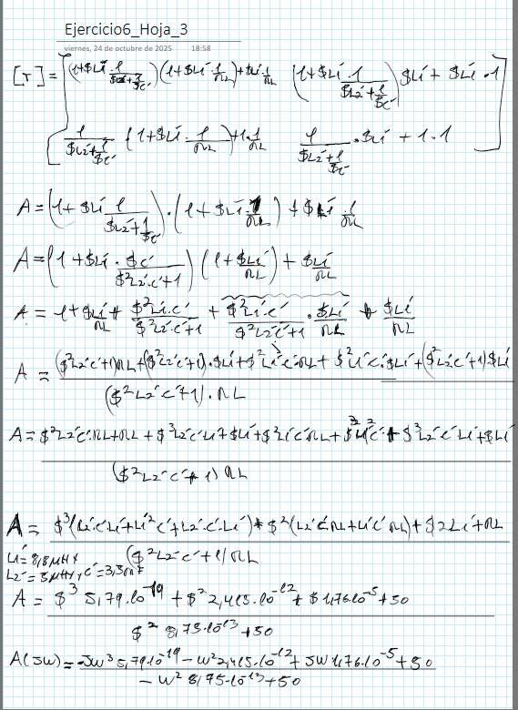
Exercises
wermes, October 2nd of

of

r

AL

Az

W*

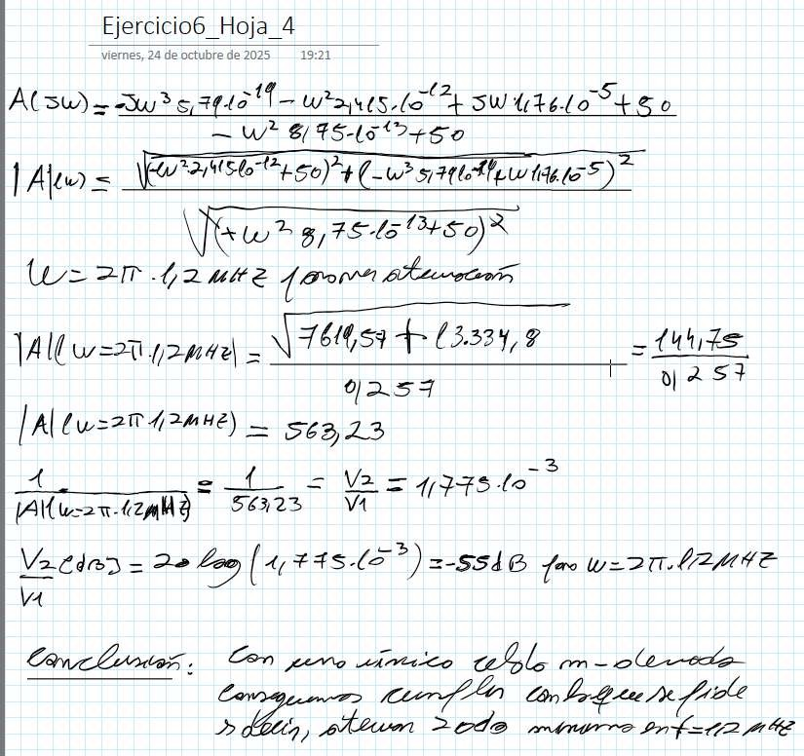
VI
to
goes
[To
Exerciseb_Hoja_4
Friday, of October
Simulation:

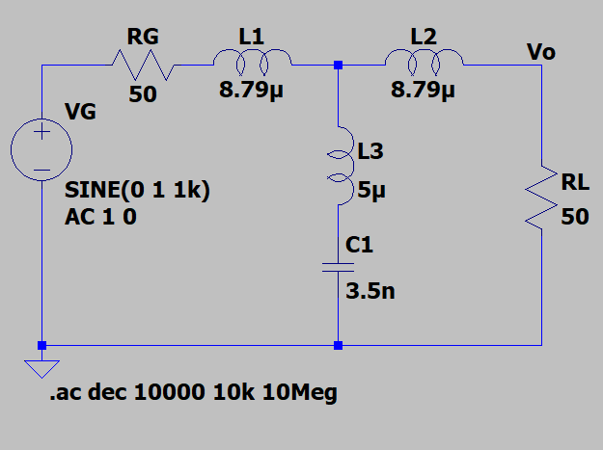
Circuit of exercise 6.
RG
L1
L2
O
1k)
.ac dec
And
Plot
10k 10Meg
SINE(O

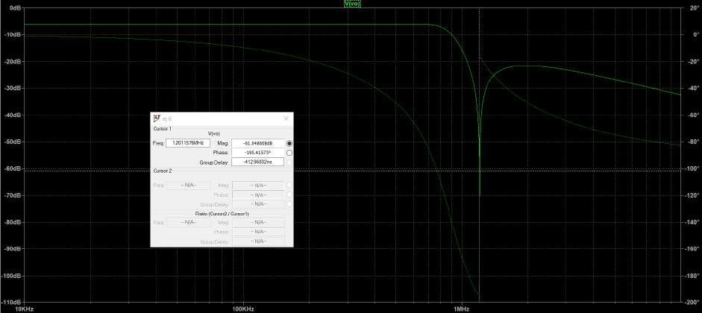
Cursor
Live)
PMhagase6:1.048608d8

Group Delay:
Ratio (Cursor2
100KHz
1MHZ
Graph
Frequency response of the voltage transfer of the circuit from exercise 6.

Exercise #7
Obtain a filter with a cutoff frequency of 1 kHz loaded with 600 ohms. To have good discrimination, it is desired to obtain an infinite attenuation frequency for some cell at 1.05 kHz. To properly match, sections with m=0.6 at the input and output are requested.
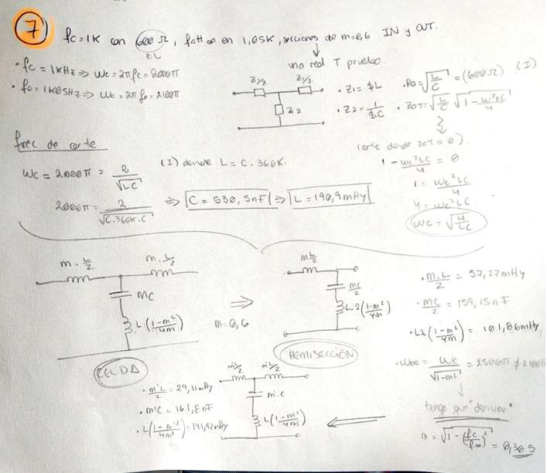
Wwe

Simulation:

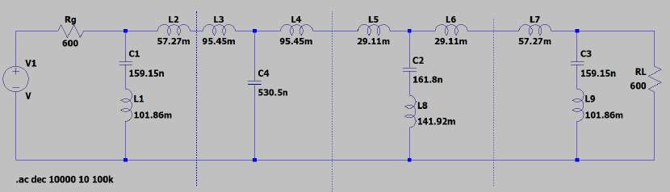
Circuit of exercise 7.
Graph

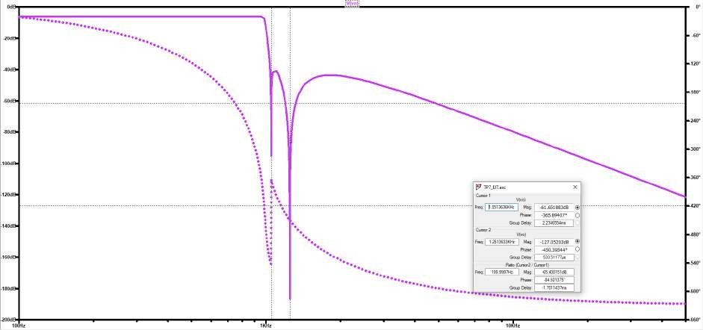
Cursor
Live)
Group Delay:
Cursor2
Live)

RGaroutpiDoelay:
po
Phase:
Group Delay:
Hz
Phase:
Meg:
Phase:
Mag:
Plot
Frequency response of the voltage transfer function of the circuit from exercise 7.

Exercise #8
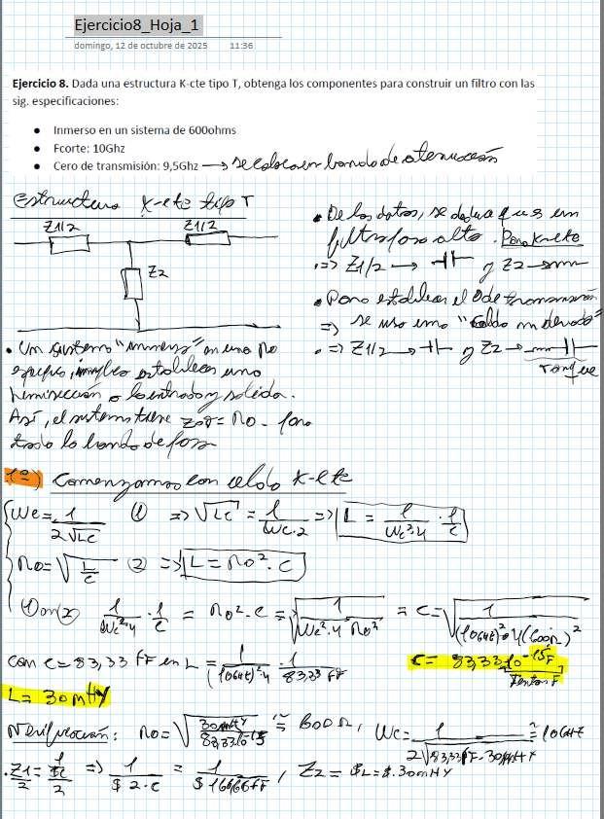
Exercises Sheet 1

Sunday, October 12, 2075

11:56

Exercise 8. Given a K-cte type T structure, obtain the components to build a filter with the following specifications:
Immersed in a system of 6000 ohms
Cutoff; 10GHz j —
e
transmission: 9.5GHz —>

LY
Zal>
the
Pair

— do 22
to Were Aa,

.>
Ab 9 222
Guitar
- £
jar pots =-7= No.

=
ez 1
"az [a Y

0. 4 T = More

Cam
Feny =

ño nr! ml e NE- feat >

== z > ALLI FBaco>
o fo (e)

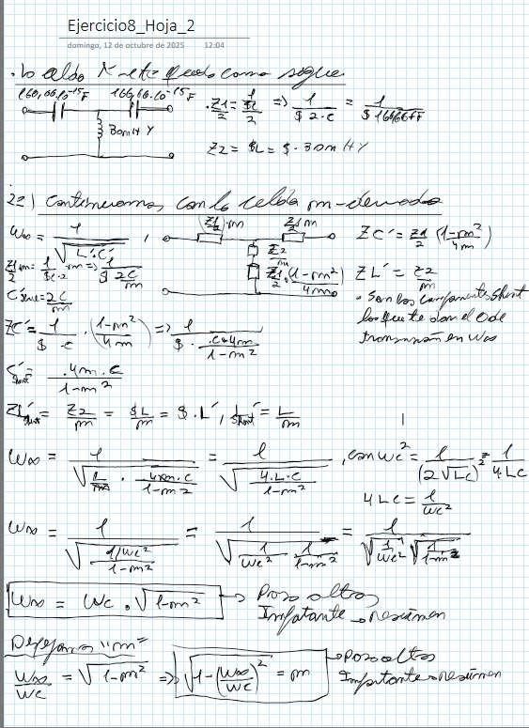
Exercises
from October

And

him/her

to

"Le

A

We

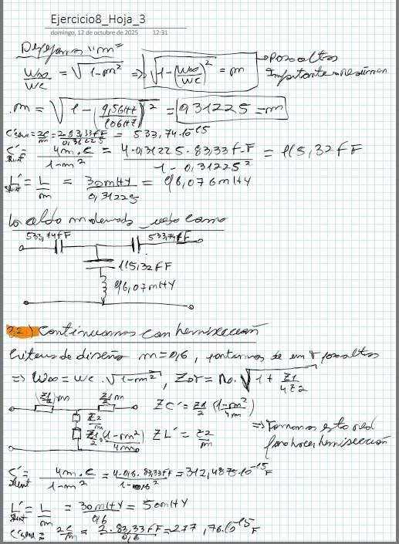
*T

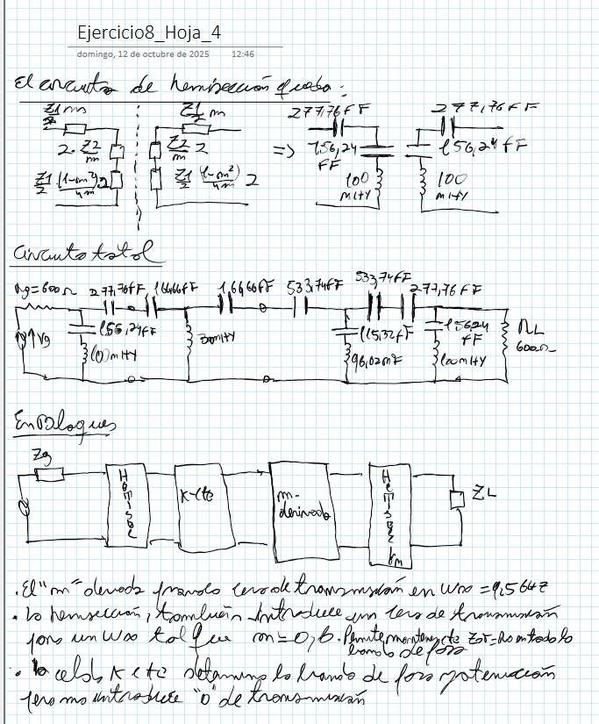
Exercises Sheet
of October

m

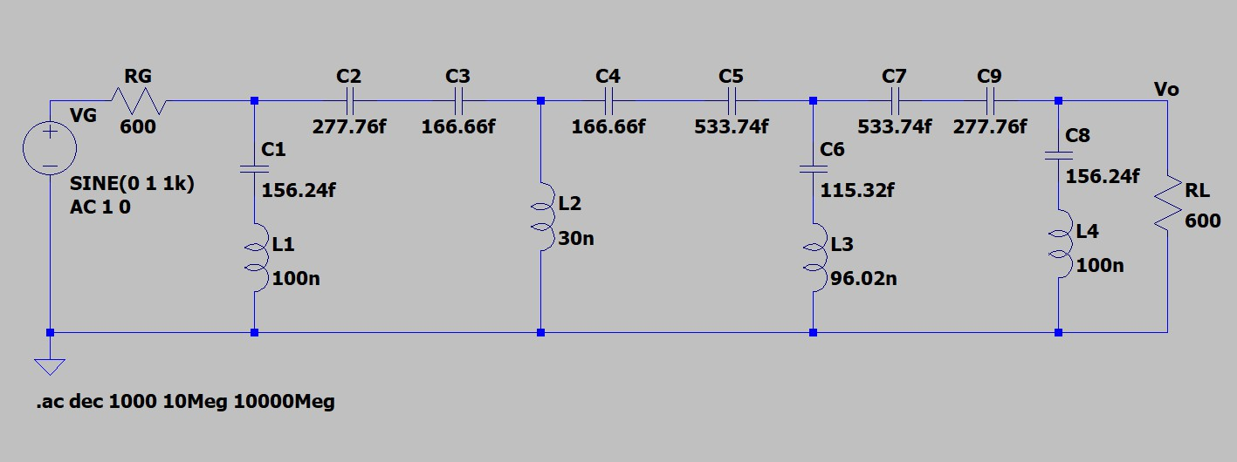
Simulation:
ci
L2
c6
—
SINE(O 1 1k)
AC10
156.24f
RL
cs
96.02n
L3
100n
L1
100n
The
1
|
600
|
Figure 13
vo
30n
600
115.32f
156.24f
533.74f
|
VG
,
RG
(o7)
[o]
ca
(or)
|
If
166.66f
c2
+
.ac dec 1000 10Meg 10000Meg
,

||
If
277.76f

Circuit of exercise 8.
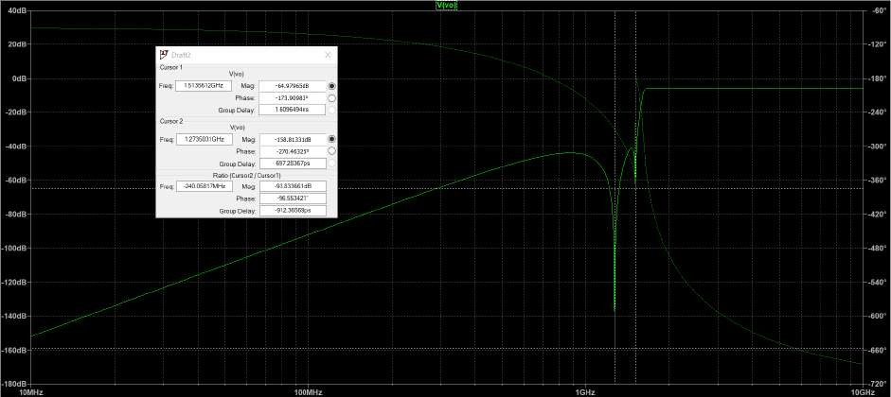
Cursor1
Live)
Freq:| 15135612GHz |Mag -64.97965d8
Group Dela|y:

Live
Phase -173.90983*
Freg[ 12735031GH2PM]haags:e|-1:58.81331d8

Group Delay: 6972836705
Ratio (Cursor2/ Cursor!)
-24005817MHzM| ag:|
Phase:
Group Delay: -912.36569ps
10MHZ
T
100MHZ
)
Cursor2
Figure 14
Freg|
Frequency response of the voltage transfer of the circuit from exercise 8.

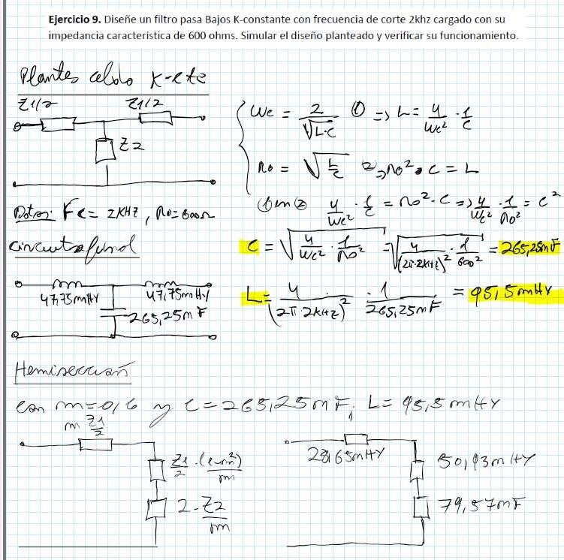
Exercise #9
25m Y
TT ZA
L
E
en
No 3 to
r
RL YY
_{E} PYR_{Y} PYEEPZYEAZ L _{Y} _{L} ZEP«Y ZEZL _{Y} ZL ZE" PL _{Y} _{Y}
|
L
y
0
T
1
We
F
A e
L RE
Use
mi
|| 79,5
=
AZ _{E} _{Y} _{Y} LL ZU
ka
|
=>
|
e
ñ
KN
290
= €
Mo?
2/7
(
-
-
RC
CY
2
pe
->
= ho
x
to E
Exercise 9, Design a low-pass filter with K-constant with a cutoff frequency of 2kHz loaded with its
characteristic impedance of 600 ohms. Simulate the proposed design and verify its operation.
r
E
25m
=>
LL.
Y
il
La
NE,
u
«
N
4
Zz
177 do,
Y
m
2
the Le
>

—
A
50 — 43m 7
C
92,5 mi
-
L

 | m | 4
We (

Simulation:

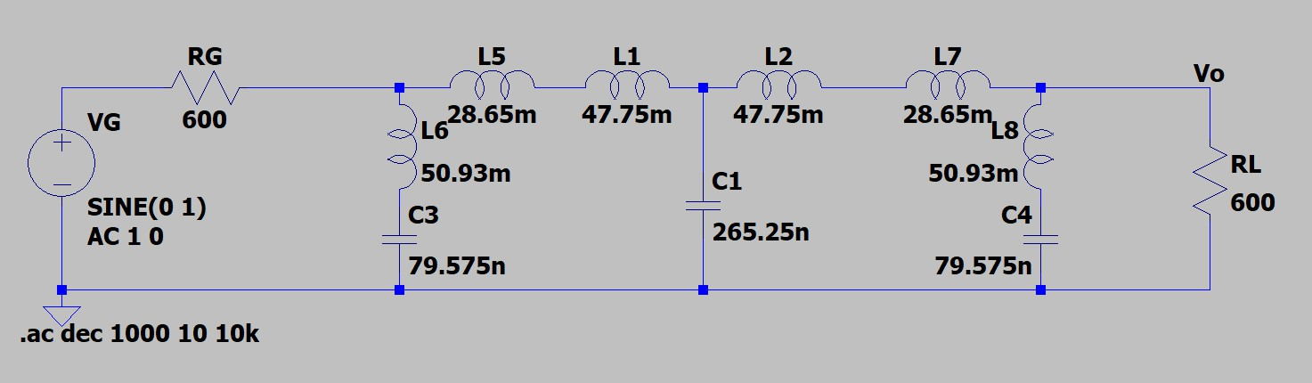
Graph 15

Circuit of exercise 9.

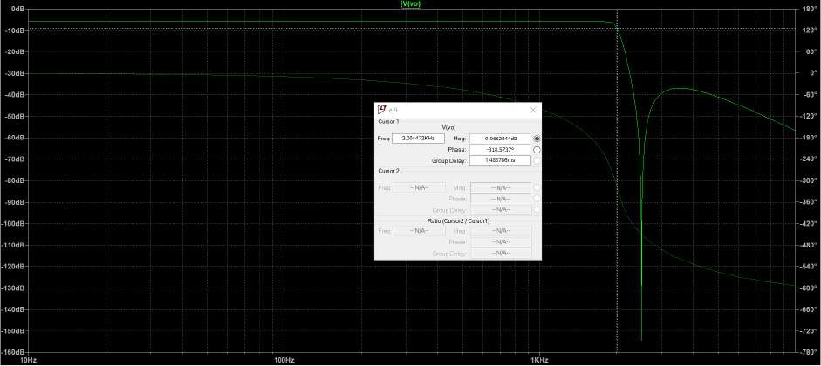
B-
Cursor
LiveM) ag: Phase9:.0662844d8

Group Delay: 1488786ms
Cursor2
Ratio (Cursor2
Frequency response of the voltage transfer of the circuit in exercise 9.
Graph

Exercise #10
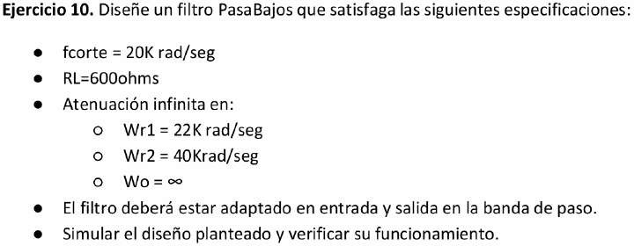
Exercise 10. Design a Low-Pass filter that satisfies the following specifications:
RL=6000 ohms
Wrl=22Krad/s
Wr2= 40Krad/s
The filter must be impedance-matched at input and output in the passband.
Simulate the proposed design and verify its operation.
or
or
or
Infinite attenuation in:
cutoff = 20K rad/s

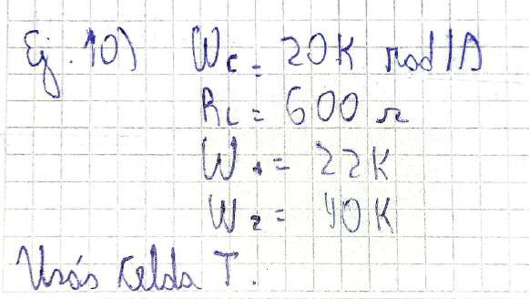

Kldo

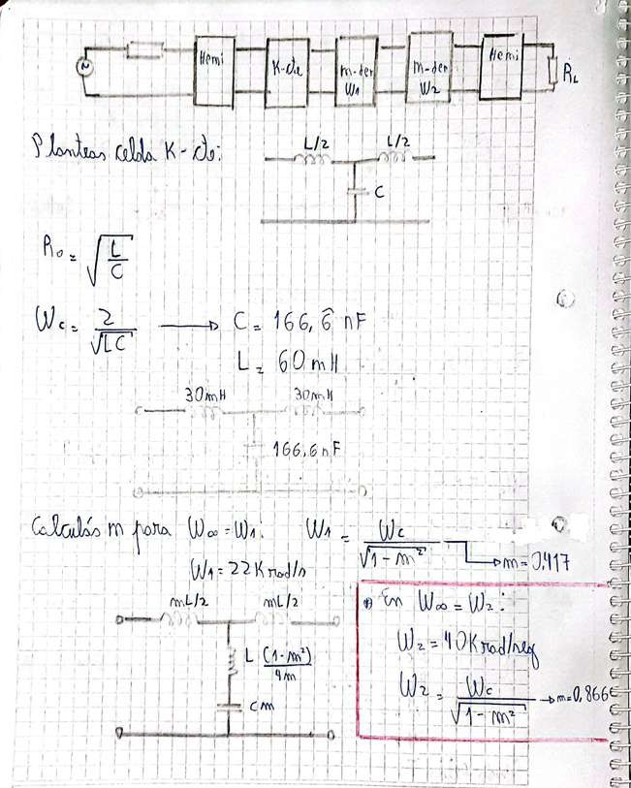
to

ES

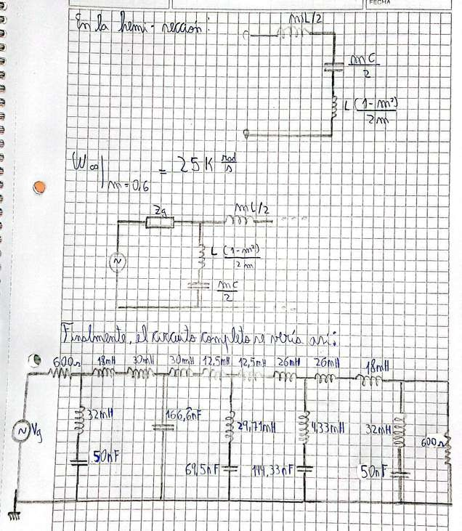
q
u
o
E
Í
E

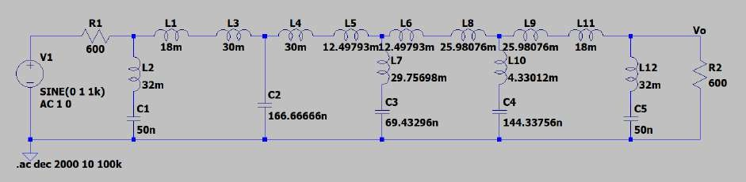
Simulation:
R1
Li
L3
The L5
vo
30m 12.49793mi2.49793m 25.98076m 25.98076m
vi
L2
AC10
Figure 17
SINE(O 1 1k)
32m
L12
.ac dec 2000 10 100k
50n
50n
69.43296n
166.66666n
[o7]
32m
R2
600
600
18m
30m
18m
L11

Circuit of exercise 10.
e
ca
[o]
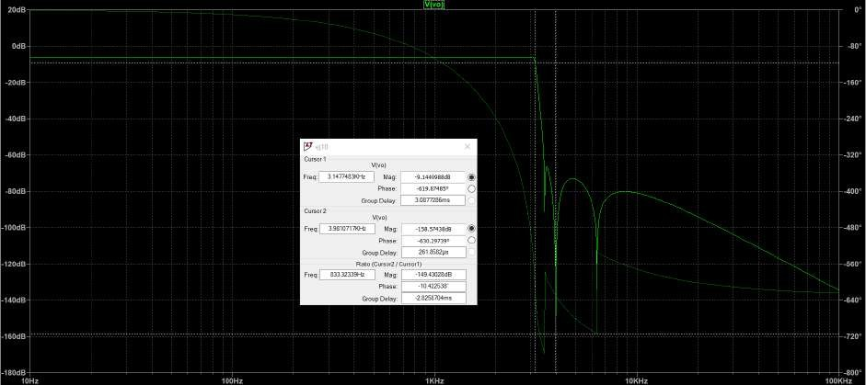

5
Cursor 1
Alive)
Mag -9.1440988d8
Phase:
Group Delay: 30877286ms
Cursor2
Alive)
Freq: 39810777XH7 | Mag -158.57438d8
Phase
RGarotuipoDelay:
833.32339H7 Mag -14943028d8
-630.297399
Phase 10422538
Group Delay -2.8258704ms
Figure 18

Frequency response of the voltage transfer of the circuit from exercise 10 number 1.

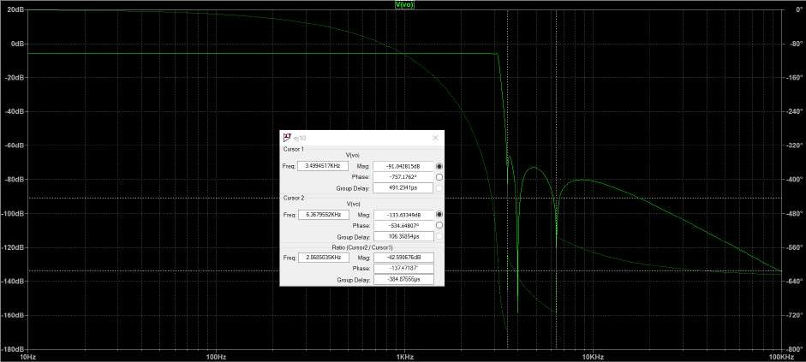
Frequency response of the voltage transfer of the circuit from exercise 10 number 2.

Cursor 1
Alive)
Freq:[ 34994517KH2 |Mag -91.042815d8
Phase
Group Delay

Alive)
Freq:[ 63679552KH7 | Magn -133.63340d8
Phase
Group Delay 106.35854ps
Ratio (Cursor2 /
Mag
Phase: 13747187
Group Delay:
Gráfico 19

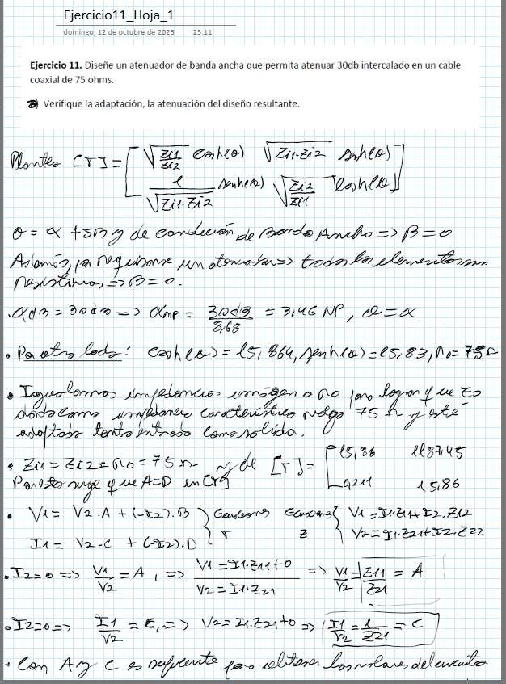
Exercise #11
Sunday, October 17, 2025
Exercise 1. Sheet 1
2311
Exercise 11. Design a broadband attenuator that allows 30 dB attenuation interleaved in a 75 ohm coaxial cable,

Death
And

z
ZA
6 K Alo 14
(27% Ando
=> a
NE aa
—£
of

MM
0 > dot —>
- 3049 268
AX

ld:

e of lares 17005
or fe
17 e Eo
644, mbia)-65,22,00= 156
»
Loria Cone

e

a and AD
a

+
La=
mA from 3 Y
Chaos)
0,241
Vi

V-= wea

MZA |
Va
ETRE A = A

=
Vez
—-

“ Can A € 90 lighthouse He
El

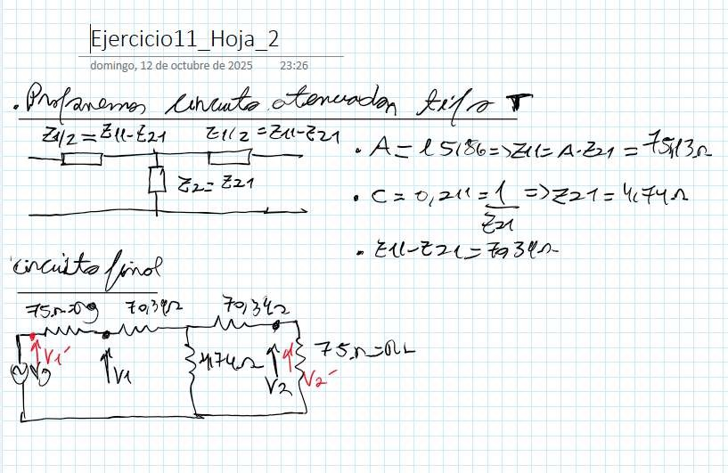
C=
of October
Sunday,

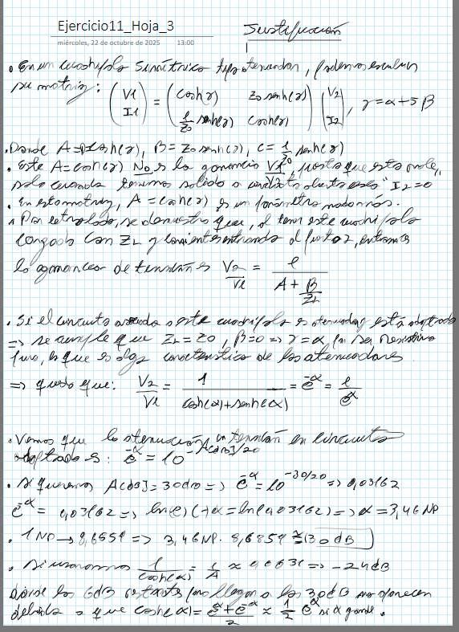
Exercise11
Wednesday, of October

and

E

Cam

fa

A

A

La

and
LE

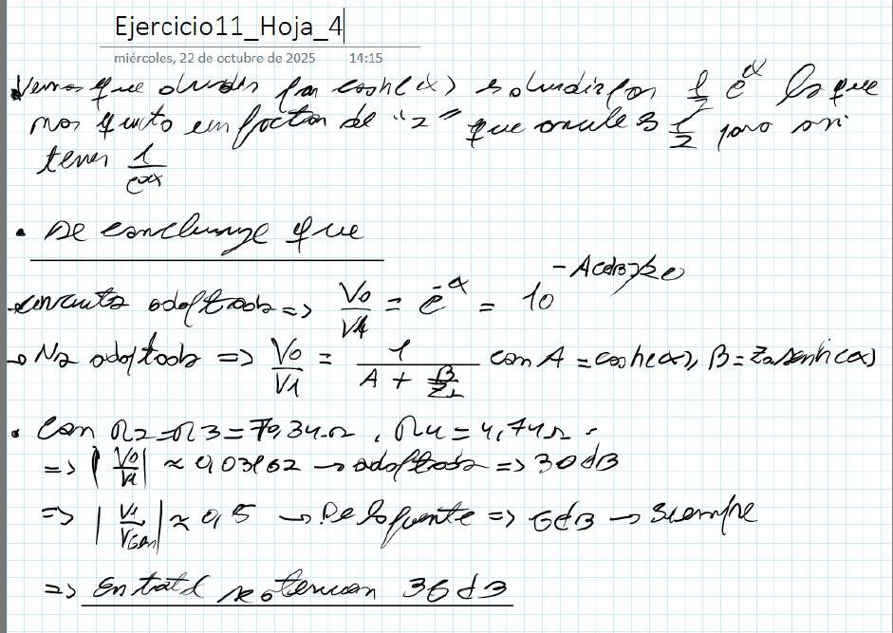
Wednesday,of October of
Ale
Jem
A
With
and»
E A “A

Simulation:

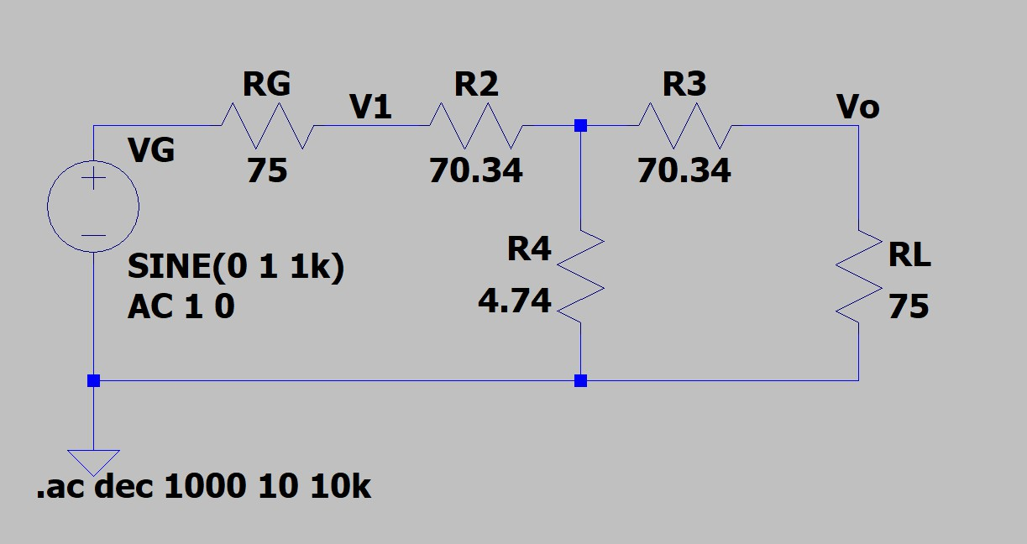
Chart

Circuit of exercise 11.

Mag
Ph | ase:

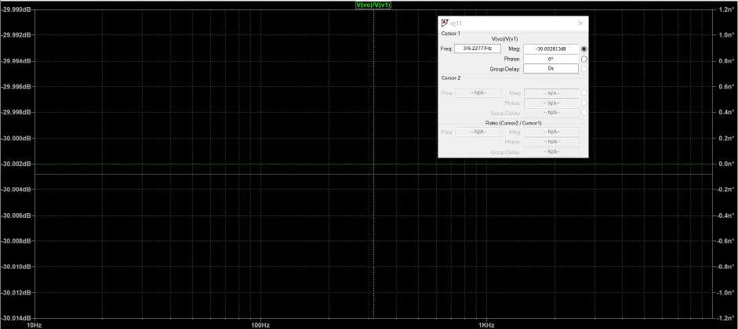
Frequency response of the voltage transfer of the circuit from exercise 11.
A
:
-30.002813d8
Group Delay:
Ratio (Cursor2
VIA:
-30.006dB
-30.010dB
-30.012dB
100Hz
Graph

Exercise #12
Ejerciciol2 Page_1
Sunday, October 17, 2075
23:56
Exercise 12. Design a broadband matcher that allows interconnecting by adapting two cables

In its input it should allow connection of a 75 ohm impedance coaxial cable

characteristic and at its output one of 50 ohms impedance. It must attenuate 5.72 of.
verify the matching, the attenuation of the resulting design and draw conclusions,

zZ

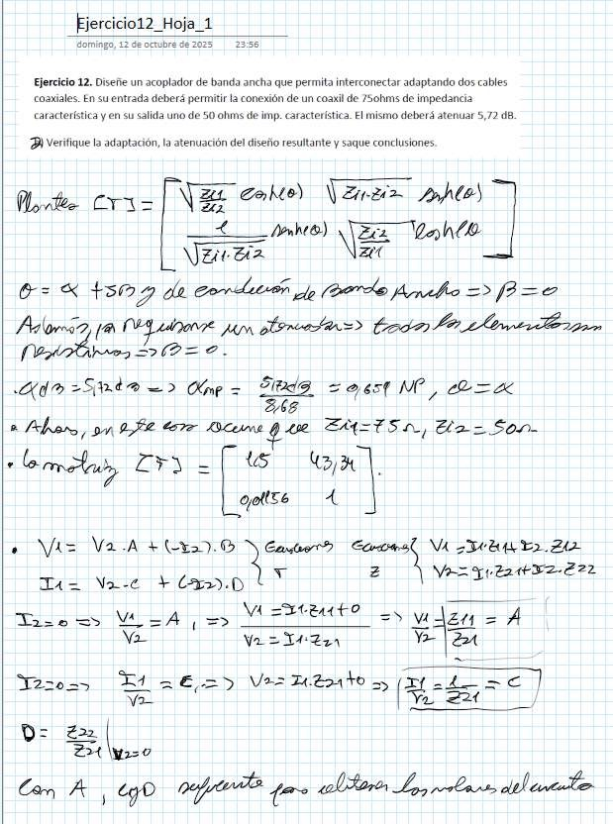
What
zz
NE 7072
<
ó= ln

(27 Ando =>

pa
Pa Aer Aga
(4 there
=E
0.
Xx

Are
Ad a hor, 97 254
677
- see -= 265
SS

»

Ta= Na-€ +
4

Vi
PH tr
=
Tr

VA or

=> >
Yi 224

a

NC =
= Va - A

> Va _{=>}
y
Dd: E ZH W-0

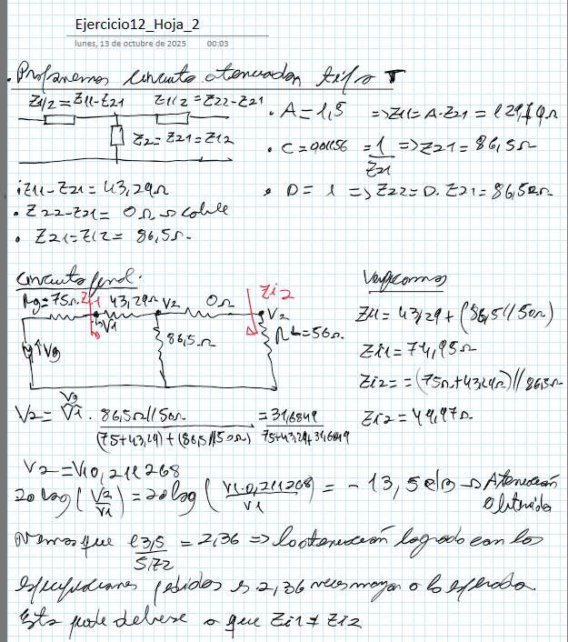
Sheet
Monday, of October of

In
A =y

Time

Selo
Lg with

poly Zas

Simulation:
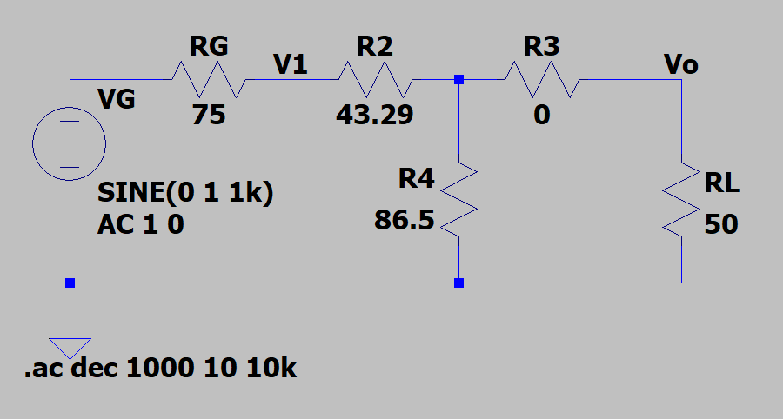
RG
R2
Vi
R3
Vo
1k)
RL
10k
SINE(O
AC10

Circuit of exercise 12.

P | Mag
 | hase

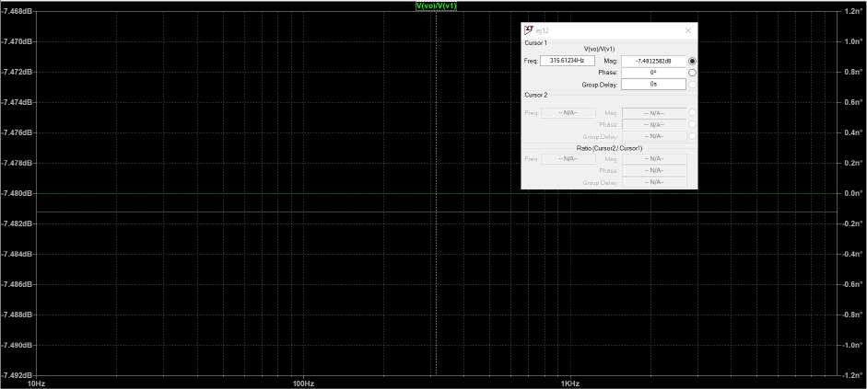
Frequency response of the voltage transfer of the circuit from exercise 12.
Cursor
:
-7.472dB
Group Delay:
Ratio (Cursor2
Graph

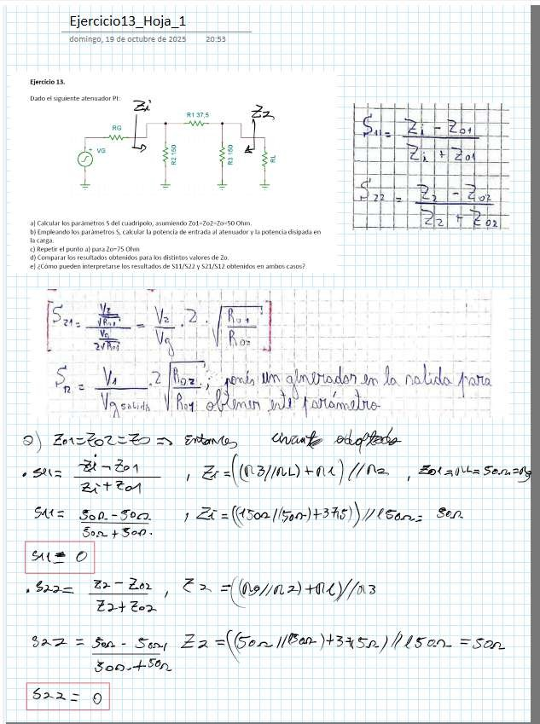
Exercise #13
Exercise13 Sheet 1
Sunday, October 15, 2075
20:53
Exercise 1%.

Given the following PI attenuator:

|
o
E
2h
|*| zo
1
|

|
+
y
E

Ll H Ll -
-
ho to LA==

Empreando Calculate the parameters parameters 5 of the $, calculate quadripole,
al
bj
|
thtehepaplotwheer paossinutmtiongfomr eZaos=ur7e5d at the attenuator and the power dissipated in
cm
1) Compare the results obtained for the different values of Zo,
€) How can you interpret the results of 611/622 and
obtained in both cases?
L “ ui 2
y

| Sa: +

! |
| a 7 RE

|

Um aaron

- hos:

o noldo: paa

Jean E
9) >
—
7
Ze -[ (03/00) +04)
sz
,,

Sa-900 and Sen
Ena

2

-

$22 — 9

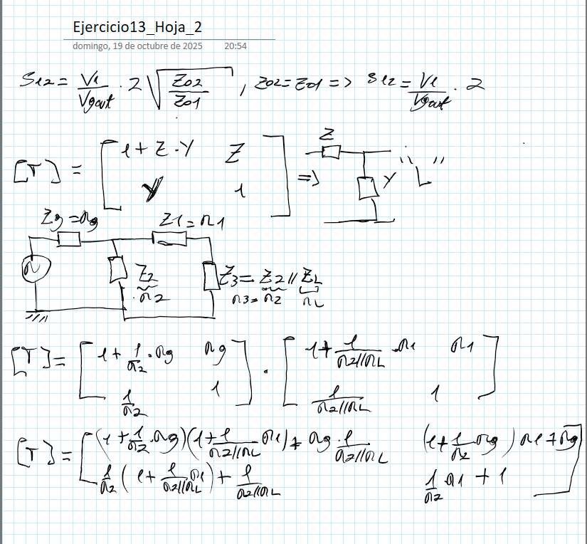
Suz=
and
L
The
LI
Exercise13 Sheet
Sunday, |  | of October

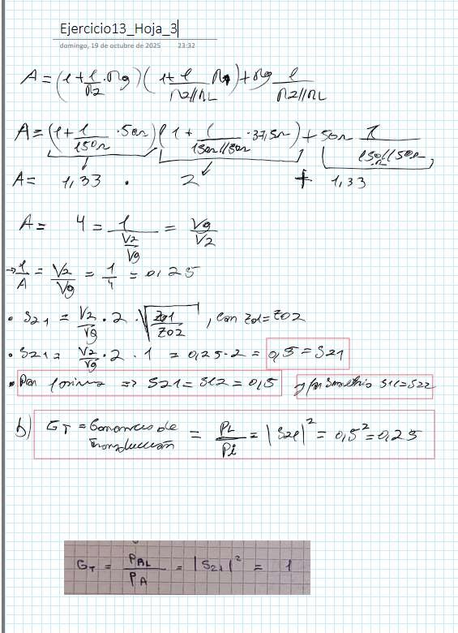
o

Bad
T
ul

The

f

N
E N N

Sunday,
of October

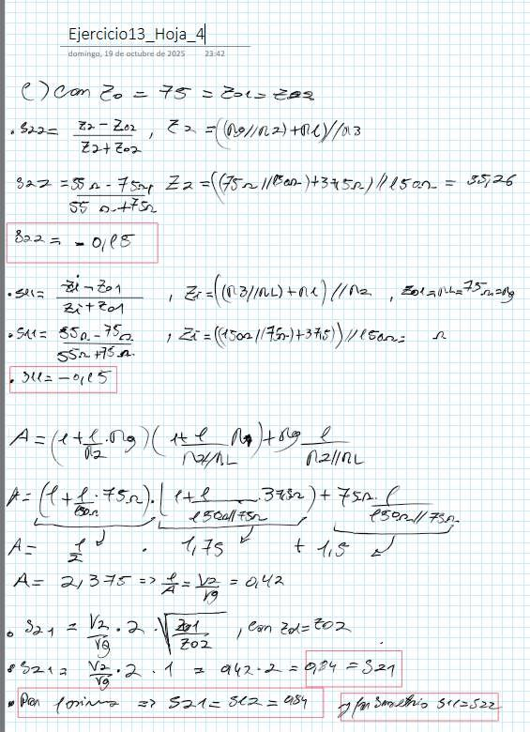
TS

ES AND

A

b

a

Per

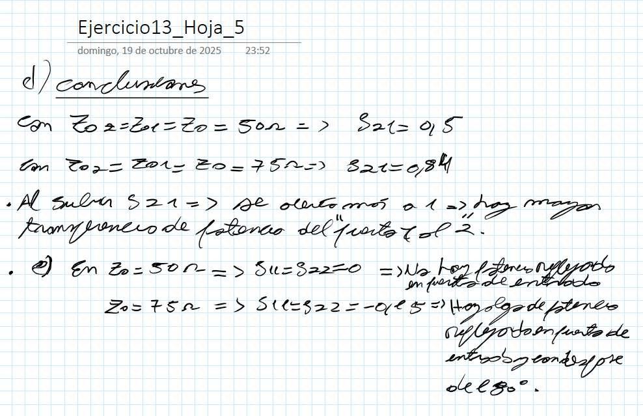
23H
ole
It is
d)
of October
Sunday,

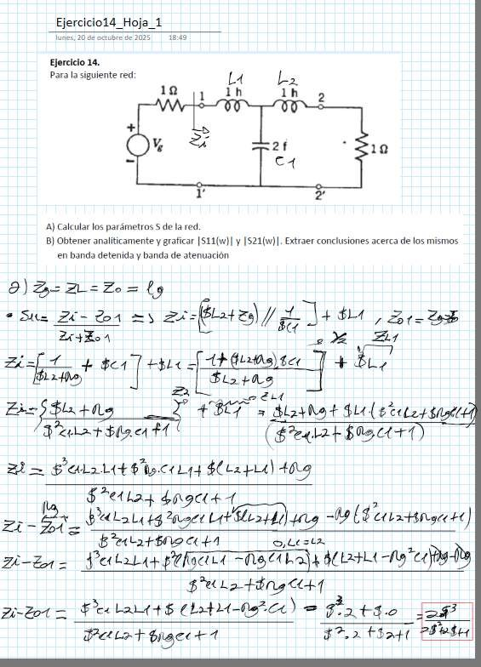
Exercise #14

Ejerciciol4 Sheet 1
Monday, October 20, 2025
For the following network:
18:49
Exercise 14.
LA The

Aj Calculate the network parameters 5 of the network.
B) Obtain analytically and plot |S11(v)| and |S21(v)|. Draw conclusions about them in the stopband and attenuation band

5)
* Sus 1 =s
ox A
$
Ze = fs

Z= 7 + | +

Zi=9
47 +
7
1 (
—
3

409
$

9 [$ 2
)
+1
has
$

Bla+tno 4
sta

+41
Zi-Z1— nt
—4”

try

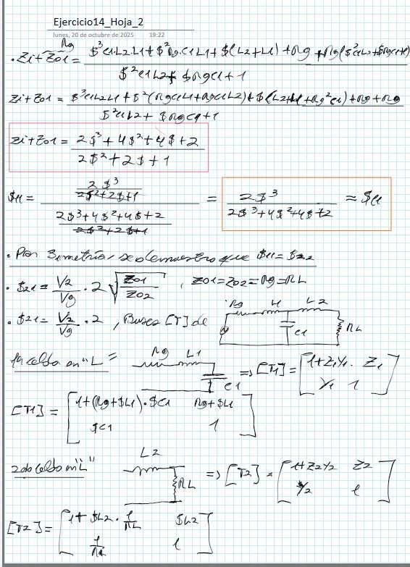
a
Ter
Lz
Exercise14 Sheet

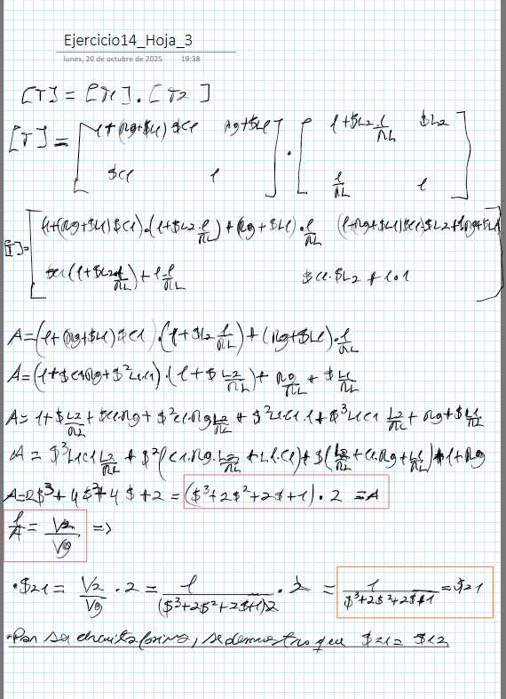
Exercise14 Sheet_3
of October

(a

A=

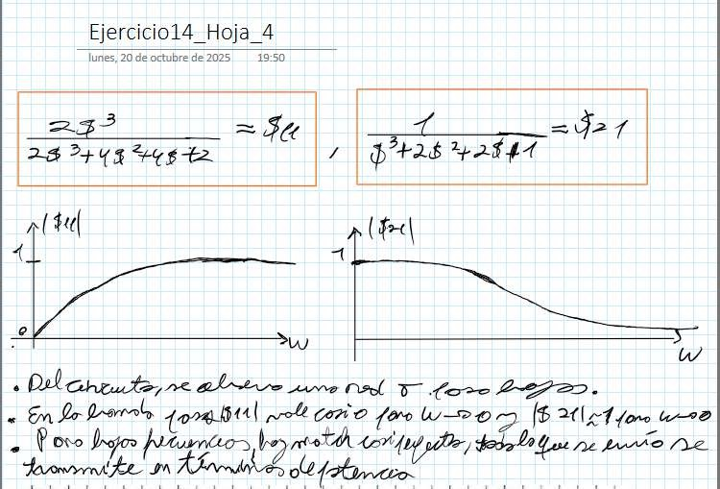
Sheet
Monday,of October
to
L L
E

