CONFIDENTIAL — VENDOR RESTRICTED
NILAM Field Hardware Device
Technical Requirements Specification
Hardware Interface & Responsibility Spec for OEM / Device Manufacturer
Document Type: Requirements Specification (Draft)
Version: 1.0
Date: 2026-07-08
Classification: Confidential — Vendor Restricted
Prepared for: Hardware OEM / Device Manufacturer
Prepared by: Software / Platform Team
(DoSLR WebGIS / GeoNilam / NILAM mobile field context)
This document defines roles, interfaces, latency, offline behaviour, use cases, and acceptance criteria for a hardware mediation device between the NILAM mobile field application and DGPS rover instruments. It is a V1.0 draft for vendor technical response and does not constitute a binding procurement contract or legal warranty statement.
Document Control
Version | Date | Author | Status | Notes
0.9 | 2026-07-01 | Platform Team | Internal draft | Screen inventory from mobile prototype
1.0 | 2026-07-08 | Platform Team | Vendor draft | Full TRS for OEM response

Table of Contents
Sections are numbered 1–14 with Appendices A–B. Figures and tables are referenced inline. Update automated TOC fields in Microsoft Word if desired (References → Table of Contents).
1. Executive Summary
2. Scope & Non-Goals
3. System Architecture
4. Roles & Responsibilities (RACI)
5. Functional Requirements
6. Non-Functional Requirements
7. Interfaces & Protocols
8. Data Model
9. Use Cases & Scenarios
10. Workflow Charts
11. Acceptance Test Plan
12. Deliverables from Hardware Vendor
13. Open Questions / Assumptions
14. Glossary
Appendix A — Mapping to NILAM Mobile Screens
Appendix B — Attribute Dictionary

1. Executive Summary
NILAM field operations require centimetre-to-decimetre accurate cadastral control-point collection using Differential GPS (DGPS) / Real-Time Kinematic (RTK) instruments, resilient offline survey packets, and transparent compliance evidence that a surveyor followed (or justifiably diverged from) a proposed field path. The NILAM mobile application — presently demonstrated as a web PhoneFrame prototype within the DoSLR WebGIS platform — owns surveyor UX, packet lifecycle, DPR reporting, emergency alerting, and backend synchronisation.
The hardware mediation device specified herein sits between the mobile application and the DGPS rover (and, where applicable, base / NTRIP correction sources). Software configures the rover through the phone; the device executes transport, protocol adaptation, durable offline storage of GNSS epochs and track samples, and deterministic acknowledgement of capture and sync operations.
Business outcomes enabled by compliant hardware:
- Reliable live telemetry for the six on-screen GNSS boxes: Latitude, Longitude, Accuracy (m), Satellite Count, HDOP, VDOP.
- Editable Point ID (illustrative pattern GCP-KHT-##) stamped into each captured control point before commit.
- Offline durability for village packets such as pkt-khutal-042 (Khutal) and pkt-khutal-011 (Khutal Bangla).
- Actual path logging with direction and timestamp to support Proposed (blue dashed) vs Actual (orange) map storytelling.
- Pass-through of Rover Settings and guarded App Settings (API URL, bearer token) without exposing instrument vendor lock-in to the app layer.
Illustrative demo values used throughout (labelled demo / illustrative where relevant): surveyor K. Murugesan (TN-SRV-1042); rover Trimble R12 · Bluetooth name TRMBLE_R12_88421; live Lat 19.29352 / Lng 73.52641 / Accuracy 0.09 m / 14 satellites / HDOP 0.8 / VDOP 1.2; API base https://api.nilam.tn.gov.in/v2/field; NILAM Mobile v2.4.1.

2. Scope & Non-Goals

2.1 In Scope (Hardware Vendor)
- Physical device design suitable for Tamil Nadu / Puducherry / Karaikal field conditions.
- Wireless and/or wired bridging: BLE 5.x (preferred), USB-C serial, optional Wi-Fi AP / client.
- Protocol adapters for NMEA 0183, RTCM 3.x, and extensible proprietary receiver SDKs.
- Local encrypted-at-rest storage for points, path samples, configs, and sync queues.
- Telemetry streaming, capture ACK, offline queue, sync resume, path ingest/logging, diagnostics, OTA firmware.
- Interface Control Document (ICD), sample SDK, test harness logs, and acceptance evidence.

2.2 Out of Scope
- Mobile UI/UX design and DPR screens — owned by Software (Home DPR charts, parcel overlays, island notifications).
- DGPS instrument firmware and NTRIP caster operations — owned by instrument OEM / network operator unless explicitly subcontracted.
- Backend WebGIS business rules, conflict resolution policy finals, and cadastral legal sealing.
- Emergency district alert cascade (mail / phone / call) — primarily Software/Backend; hardware panic button is optional (MAY).
- Surveyor training content and administrative HR workflows.

2.3 Related Software Surfaces (Context Only)
Mobile tabs and overlays observed in the prototype: Home, Map, Emergency, Capture (DGPS / GNSS), Sync; overlays Profile, Settings, App Settings, Rover Settings, DPR date/parcel. Hardware must honour API contracts that back Connect, Capture control point, Sync now, Download for offline, and Rover Settings apply.

3. System Architecture
The field stack comprises three layers with clear ownership boundaries.
- NILAM Mobile App (Android/iOS targets; current demonstration is a web PhoneFrame prototype) — UI, permissions, API auth UX, map rendering, DPR, emergency UI.
- Hardware mediation device (THIS VENDOR) — BLE/USB/Wi-Fi bridge, local store, optional GNSS link stack, telemetry and path logging engine.
- DGPS Rover / Base / NTRIP / RTK instruments — produce fixes and corrections (e.g., illustrative Trimble R12, Trimble NetR9, caster ntrip.tn.gov.in:2101, mount point TN-GNSS-RTK).
Data planes:
- App ↔ Hardware Device: control and telemetry (JSON over BLE GATT notifications / indications or WebSocket-serial).
- Hardware Device ↔ Rover: Bluetooth SPP/GATT or USB serial; NMEA/RTCM or vendor SDK.
- App ↔ Backend API: HTTPS sync of packets and proposed paths; Device MAY assist uplink when phone tethering is weak but Software remains policy owner.
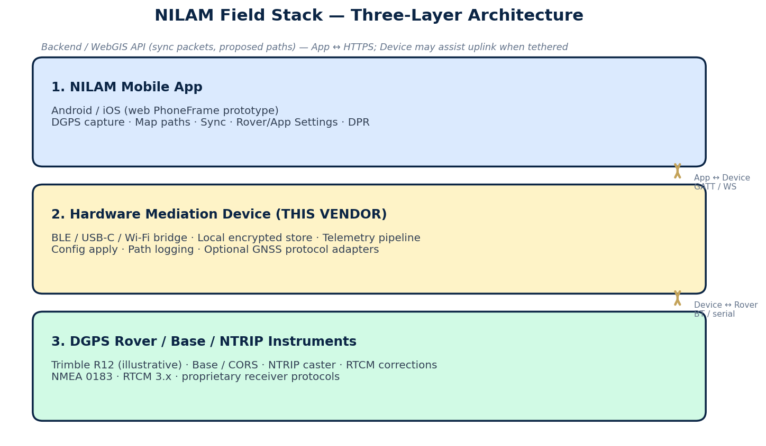
Figure 1. Three-layer NILAM field architecture (App · Hardware Device · Rover / NTRIP).
Reference sequence for a captured point: Surveyor taps Connect → Device pairs and streams telemetry.live → six UI boxes populate → Surveyor edits Point ID → Capture control point → Device freezes epoch, persists, returns ACK → point appears Pending until Sync now → Backend marks Synced.

4. Roles & Responsibilities (RACI-style)
R = Responsible, A = Accountable, C = Consulted, I = Informed. Primary owner is bolded in notes.
Activity | Hardware | Software (App) | Surveyor | Backend
Device pairing / discovery | R/A | C | C | I
Rover RF/serial connect | R/A | C (Connect UX) | C | I
Live telemetry framing | R/A | R (render) | I | I
Point ID propose / edit | C (accept rename) | R/A (UX) | R (edit) | I
Point capture stamp | R/A (store) | R (request) | R (trigger) | I
Offline queue durability | R/A | C | I | I
Sync upload transport | R (if device uplink) / C | R/A | R (Sync now) | R (ingest)
Conflict policy | C | C | I | R/A
Rover config apply | R (apply) | R/A (settings UI) | C | I
API token storage UI unlock | C (secure element optional) | R/A | C (admin) | C
Proposed path ingest | R (store/track) | R (download UI) | I | R/A (author)
Actual path logging | R/A | R (map display) | C | C
Clock discipline | R/A | C | I | C (NTP ref)
Emergency alert cascade | MAY button | R/A | R | R
DPR aggregation UI | I (feeds points) | R/A | I | C
Instrument firmware | C | I | I | I (instrument OEM A)

Boundary summary: Hardware owns truthful sensor time-series and durable offline artefacts; Software owns human workflow and presentation; Backend owns cadastral system of record; Surveyor owns field decisions; Instrument OEM owns receiver internals.

5. Functional Requirements
Requirements use RFC 2119 language: SHALL (mandatory), SHOULD (strongly recommended), MAY (optional). Demo names (GCP-KHT-06, Khutal, Trimble R12) are illustrative.

5.1 Device Discovery & Pairing
Preconditions: Device powered; surveyor within ~10 m; phone Bluetooth enabled.
- Hardware SHALL advertise a stable BLE name and service UUID documented in the ICD.
- Hardware SHALL support first-time pairing with PIN or numeric comparison within 30 seconds under nominal RF conditions.
- Hardware SHALL persist bonding keys so Auto-reconnect rover (App toggle) can restore the session on launch.
- Hardware SHALL reject unpaired hosts from reading stored credentials or offline points.
- Hardware SHOULD support USB-C fallback discovery when BLE is congested.
- Hardware MAY expose a Wi-Fi SoftAP mode for lab diagnostics.
Postconditions: Paired bond stored; App can request Connect.
Failure modes: Bonding timeout; spoofed advertisement (see Scenario 16); insufficient battery.
Acceptance criteria:
- Pairing success rate ≥ 95% in open field RF tests; unpaired device cannot dump points via GATT without auth.

5.2 Session / Connect to Rover (Connect Button Equivalent)
Preconditions: Pairing complete; Rover Settings populated; rover powered.
- Hardware SHALL on App connectGnss / Connect, attempt rover link using configured Bluetooth name (e.g., TRMBLE_R12_88421).
- Hardware SHALL establish a usable session within ≤ 15 seconds typical; hard timeout ≤ 30 seconds with typed error.
- Hardware SHALL publish connection state events matching App island notifications: Searching for rover… → Trimble R12 connected / failure.
- Hardware SHALL honour Disconnect by cleanly closing rover and NTRIP sockets and stopping telemetry.live.
- Hardware SHOULD auto-start NTRIP when Auto NTRIP on connect is enabled in Rover Settings.
Postconditions: gnssConnected equivalent true; telemetry flowing or explicit degraded state.
Failure modes: Rover out of range; wrong Bluetooth name; RTK corrections unavailable (still MAY stream autonomous fix with quality flags).
Acceptance criteria:
- Connect → live telemetry within 15 s median; timeout emits error code ROVER_CONNECT_TIMEOUT.

5.3 Live Telemetry Stream (Six Attributes Minimum)
Preconditions: Rover connected; corrections optional.
- Hardware SHALL stream Latitude, Longitude, Accuracy (horizontal, metres), Satellite Count, HDOP, and VDOP at ≥ 1 Hz when a fix is available.
- Hardware SHALL deliver end-to-end App UI update within 200–500 ms after a fix becomes available on the device bus.
- Hardware SHALL mark fields null/unknown when disconnected so the App can hide metric boxes (matching prototype behaviour).
- Hardware SHALL include a monotonic sequence number and device UTC timestamp on each telemetry.live message.
- Hardware SHOULD also stream optional fixType (NONE/GPS/DGPS/FLOAT/FIX/RTK), PDOP, mean SNR, rover battery %, GPS week/TOW.
- Hardware SHOULD apply antenna height from config when reporting ground-referenced height if/when vertical displayed.
Postconditions: App boxes show values such as Lat 19.29352, Lng 73.52641, Accuracy 0.09 m, Satellites 14, HDOP 0.8, VDOP 1.2 (illustrative).
Failure modes: Bus congestion; malformed NMEA — Device SHALL drop bad sentences and raise DIAG_PARSE_ERROR counters.
Acceptance criteria:
- All six fields update continuously while connected; latency SLA met under lab load test.

5.4 Point ID / Name Generation & Edit Before Capture
Preconditions: Connected session; active field packet downloaded.
- Hardware SHALL accept an App-proposed Point ID (e.g., GCP-KHT-06) via point.capture.request and use that label at stamp time.
- Hardware SHALL accept a rename (point.update / pre-capture setNextPointId) issued before commit; last App value wins.
- Hardware SHALL support Auto-increment sequences consistent with App pattern GCP-KHT-## when App delegates generation.
- Hardware SHOULD validate uniqueness within the active packet on-device and warn on duplicates.
- Hardware MAY propose a provisional ID if App sends empty string.
Postconditions: Captured record.label equals edited Point ID.
Failure modes: Empty ID after trim — Device SHALL reject with POINT_ID_REQUIRED unless App confirms auto-name.
Acceptance criteria:
- Edit GCP-KHT-06 then capture → stored label is GCP-KHT-06.

5.5 Point Capture / Collect
Preconditions: gnssConnected; Point ID set; surveyor triggers capture.
- Hardware SHALL on Capture control point, freeze one epoch containing all six core attributes plus quality flags.
- Hardware SHALL return point.capture.response ACK within ≤ 1 second under normal flash write conditions.
- Hardware SHALL persist source channel (bluetooth | ntrip | file) analogous to CapturedGnssPoint.source.
- Hardware SHALL default reject or warn when quality below Min accuracy threshold (±0.15 m · RTK Fixed required) if Rover Settings enforce it — final UX gate may be App-owned but Device MUST supply quality.
- Hardware SHOULD store optional raw NMEA/RTCM sentence dump or RINEX observation handle when Store raw observations is on.
Postconditions: Point listed with synced=false (Pending); durable on power-cycle.
Failure modes: Flash full; mid-write power loss (see 5.7); float fix when fixed required.
Acceptance criteria:
- Power-cycle after capture retains point; ACK ≤ 1 s p95.

5.6 Edit / Delete / Re-measure Points Offline
Preconditions: Points exist in local store.
- Hardware SHALL allow App to update label/metadata of Pending points offline via point.update.
- Hardware SHALL allow delete of Pending points with tombstone until sync.
- Hardware SHALL allow re-measure: new epoch supersedes prior geometry while retaining audit trail of prior measurement.
- Hardware SHOULD forbid silent mutation of already Synced points without backend-coordinated revision token.
Postconditions: Queue reflects edits; sync carries net intent.
Failure modes: Edit during active sync chunk — Device SHALL serialize with transaction lock.
Acceptance criteria:
- Offline delete of Pending point removes it from subsequent sync.upload.

5.7 Offline Storage Persistence
Preconditions: N/A continuous.
- Hardware SHALL survive unexpected power loss without corrupting the points database (dual-buffer / transactional write).
- Hardware SHALL retain data for ≥ 14 days without wipe under ambient storage temperatures in scope.
- Hardware SHALL encrypt at rest preferred (AES-128+); if deferred, document residual risk — encryption SHOULD be default for OEM bid.
- Hardware SHALL report storage used / free via diagnostics so App can warn before Storage full scenario.
- Hardware MAY offer secure element for tokens.
Postconditions: No torn writes after crash-recovery boot.
Failure modes: Filesystem journal replay failure → enter safe mode, refuse capture, emit STORAGE_CORRUPT.
Acceptance criteria:
- Pull battery mid-write 50×; ≤ 1 point lost; never silent corruption.

5.8 Sync / Connect to Software & Backend
Preconditions: Connectivity available; bearer token valid if Device participates in HTTPS; Pending > 0.
- Hardware SHALL serve sync.upload for pending GNSS points and path batches for the active packet (e.g., pkt-khutal-042).
- Hardware SHALL support resume from byte/record offset after partial failure.
- Hardware SHALL emit progress events suitable for the Sync UI progress bar (prototype animates ~62% → 100% in steps).
- Hardware SHALL cooperate with App notifications: Looking for internet… → Connected → Uploading field data… → Sync complete.
- Hardware SHOULD compress payloads when Compress uploads is enabled in App Settings.
Postconditions: Points marked Synced; packet status synced when complete.
Failure modes: Wrong token (Scenario 7); mid-upload disconnect — resume without duplicate commits (idempotent point IDs).
Acceptance criteria:
- Kill network at 40%; resume completes without duplicates; progress events ≥ 2 Hz during transfer.

5.9 Rover Configuration from App Settings / Rover Settings
Preconditions: Paired; admin/surveyor edited Rover Settings (Trimble R12, antenna 1.85 m, caster ntrip.tn.gov.in:2101, mount TN-GNSS-RTK, user tn_field_1042 — illustrative).
- Hardware SHALL accept config.rover.apply including: rover model/serial/Bluetooth name; base model/serial/IP; mount point; caster URL; NTRIP username/password (secure); antenna height (m); receiver type; min accuracy; store-raw flag; Auto-reconnect; Bluetooth priority.
- Hardware SHALL apply configs to the link layer and return typed ACK/NACK.
- Hardware SHALL not require the App to embed vendor SDKs beyond the ICD.
- Hardware SHOULD validate caster reachability when Test path is requested; separate from App Test Connection (API).
Postconditions: Subsequent Connect uses new settings.
Failure modes: Invalid mount point; auth fail at caster → NTRIP_AUTH_FAILED.
Acceptance criteria:
- Change antenna height 1.85→2.00 → ACK; next capture metadata reflects 2.00.
Note: App Settings Database Configuration (API URL, Bearer token, API key, Environment Production/Staging/Development, Test Connection) is primarily Software↔Backend. Hardware MAY cache link status or hold tokens in secure storage only when product architecture selects device-mediated sync; otherwise Device SHALL treat tokens as optional.

5.10 Proposed Path Ingest & Actual Path Logging
Preconditions: Proposed path downloaded with offline packet.
- Hardware SHALL accept path.proposed.set polylines/waypoints from App/server for the active packet.
- Hardware SHALL continuously log actual track samples with WGS84 position, heading/direction, and timestamp.
- Hardware SHALL default sample at 1 Hz, configurable 0.2–5 Hz.
- Hardware SHALL retain mid-route excursions (e.g., tea-stall detour story in demo routes) without snapping away legitimate deviations.
- Hardware SHALL batch upload via path.actual.batch compatible with Map legend: Proposed (blue dashed) vs Actual (orange) with direction arrows and waypoint timestamps.
- Hardware SHOULD tag samples with packetId and surveyorId (e.g., surveyor.tn.1042).
Postconditions: Map can render compliance narrative: start on path, excursion, return.
Failure modes: GPS outage — continue logging with gap flags rather than inventing geometry.
Acceptance criteria:
- Detour retained; timestamps monotonic; arrows reflect headingRad semantics.

5.11 Time Sync / Clock Discipline
Preconditions: Power on.
- Hardware SHALL synchronise device clock to GNSS time when fix available; fallback to phone NTP via App time sync message.
- Hardware SHALL stamp captures with UTC; document local offset handling.
- Hardware SHALL detect drift > 2 s versus GNSS and self-correct, emitting CLOCK_CORRECTED events.
Postconditions: Capture timestamps comparable to App displayed capturedAt (e.g., 2026-06-10 09:14).
Failure modes: No GNSS and no phone time — refuse capture or mark TIME_UNTRUSTED.
Acceptance criteria:
- After 24 h offline, drift residual < 500 ms once GNSS returns.

5.12 Firmware Update Capability
- Hardware SHALL support signed OTA packages delivered via App or USB.
- Hardware SHALL A/B or fail-safe rollback if boot fails.
- Hardware SHALL report firmware version string to App About/diagnostics.
- Hardware SHOULD allow staged updates without wiping offline points.
Acceptance criteria:
- Interrupted OTA recovers to last known good.

5.13 Diagnostics & Health
- Hardware SHALL expose DeviceHealth: battery, storage, temperature, BLE RSSI, rover link state, NTRIP state, error counters.
- Hardware SHALL retain a ring-buffer diagnostic log exportable for vendor support.
- Hardware MAY use status LEDs: power, pair, rover, error.
Acceptance criteria:
- ICD health message maps to App debug overlay or support export.

5.14 Security / Credentials
- Hardware SHALL never emit NTRIP passwords or bearer tokens in plaintext logs.
- Hardware SHALL require pairing auth before sensitive GATT characteristics are readable.
- Hardware SHALL support remote/local wipe of credentials on command from authenticated App admin session.
- Hardware SHOULD lock out after N failed pairing attempts (configurable) and require physical confirm.
- Hardware MAY store API tokens only when device-mediated sync is selected.
Failure modes: Spoofed BLE — see Scenario 16.
Acceptance criteria:
- Static analysis / review of firmware shows secrets not in world-readable storage.

6. Non-Functional Requirements

6.1 Latency / Timing
Metric | Target | Timeout / Bound | Notes
Telemetry → App UI | ≤ 200–500 ms E2E after fix | Watchdog 2 s stale | Six-box refresh
Point capture ACK | ≤ 1 s p95 | Hard fail 3 s | Includes durable write
Connect to rover | ≤ 10–15 s typical | 30 s timeout | Includes NTRIP start if enabled
Path sample interval | 1 Hz default | Configurable 0.2–5 Hz | Jitter < 20%
Sync progress events | ≥ 2 Hz while transferring | — | Matches Sync now UX
Offline sync throughput | ≥ 0.5 MB/s Wi-Fi; ≥ 50 KB/s cellular assist | — | Depends on phone uplink
Config apply ACK | ≤ 5 s | 15 s | Excludes long NTRIP auth

6.2 Reliability
Metric | Requirement
MTBF guidance | ≥ 5,000 field hours electronics; document test basis
Offline durability | ≥ 14 days retention without wipe
Write integrity | Dual-buffer / transactional point commits
Crash recovery | Boot self-check ≤ 10 s; refuse capture if corrupt
Queue durability | No silent loss of Pending points on power cycle

6.3 Environmental
Aspect | Expectation
Ingress protection | IP54 minimum; IP65 recommended for monsoon dust/rain
Temperature | Operating −5 °C to +55 °C (TN / coastal heat), storage −20 °C to +70 °C
Humidity | 10–95% RH non-condensing; conformal coat preferred
Vibration / drop | Survive motorcycle pannier transport; 1.2 m drop to packed soil (sample units)
Battery life | ≥ 10 hours active survey day with 1 Hz telemetry + path logging
Charging | USB-C; field chargeable midday

6.4 Capacity
Artefact | Minimum Capacity
Offline control points | ≥ 10,000 points
Track samples | ≥ 2,000,000 samples (~23 days @ 1 Hz)
Field packets concurrent | ≥ 20 packets metadata
Diagnostic log | ≥ 64 MB ring
Firmware slot | ≥ 2 images (A/B)

6.5 Interoperability
- BLE 5.x GATT with documented UUIDs; USB-C CDC-ACM or vendor serial; optional Wi-Fi.
- NMEA 0183 parser; RTCM 3.x pass-through / decode as needed; proprietary adapters behind a plugin interface.
- Illustrative instruments: Trimble R12/R10, Leica GS18, South Galaxy G7; bases Trimble NetR9, Leica GR30, Septentrio Mosaic, Custom CORS.

6.6 Security & Compliance
- TLS 1.2+ for any device-originated HTTPS to backend.
- Pairing PIN / numeric compare; optional wipe-after-N-failures policy.
- No weak hardcoded debug backdoors in production firmware.
- Align credential handling with App unlock Administration → Update Database Configuration (admin key gated).

6.7 Accessibility / UX Constraints Hardware Imposes
- Status LEDs SHOULD map to colour-blind-safe patterns (shape/blink, not colour alone).
- Optional hardware capture button MAY debounce ≥ 300 ms and mirror App Capture control point.
- Haptic feedback remains App-owned; Device SHOULD not inject duplicate confirms unless App requests.

7. Interfaces & Protocols
Recommended transport: JSON messages over BLE GATT (notify/write) or length-prefixed WebSocket/serial for USB. All messages include schemaVersion, messageType, messageId, and tsUtc.

7.1 Message Catalogue
messageType | Direction | Purpose
telemetry.live | Device → App | 1 Hz+ fix stream
point.capture.request | App → Device | Capture with Point ID
point.capture.response | Device → App | ACK/NACK + record
point.update | App → Device | Rename / delete / remeasure
config.rover.apply | App → Device | Rover/base/NTRIP/antenna
config.rover.ack | Device → App | Apply result
path.proposed.set | App → Device | Ingest planned polyline
path.actual.batch | Device → App | Track samples upload to App
sync.upload | App ↔ Device | Chunked pending artefact upload
device.health | Device → App | Diagnostics
error | Either | Typed failure

7.2 Example Payloads
telemetry.live (illustrative):
{
"schemaVersion": "1.0",
"messageType": "telemetry.live",
"messageId": "tel-88421-10042",
"tsUtc": "2026-07-08T09:14:03.210Z",
"seq": 10042,
"lat": 19.29352,
"lon": 73.52641,
"accuracyM": 0.09,
"satelliteCount": 14,
"hdop": 0.8,
"vdop": 1.2,
"fixType": "RTK_FIXED",
"roverId": "TRMBLE_R12_88421"
}
point.capture.request / response:
{
"messageType": "point.capture.request",
"pointId": "GCP-KHT-06",
"packetId": "pkt-khutal-042",
"requireFixed": true,
"maxAccuracyM": 0.15
}
— —
{
"messageType": "point.capture.response",
"status": "OK",
"record": {
"id": "gnss-006",
"label": "GCP-KHT-06",
"lat": 10.92580,
"lng": 79.83690,
"accuracyM": 0.08,
"satelliteCount": 14,
"hdop": 0.8,
"vdop": 1.2,
"source": "bluetooth",
"capturedAt": "2026-06-10 09:14",
"synced": false
}
}
config.rover.apply (subset):
{
"messageType": "config.rover.apply",
"rover": {"model": "Trimble R12", "serial": "R12-88421", "btName": "TRMBLE_R12_88421"},
"base": {"model": "Trimble NetR9", "ip": "192.168.1.50", "mountPoint": "TN-GNSS-RTK"},
"ntrip": {"caster": "ntrip.tn.gov.in:2101", "username": "tn_field_1042", "password": "***"},
"antennaHeightM": 1.85,
"autoNtripOnConnect": true,
"bluetoothPriority": true
}
path.actual.batch sample:
{
"messageType": "path.actual.batch",
"packetId": "pkt-khutal-042",
"samples": [
{"lon": 79.83690, "lat": 10.92580, "headingRad": 1.02, "ts": "2026-06-10T09:14:00Z", "kind": "actual"},
{"lon": 79.83710, "lat": 10.92595, "headingRad": 1.10, "ts": "2026-06-10T09:14:01Z", "kind": "actual"}
]
}

7.3 Error Code Registry (Initial)
Code | Meaning
ROVER_CONNECT_TIMEOUT | Connect exceeded 30 s
ROVER_NOT_FOUND | Bluetooth name not seen
QUALITY_BELOW_THRESHOLD | Accuracy/fix not meeting policy
POINT_ID_REQUIRED | Empty Point ID
STORAGE_FULL | Cannot persist
STORAGE_CORRUPT | Safe mode
NTRIP_AUTH_FAILED | Caster rejected credentials
SYNC_AUTH_FAILED | API token rejected
SYNC_RESUME_REQUIRED | Partial upload; retry with offset
CLOCK_UNTRUSTED | Refuse capture
PAIRING_LOCKED | Too many failed attempts
OTA_SIGNATURE_INVALID | Reject firmware

8. Data Model

8.1 Point Record (aligns to CapturedGnssPoint + extensions)
Field | Type | Notes
id | string | Stable UUID / gnss-###
label | string | Point ID e.g. GCP-KHT-12
lat / lng | float64 | WGS84 degrees
accuracyM | float | Horizontal metres
satelliteCount | int | Core UI
hdop / vdop | float | Core UI
fixType | enum | Optional extension
source | enum | bluetooth | ntrip | file
capturedAt | string/ISO | Display + audit
synced | bool | Pending vs Synced
packetId | string | pkt-khutal-042
antennaHeightM | float | From config
rawRef | string? | Optional dump handle
qualityFlags | object | requireFixed result etc.

8.2 Field Packet
Mirrors FieldPacket: id, village (Khutal / Khutal Bangla), parcelCount, status (assigned | downloaded | in-progress | synced), dueDate, progressPct.

8.3 PathSegment / Route
SurveyorDemoRoute analogue: id, label, proposed[], actual[], arrows[] with lon, lat, headingRad, timestamp, kind.

8.4 DeviceHealth
batteryPct, storageFreeMb, temperatureC, bleRssi, roverLink, ntripState, firmwareVersion, lastErrorCode, uptimeSec.

9. Use Cases & Scenarios
Each scenario lists Actors, Preconditions, Steps, Expected hardware behaviour, and Failure handling.

9.1 First-time pairing
Actors: Surveyor, App, Device
Preconditions: Device factory-reset; phone BT on.
Steps: 1) App scans. 2) Surveyor confirms PIN. 3) Bond stored.
Expected hardware behaviour: Advertise ICD UUID; complete bond ≤ 30 s; lock sensitive chars.
Failure handling: On fail: PAIRING_LOCKED after N tries; clear instruction to reset.

9.2 Connect → six boxes populate
Actors: Surveyor, App, Device, Rover
Preconditions: Paired; Rover Settings set to Trimble R12.
Steps: 1) Tap Connect. 2) Searching… 3) Connected. 4) Lat/Lng/Accuracy/Sats/HDOP/VDOP update.
Expected hardware behaviour: Open rover link; stream telemetry.live ≥ 1 Hz; latency ≤ 500 ms.
Failure handling: Timeout 30 s → ROVER_CONNECT_TIMEOUT; App shows No rover connected.

9.3 Edit Point ID GCP-KHT-06 → capture
Actors: Surveyor, App, Device
Preconditions: Connected; nextPointId editable.
Steps: 1) Pencil edit → GCP-KHT-06. 2) Capture control point.
Expected hardware behaviour: Stamp label exactly; ACK ≤ 1 s; Pending in store.
Failure handling: Reject empty ID; if quality poor and policy on → QUALITY_BELOW_THRESHOLD.

9.4 Lose RTK fix mid-capture
Actors: Surveyor, App, Device, Rover, NTRIP
Preconditions: Was RTK_FIXED; corrections drop.
Steps: 1) Capture pressed during FLOAT.
Expected hardware behaviour: Supply fixType FLOAT; enforce threshold; prefer warn/reject over silent cm claim.
Failure handling: App may override with explicit confirm — Device still records true quality.

9.5 Offline all day then Sync Now
Actors: Surveyor, App, Device, Backend
Preconditions: Khutal packet downloaded; cellular spotty all day.
Steps: 1) Capture many points. 2) Evening Sync now. 3) Progress 62→100. 4) Sync complete.
Expected hardware behaviour: Durable queue; chunked sync.upload; mark Synced only after ACK.
Failure handling: If offline persists: keep Pending; do not wipe.

9.6 Partial sync failure resume
Actors: App, Device, Backend
Preconditions: Upload interrupted at ~40%.
Steps: 1) Retry Sync now. 2) Resume offset.
Expected hardware behaviour: Idempotent records; SYNC_RESUME_REQUIRED then continue.
Failure handling: Never duplicate GCP labels on server.

9.7 Wrong API token / Test Connection failed
Actors: Admin, App, Backend (± Device)
Preconditions: Update Database Configuration unlocked; bad token.
Steps: 1) Test Connection. 2) Failure: Check URL and token.
Expected hardware behaviour: If Device holds token for uplink, return SYNC_AUTH_FAILED; do not retry storm.
Failure handling: App remains source of UX; Device must not log token.

9.8 Rover config change via App → Device ACK
Actors: Surveyor, App, Device, Rover
Preconditions: Connected or idle.
Steps: 1) Change caster/mount/antenna. 2) Apply. 3) Reconnect.
Expected hardware behaviour: config.rover.apply → hardware applies → config.rover.ack.
Failure handling: NTRIP_AUTH_FAILED surfaces; retain last good config.

9.9 Proposed path; tea-stall detour; actual path logged
Actors: Surveyor, App, Device, Map
Preconditions: path.proposed.set loaded.
Steps: 1) Start along proposed. 2) Mid-route excursion. 3) Return. 4) Map shows orange actual + arrows + timestamps.
Expected hardware behaviour: Log 1 Hz actual with heading/ts; no destructive snap-to-proposed.
Failure handling: GPS gaps flagged; continuity restored on reacquire.

9.10 Power loss mid-write
Actors: Field environment, Device
Preconditions: Capture in progress write.
Steps: 1) Battery pull. 2) Reboot. 3) Inspect store.
Expected hardware behaviour: Transactional commit: either full point or none; journal replay.
Failure handling: If corrupt → STORAGE_CORRUPT safe mode.

9.11 Multi-surveyor / multi-device same packet
Actors: Two surveyors, Apps, Devices, Backend
Preconditions: Same pkt-khutal-042 assigned (policy permitting).
Steps: 1) Both capture. 2) Sync.
Expected hardware behaviour: Namespace points with deviceId + label; Backend conflict rules final.
Failure handling: Device SHALL NOT assume global uniqueness across devices without backend.

9.12 Clock drift correction
Actors: Device, GNSS, App
Preconditions: Device free-running overnight.
Steps: 1) Acquire GNSS. 2) Correct clock. 3) Emit CLOCK_CORRECTED.
Expected hardware behaviour: Align to GNSS time; subsequent stamps trustworthy.
Failure handling: If unsynced → CLOCK_UNTRUSTED on capture.

9.13 Dual base failover
Actors: Device, Base IP, NTRIP
Preconditions: Primary base IP unreachable; caster available.
Steps: 1) Detect base fail. 2) Fail over to NTRIP mount TN-GNSS-RTK.
Expected hardware behaviour: SHOULD switch per Rover Settings toggles; emit health event.
Failure handling: If both fail → continue autonomous with QUALITY flags.

9.14 Emergency (software-primary)
Actors: Surveyor, App, Backend
Preconditions: Threat event.
Steps: 1) Slide to activate on Emergency tab. 2) Mail/phone/call cascade.
Expected hardware behaviour: Hardware typically idle; MAY send last GPS ping if panic button implemented.
Failure handling: Do not block soft emergency on device offline.

9.15 Storage full
Actors: Surveyor, App, Device
Preconditions: Capacity nearing limit.
Steps: 1) Health warns. 2) Capture attempted.
Expected hardware behaviour: Return STORAGE_FULL; refuse new captures; allow sync to free (after server ACK delete policy).
Failure handling: Never overwrite unsynced points silently.

9.16 Spoofed BLE
Actors: Attacker, App, Device
Preconditions: Malicious advertisement mimicking name.
Steps: 1) App attempts pair to impostor.
Expected hardware behaviour: Numeric compare / bonded identity; refuse secrets to unknown host.
Failure handling: Log security event; PAIRING_LOCKED escalation.

9.17 Download for offline then go dark
Actors: Surveyor, App, Backend, Device
Preconditions: pkt-khutal-011 Assigned.
Steps: 1) Download for offline → Downloaded. 2) Enter RF-dark zone.
Expected hardware behaviour: Device retains proposed path + empty point set; operates offline.
Failure handling: If download incomplete, do not mark downloaded.

9.18 File import source points
Actors: Surveyor, App, Device
Preconditions: Legacy GNSS file available.
Steps: 1) Import path via App. 2) Device stores source=file.
Expected hardware behaviour: Accept validated imports per ICD; quality may be unknown.
Failure handling: Reject malformed files with PARSE_ERROR.

10. Workflow Charts
The following figures define sequence and swimlane expectations for OEM implementation and Software integration testing.
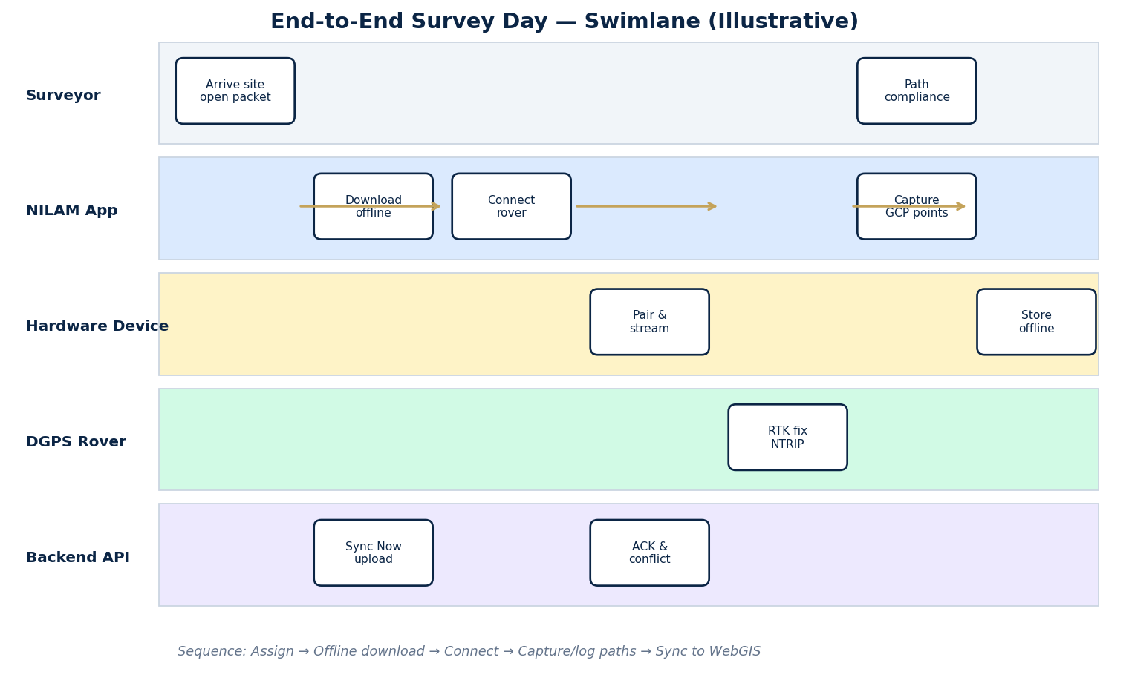
Figure 2. End-to-end survey day swimlane (Surveyor · App · Hardware · Rover · Backend).
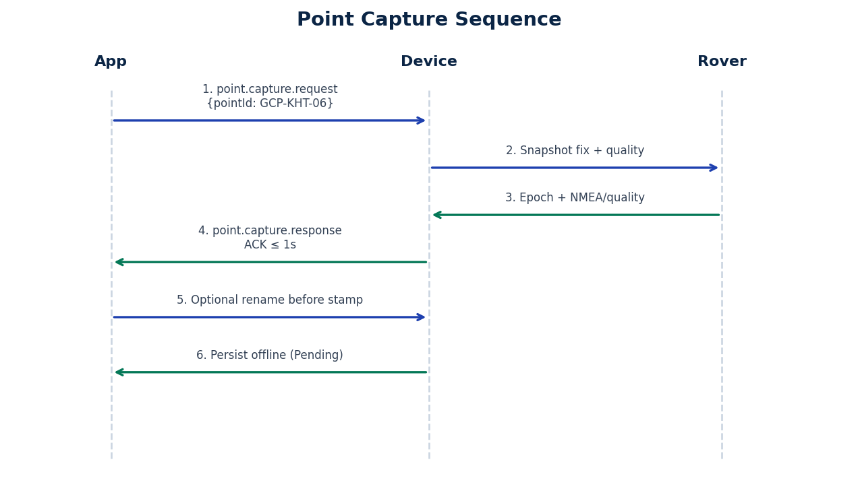
Figure 3. Point capture sequence.
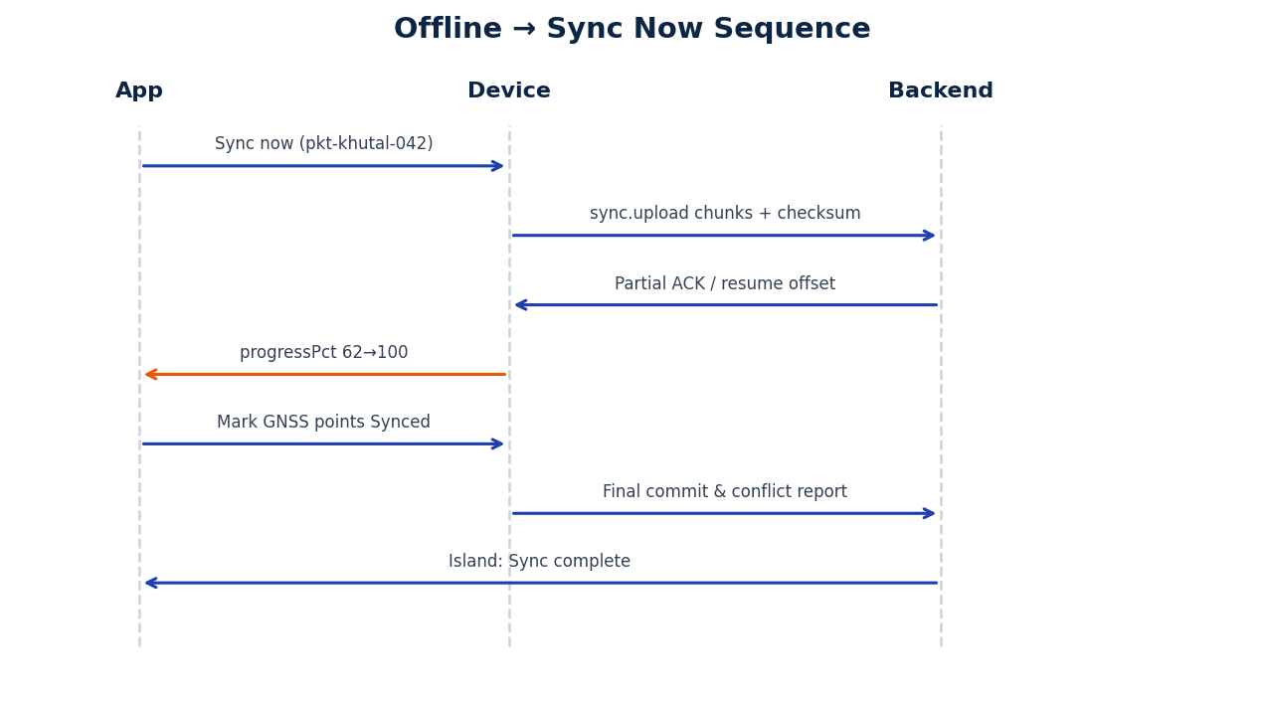
Figure 4. Offline → Sync Now sequence.
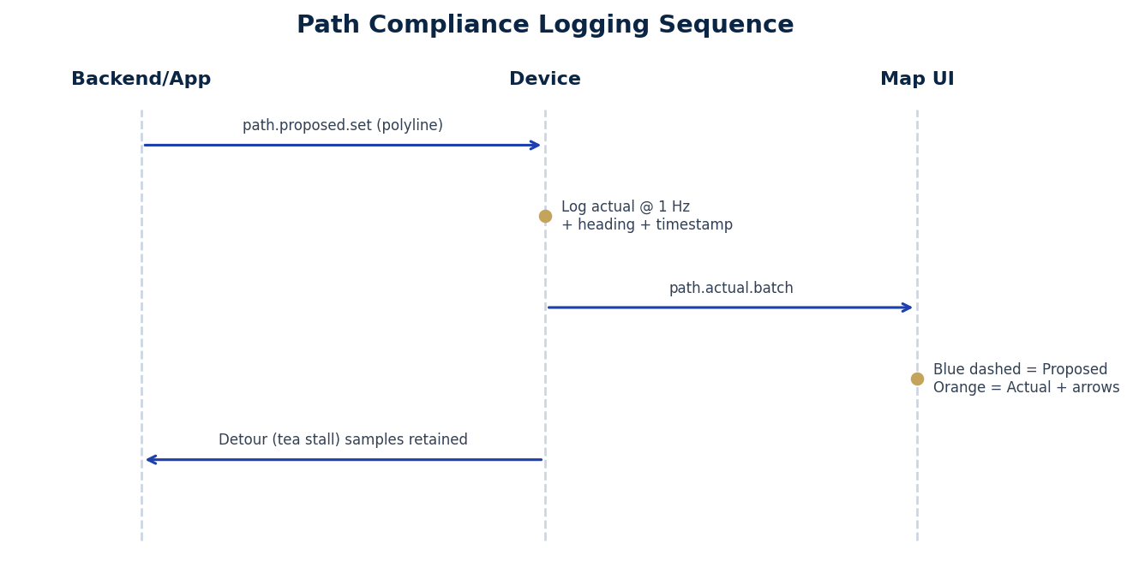
Figure 5. Path compliance logging sequence.
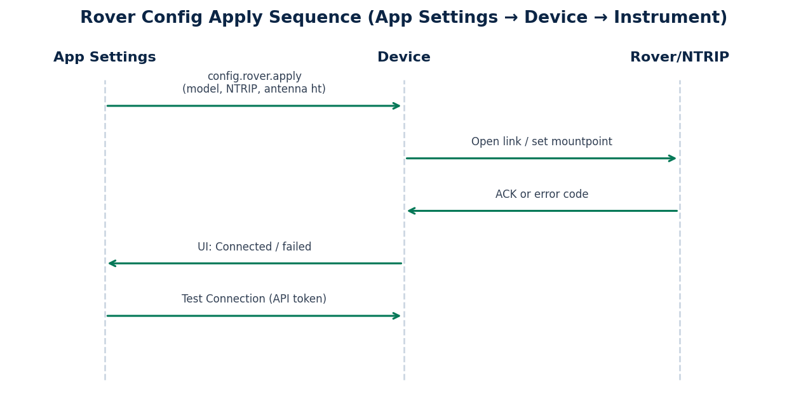
Figure 6. Rover configuration apply sequence.

11. Acceptance Test Plan
Vendor must pass the following checklist before Software integration sign-off. Evidence: logs, timing traces, and sample unit results.
ID | Test | Pass criteria
AT-01 | BLE pair + reconnect | Bond persists across App relaunch
AT-02 | Connect latency | Median ≤ 15 s; timeout ≤ 30 s
AT-03 | Six-box telemetry | All fields stream; E2E ≤ 500 ms
AT-04 | Capture ACK | p95 ≤ 1 s; durable after power cycle
AT-05 | Point ID edit | GCP-KHT-06 stamped correctly
AT-06 | Quality gate | FLOAT rejected/warned when Fixed required
AT-07 | Offline retain 14d | Points intact after simulated delay
AT-08 | Sync resume | No duplicates after 40% interrupt
AT-09 | Config apply | NTRIP fields applied with ACK
AT-10 | Path 1 Hz logging | Detour retained; headings present
AT-11 | Clock discipline | Drift corrected; stamps valid
AT-12 | OTA signed update | Bad signature rejected; rollback works
AT-13 | Storage full | STORAGE_FULL; no silent wipe
AT-14 | Security pairing | Impostor cannot read points
AT-15 | Env soak | IP & temp profile report from lab
AT-16 | ICD conformance | Golden JSON fixtures pass parser

12. Deliverables from Hardware Vendor
- Production-intent firmware images (signed) and OTA packages with release notes.
- Mobile/reference SDK or stub implementing the ICD message set.
- Interface Control Document (ICD) synchronized to this TRS V1.0.
- Sample hardware units (quantity peri procurement).
- Factory test reports: RF, environmental, battery, storage endurance.
- Diagnostic log samples for AT-01…AT-16.
- Bill of materials summary for supportability (high-level, non-IP-abusive).
- Security statement: encryption-at-rest status, pairing model, vulnerability disclosure contact.

13. Open Questions / Assumptions
Assumptions:
- Android is the primary field OS; iOS is a secondary target; current demo is web PhoneFrame.
- BLE is the preferred phone↔device link; USB-C is mandatory fallback for labs/support.
- Instrument OEM protocols may require commercial SDKs licensed by the hardware vendor.
- Emergency remains software-owned unless OEM offers an optional panic accessory.
- Illustrative demo data (Khutal, GCP-KHT-##, Trimble R12, api.nilam.tn.gov.in) may differ in production tenants.
- Backend conflict policy is authoritative for multi-device packet merges.
Open questions for vendor response:
- Will the device perform HTTPS sync directly or only bridge to the phone?
- Preferred secure element for NTRIP/API secrets?
- Which proprietary receivers are day-1 vs roadmap?
- Can path sampling raise to 5 Hz without thermal throttle in +50 °C sun?
- Lead time for IP65 sealed enclosure variants?

14. Glossary
Term | Definition
NILAM | Field/mobile cadastral survey application context within DoSLR / GeoNilam demos
DoSLR | Directorate / department WebGIS demonstration programme (platform README)
DGPS | Differential GPS — positioning with correction sources
RTK | Real-Time Kinematic centimetre-level GNSS technique
NTRIP | Networked Transport of RTCM via Internet Protocol
HDOP / VDOP / PDOP | Horizontal / Vertical / Position Dilution of Precision
NMEA 0183 | Standard ASCII GNSS sentence protocol
RTCM 3.x | Binary GNSS correction message standard
FMB | Field Measurement Book — cadastral extract artefact in broader platform
ULPIN | Unique Land Parcel Identification Number (parcel search key in mobile data)
DPR | Daily Progress Report screens in NILAM Home
GCP | Ground Control Point (Point ID prefix GCP-KHT-##)
ICD | Interface Control Document
OTA | Over-the-Air firmware update
SHALL / SHOULD / MAY | RFC 2119 requirement levels

Appendix A — Mapping to NILAM Mobile Screens
UI references below are Illustrative UI Reference wireframes derived from the PhoneFrame prototype feature set (not production screenshots of a physical device session).

Figure A1. Home / DPR (illustrative) — DPR counts fed by synced GNSS points; hardware has no direct DPR UI role.

Figure A2. Map with Proposed (blue) vs Actual (orange) paths, direction, timestamps.

Figure A3. DGPS / GNSS capture — six telemetry boxes + editable Point ID + Capture control point.

Figure A4. Field sync — Sync now, Download for offline, Khutal packets.

Figure A5. Rover Settings — model, base, NTRIP, antenna height.

Figure A6. App Settings — Database API URL, Bearer token, Test Connection.

Figure A7. Emergency — software cascade; optional hardware panic note.
UI control / screen | Hardware API / behaviour
Connect / Disconnect (Capture) | Rover session open/close; telemetry.live start/stop
Six metric boxes | telemetry.live fields
Point ID pencil edit | Pre-capture pointId on request / point.update
Capture control point | point.capture.request/response
Synced / Pending badges | synced flag after sync.upload ACK
Sync now | sync.upload + progress events
Download for offline | App/Backend primarily; Device stores proposed path + packet context
Rover Settings Save/Apply | config.rover.apply
App Settings Test Connection | Software↔API; Device only if uplink mediated
Map path legend | path.proposed.set + path.actual.batch
Emergency slide | No mandatory hardware call; optional GPS ping
DPR Home chart | Indirect — uses captured point counts post-sync
Auto-increment Point IDs toggle | Device/App collaborate on GCP-KHT-##
Min accuracy ±0.15 m RTK Fixed | Quality gate in capture path

Appendix B — Attribute Dictionary (6+ Fields)
Attribute | Unit | Typical range | Precision (display) | Update rate
Latitude | decimal degrees | −90…90 (TN ~8–13°N) | 5+ decimals (app shows 5) | ≥ 1 Hz
Longitude | decimal degrees | −180…180 (TN ~76–80°E) | 5+ decimals | ≥ 1 Hz
Accuracy | metres (horizontal) | 0.01…30+ | 0.01 m | ≥ 1 Hz
Satellite Count | count | 0…60+ | integer | ≥ 1 Hz
HDOP | dimensionless | 0.5…20+ | 0.1 | ≥ 1 Hz
VDOP | dimensionless | 0.5…20+ | 0.1 | ≥ 1 Hz
fix type (opt.) | enum | NONE…RTK_FIXED | — | ≥ 1 Hz
PDOP (opt.) | dimensionless | 0.5…20+ | 0.1 | ≥ 1 Hz
SNR mean (opt.) | dB-Hz | 20…55 | 0.1 | ≥ 1 Hz
Rover battery (opt.) | % | 0–100 | 1 | 0.2 Hz
GPS week / TOW (opt.) | week / s | GNSS time | ms | ≥ 1 Hz
Antenna height | m | 0–5 | 0.01 | on config
Path heading | radians | −π…π | 1e-3 | path rate
Path timestamp | UTC ISO | — | 1 s | path rate

Illustrative connected snapshot from Capture screen prototype: Lat 19.29352, Lng 73.52641, Accuracy 0.09 m, Satellite Count 14, HDOP 0.8, VDOP 1.2. Field packets may alternatively show coordinates near 10.92°N, 79.83°E (Thanjavur / coastal demo points GCP-KHT-12…16).
— End of Document —
NILAM Field Hardware Device Technical Requirements Specification V1.0 · 2026-07-08 · Confidential — Vendor Restricted

