EDUC8AFRICA
Capstone Assignment Completion Report
Mastering Linux Basics in 10 Levels
Name | Iddrisu Fadel
Course | Cybersecurity Essentials / Linux System Administration
Institute | Educ8Africa
Date | 19 June 2026

1. Objective
This report documents my completion of the Educ8Africa Linux capstone challenge, a 10-level, hands-on exercise covering basic navigation, file and directory management, file viewing and editing, permissions, searching and sorting, text processing, networking, process management, disk usage, and system monitoring on a Kali Linux terminal.
Each level below recaps the assigned tasks, reproduces the commands and key output exactly as run in the terminal, marks a placeholder for the corresponding screenshot, and gives an honest status (Completed / Partially Completed / Not Completed) so that any outstanding work is clear before final submission.
How to use this document: Each dashed yellow box below is a placeholder. Open the corresponding image from our chat (numbered Image 1–18) and paste it into Word in place of the matching box, then delete the placeholder text. Save the final file as Iddrisu Fadel - LinuxChallenge.docx before submitting.

2. Level-by-Level Evidence

Level 1: Basic Navigation
Tasks: print the working directory, list its contents, change into /tmp, then return to the home directory.

Commands & Output

C:\home\iddrisu> pwd
/home/iddrisu
C:\home\iddrisu> ls
calculator calculator.c calculator.c.save Desktop Documents Downloads Makefile Music Pictures Public Templates Videos
C:\home\iddrisu> cd /tmp
cd:\tmp>
C:\home\iddrisu> cd ~
C:\home\iddrisu> cd

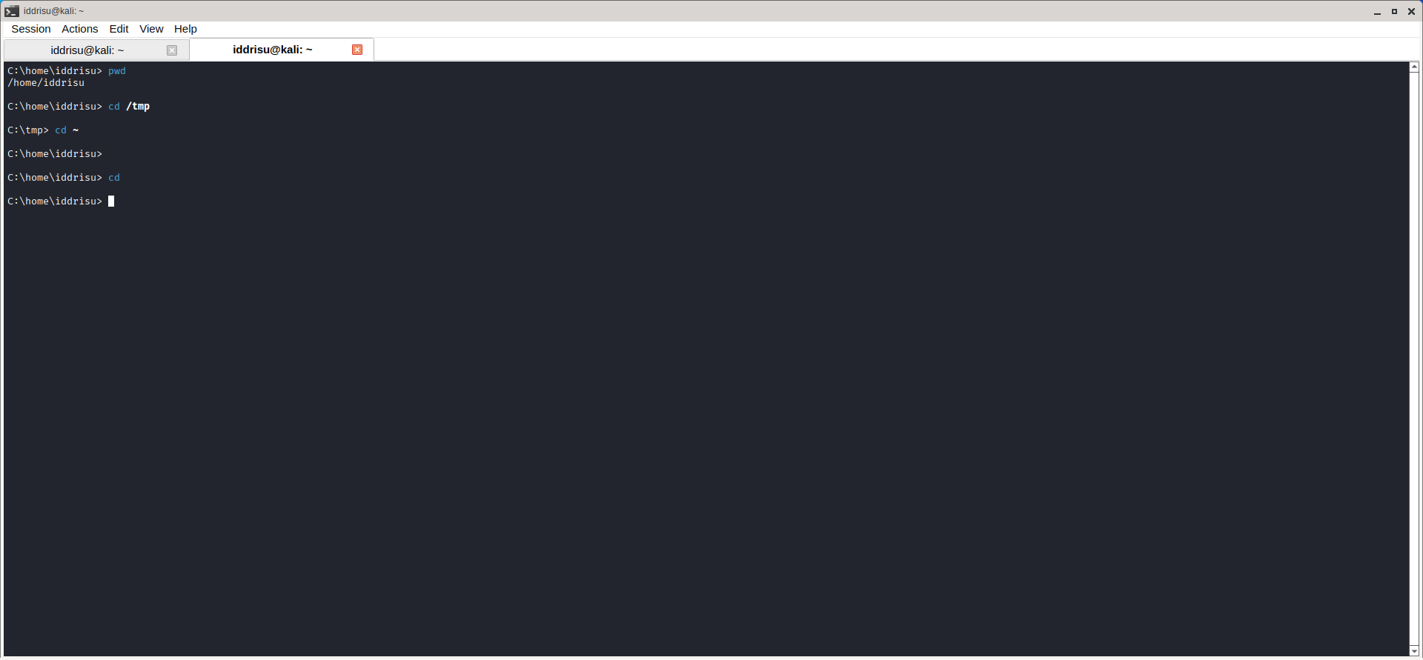

Level 2: File and Directory Management
Tasks: create directory Level2, create file.txt inside it, copy it to file_copy.txt, create directory Level2Copy, and move file_copy.txt into it.

Commands & Output

C:\home\iddrisu> mkdir Level2
C:\home\iddrisu> cd Level2
C:\home\iddrisu\Level2> touch file.txt
C:\home\iddrisu\Level2> cp file.txt file_copy.txt
C:\home\iddrisu\Level2> mkdir Leve2Copy
C:\home\iddrisu\Level2> mv file_copy.txt Leve2Copy

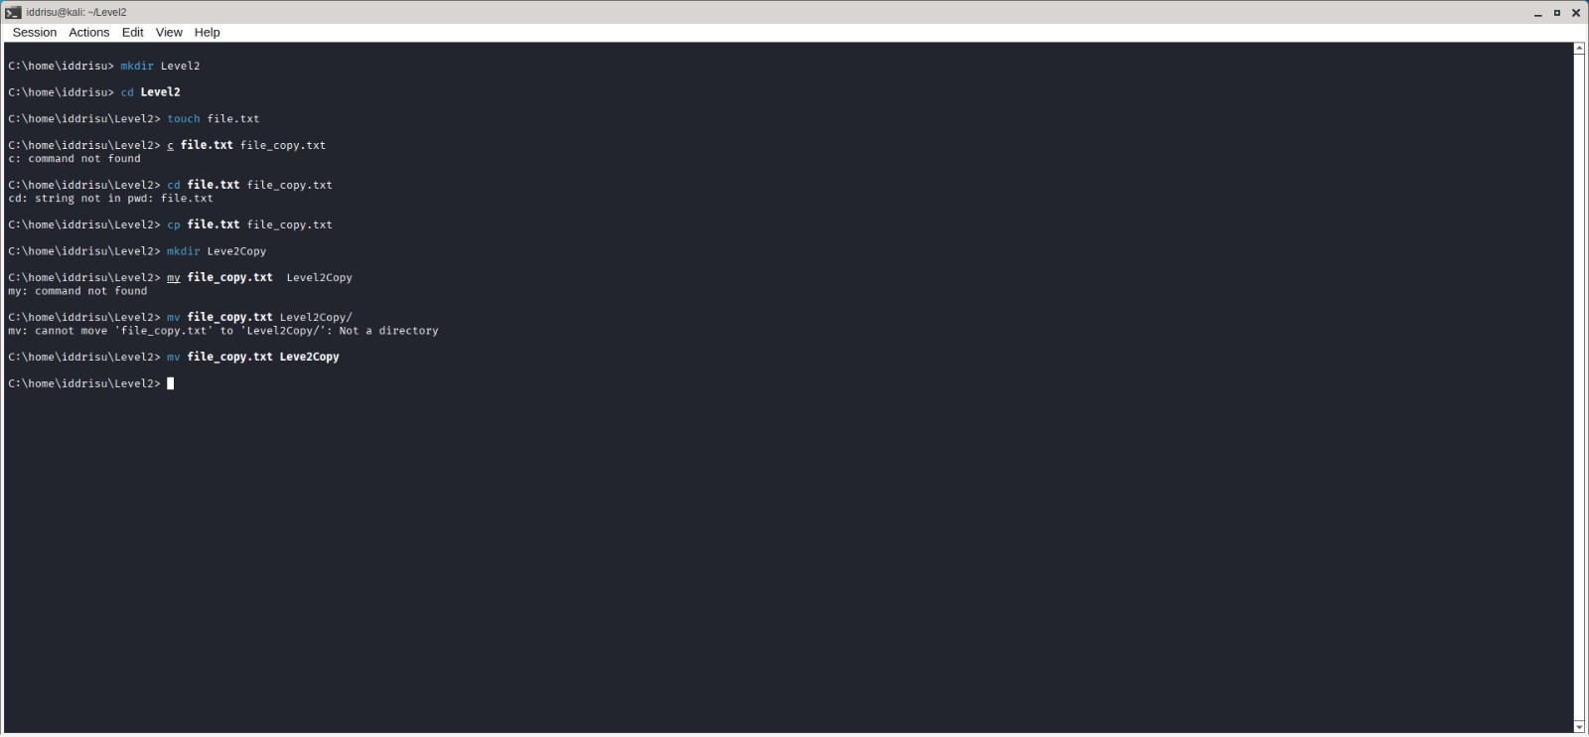

Level 3: File Viewing and Editing
Tasks: create content.txt containing "Linux is fun!", display it, append "Learning is ongoing.", then display only the first line.

Commands & Output

C:\home\iddrisu> echo "Linux is fun" > content.txt
C:\home\iddrisu> cat content.txt
Linux is fun
C:\home\iddrisu> echo "Learning is ongoing" >> content.txt
C:\home\iddrisu> head -n content.txt
head: invalid number of lines: 'content.txt'
C:\home\iddrisu> head -n 1 content.txt
Linux is fun

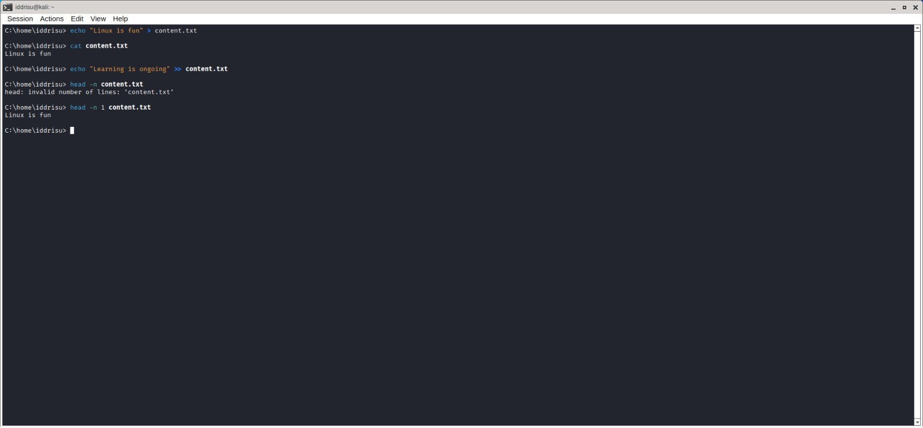

Level 4: File Permissions
Tasks: create directory Level4 with script.sh inside, set permissions to rwxr-xr-- (754), and change the owner to your user with group "users".

Commands & Output

C:\home\iddrisu> mkdir Level4
C:\home\iddrisu> cd Level4
C:\home\iddrisu\Level4> touch script.sh
C:\home\iddrisu\Level4> chmod 754 script.sh
C:\home\iddrisu\Level4> sudo chown iddrisu:users script.sh
[sudo] password for iddrisu:
C:\home\iddrisu\Level4> getent group users
Users:x:100:iddrisu
C:\home\iddrisu\Level4> ls -l script.sh
-rwxr-xr—1 iddrisu users 0 june 20 05:36 script.sh
C:\home\iddrisu\Level4>

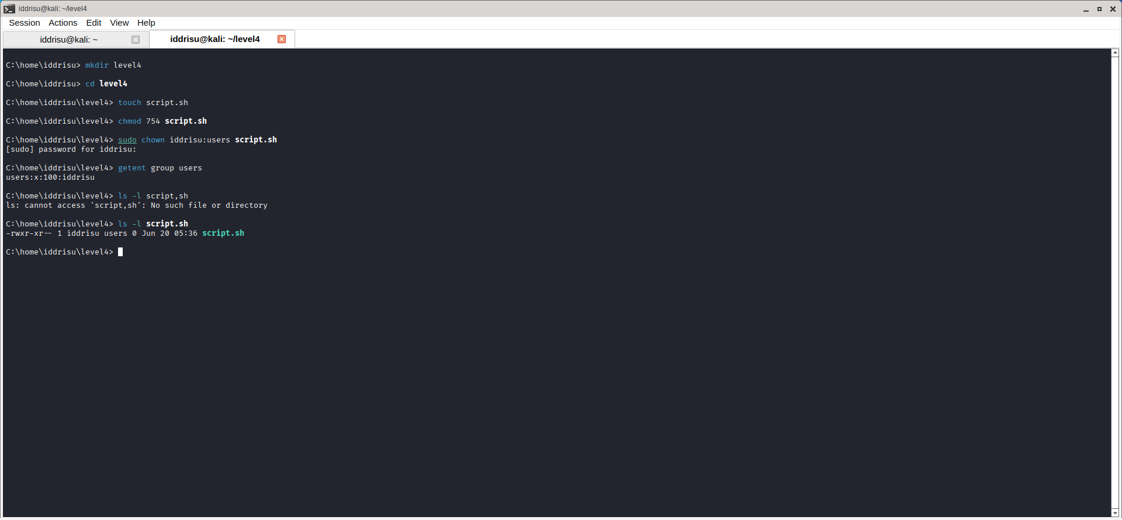

Level 5: Searching and Sorting
Tasks: create names.txt with Alice, Bob, Charlie, Diana, Eve; use grep to find lines containing the letter "a"; sort the file into sorted_names.txt.

Commands & Output

C:\home\iddrisu> cat > names.txt << EOF
heredoc> Alice
heredoc> Bob
heredoc> Charlie
heredoc> Diana
heredoc> Eve
heredoc> EOF
C:\home\iddrisu> grep "a" names.txt
Charlie
Diana
C:\home\iddrisu> sort names.txt > sorted_names.txt

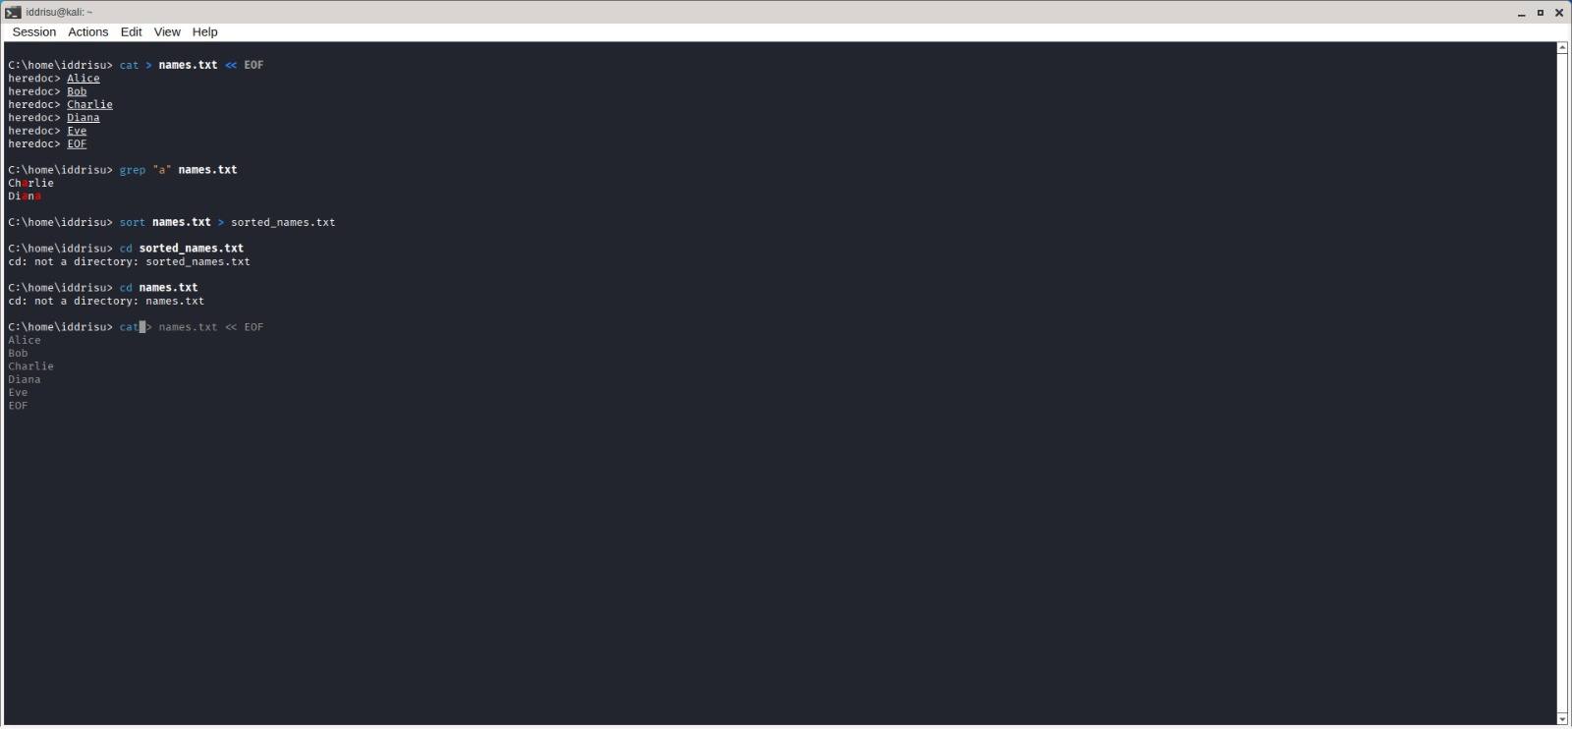

Level 6: Basic Text Processing
Tasks: create a data file with name/age/occupation columns, use awk to print names and ages, and use sed to replace "Developer" with "Programmer".

Commands & Output

C:\home\iddrisu> cat > employees.txt << EOF
heredoc> Alice Developer 30
heredoc> Bob Developer 25
heredoc> Charlie Developer 28
heredoc> Diana Developer 35
heredoc> Eve Developer 27
heredoc> EOF
C:\home\iddrisu> awk '{print $1, $3}' employees.txt
Alice 30
Bob 25
Charlie 28
Diana 35
Eve 27
C:\home\iddrisu> sed 's/Develper/Programmer/g' employees.txt (typo — no match, file unchanged)
C:\home\iddrisu> sed -1 's/Developer/Programmer/g' employees.txt
sed: invalid option -- '1'
C:\home\iddrisu> sed -i 's/Developer/Programmer/g' employees.txt (corrected flag — ran successfully)

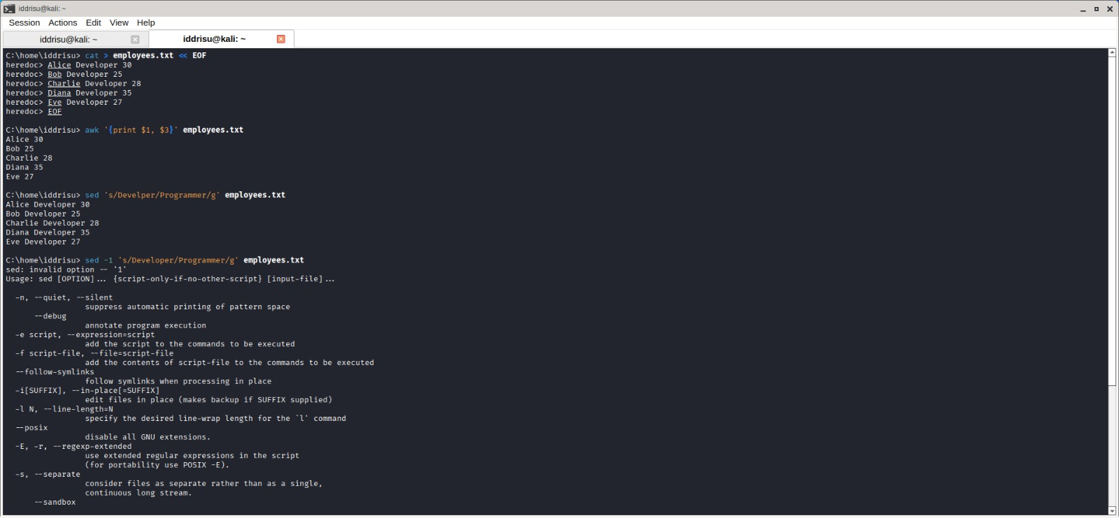
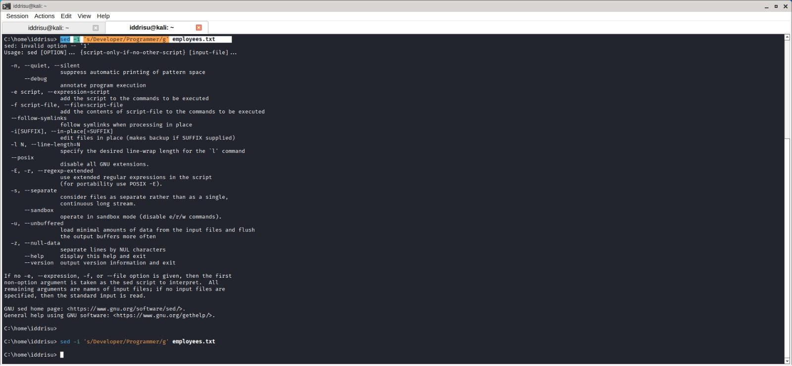

Level 7: Networking Basics
Tasks: display the machine's IP address, ping google.com to check connectivity, and display the network interfaces.

Commands & Output

C:\home\iddrisu> ip addr show
2: eth0: ... inet 10.0.2.15/24 ... eth0
C:\home\iddrisu> ping google.com
64 bytes from wk-in-f102.1e100.net (74.125.206.102): icmp_seq=1 ttl=255 time=186 ms
... (continuous replies, manually stopped with Ctrl+C) ...
--- google.com ping statistics ---
39 packets transmitted, 39 received, 0% packet loss
C:\home\iddrisu> ping -c 4 google.com
4 packets transmitted, 4 received, 0% packet loss
C:\home\iddrisu> ip link show
1: lo: <LOOPBACK,UP,LOWER_UP> ... 2: eth0: <BROADCAST,MULTICAST,UP,LOWER_UP> ...
C:\home\iddrisu> ifconfig -a
eth0: flags=4163<UP,BROADCAST,RUNNING,MULTICAST> ... inet 10.0.2.15 netmask 255.255.255.0
lo: flags=73<UP,LOOPBACK,RUNNING> ... inet 127.0.0.1 netmask 255.0.0.0

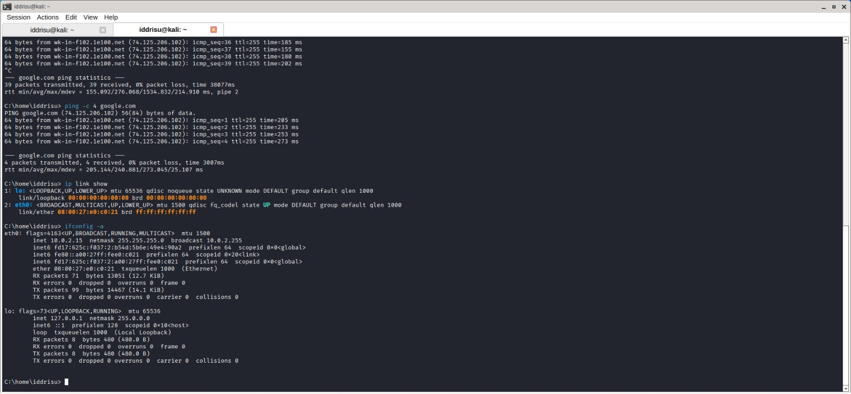
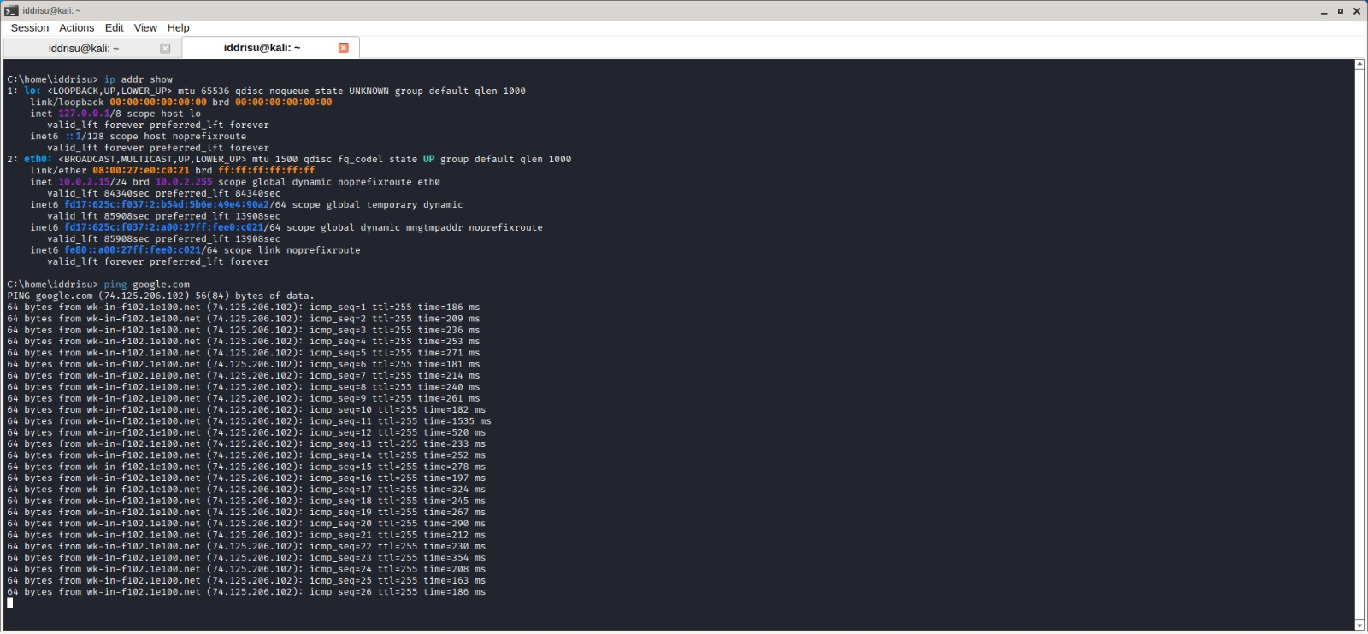

Level 8: Process Management
Tasks: list all running processes, show the details of the highest-CPU process, and safely kill a process by its PID.

Commands & Output

C:\home\iddrisu> ps aux
... full process table (USER, PID, %CPU, %MEM, COMMAND, etc.) ...
C:\home\iddrisu> top
... load average, CPU/MEM summary, live sorted process table ...
C:\home\iddrisu> cat > sleep_script.sh <<EOF
heredoc> #!/bin/basj
heredoc> sleep 300
heredoc> EOF
C:\home\iddrisu> chmod +x sleep_script.sh
C:\home\iddrisu> ./sleep_script.sh &
zsh: ./sleep_script.sh: bad interpreter: /bin/basj: no such file or directory
[1] + exit 127 ./sleep_script.sh
C:\home\iddrisu> ps aux | grep sleep_script
iddrisu 3341 ... grep --color=auto sleep_script
C:\home\iddrisu> kill 3341
kill: kill 3341 failed: no such process
C:\home\iddrisu> kill 3341 33.3 0.1 2348
kill: illegal pid: 33.3 / kill: illegal pid: 0.1 / kill: kill 2348 failed: no such process

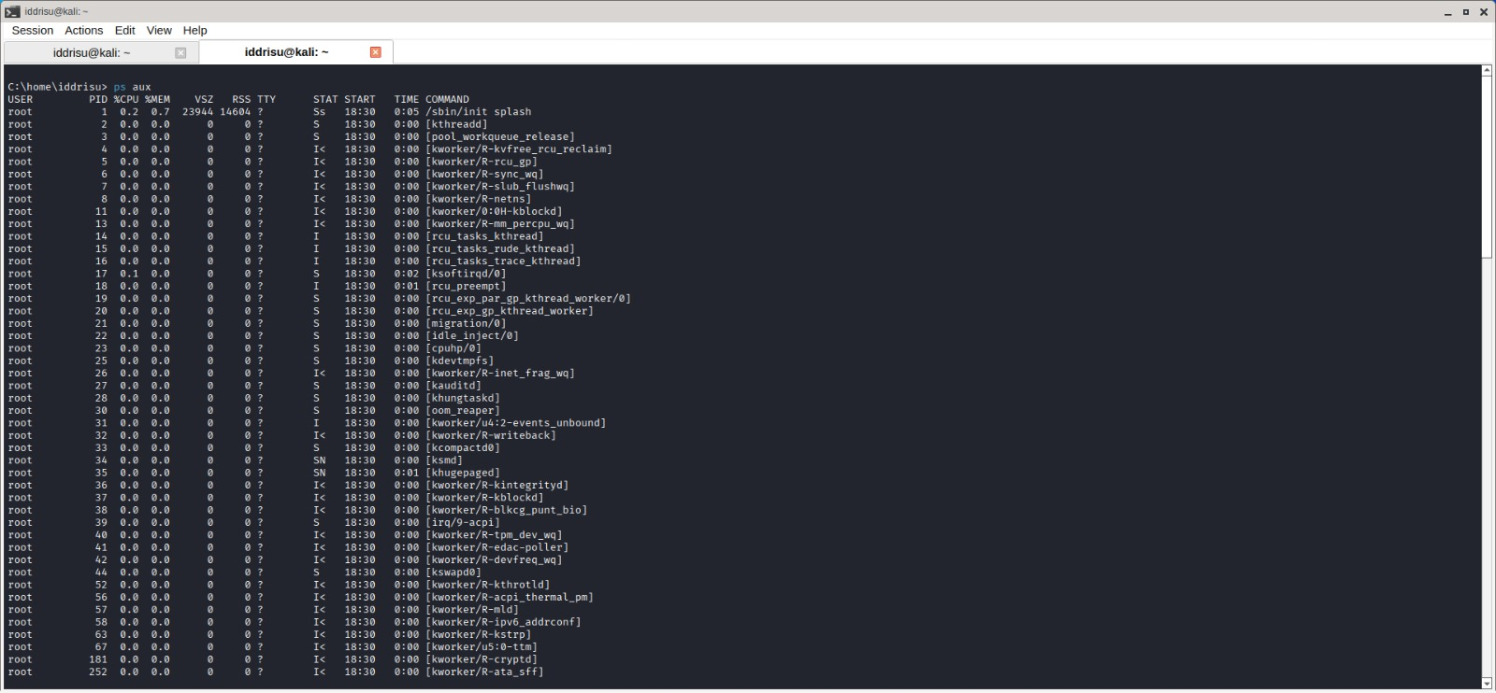
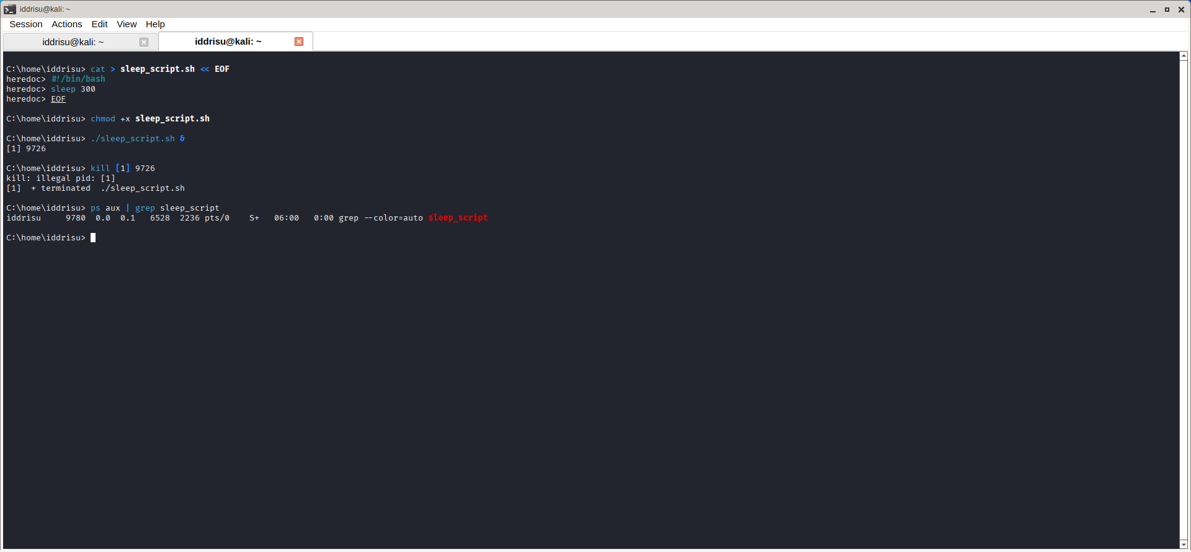
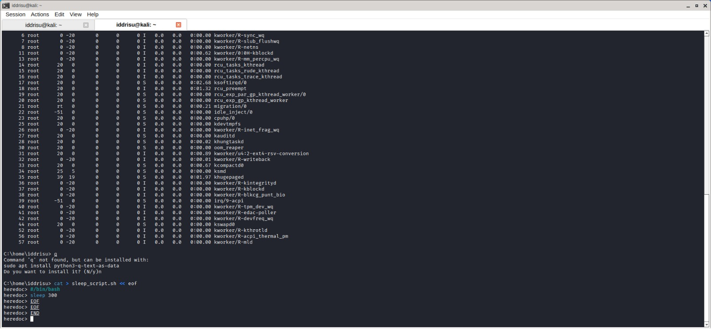

Level 9: Disk Usage and Storage
Tasks: show the disk usage of the home directory, find the top 5 largest files, and display free disk space.

Commands & Output

C:\home\iddrisu> du -sh ~/
149M /home/iddrisu/
C:\home\iddrisu> du -h ~/ | sort -hr | head -10
... top directories by size (.cache, .mozilla, .maltego, etc.) ...
C:\home\iddrisu> find ~ -type f -exec ls -lh {} \; | sort -k5 -hr | head -5
... top 5 largest files listed with size, date, and path ...
C:\home\iddrisu> df -h
... filesystem size/used/available table, including / at 90% use ...

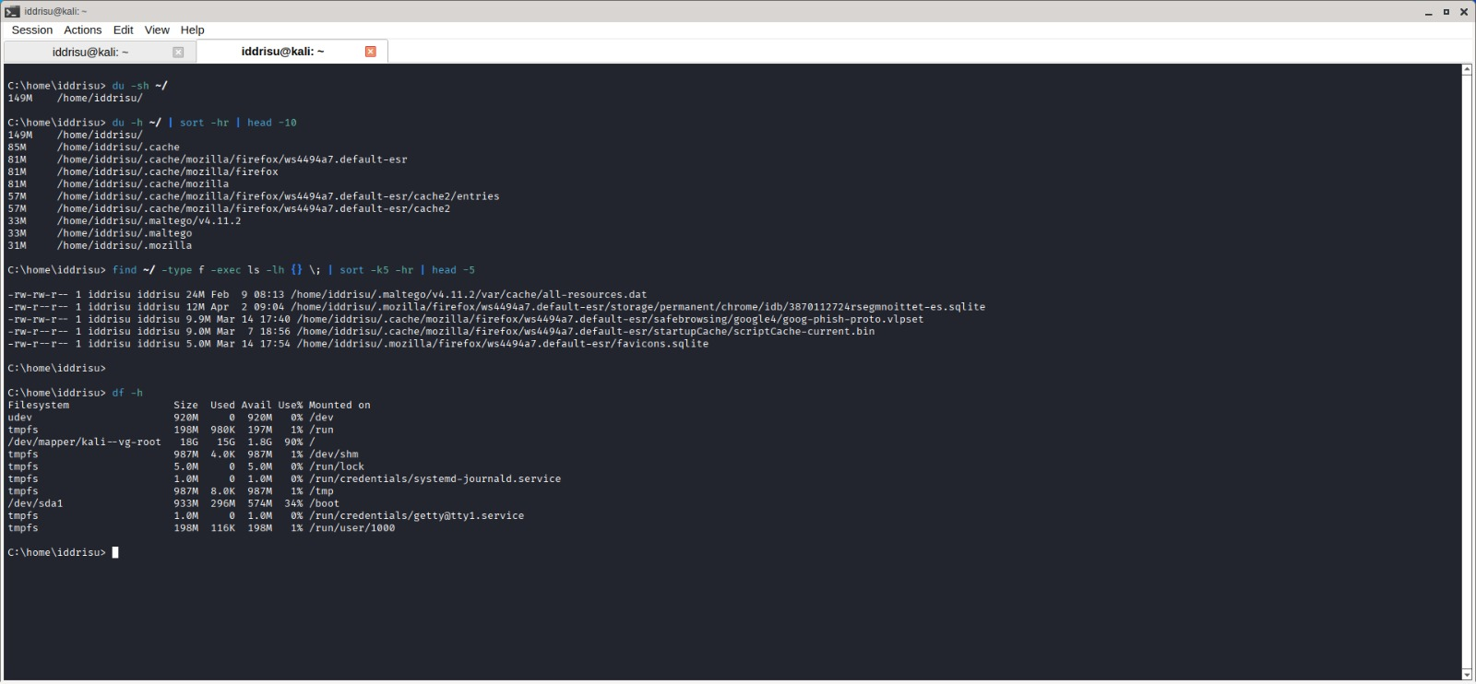

Level 10: System Monitoring and Logging
Tasks: display the last 20 lines of the system log file, monitor the log in real time, and grep for log entries containing "error".

Commands & Output
C:\home\iddrisu> sudo journalctl -n 20
C:\home\iddrisu> sudo journalctl -f
C:\home\iddrisu> sudo journalctl | grep -i error

