Available online at www.sciencedirect.com




Procedia Computer Science 00 (2018) 000–000

www.elsevier.com/locate/procedia

3rd International Conference on Computer Science and Computational Intelligence 2018

Permutation Modification of Reversible Data Hiding Using Difference Histogram Shifting in Encrypted Medical Image
Muhammad Fadhlan Putranto^{a,} , Ari Moesriami Barmawiª, Bambang Ari Wahyudiª
- Telkom university, Telekomunikasi Street No. 01, Bandung, 40267, Indonesia

Abstract

Recently, preserving the integrity of medical record, especially image medical record is important. One method for preserving the integrity is reversible data hiding (RDH) proposed by Huang et al. Reversible data hiding algorithm can recover the original image from marked image. In this paper, we implement reversible data hiding (RDH) on medical image because the correlation between the neighboring pixel can be preserved in encrypted image. In RDH, plain image is encrypted using specific encryption algorithm that consists of two processes (stream encryption algorithm and block permutation). However, since RDH used fixed block permutation, the security is weak against known plain text attack. To overcome this problem, dynamic permutation was proposed, such that the permutation would be specific for one session. In other session, different permutation would be used. Based on the experiment’s result, it was shown that the security of the proposed method against known plain text attack is stronger than the previous method’s one.

c 2018 The Authors. Published by Elsevier Ltd.

This is an open access article under the CC BY-NC-ND license (https://creativecommons.org/licenses/by-nc-nd/4.0/)
Selection and peer-review under responsibility of the 3rd International Conference on Computer Science and Computational Intel-ligence 2018.

Keywords: Reversible Data Hiding; Difference Histogram Shifting; Encrypted Image;

1. Introduction

Due to the increasing use of internet, data security is getting important especially for preserving the integrity and the confidentiality of medical image (such as X-ray image, MRI etc). One method for preserving the data integrity is steganography. There are several steganography methods that has been proposed, and one of them is reversible data hiding (RDH) proposed by Ni ¹. RDH is one of the data hiding technique, where the original image can be completely recovered after the embedded data have been extracted out². Reversible data hiding will have benefits when true fidelity is needed, in the case of medical images. True fidelity is needed for medical image, because modifying on medical image can be deliberately dangerous or inadvertently affect the content interpretation. For example, uninten-

I

Corresponding author. Tel.: +62-813-1218-56900.

E-mail address: fadhlanputranto@student.telkomuniversity.ac.id

1877-0509 c 2018 The Authors. Published by Elsevier Ltd.

This is an open access article under the CC BY-NC-ND license (https://creativecommons.org/licenses/by-nc-nd/4.0/)

Selection and peer-review under responsibility of the 3rd International Conference on Computer Science and Computational Intelligence 2018.
2 Muhamamd Fadhlan Putranto et al. / Procedia Computer Science 00 (2018) 000–000

tional changes in X-ray images may cause misdiagnosis, which may result in criminal and legal offenses that could harm various parties. Therefore, RDH is designed to solve the problem.
The classical RDH schemes uses three fundamental strategies: lossless compression³, difference expansion (DE) ⁴, and histogram shifting (HS)¹. In the proposed, method difference histogram shifting (DHS) ⁵ algorithm for data hiding is used. The proposed method used DHS because DHS has large embedding capacity and high fidelity. The main idea of this method is to explore the correlation between the neighboring pixels in a cover image. Then the additional message can be reversibly embedded into the cover image by modifying the difference histogram. It means that, the cover image can be completely recovered after message extraction. However, using this method, additional message can’t be embedded into the encrypted image, because the correlation between the neighboring pixels does not exist anymore.

In this paper, we focus on preserving correlation between neighboring pixel. However, since Huang’s ⁶ method uses static permutation (one permutation for all session), then it is easy to recover the encrypted image if the attacker has obtained the permutation for a specific session. The attacker who has access plain image and cipher image may obtain the permutation using know plain text attack. In this case, suppose the sender is the doctor and the attacker are the nurse who does not know the encryption system but she knows the plain image and can access the cipher image. In this case, she can obtain the static permutation from plain images cipher images and implement this permutation to impersonate the doctor. By implementing the permutation, she can embed fake secret message into the plain image and send it to the receiver. To overcome this problem, dynamic permutation was proposed. Using dynamic permutation, the permutation for one session is different with the others. As the impact, even the attacker knows the plain image and the related cipher image of several sessions, he/she can’t obtain the permutation because the permutation for one session is different with the others.

2. Huang et al. Method

Huang et al⁶ proposed a new framework to preserve the correlation between neighboring pixel of an encrypted image. Huang method consisted of two sub-processes; image encryption and embedding process as shown in Fig.1(a). The encryption algorithm includes two sub-processes: stream encryption and permutation. In the stream encryption process, the plain image I is divided into N non-overlapping sub-blocks fB₁, B₂, . . . , B_{N} g. The size of each sub-block is m X n and block numbering begin from the leftmost to the right blocks. This numbering method will be repeated for each row of blocks. Let P_{i;} _{j}(1 i N,1 j m X n) denotes one of the pixels in sub-block B_{i}, where i represents the index of a sub-block, and j represents the index of the pixel in the sub-block B_{i} . In each sub-block, the pixels numbering begins from the leftmost to the right pixel. This numbering method will be repeated for each row of pixels. Furthermore, each pixel value is ex-or-ed with (key-1), then permuted using (key-2) based permutation. In data hiding process, they uses difference histogram shifting and prediction-error histogram shifting for hiding additional data to the encrypted image. Based on Huang’s experiment, the receiver can decrypt the marked image and the PSNR of the marked image is 48dB.
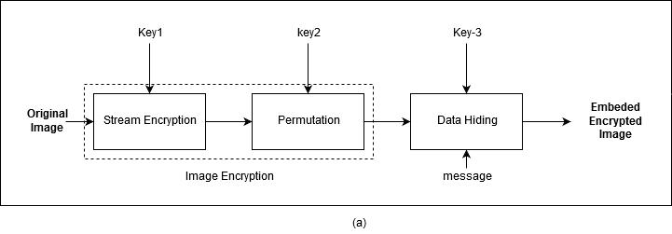
Muhamamd Fadhlan Putranto et al. / Procedia Computer Science 00 (2018) 000–000 | 3
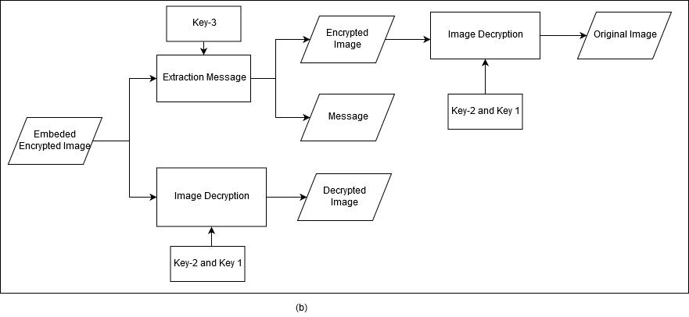

Fig. 1: Block Diagram of Huang et al a) Data hiding process b) Data extraction and image restoration

3. Proposed Method

The proposed method consisted of two processes, embedding (Fig.2 ) and extracting method (Fig.3). Embedding method consisted of two process, image encryption and data hiding, while extracting method consisted of data extraction and image recovery processes. In the proposed method, Huang’s method is used for image encryption, but with modification in permutation process, by implementing dynamic permutation to scramble all sub-blocks in encrypted medical image. Dynamic permutation is a permutation based on polynomial congruence, such that for each session with the same receiver a unique key is applied.
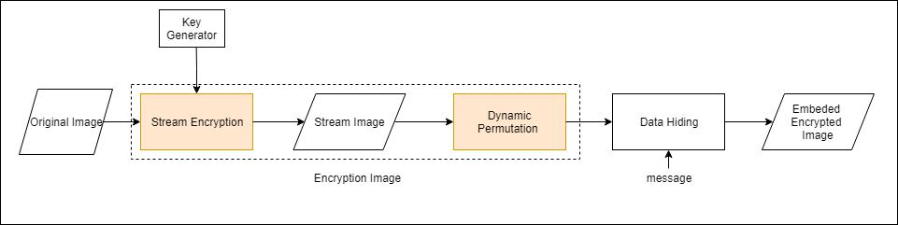

Fig. 2: Embedding process of the proposed method

3.1. Embedding

The embedding process consisted of two processes i.e. image encryption and data hiding, as shown in Fig.2. Since the correlation between neighboring pixel should be preserved after image encryption, we could implement RDH independently, such that the receiver may either decrypt the encrypted image without extracting the embedded message or decrypt the encrypted image after extracting the embedded message.

3.1.1. Image Encryption Algorithm

The encryption algorithm consisted of two processes, i.e. specific stream encryption and permutation. For pre-serving the correlation between neighboring pixel after image encryption, Huang’s stream encryption was used. In encryption process, the cover image I was divided into N non-overlapping sub-blocks ( B₁, B₂, . . . , B_{N} ). The sub-blocks size used in this research is 3 x 3 and block numbering begins from the leftmost to the right blocks. Then, we have N sub-block with 9 pixels in each sub-block. Let P_{i;} _{j}(1 i N,1 j 9) denotes pixel value of j^{th} pixel in sub-block B_{i}, where i represents the index of a sub-block, and j represents the index of the pixel in the sub-block B_{i}.
4 Muhamamd Fadhlan Putranto et al. / Procedia Computer Science 00 (2018) 000–000

For generating N encryption keys K_{i} ( a key for encrypting block B_{i}) and RC4 key scheduling algorithm was used. To preserve correlation between neighboring pixels after image encryption, each sub-block is encrypted with the same key. For encrypting the sub-block B_{i}, each Pixel P_{i;} _{j} of the cover image and K_{i} should be bit-wise ex-or-ed one another, as shown in Eq.1.

E_{i;} _{j} = P_{i;} _{j} K_{i}(1 i N; 1 j 9) | (1)
For block permutation, polynomial congruence (as shown in Eq.2) was introduced, where g is a number between 1 and P-1 and must be relatively prime to P, and x is the index of the sub block. For permuting sub blocks, N number of Y_{i} should be generated. Then we swap all pixels in the sub-block x with the one in sub-block Y_{i}. In this step, we only permuted sub-block while the pixel within each sub-block is preserved.

Y_{i} = g^{x} mod P | (2)

3.1.2. Data Hiding

In this phase, we used RDH algorithm for embedding additional message into the encrypted image. After image encryption process, the higher points of difference histogram in encrypted image situated at 0 and 1 and correlation between the neighboring pixel still preserved ⁶, such that we can easily accomplished RDH algorithm in the encrypted domain. In this paper, we used differences histogram shifting (DHS) based method.We used DHS because of their large embedding capacity and high fidelity. The main idea from this method is to explore the correlation between the neighboring pixels in a cover image. In the beginning, we divide the encrypted image into sub-block with size 3 x 3 and the pixel in the encrypted image is represented by C_{i;} _{j}(1 i N_{E} ,1 j 9), where N_{E} represented the number of sub-block.

To avoid the overflow or underflow during the embedding process, we modified the pixel with pixel value 0 or 255 and noted in a location map L (initialized to be empty) as discussed in ⁷. To implement this method, chose pixels sequentially and appended a bit “0” to L if C_{i;} _{j} 2 f1; 254g. If C_{i;} _{j} 2 f1; 255g, appended a bit “1” to L and modify C_{i;} _{j} to
0
C_{i;} _{j} using Eq.3.
 | C_{i}⁰; _{j} | = | 8 | 1; | i f Ci; j = 0 | (3)
 |  |  | > | 254 | i f C_{i;} _{j} = 255
 |  |  | >
 |  |  | > |  | otherwise
 |  |  | >C_{i;} _{j}; |  | otherwise
 |  |  | >
 |  |  | <
 |  |  | >
 |  |  | >
 |  |  | >
 |  |  | >
 |  |  | :
After modifying the pixel, we embedded | additional message into encrypted domain via modifying the difference
After modifying the pixel, we embedded |  |  | >
histogram. Difference value in each block is calculated using Eq.4.

^{D}i j ⁼ ^{C}i; j ^{C}i;1
Finally, eq 5 is used for finishing the embedding process.

 |  | C_{i}⁰; _{j} |  |  |  |  | 1; i f D_{i;} _{j} < 1
00 | = | ⁸_{Ci}0; _{j} |  |  |  |  | b; |  | i f D_{i;} _{j} | = |  | 1
^{C}i; j | = | > | 0
 |  | > | 0 |  |  | + |  | ; |  | =
 |  | > |  | ; |  | + | b | ; | i f D_{i;} _{j} | = | 0
 |  | >_{C} | i | ; | j |  | b |  | i f D_{i;} _{j} |  | 0
 |  | > | i |  | j
 |  | >
 |  | > | 0
 |  | > | 0
 |  | <
>
>
>
>
>
>
>
>C + 1; i f D ; > 0
:
i; j ^{i j}

(4)

(5)

where b 2 [0,1] is a message bit to be embedded and message will embedded if the difference value is equal to -1 or 0.

3.2. Data Extraction

In this process , we have two scenarios. In the first scenario, we can decrypt the stego-encrypted image sent by the sender. This scenario was used if the patient would like to see the medical image directly without knowing the embedded message. For realizing this scenario, the receiver should conduct inverse permutation and decrypt the

Muhamamd Fadhlan Putranto et al. / Procedia Computer Science 00 (2018) 000–000 | 5
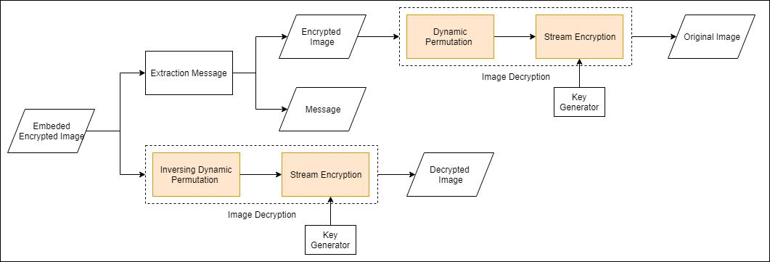

Fig. 3: Block Diagram Extraction and Decryption Image

result using the key generated by the key generator. The key was obtained by calculating it using Eq.2. After inversing the dynamic permutation, then we generated random number using RC4 key scheduling and perform the bit-wise exclusive-or (XOR) operation to each sub-block in the image following Eq.1. In the second scenario, the embedded message was extracted using Eq.6, where b is the extracted bits represented the message. Then, we decrypted the image using similar method as in the first scenario.

 | 8 | 1; |  |  | i f C_{i}⁰⁰; _{j} |  | C_{i}⁰⁰; _{j} |  | = 1; |  |  | 2
b = | > | 0; |  |  | i f C_{i}⁰⁰; _{j} |  | C_{i}⁰⁰_{;1} |  | = 0; |  | 1
 | >
 | <
 | >
 | >
Furthermore, restore the image using Eq.7. | :
C_{i}⁰; _{j} = | C_{i}⁰⁰; _{j} 1; i f C_{i}⁰⁰; _{j} C_{i}⁰⁰_{;1} > 0 |  |  |  |  |  |  |  |  |  |  |  |  | 1
C_{i}⁰; _{j} = | ⁸_{Ci}00; _{j} |  |  | + 1; i f C_{i}⁰⁰; _{j} |  |  |  |  |  | C_{i}⁰⁰; _{j} | < |  |  | 1
 | > |  | 00
 | > |  | 00
 | >
 | >C |  | i; j | ; | otherwise
 | > |  | i; j
 | <
 | >
>
>
>
>
:

(6)

(7)

where C_{i;} _{j} represented the restore pixel value. After image restoration, the original encrypted image can be recovered using the extracted location map (L) represented by |  |  |  |  | Eq.8.
C_{i;} _{j} | = | 8 | 255; |  | i f C_{i}⁰ | ; _{j} = 254 | (8)
C_{i;} _{j} | = | 8 | 0; |  | i f C_{i}⁰ | ; _{j} = 1 | (8)
 |  | >
 |  | > | 0
 |  | > | i; j
 |  | > | i; j
 |  | <
 |  | >
 |  | >
 |  | >
 |  | > |  |  | otherwise
 |  | >C ;
 |  | >
:

(a) Image 1 (b) Image 2 (c) Image 3 (d) Image 4 (e) Image 5 (f) Image 6 (g) Image 7
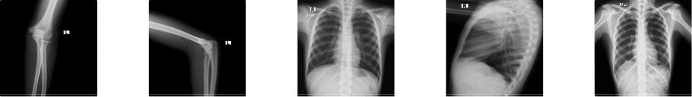

(h) Image 8 (i) Image 9 (j) Image 10 (k) Image 11 (l) Image 12

Fig. 4: Test Image

6 Muhamamd Fadhlan Putranto et al. / Procedia Computer Science 00 (2018) 000–000

4. Experiment Result and Analysis

In this section, we describe our experiment which consisted of experiment and analysis on image encryption, visual quality, embedding capacity, and security analysis. These experiments used twelve medical images with size of 1024 x 1024 pixels as the test image as shown in Fig.4.

Table 1: Comparison of The Pixel Distribution between Previous and Proposed Method

Previous Method Proposed Method
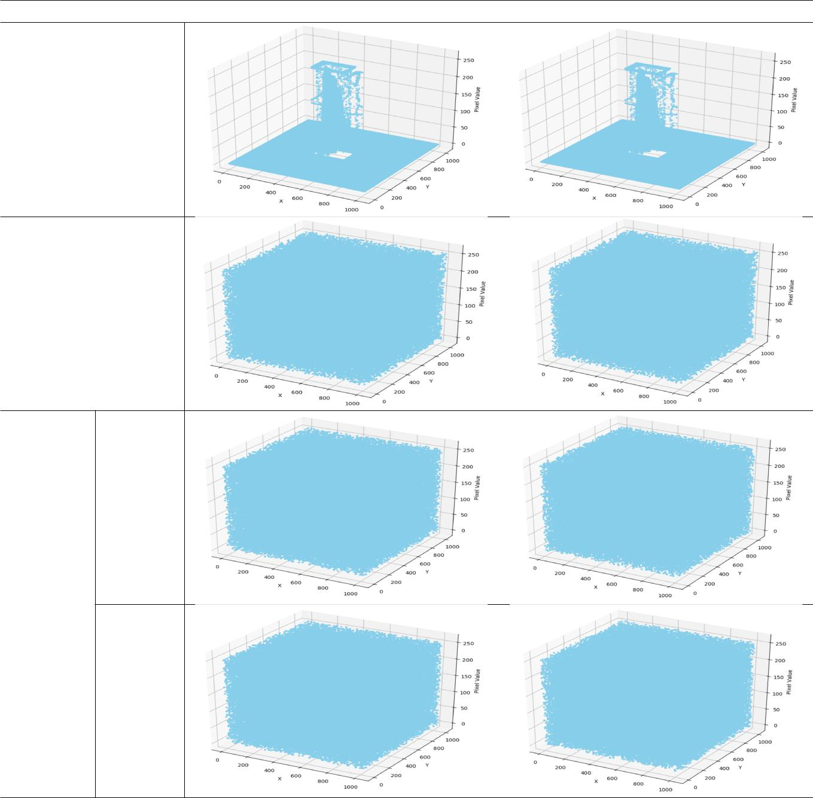

Original

Image

(Image 1)

Encrypted

Image

Permuted Session 1

Encrypted

Image

Session 2

4.1. Security Analysis

In implementation of encryption process, the generated key was reused for 9 pixels. So, the encryption process may leak the difference information between the neighboring pixel in the same sub-block. For analyzing the security of the proposed method, we have to calculate the probability of obtaining the secret image. Based on the basic concept of the proposed method, an attacker may obtain the difference value between two pixels if the attacker can intercept
Muhamamd Fadhlan Putranto et al. / Procedia Computer Science 00 (2018) 000–000 | 7

two pixels encrypted with the same key. Thus, for securing the secret message, permutation is applied. However, if the permutation is static, then the key of the permutation can be obtained by the attacker using known plain text attack. To secure our proposed framework, a dynamic permutation algorithm is conducted using Eq.2. To restore the original image, the attacker must restore the original arrangement of the sub-block. For obtaining the encrypted image, the attacker should find the invers of the dynamic permutation. Suppose the probability of a successful known plain text attack on an encryption system is 1 / u, then using a static permutation the probability of success is 1 / u. Meanwhile, when using dynamic permutations the probability of successfully performing a known plain text attack on an encryption system would be 1 / (u.N)! or 1/N! less than when using static permutations, where N is the number of sub-block. Thus, the security level of the proposed method will increase such that it is greater than the security level of Huang’s method.

Table 2: Comparison of The Pixel Value Difference between Previous and Proposed Method

Previous Method Proposed Method
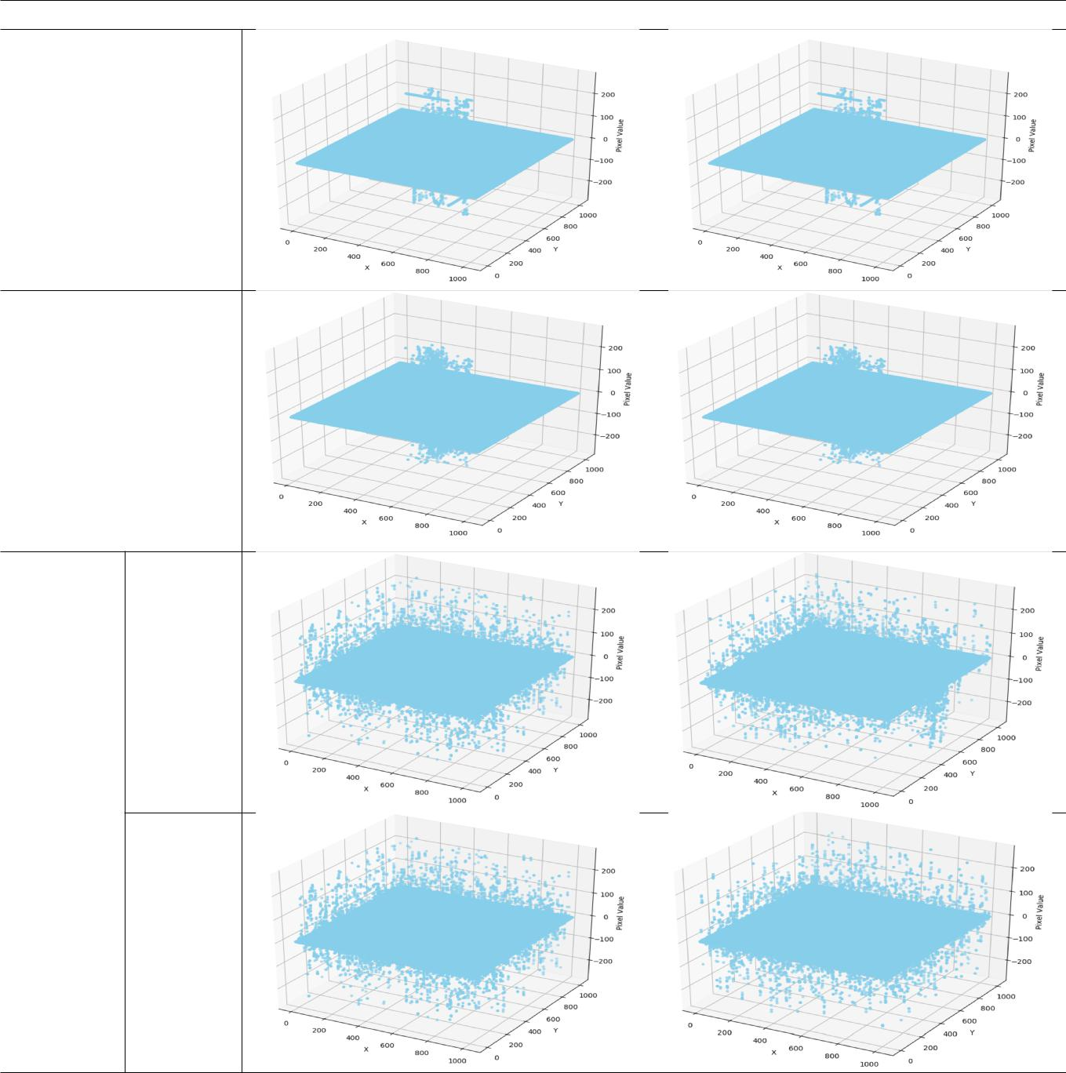

Original

Image

(Image 1)

Encrypted

Image

Permuted Session 1

Encrypted

Image

Session 2
8 Muhamamd Fadhlan Putranto et al. / Procedia Computer Science 00 (2018) 000–000

4.2. Experiment and Performance Analysis of The Proposed Method

This section discusses about the experiment conducted for observing the correlation between neighboring pixels in the encrypted image, the recovered and decrypted image quality, as well as the embedding capacity.

Suppose in session 1 we encrypted image (a), then permuted it using key 1. Based on the proposed method, in the second session we encrypted image (a), then permuted it using another key, while using the previous method, they used key 1 to permute the encrypted image in session 2. The result of encryption and permutation process is shown in Table.2. Based on the difference histogram, it is shown that the correlation between neighboring pixel of encrypted image could be preserved because the pixels are still randomly distributed as shown in Table.2, even we used different permutation. However, the pixel value differences were slightly different between the first and second session. this condition was occurred because of the different permutation. Thus, since the permutation key of each session is unique, then it is harder to obtain the key than using similar key for all session as has been discussed in subsection 4.1.

Table 3: Visual Quality of Recovered Image (PSNR 1) and Decrypted Image Without Message Extraction (PSNR 2)

 | DHS1 |  |  |  | DHS3
 | Previous |  | Proposed |  | Previous |  | Proposed
 | Method |  | Method |  | Method |  | Method
 | PSNR1 | PSNR2 | PSNR1 | PSNR2 | PSNR1 | PSNR2 | PSNR1 | PSNR2
Image 1 | 69,160 | 31,680 | 69,160 | 31,950 | 69,160 | 26,163 | 69,160 | 26,408
Image 2 | 69,196 | 26,540 | 69,190 | 26,520 | 69,196 | 25,410 | 69,196 | 25,409
Image 3 | 69,120 | 26,400 | 69,129 | 26,400 | 69,120 | 25,420 | 69,129 | 25,425
Image 4 | 69,188 | 25,220 | 69,188 | 25,225 | 69,188 | 25,190 | 69,188 | 25,194
Image 5 | 69,118 | 25,985 | 69,118 | 25,989 | 69,118 | 25,985 | 69,118 | 25,989
Image 6 | 69,415 | 28,799 | 69,415 | 28,830 | 69,415 | 26,801 | 69,415 | 26,855
Image 7 | 69,015 | 28,210 | 69,008 | 28,120 | 69,015 | 27,411 | 69,008 | 26,480
Image 8 | 69,290 | 28,210 | 69,293 | 28,330 | 69,290 | 25,148 | 69,293 | 25,233
Image 9 | 69,192 | 28,170 | 69,198 | 28,206 | 69,192 | 24,000 | 69,198 | 25,099
Image 10 | 69,177 | 25,996 | 69,170 | 25,910 | 69,177 | 25,650 | 69,170 | 25,612
Image 11 | 69,210 | 26,194 | 69,207 | 26,104 | 69,210 | 25,832 | 69,207 | 25,782
Image 12 | 69,150 | 25,662 | 69,157 | 25,540 | 69,150 | 25,100 | 69,157 | 25,009

For observing the quality of the decrypted image, we conducted experiment for measuring the peak signal-to-noise ratio (PSNR). The higher PSNR, the closer an image to the original one. In the experiment, we used two messages that have different size to be embedded into the cover image. The first message’s size was 160000 bits, while the second one was 640000 bits. The experiment’s result is shown in Table.3. PSNR1 measured when the image is decrypted after extracting the secret message, while PSNR2 is measured when the image is decrypted without extracting the secret message. Based on the result, it can be concluded that the PSNR1 using previous and proposed method were similar using our test image, but PSNR2 was different when using the previous and proposed method. This condition is occurred because the permutation used in the previous and proposed method were different. The significant difference was occurred between PSNR1 and PSNR2 using either previous and proposed method. This condition was occurred because the result of image decryption without extracting message will generate noise.

For observing the capacity, we calculate the number of two neighboring pixel whose difference is 0 and -1. In this case, since we used similar cover image for previous and proposed method, then the embedding capacity using those methods are equal. The result is shown in Table.4.
Muhamamd Fadhlan Putranto et al. / Procedia Computer Science 00 (2018) 000–000 | 9

Table 4: The Embedding Capacity (EC) of Example Image

Test | Embedding Capacity (bits)
Image | Previous Method | Proposed Method
Image 1 | 911997 | 911997
Image 2 | 375320 | 375320
Image 3 | 381175 | 381175
Image 4 | 176035 | 176035
Image 5 | 99713 | 99713
Image 6 | 686576 | 686576

Test | Embedding Capacity (bits)
Image | Previous Method | Proposed Method
Image 7 | 614096 | 614096
Image 8 | 712379 | 712379
Image 9 | 695552 | 695552
Image 10 | 289499 | 289499
Image 11 | 299350 | 299350
Image 12 | 346925 | 346925

5. Conclusions

In this paper, we present RDH scheme using encryption and dynamic permutation for strengthening the security against known plain text attack. Based on the experiment result it can be concluded that the proposed method is stronger than previous one while maintaining the correlation between neighboring pixels, as well as the embedding capacity. However, in the proposed method the sender and the receiver should remember the session number before they start the session.

References

- Ni, Z., Shi, Y.Q., Ansari, N., Su, W.. Reversible data hiding. IEEE Transactions on circuits and systems for video technology 2006; 16(3):354–362.

- Ramaswamy, R., Arumugam, V.. Lossless data hiding based on histogram modification. Int Arab J Inf Technol 2012;9(5):445–451.

- Barton, J.M.. Method and apparatus for embedding authentication information within digital data. 1997. US Patent 5,646,997.

- Tian, J.. Reversible data embedding using a difference expansion. IEEE transactions on circuits and systems for video technology 2003; 13(8):890–896.

- Lee, S.K., Suh, Y.H., Ho, Y.S.. Reversiblee image authentication based on watermarking. In: Multimedia and Expo, 2006 IEEE International Conference on. IEEE; 2006, p. 1321–1324.
- Huang, F., Huang, J., Shi, Y.Q.. New framework for reversible data hiding in encrypted domain. IEEE Transactions on Information Forensics and Security 2016;11(12):2777–2789.

- Yin, Z., Luo, B., Hong, W.. Separable and error-free reversible data hiding in encrypted image with high payload. The Scientific World Journal 2014;2014.

