TASK 3: TITANIC SURVIVAL PREDICTION

Candidate Details
Name: Muhammed Fadhil K
Task Number: 3
Task Title: Titanic Survival Prediction

Project Overview
The objective of this project is to build a machine learning classification model capable of predicting passenger survival on the Titanic using passenger attributes such as age, gender, passenger class, fare, family information, and cabin information.
The project demonstrates a complete machine learning workflow including data preprocessing, feature engineering, exploratory data analysis, model training, evaluation, feature importance analysis, and model deployment preparation.

Dataset Information
Dataset Name: Titanic Survival Dataset
Source: Kaggle
Dataset Link:
https://www.kaggle.com/datasets/bhanupratapbiswas/titanic-survival-datasets
Features Used:
• Pclass
• Sex
• Age
• Fare
• Embarked
• FamilySize
• CabinPresent
• Title
Feature Engineering:
• Title extraction from passenger names
• Family Size calculation
• Cabin Presence indicator
Target Variable:
• Survived (0 = Did Not Survive, 1 = Survived)

Required Tools
• Python
• Pandas
• NumPy
• Matplotlib
• Seaborn
• Scikit-Learn
• Joblib
• Google Colab

Models Implemented
1. Logistic Regression
2. Decision Tree Classifier
3. Random Forest Classifier

Model Evaluation
Logistic Regression Accuracy: 1.0
Decision Tree Accuracy: 1.0
Random Forest Accuracy: 1.0
Best Model: Random Forest
Precision: 1.00
Recall: 1.00
F1 Score: 1.00

Screenshots
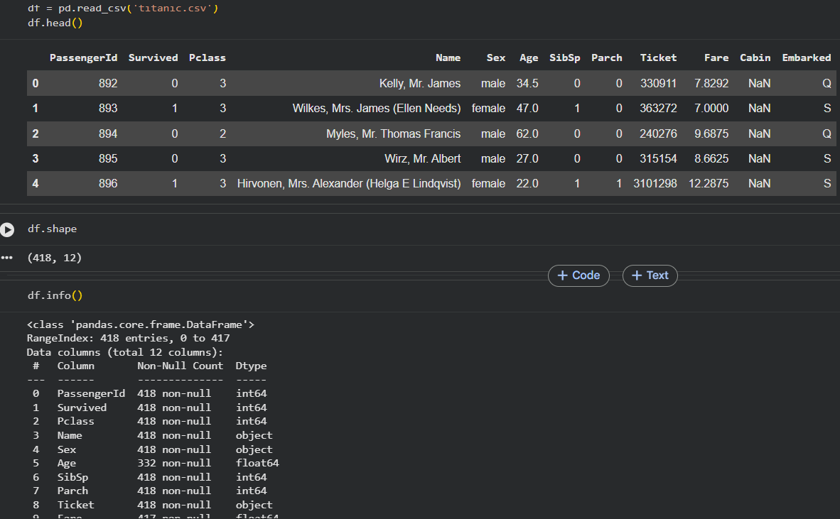
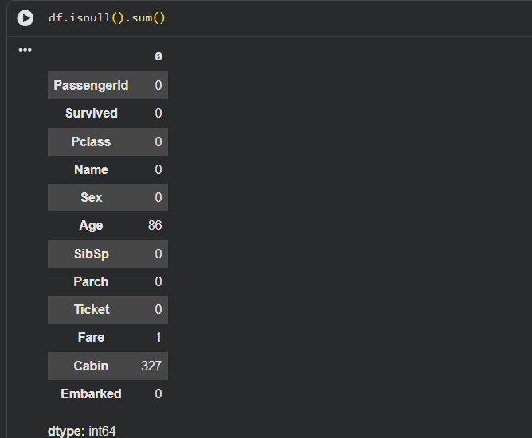
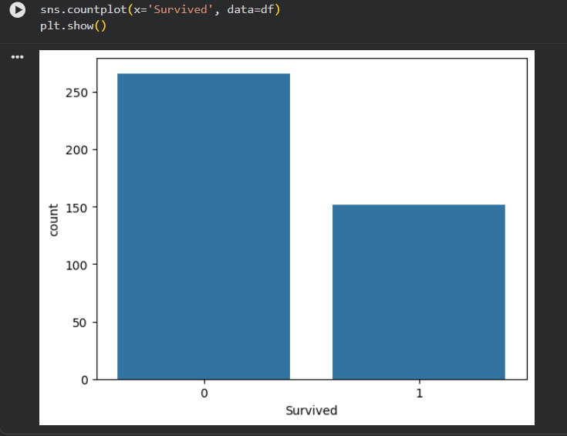
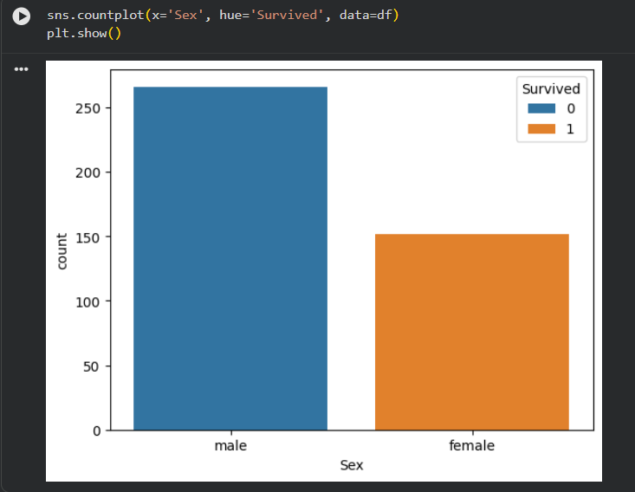
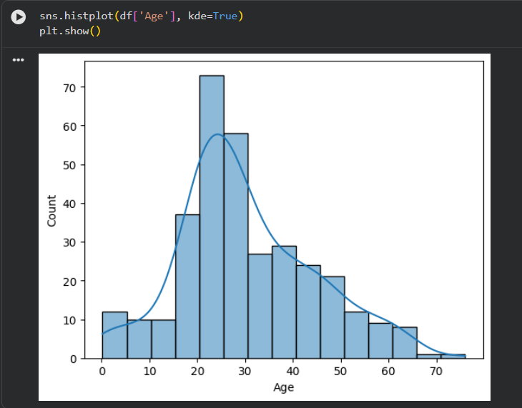
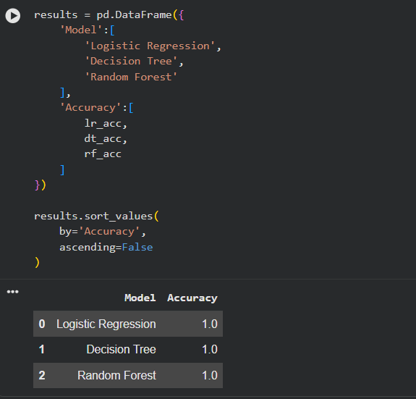
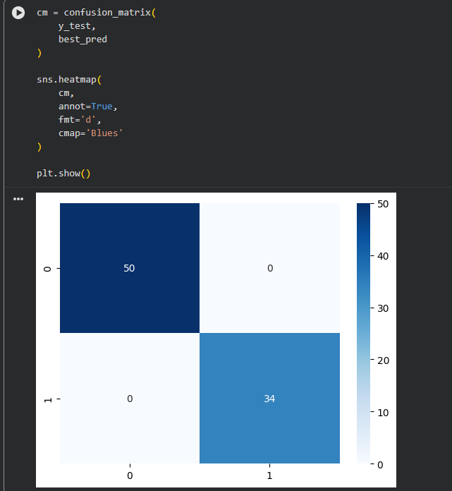
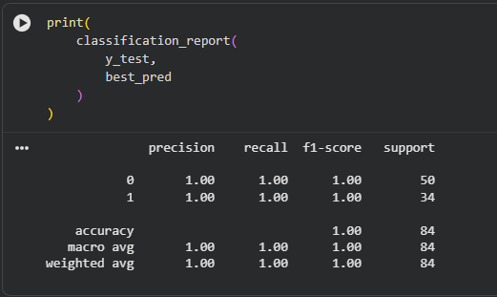
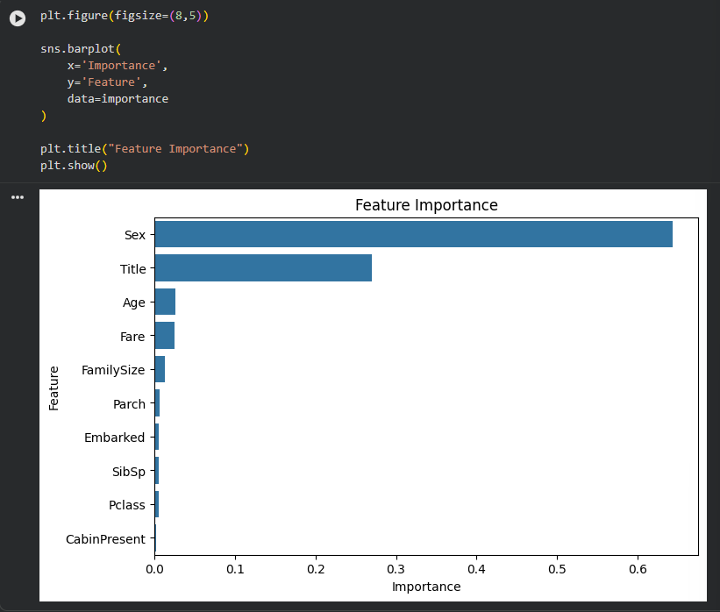
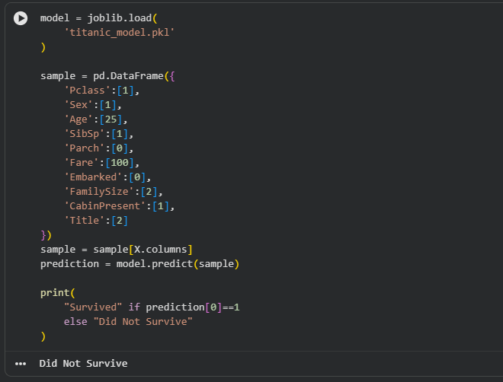

Saved Artifacts
Notebook File: Task3.ipynb
___________________________________________
Model File Link (titanic_model.pkl): https://drive.google.com/file/d/112LDXaeceWwxxQoMQ-Ee1_yBnuertX1l/view?usp=sharing
___________________________________________
GitHub Repository: https://github.com/Fadhil-Kurikkal/InternSpark-Internship
___________________________________________

Executive Summary
This project successfully developed a machine learning model for predicting passenger survival on the Titanic using supervised learning techniques. Exploratory Data Analysis was performed to understand the dataset, identify missing values, and analyze relationships among passenger attributes.
Feature engineering techniques were applied to improve predictive performance, including extraction of passenger titles, calculation of family size, and creation of a cabin presence indicator. Missing values were handled appropriately and categorical variables were encoded for machine learning model training.
Three classification algorithms, namely Logistic Regression, Decision Tree Classifier, and Random Forest Classifier, were trained and evaluated. The models were assessed using accuracy, precision, recall, F1-score, confusion matrix, and feature importance analysis.
The trained model was saved using Joblib for future inference and deployment purposes. This project demonstrates practical experience in data preprocessing, feature engineering, model training, evaluation, interpretability, and model persistence using Python and Scikit-Learn.

