INTERNSPARK MACHINE LEARNING INTERNSHIP

TASK 1: IRIS CLASSIFICATION

Candidate Details
Name: Muhammed Fadhil K
Task Number: 1
Task Title: Iris Classification

Project Overview
The objective of this project is to build a machine learning model capable of classifying Iris flowers into three species: Setosa, Versicolor, and Virginica using flower measurements.
The project demonstrates the complete machine learning workflow including data preprocessing, exploratory data analysis (EDA), visualization, model training, evaluation, model selection, and inference.

Dataset Information
Dataset Name: Iris Classification Dataset
Source: Kaggle
Dataset Link: https://www.kaggle.com/datasets/bhanupratapbiswas/iris-classification-dataset
Number of Records: 150
Target Variable: Species
Features:
• Sepal Length
• Sepal Width
• Petal Length
• Petal Width

Required Tools
• Python
• Pandas
• NumPy
• Matplotlib
• Seaborn
• Scikit-Learn
• Joblib
• Google Colab

Models Implemented
1. Logistic Regression
2. K-Nearest Neighbors (KNN)
3. Decision Tree Classifier
The models were trained and evaluated using accuracy score, confusion matrix, precision, recall and F1-score metrics.

Results
Model Accuracy Comparison
Model | Accuracy
KNN | 0.933333
Logistic Regression | 0.933333
Decision Tree Classifier | 0.900000
Best Model: KNN
Final Accuracy: 0.933333
Additional Metrics:
- Precision: 0.94
- Recall: 0.93
- F1 score: 0.93

GitHub Repository
Repository Link:
https://github.com/Fadhil-Kurikkal/InternSpark-Internship
Notebook File:
Task1.ipynb

Model Files
iris_model.pkl:
https://drive.google.com/file/d/1SCAJk7jpciN2UuyxCVrxnrkwlXWDjZz2/view?usp=sharing
scaler.pkl:
https://drive.google.com/file/d/1ArFN5sODsXZADj_mRFe4PisVtYvqGSFM/view?usp=sharing

Inference Example
Sample Input:
SepalLengthCm = 5.1
SepalWidthCm = 3.5
PetalLengthCm = 1.4
PetalWidthCm = 0.2
Predicted Output:
Iris-setosa
Screenshots
1. Dataset Preview
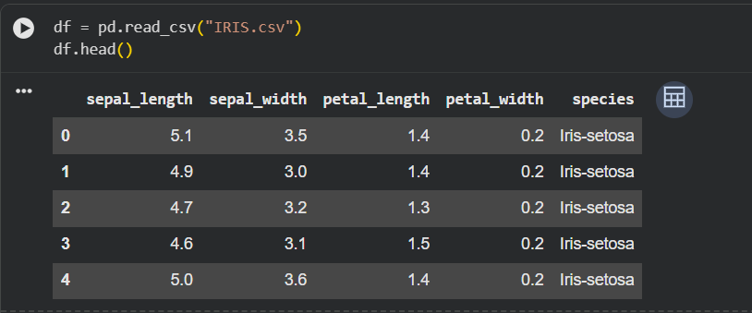
2. Dataset Information
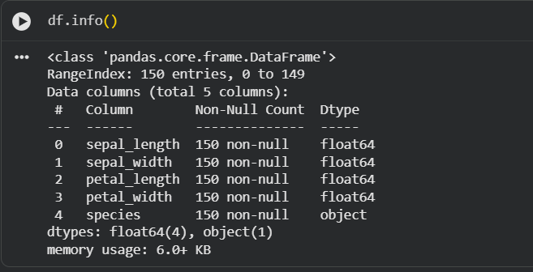

3. Dataset Statistics
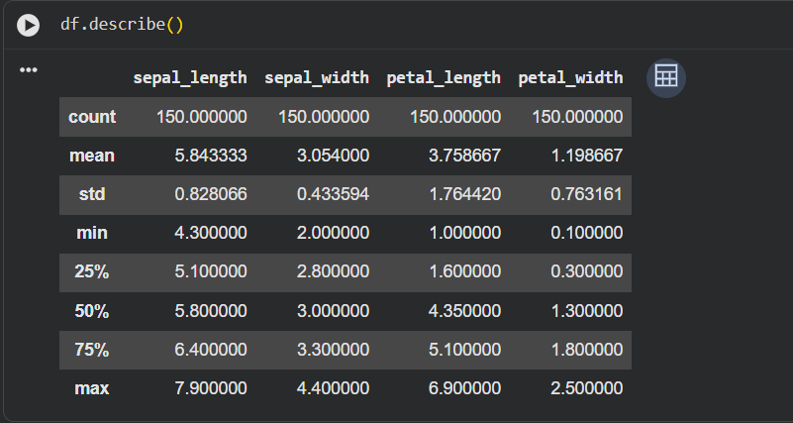
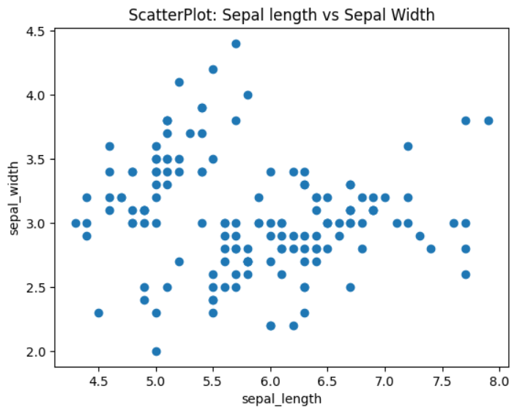
4. Scatter Plot
5. Box Plot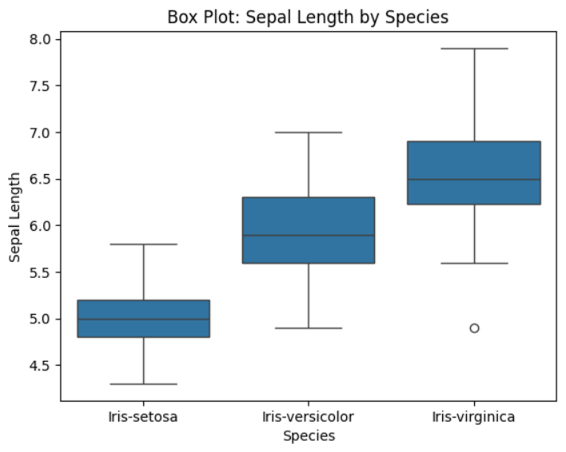
6. Histogram
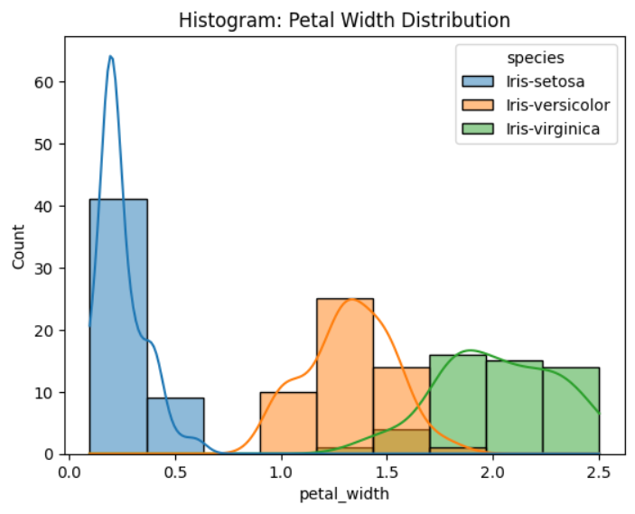

7. Pair Plot
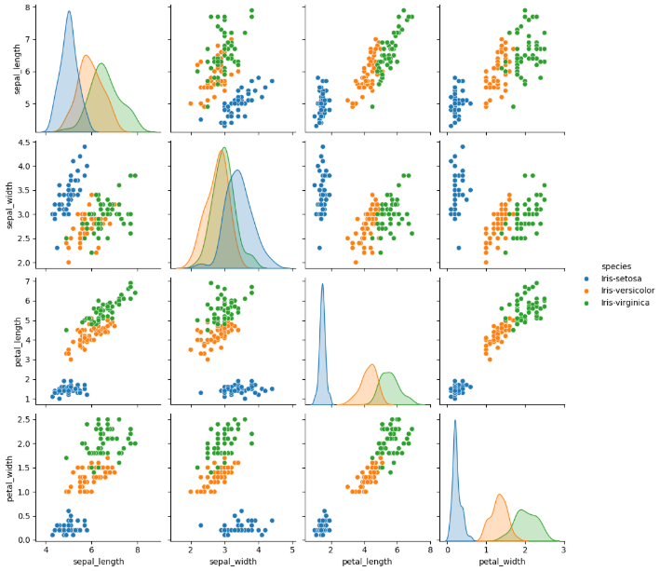

8. Model Comparison Table
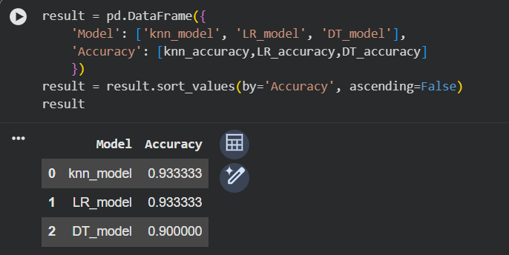
9. Confusion Matrix
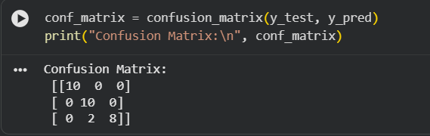

10. Classification Report
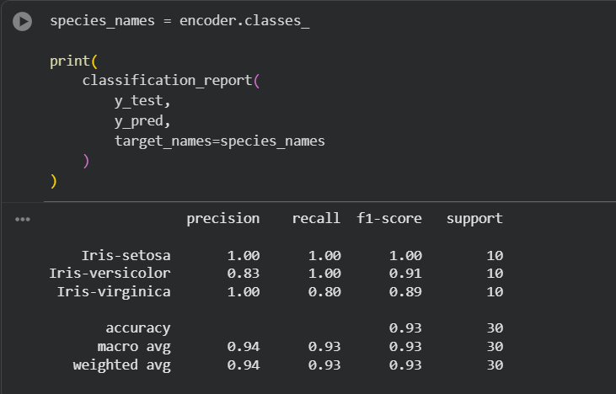

11. Inference Output
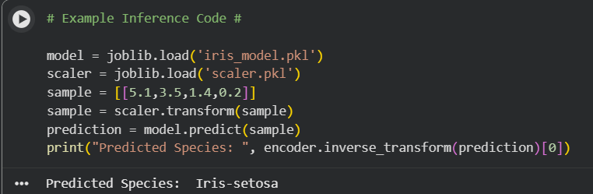

Executive Summary
This project successfully implemented a machine learning classification system for predicting Iris flower species. The Iris dataset obtained from Kaggle was explored using Exploratory Data Analysis techniques and visualizations to understand the relationships between various flower measurements.
Three machine learning algorithms, namely Logistic Regression, K-Nearest Neighbors (KNN), and Decision Tree Classification, were trained and evaluated. Feature scaling and train-test splitting were applied to ensure proper model performance. The models were compared using accuracy, precision, recall, F1-score, and confusion matrix metrics.
The best-performing model was KNN model with high accuracy of 93% among the other models and was selected as the final model. An inference example was also implemented to demonstrate how new flower measurements can be classified using the trained model.
The project demonstrates a complete end-to-end machine learning pipeline, from data preprocessing and visualization to model deployment preparation, and highlights the effectiveness of machine learning techniques for classification tasks.

