# Documentation API

API GET TOKEN USER  
**METHOD**: POST

**URL** : /users/token

**HEADER** : Content-Type : application/x-www-form-urlencoded

**BODY** : ***username***:testuser

***password***:testuser123!

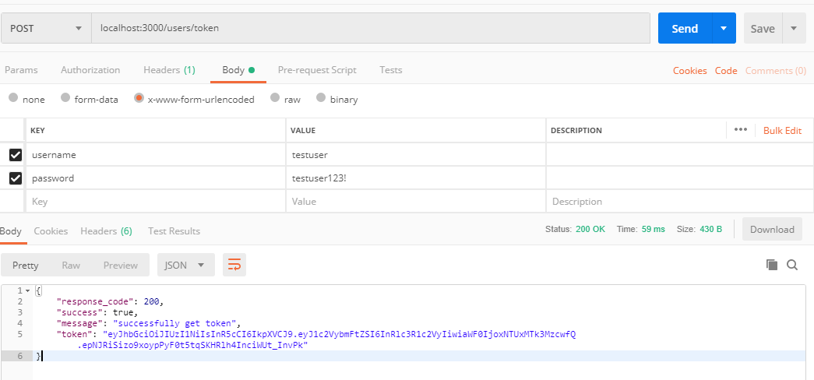

API GET ALL LIST TASK  
**METHOD**: POST

**URL** : /tasks/

**HEADER** : Content-Type : application/x-www-form-urlencoded

**BODY** : ***token***: token_user

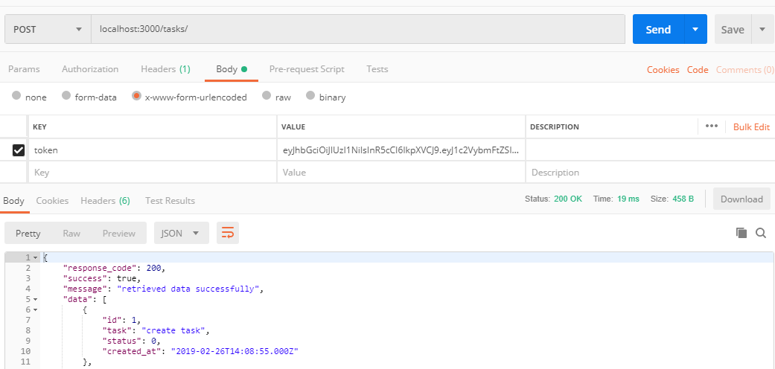

API GET TASK BY ID  
**METHOD**: POST

**URL** : /tasks/:id/detail

**HEADER** : Content-Type : application/x-www-form-urlencoded

**BODY** : ***token***: token_user

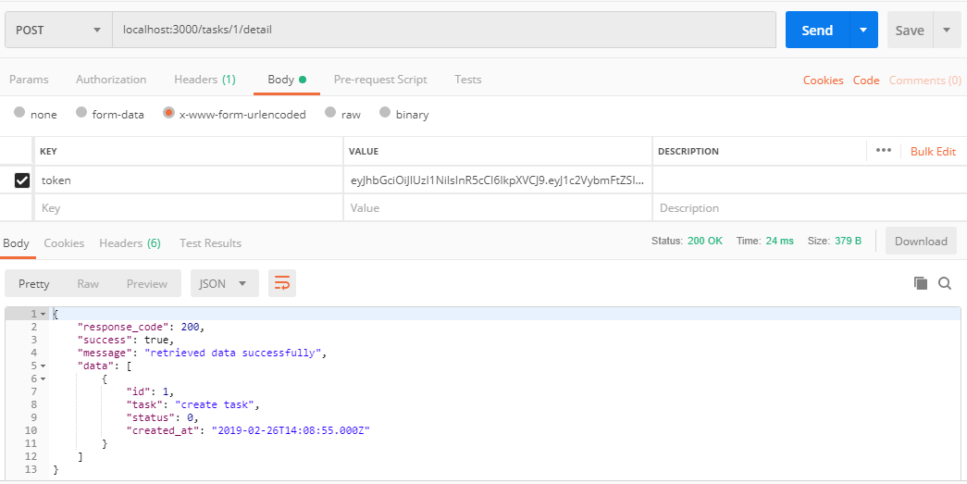

API DELETE TASK BY ID  
**METHOD**: DELETE

**URL** : /tasks/:id

**HEADER** : Content-Type : application/x-www-form-urlencoded

**BODY** : ***token***: token_user

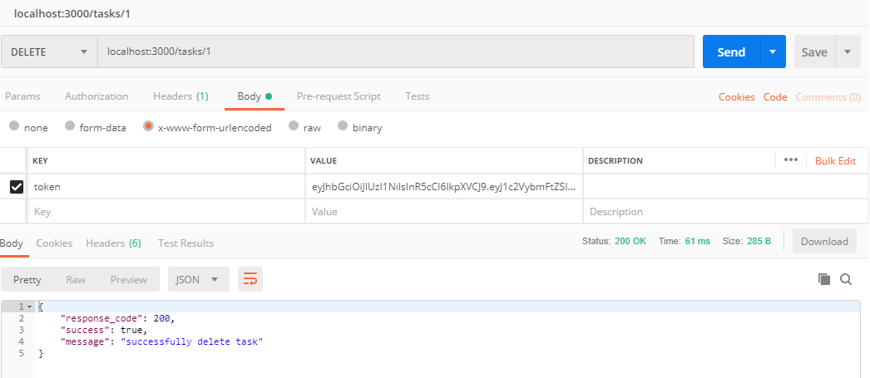

API CREATE TASK  
**METHOD**: POST

**URL** : /tasks/create

**HEADER** : Content-Type : application/x-www-form-urlencoded

**BODY** : ***token***:token_user

***task***:content_task

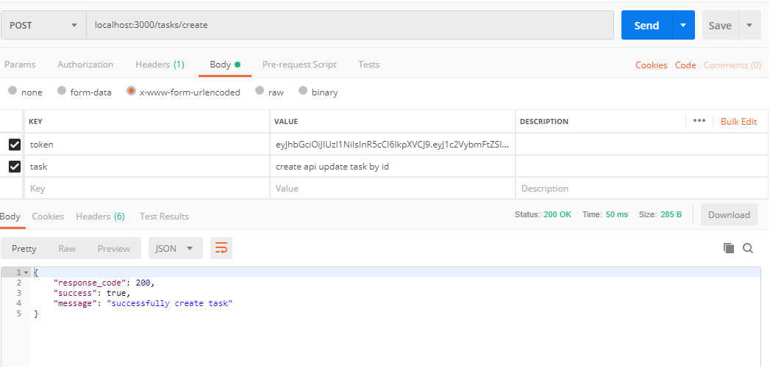

API UPDATE TASK BY ID  
**METHOD**: POST

**URL** : /tasks/:id/update

**HEADER** : Content-Type : application/x-www-form-urlencoded

**BODY** : ***token***:token_user

***task***:update_content_task

