Nama : M.Fadhil Riza Alzaki
NPM : 5520125050
Kelas : IF B 25
Tugas Prak PWD P2
<!DOCTYPE html>
<head>
<title>Tugas Praktikum Fadhil 2</title>
</head>
<body>

<table border="1" width="100%" cellpadding="10" cellspacing="0">
<tr>
<td>
<h1 align="center">Absensi Mahasiswa Teknik Informatika</h1>

<table border="1" align="center" cellspacing="0" cellpadding="2">
<tr>
<th rowspan="3">NO</th>
<th rowspan="3">NPM</th>
<th rowspan="3">NAMA</th>
<th colspan="7">PERTEMUAN</th>
</tr>
<tr>
<th>1</th>
<th>2</th>
<th>3</th>
<th>4</th>
<th>5</th>
<th>6</th>
<th>7</th>
</tr>
<tr>
<td>9-Feb</td>
<td>16-Feb</td>
<td>23-Feb</td>
<td>2-Mar</td>
<td>9-Mar</td>
<td>16-Mar</td>
<td>23-Mar</td>
</tr>
<tr>
<td>1</td>
<td>1111111111</td>
<td>Nyjah Huston</td>
<td align="center">v</td>
<td></td>
<td></td>
<td></td>
<td></td>
<td></td>
<td></td>
</tr>
<tr>
<td>2</td>
<td>2222222222</td>
<td>Luan Olivera</td>
<td align="center">v</td>
<td></td>
<td></td>
<td></td>
<td></td>
<td></td>
<td></td>
</tr>
<tr>
<td>3</td>
<td>3333333333</td>
<td>Yuto Horigome</td>
<td align="center">v</td>
<td></td>
<td></td>
<td></td>
<td></td>
<td></td>
<td></td>
</tr>
</table>
</td>
</tr>
</table>

<br>
<hr>
<br>

<h2>Form Mahasiswa</h2>

<form action="#" method="post">

<fieldset>
<legend>Data Mahasiswa</legend>
<table cellpadding="3">
<tr>
<td>Nama</td>
<td>:</td>
<td><input type="text" name="nama"></td>
</tr>
<tr>
<td>NPM</td>
<td>:</td>
<td><input type="text" name="npm"></td>
</tr>
<tr>
<td>Kelas</td>
<td>:</td>
<td>
<select name="kelas">
<option value="">-</option>
<option value="A">A</option>
<option value="B">B</option>
<option value="C">C</option>
</select>
</td>
</tr>
<tr>
<td>Jenis Kelamin</td>
<td>:</td>
<td>
<input type="radio" name="jk" id="pria" value="Pria">
<label for="pria">Pria</label>
<input type="radio" name="jk" id="wanita" value="Wanita">
<label for="wanita">Wanita</label>
</td>
</tr>
</table>
</fieldset>

<fieldset>
<legend>Tempat Tinggal Mahasiswa</legend>
<table cellpadding="3">
<tr>
<td valign="top">Alamat</td>
<td valign="top">:</td>
<td><textarea name="alamat" rows="6" cols="25"></textarea></td>
</tr>
<tr>
<td>Kecamatan</td>
<td>:</td>
<td><input type="text" name="kecamatan"></td>
</tr>
<tr>
<td>Kabupaten/Kotamadya</td>
<td>:</td>
<td><input type="text" name="kabupaten"></td>
</tr>
<tr>
<td>Provinsi</td>
<td>:</td>
<td><input type="text" name="provinsi"></td>
</tr>
<tr>
<td>Kode Pos</td>
<td>:</td>
<td><input type="text" name="kodepos"></td>
</tr>
</table>
</fieldset>

<fieldset>
<legend>Lain-lainnya</legend>
<table cellpadding="3">
<tr>
<td valign="top">Bahasa Pemrograman</td>
<td valign="top">:</td>
<td>
<input type="checkbox" name="bahasa[]" value="C/C++"> C / C++
<input type="checkbox" name="bahasa[]" value="Go Lang"> Go Lang
<input type="checkbox" name="bahasa[]" value="Python"> Python
<input type="checkbox" name="bahasa[]" value="Lainnya"> Lainnya
<br>
<input type="checkbox" name="bahasa[]" value="PHP"> PHP
<input type="checkbox" name="bahasa[]" value="Javascript"> Javascript
<input type="checkbox" name="bahasa[]" value="Ruby"> Ruby
</td>
</tr>
<tr>
<td valign="top">Kegiatan</td>
<td valign="top">:</td>
<td>
<input type="checkbox" name="kegiatan[]" value="Organisasi Kemahasiswaan"> Organisasi Kemahasiswaan
<input type="checkbox" name="kegiatan[]" value="Bidang Olahraga"> Bidang Olahraga
<input type="checkbox" name="kegiatan[]" value="Lainnya"> Lainnya
<br>
<input type="checkbox" name="kegiatan[]" value="Organisasi di Luar Kampus"> Organisasi di Luar Kampus
<input type="checkbox" name="kegiatan[]" value="Bidang Seni"> Bidang Seni
</td>
</tr>
</table>
</fieldset>

<br>
<input type="reset" value="Reset">
<input type="submit" value="Submit">

</form>

</body>
</html>
No1
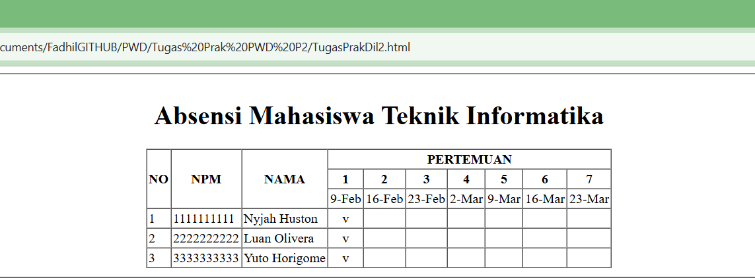

No 2
