

Kingdom of Saudi Arabia
Ministry of Higher Education
Imam AbdulRahman Bin Faisal University
College of Computer Sciences & Information Technology

Predicting Next-Hour Household Electricity Consumption from Two Earlier Readings
A Comparison of Linear Regression with Previous-Hour and Previous-Day Baselines
CIS 517 Data Mining & Data warehousing
Instructor: Dr. Tareq Alkhaldi
Date: 14/11/2026
Team Members
Fadhlallah Almohammed | 2230006097 | Leader
Salam AlAwa | 2230004271 | Hourly data
Ahmed Alnasser | 2220001575 | Prediction inputs
Moamen Rabah | 2230009004 | Prediction and errors
Mohammad Alsadiq | 2230000092 | Charts
Hassan Alkhamis | 2230003826 | Report
Abdullah Almushar | 2230005728 | Integration and slides

1. Introduction and Research Question
Household electricity use changes from hour to hour as people wake up, cook, work and sleep. Knowing roughly how much electricity a home will use in the next hour is useful because many short-term decisions about energy are made at that scale. This project studies how well that next hour can be predicted when only very little information is available: the same home's consumption in recent hours.
The project asks the following research question:
Research question: How accurately can a household's electricity consumption in the next hour be predicted from two earlier readings of the same home, the reading one hour earlier and the reading at the same hour on the previous day, and does a linear regression model predict more accurately than simply repeating either of those readings?
To answer it, the team compares three methods on exactly the same homes and hours. Two are simple baselines that copy an earlier reading (previous hour and previous day), and the third is a linear regression model that combines both readings. A baseline performing best is treated as a valid finding, because it shows whether the extra model adds value.
Short-term forecasts of this kind could support uses such as helping energy suppliers and network operators anticipate demand, or giving households an indication of their expected use. This report measures prediction accuracy only. It does not test whether such forecasts lead to energy or cost savings, and no such claim is made.

1.1 Objectives
- Convert half-hourly smart-meter readings into hourly consumption while keeping missing readings separate from measured zeros.
- Build prediction rows that pair each target hour with the same home's values one hour and 24 hours earlier.
- Fit a linear regression model on the training period only and compare it with the two baselines on identical validation rows.
- Evaluate the fixed methods once on the final test period using MAE and RMSE in kWh.

2. Dataset

2.1 Source
The data comes from the Smart Meters in London dataset. The original readings, SmartMeter Energy Consumption Data in London Households, were collected in the Low Carbon London project led by UK Power Networks and are published on the London Datastore (UK Power Networks, n.d.). The source covers 5,567 London households between November 2011 and February 2014, with energy consumption recorded every half hour in kWh. It is released under the Creative Commons Attribution 4.0 licence.
The team used the Kaggle copy of this dataset (jeanmidev, 2022). Local file names were chosen to describe each file's contents, but the source readings and CSV column names were not changed. Source attribution and the original licence information are kept with the shared dataset package.

2.2 Project Data Files
The project works with a fixed selection of 300 homes and the readings for the year 2013. Each home is identified by its source identifier, LCLid (for example, MAC000038). Table 1 lists the starting files.
Table 1
Starting Data Files Used in the Project
File | Contents
data/raw/half_hour_readings_2013.csv | Half-hourly readings for the selected homes
data/raw/household_metadata.csv | Household descriptions and selection evidence
data/raw/selected_household_ids.csv | Selected home IDs and their source blocks
data/household_split.csv | Assignment of each of the 300 homes to the development or reserved group
data/split_rules.json | Fixed rules for the home split and the date periods
data/pilot/ (two sample files) | A small half-hourly sample and its hourly version, used to test the notebooks

The raw readings file contains 5,219,816 half-hour readings for the 300 homes, with timestamps from 1 January 2013 00:00 to 31 December 2013 23:30 UTC. No reading is blank, and 70,005 readings are measured zeros.
The selection evidence for each home is recorded in household_metadata.csv. Each home was checked on its TRAIN-period readings (1 January to 31 August 2013), when a complete home has 11,664 half-hour readings (243 days × 48). The checks recorded the share of expected readings present (coverage), the longest run of missing readings, the share of invalid values, duplicate timestamps, and timestamps that do not fall on a half-hour mark. All 300 homes are marked as eligible, and none has an exclusion reason. Coverage ranged from 98.74% to 100% (median 99.99%). 110 homes had no missing readings, and 297 had at least 99% coverage. The longest gap in any home was two days (two homes); twelve homes had a longest gap of one day. No home had invalid values, duplicate timestamps, or timestamps off the half-hour grid. The selected homes come from 107 of the source's data blocks, which are listed in selected_household_ids.csv. [Confirm with M1: the eligibility thresholds used and how many candidate homes were screened.]
The source assigns each home an electricity tariff group and an Acorn category. Acorn is a socio-economic classification of households, and the source groups its categories into Affluent, Comfortable and Adversity. All 300 selected homes were on the standard tariff (“Std”); none of the source's time-of-use tariff homes (“ToU”) are included. Table 2 shows the Acorn groups. The selection is broadly balanced, with Affluent the largest group (37.7%), then Adversity (34.0%) and Comfortable (27.3%). Three homes (1.0%) are listed as ACORN-U and belong to none of the three groups. The most common single categories are ACORN-E (77 homes), ACORN-Q (52) and ACORN-F (40). The reserved group has proportionally more Affluent homes and fewer Comfortable homes than the development group. This does not affect this project, because the reserved homes are not used.
Table 2
Acorn Groups of the Selected Homes
Acorn group | Development (n = 240) | Reserved (n = 60) | Total (n = 300)
Affluent | 86 (35.8%) | 27 (45.0%) | 113 (37.7%)
Adversity | 81 (33.8%) | 21 (35.0%) | 102 (34.0%)
Comfortable | 71 (29.6%) | 11 (18.3%) | 82 (27.3%)
ACORN-U | 2 (0.8%) | 1 (1.7%) | 3 (1.0%)
Note. All homes are on the standard tariff. Source: data/raw/household_metadata.csv and data/household_split.csv.

2.3 Development and Reserved Homes
The 300 selected homes were divided once into 240 development homes and 60 reserved homes (Table 3). The division is deterministic: for each home, a SHA-256 hash is calculated from the text “42:” followed by its LCLid, the hashes are sorted, and the 60 homes with the lowest hashes are reserved. Because the rule does not depend on any consumption values, the groups were not chosen by looking at the data, and anyone can reproduce the same split.
All training, validation and testing in this project use the 240 development homes only. The 60 reserved homes are kept aside and are not used in any step.
Table 3
Division of the Selected Homes
Group | Homes | Use in this project
Development | 240 | Training, validation and final testing
Reserved | 60 | Set aside; not used
Total selected | 300
Note. Counts from data/household_split.csv and data/split_rules.json.

2.4 Time Periods
The 2013 readings are divided by date into three consecutive periods (Table 4). Each period has one job: the model learns from TRAIN, method choices are made on VALIDATION, and the fixed methods are measured once on TEST. Because TEST uses later dates for the same development homes, it checks how well the methods predict a future period that played no part in fitting or choosing them.
Table 4
Date Periods Used for Training, Validation and Testing
Period | Dates (2013) | Purpose
TRAIN | 1 January – 31 August | Fit the linear regression model
VALIDATION | 1 September – 31 October | Compare methods and fix the final choices
TEST | 1 November – 31 December | Measure the fixed methods once
Note. Each period includes its start date and excludes the start date of the next period (split_rules.json). In the saved prediction rows, the period label follows the hourly start time of the target hour: the first VALIDATION row is 1 September 00:00 and the first TEST row is 1 November 00:00 (UTC). [M3 to confirm this is the intended rule.]

3. Data Preparation

3.1 From Half-Hourly to Hourly Readings
Each raw timestamp marks the end of a half-hour reading in UTC. To place a reading in the correct hour, 30 minutes are subtracted from its timestamp to find when the half hour started, and the reading is then grouped by UTC hour. The hourly consumption is the sum of the two half-hour readings in that hour. In the prepared hourly data, each timestamp marks the start of the hour.
Table 5
Example of Combining Two Half-Hour Readings Into One Hourly Value
Raw timestamp (end, UTC) | Half hour covered | kWh | Hour (start, UTC)
14 Mar 2013 08:30 | 08:00–08:30 | 0.383 | 14 Mar 2013 08:00
14 Mar 2013 09:00 | 08:30–09:00 | 0.146 | 14 Mar 2013 08:00
 | Hourly total | 0.529
Note. Home MAC000038, a development home. The hourly total matches the value saved for this home and hour in data/processed/hourly_readings.csv.

3.2 Missing Readings and Measured Zeros
An hourly value is kept only when both half-hour readings in that hour are valid. If one or both readings are missing, the hour is recorded as missing rather than as zero. A missing reading means the meter supplied no value, whereas a measured zero is a real reading of no consumption; the two are therefore kept distinct, and measured zeros remain in the data.
The prepared hourly file has one row for every home and every hour of 2013 (Table 6). Each row records the hourly kWh, the number of valid half-hour readings in that hour (0, 1 or 2) and whether the hour is complete. Missing hours keep a blank kWh value rather than zero. Of the 18,655 missing hours, 17,829 had no valid reading and 826 had only one. The final hour, 31 December 2013 23:00, is missing for every home, because its second half-hour reading is stamped 1 January 2014 00:00 and is not in the 2013 file. Likewise, the first raw reading of each home, stamped 1 January 2013 00:00, belongs to the last half hour of 2012 and is not part of any 2013 hour.
Completeness differs between periods. For the 240 development homes, 99.94% of TRAIN hours, 99.49% of VALIDATION hours and 97.94% of TEST hours are complete.
Table 6
Summary of the Prepared Hourly Data
Measure | Value
Homes in the hourly file | 300
Hours per home | 8,760
Total home-hour rows | 2,628,000
Complete hours (both readings valid) | 2,609,345 (99.29%)
Missing hours (fewer than two valid readings) | 18,655 (0.71%)
Complete hours with a measured zero | 25,661
First and last hour in the file | 1 Jan 2013 00:00 – 31 Dec 2013 23:00 UTC
Note. Complete hours plus missing hours equal the total number of rows. Hours are labelled by their start time. Source: data/processed/hourly_readings.csv (M2, Week 1), checked against the raw readings.

3.3 Building the Prediction Inputs
For each development home and each target hour, the prediction row contains the target consumption and two inputs taken from the same home: the hourly value exactly one hour earlier (lag_1h_kwh) and the hourly value exactly 24 hours earlier (lag_24h_kwh). Rows missing the target or either input are removed and counted; gaps are never filled with zero. Each remaining row is labelled TRAIN, VALIDATION or TEST according to the date of its target hour. Table 7 shows that 2,084,732 of the 2,102,400 possible rows were kept (99.2%). The share kept is 99.5% in TRAIN, 99.4% in VALIDATION and 97.8% in TEST. Six development homes have far fewer TEST rows than the typical 1,463 because their readings stop early: MAC000668 has no complete prediction rows after 3 September 2013 (so no TEST rows), MAC002451 and MAC004226 stop after 5 and 10 November (120 and 240 rows), MAC003576 after 16 November (383 rows), and MAC000700 and MAC002567 after 4 December (816 rows each). For the first three homes, the gaps are confirmed as missing source data (the meters stop reporting), not a preparation error. All six homes are kept and their empty hours are excluded as missing, so TEST covers 239 homes. [Confirm with M3 that the last three homes are also source-data gaps.]
Table 7
Prediction Rows Kept and Excluded by Period
Period | Rows kept | Rows excluded | Total
TRAIN | 1,392,091 | 7,589 | 1,399,680
VALIDATION | 349,127 | 2,233 | 351,360
TEST | 343,514 | 7,846 | 351,360
Total | 2,084,732 | 17,668 | 2,102,400
Note. Development homes only. Total is the number of home-hour rows in each period (240 homes × hours in the period). A row is excluded for the first reason that applies: missing target (782 TRAIN, 1,806 VALIDATION, 7,221 TEST), then missing one-hour input (547, 75, 91), then missing 24-hour input (6,260, 352, 534). Most of the TRAIN lag-24 exclusions (5,760 of 6,260) are the first day of the year, which has no earlier day. Source: data/processed/prediction_input_counts.csv (M3, Week 2).

4. Exploratory Charts
The exploratory charts use development homes and TRAIN dates only, so the later periods are not examined before the methods are fixed. Measured zeros are kept, missing hours are excluded from averages, and gaps on time charts are left as gaps rather than drawn as zero.
Figure 1
Hourly Consumption of Home MAC000038, 1–14 January 2013
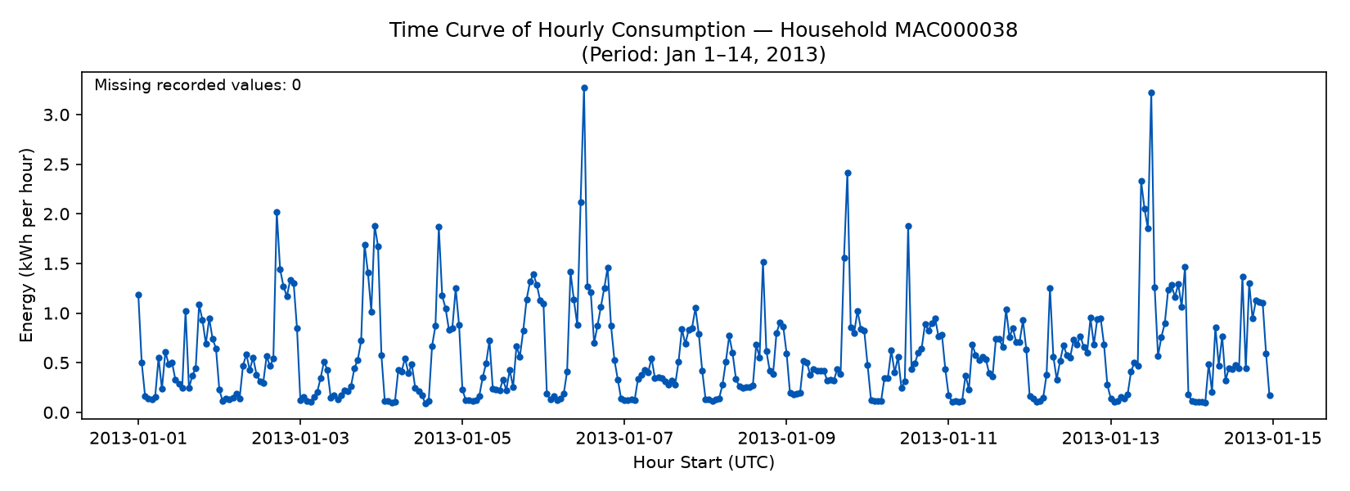
Note. Home MAC000038 (a development home), hourly consumption in kWh, 1–14 January 2013 (TRAIN period). Each point is one hour, labelled by its start time in UTC. No hours are missing in this window. Source: figures/hourly_consumption.png (M5, Week 2).
Figure 2
Distribution of Hourly Consumption, Development Homes, TRAIN Period
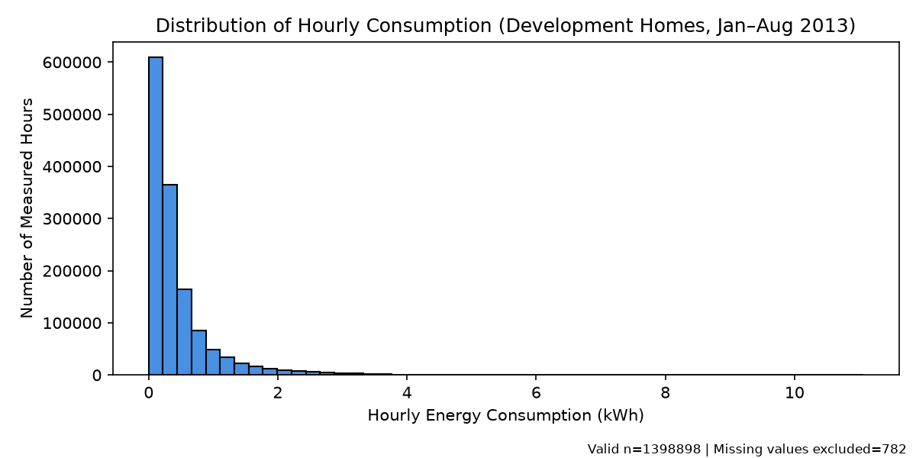
Note. Development homes, TRAIN period (January–August 2013); each observation is one home-hour. The chart uses 1,398,898 measured hourly values; 782 missing hours are excluded. Source: figures/hourly_distribution.png (M5, Week 2).
Figure 3
Average 24-Hour Consumption Profile of Home MAC000038, TRAIN Period
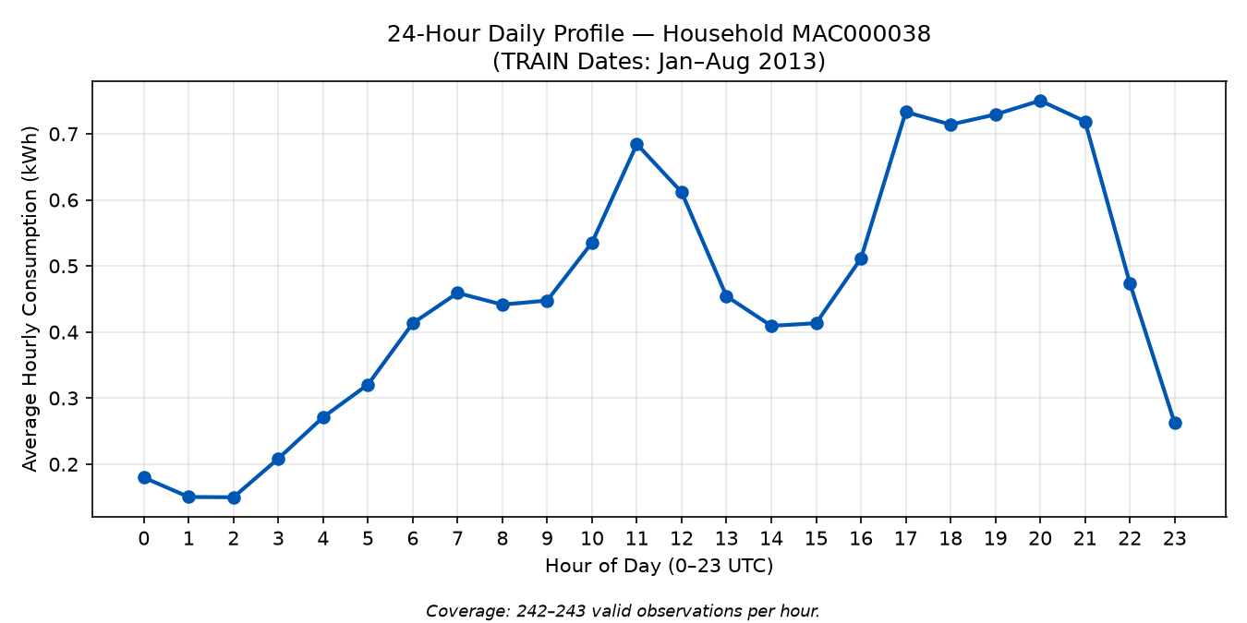
Note. The profile shows 24 hourly means based on available hourly readings. Each mean uses 242–243 valid hourly readings (out of 243 days) for that hour of the day, in UTC, for home MAC000038 (a development home), January–August 2013. Source: figures/daily_profile.png (M5, Week 2).
Together the charts show a clear pattern. A single home’s hourly use is usually low, mostly below about 1 kWh, with short peaks that exceed 3 kWh on a few days (Figure 1), and across the development homes most hours are below about 0.5 kWh, with a long tail of rare high values up to about 11 kWh (Figure 2). The example home also follows a daily routine: it uses least in the early hours, rises through the morning, peaks around 11:00 and again between 17:00 and 21:00, and drops after 21:00 (Figure 3).

5. Methods
All three methods predict the target hour's consumption, written here as ŷ_{t}, for a home at hour t, using only that home's consumption one hour earlier (y_{t−1}) and 24 hours earlier (y_{t−24}). Table 8 summarises them.

5.1 Previous-Hour Baseline
The previous-hour baseline assumes that the next hour will be the same as the hour just before it. Its prediction is the lag_1h_kwh input:
ŷ_{t} = y_{t−1}

5.2 Previous-Day Baseline
The previous-day baseline assumes that the home repeats its daily routine, so it predicts the value recorded at the same hour on the previous day, which is the lag_24h_kwh input:
ŷ_{t} = y_{t−24}

5.3 Linear Regression
The linear regression model combines both earlier readings using a weighted sum:
ŷ_{t} = b₀ + b₁ y_{t−1} + b₂ y_{t−24}
The intercept b₀ and the weights b₁ and b₂ are learned by ordinary least squares from TRAIN rows only. [Confirm with M4 how the model is fitted (for example, NumPy least squares or scikit-learn LinearRegression) and cite the library if needed.] The two inputs are lag_1h_kwh and lag_24h_kwh, and the target is target_kwh; the target is never used as an input. The fitted model is then applied to the validation and test rows without refitting.
[PENDING: regression settings and the dated fixed-method note recorded in Week 3 (M4 and M1).]
Table 8
Summary of the Three Prediction Methods
Method | Prediction rule | Inputs used | Learns from TRAIN
Previous hour | Copy the value one hour earlier | lag_1h_kwh | No
Previous day | Copy the value 24 hours earlier | lag_24h_kwh | No
Linear regression | Weighted sum of both inputs plus an intercept | Both | Yes

5.4 Evaluation
Prediction errors are measured with the mean absolute error (MAE) and the root mean squared error (RMSE), both in kWh. For n scored rows with actual values y_{i} and predictions ŷ_{i}:
MAE = (1/n) Σ |y_{i} − ŷ_{i}|
RMSE = √[ (1/n) Σ (y_{i} − ŷ_{i})² ]
MAE is the average size of an error. RMSE squares each error before averaging, so it gives more weight to large errors such as missed peaks. For both measures, smaller values mean more accurate predictions.
To keep the comparison fair, the evaluation follows four rules:
- All three methods are scored on exactly the same home and hour rows.
- The regression model is fitted on TRAIN rows only.
- Choices about the method are made using VALIDATION results only.
- The fixed methods are evaluated on TEST once, and no choice is changed after the test scores are seen.
The analysis was carried out in Python 3.11 using Jupyter notebooks, with pandas (McKinney, 2010) for data handling and NumPy (Harris et al., 2020) for numerical calculations. [Add any other libraries the team uses, such as the charting library (M5).]

6. Results

6.1 Validation Results
Table 9
Validation Errors of the Three Methods (September–October 2013)
Method | Rows scored | MAE (kWh) | RMSE (kWh)
Previous hour | 349,127 | 0.1745 | 0.3598
Previous day | 349,127 | 0.2094 | 0.4315
Linear regression | [PENDING] | [PENDING] | [PENDING]
Note. All methods are scored on the same rows. Source: results/validation_scores.csv (M4, Week 2); error values rounded to four decimals. [PENDING: linear regression row, from M4’s Week 3 results.]
On the 349,127 validation rows, the previous-hour baseline has the lower errors of the two baselines (MAE 0.1745 kWh, RMSE 0.3598 kWh). The previous-day baseline’s errors are about 20% higher (MAE 0.2094 kWh, RMSE 0.4315 kWh). [PENDING: add the linear regression result and state which of the three methods is best, after M4’s Week 3 results.]
Figure 4
Actual and Regression-Predicted Hourly Consumption for Home [LCLid], [validation dates]
[PENDING: insert figures/validation_prediction_example.png]
Note. [PENDING: M5 caption describing one agreement and one mistake.]

6.2 Final Test Results
Table 10
Test Errors of the Three Methods (November–December 2013)
Method | Rows scored | MAE (kWh) | RMSE (kWh)
Previous hour | [PENDING] | [PENDING] | [PENDING]
Previous day | [PENDING] | [PENDING] | [PENDING]
Linear regression | [PENDING] | [PENDING] | [PENDING]
Note. [PENDING: values from results/test_scores.csv (M4, Week 4).]
Figure 5
Final Test Comparison of MAE and RMSE for the Three Methods
[PENDING: insert the final comparison chart from figures/]
Note. [PENDING: M5 caption.]
[PENDING: explain whether the test finding agrees with the validation finding.]

7. Limitations
[DRAFT: confirm each point against the final results before submission.]
- The methods use only two earlier readings. Other information that may affect consumption, such as weather or the day of the week, is not included.
- The data cover one year (2013) and 240 London homes from one trial, so the results may not apply to other places, years or types of household.
- Rows missing the target or an input are removed, so the scores describe hours with complete data only. More hours are missing in TEST (2.06% for development homes) than in TRAIN (0.06%), so slightly fewer test rows are scored.
- Six development homes stop reporting before the end of the test period (Section 3.3), so they contribute few or no TEST rows and the final test covers 239 homes. These homes are kept; scores for them rest on few hours, so the overall TEST scores are the main result.
- Linear regression can produce negative predictions, which are not physically possible. These are kept visible rather than adjusted. [PENDING: report how many occurred.]
- The final test uses later dates for the same development homes. The 60 reserved homes are not evaluated.

8. Conclusion
[PENDING: answer the research question using the final test results, state which method performed best, and note whether this agrees with validation.]

Team Contributions
Table 11
Contribution of Each Team Member
Code | Member | Contribution
M1 | Fadhlallah Almohammed | Project leadership, checks and final submission. [Add details.]
M2 | Salam AlAwa | Preparation of the hourly readings. [Add details.]
M3 | Ahmed Alnasser | Prediction inputs and split checks. [Add details.]
M4 | Moamen Rabah | Baselines, regression model and error scores. [Add details.]
M5 | Mohammad Alsadiq | Charts and figure captions. [Add details.]
M6 | Hassan Alkhamis | Report writing and editing. [Add details.]
M7 | Abdullah Almushar | Workflow integration and presentation slides. [Add details.]

References
Harris, C. R., Millman, K. J., van der Walt, S. J., Gommers, R., Virtanen, P., Cournapeau, D., Wieser, E., Taylor, J., Berg, S., Smith, N. J., Kern, R., Picus, M., Hoyer, S., van Kerkwijk, M. H., Brett, M., Haldane, A., Fernández del Río, J., Wiebe, M., Peterson, P., … Oliphant, T. E. (2020). Array programming with NumPy. Nature, 585(7825), 357–362. https://doi.org/10.1038/s41586-020-2649-2
jeanmidev. (2022). Smart meters in London [Data set]. Kaggle. https://www.kaggle.com/datasets/jeanmidev/smart-meters-in-london
McKinney, W. (2010). Data structures for statistical computing in Python. In S. van der Walt & J. Millman (Eds.), Proceedings of the 9th Python in Science Conference (pp. 56–61). https://doi.org/10.25080/Majora-92bf1922-00a
UK Power Networks. (n.d.). SmartMeter energy consumption data in London households [Data set]. London Datastore. https://data.london.gov.uk/dataset/smartmeter-energy-use-data-in-london-households

