


Building Smart Medical Consulting App in Arabic

(Hakeem)

Prepared to obtain the degree of B.Sc. in the Department of Software Engineering
and Information Systems

Prepared by:
Fadi Basem Alkhoury Hanna

Supervised by:
Dr. Majida AlBakoor

Academic Year 2025-2026

Dedication

We would like to express our deep gratitude and great appreciation to everyone who supported and stood by us throughout our academic journey, and to everyone who had a positive impact on completing this work.

We dedicate this effort to our beloved families, who were a source of strength and constant encouragement, to our esteemed teachers for their knowledge, guidance, and advice, and to every friend who stood by us and offered help and support.

We also dedicate this work to everyone who believed in our abilities and encouraged us to keep going and strive for success and growth.

First Chapter :General Introduction

Project Overview and Background

The rapid advancement of Artificial Intelligence (AI) and Natural Language Processing (NLP) has significantly transformed the healthcare sector by enabling intelligent systems to understand human language and provide automated medical assistance. These technologies have improved access to healthcare services by allowing users to obtain preliminary medical information quickly and efficiently.
Despite these developments, Arabic-speaking communities still suffer from the lack of intelligent medical consultation systems capable of understanding Arabic medical questions accurately. Most existing medical consultation platforms primarily support the English language and provide limited capabilities for Arabic language processing.
To tackle this problem, the project proposes developing Hakeem, a smart medical consultation app in Arabic that uses Retrieval-Augmented Generation (RAG) and large language models (LLMs) to provide reliable initial medical guidance. The system pulls trustworthy medical information from a database and generates context-aware responses in Arabic. From a software engineering standpoint, the project is built as a modular system with several interconnected components, including the user interface, application server, vector database, retrieval engine, and the smart model, along with additional features that understand the user, combining both human and AI elements. This setup makes maintenance easier, the system more scalable, and flexible for future development, while also supporting future enhancements.

  - Problem Statement
Although digital healthcare applications have become increasingly popular worldwide, Arabic-speaking users still face several challenges when searching for reliable medical information. Most intelligent healthcare systems focus on English and provide limited support for Arabic language understanding.

The major problems addressed by this project include:
- Limited availability of intelligent Arabic medical consultation systems.
- Poor semantic understanding of Arabic medical questions.
- The lack of application that combine the human and the intelligent element
- Lack of medical services in medical programs

Project Objectives

Main Objective
Building a smart app that serves the user by providing access to a supervising doctor and AI built with RAG technology to provide reliable and accurate preliminary medical consultations.
Building a web platform for the doctor so they can manage the app and communicate with patients.

Specific Objectives
Building a mobile app that serves users medically.
Building a web platform that makes it easier for doctors to supervise and answer patients' questions.
Develop an intelligent software system capable of answering Arabic medical questions.
Integrate Retrieval-Augmented Generation (RAG) to improve answer quality.
Building a system for chatting with the doctor, a posts system, a measurements system, and user healthcare.

Project Scope, Constraints, and Assumptions

Project Scope
A mobile app for medical consultations in Arabic, along with other services.
A website for the doctor to connect with patients and share awareness posts
AI-generated responses using RAG.

Project Constraints
The project is subject to several constraints:
- Limited development time.
- Limited computational resources for training large language models.
- Dependence on available Arabic medical datasets.
- Limited availability of verified Arabic medical resources.
- Performance requirements for real-time response generation.
- It requires a strong internet connection and a VPN.
- Direct connection with the grog server.
    - Project Assumptions
The project assumes that:
- Users have Internet access.
- Users submit questions in Arabic.
- The user has the app.

Research Contribution

Bringing AI together with software engineering through natural language processing and a RAG system.
Creating a software architecture that can easily scale for future growth.
Making it easier for Arabic-speaking users to access trustworthy medical info.
Unlike many existing systems, this solution really focuses on software quality think maintainability, scalability, modular design, and flexibility along with AI features.

Research Methodology
This research follows an Engineering Research Methodology consisting of the following phases:
- Problem Identification.
- Literature Review.
- Requirements Analysis.
- System Design.
- Software Development.
- System Integration.
- System Testing.
- Performance Evaluation.

Organizational Document Structure

This thesis is organized into ten chapters as follows:
- Chapter One: General Introduction.
- Chapter Two: Software Development and Project Management Methodology.
- Chapter Three: Literature Review and Related Work.
- Chapter Four: Requirements Analysis and System Modeling.
- Chapter Five: System Architecture and Software Design.
- Chapter Six: Development Environment and Implementation Tools.
- Chapter Seven: Software Implementation.
- Chapter Eight: System Testing and Evaluation.
- Chapter Nine: Results and Performance Analysis.
- Chapter Ten: Conclusion and Future Work.

Definitions and Basic Concepts

Term | Definition
Artificial Intelligence (AI) | The simulation of human intelligence by computer systems.
Natural Language Processing (NLP) | A branch of AI that enables computers to understand and process human language.
Retrieval-Augmented Generation (RAG) | An AI technique that combines information retrieval with language generation.
Large Language Model (LLM) | A deep learning model capable of understanding and generating human language.
Embedding | Numerical representation of text used for semantic similarity search.
Vector Database | A database optimized for storing and searching vector embeddings.
API | Application Programming Interface used for communication between software components.
Frontend | The graphical user interface that users interact with.
Backend | The server-side application responsible for processing requests and business logic.
Software Architecture | The high-level structure of a software system and the interaction between its components.
MVC | Model-View-Controller
Client-server | The client is the one requesting data or services, and the server is the one that processes these requests and provides the required response.

Chapter Two: Software Development and Project Management Methodology

2.1 Software Development Methodology

The development of the Hakeem system followed the Incremental Software Development Model, in which the system was developed and delivered through a sequence of small, functional increments. Each increment added new features to the existing system until the complete application was successfully implemented.
The Incremental Model was selected because it allows the development team to divide the project into manageable modules that can be designed, implemented, tested, and integrated independently. This approach reduces development risks, facilitates early detection of defects, and enables continuous validation of each completed increment before proceeding to the next one.
The development process was organized into several increments, where each increment delivered a specific set of functionalities:
- Increment 1: Requirements Analysis and Project Planning.
- Increment 2: System Design, including UML diagrams, database design, and software architecture.
- Increment 3: User Authentication Module (Registration and Login).
- Increment 4: Medical Consultation Module and User Interface Development.
- Increment 5: Integration of the Retrieval-Augmented Generation (RAG) engine and the Arabic medical knowledge base.
- Increment 6: System Integration, Testing, Performance Evaluation, and Documentation.
Each increment followed the software engineering activities of analysis, design, implementation, and testing before being integrated with the previously completed increments. This ensured that every module was fully functional and validated prior to the development of subsequent features.
The Incremental Development Model provided several advantages, including improved software quality, easier maintenance, reduced development risks, and the ability to verify the functionality of each module throughout the software development life cycle.

2.2 Project Planning

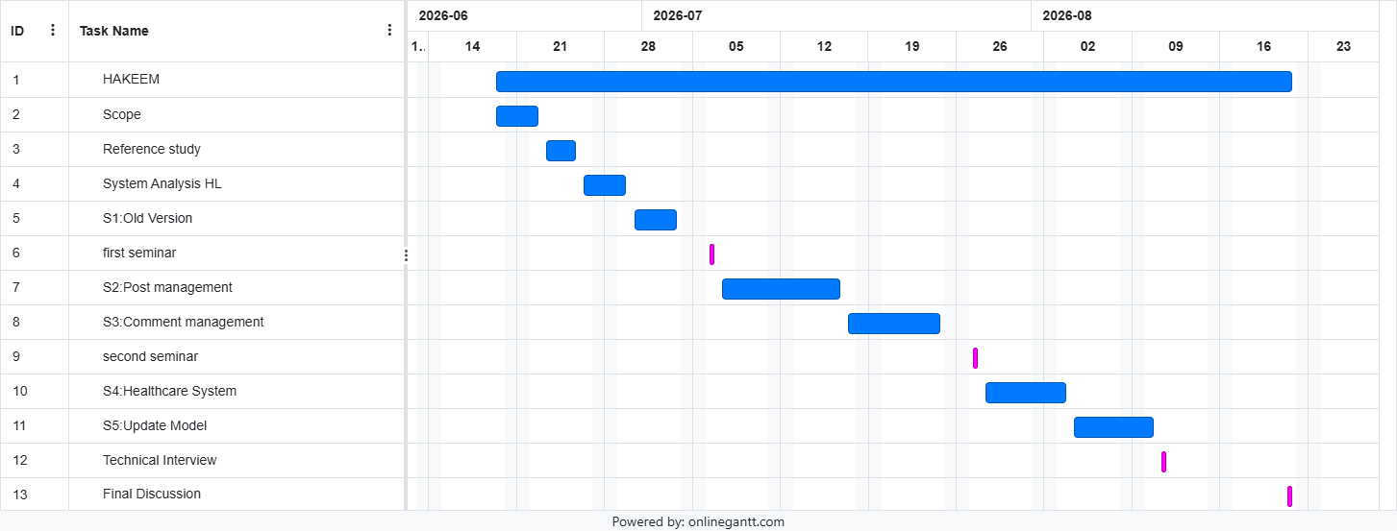
Gantt Chart:
Smart medical consulting application | Project Title
20/2/2026 | Project start date
1/6/2026 | Project end date
Dr.Majida AlBakoor | Project Supervisor
Smart medical consulting application | Project Title
20/2/2026 | Project start date
1/6/2026 | Project end date
Dr.Majida AlBakoor | Project Supervisor

Smart medical consulting application  (Hakeem) | Project Title
20/6/2026 | Project start date
22/8/2026 | Project end date
Dr.Majida AlBakoor | Project Supervisor

Project charter

2.3 Risk Management

Mitigation Plan | Impact | State | Tracking Frequency | Raised Date | Risk Description | Risk Title
Divide the project into sprints, use tools such as Gantt charts, and prioritize tasks | Hight | Active | weekly | 1/7/2026 | Failure to adhere to the timeline due to development complexities and resource shortages | Delay in the schedule
Using Jira to distribute tasks and daily meetings | Medium | Active | weekly | 26/6/2026 | Tasks piled up on one team member | Conflict in the distribution of tasks
Schedule weekly educational sessions | Hight | Active | weekly | 4/7/2026 | The team was slow to master the project's languages, which delayed delivery | Difficulty in learning new techniques
Frequent integration testing, use of API documentation, coordination among team members | Hight | Active | daily | 8/7/2026 | Conflict between backend and frontend interfaces during development | Interface integration problems
Manual testing application  For each feature and member's customization to understand the basics of the test | Hight | Active | weekly | 20/7/2026 | The emergence of undetected errors is due to the lack of a specialized laboratory within the team | Lack of testing experts
Upload the model to the website and obtain the API | Medium | potential | weekly | 25/7/2026 | The connection between the model and the interface is broken | Problems with the Moodle system
Use another API  Key from the Groq server | Hight | Active | weekly | 29/7/2026 | The API key stopped connecting | Ban the server
Risk management was performed throughout the software development lifecycle to identify potential issues and define mitigation strategies

2.4 Team Roles and Responsibilities

The project was developed by a one person:

Team Member | Responsibilities
Fadi Basem Alkhoury Hanna | Software implementation, backend development, frontend integration, testing and documentation.  Data collection, NLP model development, AI integration, documentation

2.5 Software Quality Management
Software quality was maintained by applying Software Engineering best practices throughout the project.
The quality assurance activities included:
- Code reviews
- Modular software design
- Version control using Git
- Unit testing
- Integration testing
- Functional testing
- Performance evaluation
- Documentation review
These activities ensured that the software remained maintainable, reliable, and scalable.

2.6 Project Management Tools
Tool | Purpose
GitHub | Source Code Management
Visual Studio Code | Code Development
Draw.io | UML Diagrams
PostMan | Test APIs
Microsoft Word | Documentation
Xampp | DataBase
Git | Version Control
Several software engineering tools were used during project development.

2.7 Monitoring and Progress Evaluation
Project progress was monitored throughout the development lifecycle.
Monitoring activities included:
- Weekly progress meetings.
- Task completion tracking.
- Milestone verification.
- Continuous testing after each implementation phase.
- Documentation updates.
- Supervisor feedback and review.
Continuous monitoring ensured that the project remained aligned with its objectives and schedule.

2.8 Software Configuration Management (SCM)

Software Configuration Management (SCM) was implemented to maintain software consistency and support collaborative development.
Git was used as the primary version control system.
The following branching strategy was adopted:
- main – Stable production-ready version.
- development – Integration branch for ongoing development.
- feature/* – Separate branches for implementing new features.
- bugfix/* – Branches dedicated to fixing software defects.
Each completed feature was reviewed before being merged into the development branch, ensuring code quality and minimizing integration conflicts.

Chapter Three:

Literature Review and Related Work

3.1 Introduction
Apps that mix software services with AI have become some of the most influential in modern healthcare. Lately, progress in natural language processing (NLP), large language models (LLMs), and retrieval-augmented generation (RAG) has led to smart medical consultation systems that can get what users are asking and give answers that fit the context.

Even with these advances, Arabic medical consultation systems are still kinda limited compared to English-based ones. Most of them either don’t support Arabic well or use old-school rule-based methods that can’t fully grasp natural Arabic medical language.

This chapter goes over the most relevant research, checks out the current medical systems, talks about the technologies used in this project, and points out the research gap that pushed for the proposed solution.

3.2 Recent Studies in Intelligent Medical Consultation Systems
- In 2024, a study titled “BERT-Based Medical Chatbot: Enhancing Healthcare Communication through Natural Language Understanding” introduced a deep learning–driven medical chatbot designed to improve healthcare communication and patient support. The authors emphasized that modern technologies such as AI, IoT, and deep learning are reshaping healthcare delivery, enabling more personalized and accessible medical services. As stated in the paper, “the advent of modern technologies like Artificial Intelligence (AI), Internet of Things (IoT) and Deep Learning (DL) has ushered in a transformative era in healthcare” [1] .
The proposed system leverages BERT, a bidirectional transformer-based model, to overcome limitations of traditional rule-based and machine-learning chatbots, particularly their difficulty in understanding medical jargon, maintaining context, and generating accurate responses. The study highlights that BERT’s contextual understanding enables the chatbot to interpret complex medical terminology and support multi-turn conversations with high precision. The authors note that “BERT’s bidirectional pre-training enables the chatbot to comprehend medical queries with exceptional degree of accuracy” .
To train the model, the researchers used several medical datasets, including MIMIC-III, BioASQ, PubMed, and COVID-19 corpora, ensuring broad coverage of clinical terminology and real-world medical inquiries. The system architecture includes modules for text preprocessing, entity recognition, intent classification, context management, and knowledge-base integration.
Experimentally, the BERT-based chatbot achieved 98% accuracy, 97% precision, 97% AUC-ROC, 96% recall, and an F1-score of 98%, outperforming baseline models such as LSTM, Bi-LSTM, and SVM. These results demonstrate the model’s strong predictive capability and its effectiveness in delivering reliable medical information.
- In 2024, the study “A RAG Chatbot for Precision Medicine of Multiple Myeloma” introduced a Retrieval-Augmented Generation (RAG) framework designed to support precision oncology by integrating genomic data with curated biomedical literature. The goal was to build an intelligent assistant capable of interpreting complex genomic variants and providing personalized treatment insights for Multiple Myeloma (MM), a highly heterogeneous cancer. As the authors state, “we present an innovative Retrieval-Augmented Generation (RAG) based chatbot framework that harnesses the power of NLP and state-of-the-art language models to curate and analyze MM-specific literature” [2].
The system combines BioMed-RoBERTa-base for embedding generation with the Mistral-7B model for clinical question answering, supported by Amazon OpenSearch for fast semantic retrieval. The researchers collected decades of PubMed articles, processed them into a structured dataset, and deployed the chatbot using Amazon Kendra, enabling scalable access to MM knowledge.
The study demonstrates that this RAG-based chatbot can effectively retrieve relevant literature, interpret genomic findings, and assist clinicians in forming personalized treatment plans. By integrating AI, NLP, and domain-specific data, the framework represents a significant step toward democratizing precision medicine and improving clinical decision-making in complex diseases like MM.
- In 2024, the study “BioMistral: A Collection of Open-Source Pretrained Large Language Models for Medical Domains” introduced BioMistral, a specialized biomedical LLM built upon the Mistral-7B architecture and further pre-trained on PubMed Central. The work aimed to overcome the limitations of general-purpose LLMs in healthcare by providing an open-source, domain-adapted model capable of strong medical reasoning. As the authors note, “we introduce BioMistral, an open-source LLM tailored for the biomedical domain” [3].
The researchers constructed a 3-billion-token medical corpus and adapted Mistral-7B using advanced training strategies, including supervised fine-tuning, few-shot prompting, quantization for efficient deployment, and model-merging techniques such as SLERP and DARE. They also introduced a comprehensive benchmark of 10 medical QA tasks and extended it to seven additional languages, marking the first large-scale multilingual evaluation of medical LLMs.
Across English and multilingual settings, BioMistral consistently outperformed existing open-source medical models and demonstrated competitive performance relative to proprietary systems. The study positions BioMistral as a robust, accessible, and efficient biomedical LLM, advancing the development of trustworthy and domain-specialized AI tools for healthcare.
- In 2024, a study titled “AHD: Arabic Healthcare Dataset” introduced one of the largest publicly available Arabic medical datasets designed to support healthcare NLP applications, particularly chatbots and text classification systems. The work addresses a major gap in Arabic NLP, where progress has been limited due to the absence of large, domain-specific datasets. As the authors note, “the primary shortcoming of these models is the lack of suitable Arabic datasets for training” [4].
The researchers constructed the AHD dataset by scraping the Altibbi medical website, resulting in more than 808,000 Arabic questions and answers distributed across 90 healthcare categories, making it the most comprehensive Arabic medical corpus to date. The dataset preserves raw text without preprocessing, capturing real-world linguistic variability such as punctuation, mixed symbols, and the absence of diacritics. Statistical analysis shows that questions average 115 characters and answers 152 characters, with significant variation in length across categories.
AHD is made publicly accessible through Mendeley Data and is intended to support a wide range of NLP tasks, including text classification, question answering, chatbot development, and word embedding training. Compared with existing Arabic healthcare datasets, AHD is substantially larger and more diverse, offering a valuable resource for advancing Arabic medical AI and enabling more accurate and practical healthcare applications.
- In 2023, a study titled "Deep Learning for Arabic Healthcare: MedicalBot" was published in the journal Social Network Analysis and Mining. The study aimed to develop an intelligent Arabic model that functions as a virtual medical consultant, capable of understanding medical questions posed by users and providing accurate answers based on Deep Learning techniques. The researchers focused on the significant lack of Arabic medical resources, as well as language-related challenges such as dialect variations, ambiguity in meaning, and limited coverage in open medical databases [5].
The work began by utilizing an Arabic medical question-answering dataset from Harvard University called MAQA, which contains more than 430,000 medical questions and answers covering 20 different medical specialties, including dermatology, cardiology, surgery, pediatrics, and orthopedics. The data was collected from well-known Arabic medical platforms such as Altibbi, Tbeeb.net, and Cura.healthcare. It was manually cleaned to remove linguistic errors, duplicates, and non-Arabic symbols, forming a solid foundation for training the intelligent models.
The researchers employed three main Deep Learning techniques: the LSTM (Long Short-Term Memory) model for sequential text analysis, the Bi-LSTM (Bidirectional LSTM) model to capture context from both directions, and the Transformer model based on the Attention Mechanism, which has proven highly effective in NLP tasks. They also used pretrained Arabic word embeddings from AraVec (CBOW, 300 dimensions) to enhance semantic understanding.
The models were trained using the PyTorch library on Google Colab with an NVIDIA GTX 1080 GPU. The dataset was split into 70% for training, 20% for validation, and 10% for testing.
The results showed that the Transformer model significantly outperformed the other models in terms of answer quality and understanding accuracy. It achieved a cosine similarity score of 80.81% and a BLEU score of 58%, while the LSTM and Bi-LSTM models demonstrated lower performance. The researchers also noted that the BLEU metric does not fully reflect the quality of Arabic responses due to the language’s rich morphology and the presence of multiple synonyms.
- In 2024, a study titled "BiMediX: Bilingual Medical Mixture of Experts LLM" was introduced, aiming to develop the first large-scale bilingual medical language model capable of seamlessly interacting in both Arabic and English. The study focused on building an intelligent medical consultation system that can conduct multi-turn conversations with patients and answer both open-ended and multiple-choice medical questions in a way that simulates real doctor–patient interactions [6].
The researchers based their work on the Mixtral-8x7B model, which utilizes the Mixture of Experts (MoE) architecture to efficiently handle different types of data through specialized expert networks. To reduce training costs, they applied the QLoRA-based Parameter-Efficient Fine-Tuning (PEFT) technique, which allows fine-tuning the model without retraining it.
In addition, the study developed a semi-automated translation system between English and Arabic using ChatGPT for initial translation, followed by human review from medical experts to ensure the accuracy of medical terminology and linguistic quality.
The researchers constructed a large-scale bilingual medical dataset called BiMed1.3M, one of the largest of its kind, containing over 1.3 million medical interactions. This includes open-ended questions and answers, multiple-choice questions, and more than 250,000 multi-turn conversations simulating doctor–patient dialogues. The data was collected from reliable medical sources such as PubMedQA, MedMCQA, HealthCareMagic, iCliniq, and UMLS, and was published on Hugging Face.
The results showed that the BiMediX model outperformed several recent medical models such as Med42, Meditron, and Jais-30B. It achieved an accuracy of 75.4% in English, 56.5% in Arabic, and 65.4% in bilingual evaluation. Moreover, it demonstrated superior efficiency, being up to eight times faster than other models while consuming fewer computational resources.

- In 2024, a research team from Dr. T. Thimmaiah Institute of Technology and REVA University presented a study titled “Medical ChatBot Assistance for Primary Clinical Guidance using Machine Learning Techniques.” The study aimed to design an intelligent system that provides automated preliminary medical consultations, called the Robotic Medical Support ChatBot (RMSCB). This system was developed to assist patients in areas with limited access to continuous healthcare services, especially in rural regions [7].
The system relies on Machine Learning techniques to process and analyze medical questions submitted by users in order to predict possible diagnoses and provide appropriate medical guidance. It operates through several sequential stages:
- Pre-processing Stage: Keywords are extracted from medical questions using the Pre-Fixed Stopping Words Model (PFSWM), which removes unnecessary words such as common connectors and verbs to improve analysis accuracy.
- Training Stage: The processed questions are classified into predefined disease categories using the Pre-Fixed Class Label Model (PFCLM). Each category is then linked to specific treatment responses through the Pre-Fixed Answer and Question Model (PFAQM).
- Classification Stage: New user questions are analyzed and compared with the trained dataset to determine the closest disease category by calculating statistical probabilities, enabling the system to suggest the most likely diagnosis.
The system was trained on a large collection of medical textual data consisting of patient–doctor interactions collected from online medical servers. The dataset includes common diseases such as fever, cold, cough, and headache, along with their initial treatment procedures. For instance, in cases of fever, the system recommends medications such as Paracetamol 500 mg and Nimesulide 100 mg for adults, and Tylenol for children, while advising users to consult a doctor afterward.
The results indicated that the system is capable of classifying medical questions with high accuracy and providing initial treatment responses within seconds. However, the study did not present detailed numerical results or evaluation tables.
- In a 2023 study titled “Personal Healthcare Chatbot for Medical Suggestions Using Artificial Intelligence and Machine Learning,” researchers developed an intelligent medical assistant (chatbot) designed to diagnose diseases based on symptoms provided by users and to offer preliminary medical guidance. The system primarily relied on Natural Language Processing (NLP) techniques to understand human language, along with retrieval-based machine learning algorithms to select the most appropriate response from a predefined knowledge base [8].
The results of the study showed that the developed system achieved a diagnostic accuracy of approximately 82%, outperforming other comparable intelligent medical systems whose accuracy ranged between 65% and 75%. This significant improvement was attributed to a mechanism introduced by the researchers that required a confidence threshold of at least 80% in analyzing user symptoms before providing any diagnosis, which helped reduce incorrect predictions.
It is worth noting that the study did not provide a publicly available link to the dataset used for training and evaluation. Instead, it only mentioned that the system was designed to store data and user interactions in a database to improve its responses over time.
- In a 2023 study titled “An artificially intelligent, natural language processing chatbot designed to promote COVID-19 vaccination,” an intelligent assistant was developed to provide accurate and persuasive information about COVID-19 vaccines. The system relied on advanced Natural Language Processing (NLP) and Machine Learning techniques, implemented using Python pipelines with specialized libraries such as NumPy, Pandas, and scikit-learn. It was deployed on Amazon Web Services EC2 and IBM Watson Assistant [9].
The system featured a hybrid approach combining manual data updates with automated machine learning. A comprehensive knowledge base was created, consisting of 66 intents covering various vaccine-related topics. For training, the researchers used Amazon Mechanical Turk to collect thousands of diverse question formulations from users, enabling the system to better understand natural language and tolerate spelling errors. To ensure effectiveness, responses were designed based on established behavioral and persuasion theories and written at an accessible reading level (approximately 8th grade), in both English and Spanish.
A total of 2,479 users interacted with the system, exchanging 3,994 messages. The most frequently discussed topics included booster doses and vaccination locations. The system’s response-matching accuracy improved significantly from 54% at launch to 91.1% by the end of the study period, with an average response time of 0.199 seconds.
The study also observed that accuracy decreased when new information about the virus emerged (such as the Delta variant) and improved again after system updates. Although no public dataset link was provided, the methodology relied on large-scale crowdsourcing to build a robust linguistic dataset, with an average of 57.34 questions per intent.

3.3 Modern Technologies Used in the Project
The proposed system combines several modern software and Artificial Intelligence technologies.

Natural Language Processing (NLP)
Natural Language Processing enables computers to understand, process, and analyze human language. Within this project, NLP techniques are responsible for interpreting Arabic medical questions before generating responses.

Large Language Models (LLMs)
Large Language Models provide advanced capabilities for language understanding and response generation. Their contextual reasoning significantly improves answer quality compared with traditional chatbot systems.

Retrieval-Augmented Generation (RAG)
Retrieval-Augmented Generation combines semantic retrieval with text generation.
Instead of generating answers from memory alone, the system first retrieves relevant medical documents from a knowledge base and then uses them to generate an accurate response.
This architecture improves:
- Reliability
- Accuracy
- Explainability
- Knowledge freshness

Vector Databases
Vector databases store text embeddings instead of plain text.
The proposed system utilizes semantic similarity search to retrieve the most relevant medical documents before answer generation.

Embedding Models
Embedding models convert Arabic medical text into numerical vectors that preserve semantic meaning.
These vectors enable efficient similarity search within the knowledge base.

3.4 Comparative Analysis of Existing Systems


- Health tap :
Is a prominent virtual healthcare platform founded in 2010 in USA. It connects users with a vast network of board-certified physicians to provide affordable
(Pros):
Free answers: The site allows you to ask general questions for free and receive short answers from real doctors.
Presence of on-duty doctors on the platform.
Electronic payment feature
Feature of uploading body images.
(Cons):
Relying solely on doctors for answers and the absence of a medical model.
Patients' inability to raise suggestions to the admin.


- Ada Health:
"Ada Health was founded in Germany in 2011 by a team of doctors and scientists. Its core concept is to provide a 'Symptom Assessment'. When you feel unwell, the app asks you a series of intelligent, sequential questions Based on your answers and by comparing them with a vast medical database, it provides a report outlining the potential causes of your symptoms and the next steps you should take.

(Pros):
The presence of a medical module that supports :
High Clinical Accuracy Developed and continuously updated by a large team of medical doctors and scientists, making its AI highly reliable.
Comprehensive for rare diseases: Covers thousands of medical cases, including some rare diseases that ordinary search engines may overlook.

(Cons):
Absence of human medical participation:
Not a substitute for a doctor: The platform always emphasizes that it is only a guidance tool, and it cannot provide a final diagnosis or a treatment plan (it does not prescribe medications).
Lack of human follow-up: There are no real doctors within the app to discuss the case immediately, as is the case on other telemedicine platforms.


- Medsy:
It is a Syrian program made in 2023. It aims to connect patients with doctors, support the clinic system, and book appointments.

(Pros):
Ease of use and browsing speed: programmed to be lightweight and compatible with the internet speeds available to users in Syria.
Provides appointment booking service through the clinics system and appointment booking.
(Cons):
The absence of technological and smart development in the program.
Lack of subscription or electronic payment feature.


- PathAI:
It is an advanced medical program that relies on artificial intelligence and deep learning to analyze medical consultations, in addition to the presence of medical personnel, and the program was developed in USA in 2015.

(Pros):
Standardizing diagnostic criteria as the program provides an objective and unified assessment for diagnosis, eliminating differences in opinions between one doctor and another.
Presence of doctors supervising all medical procedures.

(Cons):
Not available for patients. The program is exclusively designed for hospitals, laboratories, and researchers, and cannot be used personally by an ordinary individual.

comparison between the literature reviews used in this project and the “Hakeem” application.

System feature | Health tap | Ada health | Medsy | PathAI | Hakeem
توثيق بالايميل | X | X | - | X | X
اقتراحات | - | X | X | - | X
طبيب مشرف | X | - | X | X | X
Dashboard | X | X | X | -
مودل طبي | - | X | - | - | X
بوست | - | X | X | - | X
BMI | - | - | - | X | X
Sleep tracker | - | X | - | X | X
Calories calculator | - | X | - | X | X

3.5 Research Gap

The literature review reveals several limitations in existing intelligent healthcare systems.
The identified research gaps include:
Limited support for Arabic medical language.
Lack of Retrieval-Augmented Generation in Arabic consultation systems.
Limited availability of high-quality Arabic medical datasets.
Difficulty in understanding complex Arabic medical terminology.
Poor scalability of many existing healthcare applications.
These limitations motivated the development of the proposed Hakeem system, which combines modern software engineering practices with advanced NLP technologies to provide an intelligent Arabic medical consultation platform.

3.6 Theoretical Foundation

The proposed system is built upon several theoretical concepts:
Natural Language Processing.
Retrieval-Augmented Generation.
Semantic Search.
Vector Embedding.
Software Architecture Principles.
RESTful API Design.
Client–Server and MVC Architectures.

3.7 Future Trends

Recent trends in smart healthcare systems include:

- Large Language Models (LLMs).
- Understanding and interpreting medical tests.
- Supporting multilingual communication.
- AI-powered support for sign language for the deaf and mute.

Chapter Four:

Requirements Analysis and System Modeling

4.1 Introduction

Requirements analysis is one of the most critical phases in Software Engineering because it defines what the system should accomplish before implementation begins. Proper requirements analysis reduces software defects, minimizes development risks, and improves software quality.

For the Hakeem system, requirements were gathered from medical consultation platforms, research papers, healthcare applications, and discussions with potential users. These requirements were analyzed, documented, prioritized, and transformed into software models before implementation

4.2 Feasibility Study

Before beginning system development, a feasibility study was conducted to evaluate whether the proposed system could be successfully implemented.

4.2.1 Technical Feasibility

The proposed system is technically feasible because the required technologies are mature and widely available.
The project utilizes:
- Flutter Framework
- Laravel Framework
- Python
- Qdrant Vector Database
- Large Language Models

4.2.2 Economic Feasibility

The project is pretty cheap to develop since it's mostly based on open-source software.
You'll need:
- A personal computer
- Internet connection
- Open-source frameworks
- Public Arabic medical datasets
- A Groq server subscription
So, it doesn't need a huge financial investment.

4.2.3 Operational Feasibility

The system is intended for Arabic-speaking users seeking preliminary medical consultation.
Its graphical user interface is simple and intuitive, allowing users to submit medical questions without requiring technical knowledge.
Healthcare institutions may also benefit from the system as a supportive consultation tool.

4.2.4 Schedule Feasibility

The project was completed within the planned academic timeline.
The development schedule included:
- Requirements analysis
- System design
- AI model development
- Software implementation
- Testing
- Documentation
Project progress was monitored throughout development.

4.3 Requirements Gathering

Requirements were collected using several complementary sources.
The primary methods included:
- Literature review.
- Analysis of existing healthcare platforms.
- Dataset analysis.
- Discussions with potential users.
- Supervisor recommendations.
These methods helped identify both functional and non-functional requirements.

4.4 Stakeholder Analysis

Responsibility | Role | Stakeholder
Guides the project and provides feedback | Project Manager & Supervisor | Dr.Majida AlBakoor
Frontend development, ensure a seamless user experience .  Design and implement user interfaces, Develop backend functionalities, implement authentication, handle database integrations. connect fronted with backend.  Applying preprocessing to the data used ,building an NLP model using RAG technology | Software Engineer | Fadi Alkhoury Hanna

4.5 Functional Requirements

The functional requirements describe the services provided by the system:
- FR1:User can login to the system.
- FR2:Doctor can login to the system.
- FR3:User can verify email.
- FR4:User can manage profile information.
- FR5:User can reset forgotten password.
- FR6:User can contact doctor.
- FR7:User can view health posts.
- FR8:User can comment on posts.
- FR9:User can ask medical questions.
- FR10:User can send suggestions.
- FR11:User can calculate BMI.
- FR12:User can calculate daily calories.
- FR13:User can track daily water intake.
- FR14:User can track sleep.
- FR15:User can manage emergency contacts.
- FR16:Doctor can manage inbox messages.
- FR17:Doctor can view users.
- FR18:Doctor can view suggestions.
- FR19:Doctor can view users' questions.
- FR20:Doctor can answer medical questions.
- FR21:Doctor can manage posts.
- FR22:Doctor can create posts.
- FR23:Doctor can delete posts.
- FR24:Doctor can view comments.
- FR25:Doctor can ban users.

4.6 Non-Functional Requirements

• Compatibility: The application must be compatible with various operating systems and devices used by users, such as smartphones and tablets.
• Ease of use: We worked to make the application easy to use and simple so that patients can access information easily.
• Scalability: The application is capable in the future of handling an increase in data volume and the number of users without affecting the application's performance.
• Security and privacy: We have protected patients' data and sensitive information related to personal accounts.
• Integration: The application is capable of integrating with other systems such as online payment systems, and others.

4.7 Requirement Prioritization (MoSCoW)

The project requirements were prioritized using the MoSCoW technique.

Must Have
- User authentication.
- Medical question submission.
- AI-generated responses.
- Knowledge retrieval.
- Database connectivity.
- Mobile application.
Should Have
- User profile management.
- Consultation history.
- -Dashboard.
- Medical category filtering.
Could Have
- Voice input.
- Medical image upload.
- Multi-language support.
Won't Have
The following features were intentionally excluded from the current project scope:
- Online doctor appointments.
- Electronic prescriptions.
- Video consultation.
- Hospital management.

4.8 UML diagrams

4.8.1 Use Case Diagram(Low level)

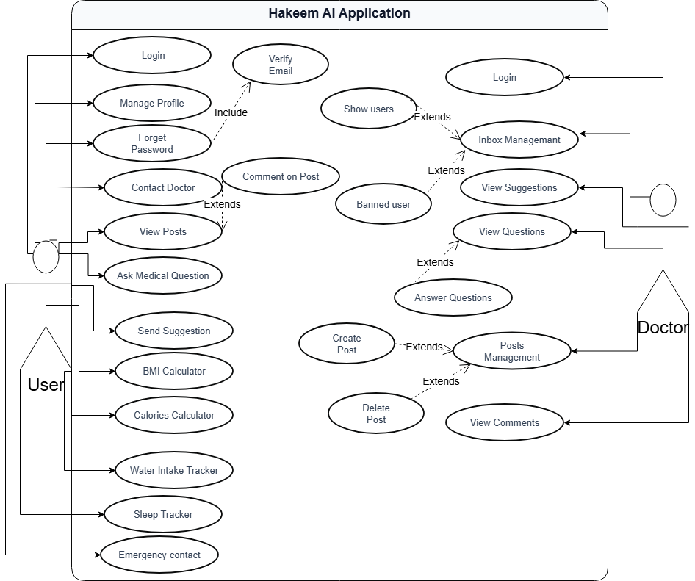

4.8.2 Use Case Diagram(Heigh level)

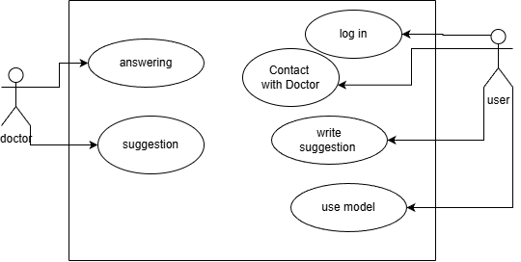

4.8.3 Use Case Specification

- Use Case Specification (log in):

Use Case ID | UC-01
Use Case Name | Log in
Actors | User
Description | Create a new account and user registration
Preconditions | The user does not have a previous account in the program
Postconditions | Successful login of the person to their account
Normal Flow | 1. The system asks for the email and password.  2. The user enters the name, email, and password, and confirms the password.  3. The system verifies the account via email and sends a code to the entered email.  4. The user enters the code received in the email.  5. The system verifies the entered code.  6. The system displays the personal page.
Alternative flow | A) At step 5, if an incorrect code is entered, it goes back to step 1

- Use Case Specification(Use Model):

Use Case ID | UC-09
Use Case Name | Use Model
Actors | User
Description | The user's desire to obtain medical consultation from the model
Preconditions | The user must be logged in
Postconditions | The user obtaining the information
Normal Flow | 1. The user opens the Model page  2. The system displays the Model page  3. The user writes the question in the box  4. The user clicks send  5. The system sends the answer from Model and displays it to the user
Alternative flow | There is none

- Use Case Specification(Replying Question):

Use Case ID | UC-020
Use Case Name | replying question
Actors | Doctor
Description | Doctor's answer to the patient's question
Preconditions | The record contains a question
Postconditions | The patient receiving the answer
Normal Flow | 1. The doctor opens the patient questions page  2. The system displays the patient questions record  3. The doctor selects the question and clicks answer  4. The system displays a box for the doctor's answer  5. The doctor writes the answer and clicks send  6. The system gives a success message
Alternative flow | There is none

4.8.4 Activity Diagram

- Activity Diagram(Log in):

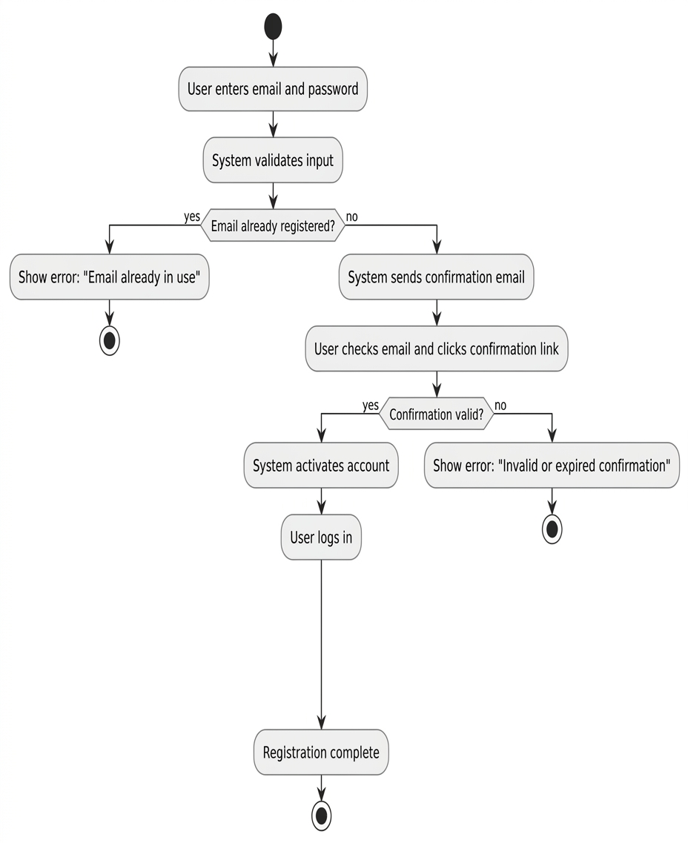
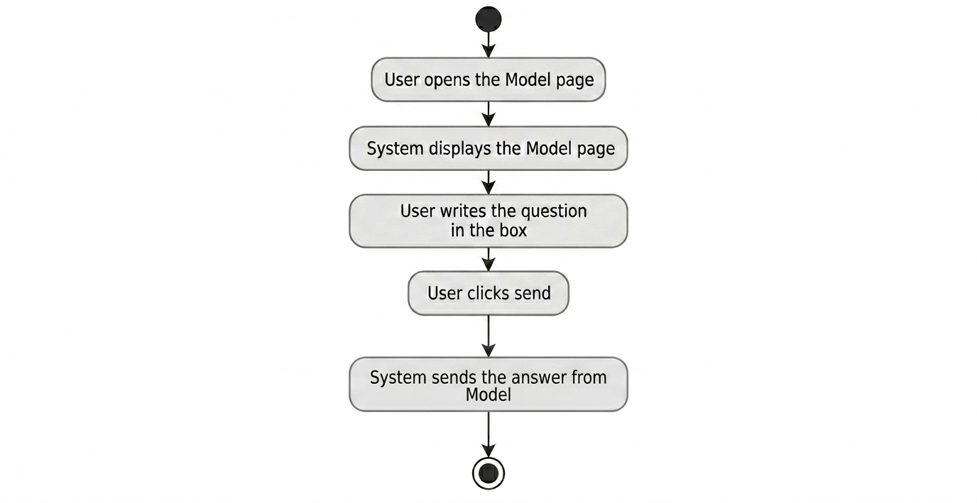
- Activity Diagram(Use Model):
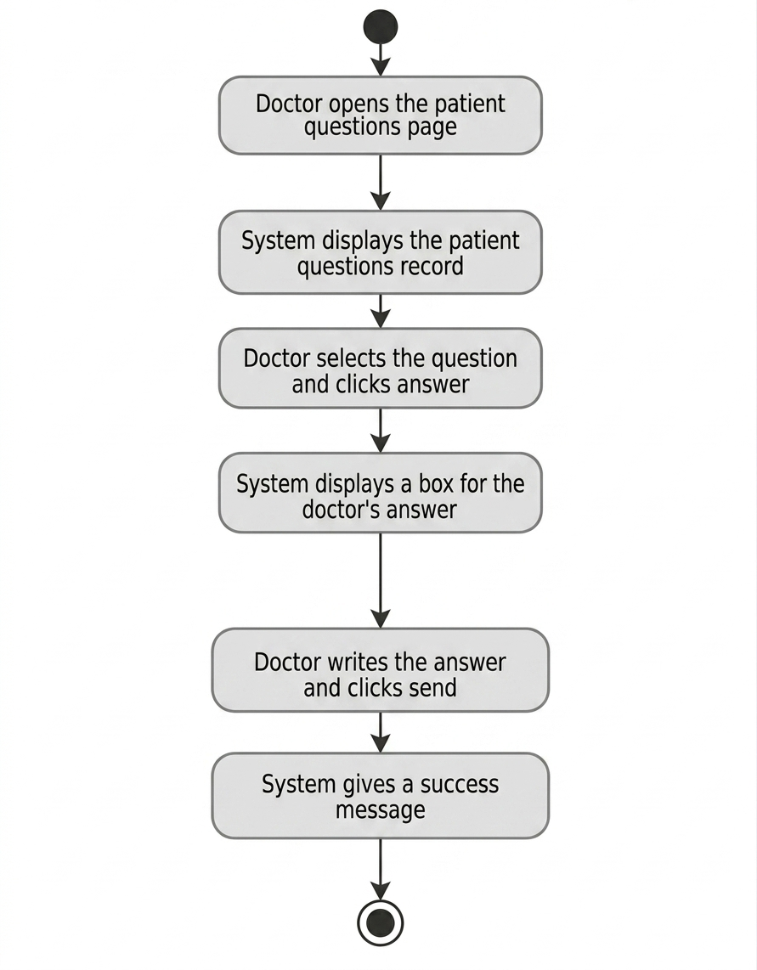
- Activity Diagram(Replying Question):

4.8.5 Sequence Diagrams

- Sequence Diagram(Log in):
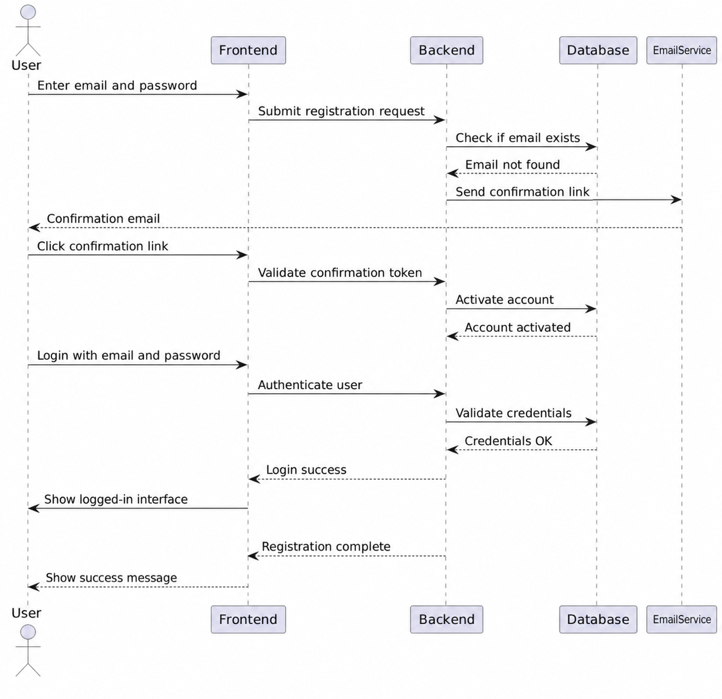

- Sequence Diagram(Use Model):

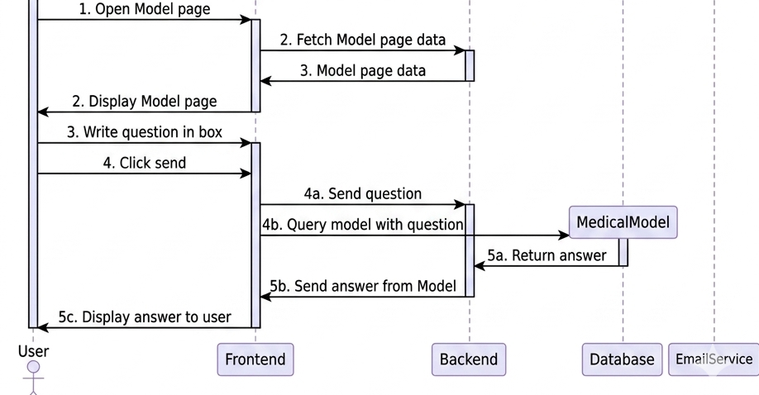

- Sequence Diagram(Replying Question):

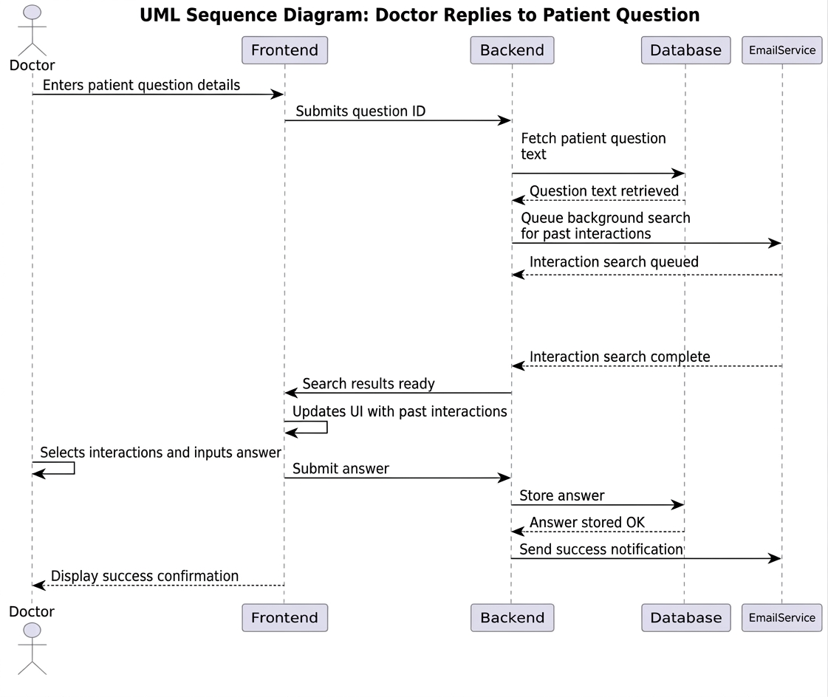

4.8.6 Requirements Traceability Matrix

A Requirements Traceability Matrix (RTM) was prepared to ensure that every requirement is linked to its corresponding design component and test case.

Req ID | Functional Requirement | Actor | Use Case | Priority | Test Case ID | Status
FR-01 | User can login to the system | User | Login | High | TC-01 | ✔
FR-02 | Doctor can login to the system | Doctor | Login | High | TC-02 | ✔
FR-03 | User can verify email | User | Verify Email | High | TC-03 | ✔
FR-04 | User can manage profile information | User | Manage Profile | High | TC-04 | ✔
FR-05 | User can reset forgotten password | User | Forget Password | High | TC-05 | ✔
FR-06 | User can contact doctor | User | Contact Doctor | High | TC-06 | ✔
FR-07 | User can view health posts | User | View Posts | Medium | TC-07 | ✔
FR-08 | User can comment on posts | User | Comment on Post | Medium | TC-08 | ✔
FR-09 | User can ask medical questions | User | Ask Medical Question | High | TC-09 | ✔
FR-10 | User can send suggestions | User | Send Suggestion | Medium | TC-10 | ✔
FR-11 | User can calculate BMI | User | BMI Calculator | Low | TC-11 | ✔
FR-12 | User can calculate daily calories | User | Calories Calculator | Low | TC-12 | ✔
FR-13 | User can track daily water intake | User | Water Intake Tracker | Low | TC-13 | ✔
FR-14 | User can track sleep | User | Sleep Tracker | Low | TC-14 | ✔
FR-15 | User can manage emergency contacts | User | Emergency Contact | Medium | TC-15 | ✔
FR-16 | Doctor can manage inbox messages | Doctor | Inbox Management | High | TC-16 | ✔
FR-17 | Doctor can view users | Doctor | Show Users | Medium | TC-17 | ✔
FR-18 | Doctor can view suggestions | Doctor | View Suggestions | Medium | TC-18 | ✔
FR-19 | Doctor can view users' questions | Doctor | View Questions | High | TC-19 | ✔
FR-20 | Doctor can answer medical questions | Doctor | Answer Questions | High | TC-20 | ✔
FR-21 | Doctor can manage posts | Doctor | Posts Management | High | TC-21 | ✔
FR-22 | Doctor can create posts | Doctor | Create Post | High | TC-22 | ✔
FR-23 | Doctor can delete posts | Doctor | Delete Post | Medium | TC-23 | ✔
FR-24 | Doctor can view comments | Doctor | View Comments | Medium | TC-24 | ✔
FR-25 | Doctor can ban users | Doctor | Banned User | High | TC-25 | ✔

4.8.7 Initial Test Cases

The following initial test cases were defined during the analysis phase.
Test Case | Description | Expected Result
TC01 | Register a new user | User account created successfully
TC02 | User login | Successful authentication
TC03 | Submit medical question | Question stored successfully
TC04 | Retrieve medical knowledge | Relevant medical documents retrieved
TC05 | Generate AI response | Accurate response displayed
TC06 | Invalid login | Appropriate error message displayed
TC07 | Admin manages users | Changes saved successfully
TC08 | View consultation history | Previous consultations displayed

These test cases provide an initial validation plan and will be expanded during the testing phase in Chapter Eight.

Chapter Five:

System Architecture and Software Design

5.1 High-Level Design

5.1.1 System Block Diagram

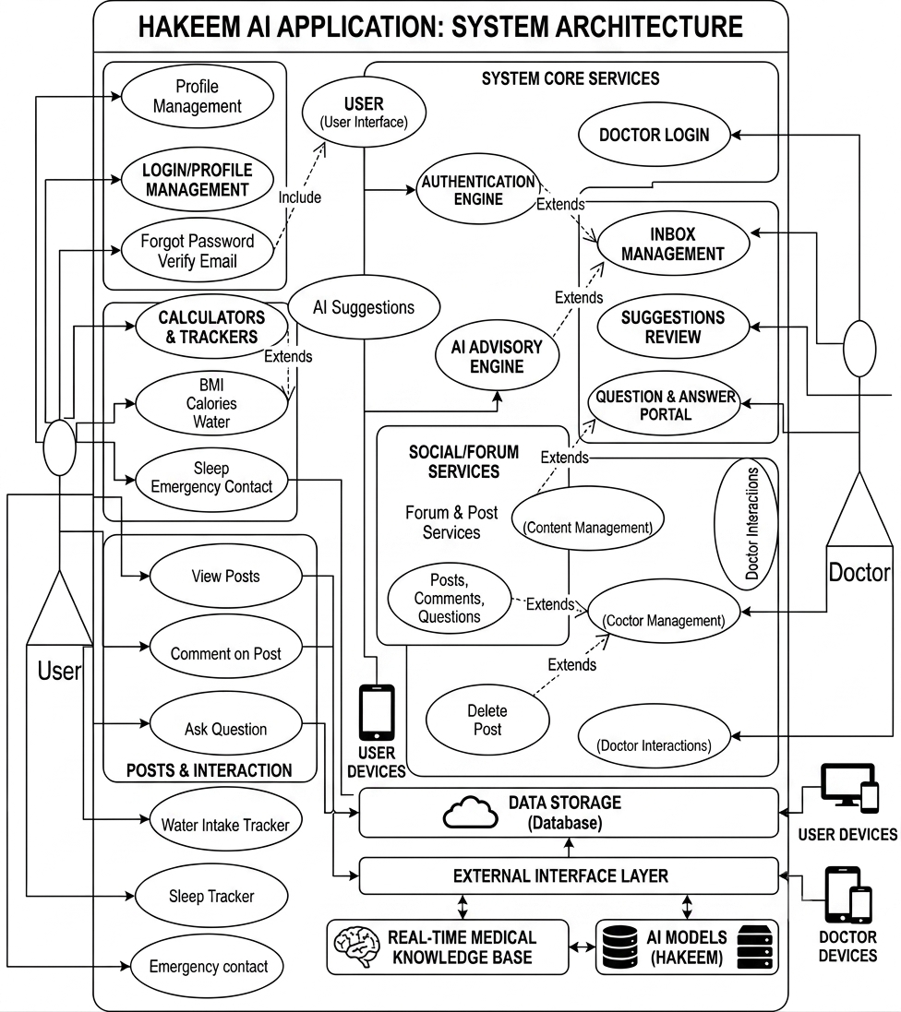

5.1.2 The architectural design style used

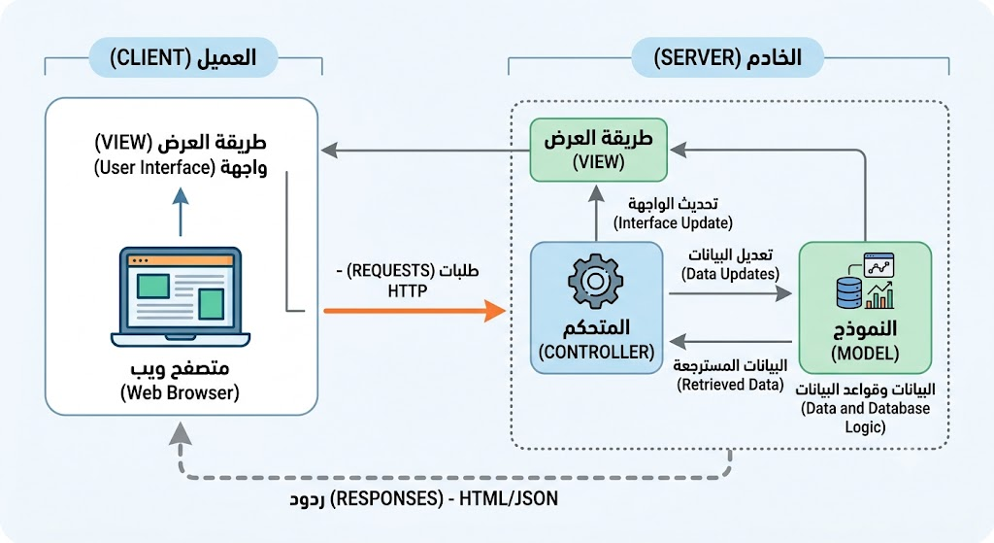

5.1.3 System Architecture Design

The proposed Hakeem system adopts a hybrid architectural approach that combines the Client–Server Architecture with the Model–View–Controller (MVC) Architecture. The Client–Server architecture is responsible for managing communication between clients and the server, while the MVC architecture organizes the internal structure of the server application by separating the presentation layer, business logic, and data management.

- Client–Server Architecture
The Client–Server architecture relies on distributing the system's responsibilities between two main parties: the client and the server.
- Client
Represents the user interface and does the following tasks:
- Logging in.
- Sending medical questions.
- Displaying consultation results.
- Managing the profile.

- Server
Handles all client requests and includes:
- Verifying user identity.
- Executing business logic.
- Managing the database.
- Calling AI services.
- Sending results back to the client.

- MVC Architecture
On the server side, we went with a Model-View-Controller (MVC) setup to split the app into three separate parts.
- Model
Takes care of the data and database stuff, including:
- Users
- Consultation records
- Medical data
- AI results

- View
Handles the user interfaces, showing info and taking input from users.

- Controller
Serves as the go-between for the Model and the View, taking requests, processing them, working with the database and AI services, and then sending the results back to the user.

This way of organizing things helps keep components loosely connected and makes the system more reusable, which makes it easier to develop and maintain.

5.2 Database Design

5.2.1 ERD Diagram
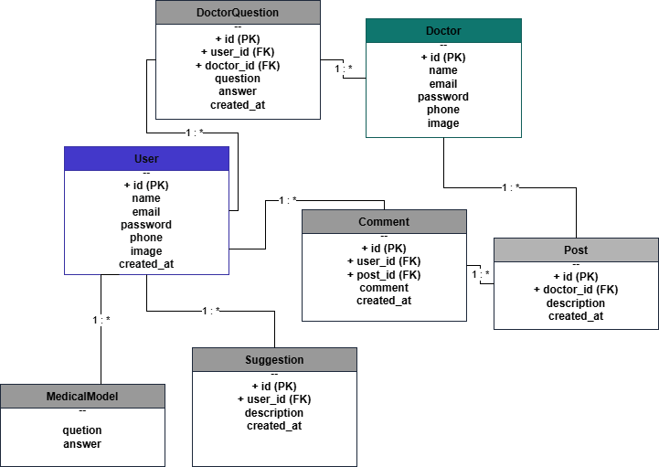

5.2.2 Relational Schema
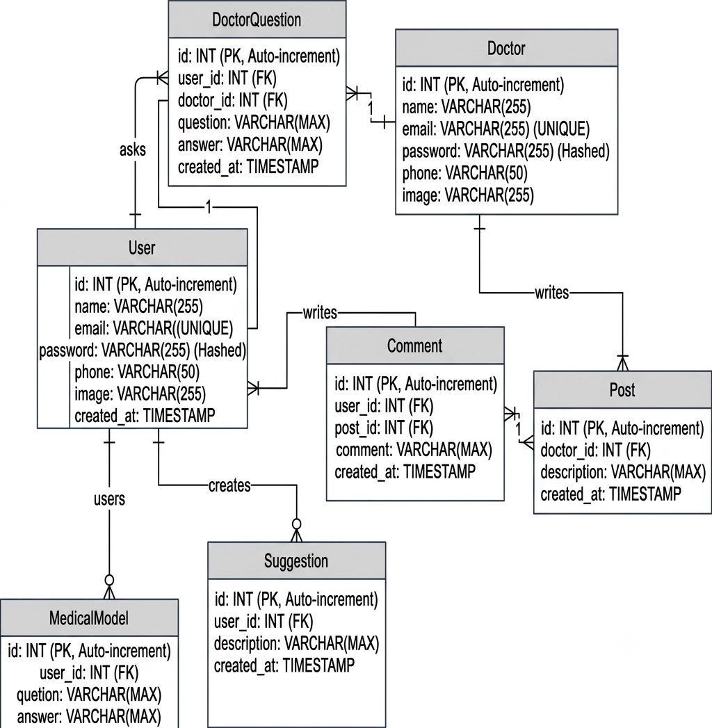

5.3 External facades design APIs

All the APIs are shown in Postman, and this is part of them:
Endpoint | Method | Description
/login | POST | User authentication
/register | POST | Create new account
/logout | GET | User logout

5.4 Security Design

Security is an essential aspect of healthcare software systems.
The following mechanisms were implemented:
Authentication
Registered users must log into the system before accessing protected services.
Authorization
Different permissions are assigned according to user roles.
Roles include:
- User
- Administrator
Each role has specific access privileges.
Password Security
Passwords are securely encrypted before being stored in the database.
Data Validation
All user input is validated before processing to prevent invalid or malicious requests.

Chapter Six:

Development Environment and Implementation Tools

6.1 Software Tools

Several software development tools were used during the implementation of the project.

Tool | Purpose
Visual Studio Code | Source code development  Application deployment and containerization
Git | Version control
GitHub | Source code repository
Draw.io | UML diagrams
Postman | API testing
xampp | Database
Google Chrome | Web application testing

6.2 Development Environment

The development environment consisted of the following hardware and software components.
- Hardware Requirements
Component | Specification
Processor | Intel Core i5 or higher
RAM | Minimum 8 GB
Storage | SSD recommended
Internet | Required for model access and package installation

- Software Environment
component | Description
Operating System | Windows 11 / Ubuntu Linux
Python | Primary programming language
flutter | Frontend runtime environment
Laravel | Backend development
Python | AI Development
Git | Version control

6.3 Programming Languages and Frameworks

The project combines modern software engineering technologies for frontend, backend, and AI development

Technology | Purpose
Python | Backend development and AI integration
Flutter | Frontend development
laravel | Backend development

6.4 Database Management System

XAMPP
The XAMPP package was used as a local development environment for the system. It provides the Apache web server to host the application and MySQL as a relational database management system for storing and managing the application's data.

The MySQL database stores all the structured information of the system, including:
- User accounts.
- Authentication data.
- Medical consultation records.
- User notes and evaluations.
- Posts and comments.

Using XAMPP provides a simple and integrated development environment, allowing efficient application development, database management, and local testing before deployment.

Qdrant Vector Database
Qdrant stores vector embeddings created from the Arabic medical dataset.

It's in charge of:
- Vector indexing
- Semantic similarity search
- Quick document retrieval
- Preparing context for RAG

6.5 Libraries and Dependencies

Several open-source libraries were integrated into the Hakeem system to support API development, semantic retrieval, natural language processing, and communication with Large Language Models (LLMs). Each library was selected based on its functionality and compatibility with the overall software architecture.
The following table summarizes the main libraries used in the project and their purposes.

Artificial Intelligence Libraries

Library | Purpose
FastAPI | Develop REST APIs and manage communication between the client and server
Pydantic | Validate incoming request data and data models
Qdrant Client | Connect to the Qdrant vector database and perform semantic search
LangChain HuggingFace | Generate text embeddings using Hugging Face embedding models
LangChain Qdrant | Integrate LangChain with the Qdrant vector database
ContextualCompressionRetriever | Retrieve and compress relevant documents before response generation
CrossEncoderReranker | Re-rank retrieved documents according to semantic relevance
HuggingFaceCrossEncoder | Implement the Cross-Encoder model used for document re-ranking
ChatGroq | Connect to the Groq Large Language Model (LLM) API
ChatPromptTemplate | Create prompt templates for AI response generation
Python Standard Libraries (re, contextlib) | Regular expression processing and application lifecycle management

Software Engineering Frameworks

Framework / Library | Purpose
Laravel | Backend web application development using the MVC architecture
PHP | Server-side programming language
Flutter | Cross-platform mobile application development
Dart | Programming language used by Flutter
XAMPP | Local development environment (Apache & MySQL)
MySQL | Relational database management system
Flutter SDK | Building and compiling the mobile application

6.6 Version Control

Version control was managed using Git.
The following workflow was adopted:
- Create a feature branch.
- Implement the new functionality.
- Perform local testing.
- Merge into the development branch.
- Merge into the main branch after successful validation.
This workflow reduced integration conflicts and improved code quality.

6.7 Continuous Integration and Deployment

The development process followed several continuous integration practices.
These practices included:
- Frequent commits.
- Regular code merging.
- Continuous testing after implementing each feature.
- Early detection of software defects.
- Documentation updates after each milestone.
These activities improved software quality throughout development.

6.8 Testing Environment

The application was evaluated within a controlled development environment before deployment.
Testing included:
- Localhost testing.
- -API validation using Postman.
- Frontend integration testing.
- Backend integration testing.
- AI model evaluation.
- Database connectivity testing.
Each software component was verified individually before full system integration.

Chapter Seven:

Software Implementation

7.1 Project Structure (Project Folder Organization)

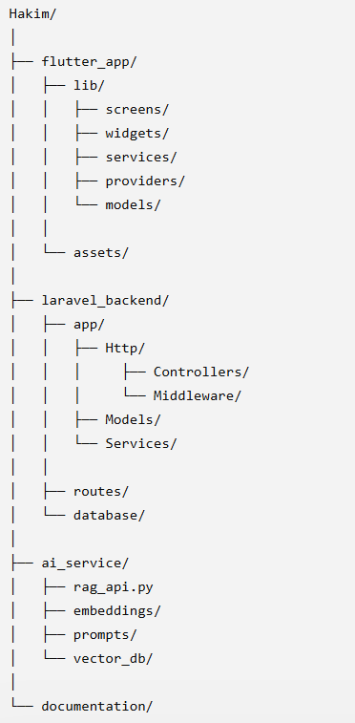

The Hakeem project follows a modular folder structure to improve maintainability, readability, and scalability. The system is divided into three main components: the Flutter client application, the Laravel backend server, and the AI microservice implemented using FastAPI.

7.2 APIs Implementation

Route::post('/ask',[ConsultationController::class,'ask']);

public function ask(Request $request)
{
$question=$request->question;
$response=Http::post(
'http://127.0.0.1:8000/ask',
['question'=>$question]
);
return $response->json();
}
Laravel gets the question from the Flutter app, then passes it to the AI service through FastAPI, and once the reply comes back, it sends it back to the app.

7.3 Data Access Layer

$user=User::where('email',$request->email)->first();

Consultation::create([
'user_id'=>$id,
'question'=>$question,
'answer'=>$answer
]);

Instead of writing SQL queries directly, the system uses Eloquent ORM to handle inserts, updates, and queries in a safer and easier way.

7.4 Business Logic Layer

The business layer contains all the system's logical operations.

if(empty($question))
{
return response()->json([
'message'=>'Question Required'
]);
}

7.5 User Interface Implementation

