READ ME FILE

Hello First of all if you want to use our project you must download the files and put this files in the same file in your desktop:

1) static

2) templates

3) __pycache__

4) .idea

5) Project.py

Then in the file Project.py go to line 1091 and put an API_KEY, you will use this api to calculate distance using googlemaps if you Login like patient.

When you run the code you will see this pages :

1. If you did not registered in our site you can sign up like Doctor/Patient

[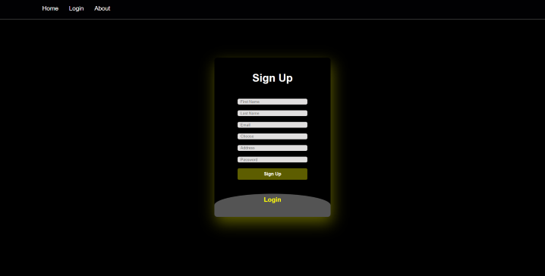](https://user-images.githubusercontent.com/73485499/171308430-d3ae5226-ca57-49a5-b788-7db7499270cf.png)

1. If you already registered like doctor

[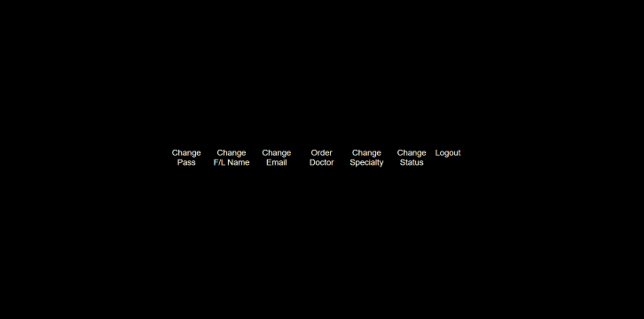](https://user-images.githubusercontent.com/73485499/171308862-d8bf75f7-755e-4fe0-8109-7a20a6ad8d1a.png)

1) Change pass - the doctor can change his password

2) Change F/L name - the doctor can change his first / last name

3) Change Email - the doctor can change his email

4) Doctor orders - the doctor can see his orders and approve or not

5) Change Specialty - the doctor can change his Specialty like Family medicine/Anesthesiology.....

6) Change Status - the doctor can change his status Available/Unavailable

7) Logout

1. If you already registered like patient

[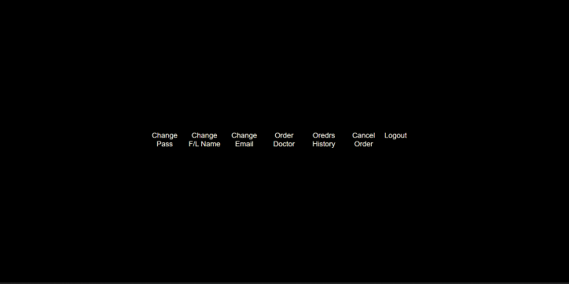](https://user-images.githubusercontent.com/73485499/171309813-9dd8d230-04ec-449b-81f6-ddcb86ec983f.png)

1) Change pass - the patient can change his password

2) Change F/L name - the patient can change his first / last name

3) Change Email - the patient can change his email

4) Order Doctor - the patient can Order the doctor that he want, he can see doctor specialty and distance of doctor then he can pick the right doctor

5) Orders History - the patient can see his Orders History

6) Cancel Order - the patient can cancel his order just in case that the doctor did not approve

7) Logout

Thanks you for using this code :)