ECS and EKS Container Delivery Workshop
GitHub, Jenkins, Amazon ECR, Amazon ECS, and Amazon EKS
Cloud Computing Lab Report

Fadil Mohammed Surur
The George Washington University
November 13, 2026

Abstract
This report documents an end-to-end container delivery workshop that used a private GitHub repository, GitHub Actions, Jenkins, Amazon Elastic Container Registry (ECR), Amazon Elastic Container Service (ECS), and Amazon Elastic Kubernetes Service (EKS). The initial application (version 1.0.0) was deployed successfully to both platforms. An enhancement introduced a four-part ECS-versus-EKS comparison API and release 2.0.0, with five passing application tests and a merged pull request. The Jenkins verification artifact confirmed identical source revision and container image digest across the two running services. A controlled extension then demonstrated EKS rollout failure followed by explicit undo, ECS recovery through its deployment circuit breaker, temporary scaling to two copies on each platform, and final health PASS. A private, SSE-S3-encrypted audit report preserved the recovery evidence. Results reflect a small educational workload, not a general cost or performance benchmark.

Implementation and Validation
The workstation check passed for Python 3.13.17, Git, AWS CLI, the Session Manager plugin, and kubectl. A private GitHub repository and Application CI workflow were created. The initial local unit test suite passed four tests, and GitHub Actions passed the initial workflow. CloudFormation provisioned the infrastructure, after which the workshop namespace and Jenkins environment were prepared. Jenkins used read-only GitHub access to check out main, run tests, build and push an image to Amazon ECR, and deploy to ECS and EKS.
For version 2.0.0, the enhancement/platform-comparison branch added /api/compare with application definition, scheduling, recovery, and scaling categories. The new unit test increased coverage to five tests, all passing locally. GitHub Pull Request #1 passed two checks and was merged. Both deployment previews subsequently showed version 2.0.0, healthy /healthz responses, and the source commit beginning 4d6c5f38.

Release Identity and Recovery Results
Evidence | Observed result
Deployed version | 2.0.0 on ECS and EKS
Source revision | 4d6c5f387c0f468d3104218ecd09d866ca63ddf2
Container image digest | sha256:47415236fabbd4df068d59d4427eaac05218bbeff72ce479b2bfe0f81c8b897c
EKS failed rollout | ProgressDeadlineExceeded; explicit rollout undo restored availability
ECS failed deployment | Container health checks failed; deployment circuit breaker restored prior task definition
Scale experiment | 2 ECS running tasks; 2 EKS ready replicas
Final health | PASS
Audit retention | S3 object in workshop audit bucket, encrypted with SSE-S3

ECS Versus EKS: Platform Comparison
This workshop delivered the same small Python web application to Amazon ECS and Amazon EKS. Source changes were saved in GitHub, checked with GitHub Actions, and read by Jenkins. Jenkins ran the tests, built a container image, pushed the immutable image to Amazon ECR, and deployed it to both runtimes. The build-specific verification report recorded the same merged source commit and image digest for ECS and EKS. The browser previews independently showed version 2.0.0, a healthy response, and the same source prefix. This gave stronger evidence than comparing screenshots alone because the digest identifies the actual container image contents.
The two platforms differ most clearly in how the application is described. In ECS, a task definition identifies the image and container settings, while an ECS service maintains the desired number of running tasks. In EKS, a Kubernetes Deployment describes the desired pods, and a Kubernetes Service provides a stable endpoint. Both achieve application availability, but the configuration objects, tooling, and operational vocabulary differ. The ECS workflow remained closely tied to AWS services; the EKS workflow used Kubernetes primitives, kubectl, and a namespace.
Compute responsibility also differs in this exercise. ECS used AWS Fargate, so the worker infrastructure supporting each task was managed by AWS rather than by the student. EKS used a managed EC2 node group, which required Kubernetes-capable worker capacity in addition to the AWS-managed control plane. EKS provides access to Kubernetes abstractions and broader ecosystem patterns, but it introduces more cluster and node considerations. ECS Fargate is simpler for a small AWS-centered service when the team does not need Kubernetes-specific APIs.
The recovery extension provided a direct operational contrast. The test deliberately introduced an unhealthy EKS update. Kubernetes reported that the Deployment exceeded its progress deadline, with one updated replica unavailable, and the workshop script executed an explicit rollout undo. The restored Deployment then rolled out successfully. By contrast, the ECS experiment launched tasks that failed their container health checks. ECS service events documented the failed deployment and rollback to the previous deployment through the configured circuit breaker. These outcomes do not mean that every EKS or ECS application automatically behaves this way; they reflect the recovery settings and script used here.
Both services were also scaled to two running application copies: the audit JSON recorded two ECS tasks and two ready EKS replicas. The script then restored the original scale during its successful completion, and final health was PASS. This test establishes that each platform could satisfy a simple desired-count change. It did not measure throughput, latency, service saturation, autoscaling responsiveness, or performance under realistic load. As a result, it should not be described as a benchmark proving that either orchestrator is faster or more reliable.
For an AWS-only departmental API with modest traffic and a small operations team, I would favor ECS on Fargate because it reduces responsibility for managing worker nodes and uses a direct task-and-service model. For a multi-service system requiring Kubernetes-native operators, standardized manifests, and greater portability of orchestration practices, EKS would be more appropriate if the team had the necessary expertise. The decision also depends on cost: ECS Fargate incurs task compute charges, while EKS introduces control-plane and node-related costs, plus networking, image storage, and logging charges. This small lab did not collect enough cost data to establish a universal winner. The clearest result is that one verified image can be delivered consistently to both environments while their deployment and recovery mechanisms remain different.

Limitations and Lessons Learned
The experiments demonstrated one application, a single AWS Region, and short-lived disposable infrastructure. The evidence supports controlled rollback and replica-count observations, not claims about long-term availability or performance. An initial SSM tunnel failure was isolated from service health: after refreshing the private application previews, the ECS and EKS pages were reachable without changing the deployments. The exercise reinforced the importance of checking the right layer, verifying immutable image identity, collecting pipeline artifacts, and cleaning up resources after recording evidence.

References
Course workshop guide. (2026). ECS/EKS GitHub and Jenkins workshop guide [Course handout].
Jenkins. (2026, November 13). container-delivery: Build #4, verification.json and cloud-extension.json [Pipeline artifacts].
AWS Academy Learner Lab. (2026, November 13). CloudFormation stack and S3 audit object [Lab console records].

Appendix A: Screenshots of the Completed Workflow
Figures are placed with their titles above each image. All screenshots document the November 13, 2026 workshop session and are included as first-hand lab evidence.
Figure 1
Workstation prerequisites validated
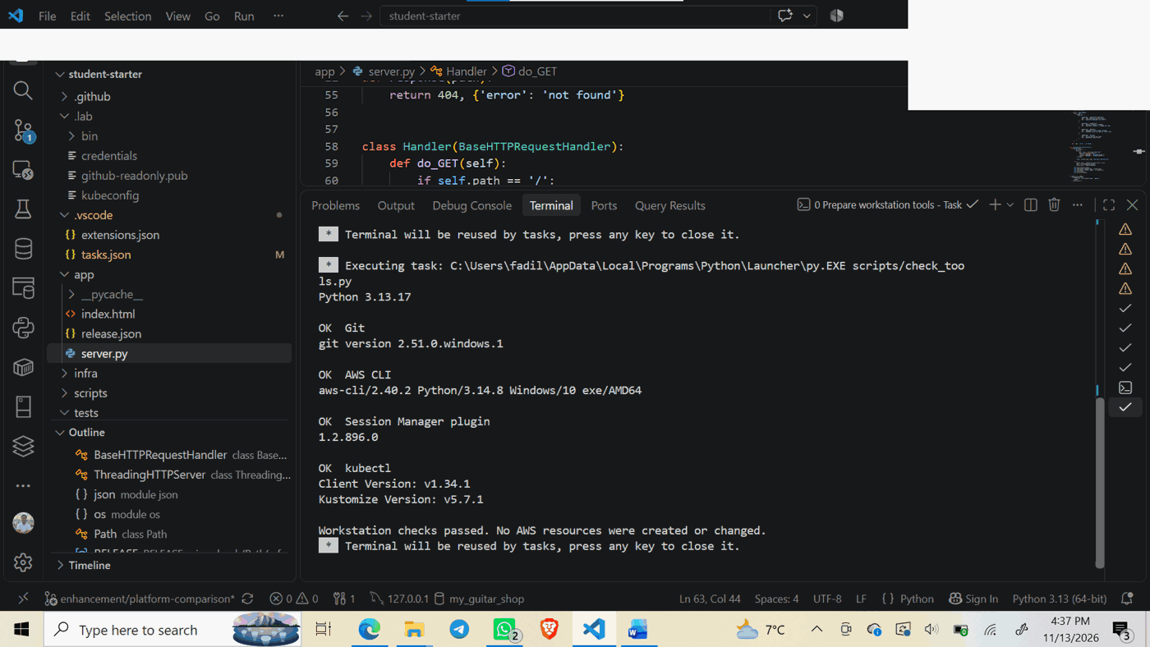
Note. The local tool checker confirmed the required command-line utilities and reported no infrastructure changes.
Figure 2
GitHub Actions initial workflow successful
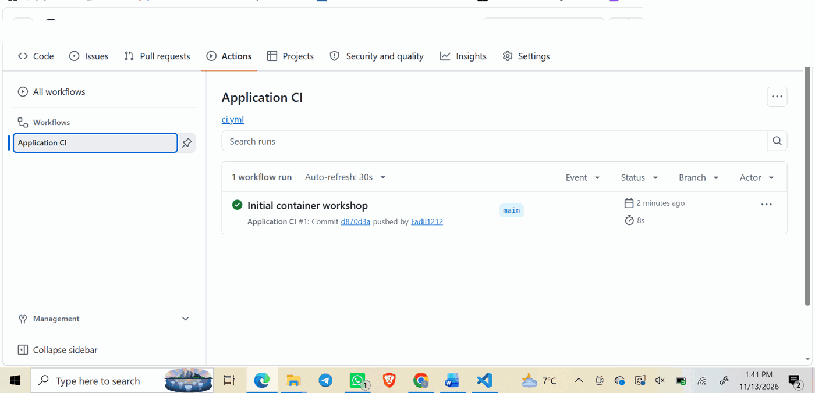
Note. The initial application CI workflow passed on the main branch.
Figure 3
CloudFormation workshop stack completed
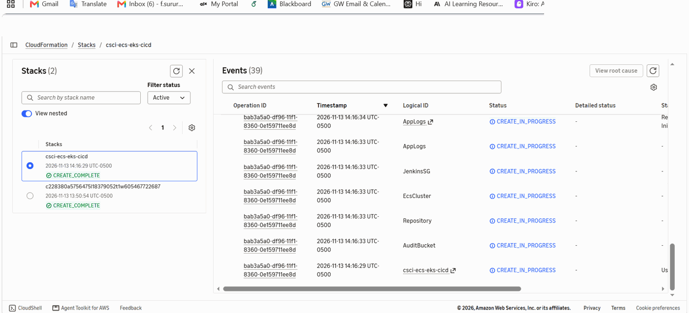
Note. The workshop CloudFormation stack reached CREATE_COMPLETE.
Figure 4
CloudFormation output resources
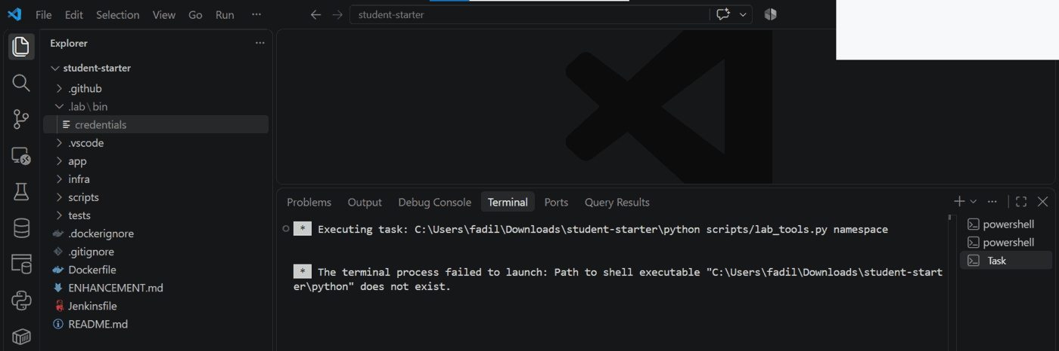
Note. CloudFormation provided the cluster names, image repository, Jenkins instance, and audit bucket.
Figure 5
Initial Jenkins deployment completed successfully
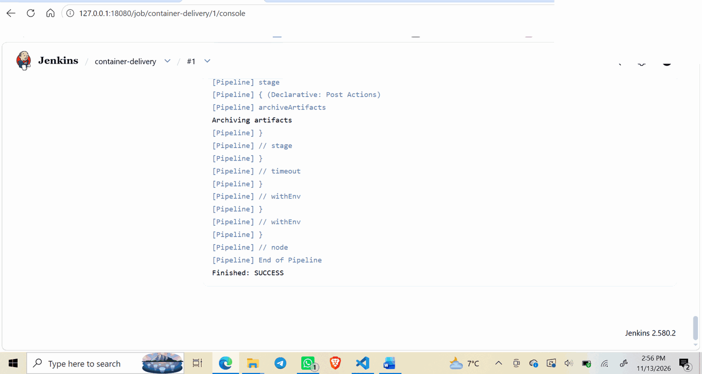
Note. The first container-delivery pipeline ended in SUCCESS.
Figure 6
Version 2 comparison feature in local application
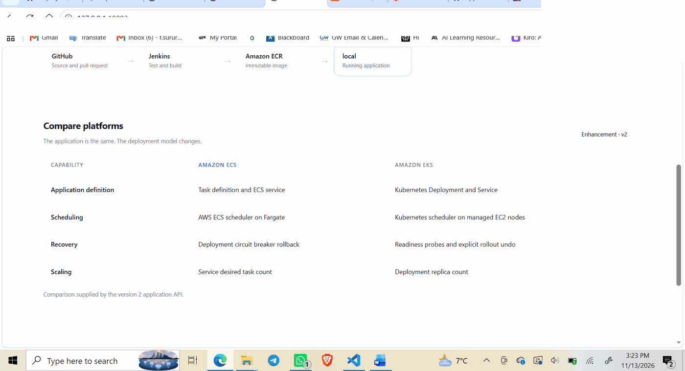
Note. The enhanced application compares four platform capabilities.
Figure 7
Five automated unit tests passing
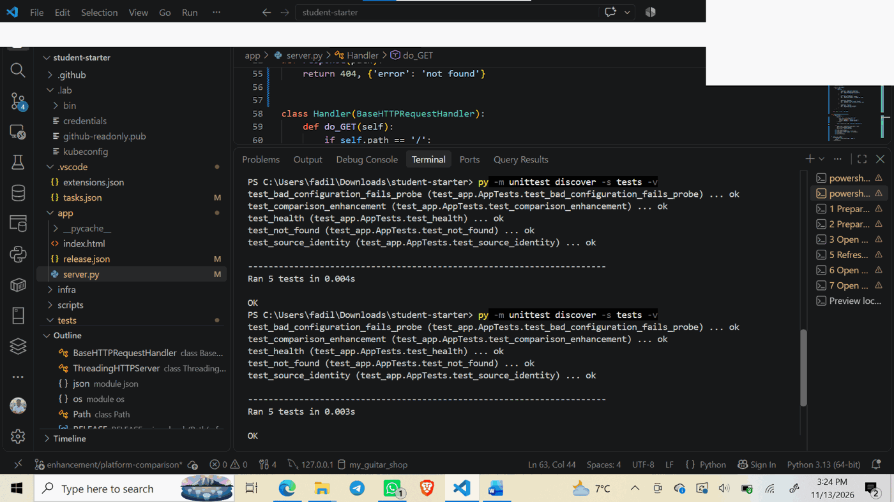
Note. The enhancement passed all five application unit tests.
Figure 8
GitHub pull request merged into main
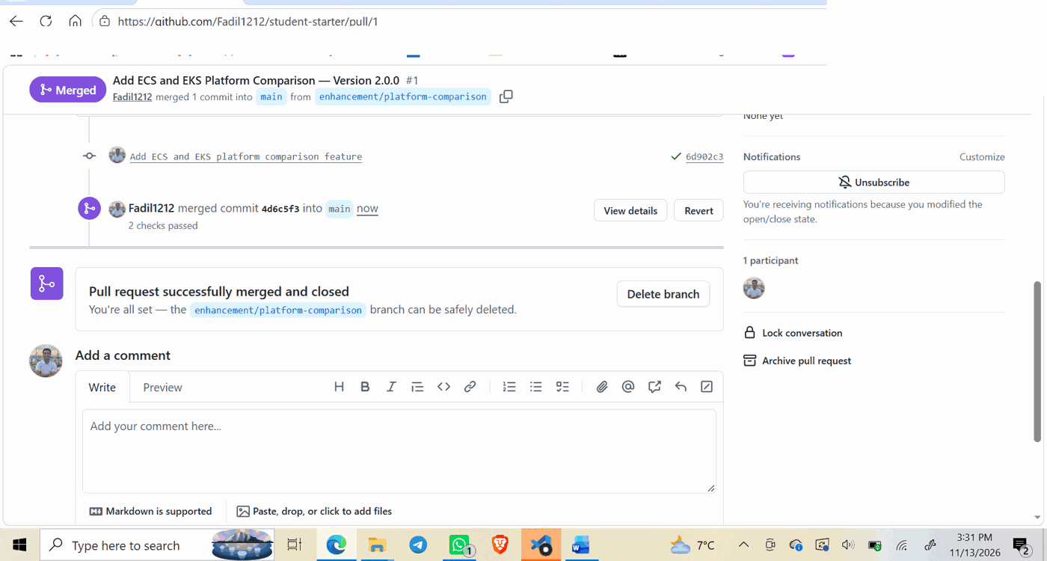
Note. Pull Request #1 was merged after the required checks passed.
Figure 9
Amazon ECS deployment of release 2.0.0
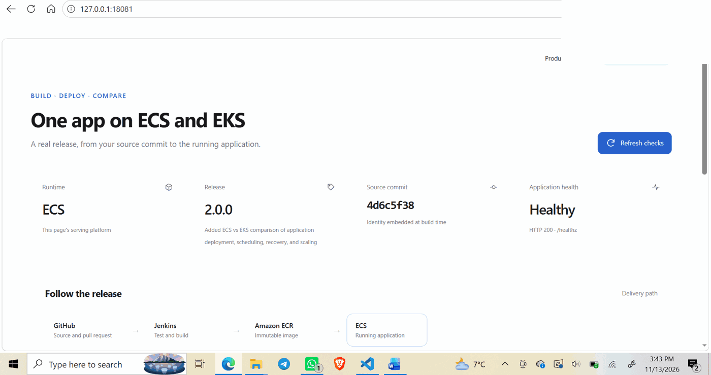
Note. The ECS preview reported a healthy version 2.0.0 application and the merged commit.
Figure 10
Amazon EKS deployment of release 2.0.0
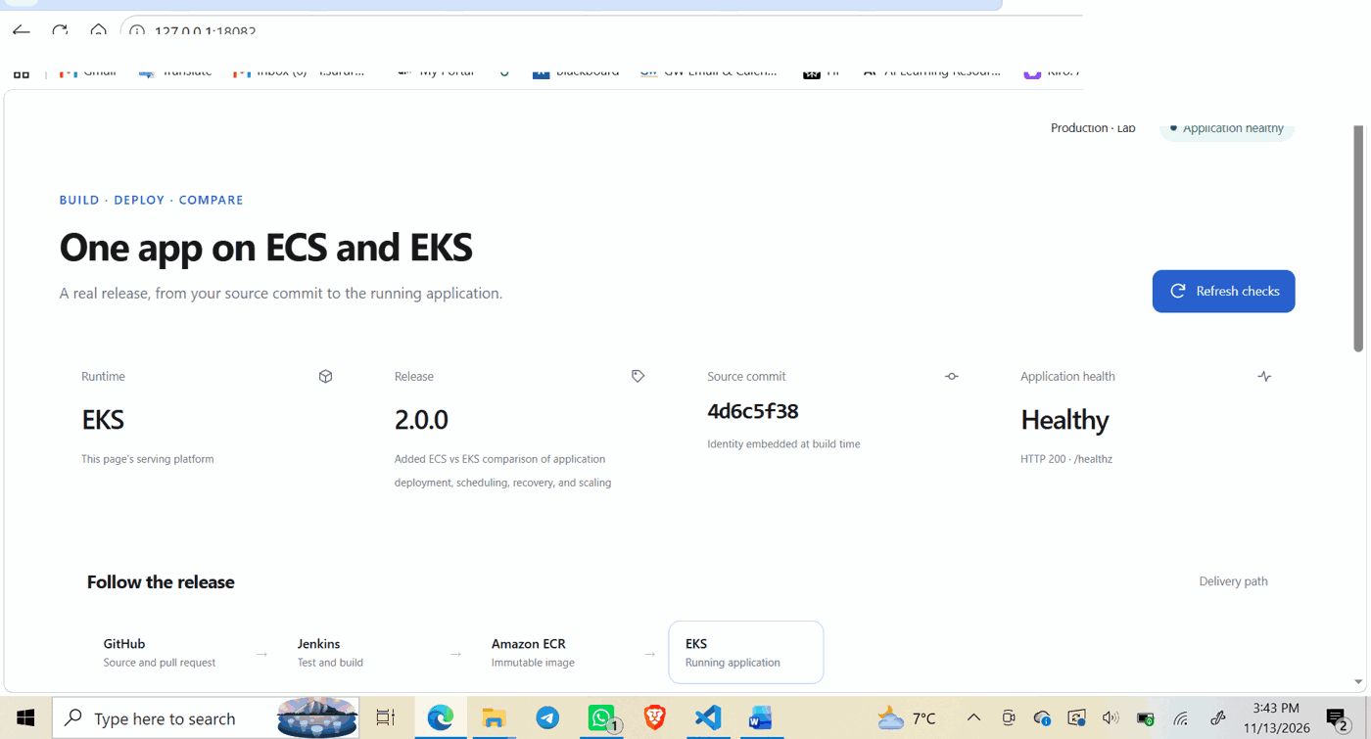
Note. The EKS preview reported the same release and merged commit as ECS.
Figure 11
Cloud Computing recovery pipeline finished successfully
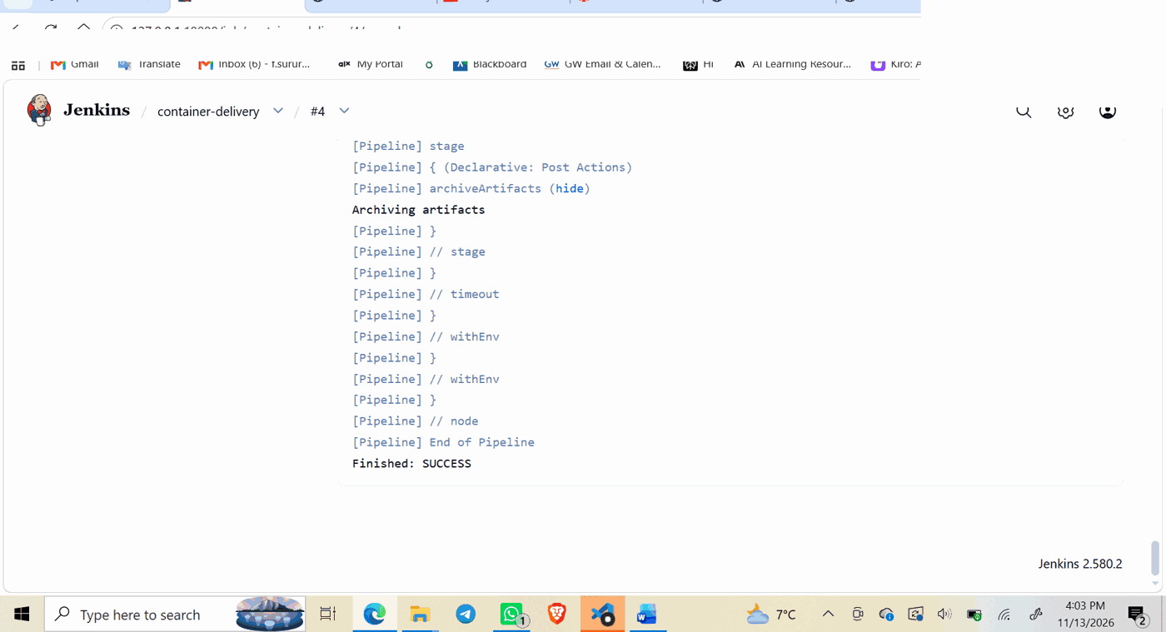
Note. Jenkins Build #4 reached SUCCESS after the controlled extension.
Figure 12
Cloud extension recovery and scaling results
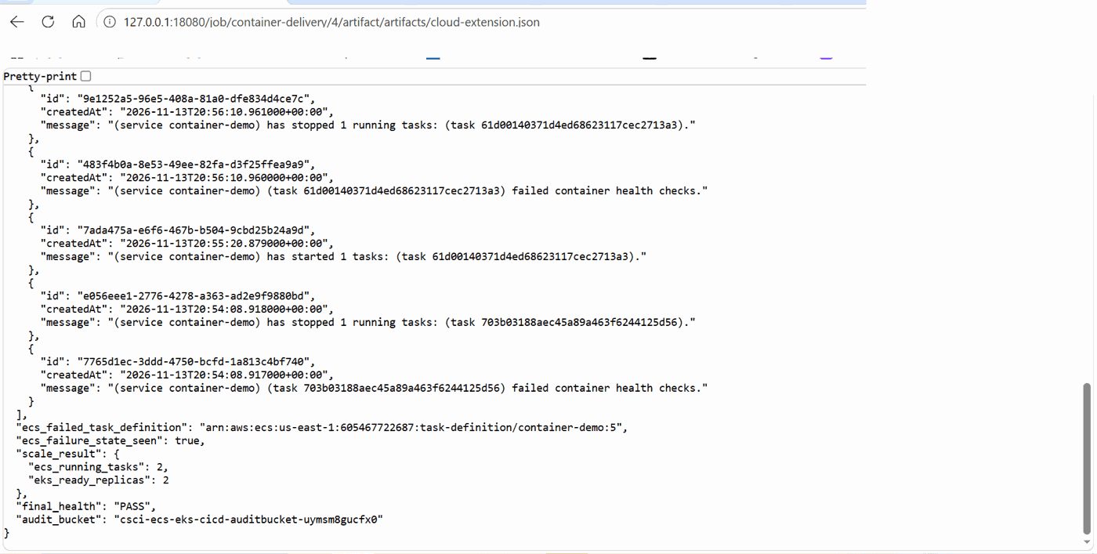
Note. The artifact records failed ECS health checks, two ECS tasks, two EKS ready replicas, and final health PASS.
Figure 13
Private S3 audit report object
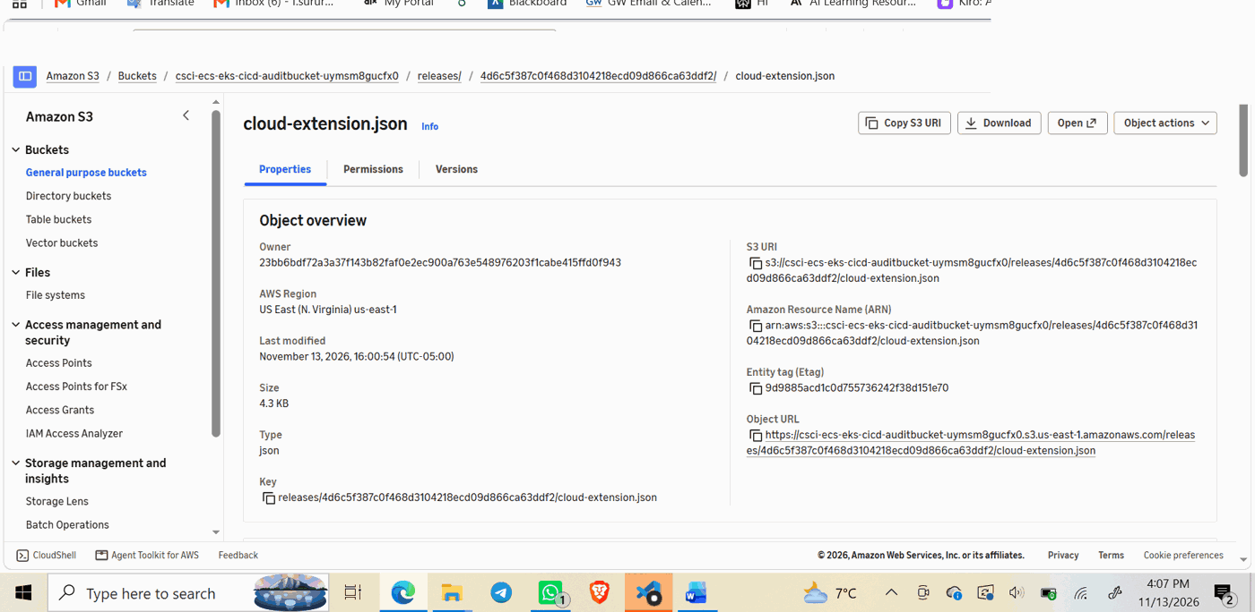
Note. The cloud-extension.json object was stored under the tested commit in the workshop audit bucket.
Figure 14
S3 managed encryption confirmed
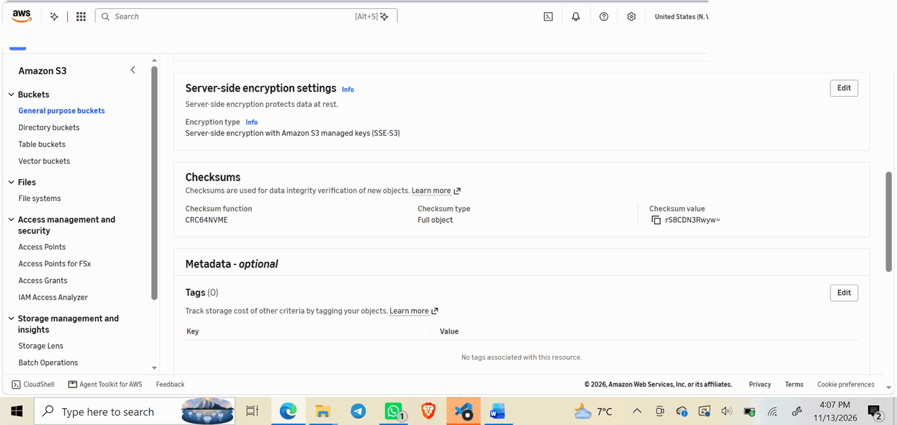
Note. Server-side encryption with Amazon S3 managed keys (SSE-S3) is enabled for the audit object.

Appendix B: Reproducible Artifact Details
The Build #4 recovery report is provided separately as cloud-extension.json. It records the specific EKS ProgressDeadlineExceeded state, the explicit undo, ECS failure events and circuit-breaker rollback, the scaling observation, and final health PASS. The evidence is specific to the tested source revision, not a synthetic or generalized result.
Data handling note: AWS access credentials, Jenkins login secrets, and API tokens are deliberately excluded from this report. Any exposed Jenkins credentials from the workshop session should be rotated or invalidated.
Cleanup note: Workshop resources should be deleted only after screenshots and artifacts have been preserved. Stopping the Learner Lab session alone does not guarantee that the underlying resources are removed.

Appendix C: Resource Cleanup and Security Verification
After preserving the deployment and recovery evidence, I removed the workshop resources to stop further unnecessary AWS usage. I first scaled the ECS service to zero running tasks, deleted the service, emptied the workshop audit S3 bucket, and deleted the CloudFormation stack. The first deletion attempt encountered an ECR repository containing images; after resolving the image dependency, the stack reached DELETE_COMPLETE. I then removed the GitHub Jenkins deploy key and scheduled the workshop Jenkins secret for deletion. The separate AWS Academy infrastructure stack and the GitHub source repository were preserved.

Figure 15
ECS service stopped with zero running tasks
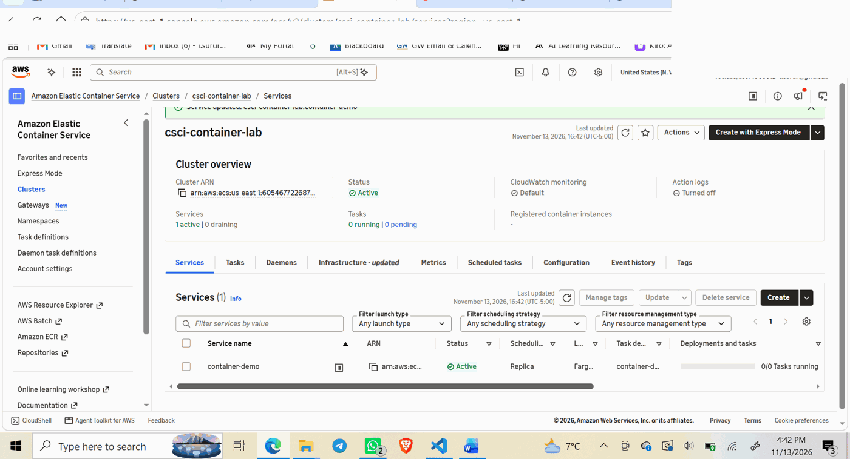
Note. The ECS cluster showed zero running and zero pending tasks after the service desired count was set to zero.

Figure 16
ECS workshop service successfully deleted
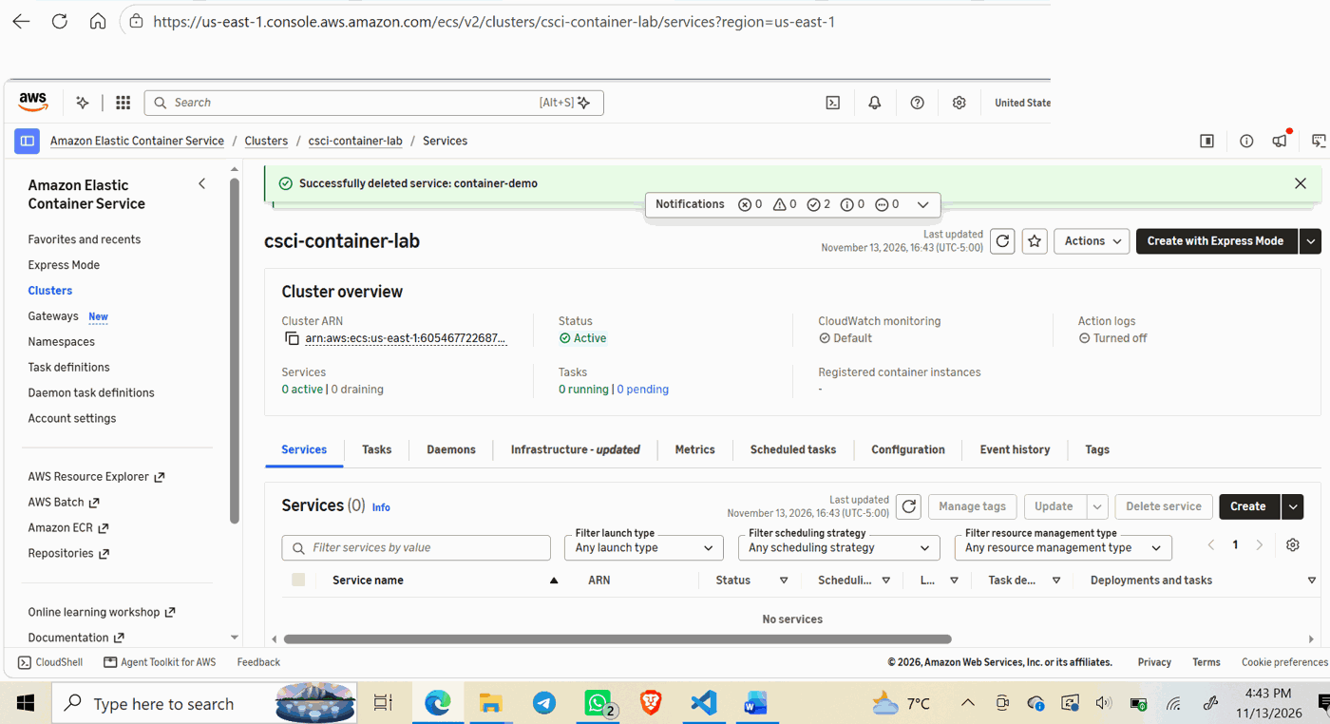
Note. AWS confirmed deletion of container-demo, leaving no active ECS services or running tasks in the workshop cluster.

Figure 17
S3 audit bucket emptied
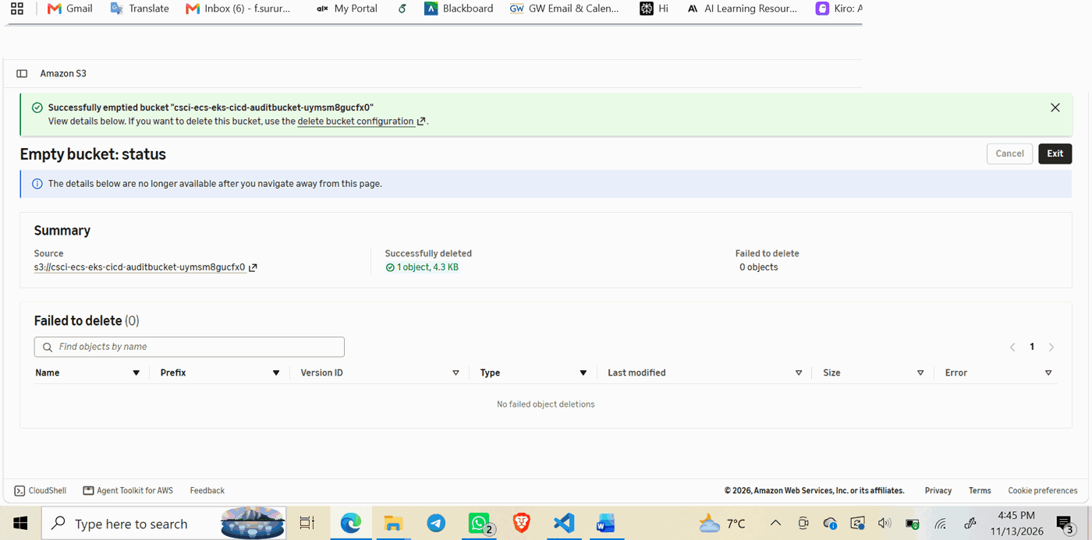
Note. AWS S3 confirmed that one workshop audit object (4.3 KB) was deleted with zero failed deletions. The report evidence was preserved separately before cleanup.

Figure 18
CloudFormation workshop stack deletion completed
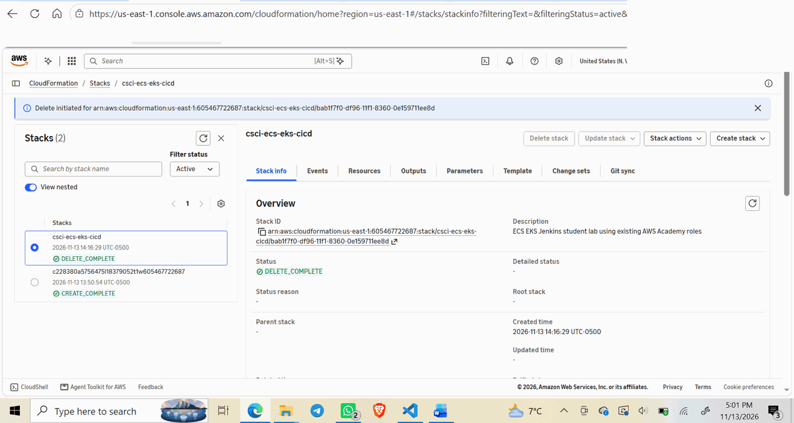
Note. The csci-ecs-eks-cicd CloudFormation stack reached DELETE_COMPLETE; the separate AWS Academy-provided infrastructure stack remained in CREATE_COMPLETE.

Figure 19
GitHub Jenkins deploy key removed
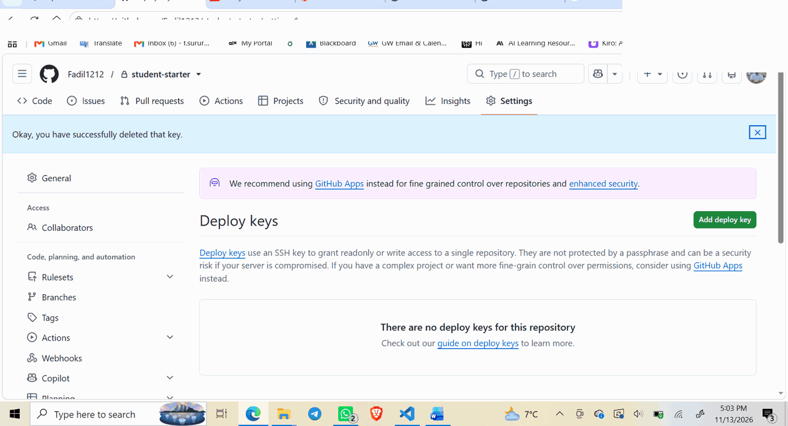
Note. GitHub confirmed successful deletion of the Jenkins Workshop deploy key, with no deploy keys remaining for the repository.

Figure 20
Jenkins secret scheduled for deletion
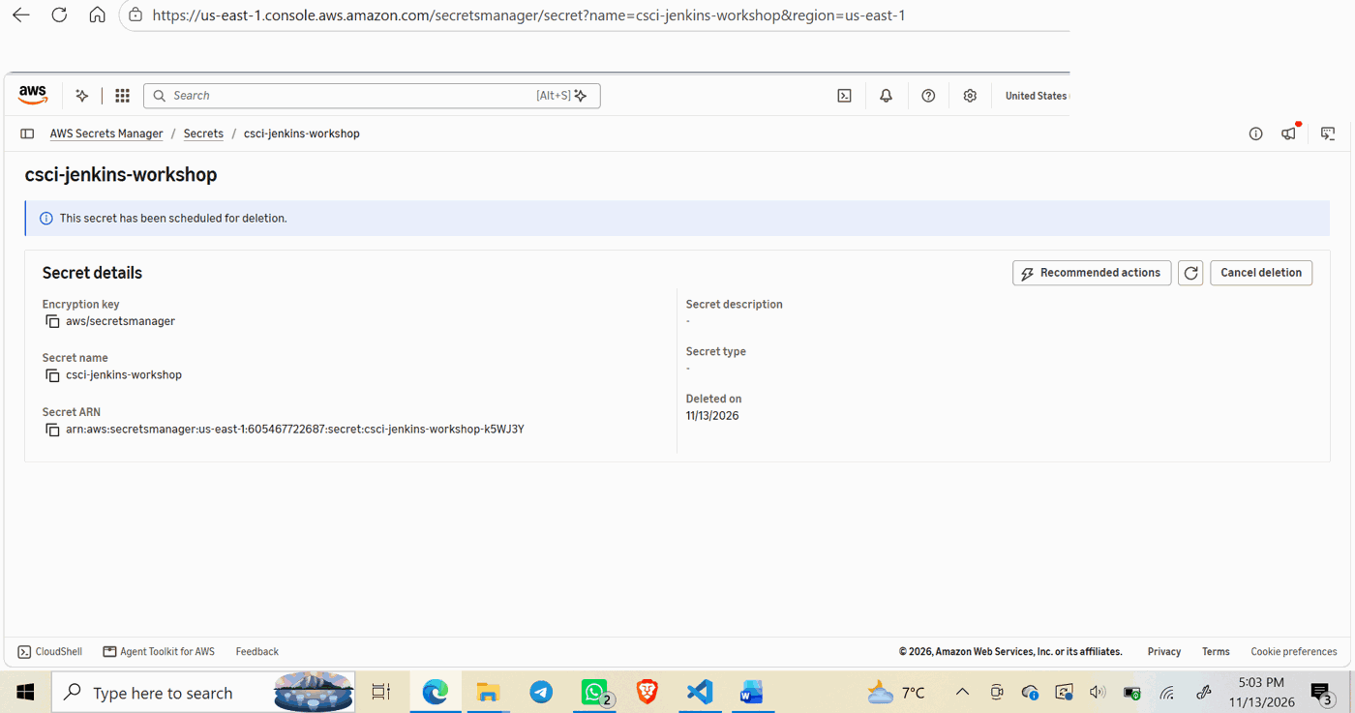
Note. AWS Secrets Manager confirmed that csci-jenkins-workshop was scheduled for deletion; this is not evidence that permanent deletion had already occurred.

Final Summary and Lessons Learned
The workshop successfully delivered the same Python web application through GitHub and Jenkins to Amazon ECS and Amazon EKS. The initial release was enhanced to version 2.0.0 with a comparison endpoint, and all five unit tests passed. The merged source commit and the immutable container digest were verified to match across both deployments, and both application previews returned healthy responses.
The controlled extension demonstrated different recovery mechanisms: EKS required an explicit undo of a failed rollout, while ECS used deployment failure detection and its configured circuit breaker. Scaling was verified at two running ECS tasks and two ready EKS replicas, with final application health marked PASS. The audit report was written to S3 using SSE-S3 encryption.
For cleanup, the ECS service was stopped and deleted; the audit bucket was emptied; CloudFormation reported DELETE_COMPLETE after the ECR image dependency was resolved; the GitHub Jenkins deploy key was deleted; and the Jenkins secret was scheduled for deletion. This removed the documented workshop deployment and access paths while preserving the GitHub repository and the AWS Academy-provided stack. The secret was not yet confirmed permanently deleted.
The main lesson was to verify each delivery stage with independent evidence, distinguish application health from local tunnel connectivity, understand the differences between ECS and EKS recovery behavior, and clean up AWS resources in dependency-aware order. Together, the implementation, validation, recovery, scaling, and teardown activities demonstrated a complete container delivery lifecycle.

