WT Assignment 1: Part 1: Project Proposal
Recipe Sharing & Meal Planner

Module: Web Technologies (WT)
Assignment: 1: Project proposal & user interface design
Date: 3rd March 2026

PART -1

1. Project Description & Value Proposition

Project idea
Our project is a Recipe Sharing & Meal Planner web application. It allows users to discover, save, and share recipes, and to plan their meals across days or weeks. The application will be built using the MERN stack (MongoDB, Express.js, React.js, Node.js) and will provide a single place for recipe discovery, meal planning, and community sharing.

Value proposition

- Solves a problem: Many people struggle to decide what to cook, keep recipes in one place, or coordinate meals for the week. Existing solutions often mix recipes with meal planning poorly or lack a simple, focused experience.
- Delivers benefits: Users get one app to browse and search recipes, save favourites, plan weekly meals, and share their own recipes with others—with their data saved across devices and sessions.
- Distinguishes from competitors: We focus on clarity and ease of use: straightforward recipe upload and sharing, a visual meal planner, and personalisation (e.g. dietary filters, saved recipes) without unnecessary complexity.

The project fulfils the assignment requirements by providing dynamic behaviour (search, filter, plan updates), client-side logic (validation, filtering, sorting), server-side logic (CRUD, authentication, business rules), and full support for multiple users and persistent sessions via a database.

---

2. User & Competitor Research

User research

- Target users: Home cooks, students, families, and anyone who wants to organise meals and try new recipes. Users may cook daily or occasionally and want to reduce decision fatigue and food waste.
- Needs: Easy recipe search and filtering, ability to save and organise recipes, a simple meal planner (e.g. weekly view), and optional social features (sharing recipes, viewing others’ plans for inspiration).
- Pain points: Scattered recipes (screenshots, links, books), no single place to plan meals, and difficulty reusing previous meal plans.

Competitor analysis

Competitor | Strengths | Weaknesses / gaps
AllRecipes | Large recipe database | Meal planning is limited; cluttered UI
Mealime | Strong meal planning | Less focus on user-generated sharing
Pinterest | Visual discovery | Not built for meal planning or structure
Paprika / Yummly | Recipe saving, some planning | Often paid; not always simple to use
Opportunity: A single, free-to-use app that combines recipe sharing, saving, and meal planning in a clear, user-friendly way, with content created and shared by the community.

Stakeholders

- Primary: End users (home cooks, students, families) who cook and want to plan meals.
- Secondary: Recipe contributors who share recipes and want visibility or feedback.
- Tertiary: The development team (us) and the module assessors, who need a well-scoped, feasible MERN project.

3. Description of Functionalities
The application will include at least six functionalities, each with a clear purpose, behaviour, usage, and user benefit. Client-side and server-side logic are indicated where relevant.

Functionality 1: User registration and authentication

- Purpose: Allow users to create accounts and sign in so that their recipes, meal plans, and preferences are private and persistent.
- What it does: Users can register (email/username, password), log in, and log out. Passwords are hashed on the server; sessions or tokens keep users logged in across visits.
- How it is used: User fills in registration form or login form; submits; is redirected to home or dashboard. Client-side: basic validation (e.g. required fields, password strength). Server-side: validation, hashing, session/token creation, and storage.
- User benefit: Secure, personalised experience; data is tied to their account and available on any device.

Functionality 2: Browse and search recipes

- Purpose: Let users discover recipes by keyword, ingredients, or category.
- What it does: Displays a list of recipes (from the database). Users can type in a search box and optionally apply filters (e.g. category, dietary tags, time). Results update as they search or change filters.
- How it is used: User opens “Recipes” or “Discover”; enters search term and/or selects filters; sees updated list. Client-side: filtering/sorting of loaded results where appropriate; server-side: search and filter queries, pagination.
- User benefit: Quick way to find recipes that match what they have or what they want to cook.

Functionality 3: Create and publish recipes

- Purpose: Let users add their own recipes and make them visible to others (or keep them private if we support that).
- What it does: Authenticated users can submit a new recipe (title, ingredients, instructions, optional image, category, dietary tags, prep/cook time). Data is validated and stored in the database.
- How it is used: User clicks “Add recipe”; fills in the form; submits. Client-side: form validation (required fields, formats). Server-side: validation, sanitisation, and saving to MongoDB.
- User benefit: Contribute to the community and keep their own recipes in one place.

Functionality 4: Save and manage favourite recipes

- Purpose: Let users bookmark recipes they like for quick access later.
- What it does: Logged-in users can “save” or “favourite” a recipe; saved recipes appear in a “My recipes” or “Favourites” list. Users can remove items from this list.
- How it is used: User views a recipe and clicks “Save”; later opens “My recipes” to see saved list and remove if desired. Client-side: optimistic UI updates; server-side: add/remove favourite in database (e.g. user–recipe association).
- User benefit: Personal collection of go-to recipes without losing them in the main feed.

Functionality 5: Weekly meal planner

- Purpose: Let users assign recipes to days (e.g. Monday–Sunday) to plan meals ahead.
- What it does: A calendar or grid view (e.g. by day and meal slot). User can drag or click to assign a recipe to a day/slot; can clear or change assignments. Data is stored per user.
- How it is used: User opens “Meal plan”; selects a week; picks a day/slot and chooses a recipe (from search or saved). Client-side: responsive grid, optional drag-and-drop, validation of selections. Server-side: save/update/delete meal plan entries in database.
- User benefit: Clear view of the week’s meals, less daily “what’s for dinner?” stress, and easier grocery planning.

Functionality 6: User profile and recipe collection

- Purpose: Let users see their own profile, their published recipes, and optionally edit or delete them.
- What it does: Profile page shows username, maybe avatar, list of recipes they’ve created, and possibly stats (e.g. number of recipes, number of favourites). User can edit or delete their own recipes.
- How it is used: User opens “Profile” or “My account”; sees summary and recipe list; clicks a recipe to edit or delete. Client-side: form pre-fill, confirm before delete. Server-side: fetch user’s recipes, update/delete with ownership checks.
- User benefit: Ownership of their content and a single place to manage what they’ve shared.

Summary: client-side vs server-side logic

- Client-side: Form validation, search/filter/sort on current data, auto-formatting (e.g. ingredient list), responsive meal planner UI, optimistic updates for favourites.
- Server-side: User authentication and session handling, input validation and sanitisation, all CRUD for users, recipes, favourites, and meal plans; business rules (e.g. only owner can edit/delete recipe); handling HTTP requests and database queries.

4. Multiple Users and Multiple Sessions

Multiple users

- Each user has a unique account (email/username and password). Data is stored per user in MongoDB (e.g. users collection, recipes linked to `userId`, favourites and meal plans keyed by `userId`).
- When a user performs an action (e.g. save a recipe, update meal plan), the server identifies them via session or JWT and reads/writes only their data. Sessions do not overlap: User A cannot see or change User B’s favourites or meal plan.
- Concurrent access is handled by the database and stateless API design: each request is tied to the authenticated user, so multiple users can use the app at the same time without interference.

Multiple sessions

- Returning users log in and see their existing data (saved recipes, meal plans, profile) because everything is persisted in MongoDB.
- Sessions (or tokens) allow the same user to use the app from different devices or browsers; as long as they log in, they retrieve the same information. No requirement for “single device” — the app supports multiple sessions per user with data consistency.

5. Project Timeline

Phase | Activities | Approx. timeframe
1. Proposal & UI design | Project proposal (Part 1), sitemap, wireframes, colour palette, fonts (Part 2) | Weeks 1–2 (Assignment 1)
2. Back-end setup | Node.js + Express server, MongoDB connection, basic API routes, user model and auth (register/login) | Weeks 3–4
3. Front-end setup | React app, routing, basic layout, auth (login/register forms and state) | Weeks 4–5
4. Core features | Recipe CRUD (create, read, update, delete), browse/search recipes, save favourites | Week 5-6
5. Meal planner | Meal planner data model and API, planner UI (weekly view, assign recipes) | Weeks 7–8
6. Profile & polish | User profile page, “my recipes” and “favourites” views, validation and error handling | Weeks 8–9
7. Testing & submission | End-to-end testing, bug fixes, documentation, final assignment submissions | Weeks 9–10

6. Division of Labour

!!!!WILL MAKE IT AT THE END!!!!!!!!

Part 2: User Interface Design

Site Map:
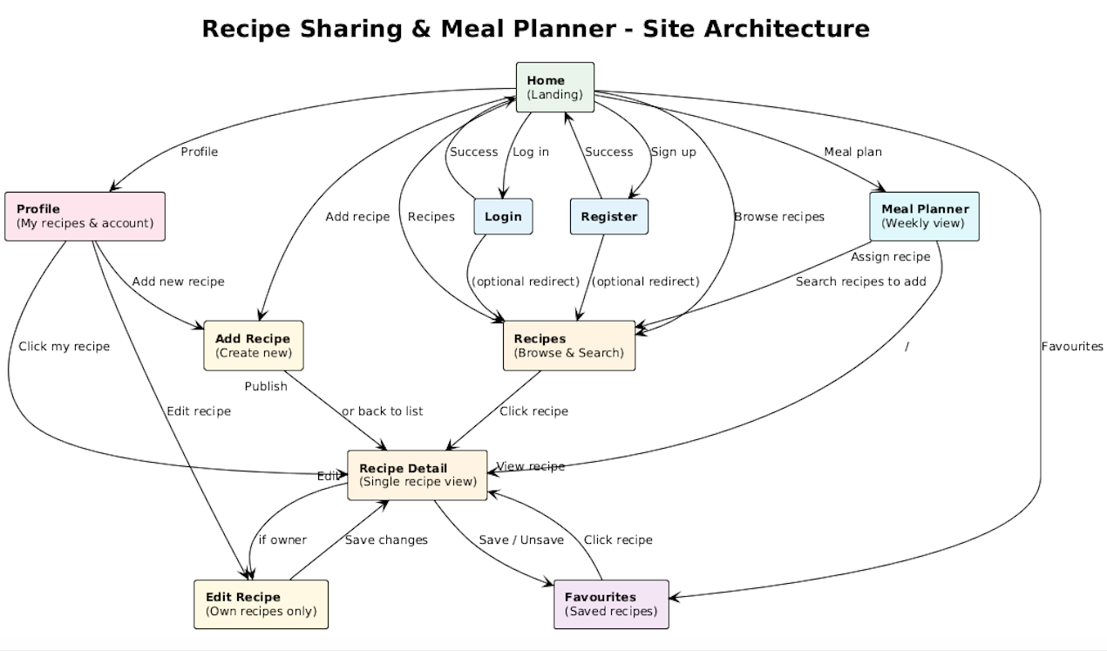

WIREFRAME

1: Home / Landing
Purpose: First screen; orient user, prompt login/register or go to recipes.
Functionality: Auth (entry point to Login/Register), discovery (Recipes).
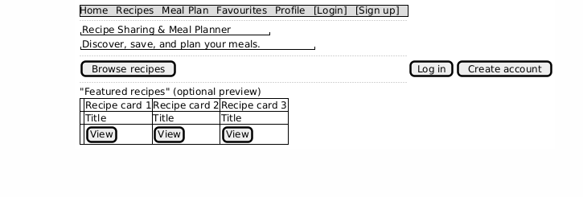

2: Login
Purpose: Authenticate returning users.
Functionality: User registration and authentication (Functionality 1).
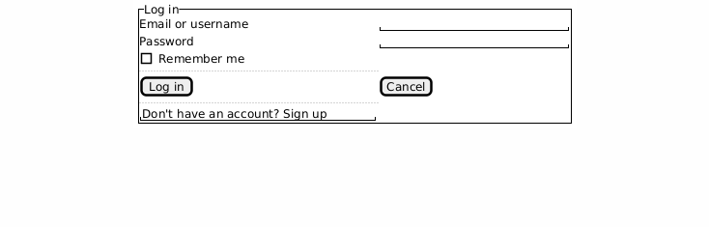

3: Register
Purpose: Create new account.
Functionality: User registration and authentication (Functionality 1).
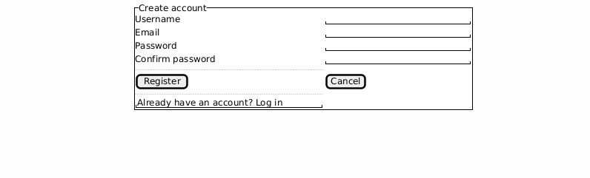

4: Recipes (Browse & Search)
Purpose: Discover recipes by search and filters.
Functionality: Browse and search recipes (Functionality 2).
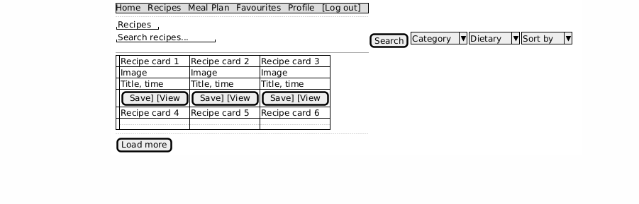

5: Recipe Detail
Purpose: View full recipe; save, edit (if owner).
Functionality: Browse (view), Favourites (save), Profile (edit if owner).
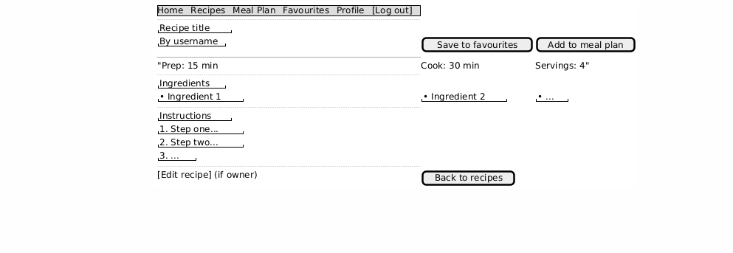

6: Add Recipe
Purpose: Submit a new recipe (title, ingredients, instructions, etc.).
Functionality: Create and publish recipes (Functionality 3).
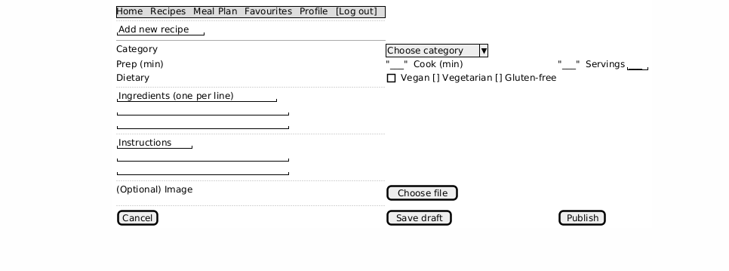

7: Favourites (Saved recipes)
Purpose: List of user's saved recipes; remove from list.
Functionality: Save and manage favourite recipes (Functionality 4).
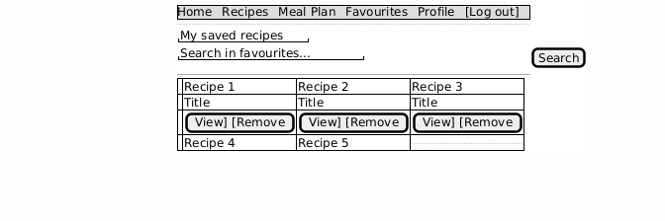

8: Meal Planner (Weekly view)
Purpose: Assign recipes to days; view/edit week.
Functionality: Weekly meal planner (Functionality 5).
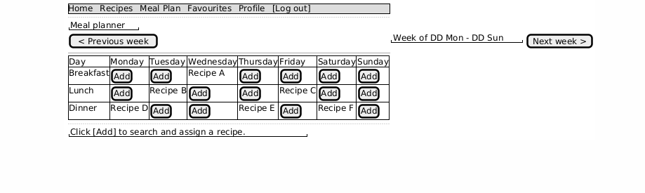

9: Profile (My recipes & account)
Purpose: User's profile, list of their recipes, edit/delete.
Functionality: User profile and recipe collection (Functionality 6).
