Generative AI
The Vibe Coding, Web Scraping, and Vector Database sections of the assignment are complete. Screenshots of the tools we used are provided below.

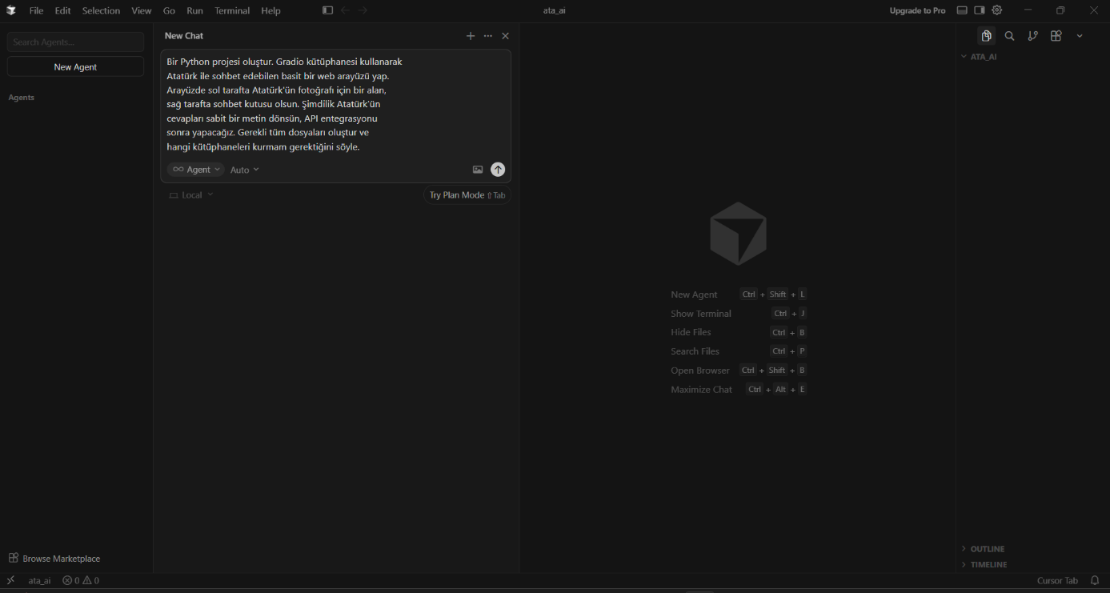
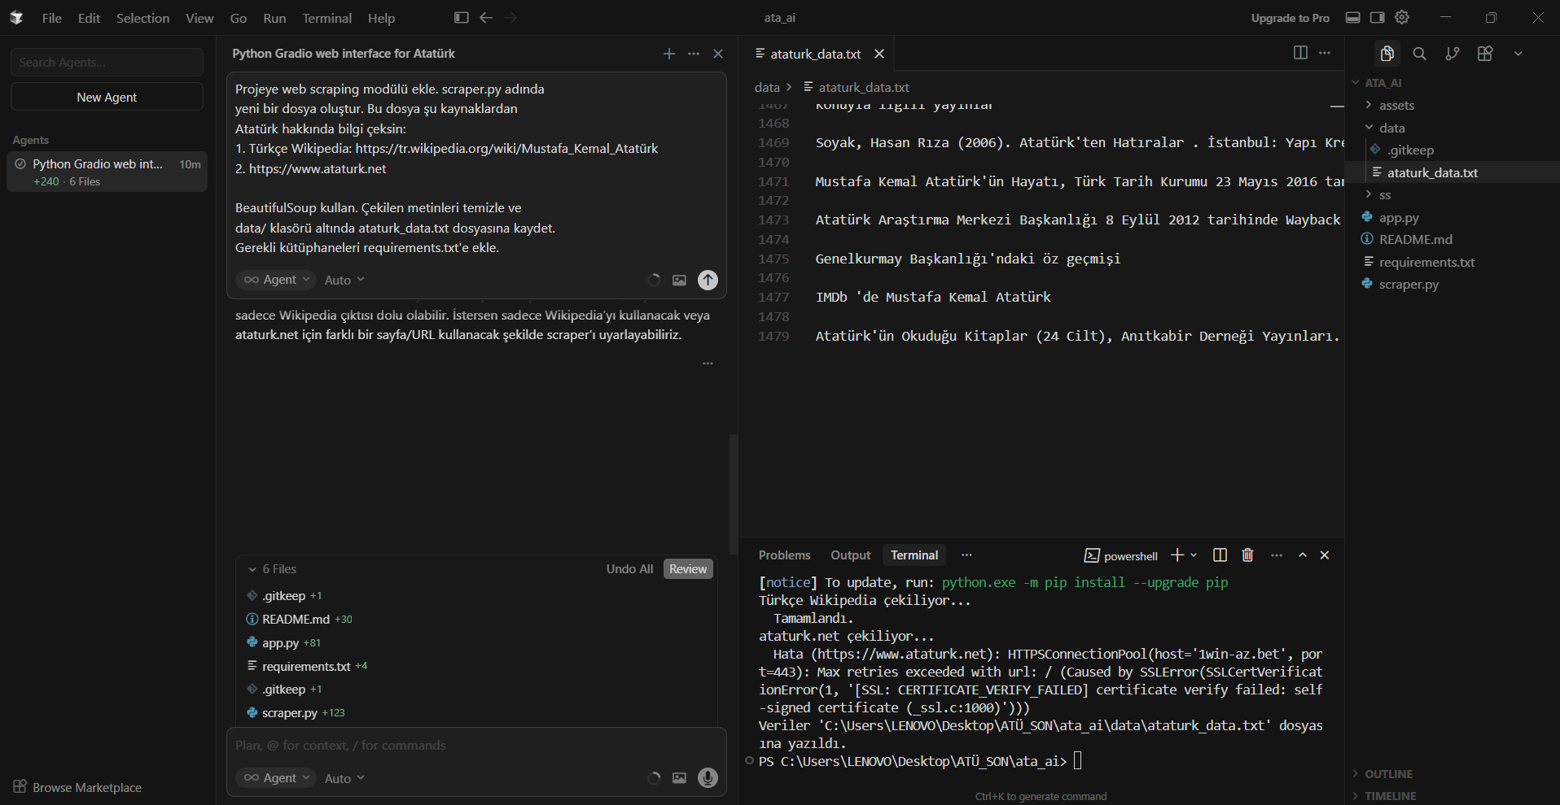

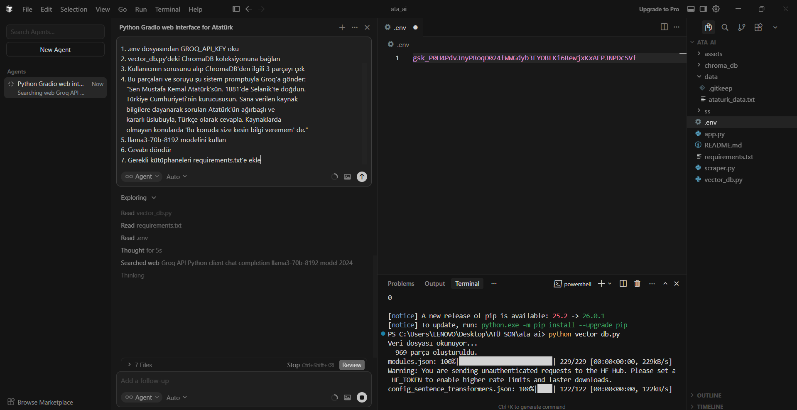

In the continuation of the project, the API integration will be cancelled, and large open-source language models will be used. The language models I plan to try are: Mistral 7B and Qwen2.5 7B.

