CSY1018: Web Development AS1 Resit

**Index Page:**

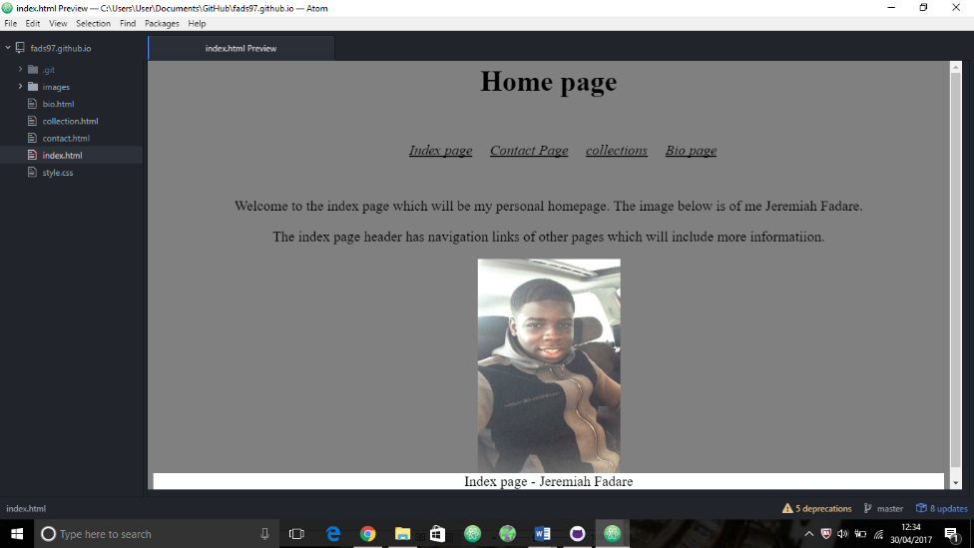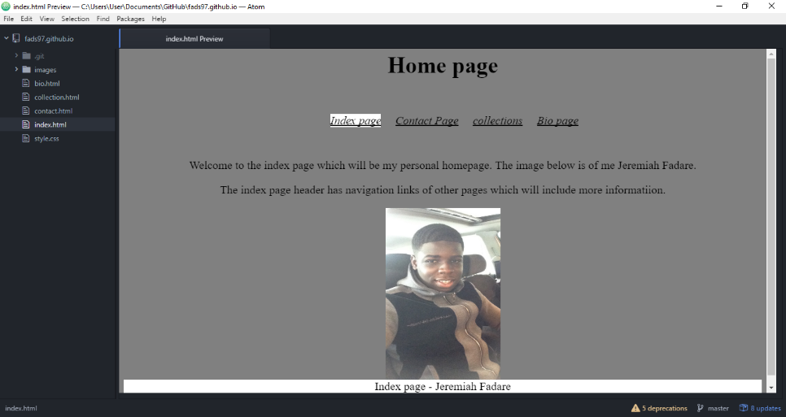The index page is the homepage of the whole file, the home page includes a big bold title which stands out so it can be read easily. It also has a navigation bar which has a white lining when the mouse goes over it. This was done by using codes in the CSS which I will state down below. The background colour that was used in the homepage was grey, this meant that I had to use the same background for the rest of the pages to keep the uniqueness of my work. The background is also clear so the words on the page can be easily read. I also added a photo of myself which has been placed in the middle of the page.

This is the homepage with the navigation with a white underline

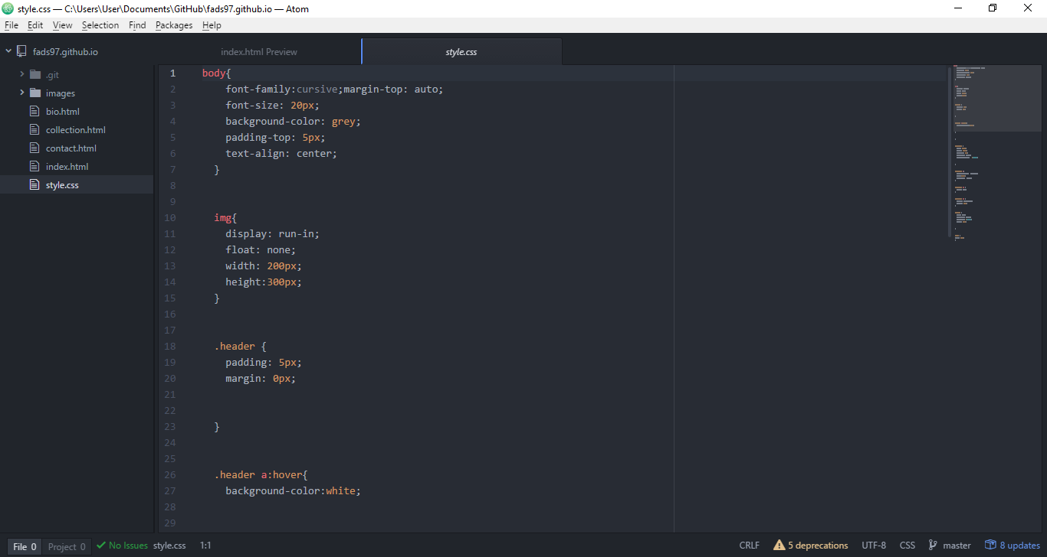

This is the style CSS page where I can add the details of the page, for example If I want to change the background colour this is where I would have to do it. It’s fun just playing around with it which is what I did. For example, the background colour of my page is grey and it was selected where the arrow is pointing.

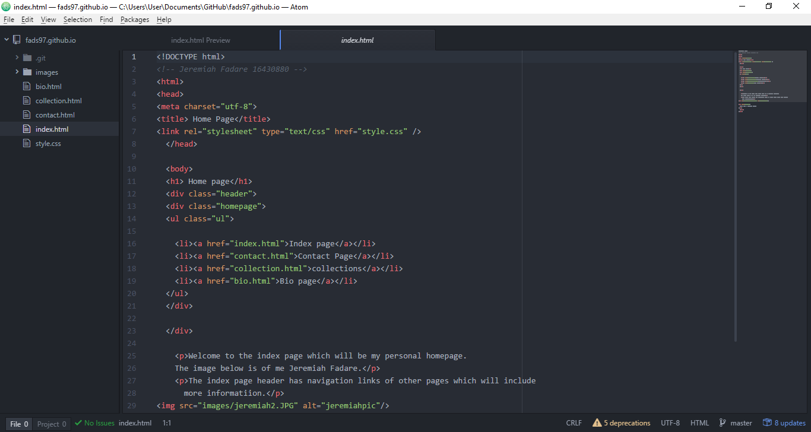

This is the index html page where I added the image of myself and the text information. This is also where the navigation was added, this is shown by the <li> shown on the image on the left.

The html that I used to add the image of myself, I changed my picture a couple times so that it could meet the requirement but at times my picture wouldn’t load and it was due to my spelling mistake. This is because if you don’t name your picture with an easy name you will have a hard time finding it.

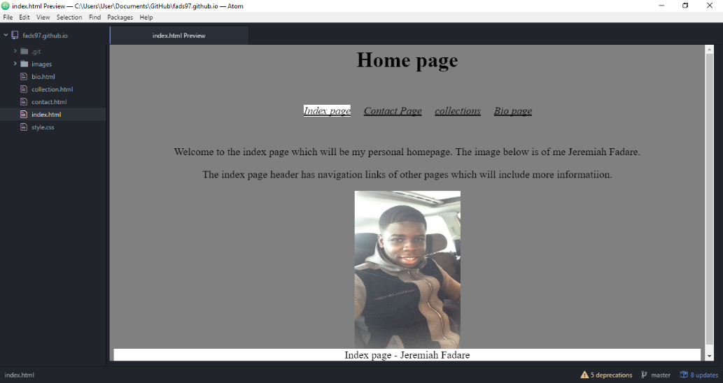

The one thing that didn’t go right in the assignment is the navigation CSS as when the pages are put on the browser the navigation changes, this is due to a problem on the CSS page which I can’t seem to fix

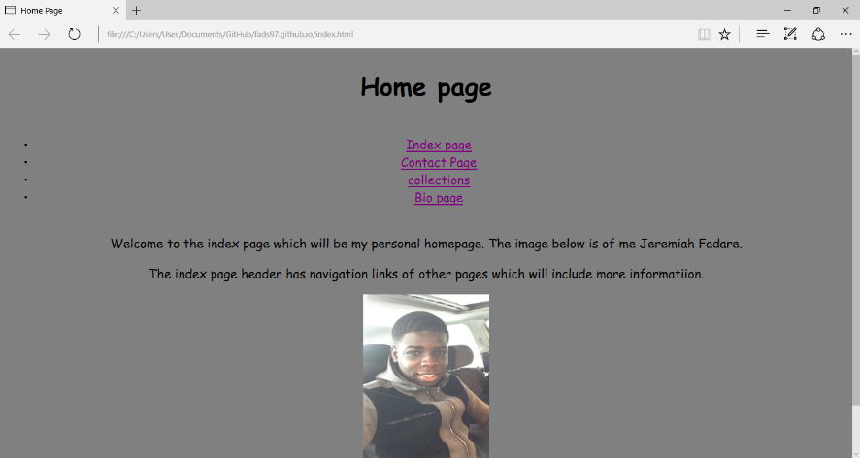

**Contact page:**

The contact page is a page where I can be reached from, the contact page has a static form which allows you to write your first name, last name, subject matter and the message you want to send. It even includes a button where you can send your message to me. In the footer, my email is also there so they know who to send the email to.

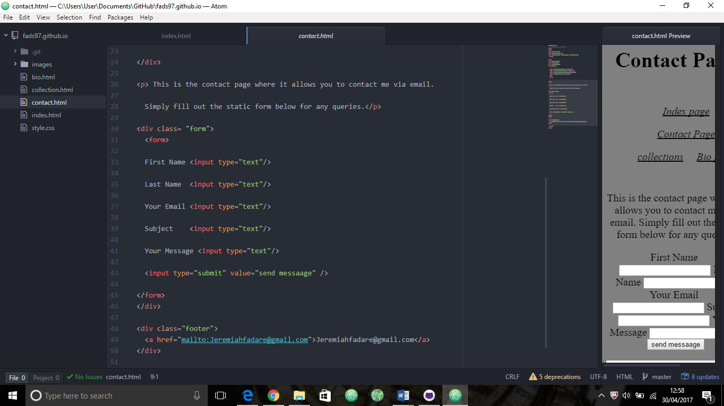

To create that I had to use a div class=”form”> so that the layout can be in a form. I got my inspiration from the website “ [www.w3schools.com/html/html_forms.asp](http://www.w3schools.com/html/html_forms.asp)” but nothing was copied.

This is how the form looks on the contact page. As you can see I had the same navigation problem with the rest of my pages. I also had a problem putting the footer all the way at the bottom

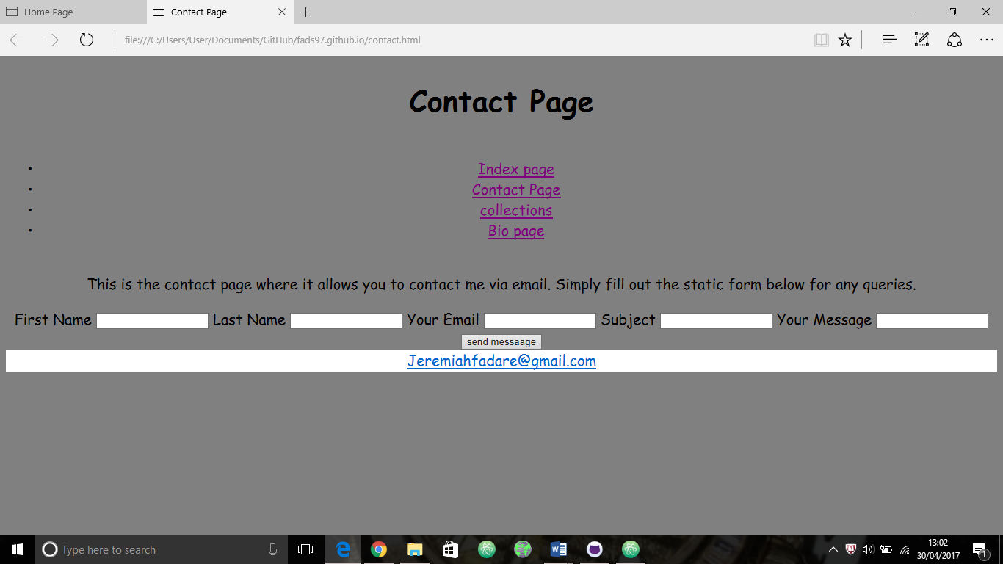

**Collection page:**

The collection page has the relevant pictures that the bio page has the information for. As you can see it’s about fitness and health by looking at the collection images. The images are organised grid like and are optimised so you can clearly see it without it being stretched. All the images are copyright free and are Harvard referenced which is in a table at the end of the page.

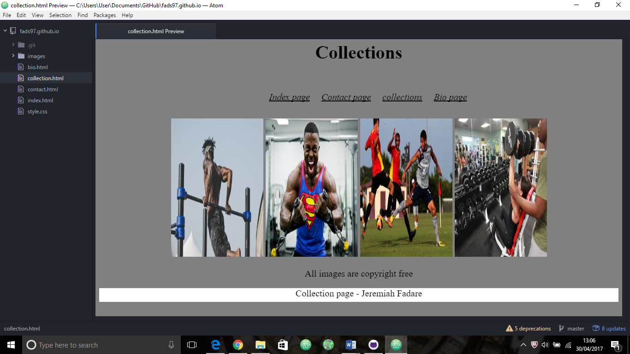

This is how the collection page looks in a browser , as you can see the images are clearly organised.

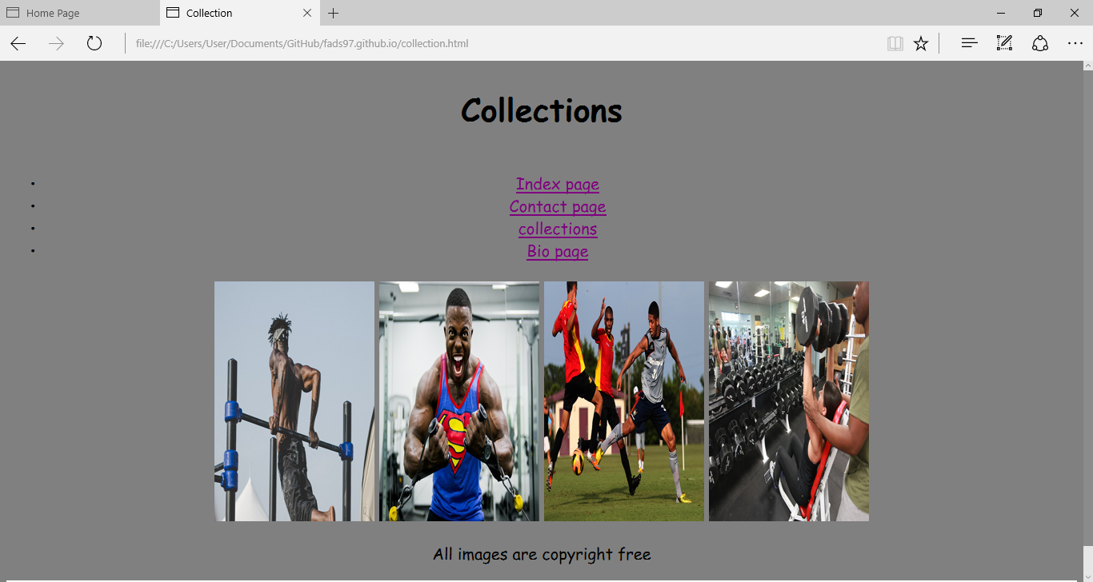

**Bio page:**

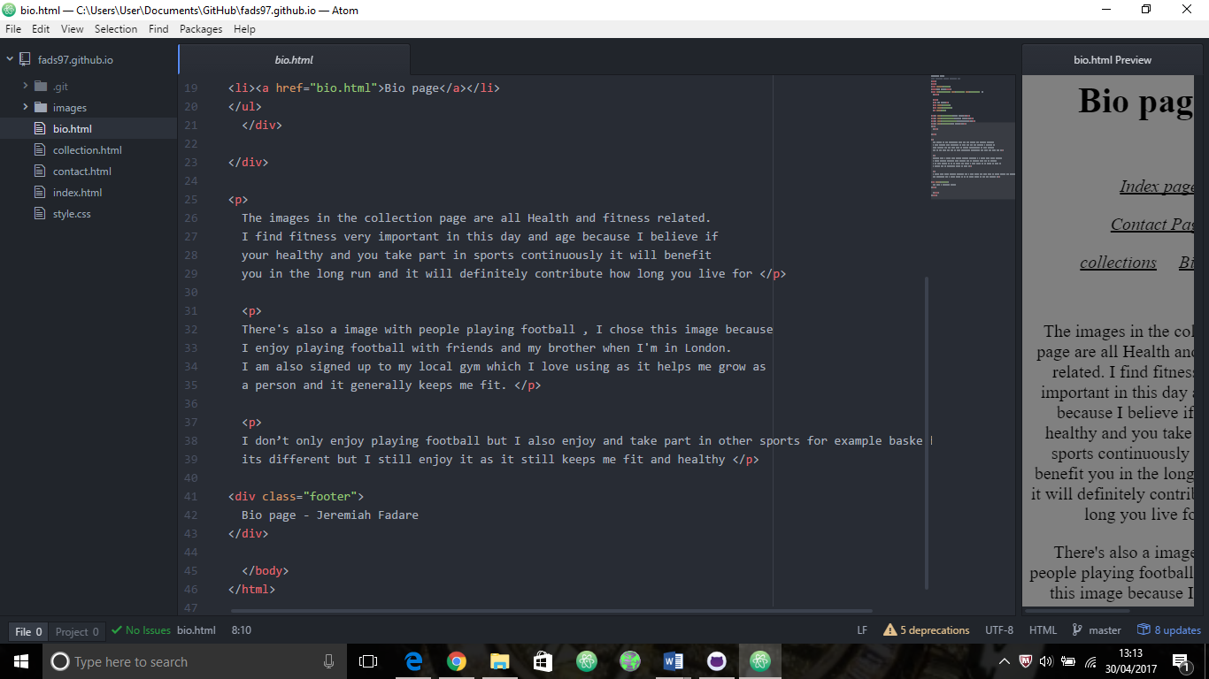The bio page is a short biography about the collection of the images that I included. In the bio page, I wrote about what the images mean to me and why I picked them. In the bio html page, I had to use the <p> div which represents paragraph so I had to use that a few times and </p> to signify at the end of the paragraph.

This is how the bio page looks in the browser and as you can see I had the same problem with the footer as I couldn’t place it all the way at the bottom of the page, it was a bit higher and I couldn’t manage to fix it unfortunately.

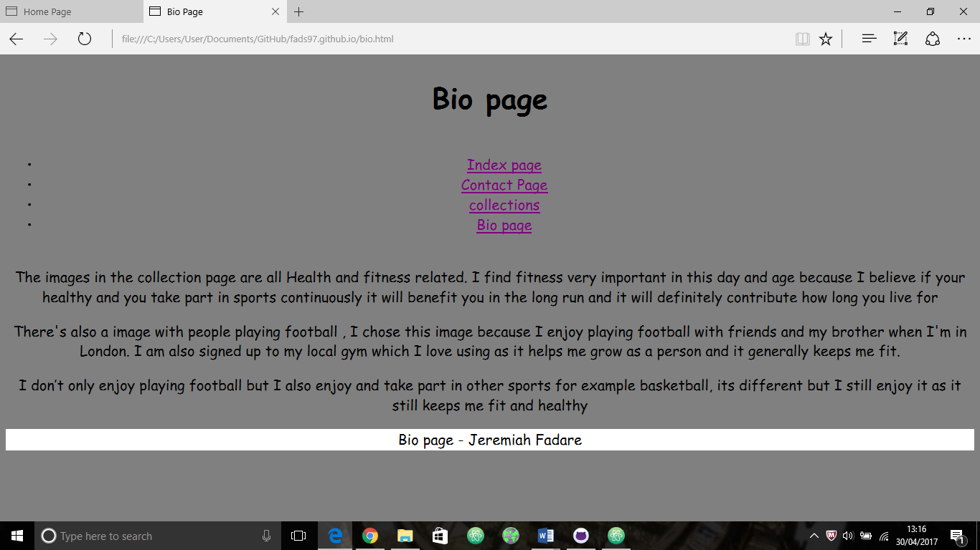

Bibliography – all images are copyright free and are from <https://pixabay.com>

|  |  |
| --- | --- |
| Image | Author |
|  | Cityofdeltona  <https://pixabay.com>  website  (image was used in file to represent fitness/health) |
|  | Trysh  <https://pixabay.com>  (image was used in file to represent fitness/health) |
|  | Skeeze  <https://pixabay.com>  (image was used in file to represent fitness/health) |
|  | Skeeze  <https://pixabay.com>  (image was used in file to represent fitness/health) |