STOCK MARKET ANALYSIS SYSTEM
Using Streamlit & Yahoo Finance API

Field | Details
Course | Business & Information Technology
Instructor | Dr. Khalaf
Institution | Canadian International College – Cairo
Team Size | 4 Members
Technologies | Python · Streamlit · yFinance · Plotly · Pandas
Date | 9 May 2026

1. Project Overview
StockVision is a web-based stock market analysis application developed using Streamlit that allows users to view and analyze real-time stock market data. The system fetches data from Yahoo Finance via the yFinance library and provides interactive visualizations and key financial indicators to help users understand market trends.

1.1 Objectives
- Understand how stock market data is collected and displayed in real time.
- Build a simple, interactive web application using the Streamlit framework.
- Visualize stock price trends using interactive Plotly charts.
- Provide basic stock information including OHLCV data and technical indicators.
- Implement clean error handling for invalid inputs and API failures.

1.2 Scope
- Allow users to search for any stock symbol listed on Yahoo Finance.
- Display current price, previous close, Day High/Low, 52-Week High/Low, and Volume.
- Show graphical representations including Line Chart, Candlestick, Volume Bar Chart, and Moving Averages.
- Provide historical data table (OHLCV) for the selected time period.
- Support time periods: 7 days, 1 month, 3 months, 6 months, 1 year, 2 years.

2. Team Task Allocation
The project was divided into four distinct roles, each handled by one team member, ensuring clear ownership and accountability:

Member | Role | File | Responsibilities
Member 1 | Project Lead / Backend Dev | backend.py | yFinance API integration, symbol validation, error handling
Member 2 | Data Processing & Analysis | data_processing.py | Data cleaning (Pandas), OHLCV extraction, MA / VWAP / Daily Change
Member 3 | Visualization Developer | visualization.py | Plotly charts: line, candlestick, volume, moving averages
Member 4 | UI Developer / Tester / Docs | app.py | Streamlit UI, session state, testing, documentation & PPT

3. Requirements

3.1 Functional Requirements
- Accept a stock ticker symbol (e.g., AAPL, TSLA, MSFT) as user input.
- Validate symbol format before calling the API.
- Fetch current and historical stock data from Yahoo Finance via yFinance.
- Display stock name, sector, industry, currency, and current price.
- Render interactive line chart or candlestick chart for price trends.
- Display moving average overlays (MA7, MA20, MA50).
- Show trading volume bar chart colored by price direction.
- Provide a collapsible historical OHLCV data table.
- Handle invalid inputs and API failures with descriptive error messages.

3.2 Non-Functional Requirements
- Performance: data should load within 3 seconds for standard queries.
- Usability: the interface must be intuitive with no technical background required.
- Reliability: graceful degradation when the API is unavailable.
- Responsiveness: works on desktop and tablet browsers.
- Maintainability: code split into four modules with clear responsibilities.

4. Tools & Technologies
Category | Technology | Purpose
Frontend & Backend | Streamlit >= 1.32 | Web UI framework – renders components server-side
Language | Python 3.10+ | Core programming language
Data Source | yFinance >= 0.2.36 | Yahoo Finance API wrapper for OHLCV data
Data Processing | Pandas >= 2.0 / NumPy >= 1.26 | DataFrame manipulation, cleaning, indicators
Visualization | Plotly >= 5.20 | Interactive charts: line, candlestick, bar
Version Control | Git / GitHub | Source control and collaboration
IDE | VS Code / PyCharm | Development environment

5. System Workflow
- Step 1 – User enters a stock symbol (e.g., AAPL) in the sidebar input field.
- Step 2 – app.py calls validate_symbol() in backend.py to check format.
- Step 3 – If valid, fetch_stock_data() calls yFinance and returns raw OHLCV + company info.
- Step 4 – process_stock_data() cleans the DataFrame (drops NaN, normalises columns).
- Step 5 – compute_indicators() appends MA7, MA20, MA50, VWAP, Daily Change columns.
- Step 6 – visualization.py renders the selected chart type (line or candlestick).
- Step 7 – Optional volume and moving average charts are rendered below.
- Step 8 – The full dashboard is displayed in the Streamlit UI.
- Step 9 – Any errors at any step are caught and shown as styled error messages.

6. System Diagrams

6.1 System Architecture Diagram
The system follows a layered architecture separating Presentation, Business Logic, Visualization, and Data Access layers. Each layer communicates with the one directly below it, ensuring separation of concerns.
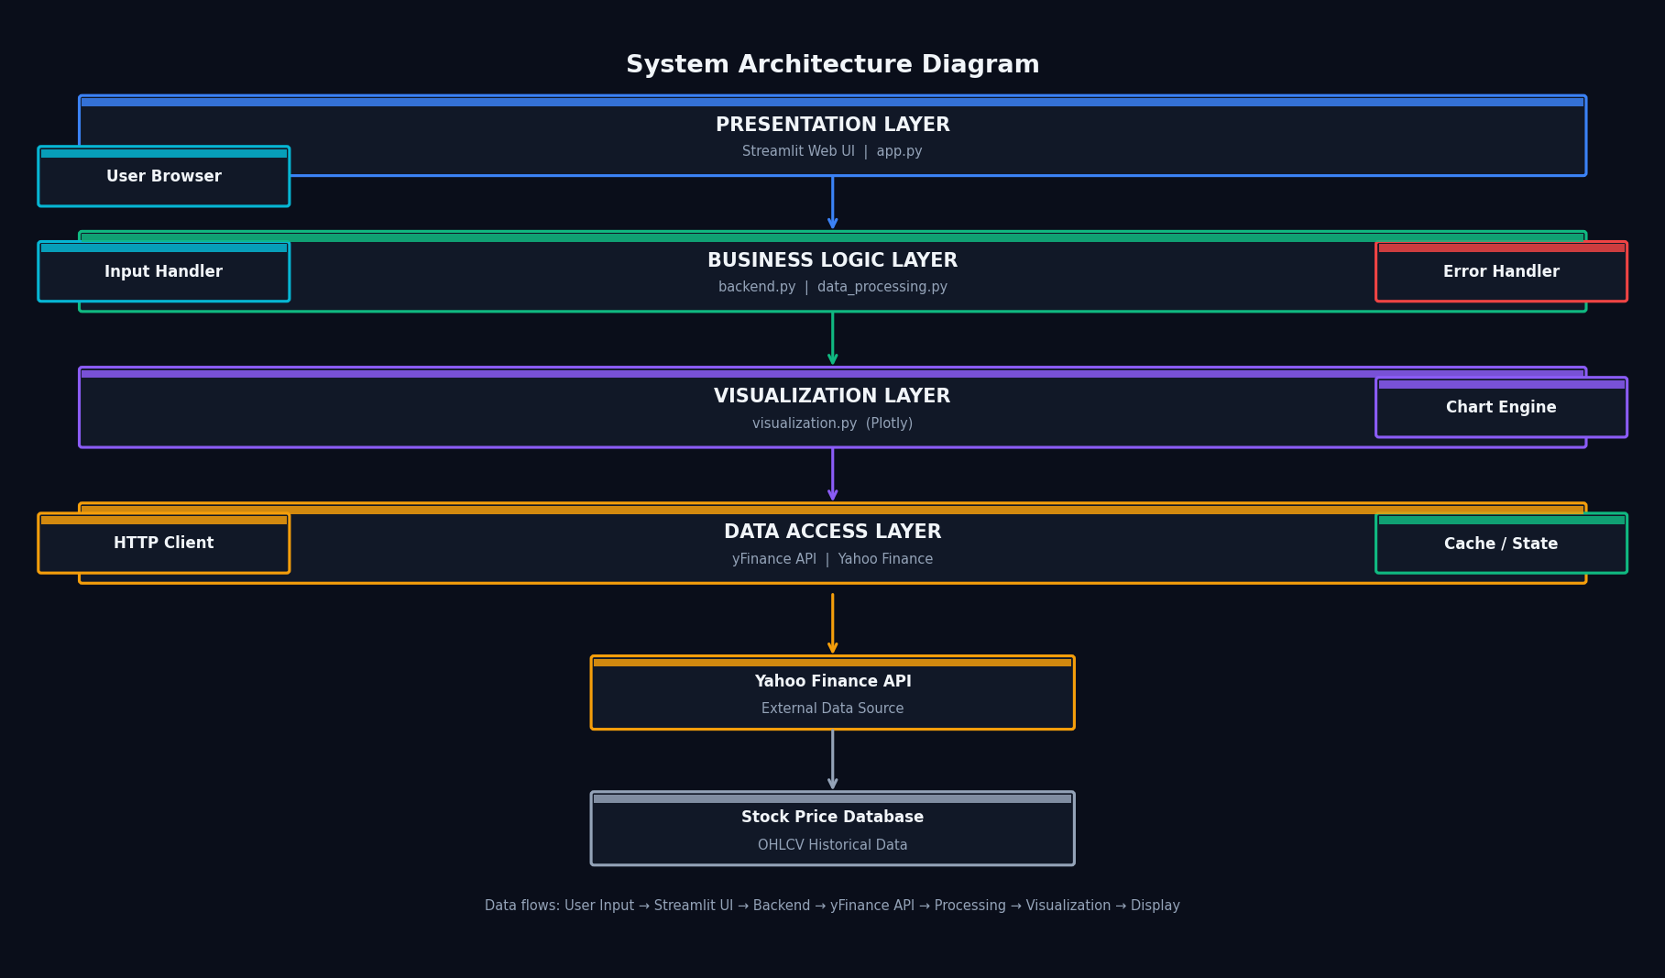

6.2 Data Flow Diagram – Level 0 (Context Diagram)
The Level 0 DFD shows the system as a single process interacting with two external entities: the User (who provides a stock symbol and receives analysis results) and the Yahoo Finance API (which provides raw stock data).
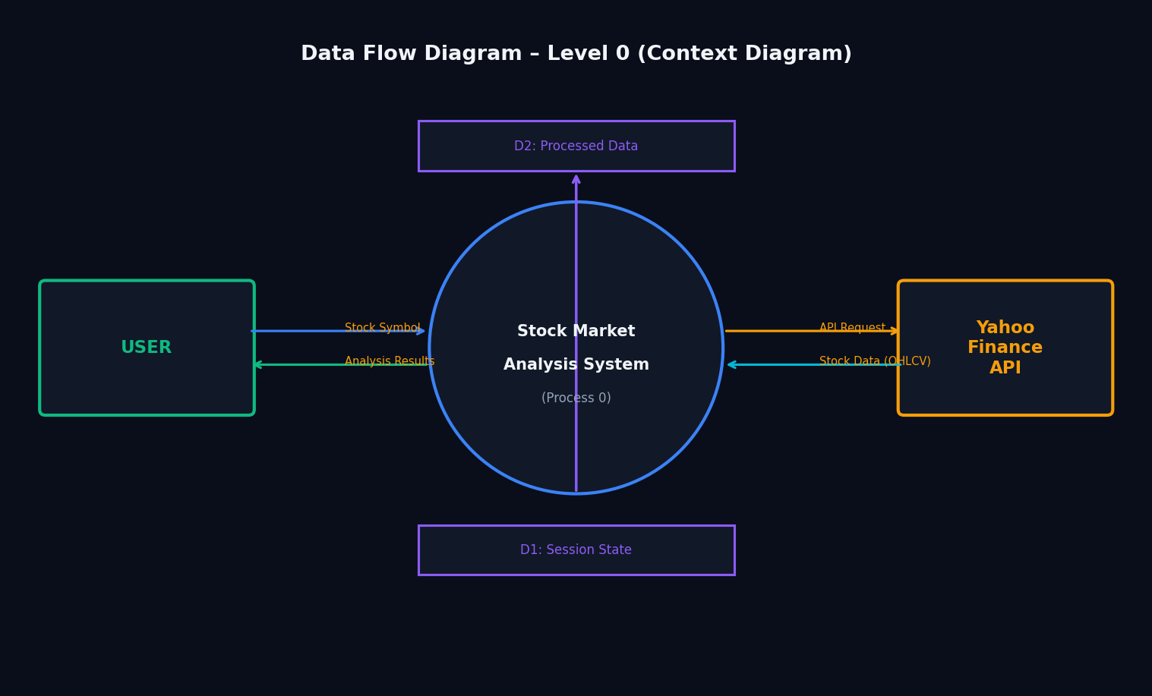

6.3 Data Flow Diagram – Level 1
The Level 1 DFD expands the system into five internal processes: (1) Validate Symbol, (2) Fetch Stock Data, (3) Process Data, (4) Generate Charts, and (5) Display UI, showing how data flows between them and the data stores.
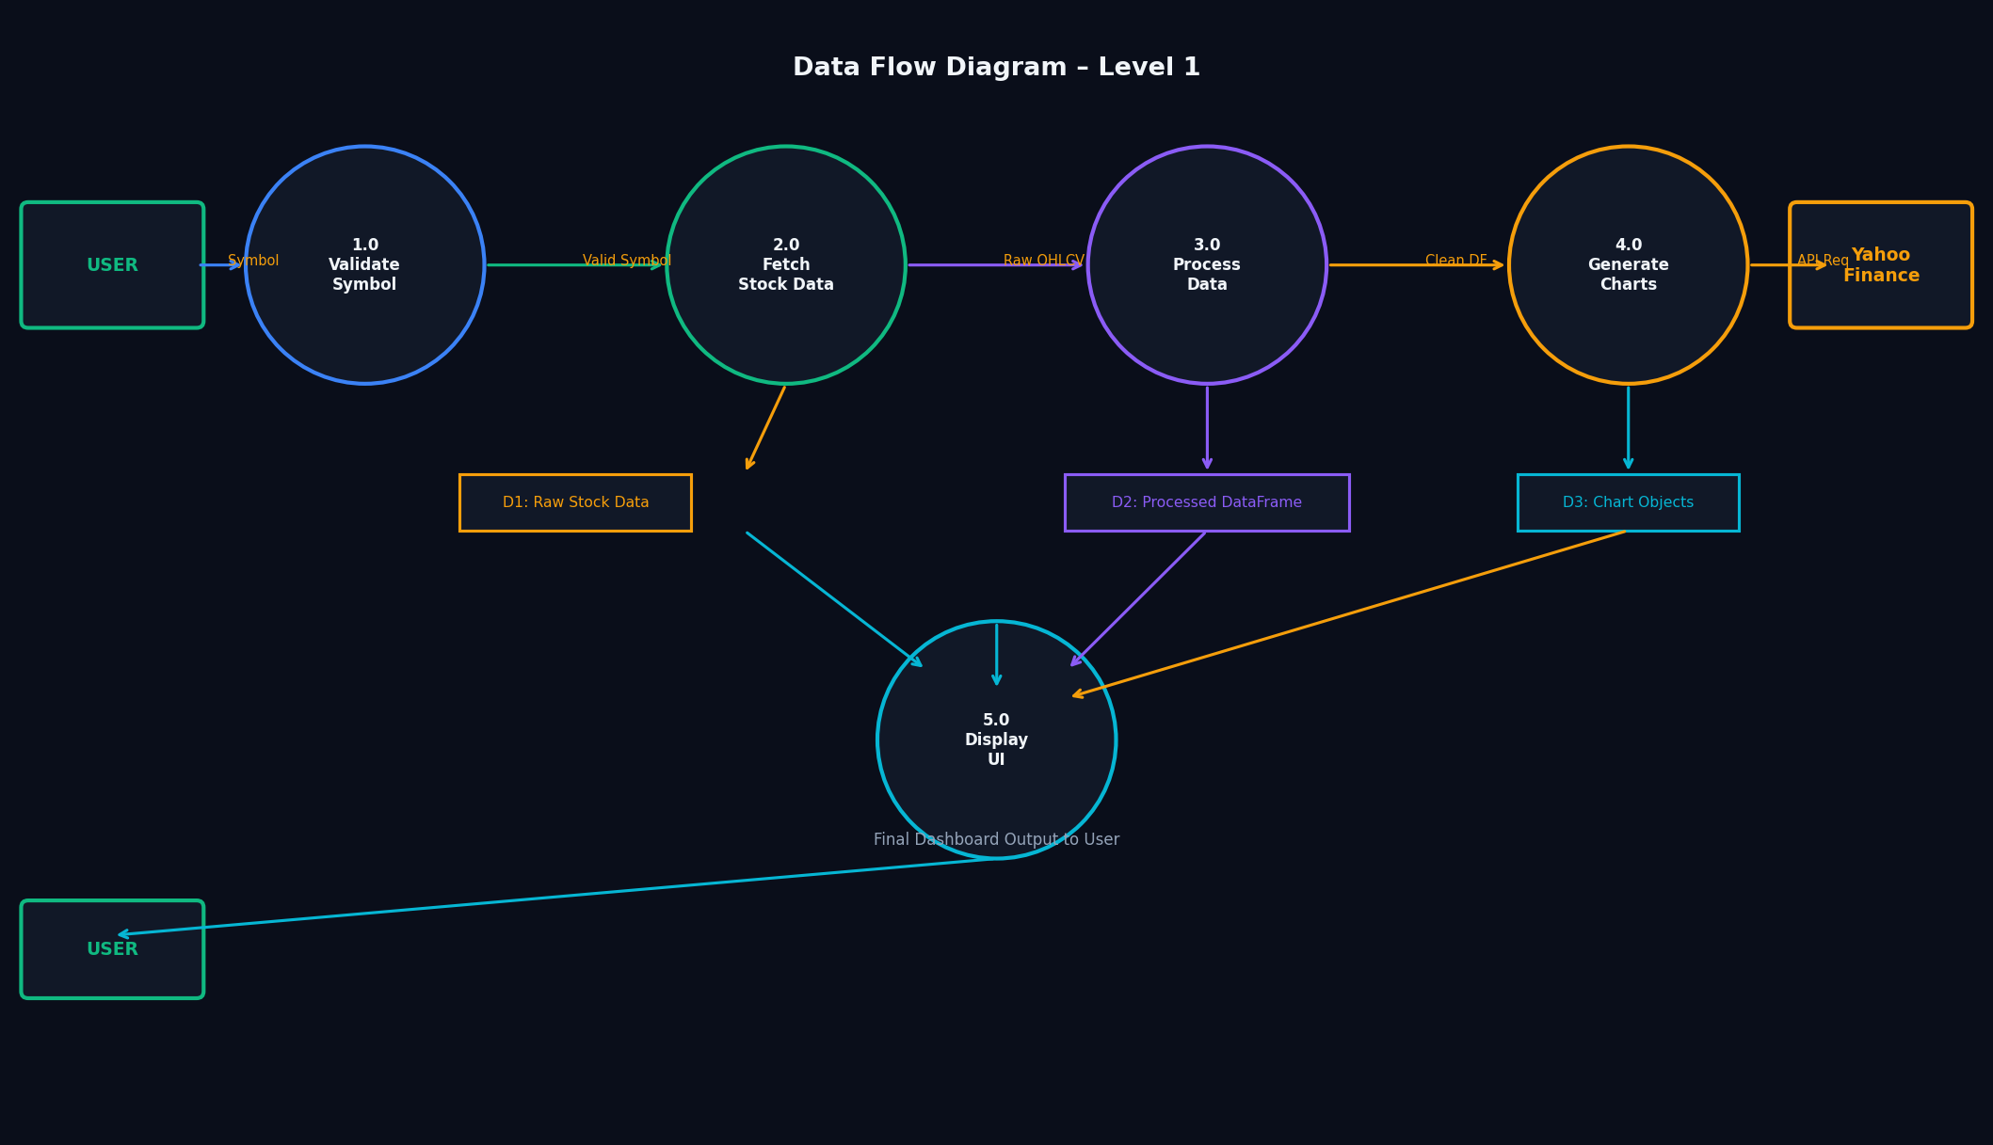

6.4 Use Case Diagram
The Use Case Diagram shows all interactions between the User actor and the system. The Yahoo Finance API acts as an external system actor participating in data fetch use cases.
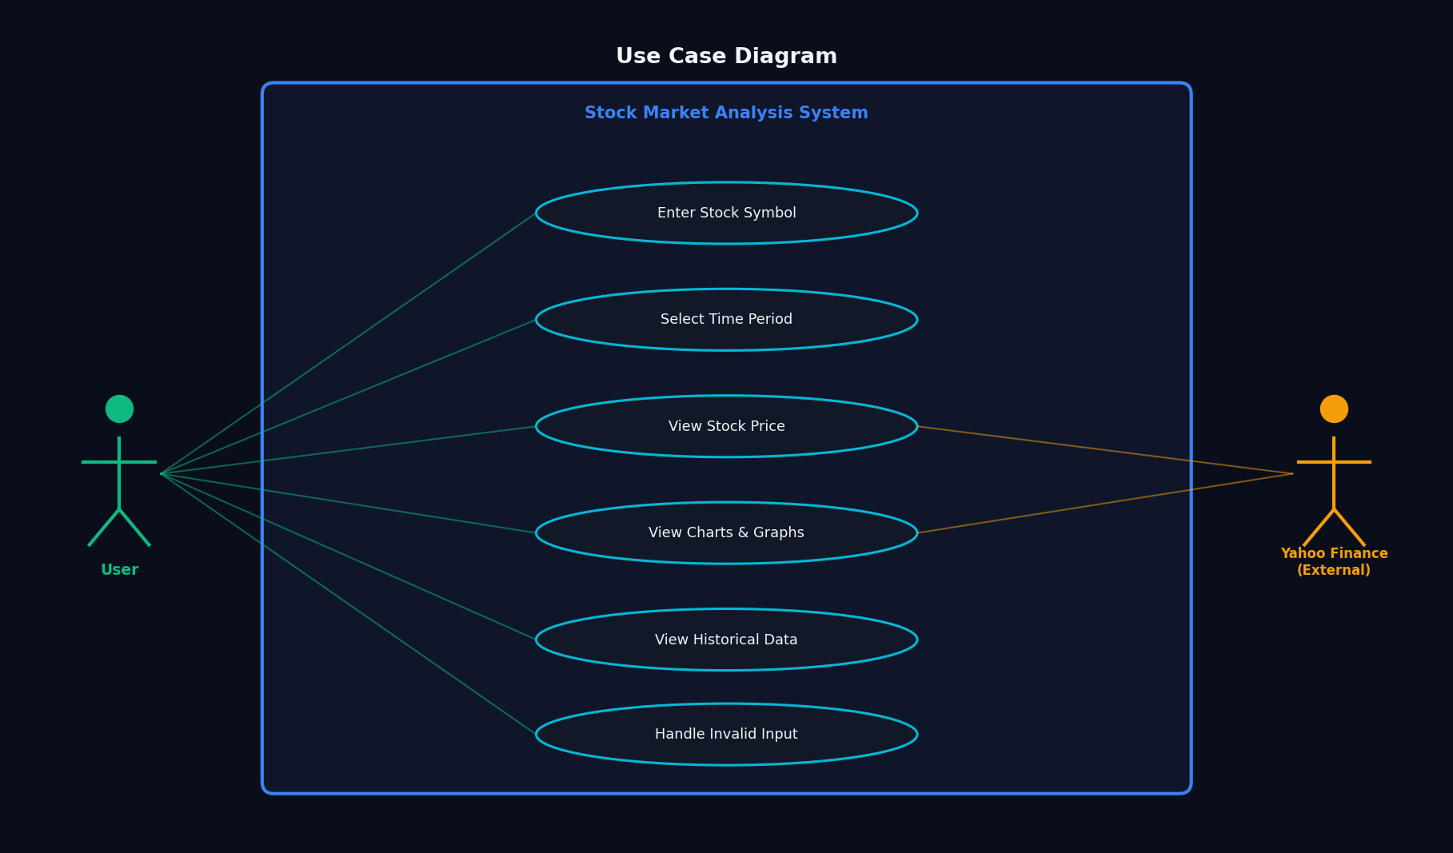

6.5 Activity Diagram
The Activity Diagram traces the full control flow from application launch through symbol validation, data fetching, processing, and chart generation, including decision points for error handling.
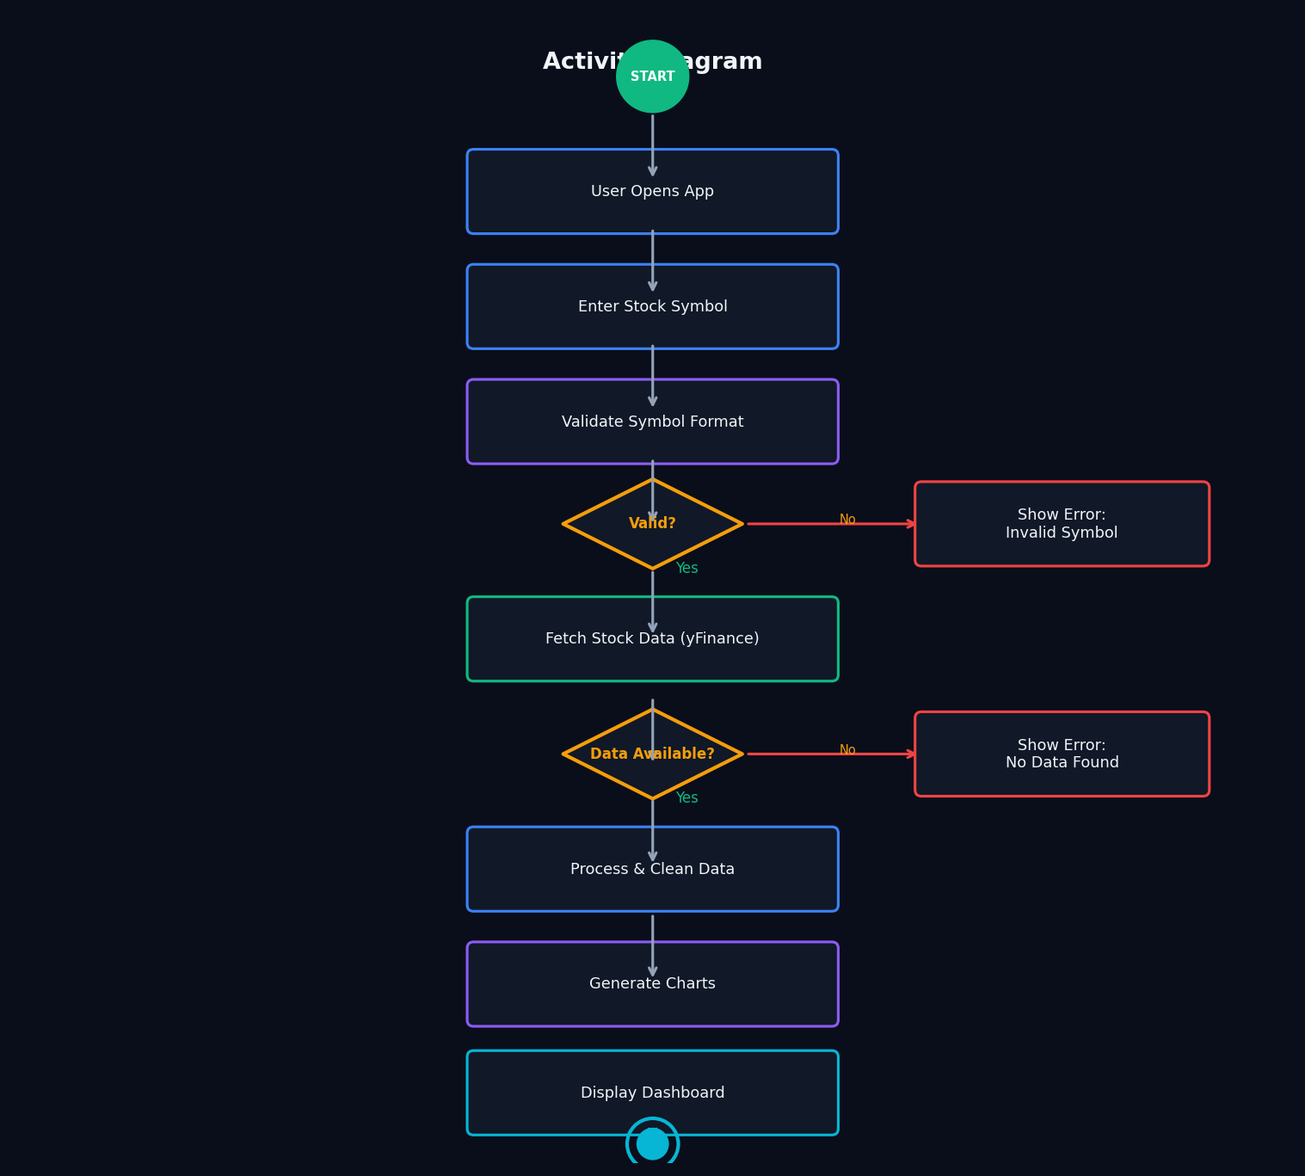

6.6 Sequence Diagram
The Sequence Diagram shows the time-ordered interactions between the User, app.py, backend.py, data_processing.py, visualization.py, and the Yahoo Finance API for a successful stock query.
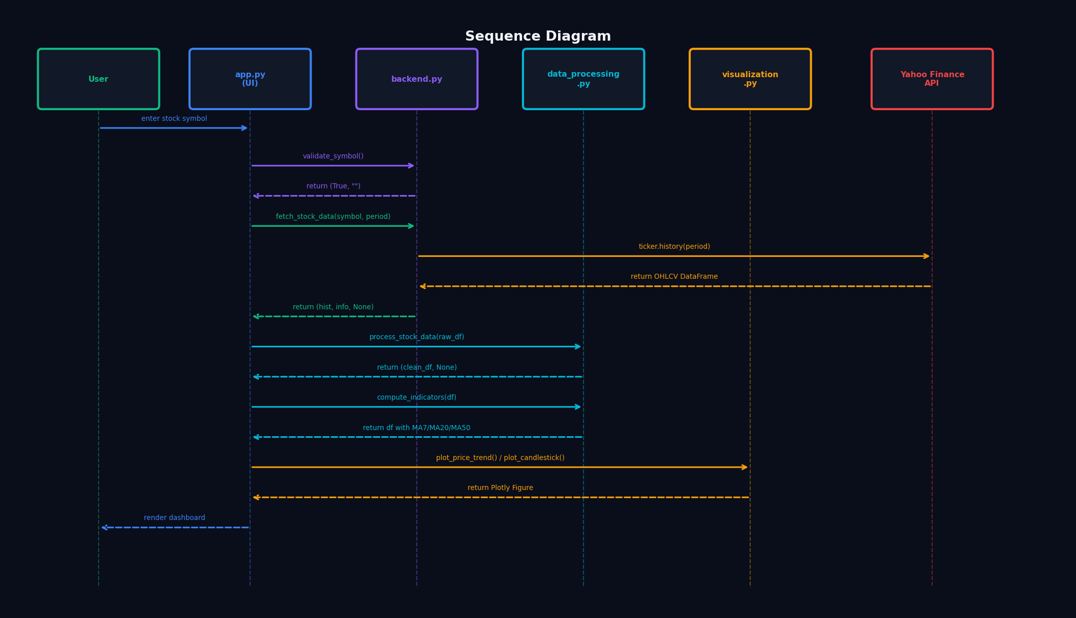

6.7 ER Diagram
The ER Diagram models the logical data structure used by the system, showing entities: STOCK, PRICE_RECORD, INDICATOR, USER_SESSION, and SEARCH_LOG, along with their relationships and key attributes.
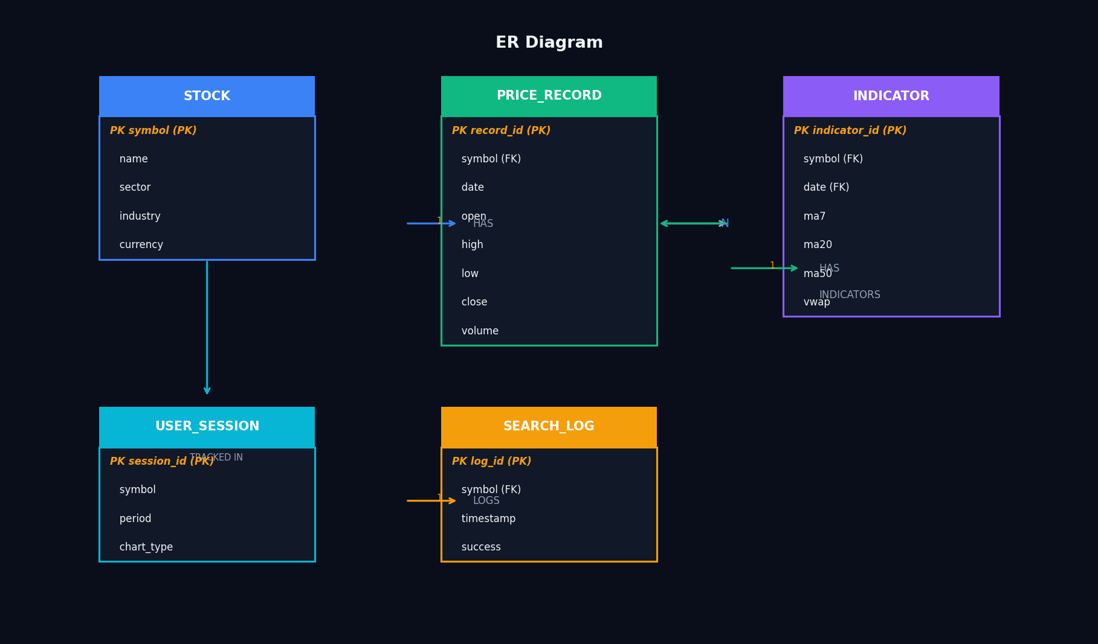

7. Testing

7.1 Test Cases
# | Test Case | Input | Expected Output | Result
TC-01 | Valid stock symbol | AAPL | Full dashboard with price, charts, metrics | PASS
TC-02 | Valid stock – TSLA | TSLA | Dashboard renders with Tesla data | PASS
TC-03 | Valid multi-class – BRK.B | BRK.B | Dashboard renders correctly | PASS
TC-04 | Unknown symbol | XXXXX | Error: "No data found for symbol XXXXX" | PASS
TC-05 | Invalid format (numbers) | 12345 | Error: "doesn't look like a valid ticker" | PASS
TC-06 | Empty input | (empty) | Error: "Please enter a stock symbol" | PASS
TC-07 | Time period – 7 days | MSFT + 7d | Chart shows 7 data points | PASS
TC-08 | Time period – 2 years | MSFT + 2y | Chart shows ~504 trading days | PASS
TC-09 | Candlestick chart type | GOOGL | Candlestick renders OHLC bars | PASS
TC-10 | Volume chart toggle | AMZN | Volume bar chart appears/disappears | PASS
TC-11 | Moving averages toggle | NVDA | MA7, MA20, MA50 lines appear | PASS
TC-12 | Popular symbol button | Click TSLA | Auto-loads TSLA dashboard | PASS
TC-13 | Historical data table | AAPL | Expandable table shows OHLCV | PASS
TC-14 | Chart accuracy – close price | AAPL | Price matches Yahoo Finance website | PASS

8. Project Structure
The project follows a modular architecture with each Python module corresponding to a team member's responsibility:

File | Owner | Description
app.py | Member 4 | Main Streamlit application entry point. Handles UI layout, session state, and orchestrates calls to other modules.
backend.py | Member 1 | yFinance API integration. Validates stock symbols and fetches historical OHLCV + company info data.
data_processing.py | Member 2 | Data cleaning and indicator computation using Pandas. Outputs a clean DataFrame with MA7/20/50, VWAP, and daily change columns.
visualization.py | Member 3 | Plotly chart generation. Produces line charts, candlestick charts, volume bars, and moving average overlays.
requirements.txt | All | Python package dependencies with minimum version constraints.
README.md | Member 4 | Setup instructions, feature list, and testing scenarios.

9. Conclusion
StockVision successfully demonstrates the core concepts of stock market data collection, processing, and visualization in a clean, user-friendly web application. The system fulfills all functional requirements defined in the project specification:

- Users can search any valid stock symbol and receive a complete market analysis dashboard.
- Data is fetched in real time from Yahoo Finance using the yFinance library.
- Interactive Plotly charts provide meaningful visualizations of price trends and volume.
- Technical indicators (MA7, MA20, MA50, VWAP) are computed and displayed correctly.
- The application handles edge cases (invalid symbols, empty inputs, API failures) gracefully.

The project provided hands-on experience with Python web development, API integration, data processing with Pandas, and interactive visualization with Plotly. It serves as a solid foundation for more advanced financial analysis systems incorporating features such as real-time WebSocket feeds, portfolio tracking, technical indicators (RSI, MACD, Bollinger Bands), and machine learning price prediction.

