**Name** **:** Fady Helal Maddy Lowndy

**Group :** 5

**Section :** 26

**B.N** **:** 3

**Sitting NO. :** 566

**Site link :** <https://fady313.github.io/ece001/>

The Project is about **computer Architecture**

The website is 4 pages beside the main page

It consists of :

Main Page and some tackled topics as inputs and outputs ,Machine cycle ,Memory Types and The motherboard

The website contains all the demanded elements : lists ,table ,images and multiple pages linked to each other

Here are screenshots for **the website** 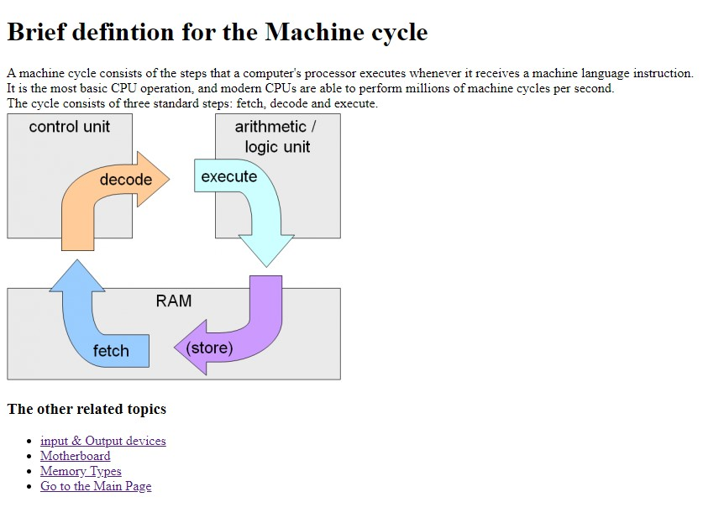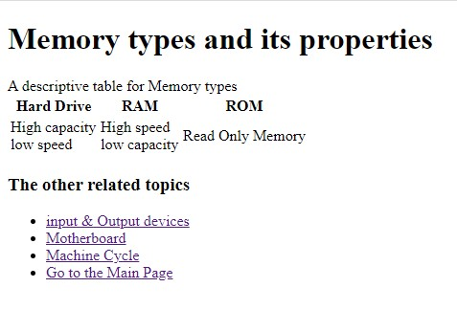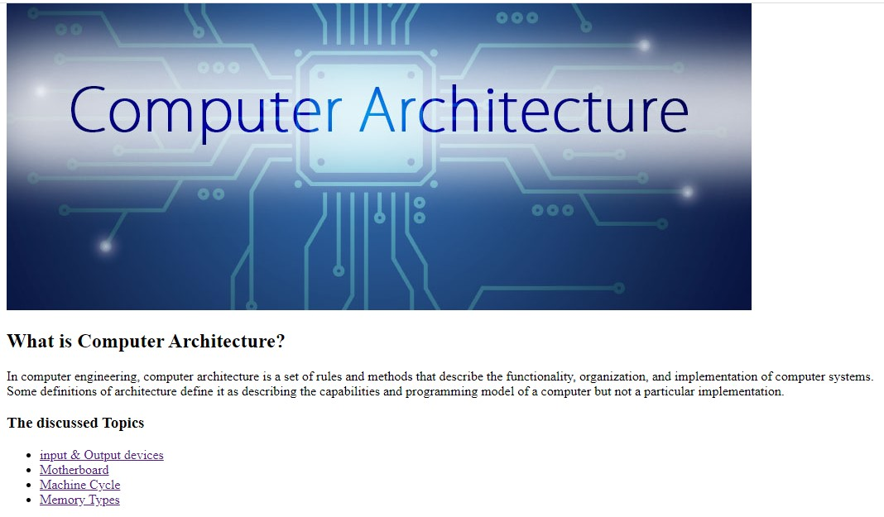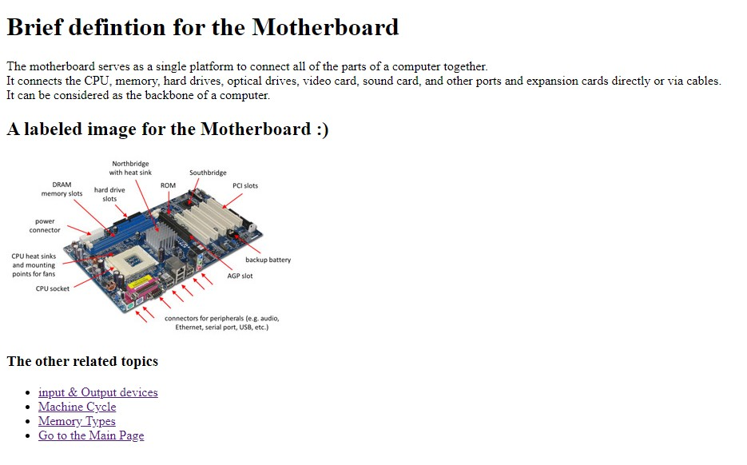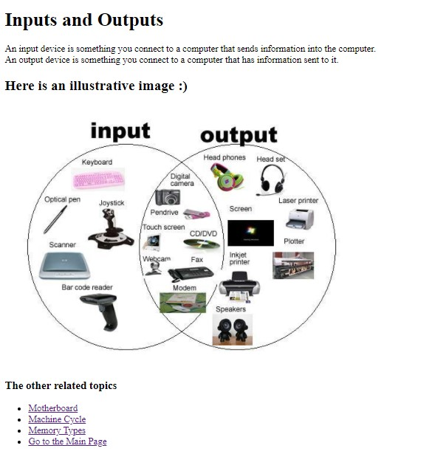

Screenshots for the **source code**

