Software Requirements Specification

(SRS) Document

Handy Hive

https://github.com/FadyEskand22/Handyhive2

05/05/2025

Final Version

Fady Eskandr (Provider)

Austin Rehner (Customer)

Table of Contents

Link to final project folder main:

<https://github.com/FadyEskand22/Handyhive2/tree/main/handyHive23%202>

Link project backend before converting to MVC:

<https://github.com/FadyEskand22/Handyhive2/tree/API-Backend>

Link to sql file:

<https://github.com/FadyEskand22/Handyhive2/blob/main/HandyHive_DB.sql>

Link to webpage templates:

<https://github.com/FadyEskand22/Handyhive2/tree/main/handyHive23%202/src/main/resources/templates>

Link to Fady Eskandr branch:

<https://github.com/FadyEskand22/Handyhive2/tree/faeskandr>

Link to Austin Rehner branch:

<https://github.com/FadyEskand22/Handyhive2/tree/arehner>

1. Project General Description

The goal of Handy Hive is to connect homeowners with professional industry providers, such as electricians, plumbers, HVAC technicians, and other home repair specialists. Our platform will help facilitate browsing, booking, and reviewing service providers, ensuring an easy customer and provider experience. The system will include features for customers to find and engage reliable professionals, for providers to showcase their expertise and manage their services, and for administrators to oversee platform operations, moderate content, and analyze service trends.

2. Product Features

Handy Hive is designed to simplify home maintenance and repair service management for both customers and service providers. The key features for the application will be:

Customer Features:

Customer Profile Creation: A customer can create a profile on the platform, providing necessary information such as contact details. Customers can also return to modify the profile at any time based on their needs or update contact information.

View Services: Customers can browse the available services on the platform, filtering options by service type (e.g., electrical work, plumbing, HVAC).

Customers should be able to view profiles of providers, schedule booking through the provider profile, and see the average rating from past reviews.

Subscription to Service: Once a customer finds a service or provider that meets their needs, they can book the service technician from a specific time slot. This will add the service to their list of booked services.

Reviews: A customer can write a review based on their experience, quality, and service. Rate the provider on a scale of 1-5. Submit the review, making it available for other customers to view the overall rating..

Customer Functional/Non-Functional Requirements:

FR1: Customers can create and update profiles.

FR2: Customers can browse available services with filters or word search.

FR3: Customers can save a provider and schedule appointments.

FR4: Customers can rate and review services.

NFR1: Profile updates should reflect immediately in the system.

NFR2: Booking confirmation should be received within 30 seconds.

Customer Scenarios:

**Actor:** Customer

**Description:** Creating a profile

**Scenario:** Customer fills out personal information such as contact information(name, phone number, email address, and home address). Once the profile is saved and created, the customer is sent to the login page to login with their new credentials. If needed, the profile can be edited later.

**Potential Issues:** Incorrect information submitted

**System State:** The app collects the customer information and once finished allows the customer to search and edit profile to meet their needs.

**Actor:** Customer

**Description:** View Services

**Scenario:** Once logged in a customer can go to view services, and filter to the correct home service that is required for maintenance. The app will give a list of available service providers based on the required service (electrician, HVAC, etc.). The customer will see the service details, location, time slots available, and overall rating.

**Potential Issues:** There may be no available technicians, incorrect information from the service provider, or possible missing filter based on customer needs.

**System State:** All the home services will be displayed and filtered once the customer begins to browse home service.

**Actor:** Customer

**Description:** Subscription to Service

**Scenario:** Once the customer has found their service provider that meets their needs, they can view the profile and select to book the service provider based off of a time slot. The app will save the service request to booked appointments, and display the information that she requested.(Service, technician, time slot)

**Potential Issues:** No available technicians for service, overbooking for a specific service, or possible incorrect service requested.

**System State:** The system displays necessary information needed for acquiring a service request and then shows the information in the booking tab.

**Actor:** Customer

**Description:** Reviews

**Scenario:** Once the customers' needs are met they can leave a review under the provider profile of 1-5(1 being lowest, 5 being highest, based on overall satisfaction of service. Then the customer can write a personalized message to the service provider.

**Potential Issues:** Customers not leaving reviews at all, or possible duplication of reviews.

**System State:** Once the customer writes the review and rating, other customers can see the rating to decide if they want that service provider.

Provider Features:  
Provider Profile Management: Service providers can create and manage their profiles, including details about their services, pricing, and availability. Profiles can be modified or removed as needed.

Service Listing: Providers can list the services they offer, including pricing, availability, and service descriptions.

Analytics Dashboard: Providers will be able to view an analytics dashboard where service engagement is shown and customer feedback. Also will be able to generate a generic report for business growth strategies.

Review Reviews: Providers can reply to customer comments under posts to address concerns and engage with their clientele. The reviews will be displayed on their dashboard to review.

Provider Functional/Non-Functional Requirements:

FR1: Providers can create, modify, and remove their profiles.

FR2: Providers can list services, including pricing and availability.

FR3: Providers can view customer statistics and analytics.

FR4: Providers can see feedback on customer reviews.

FR5: Providers can generate reports to analyze business growth.

NFR1: Services listings should be searchable in under ~2 seconds.

NFR2: Provider reports should be generated within 30 seconds.

NFR3: Customer interactions and reviews must be logged for future reference.

Provider Scenarios:

**Actor:** Provider

**Description:** Registering as a service provider.

**Scenario:** Provider enters business details such as phone numbers, hours, specialty and price to register their account.

**Potential Issues:** Unverified providers attempting to list services. A verification process should prevent fake applications.

**System State:** Approved providers can create service listings that can demonstrate deals or promotions running for the company.

**Actor:** Provider

**Description:** Adding and updating service offerings.

**Scenario:** Provider lists a service with pricing, availability, and descriptions. Updates can be made at any time.

**Potential Issues**: Incomplete service descriptions could lead to customer confusion. Required fields should be implemented to ensure clarity.

**System State:** Customers can view and book listed services based on the contact information, availability, and service.

**Actor:** Provider

**Description:** Engaging with customer feedback.

**Scenario**: Provider addresses customer concerns, acknowledges issues, or thanks customers for positive reviews.

**Potential Issues:** Negative reviews could impact reputation. Make sure there are restrictions and guidelines for responses to mitigate damage.

**System State:** Overall rating is visible next to their customer reviews.

Project Overview:

The goal of the Handy Hive web application is to connect homeowners with well-studied service providers for home maintenance and repair job assignments, such as plumbing works, electrical works,HVAC service works, and so forth.

Customers create and manage a profile for themselves, search for services available, filtered by category or word, and view service listings in full display. Once a suitable provider has been found, a customer may book an appointment. After receiving the service, customers may post reviews that assist future potential clients in making their own choices. The customer may also save a provider for future service.

Service providers create and manage their own profiles, which enable them to display their business with descriptions, pricing, and availability. They may add new services, advertise promotions, and respond to customer feedback. Providers may also keep track of customer engagement and review trends via analytics dashboards to improve their business and also print an analytics report.

UML Model

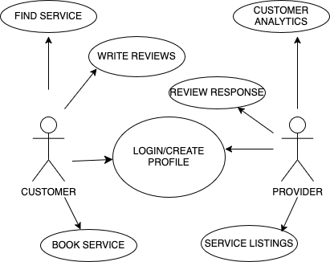

Database Schema

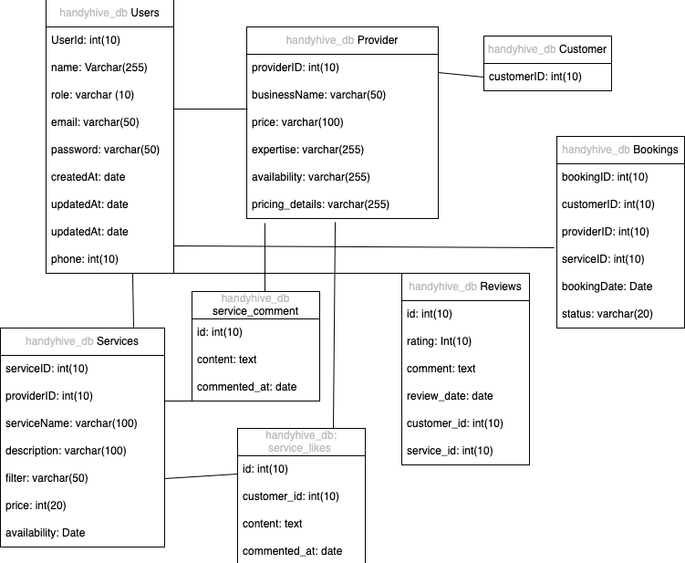

Group Member Responsibility

Fady Eskandr:

Provider folder use cases

Config folder

Service folder use cases(statistics)

Templates(bookings.ftlh, index.ftlh, posts.ftlh, register_provider.ftlh, provider_profile.ftlh, provider_statistics.ftlh)

Austin Rehner:

Customer folder use cases

Service folder use cases

Templates(customer-profile.ftlh, login.ftlh, review,ftlh, register_customer.ftlh, finde-services.ftlh)

Both for linking purposes:

Review folder use cases

Booking folder use cases

Scenarios with Screenshots

Provider: Register as provider and create profile, create service user cases.

1. Provider P1 registers their account. Provider P1 provides information containing contact info, hours of availability, and price per hour creating service listing S1. P1 then posts an advertisement post. P1 exits the app

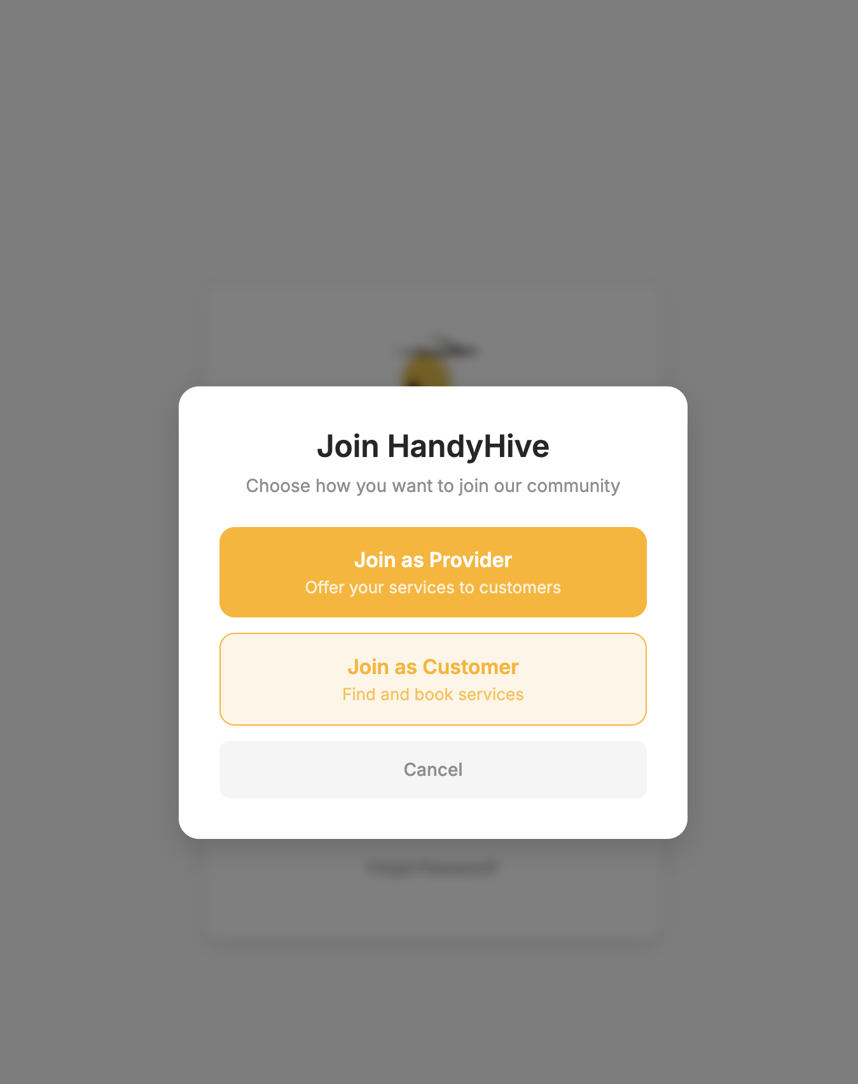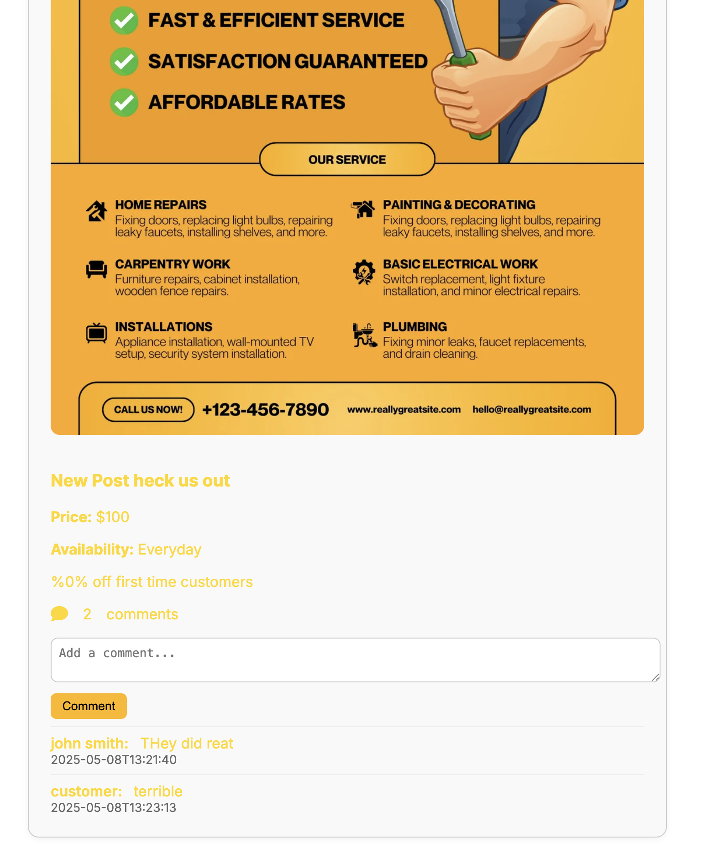

1. Provider P2 follows the same criteria as P1 creating S2. P2 exits the app.
2. P1, P2 provides searchable values for C1 and C2.

Customer: Register and creates profile. Logs in and views services use cases

1. Customer C1 registers account and creates a profile with personal information. 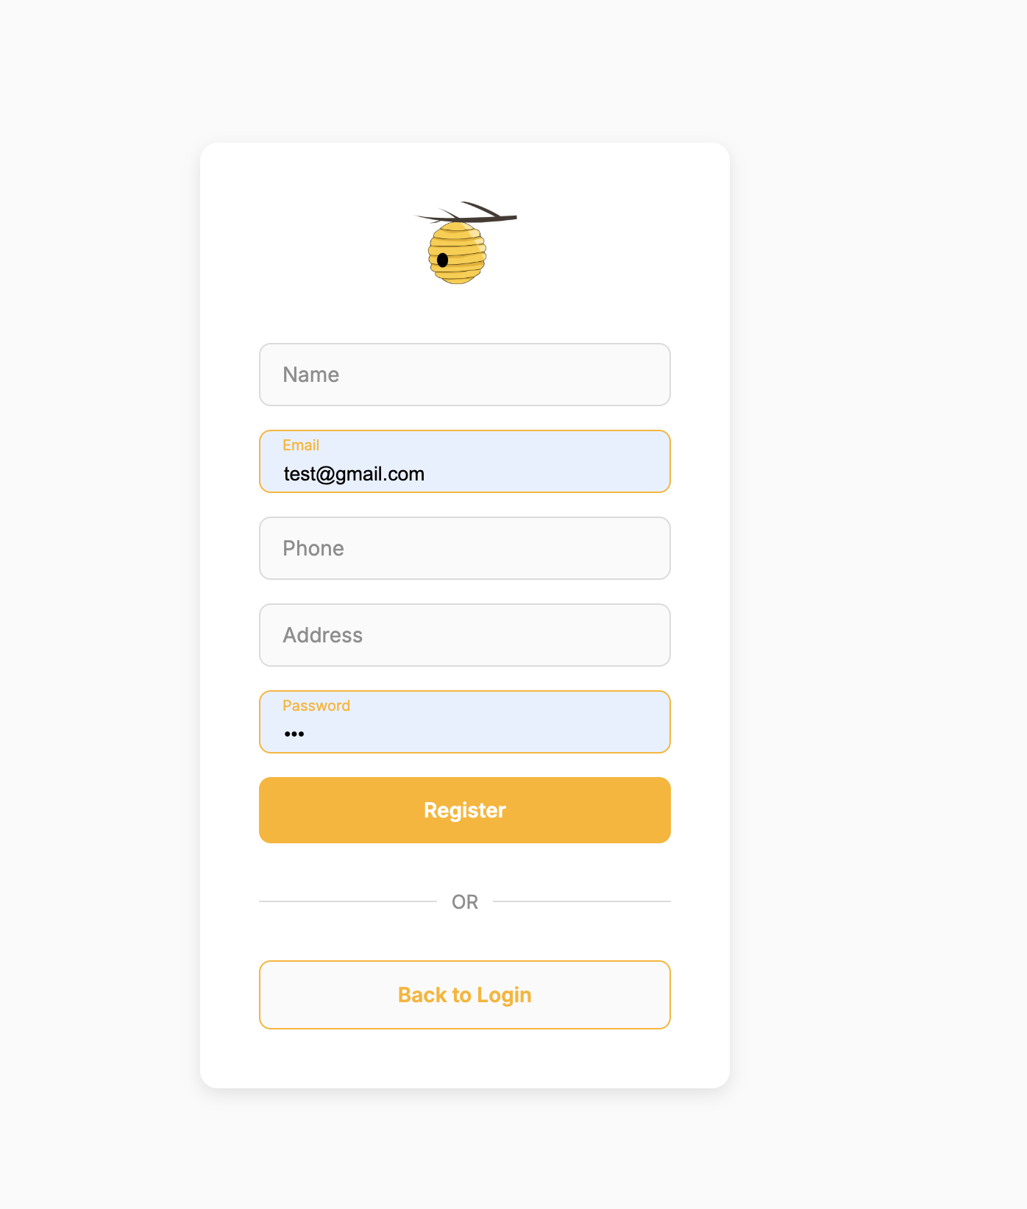
2. Customer C1 logs in for the first time and views services S1.
3. Customer C1 can view services and overall rating of S1.
4. 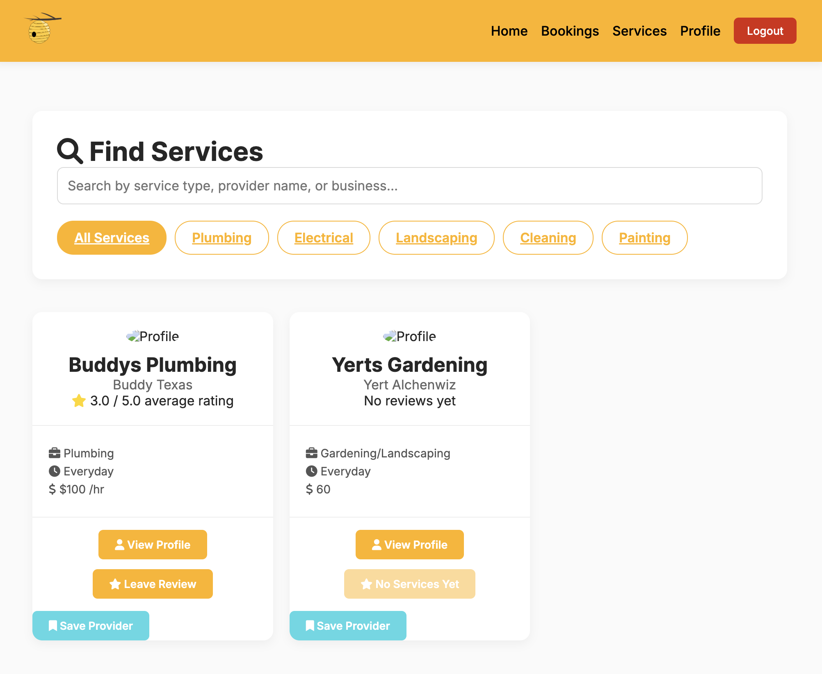

Customer: Book services and leave a review use cases.

1. Customer C1 books a service with S1.

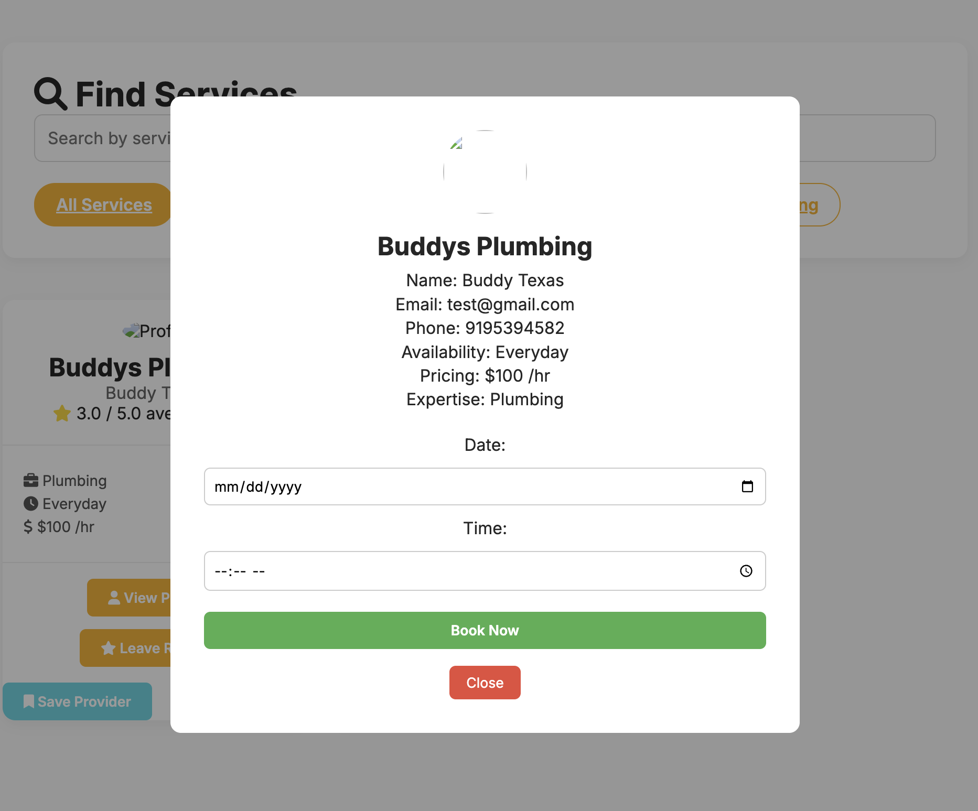

1. Customer C1 leaves a review and rating for S1.

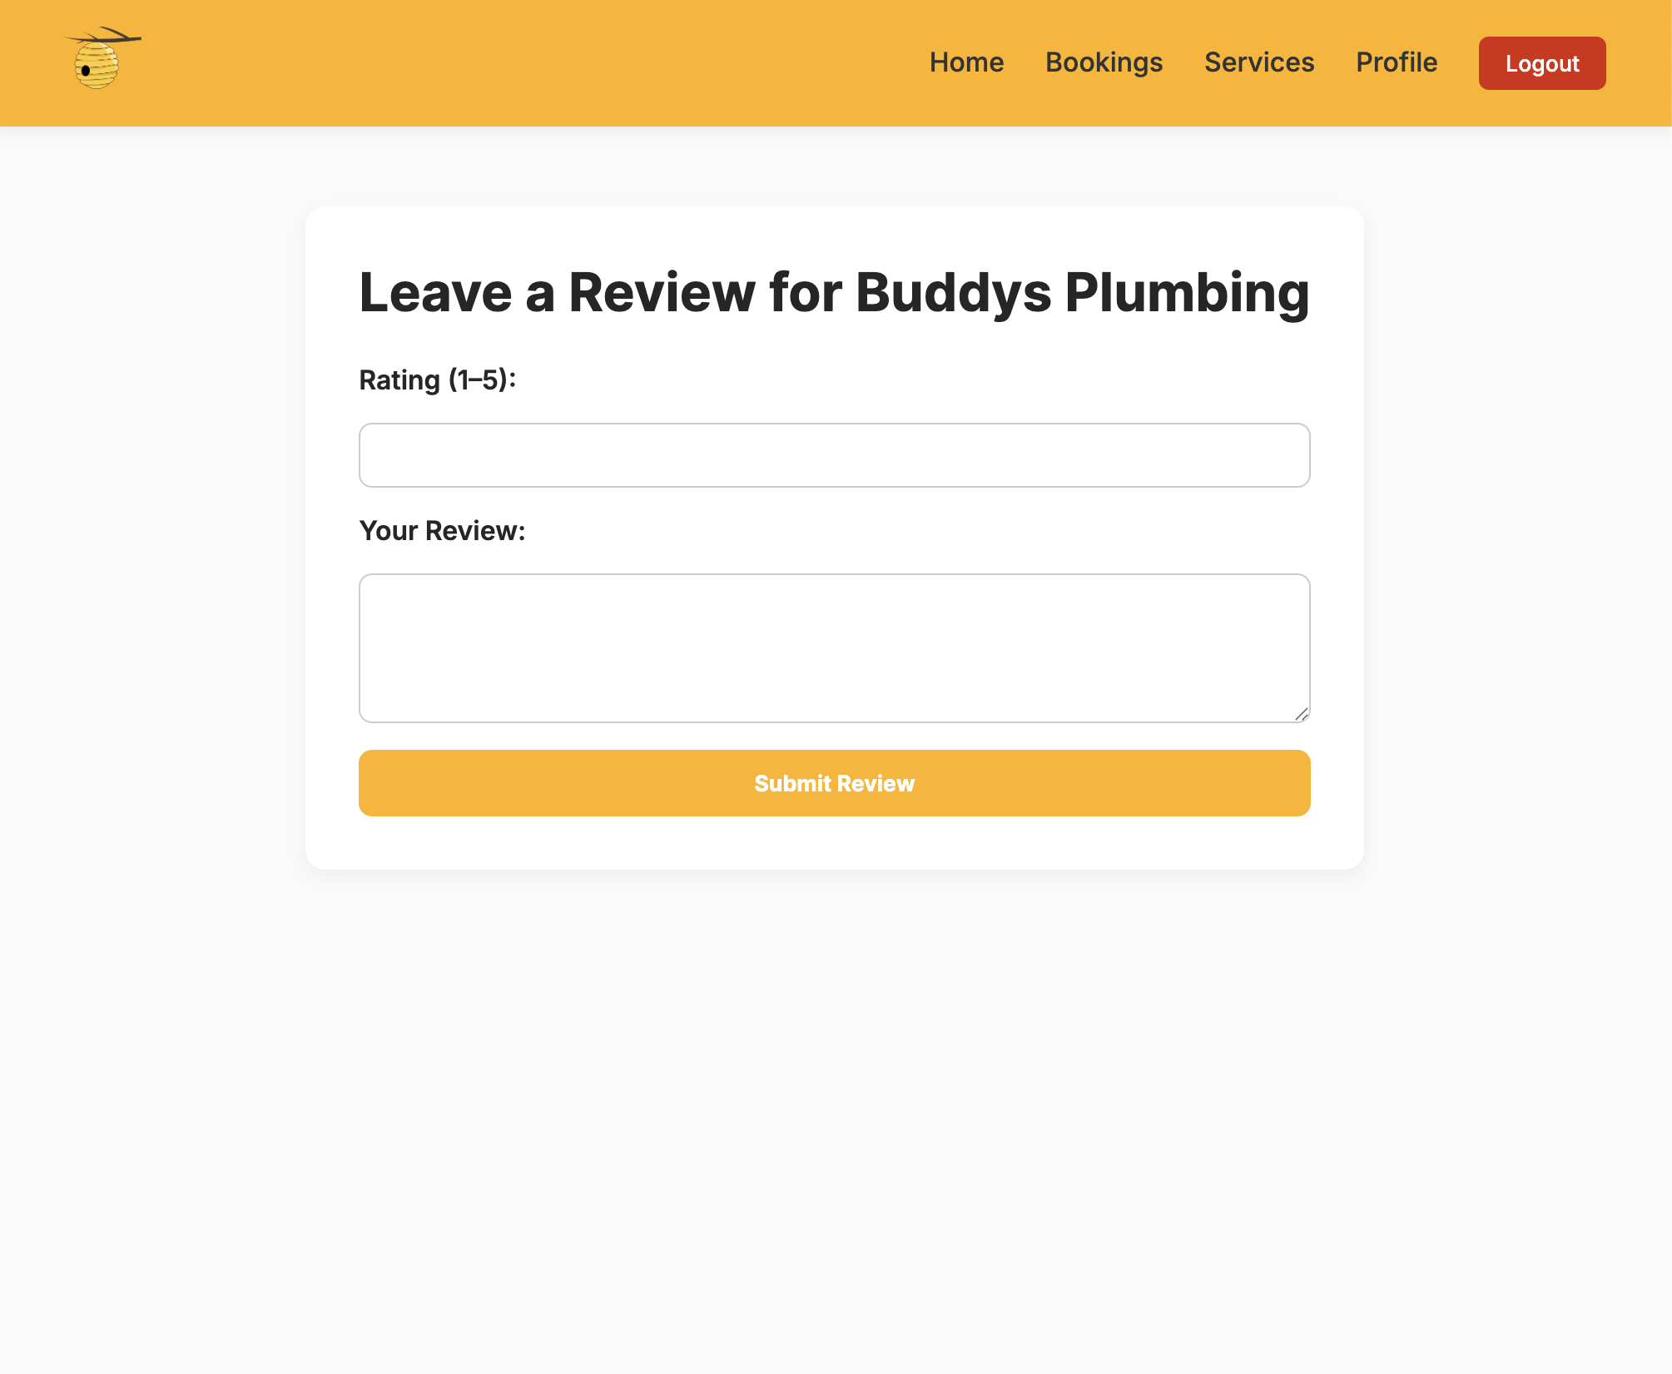

1. Customer C1 leaves a comment on advertisement post.
2. Customer C1 saves the provider P1 from service S1. C1 exits.

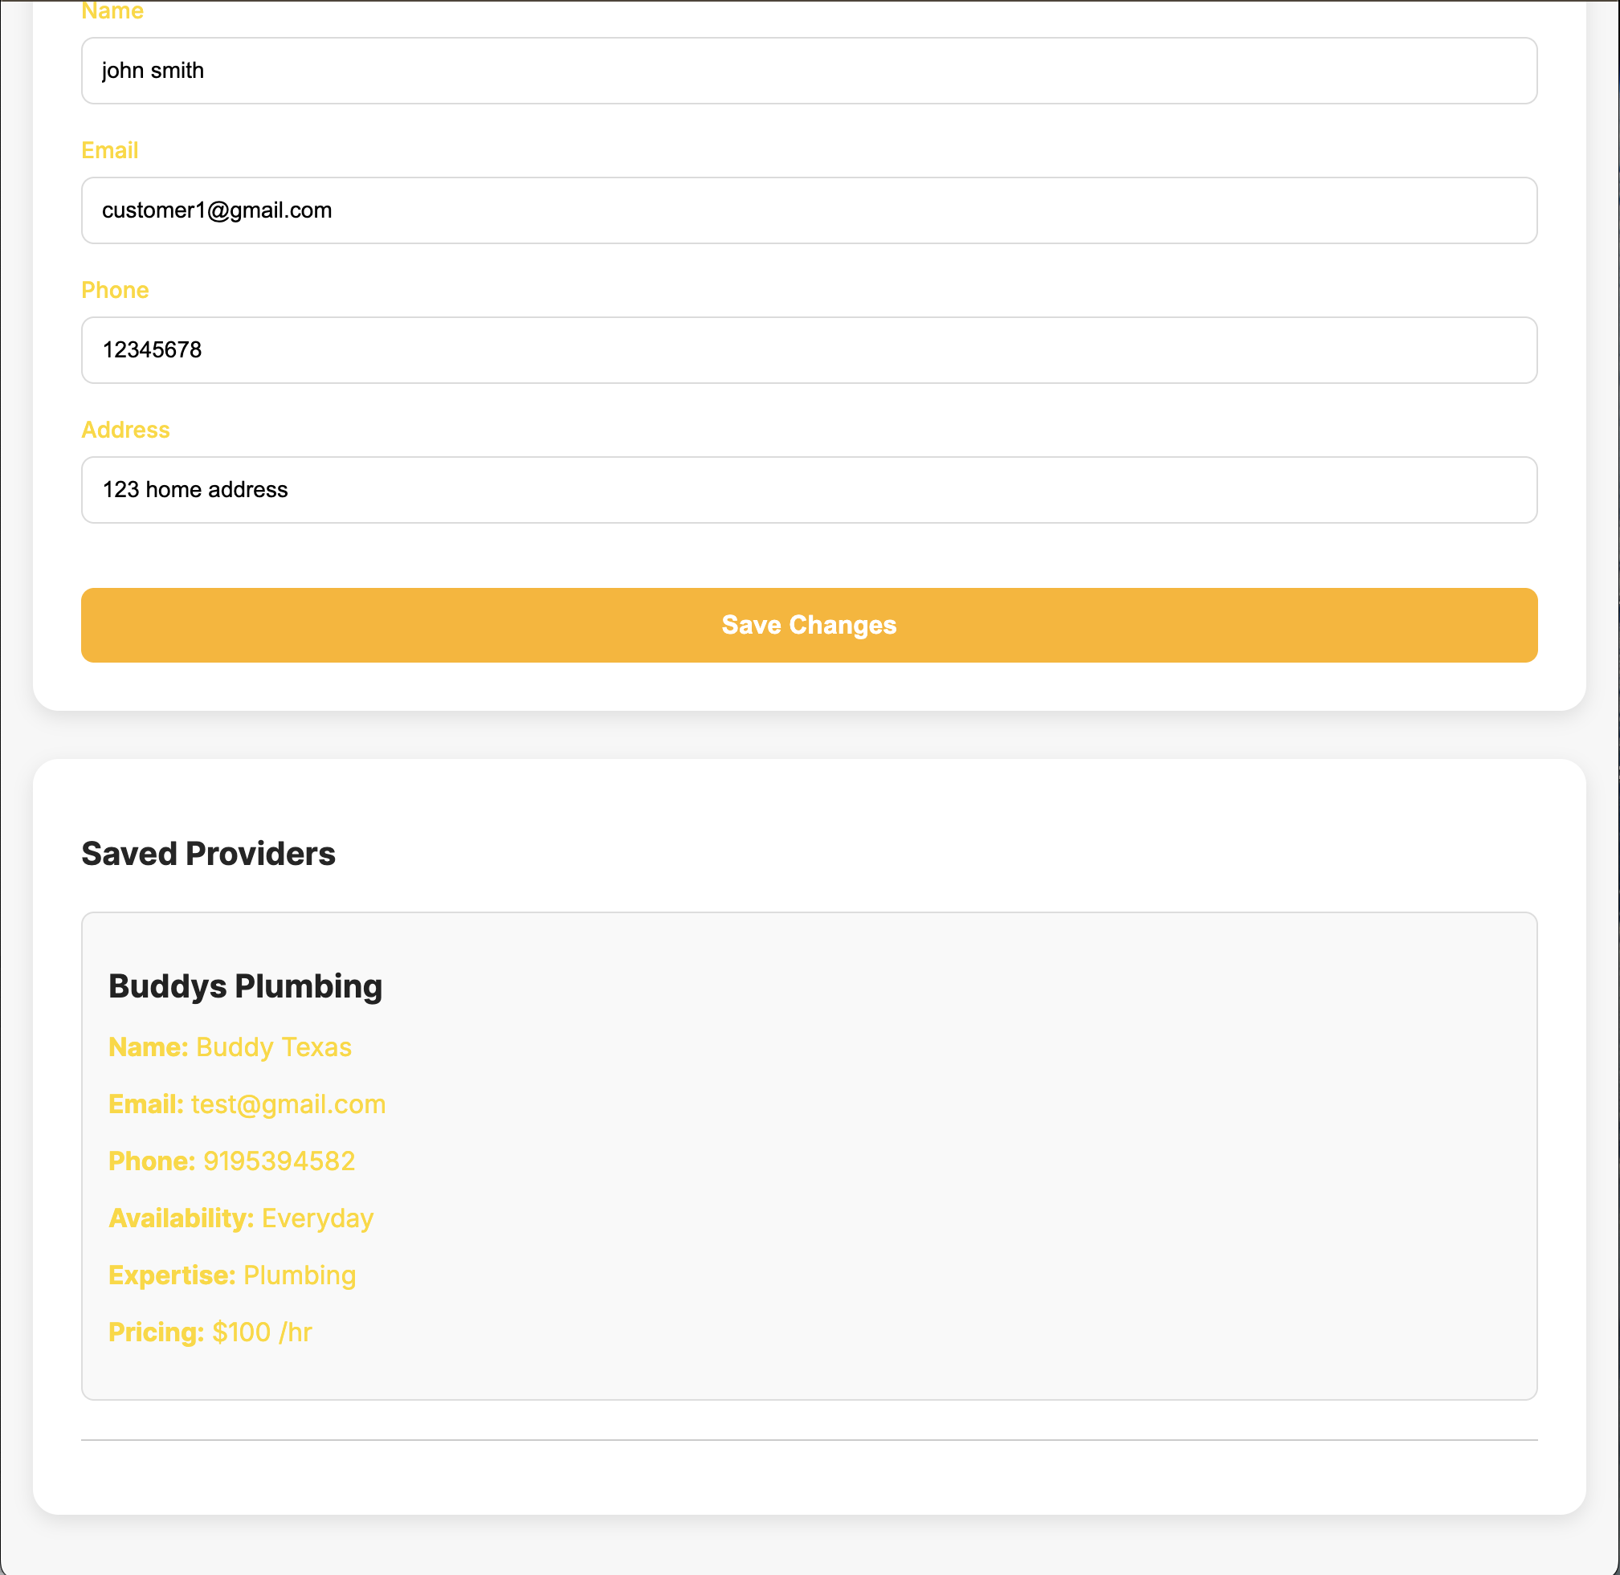

1. Customer C2 logs in for the first time and updates incorrect information. C2 makes booking then cancels booking. C2 leaves a negative review on S1. C2 views overall rating to confirm rating was posted. C2 then leaves negative comment on advertisement post. C2 exits.

Provider: Provider reviews responses and customer analytics and updates profile.

1. Provider P1 logs in to view ratings, reviews and comments under statistics.

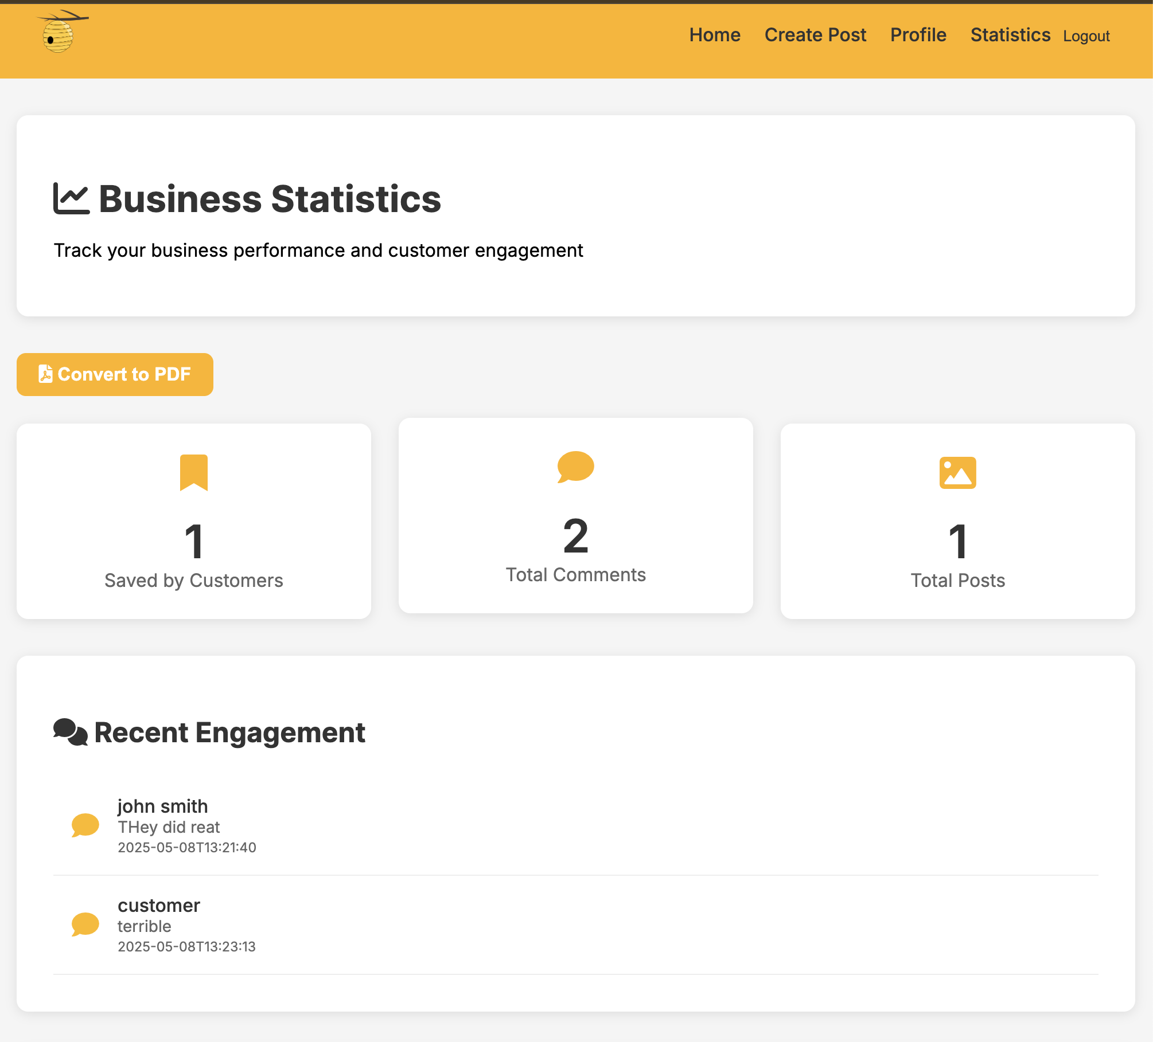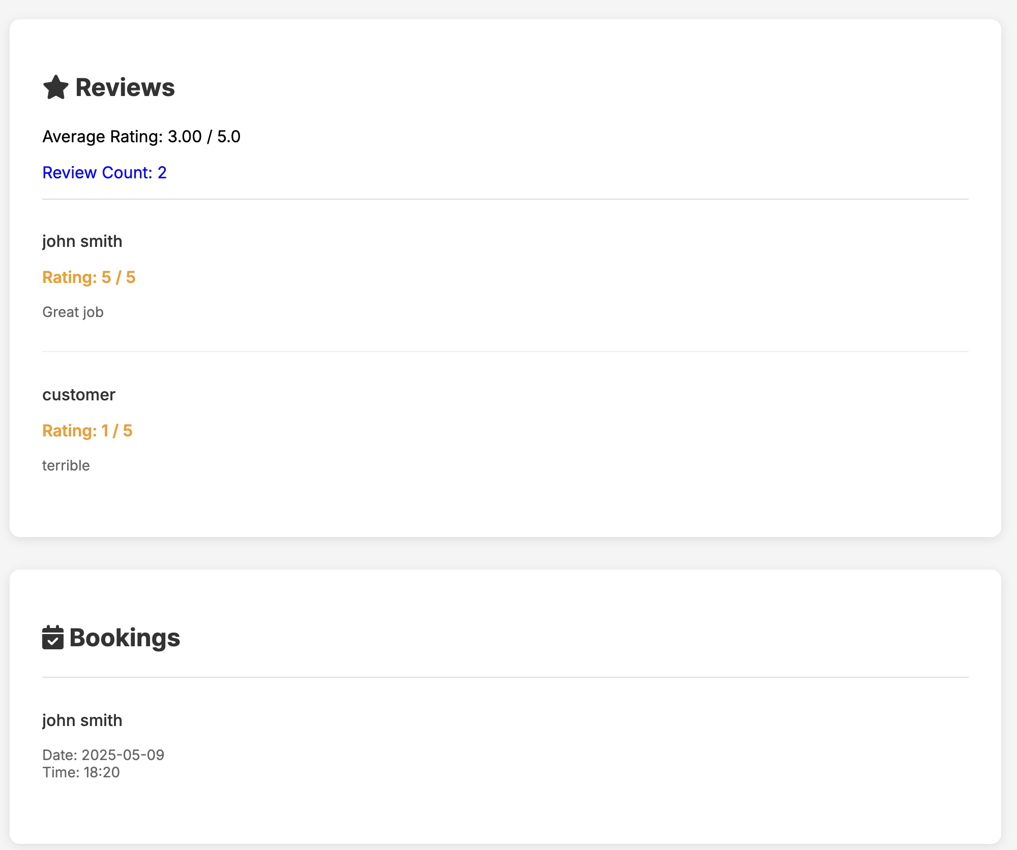

1. Provider P1 update profile information. P1 exits.